RUTESENDA INTERGRATED PROJECT

- Project Cover sheet: –

PROJECT DIRECTORS: ECOMUKA
1-Karuhuuga Michael (0702856869/0778994274)
2-Mugarra Steven (0772315510)

Period 3 years(2013-2015)
Local Community in the Ruteete and Kasenda Sub counties ; Kabarole District

II. Organizational history, mission, vision and structure:

ECOMUKA; a registered Community Based Organization; was initiated by two local residents of the Ruteete sub county in 2012 with the aim of improving the household incomes and general standard of living of the community .

STRUCTURE:
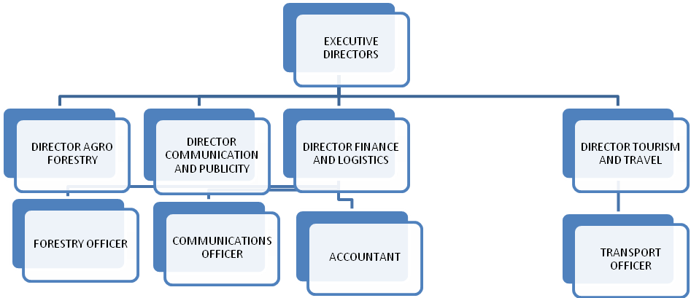

VISION : To transform the economies of the local community in Ruteete and Kasanda (RUTESENDA) into viable economic units through the sustainable exploitation and regeneration of the natural habitat in the next 15 years.

MISSION: Improve on the incomes of local community at the same time protect the environment through promotion of agro forestry and eco tourism

PARTNERS AND PARTICIPATING ORGANISATIONS:
ECOMUKA intends to link up with following categories of institutions to help realize the Mission.
1. Regulating Agencies such as NEMA, NFA
2. Local Governments (District and sub counties)
3. Local Organizations with similar objectives,
4. Regional and International Funding agencies

III. Background and analysis of the problem to be addressed
The proposal seeks to target the local community in the Sub counties of Ruteete and Kasenda; Kabarole District.
The following parishes shall be covered; Rurama, Kyamukoka and Kiko in Ruteete Sub county.
Kasenda, Nyabweya and Isungu in Kasenda Sub County.
The population is projected at 49, 000,*(2002 census)

The main economic activities are:
Tea production :( companies and out growers)
Subsistent farming; bananas (Kitika), sweet potatoes, sorghum, millet
Tourism services and fishing
The focus shall be on women groups, youth, primary schools, and religious institutions.

The area is blessed with rich habitat of natural forests, iconic birds and chimpanzees.
The area is also renowned for expansive tea plantations.
The underlying issue is that the indigenous community do not fully participate in harnessing this environment to its full potential and as such share little from the associated revenue streams.
It is the submission of this proposal that the local community are empowered to actively participate in Ecotourism and also play key roles in supporting energy needs of the blossoming tea factories

SPECIFIC INITIATIVES:

I AGRO FORESTRY
-Establish 60,000 nursery beds of eucalyptus seedlings
-Sensitize potential farmers on best practices in cultivating eucalyptus and fruits
-Sell ready tree seedlings (10,000 per parish) of eucalyptus to organized households and groups
-Establish 30,000 nursery beds of assorted fruit seed ;( high value; avocado, mangoes jackfruit etc.)
- Sell ready tree seedlings (6,000 per parish) of assorted fruits to organized households and groups
-Link and network between consumers of fire wood/timber and farmers to ensure smooth transactions in real time

11 ECO-TOURISM
The area is blessed with scenic crater lakes, such as Nyabikeere, Nyinabulitwa, Nkuruba and Kasenda. The variety of fauna, especially the chimpanzee families and bird species offers an additional and unique experience for tourists.
ECOMUKA seeks to take advantage of this rich biodiversity and exploit opportunities offered; to strengthen tourism for both local and foreign visitors.

Specific activities:
-Establish and maintain fleet of vehicles to ferry tourist to destinations of choice
-Provide relevant and up to date information of developments on the local tourist sites (print, audio video and websites)
-Seek the support and participation of experts (local) in the field of botany and zoology through facilitation of prepared seminars and training
-Construct modest and comfortable recreation facilities (camp sites and cottages) along the popular/potential tourist sites.

III INFRASTRUCTURE IMPROVEMENT /MAINTENANCE
Specific activities
- Maintain the already existing road network in partnership with the local authorities
- Improve the quality and safety of water sources with the full participation of stakeholders(Local authorities technocrats and the community)

OBJECTIVES:

- To establish reliable sources of energy(firewood) for households ,tea factories and schools
- To enable the community increase household incomes through selling timber, wood and fruits
- To provide the community with additional sources of food/nutrition through growth of a variety of fruits
- To contribute to the reduce of carbon emissions through expansion of forest cover
- To offer affordable and convenient transport to local and foreign tourists
- To offer comfortable and affordable accommodation /recreation to tourist(local and foreign)
- To empower the community with knowledge on good (beneficial) environment protection practices
- To partner with local authorities in providing and maintaining basic infrastructure such as roads and safe water points.

IV. Annual project budget –

 | ITEM/YEAR | 2013 | 2014 | 2015
I | CASH OUTFLOWS
A | Agro Forestry
a | Purchase of seedlings for Eucalyptus | 2,264 | 2,490 | 2,739
b | Nursery beds for eucalyptus | 1,132 | 1,245 | 1,369
c | Purchase of seedlings for Jack fruits, mangoes, avocados | 2,264 | 2,490 | 2,739
d | Nursery beds for assorted fruit tree seedlings | 1,132 | 1,245 | 1,369
e | Acquiring seedlings for natural tree species | 2,642 | 2,774 | 2,912
f | Nursery beds for assorted natural forest trees seedlings | 604 | 634 | 665
g | 634 | 665 | 41,344 | 45,478
h | Training and skills development costs | 604 | 634 | 665
 | SUB TOTAL | 48,226 | 52,856 | 57,936
B | Ecotourism
a | Purchase of fleet (motor vehicles) 3 VANS first year and 2 in third year | 22,642 | - | 15,094
b | Maintenance of fleet | 226 | 248 | 285
c | Designing of website | 100 | - | -
d | Print of newsletters and magazines | 377 | 414 | 455
e | Local Publicity and advertizing costs | 27 | 29 | 31
f | Video cameras, binoculars and other digital accessories | 2,584 | 1,292 | 1,292
g | Video production and storage ( library )on ecotourism | 528 | 580 | 638
 | SUB TOTAL | 26,484 | 2,563 | 17,795
C | Infrastructure
a | Road maintenance | 8,302 | 8310 | 8,315
b | Water source protection | 2,075 | 2,100 | 2,150
 | SUB TOTAL | 10,377 | 10,410 | 10,465
D | Administrative expenses
a | Office expenses | 9,943 | 10,937 | 12,030
b | Incorporation and  registration | 189 | - | -
c | Salary and emoluments | 48,906 | 53,796 | 59,175
 | SUB TOTAL | 59,038 | 64,733 | 71,205
 | TOTAL OUTFLOWS | 144,125 | 130,562 | 157,401
 | INFLOWS
 | Annual subscription | 3,019 | 3019 | 3019
 | Sale of tree seedlings | 9,245 | 10,169 | 11,185
 | Sale of Publications and videos | 906 | 915 | 930
 | Income from transportation of tourists | 10,868 | 13,041 | 15,649
 | **Grants and donations | 65,660 | 60,000 | 46,000
 | TOTAL INFLOWS | 89,698 | 87,144 | 76,783
 | SURPLUS DEFICIT | (54,427) | (43,418) | (80,618)

*In dollars(Exchange rate : (1 US dollar equivalent to 2650 Uganda shillings)

** Local and foreign sources (funding agencies)

Narrative to budget line items:
* Project Personnel - the project will require two consultants to implement the workshops and financial officers to
manage the logistics
** Training - the project objectives will be met by undertaking 9 workshops on capacity building and will include the
above costs
***Equipment - the organization would require the following equipment in order to prepare for the workshops,etc.

