Project

For

Mayer Shukh
Maternal, Newborn & Child Health Care project

Sirajgonj, Bangladesh

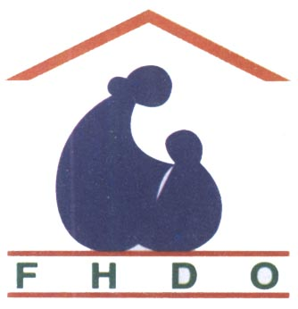

Healthy Mother, Healthy Child. Happy Family, Prosperous Country’

Directorate by
Family Health Development Organization (FHDO) Bangladesh

Sirajgonj Sador, Kazipur & Kamarkhand area of Sirajgonj
District – Sirajgonj
Bangladesh

Project submitted by
Kohinoor Begum
Director,FHDO

Mayer Shukh
Maternal, Newborn & Child Health Care project

Sirajgonj, Bangladesh

``Healthy Mother, Healthy Child. Happy Family, Prosperous Country ’’

Directorate by
Family Health Development Organization (FHDO) Bangladesh
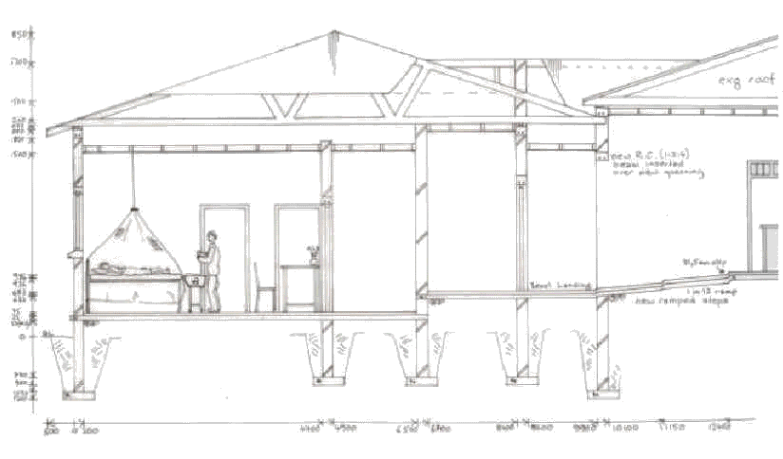

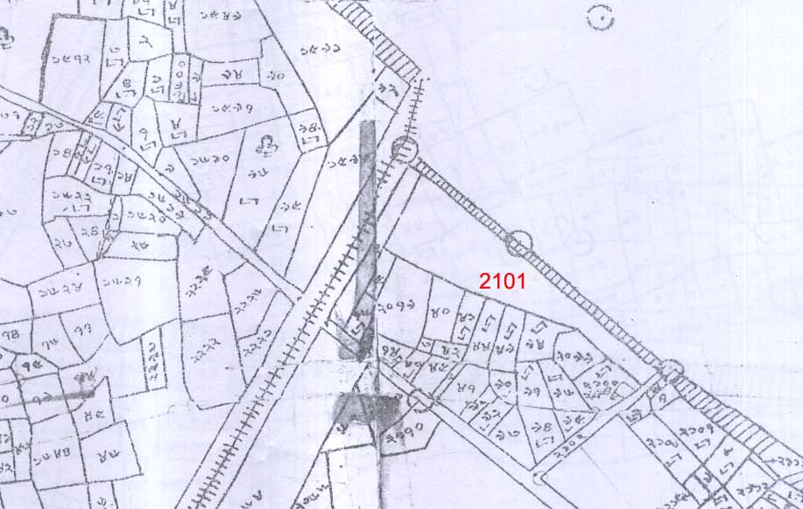

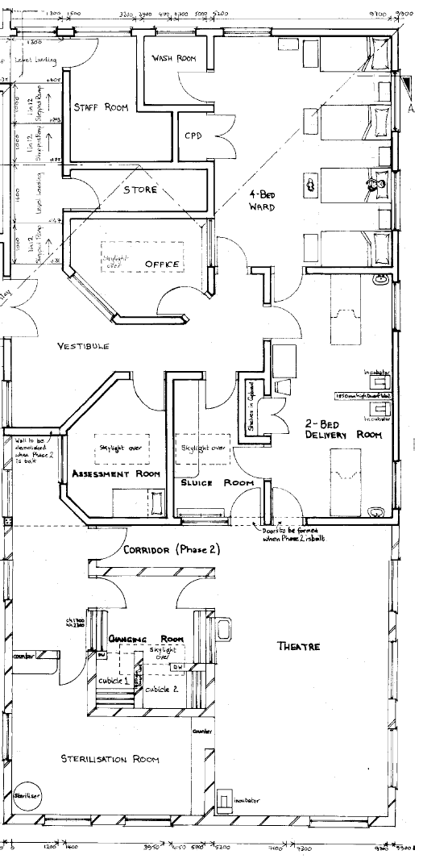

INTRODUCTION

Located in South East Asia Bangladesh is a low lying riverine densely populated poor country. she was liberated from Pakistan through arm’s struggle in 1971 and follows Parliamentary Democracy.Bangladesh is bordered by India to North, East, West and shares a short border with Myanmar in the South East.It’s land is less than 10 meters above Sea level.According to census report the population arrived at 142 million . The annual population growth is 1.34 percent which hampers development.Women are disproportionately affected.That is why it is important that reproductive heath should be redeemed security. Population density is 964 per square kilometer . Nearly half of the population spaces pregnancy by using family planning.Only 18% of birth are attended by Skilled Birth Attedants placing pregnant women to the risk maternal morbidity and mortality. Climate disasters like flood,river erosion,cyclone,are common phenomona which renders crores of people homeless, landless and jobless Manufacturing readymade garments provides employment for over 2 million people most of them are women..

BACKGROUND INFORMATION
The Family Health Development Organization (FHDO) was founded in 2001in Bangladesh. bearing no 640/ 2001. dated 14-05-2001 under the Directorate Of Social Wellfare, Government Of The People’s Republic Of Bangladesh. as a non-governmental, non-profitmaking organization with the purpose of improving maternal and neonatal health throughout the country. The working languages are Bengoli and English. Being concerned of the alarming situation of increased maternal and neonatal mortality along with higher rate of morbidity, a group of highly experienced medical professionals and eminent social workers were united and laid the foundation of the organization in 2001. FHDO as a national NGO has been working over the last ten years in the field of reproductive and child health care in different rural areas of Bangladesh.

Location of the Project

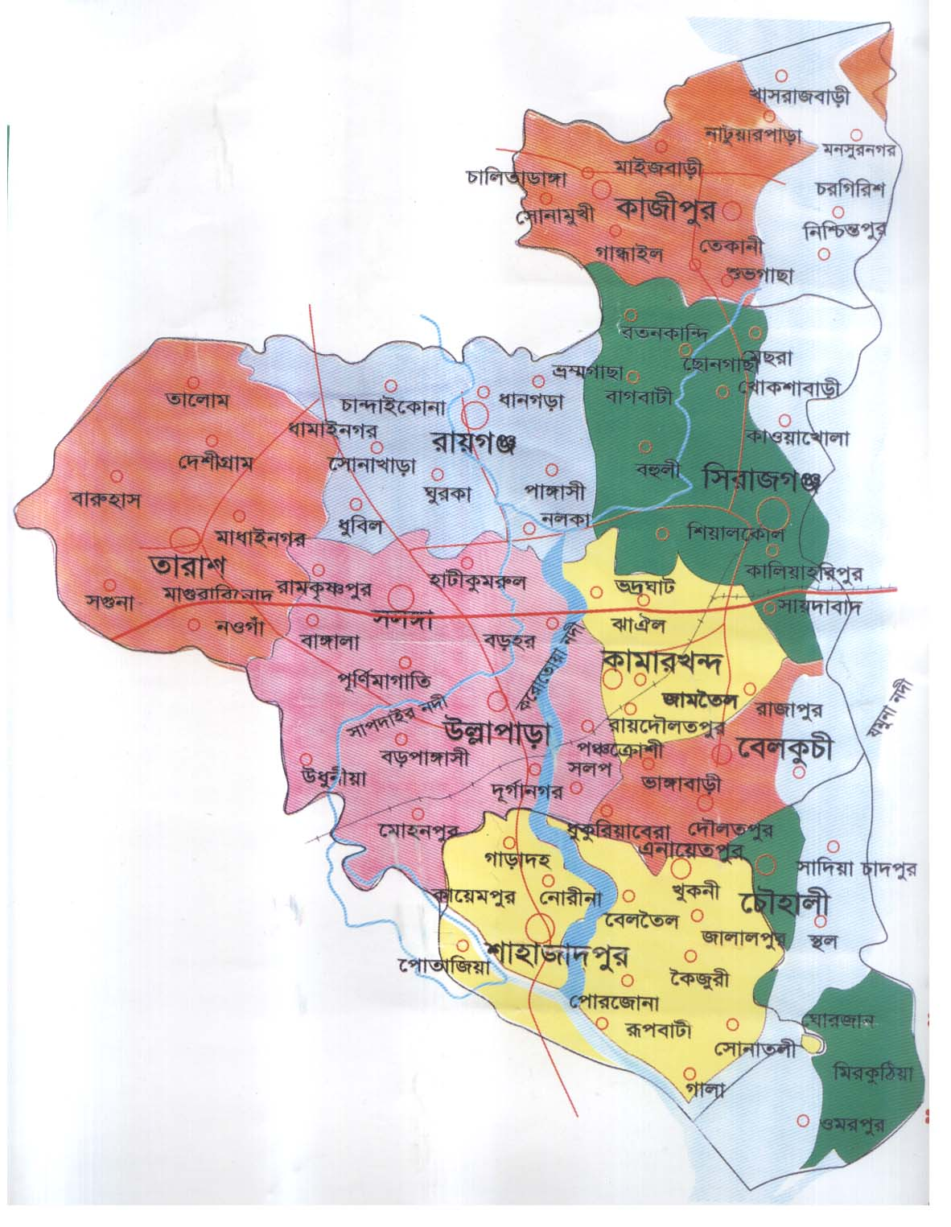

The project is located at Sirajganj District,the gateway to the nothern region of the country. Thedistrict has a size of approximately square kilometer mostly consists of flat cultivable land, rivers and waterbodies like beels and ponds.The mighty Jamuna river flows accoss the district And the district head quarter Sirajganj Town is situatedby the west side of the Bongobondhu JamunaThe Jamuna Multipurpose Bridge over the river Jamuna is constructed side by the district town. There is private medical college,3 govt colleges including a women college,A teacher’s training college venue of a private university.There is a river port and a milk processing factory namely milk vita at Bangladesh. The district headquater is well connected with rest of the country by train,highwaysand water transport.

PROJECT BACKGROUND
The issue of maternal health and infant mortality in Bangladesh has been of longstanding concern. Bangladesh's maternal mortality rate continues to be unacceptably high. For each woman who dies due to complications from pregnancy and childbirth many more suffer injuries, infections and sometimes disabilities brought about by conditions like obstetric fistula.
This project of FHDO was built with a five-year community based Maternal and Child Health Project (MCH) in the Sirajgonj Sador, Kazipur & Kamarkhand area of Sirajgonj district. The project was then re-named as Mayer Shukh to provide basic primary health care, particularly maternal, child health and family planning services through static and satellite clinics.
After the opening of the Mother and Child Health Care Centre, financed through contributions from the patients (user fees), capital built up during the life of the project, and FHDO own resources. Establishment of a clinic with outreach services and combining it with community mobilization has proved to be very effective model of positively changing health-seeking behaviour for women, and ultimately preventing maternal deaths. FHDO is now able to run and manage the Mother and Child Health Care Centre in Sirajgonj with the support of the community, who has been shown to value and use the available MCH services. Building on the Millennium Development Goal of improving maternal health.
As a result there is a prevalence of chronic energy deficiency amongst mothers and significant low weight problems and stunting in children. Lack of water and sanitation also remain key problems in the area. Overall, women in Sirajgonj district receive fewer maternal health services than average for the country. This is partly due to the differences in coverage and quality of services in the various districts and earlier conflicts within the region that have prevented access to quality primary healthcare. Only 18% of the women in this region are attended by skilled attendants during childbirth. In addition to being negatively affected by poverty and a holding a low status, women are also likely to have inadequate nutritional intake.
The government of Bangladesh's new draft health strategy foregrounds provision of access to quality primary healthcare with a focus on reproductive and maternal child health at the village level - however the strategy has not been translated into actions on the ground and the region desperately needs clinics, effective outreach and a strategy to involve the population in their own healthcare.

AIMS
With the ever-widening disparity in maternal and perinatal mortality in poor people. FHDO help with professional training, appropriate technology, suitable management protocols and operational research is urgently required. With the use of the Internet and other lines of communication, many of these needs can now be easily met, given the will and commitment of individuals. This is where the great potential benefit of FHDO lies; networking between groups and individuals to share ideas and experience. It is widely recognized that most causes of maternal and perinatal mortality can be prevented with cheap, good, basic care. A clear understanding of common problems, the prevention and correct management of important complications, the provision of practical management protocols, a short list of essential drugs, and robust, simple equipment are both available and affordable. FHDO is ideally places to provide a bridge between groups of health care workers in many poor community. Self-help training packages and distance learning courses in practical and appropriate maternal and perinatal care could be shared at minimal cost. Specific problems can be resolved by Internet communication while unsolved technical and protocol difficulties. FHDO has the committed members and good will to make a difference and improve the care of pregnant women and infants in Bangladesh.
The aims of FHDO are to promote the health and welfare of mothers and children, particularly in Bangladesh, as part of the overall goal to improve the health of all people. The health of mothers, newborns and children does not only depend on the gynecologists - obstetricians, but also the neo-natologists, midwives and nurses. FHDO should therefore aim for a closer working relationship between these categories. At regular meetings like general assembly and executive board meetings these persons should have a possibility for mutual exchange of experiences.The projects elaborated and financed by FHDO are especially destined for the basic care of the pregnant mothers and their newborns. Therefore these projects should be destined forBangladesh. Thanks to the use of complicated, technical methods in the field of gynecology and neonatology during the last decades, extraordinary results were obtained.

GOALs & OBJECTIVES:
Effective maternal healthcare offered by HC & HOS and reduced risk at birth/childbirth, infancy.Improved community practices and awareness of sexual & reproductive health issues through shared & responsible decision-making.
MDGs 4 and 5

FHDO improving the health of mothers and their newborns. reduction in deaths among children under age 5 by two-thirds (MDG 4) and among pregnantwomen by three-quarters (MDG 5). FHDO supporting programs to promote safe pregnancy and childbirth, family planning, and the sexual and reproductive empowerment of women.(MNCH)

Maternal, Newborn, and Child Health (MNCH) refers to an effective and integrated continuum of care that delivers basic services to mothers and their infants at critical points, and to children in their first five years of life, with the goal of ensuring the health and survival of each.14 The lifetime risk of a women dying from pregnancy-related causes (maternal death) in Bangladesh Of all deaths in Bangladesh among pregnant women, infants, and children under age 5, percent occur in the highest death rates recorded in Bangladesh.

FHDO include better prenatal care, having a skilled health assistant during birth, access to emergency obstetrics and newborn care, postnatal visits, and antibiotics to treat infections of mothers and newborns. Adequate nutrition and education to improve health, and good hygiene practices are also.

Improvements in child health are closely associated with the availability of basic, cost-effective prevention tools (vaccines, insecticide-treated bed nets, vitamin A supplementation), and access to treatment against infectious diseases (including antibiotics, oral rehydration therapy and zinc, pediatric ARVs, and antimalarial drugs). Access to clean water and sanitation is also. The majority of children under 5 die of five preventable or treatable diseases: pneumonia, diarrhea, serious newborn infections, prematurity, and birth asphyxia. Malaria, measles, and HIV/AIDS are also significant causes of under-5 deaths.

Postpartum hemorrhage (severe bleeding after delivery) a leading cause of maternal deaths) can now be treated with oxytocin. It can be administered by community health workers to women in rural settings using Oxytocin Injects, a pre-filled, single-use syringe which is being piloted in several countries.

• Infections of the umbilical cord—very common among infants in Bangladesh —can be prevented by cleaning the umbilical cord with a solution called chlorhexidine. Trials suggest that chlorhexidine could reduce newborn deaths by one-third.

• Topical emollient therapy— application of sunflower seed oil to improve the function of the skin and prevent infections—decreased hospital-acquired infections in very preterm infants by 40–50 percent, and newborn deaths by 24 percent in one trial in Bangladesh., 10 Key innovations with significant potential to further reduce under-5 child deaths include:

• Pneumococcal vaccines prevent common forms of pneumonia, the leading vaccine-preventable killer of children under age 5 in Bangladesh.

• Prevention of mother-to-child transmission (PMTCT) of HIV/AIDS can be achieved through the timely administration of antiretroviral treatment to HIV-infected pregnant women and their newborns. It greatly reduces the risk of HIV transmission from mother to child.

FHDO work prenatal care, childbirth with a skilled birth attendant, and better hygiene, resulting in a 30-percent reduction in neonatal mortality and an 80-percent reduction in maternal mortality.

FHDO also developing prenatal care from a skilled health worker at least once during pregnancy, during births that were attended by a skilled birth attendant .improving the health of mothers and their newborns.reduction in deaths among children under age 5 by two-thirds (MDG 4) and among pregnant women (MDG 5).

FHDO Carry programs to safe pregnancy and childbirth, family planning, and the sexual
and reproductive empowerment of women.(MNCH)

STRATEGY
The vision of FHDO is to improve maternal and perinatal care in Bangladesh by facilitating and support health care.

PLANNED ACTIVITIES:
Maternal child health surveys repeated, recorded, analysed, disseminated for both sub- districts.
Two community based health centres in operation attending to health needs of women and their children.
Increased, expanded, and enhanced direct MCH health care services for women and children in the clinics, coupled with comparable levels of MCH health promotion / community outreach activities.
Medical training of traditional birth attendants in safe home birthing techniques.
Training in health promotion and education techniques in maternal child health issues and approaches for community peer educators.
Community based health promotion activities in mother and child health, integral infant-child development, family planning, sexual health issues and strategies, especially around sexually transmitted diseases (STDs).
Community animation, community organization, leadership development among community women to ensure empowerment of women around issues of reproductive, maternal and child health.
Information sharing and dissemination of information among MCH health workers in Bangladesh.
Holistic consideration of day to day health and hygiene practices, with health education by example through ICS, organic demonstration gardens, water point and latrine provision, in cooperation with the local communities.

Community-based Health Centres (HCs) are established to provide quality maternal and natal care. Health Outreach Services (HOS) are provided to make services further available. Appropriate vaccines for polio & measles administered through National Immunization Days in targeted areas.
Traditional Birth Attendants (TBAs) & Peer Educators are provided quality training on safe child-delivery. Health Centre & Health Outreach staff members are trained on gender-sensitive information dissemination on maternal health, family planning, STDs.
Mothers' Clubs, Youth Clubs and Girls' and Women Clubs, etc are set up to empower individuals from different demographics in making choices for healthy sexuality, family planning and helping them play their part in designing community resources in these areas, providing health education to all on key issues around prevention and control of high-burden, communicable diseases, STDs, malaria, respiratory infections, diarrhoeal diseases, malnourishment etc

TARGET POPULATION:
The entire population of the target areas is expected to benefit from the project. In total, approximately 386,851 people (of whom approximately 277,541 are women) are expected to benefit from the project.
Of this population, those targeted will include:
- Expectant and New Mothers;
- Infants below five years of age;
- Adolescents
- People with or at risk of STDs
- Households without a sanitary toilet
- Inhabitants of Project Areas with no/limited water points
- Health workers (volunteer and professional)

Immunization coverage for infants in 2010 as 85%. The majority (65%+) of deliveries occur at home, mostly because of difficulty for mothers in reaching a suitable facility to deliver. Many of these deliveries are performed by Traditional Birth Attendants, or retired nurses living in the villages, without adequate supervision, or emergency drugs, or in many cases gloves being available.
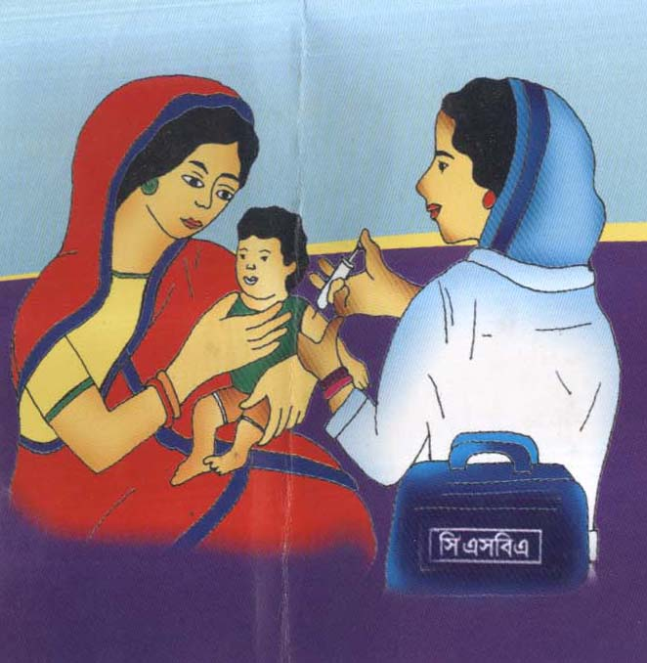

Project Aims
The main aim of the project is to improve maternal, newborn child health and nutrition. Our aim is to provide a facility for local mothers to deliver their babies, with trained staff, and emergency equipment available if needed.
The project is envisaged in two stages. The first comprises adding a delivery suite and postnatal ward to the facilities at Kohinoor nursing home and the second would be to add a small theatre to allow caesarean section on site for women who needed this. The project integrated safe motherhood, newborn care, family planning projects – aims to increase the practice of healthy maternal and newborn behaviors in sustainable and scalable manner. The project aims to address the high death rate among women and infant in the project area through improved out area of field workers, increased education for safe pregnancy and delivery and improved family planning and child spacing. The project will increase pregnancy related care, support safe delivery and increase community involvement in caring for pregnant women. The program organizes emergency transport for pregnant women in labor. The project works to increase awareness about low cost methods for saving newborn and provide education to use family planning to protect lives of women and children.
Decline infertility : The project aims at decline infertility to achieve the goals, currently married couples are being approached to use contraceptives. Bangladesh’s goals to reach fertility level of 2 children per-women below will require contraceptive use to increase substantially over the current use rate.
Antenatal care : The project aims at increasing the use of Antenatal care among pregnant women.
Child mortality rate : The project works to decline child mortality. Child health programs like vaccination coverage, management and treatment of diarrhea and acute respiratory infection.

Current senior staff of the organization
Sl. No. | Name |  | Position |  | Sex  (Male/Female) | Duration in the Present Job
1 | Mrs. Kohinoor Begum |  | Project Director |  | Female | 10 years
2 | Mr. Nassiruddin Badal |  | Chife Project Coordinator |  | Male | 5 years
3 | Mr. Nazrul Islam Lenin |  | Asst. Chife Project Coordinator |  | Male | 7 years
4 | Mr. Mofazzal Hossain | Asst. Chife Project Coordinator |  | Male |  | 5 years

Total staff of the organization
Level |  | Male | Female | Total
Coordinating Office | Senior Level | 3 | 2 | 5
 | Mid Level | 3 | 6 | 9
 | Junior Level | 6 | 6 | 12
 | Support Staff | 3 | 5 | 8
Project Based | Senior Level | 2 | 8 | 10
 | Mid Level | 13 | 10 | 23
 | Junior Level | 7 | 173 | 180
 | Support Staff | 6 | 9 | 15
Total |  | 43 | 219 | 262

Current projects/programs
Sl. No. | Name of the Project | Major focuses of the Project | Location of the Project | Donor | Duration of project (As per existing contract)
01 | Mayer Shukh (Maternal, Newborn & Child Health Care) project . Sirajgonj Sador. | Reproductive Health including FP & Maternal Health, Newborn & Child Health Care | Sirajgonj Sador, Post. & P.S. Sirajgonj, Dist. Sirajgonj | USAID via FHDO | July. 2012
02 | Mayer Shukh (Maternal, Newborn & Child Health Care) project , Kamarthond. | Mayer Shukh (Maternal, Newborn & Child Health Care) project | Vill. Tami & Randhunibary, Post. Tami & Randhunibary, P.S Kamarthond. Dist. Sirajgonj | “ | “
03 | Mayer Shukh (Maternal, Newborn & Child Health Care) project, Kazipur. | Mayer Shukh (Maternal, Newborn & Child Health Care) project | Vill. Natuyerpara, Post. Kazipur P.S. Kazipur Dist. Sirajgonj | “ | “

- Baby Incubator Machine.
- E.C.G Machine.
- Eclectic Sucker Machine.
- Sound Doppler Machine.
- Ultrasonic Machine.
- Nebulizer Machine.
- Equipment of Blood Grouping.
- Equipment of Blood Hemoglobin % Test.
- Equipment of Blood E.S.R Test.
- Equipment of Blood Sugar Level Test.
- Equipment of Urine R.E Test.
- B.P Machine with Stethoscope.
- Eclectic Baby Hitter Machine.
- PPH Medicine & Equipment

