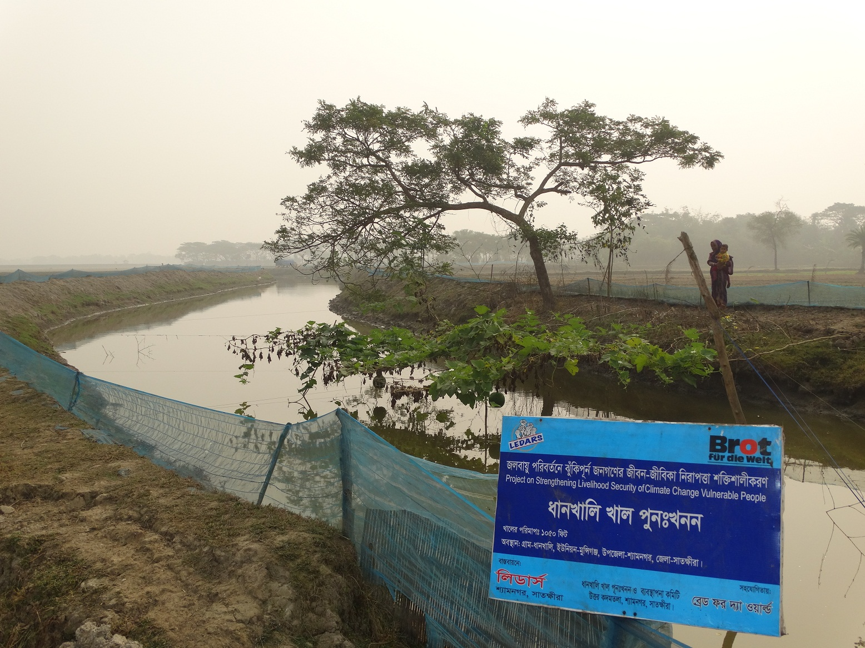

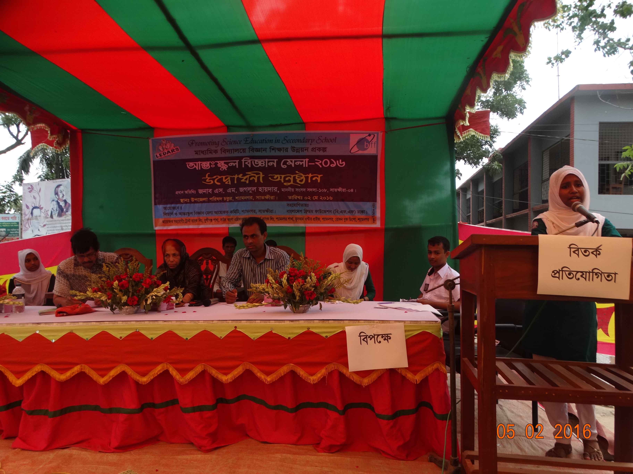
Profile
Of
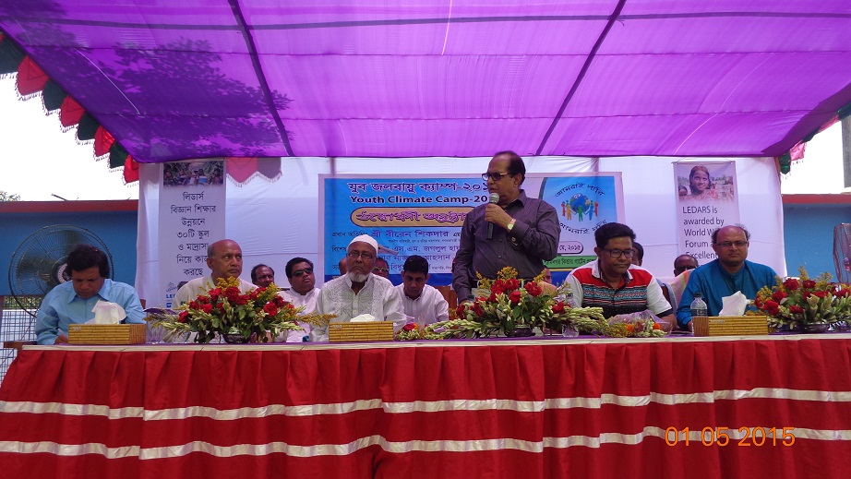
LEDARS

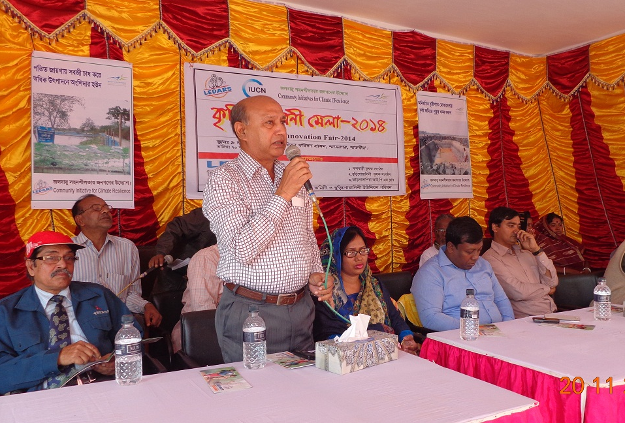

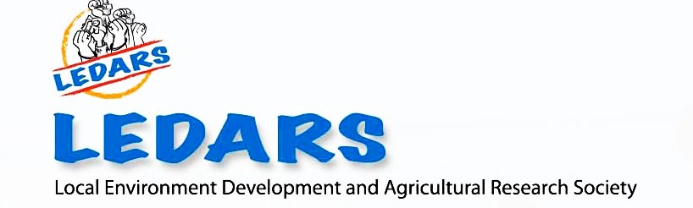

Head Office
Village: Munshigonj, Post Office: Kadamtala,
UpazilaShyamnagar, District: Satkhira, Post Code: 9455, Bangladesh.
Telephone: +8801713462821, +8801854802300
E-mail: ledars.bd@gmail.com, info@ledars.org
www.ledars.org

1. Evolution of LEDARS:
Local Environment Development and Agricultural Research Society (LEDARS) is a non-profit and non-political organization that has been working for social, economical and environmental development of the poor and marginal people of the southwest coastal region of Bangladesh since 1996. The previous name of LEDARS was Gana Unnayan Shangstha (GUS). The name was changed to LEDARS in 2007 to address a government regulation and to avoid the duplication of another organization’s name in the NGO Affairs Bureau.

When unplanned shrimp cultivation, river erosion and various natural disasters compelled the coastal people to migrate to urban areas during the early 1990s, LEDARS emerged from a local club to a development organization to stand beside vulnerable people to support their livelihood security and establish their rights. LEDARS is registered under the Social Welfare Department and NGO Affairs Bureau, Government of Bangladesh. LEDARS is working with landless, marginal farmers, labour and women headed families, children and adolescents in the climate vulnerable area of Bangladesh.

2. Vision:
To contribute in poverty reduction of the poor and marginal groups through optimum usages of local resources.

3. Mission:
LEDARS supports and equips people with appropriate methods to raise their voice for establishing basic and human rights, in order to ensure livelihood security of the most vulnerable and socially excluded segments of the population.

Mission Statement 2021: To built an environment that will facilitate to reduce vulnerability due to Climate change and empower women to develop sustainable model through our innovative intervention.

LEDARS is committed to:
- Raise awareness about adverse effect of environmental degradation and climate change,
- Building capacity of marginalized groups to cope with climate change in the areas of adaptive agriculture and alternative income sources,
- Conserving the bio-diversity of the Sundarbans mangrove forest and the coastal ecosystem,
- Creating access to education for underprivileged children,
- Organizing Sundarbans resource user community groups for sustainable resource extraction,
- Creating opportunities for the vulnerable poor to access necessary medical services,
- Creating opportunities for vulnerable women, especially female-headed households to create sustainable livelihoods,
- To establish a just society through conducting advocacy to ensuring a sustainable environment, human rights and good governance.

4. Target population:
Small and marginal farmer, women and children are our primary program participants. We have included young population in our programs in recent time focusing on youth development and bio diversity conservation.

5. Legal Status:
SL | Authority | Reg. No | Date
01 | Social Welfare Department | Sat- 241 | 11 May 1999
02 | NGO Affairs Bureau | 2477 | 2 September 2009 (renewed)

6. Staff strength:
The table below gives the present status of the staff members of the organisation.
Sl. no | Position | Total | Male | Female | Managerial  Level | Field Level
1 | Full time staff | 31 | 22 | 9 | 11 | 20
2 | Part time staff | 12 | 12 | 0 | 2 | 10
3 | Volunteers | 29 | 15 | 14 | 0 | 29
 | Total | 72 | 49 | 23 | 13 | 59

7. Present Working area:
Sl no | District | Upazila
1 | Satkhira | Shyamnagar, Asasuni
2 | Khulna | Koyra

8. Address: Head Office:
Village: Munshigonj, Post Office: Kadamtala,
Upazila Shyamnagar, District: Satkhira, Post Code: 9455, Bangladesh.
Telephone: +8801713462821, +880854802300
E-mail: info@ledars.org, ledars.bd@gmail.com,
www.ledars.org

Dhaka liaison Office:
House# 04, Road # 12, Block # Kha, Pesiculture Housing Society,
Mohammadpur Dhaka-1207

Shyamnagar Center Office:
All Modina Traders (3rd floor), Nakipur bazar, Shyamnagar, Satkhira

Koyra Center Office:
Gharilal Bazar, South Bedkashi, Koyra Khulna

9. Annual Budget: (Without loan program)

Fiscal Year | Amount in Taka | Amount in US$
2015-2016 | 1,93,14,400 | 2,48,097
2016-2017 | 2,35,70,750 | 3,02,189
2017-2018 | 2,20,00,300 | 2,68,296

10. Contact person and project personnel:
Name: Mohon Kumar Mondal, Position: Executive Director

11. Professional Background of Executive Director:
Executive Director of LEDARS is known figure in development arena in Bangladesh and world. He is post Graduate on Geography and Environmental Science has been working in the development field from student life (since 1995). He is a grassroots development actor and climate change campaigner in southwest Bangladesh.

He has taken part in national and International event in my professional carrier. He attended 4th and 7th World Water Forum in Mexico 2006 and Korea 2015 and presents a success story of LEDARS for grassroots development in water sector, which awarded by Kyoto World Water Grand Prize as top ten-semi finalist and 3rd Prize of World Water Showcase Award in 2015. He attended COP 15 and 23, Asia Pacific Adaptation Forum, 2010, International Conference on Climate Induced Migration in Geneva, 2012. He has been completed a short course from BIARI, Brown University, Roads Island, USA on Disaster Management and Humanitarian response. He also awarded of State Department of USA scholarship of International Visitor Leadership Program (IVLP on Eco-Management, Environmental Protection, and Eco-tourism) to get experience of USA's national park management. He is member of US State Alumni Association. He has visited USA, UK, India, Nepal, Switzerland, Denmark, Germany, Korea, Thailand, China, Costa Rica, Mexico, etc. to attend international meeting and seminars. He presented country papers on Climate Induced migration in Bangladesh in Geneva 2012. And presented seminar papers on Roles on CSO to achieving SDGs in Bangladesh as panelist of the workshop on "Roadmap of Implementation SDGs in Civil Society Organization", organized by TERRY Policy Center in Dhaka at 10 January 2018.

12. Sectors and Current Programs:
LEDARS has been working in the following 7 sectors since it’s inception to till now.
Sector-1: Climate Change and Livelihoods
Sector-2: Ecology and Environment
Sector-3: Water, Sanitation and Hygiene
Sector-4: Human Rights, Good Governance and Gender Development
Sector-5: Education for Dignity
Sector-6: Health and Nutrition
Sector-7: Emergency Response

Sector 1: Climate Change and Livelihoods
- Strengthening Livelihood Security of Climate Change Vulnerable People:
The negative impacts of climate change make Bangladesh one of the most vulnerable countries in the world. Increased frequency of floods, droughts, tidal surge and cyclones caused extensive economic damage and impacted livelihoods of the poor and marginal population who have been living in the fragile coastal areas of Bangladesh. Extreme weather events, monsoon variability and Sea Level Rise (SLR) induced salinity have forced to change the traditional cropping patterns of agriculture that occurs serious impact on livelihood and food security of marginalized population. The all above situation increased hardship in the life of poor and marginalized people which forced people to migration. Considering this situation LEDARS is implementing “Strengthening Livelihood Security of Climate Change Vulnerable People” with the support of ‘Bread for the World’, Germany. The major activities of the project are:

People organization formation and awareness rise: LEDARS conduct a baseline survey. LEDARS organized 820 people by forming 35 Peoples Organization (27 Climate Resilience Groups, 05 Self Help Groups, 03 Farmers cooperatives). LEDARS raising awareness of beneficiaries by organizing fortnightly meeting, farmers filed school sessions, couple meeting, annual farming innovation fail, day observation, cross learning visit, printing and distribute easy reading materials (leaflets 15000, crop calendars 3000, posters 4000) and fixing 8 bill boards.

Promoting resilient agriculture: LEDARS building capacity of the beneficiaries on resilient agriculture by providing training on adaptive paddy and vegetable cultivation, provide seed of paddy and vegetable. LEDARS support farmers for efficient management of rainwater and available surface and ground water by digging 50 small ponds, re-excavate 03 canals, install 04 deep tube wells, etc to establish resilient agriculture in it’s working area.

Support for Income Generating Activities: LEDARS trying to increase income of most vulnerable 270 women and men including tiger victims widows by provide training on alternative income generating activities, provide seen money to women beneficiaries. LEDARS also providing assistance to women beneficiaries to establish small business, small-scale aquaculture, small cottage, etc.

Support for Drinking water and health care: LEDARS supports beneficiaries to have safe drinking water by excavating ponds and install 6 new PSFs, activating 11 in active PSF and distribute 40 rainwater among beneficiaries. LEDARS also providing health care support to 5000 vulnerable families including our beneficiaries.

Capacity building of staff: By this initiative, LEDARS tried to increase capacity of staffs by provide 13 daylong training, organize quarterly staff meeting and yearly retreat.
Strengthen Local Government: LEDARS has taken initiatives to involve local government to provide good delivery on climate change issue by strengthening their capacity of Local Adaption Plan Activity (LAPA).

B. Development of Center for Coastal Climate Resilient (C3R):
The southwest coastal region of Bangladesh is one of the most disaster-prone areas of the country as well as in the world due to its geographical location. Due to salinity intrusion, sea level rise, frequent disasters, shrimp cultivation, river bank erosion, people are immersed in distress in their livelihoods which force them to extract resources from Sundarbans or to migrate to safer places for better livelihood. Almost every year, the area faces remarkable cyclones signal level of 3-7, which creates anxiety of the community people. The shrimp induced unemployed people are fiercely engaged into forest resource collection. While the poor people go into the Sundarbans to earn their livelihood, they often become victims by the tigers. A significant number of tiger victims’ widows living in this area. It is alarming that a significant number of people are under threated threatened and some are already migrated from this area for better and safe livelihoods. In the community, there are indigenous copping and adaptation technologies but that are not being promoted. Access to information on climate change, adaptation and mitigation is very poor. Considering the situation, LEDARS is trying to develop a Center for Coastal Climate Resilient (C3R) in Munshigonj union, Shyamnagar upazila of Satkhira district. The major activities of the center are,

Establish a training facility for the community people and students: LEDARS bought 158.00 decimals land for the center and already developed training facilities by the financial support of 2 different donors. LEDARS already developed a three-storied building with well-equipped training facilities.

Development of demonstration plot on adaptive technology: In the center premises, LEDARS is demonstrating the viable climate adaptive technology like water treatment technology, climate adaptive irrigation system, different types of crop cultivation etc. Anyone can see the technology in the center.

Established a laboratory: LEDARS established a laboratory in the center premises to provide support to community people. People can take support to test their soil and water in the laboratory.

Set up a technical training unit for the youth: LEDARS is trying to set up a technical training institute in the premises where people can receive training on technical work.

Knowledge management: Under the initiative, LEDARS developed a handbook on local level adaptation practice, leaflet and poster on resilient agriculture, water management etc. LEDARS developed 3 flip carts for development activist to community mobilization.

Sector 2: Ecology and Environment
A. Campaign for prevention of saline water to restore agriculture in coastal region of Bangladesh:

Saline water shrimp farming is increasing the climate vulnerability of the people in the southwest coastal region and destroying physical environment in coastal area. This practice has contributed to the degradation of agriculture, unemployment in the agriculture sector, damaged the drinking water sources, and destroyed the livestock, etc. In these circumstances, LEDARS along with other NGOs and civil society is conducting a campaign to sensitize government officials to stop the saline water shrimp farming in agricultural land and restore the agricultural-based livelihoods. LEDARS is organizing community session to raise awareness to protect saline water shrimp farming, organizing dialogue meeting with community people, civil society and policy makers, demonstration child road show, human chain, fixing posters on destruction of shrimp farming, memorandum submission to policy makers, letter and signature campaign, etc.

B. Youth Mobilization for Sundarbans Conservation:
Sundarbans is the largest mangrove forest in the world that has become the last habitat of the Royal Bengal Tiger and has declared as the world heritage site by UNESCO. The Sundarbans mangrove forest is situated in the southwest region of Bangladesh (62% of the total) and southeast part of India (remaining 38%)which has become the source of livelihoods of more than 4 million of people living in the Sundarbans zone. While the Sundarbans has the rich biodiversity having numbers of flora and fauna species. The responsible government department allows resource extraction without considering the biodiversity of the forest. Eventually, the Forest Department allows everybody to collect forest resources without considering their professional skill. Thus forest resources are being abused and the process of renewing of resources is seriously being hampered. The human settlement in the adjacent area of Sundarbans depends on the Sundarbans directly or indirectly. It is the windshield of oceanic cyclones and tidal surge. If the Sundarbans demolished, people have to move from this area. Considering the situation LEDARS implementing a project with the 3 schools and 3 colleagues to sensitize community people and policy makers. Major activities of the initiatives;
- Sundarbans Friends Club formation
- Awareness Raising of youth people in Sundarbans region
- Youth Environmental Camp
- Hiking in Sundarbans
- Day observation
- Develop easy reading and awareness materials

Sector 3: Water, Sanitation and Hygiene
A. Biosand Filter Project in Southwest Coastal Bangladesh:
Water crisis is the most crucial problem in the southwest coastal region of Bangladesh. Though there are lots of surface water but neither they can drink nor use for household purposes because of salinity, turbidity and other bacterial contamination. From 2009, LEDARS implemented Bio-Sand Filter (BSF) a household water treatment technology in coastal area of Bangladesh. Since 2015, LEDARS is implementing “Biosand Filter Project in Southwest coastal Bangladesh” project with support of OHorizon Foundation, USA. Major activities of this project are to identify vulnerable families who have scarcity of safe drinking water, install Biosand filter to the families, and regular monitoring the filter is active or not. Till January 2018, LEDARS install 4000 BSF and within December 2018 more 1000 BSF will be installed. LEDARS providing orientation about water resource management, orientation on Biosand filter management, etc.

B. Up scaling Managed Aquifer Recharge (MAR) for Community Water Supply in Saline prone areas.
LEDARS is implementing the project entitled “Up scaling Managed Aquifer Recharge (MAR) for Community Water Supply in Saline prone areas”. It is a project managed by the Department of Geology, University of Dhaka with support of Ground Water Circle of the Department of Public Health Engineering (DPHE); WASH Section of UNICEF Bangladesh; and Acacia Water of the Netherlands. The prime aim of this project is manually recharge the ground water for providing community water supplies in saline areas of the Khulna, Satkhira and Bagerhat districts. NGOs are closely working with Dhaka University to maintain properly of the sites and provide technical information for research purpose. 7 partner NGOs have been working in this three district. The Consortia members of this project is UNICEF Bangladesh, University of Dhaka (DU), Acacia Water (Netherland), Department of Public Health Engineering (DPHE), Shushilan, AOSED, Mukti Foundation, Gano Milan Foundation, Jagrata Juba Shangha (JJS), LoCOS, and LEDARS. LEDARS is working in Shyamnagar upazila where 10 MAR sits are present.

Sector 4: Human Rights, Good Governance and Gender Development

A. Socio-Economic Empowerment of the Tiger Victims' Widows in Sundarbans, Bangladesh
The Sundarbans, the second home of the coastal people, is also the heart of the people of the South West coastal region of Bangladesh. The poor people of Sundarbans surrounding area go to Sundarbans for resource tapping for livelihoods and may become victims of tiger. The widows of the death often ousted from their in-laws houses with their children and become most vulnerable segment of the society. The tiger victim widows are treated as the sign of misfortune in the society because they are thought responsible for the death of her husband. As a result, they are neglected everywhere, assaulted, socially harassed by the community. They often expelled from their in-laws houses with their children and become most vulnerable segment of the society.

LEDARS started this activity with financial support of Action Aid Bangladesh, Niagara Volunteer for Bangladesh. Then Federal German Embassy of Dhaka has funded the project. Now the project has been implementing by Bread for the World. Main focus of this program is to economic empowering the tiger widows. Under this program we have formed 8 Self Help Group, provide seed money to those group as revolving fund, providing skill training on their selected income generating activities. We are providing training to conduct right based activities, social awareness, provide rain water and bio-sand filets to the families and also provide scholarship to the meritorious students of widows’ families.

Sector 5: Education for Dignity
- Promoting Science Education in Secondary School
For the maximum utilization of the resources of our country, proper development in science and technology sector is necessary. But the reverse condition alarms the highly budgeted education sector of Bangladesh. The southwest coastal region is not deviated from of this situation. Along with the shortage of teachers, factors such as weak curriculum, low quality textbooks, poor teaching and assessment methods, inadequate incentives for teachers, and lack of trained faculty and laboratory facilities have contributed to the decline in quality of science education as well as for the disinterest and phobia towards science.

LEDARS is supporting the schools to popularize science through carry out practical experiments, leadership training, science fairs, workshop with civil society and journalists, media sensitization, district level Seminar, meeting with head teacher, guardians.

Sector 6: Health and Nutrition
- River Ambulance for Tiger Victims in Sundarbans
Sundarbans neighborhood families lead their life based on the resource tapping of Sundarbans. So sometimes they are the victim of the tiger while they are in the forest. As the place is very remote, the tiger victims do not get the opportunities to get the primary health service; even cannot go to the hospital. As a result the victims are to die on the spot due to hemorrhage and bacterial contamination for time elapse. LEDARS is providing first aid services and take the responsibilities to carry the victim from the occurred place to the hospital. LEDARS contracted three hospitals in the Shyamnagar sub-district of Satkhira.

- Primary Health Care Project in Sundarbans island area
The Sundarbans, possesses floral and faunal resources, is the core of livelihood of the neighbors. Thousands of people live around this area for resources tapping. This area is very remote for its location which is crises crossed by small canals and rivers, lack of road facilities, muddy area, illiteracy etc. for these reasons physicians are not ready to stay in the rural level Government medical services like Union Mother and Child Care Centers. People have to rely on the village doctors. The health situation is so neglected in poor community in the island area. LEDARS manage some space to organize this community medical service camp in the working area. There are medical assistants/paramedics sits there after 15 days interval, prescribe all patients and provide medicine support for the card holders.

Sector 7: Emergency Response
A. Quick Response in SIDR.
In November 2007, the southwestern part has been seriously affected by super cyclone SIDR. More than 4000 people were died in that cyclone. Total coastal area was divested. LEDARS provided quick relief to the SIDR victim households in Gabura, Burigoalini and Munshigonj union in Shyamnagar sub-district under Satkhira district.
B. Cyclone SIDR Rehabilitation Program with Pond Sand Filters (PSF)
Gabura union is the most affected area by SIDR in Shyamnagar. All the drinking water sources were damaged and filled with saline water. LEDARS de-watered the ponds, excavated and installed05 PSF in 05 villages in Gabura with the support of Asia Arsenic Network. Besides that LEDARS donated 20 cyclone resistance low cost houses to the widow families of Gabura union.
C. AILA Emergency Response Program
LEDARS quickly responded to the AILA affected area and distributed a huge relief to the community people of Padmapukur, Gabura, Burigoalini and Munshigonj union with the support of Action Aid Bangladesh, BARCIK, Asia Arsenic Network, Niagara Volunteer for Bangladesh and LEDARS own funds.
D. Early Recovery Program of AILA
LEDARS took initiatives to early recovery program in Gabura union with the support of Save the Children, Asia Arsenic Network and Niagara Volunteer for Bangladesh. LEDARS dewatered 17 pond in the area and re-activated17 PSF. LEDARS also provided support to 100 vulnerable adolescent girls’ families in Koyra and Shyamnagar sub-district which is most affected area of the AILA.

13. Completed projects of LEDARS:

Sl No | Project Name | Duration | Total Budget | Donor Name
1 | Creating access to pure drinking water for the climate vulnerable community in AILA affected areas of Satkhira district. | November 16-30 April 17 | 1,674,000 | Canada Embassy
2 | Wash in Classroom | 16 August 2015-30 November 2015 | 564,025 | Cap-Net UNDP
3 | Manage Aquifer Recharge for Community Water Supply in Costal, Urban & Draught prone Areas. | 1 July 2015-30 June 2017 | 2,455,200 | University of Dhaka
4 | Expanding Clean Water Access in Costal Bangladesh. (1st) | 01 October 2015-31 September 2016 | 5304402 | OHorizons, USA
5 | Promoting Science Education in Secondary School.(2nd phase) | 1 July 2014- to June 2018 | 1,730,775 | Bangladesh Freedom Foundation (BFF)
6 | Socio-Economic Empowerment of the Tiger Victims’ Widows in Sundarbans, Bangladesh. | 01 April 2014-03 September 2014 | 1,212,500 | Garman Embassy
7 | Strengthening Livelihood Security of Climate Change Vulnerable People (2nd phase ) | 01 November 2016 to till date | 25,600,000 | Bread For The World
8 | Community Initiative for Climate Resilience. | 01 September 2013-19 March 2015 | 1,381,700 | IUCN/MFF
9 | Youth Mobilization for Climate Justice | 01 August 2012-31 July 2013 | 400,000 | Global Green Grants Fund
10 | Strengthening Livelihood Security of Climate Change Vulnerable People (1st phase ) | 01 September 2012-31 August 2013 | 5,210,000 | Bread For The World
11 | Youth Mobilization for Sundarbans Conservation | 01 August 2012-31 July 2013 | 1,62,000 | US Alumni Association
12 | River Ambulance for tiger and crocodile victims in Sundarbans | 01 January 2012-31 August 2012 | 1,862,000 | MIVA/OneMen
13 | Promoting Science Education in Secondary School (1st phase) | 1 July 2011-30 June 2014 | 2,306,245 | Bangladesh Freedom Foundation (BFF)
14 | Child Sponsorship Program | 1 January 2011-31 December 2014 | 210,000 | Self-Finance and Niagara Volunteer for Bangladesh
15 | Strengthening Public Private Partnership for Policy Reforms | 11 November 2010-30 June 2012 | 2,64,020 | Khan Foundation
16 | Conducting Social Audit On VGD Program in Khulna Division | 11 November 2010 to 30 June 2012 | 366,981 | USAID -PROGATI
17 | Ensure Livelihood Security of the Tiger Victims Widows in the Sundarbans Impact Zone. | 1 January 2010-31 December 2012 | 787,824 | Niagara Volunteer for Bangladesh
18 | Climate Change Adaptation Center | July 01 2010-December 31, 2010 | 515,615 | LiGHT+BYTE
19 | Protection for Adolescent girls affected by AILA in Bangladesh, | 02 July 2009-20 April 2010 | 1,704,500 | Save the Children (Australia)
20 | Save the Victims of Cyclone SIDR with PSFs | 1 February 2008-30 July 2008 | 960,500 | Asia Arsenic Network
21 | Ensure Livelihood Security of the tiger victims widows in the Sunderbans impact zone | 1 July 2007-31 December 2012 | 1,896,164 | Action Aid Bangladesh
22 | Strengthening Agriculture Labour rights conservation Initiatives | 1 October 2006- September 2008 | 4,549,552 | Manusher Jonno Foundation
23 | Reducing Vulnerability to Climate Change (RVCC) | March 2003-31 January 2006 | 1,126,374 | CARE Bangladesh

14. Management of LEDARS
Governing body of LEDARS consists of 19 active, experienced and qualified rural development professionals. Governing body members are having 10–20 years experience in the development field. General members elect a seven member Executive Committee for a period of two-years from amongst themselves in accordance with procedures specified in the constitution. The Executive Committee formulates the policies and appoints an Executive Director who is full time staffs of the organization responsible for execution of the policies. He is supported by a group of committed and professional staffs. The Executive Director being the Chief Executive Officer of the organization is also the member-secretary of the Executive Committee and is the linkage between policy formulation and execution. On behalf of Executive and General Committee, Executive Director is responsible to operational activities, staff management, monitoring the activities and communicates with donors. Additionally it has an advisory committee for support the Executive Committee.

15. Current Executive Committee (2018-2020) of LEDARS:
No | Name | Designation | Gender | Profession
1. | Mr. Bidhusoroba Mondal | President | Male | Principal, Munshigonj Degree College
2. | Md. Nazrul Islam | Vice President | Male | Freedom Fighter and teacher (Rtd)
3. | Mr. Mohon Kumar Mondal | Secretary |  | Development Worker
4. | Ms. Sujata Rani Mistry | Treasurer | Female | Social Worker
5. | Ms. Shaheli Parvin Jharna | Office Secretary | Female | Social Worker
6. | Mr. Ranajit Barman | Member | Male | Journalist and teacher
7. | Mr. Manobendro Debnath | Member | Male | Assistant Professor

16. Financial management, Accountability and Transparency:
With the close cooperation of Executive Director one finance manager is representing the (head of) finance department. An assistant accountant, one logistic officer and an Administrative Officer are belongings this team. LEDARS maintaining an international standard financial system. A purchase committee is responsible for all purchases for organization. A budget committee has been formed headed by treasurer of LEDARS. The Budget Committee prepared and approve periodic (yearly and quarterly) budget for the organization. The organization is maintaining ‘Account Care’ software for maintains its books and accounts.

Our organization believes in transparency at every level of work. LEDARS has strong internal financial management system and have capacity to ensure documentation of donor fund receive & expenditure. External and internal audit is conducted regularly by annual basis. Throughout the project period financial probity is checked and support by financial expert. We manage separate bank accounts for each and every project. We maintain the entire accounts book on the computer and keep up-to-date.

17. Internal control:
LEDARS has proper controls in place so that money cannot be misused. We keep cash in a safe place (ideally in a bank account), make sure that all expenditure is properly authorized, we follow the budget, monitor how much money has been spent on what every month, employ qualified finance staff, having an audit every year and carrying out bank reconciliation every month. It proves that the amounts recorded in the cashbook and the reports based on it are accurate.

18. Monitoring system
LEDARS has internal monitoring team. The monitoring team assesses project outcomes through using monitoring tools & methods to find out Household (HH) level monthly progress against the indicators. Field Facilitators will collect data from each HHs by using assessment form. Project Coordinator (PC) will also monitor the data collection activities and s/he will also verify the collected data. After that PC and Monitoring Officer will compile and process the computerized data to find out the results and it will be reported quarterly, half yearly and yearly to the concerned authority. LEDARS also validate date through consultation with relevant stakeholders.

19. Governance
LEDARS is having separate policies on the following issues
- Human Resource Policy
• Information Disclosure Manual
• Financial Management Policy and Guideline
• Gender Policy
• Child Protection Policy
• Staff Welfare Fund Manual

20. Staff capacity development:
Capacity development of the staff is the prime area of LEDARS competency. LEDARS arrange and provide training for the staff by external institution/experts and internal experts and also provide tour program for the staff in the nationally and abroad.

21. Networking
We have the strong working relation and network with the local administration and other national and international NGOs. LEDARS is the member of following network like

- Asia Pacific Water Forum
- Asia Pacific Adaptation Network
- Bangladesh Water Partnership (BWP)
- Campaign for Sustainable Rural Livelihoods (CSRL)
- Centre For Affordable Water and Sanitation Technology (CAWST)
- Climate Action Network, South Asia-CANSA
- Climate Change Development Forum-CCDF
- Freshwater Action Network (FAN)
- Global Water Partnership (GWP)
- Japan Water Partnership
- Water Integrity Network (WIN)

22. Awards:
A. LEDARS got Excellent Third Prize of World Water Showcase in 7th World Water Forum in Korea.
LEDARS got excellent third prize of Water Showcase Award in the World Water Forum, 2015 for community level integrated water management on southwest coastal region of Bangladesh. In this award, LEDARS received a trophy and a cash grant from Korean Government and World Waster Forum.

B. LEDARS selected top ten organizations for best water management:
LEDRAS (former Gana Unnayan Sangstha) awarded by Kyoto World Water Grand Prize in 4th World Water Forum and Kyoto World Water Grand Prize 2006 as top ten organization in the world who are managing water effective and efficient way.

23. Current Partnership
- Bread for the World
- OHorizons
- MIVA/OneMen

24. Previous partnership
- Action Aid Bangladesh
- CARE Bangladesh
- Save the Children, Australia
- Massachusetts Institute of Technology (MIT)
- Niagara Volunteer for Bangladesh
- Capnet UNDP
- Asia Arsenic Network
- German Embassy, Dhaka
- MIVA/OneMen, Netherlands
- Global Greengrants Funds
- Planeteers Movement
- Massachusetts Institute of Technology (MIT) and
- Center for Affordable Water and Sanitation Technology-CAWST
- Bangladesh Freedom Foundation
- Canada Embassy, Dhaka
- Dhaka University
- UNICEF

For more information;
You are requested to contact with
Mr. Mohon Kumar Mondal, Executive Director, LEDARS
Telephone: +8801713462821, +8801854802300
+8801854802317, Ext. 301
E-mail: ledars.bd@gmail.com, ed@ledars.org
www.ledars.org

