HEDECS

ANNUAL PICTORIAL REPORT OF THE DIVERSION PROGRAMME
JANUARY 2015-DECEMBER 2015

Part 2

HEDECS GIVES BACK TO THE COMMUNITY
- VISIT AT THE JUVENILE SECTION OF THE BAMENDA CENTRAL PRISON

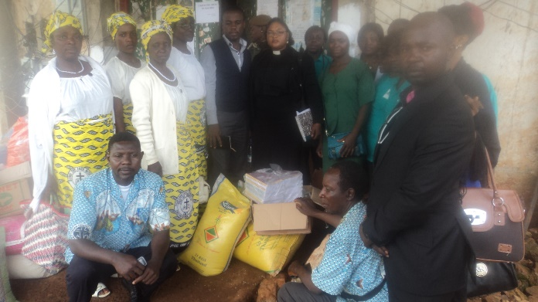
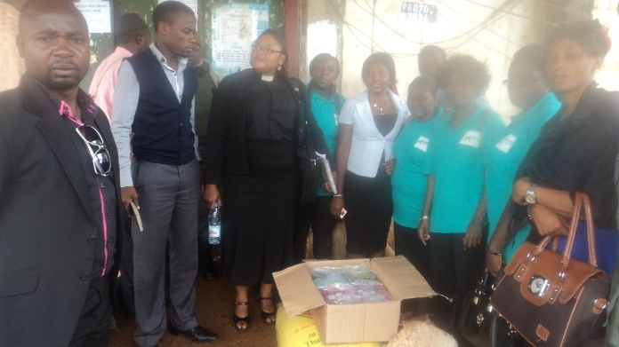

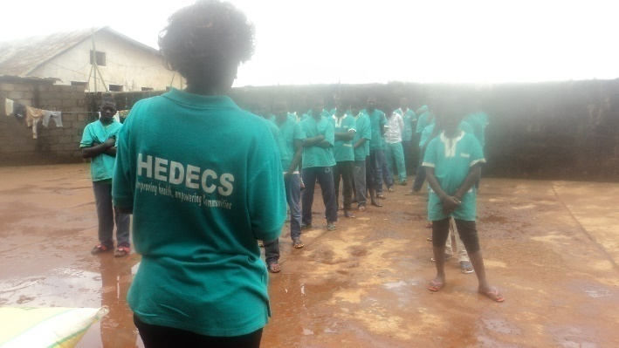
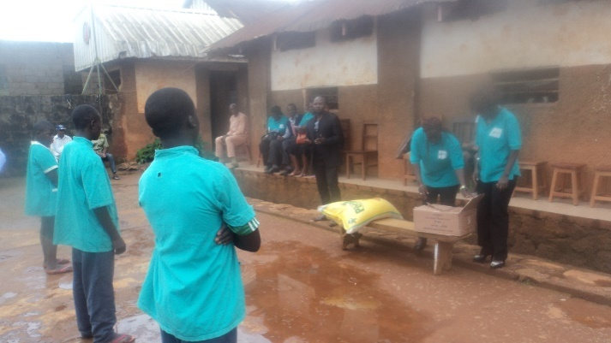

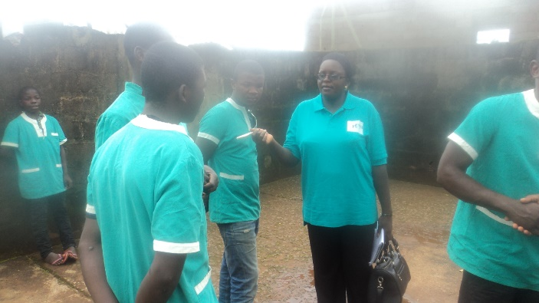
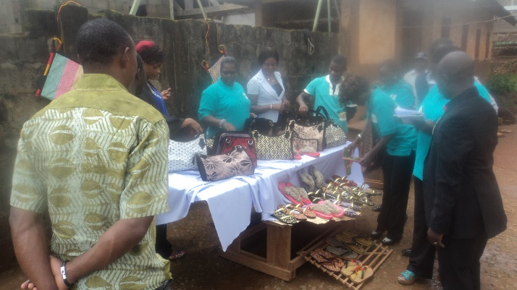

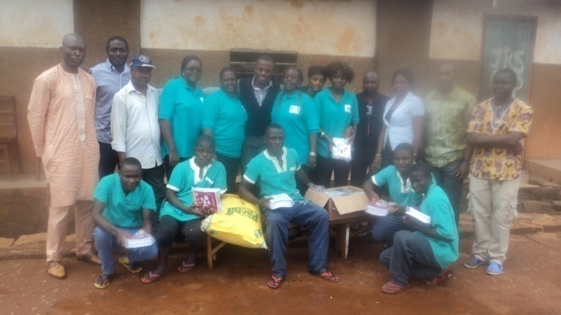
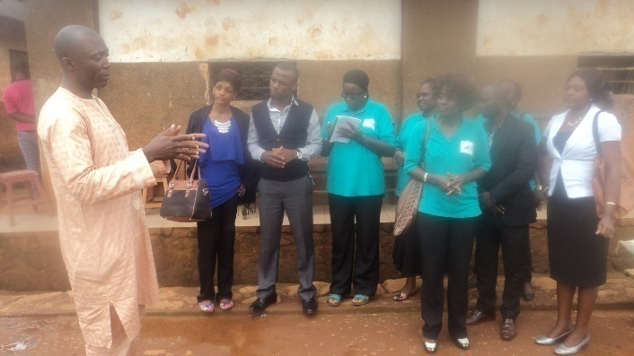

- 2015 CHRISTMAS CELEBRATION WITH JUVENILES AND FEEDBACK MOMENTS

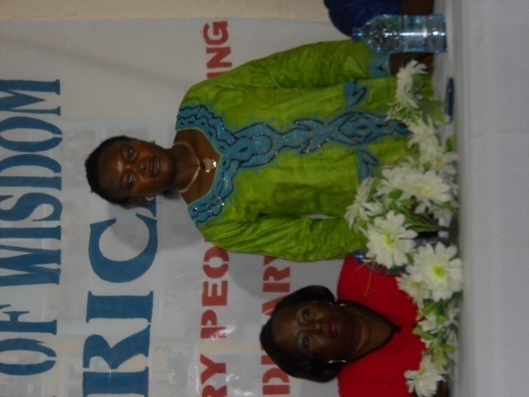
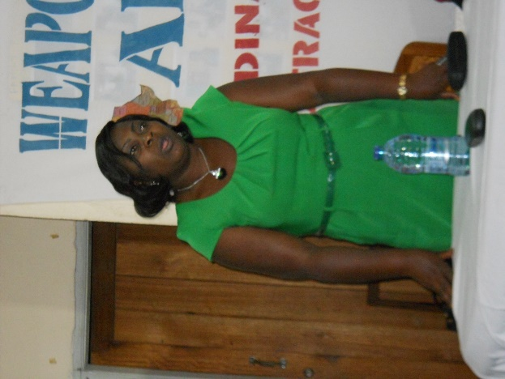

State Counsel Number 8 opens celebration Divisional Delegate MINPROFF makes inputs
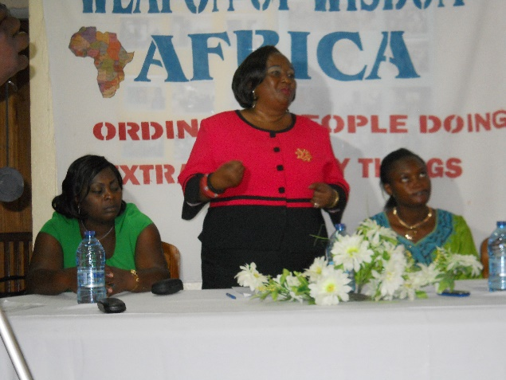
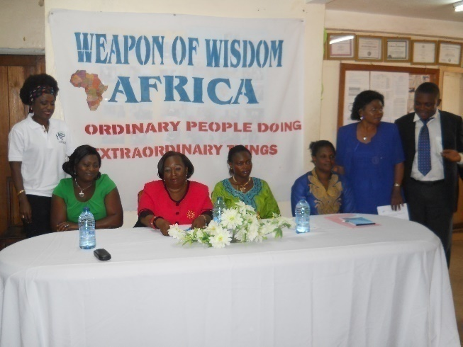

HEDECS BOD President talks to the juveniles Representative NCSAPD (sitting in blue right)
listens and later talks about how her agency
can help the juveniles with Civic Education,
Conscript training and finance
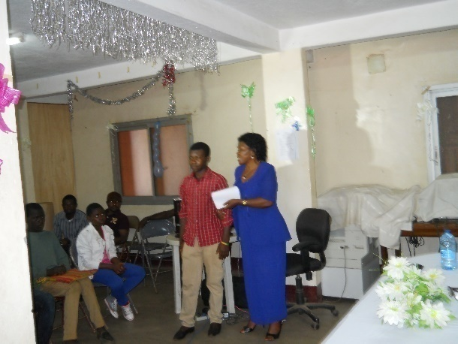

Managers of placement sites pledge to support and guide the juveniles

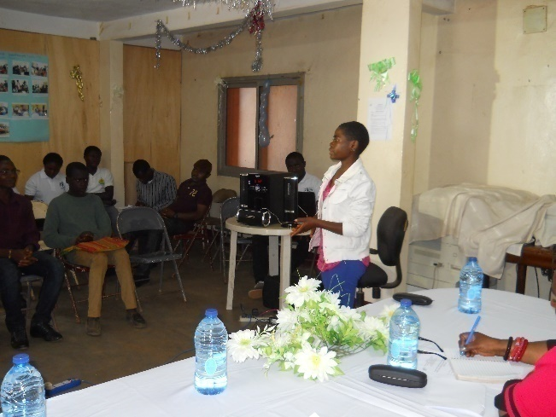
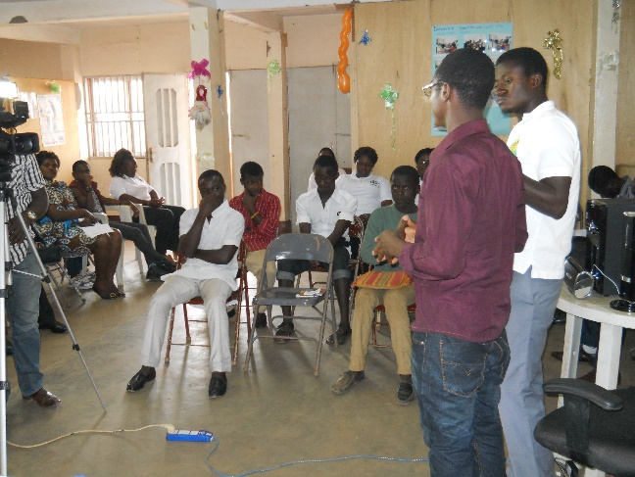

Juveniles give their testimonies
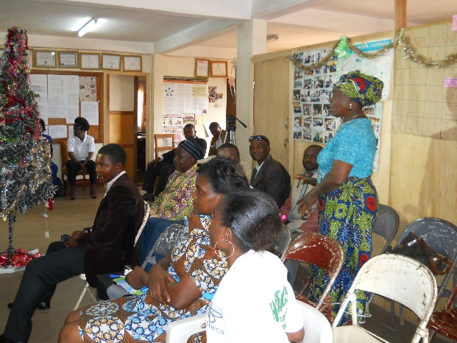
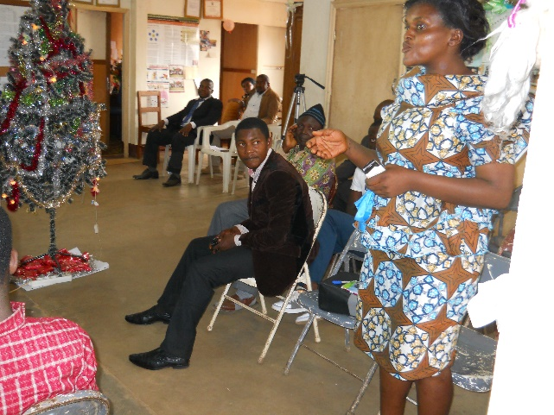

Parent and Social Worker of the Bamenda Central Prison speak on the outcome of diversion
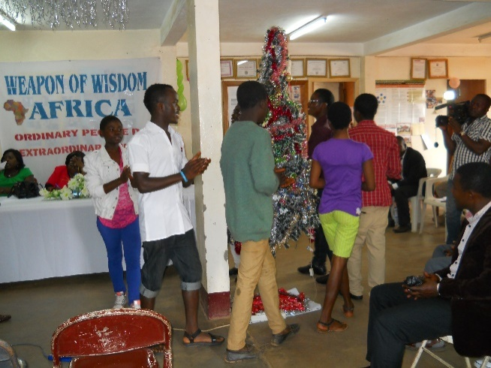
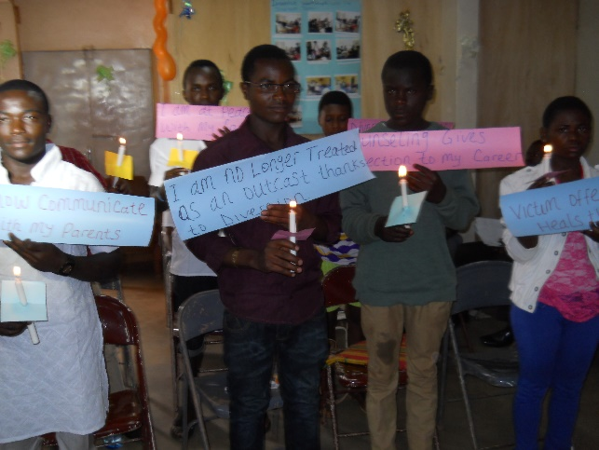

Juveniles light the Christmas tree, pick up their gifts and light the candle of change

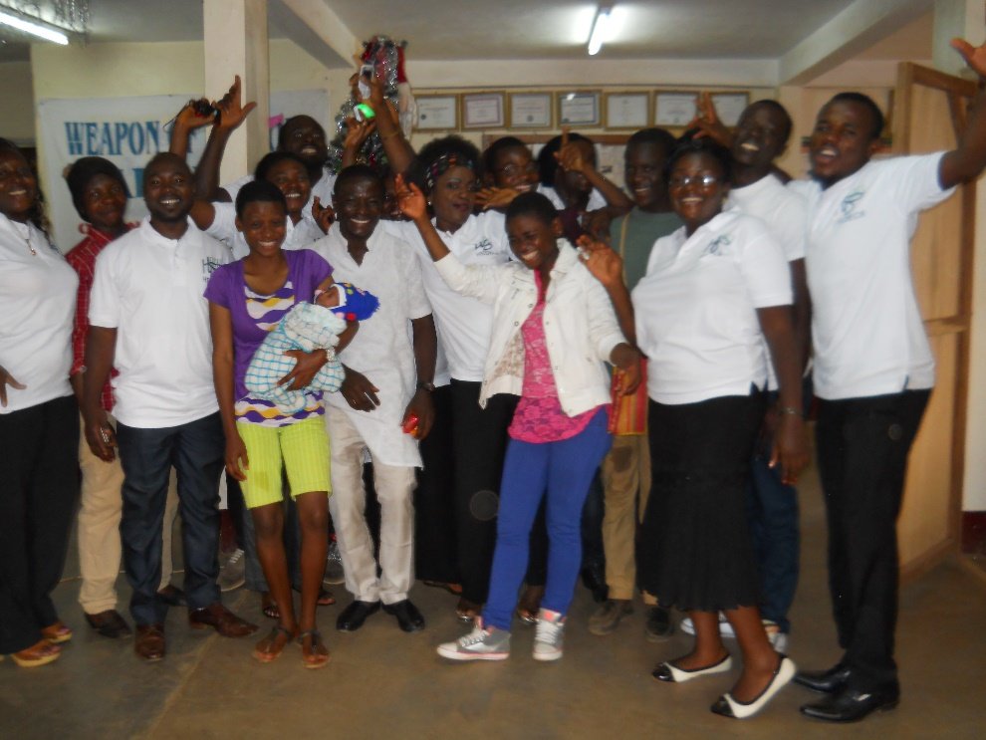

Juveniles pose with the Diversion team
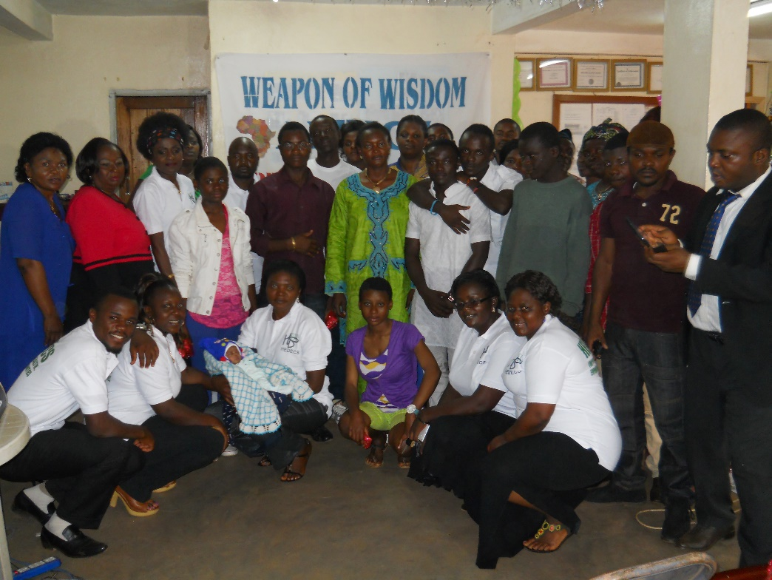

Participants pose at the end of the celebration and feedback moments

OTHER VISIBILITY ACTIONS
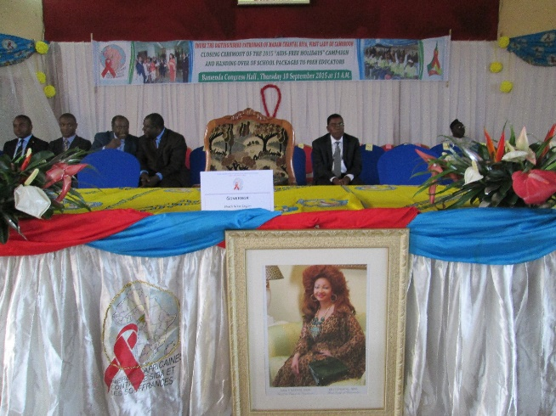
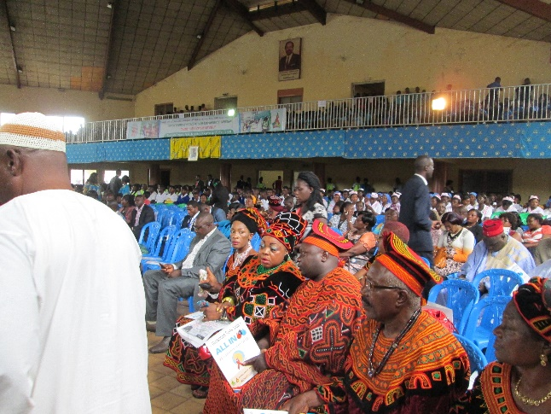

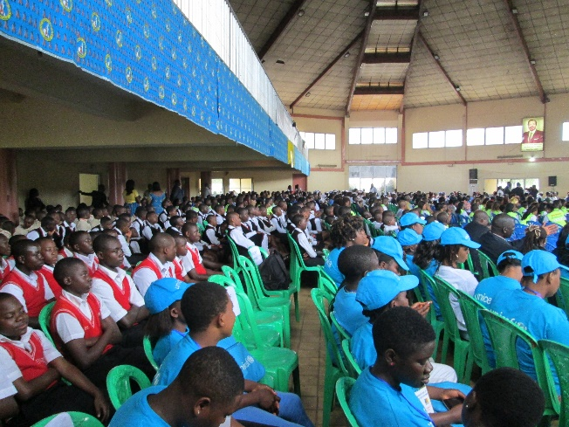
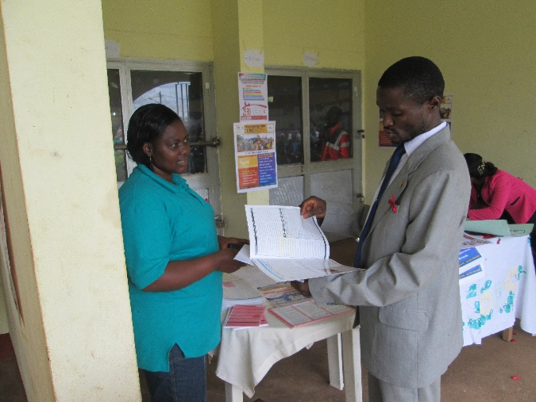

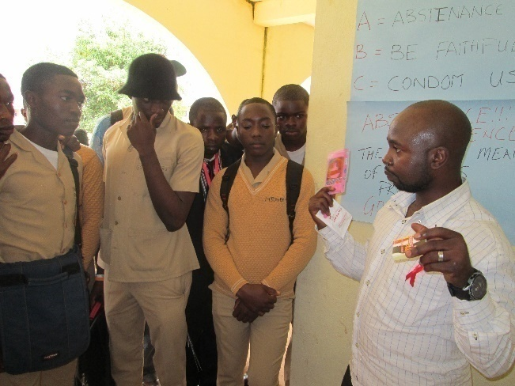
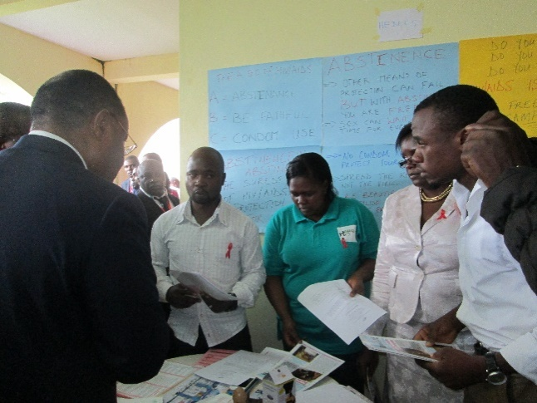

Diversion team integrates Diversion Programme at 2015 HIV/AIDS free holiday in the NWR

TRAINING OF STAKEHOLDERS

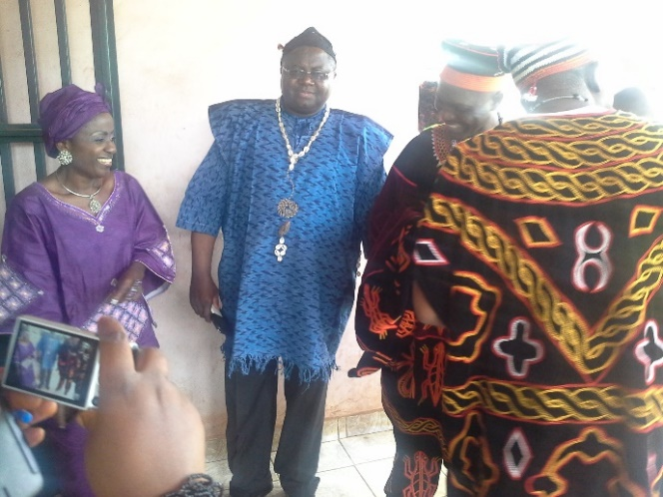
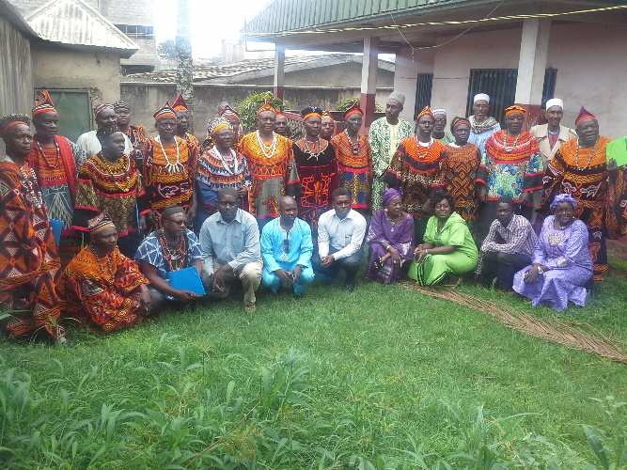

Training of Traditional Rulers
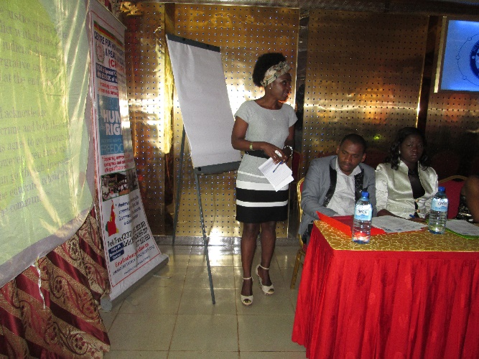
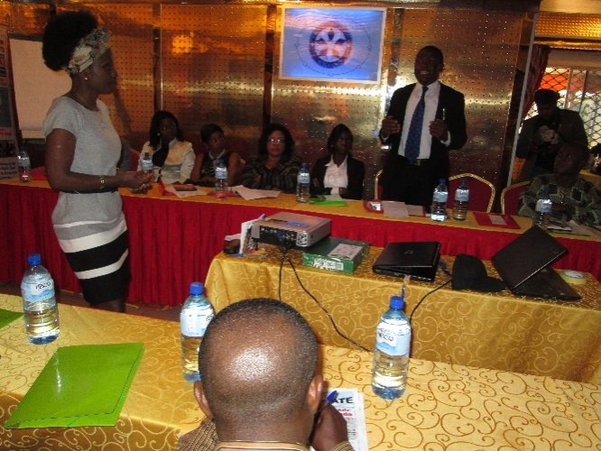

Diversion Manager facilitates on the Diversion Component at the workshop for the Magistrates and Lawyers

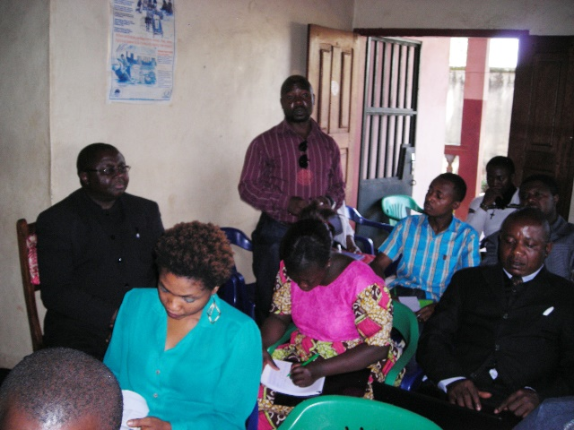
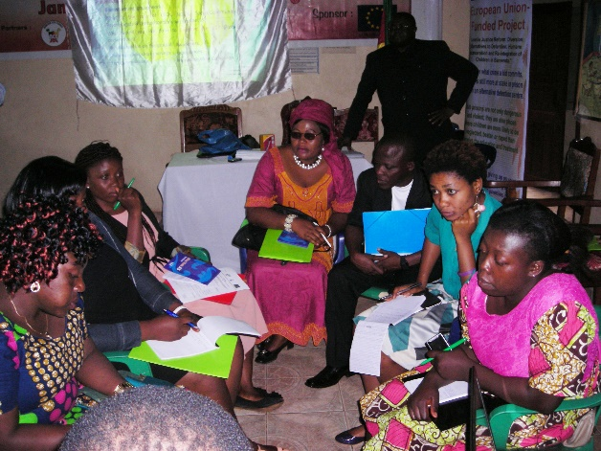

Training of Civil Society Organizations and Social Workers in process

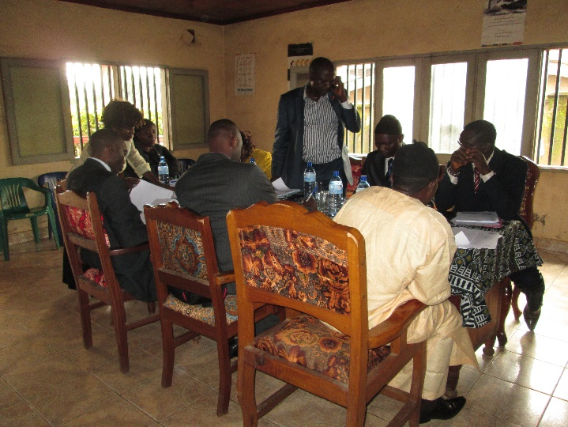

Steering Committee meeting in process

