

**YOUTH ENTREPRENEURSHIP FACILITY**

**Youth to Youth Fund (Y2YF)**

**Monthly Narrative Report**

1. **Organisation details**

|  |  |
| --- | --- |
| Name of Organisation | Health Home Initiative |
| Type of Organisation (CBO, NGO, Religious affiliated and any other) | NGO |
| Name of project | Knitting Sweaters for Wealth Creation |
| District and Region where the project is based | Kampala-Mulago11 and Makerere 111 Zones |
| Reporting period | February 2016 |
| Author of Report and Contact Details (Including email, phone, etc) |  |

1. **Funding status**

|  |  |
| --- | --- |
| Total Project Budget | 27,009,500 |
| Total Spent in the previous months | 13,011,337 |
| Total Spent this month | 0 |
| Funds remaining | 0 |

1. **Introduction**
2. **What activities have been implemented or major accomplishments for this month?**

|  |  |  |  |
| --- | --- | --- | --- |
| **Planned activity** | **Actual activity carried out/ Date** | **Reason for difference in the planned and actual activity** | **Feedback from the beneficiaries and any other comments on the activity** |
| Knitting sweaters. | On-going | On schedule | Beneficiaries require more time and materials to practice |
|  |  |  |  |

1. **Briefly explain the status progress of the project now.**

* Currently 35 beneficiaries are being equipped with hands on skills in the knitting of sweaters at the industrial site having initially undertaken capacity building in group formation and dynamics.
* This knitting activity is the major focus of the project and is anticipated to run for the next four months alongside other integrated activities on schedule/ work plan.
* Beneficiaries have demonstrated their interest and ability to learn.

1. **What challenges have you faced as an organisation and in the implementation of the project this period?**

* Though subsidizing the rate of absenteeism was the biggest fetter and encumbrance which is borne of dissimilar circumstances.
* Since the beneficiaries are just beginning regular break down of the machines have been noted.
* The machines are few and do not offer ample time for practice
* Beneficiaries complain about the lack of refreshments during the training.
* The FAQs about the training awards at the end of the knitting course ie certificates demanded.
* The FAQS about the end of knitting take home kits.

1. **What lessons have you learnt from the above noted challenges?**

* The need for the Instructor to set flexible schedules for the training in order to accommodate all the beneficiaries
* Taking each trainee systematically through the process of machine operation to curb down on the machine faults
* Plans are underway to source for more machines.
* It has been made clear to them that this is a community project with no provisions for refreshments and they have been implored to carry their own from home.
* They have been also informed systematically that hands on skills development promotes individual ability than academics paper accumulation rewards.
* We have also informed them that plans are underway to link them to community development office for more continued support as we lobby the funders for provision of end of training kits.

1. **What are the next steps or plans for your organisation and the project in following month**

* To scale up the mobilization levels to meet the target beneficiaries.
* To increase on the training session time to capture those who cannot go by the initial set training time.
* To consider some repairs and servicing of the kniting machines
* To increase on the training materials for example the threads.
* Preparations to consider integration of marketing strategies training sessions alongside knitting sessions to the beneficiaries
* To consider request for the next reimbursement to secure more machines and to cater for other expenses.

1. **Please state any other comments, if any.**

Most of the participants comment about their lack of appropriate time for the training citing other responsibilities at home but still reiterates their interest and commitment to the project.

1. **Pictorials**

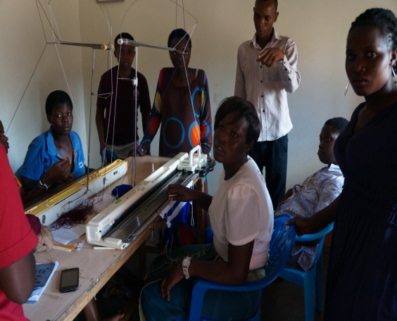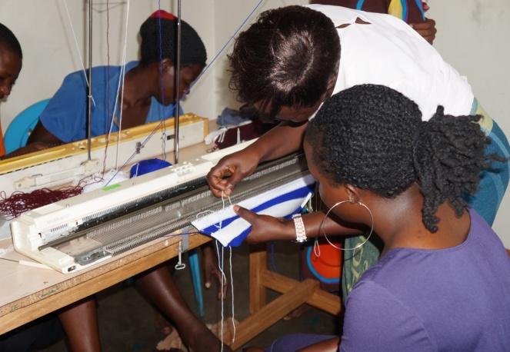

**Oliver the instructor and Daniel the finance officer HHI demonstrate to the beneficiaries during Knitting session.**

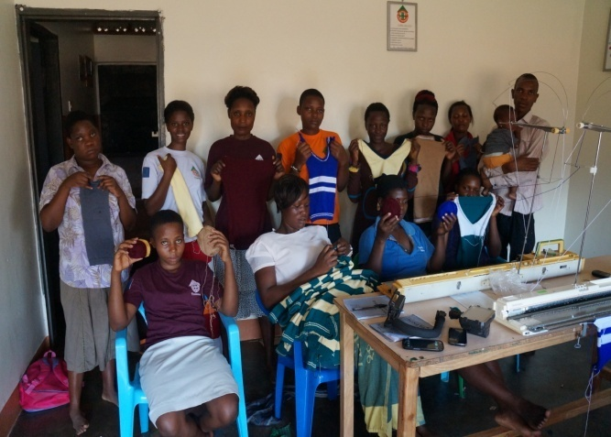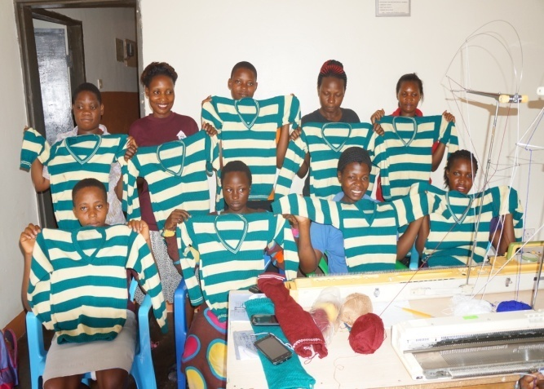

**Beneficiaries show casing the finished and unfinished products of the project.**

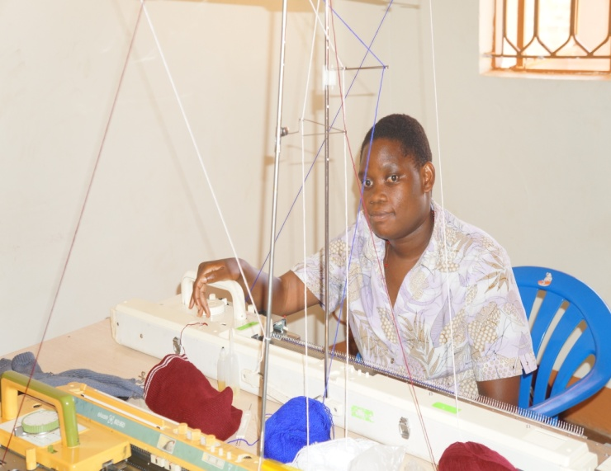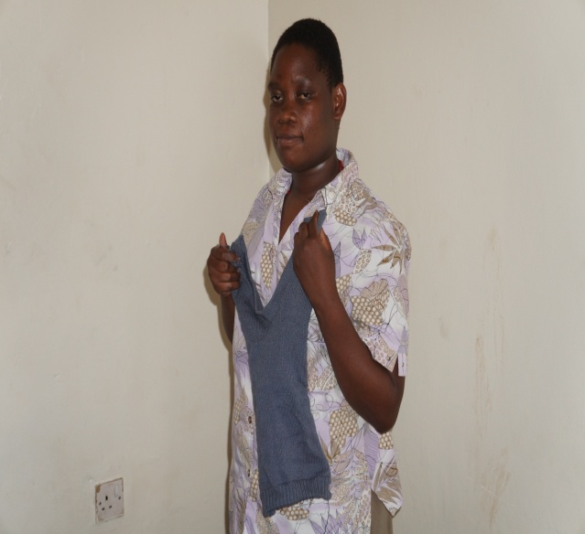

**Disability is not inability; even the right hand crippled Nabunya can knit and come out with a piece of sweater she made on her own .Thanks to our lovely instructor and HHI team.**

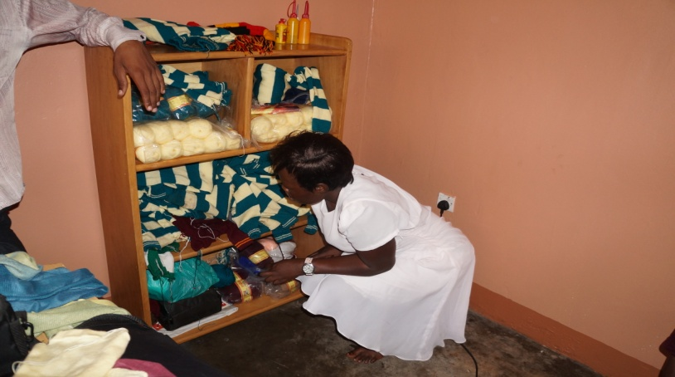

**A cross section of HHI knitting materials in stock.**