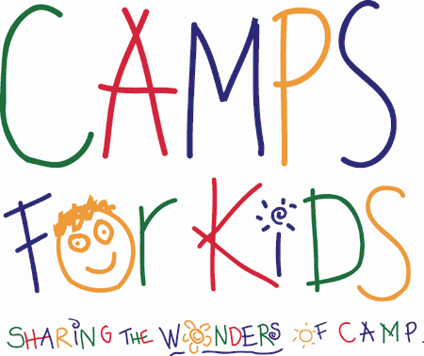
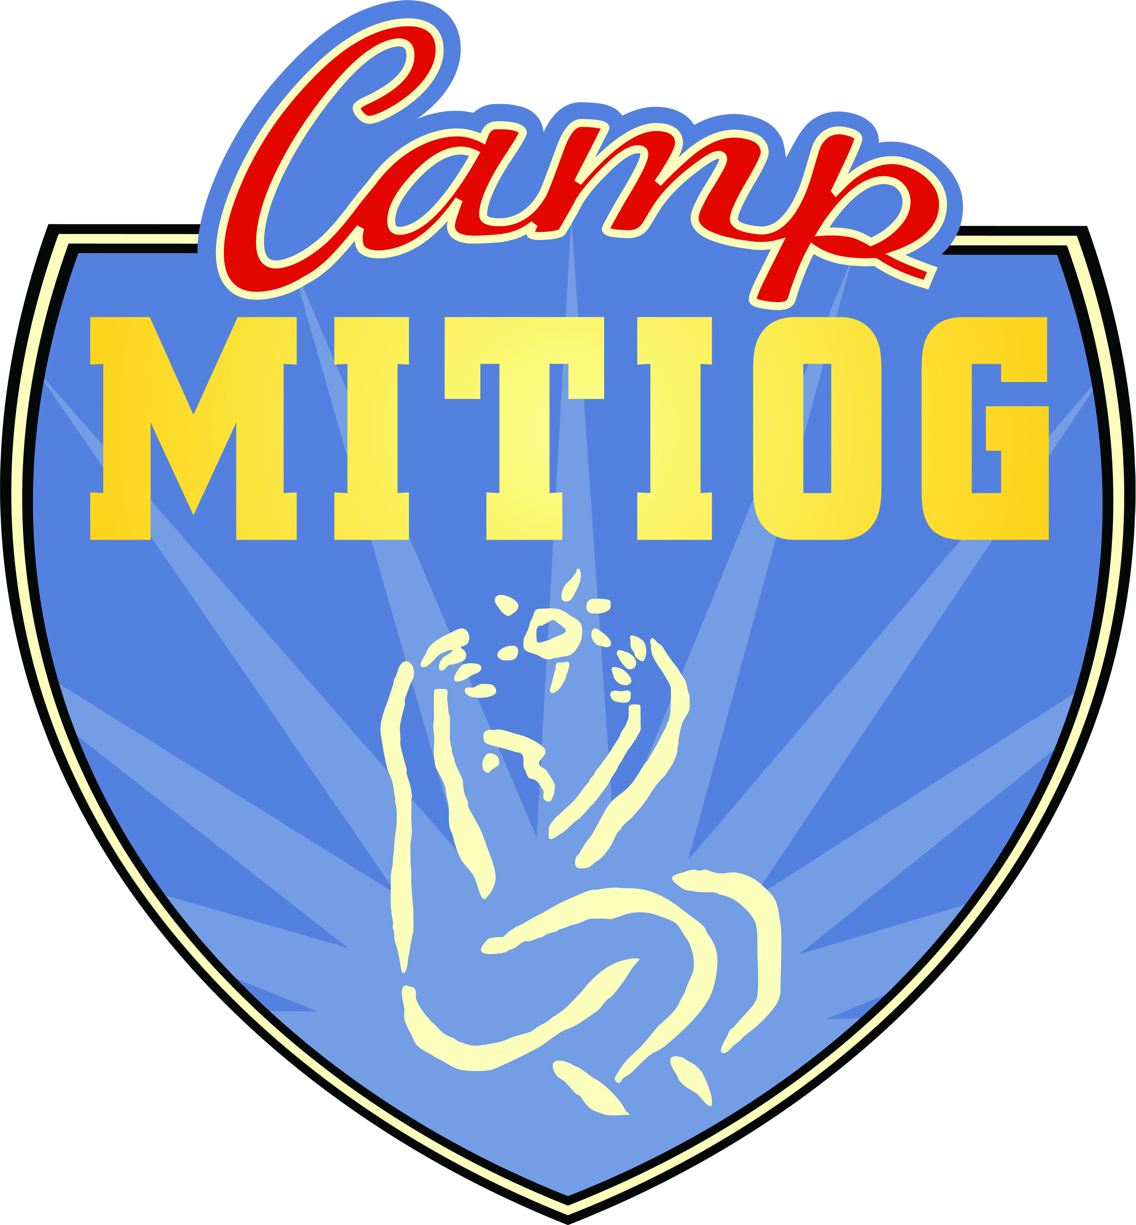
Camp M.I.T.I.O.G.
1214 SE 4th Terr
Lee’s Summit, MO 64063
www.CampMITIOG.org

Introduction

MITIOG, a project of SHARE, Inc, is devoted to organizing and creating quality life experiences and lasting memories for children born with Spina Bifida. Those children and their families are served without regard to sex, race, religion, economic condition, educational status or social level. MITIOG seeks to help the children with activities which fulfill their physical and emotional developmental needs increase their sense of self-worth and promote self-reliance in daily activities.

MITIOG operates with many professional and community volunteers to accommodate the special medical, physical and emotional needs of these children. Financial supporters of the program in the past have included Camps for Kids, The Community of Christ Tangible Love fund, David Woods Kemper Memorial Foundation, the Kearney Wornall Charitable Trust and Foundation, the Mission Road Congregation of the Community of Christ, and numerous individual contributors.

SHARE, Inc., MITIOG’s parent organization, provides administrative support, resource development and coordination of special activities for the program.

Program Services

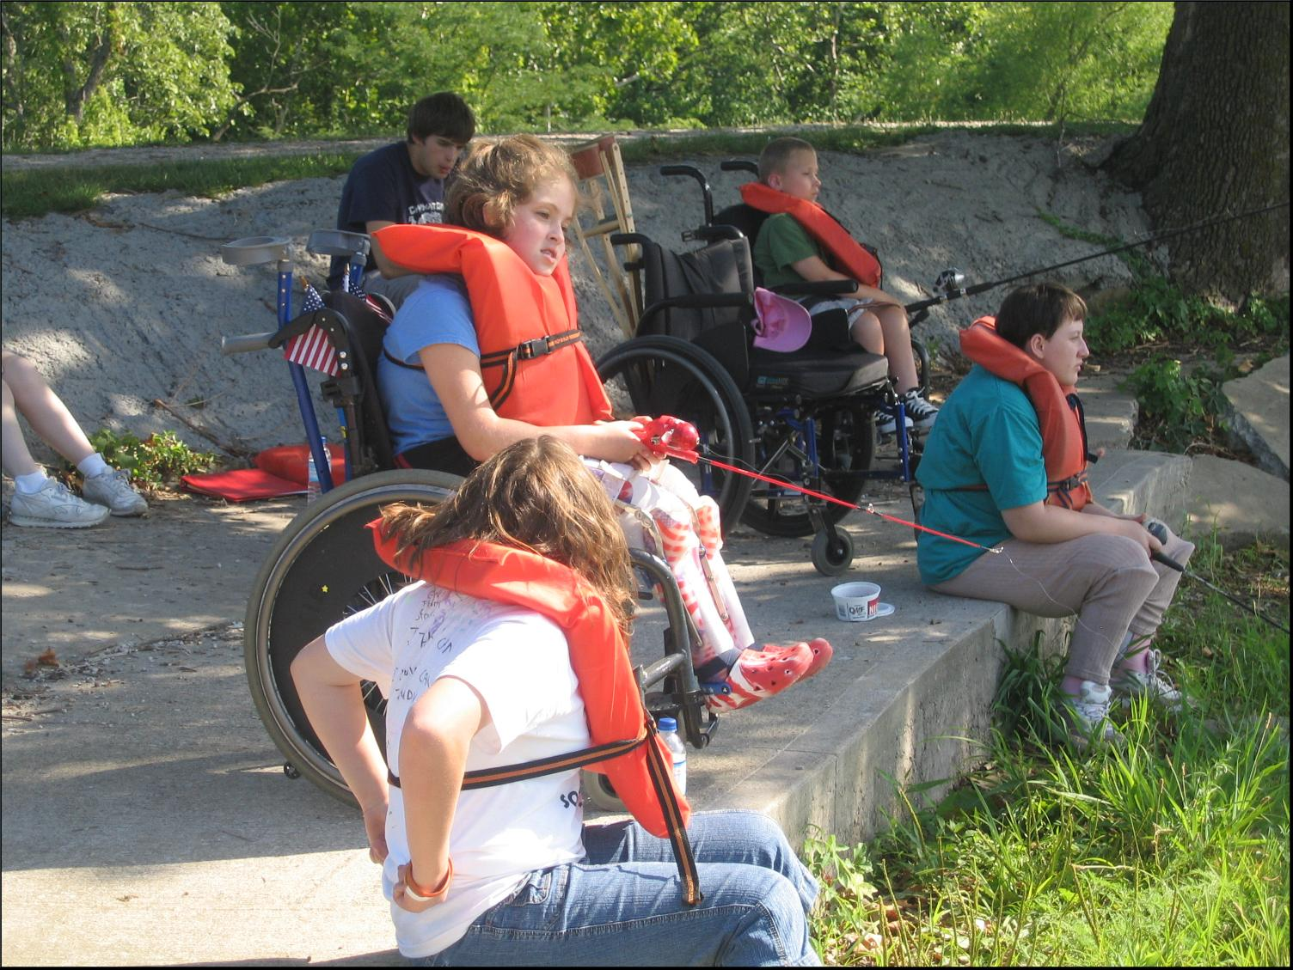
The main activity of this program is Camp MITIOG, a week-long camp accredited by the American Camping Association, held each summer for over 42 years. During their week of camp, the children participate in regular camping activities including swimming, fishing, canoeing, arts and crafts, nature classes, classes on self-help medical care and evening campfires. Memories of the week are recorded in the “Camp Log,” put together by the campers themselves which they receive by mail a short time after the close of camp. Last year, 56 Spina Bifida children attended Camp. Camp MITIOG is held at Lake Doniphan Conference and Retreat Center which is located in Excelsior Springs, Missouri and provides a wheelchair accessible environment.

For most of these children, camp is the only opportunity they have in an environment in which they are accepted as equals. The uniqueness of bringing together children with similar, yet different physical conditions helps them to discover their individual gifts, skills, and talents. They are enabled to find how they can share their unique talents to benefit themselves and others. They learn to see their abilities…not their limitations.

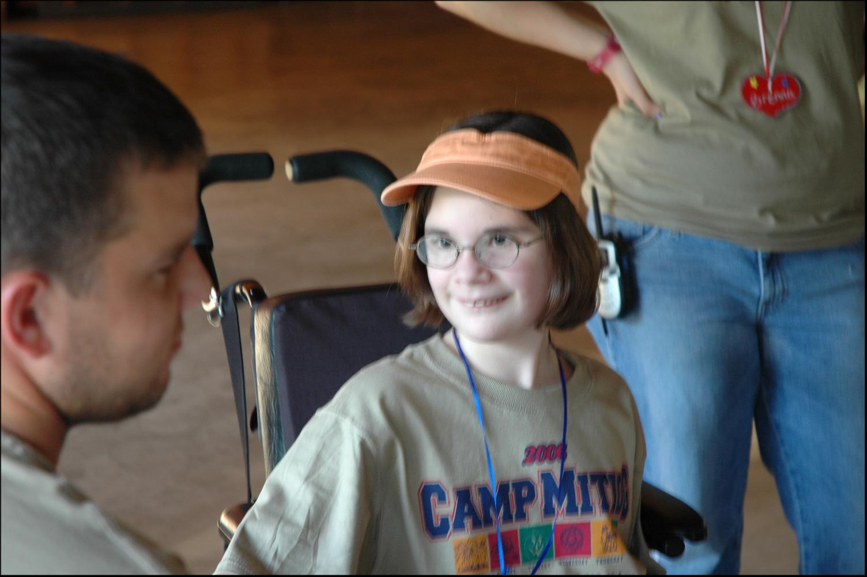
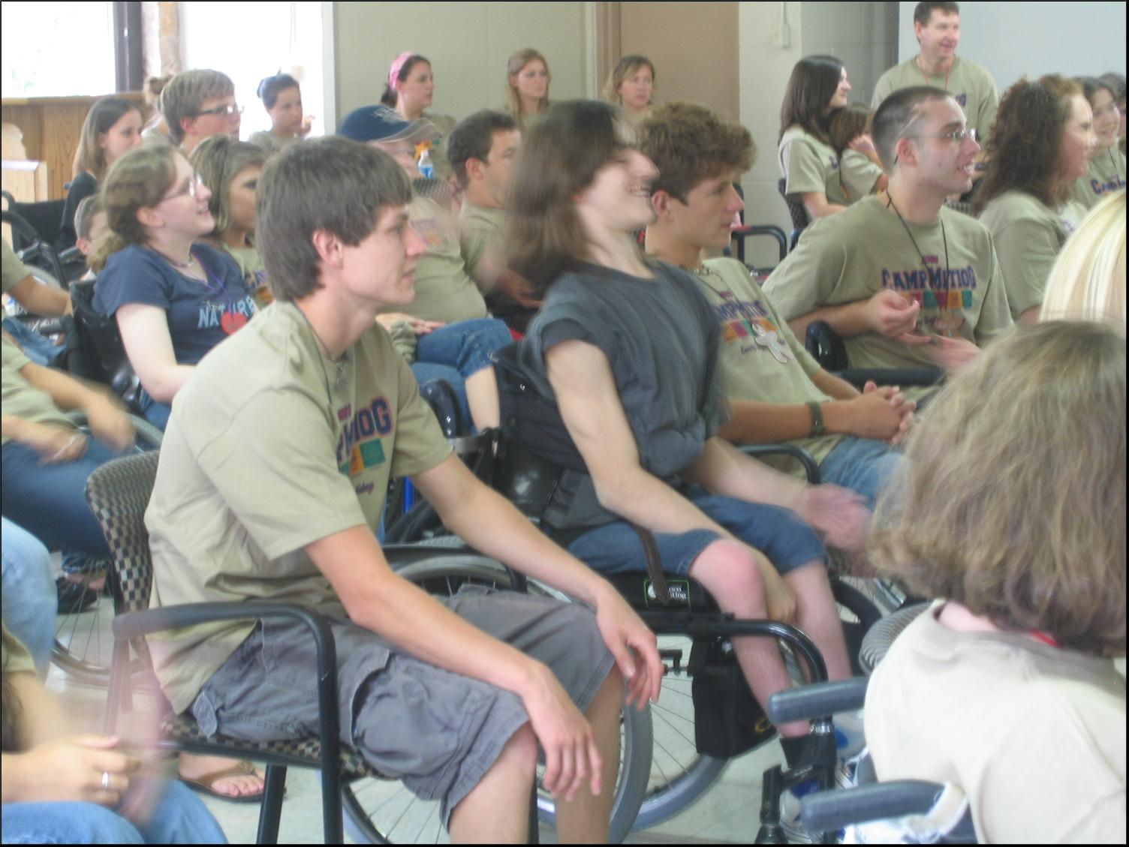
Not only does the camp serve children with Spina Bifida, it also provides a special opportunity for the volunteer counselors and staff as well. Each child is paired with their own individual counselor who is a senior high school student, college student or older young adult. Camp gives these students the unique opportunity to work with children with special needs. In a very short period of time, these counselors see campers not as people with disabilities, but as “kids” not unlike themselves.
The staff of camp MITIOG consists of over 50 other volunteers, including medical personnel, instructors, cooks, lifeguards and pastoral counselors. Many of our counselors and staff members have attended camp year after year, drawn back by the friendship of these very special children.

Comment from a Parent

I am writing to tell you what a blessing Camp MITIOG has been to my daughter, and our family. Jessica looks forward to camp each year more than any other event in her life. She says the most special thing about camp is being with other kids who have Spina Bifida and understand her in a way no one else can. I love that when other kids talk about their sports and music and church camps, none of which Jess could ever attend, I can remind her she gets to go the best camp of all where she can do all of these things. I believe Camp MITIOG is proving a more valuable experience for my daughter and family than any other organization around. Although I would pay all I had to give my daughter this experience, we do have countless other medical bills and related expenses. This makes the camps generosity an even greater blessing. I know many families so burdened with bills there is no way their child could ever attend any camp if it weren’t for Camp MITIOG. God bless you and everyone who helps make Camp MITIOG possible.

Julie Quick

From a Former Camper

Jocelyn Janes is now over 16 and is past the camping age. As part of her last year at camp, she wrote this poem.

Surveying the sights that are here and around,
Every sight, every smell, every touch, every sound.
I get a feeling that can’t be expressed,
No way to describe it, I just feel blessed.

Love fills my heart, that love comes from you,
So know that I’ll always love you too.
Camp is the greatest, camp is real fun,
But where do I go now that it’s done?

I’ll tell you where; I come back again
To laughter, to adventure, to all my dear friends.
I know there’s a God. He’s here in this place,
I see Him in you all, in the smiles on your face.

Yes, I’m leaving, yes it is sad,
But deep down inside me I can’t help but be glad.
Glad for laughter, adventure and love
And all of the things I’ve listed above.

I’ll take you all with me,
Right here in my heart.
So deep down, you see,
We’ll never really be apart.

Jocelyn Janes
MITIOG 2000

History

In 1969, Madolynn Burlington, a member of the Cystic Fibrosis Auxiliary, discovered there was no camping program for children with this disease. She approached the Kansas City Stake of the RLDS Church (Now the Community of Christ) to begin such a camp. The first camp, held in 1969, initially served two goals:
- Meeting the needs of this special population
- Providing an opportunity of involving church youth in a meaningful service project.

A few years later, adding children with Spina Bifida into the camp came about through another person who suggested combing both of these special populations into one camp. Since that time, the camp has expanded in both campers and staff. While the camp was started as a project for the Kansas City Stake of the RLDS Church, (Now the Community of Christ) it has taken on a community endeavor flavor with a number of staff, medical staff, counselors and Executive Committee being composed of interested parties from the broader community.
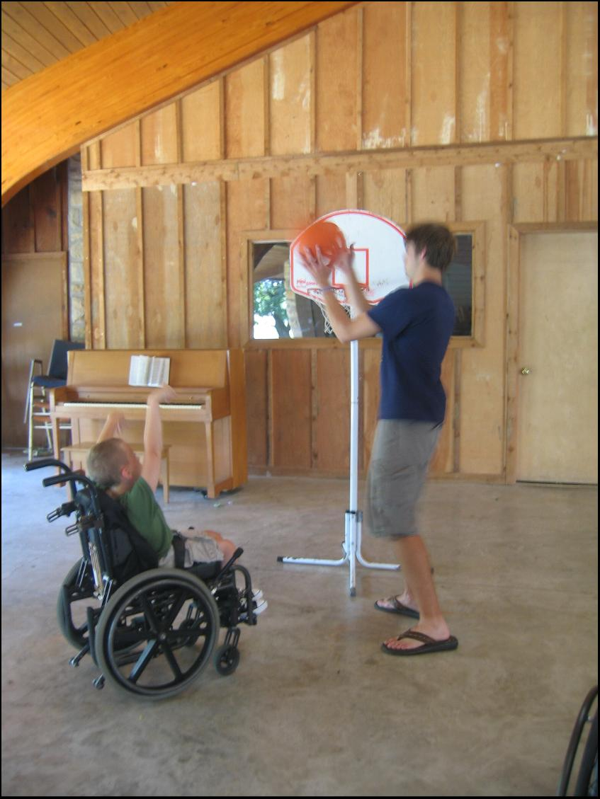
In 1989, camp leaders approached Share, Inc., a local non-profit 501-(c) (3) organization to take over the operation of the camp. Share, Inc. adopted MITIOG as one of its projects, and since that time, has worked to broaden the participation of program leadership through more community involvement in planning and promotion; increase community financial support; broaden the program to a year-round effort to provide more comprehensive services; and to look at options making it possible to serve more children in this under-served population.

In 1993, the Cystic Fibrosis Organization stopped all camping programs. This happened because of one or two deaths which occurred in other parts of the country due to association with other CF children. This left MITIOG to service only children with Spina Bifida. Because of the larger than expected number of these Spina Bifida children, MITIOG has grown to service between 50 to 55 children annually. About 57 Spinal Bifida children is the most our camp facilities can hold at this time.

Highlights & Accomplishments

Now, having completed its 42nd year, the MITIOG program continues to offer this week-long camp. Though the camp cost about $750.00 per camper, the registration fee is only $30.00, which, in the case of extreme need, is waived.

- MITIOG has again received high rating and full accreditation from the American Camping Association upon their visit to the camp in 2010. Certification by the ACA is conducted every three years and assures parents and others that the camp maintains a high level of standards. The camp is to be evaluated again in 2013.

- Camping counselors and staff are required to be certified through a training session offered through the Community of Christ church as well as an orientation specific for Camp MITIOG. This orientation includes specific training in Spina Bifida, the special care needed for the children and do’s and don’ts in working with them. This orientation is prior to the camp under the direction of the nursing staff.

- An Executive Council of community volunteers, representing a diversity of professions and careers, has been recruited and operational guidelines have been written. They devote their energy to work on resource development, fund-raising, volunteer recruitment and training, public relations and program expansion. Several Administrative Council members are also active members of the Camp MITIOG staff each summer. (See Page 7)

Financial Information

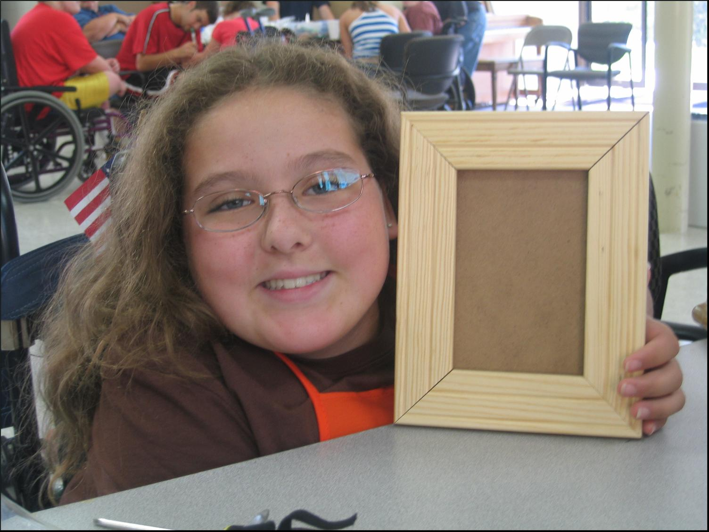
Even with the expansion of services and growth of the number of children attending camp, MITIOG continues to operate with a relatively modest budget. The camp operates with over 100 unpaid volunteers, over a third of who are nurses, student nursed and respiratory therapists. In addition, the camp received hundreds of dollars worth of medical supplies from various pharmaceutical companies, and is able to borrow a considerable amount of medical equipment from local hospitals and suppliers. None of the medical personnel, counselors, staff at Camp MITIOG, or the Administrative Council receives any financial compensation for their time. Without the generosity of the staff and the medical community, Camp MITIOG would not be possible.
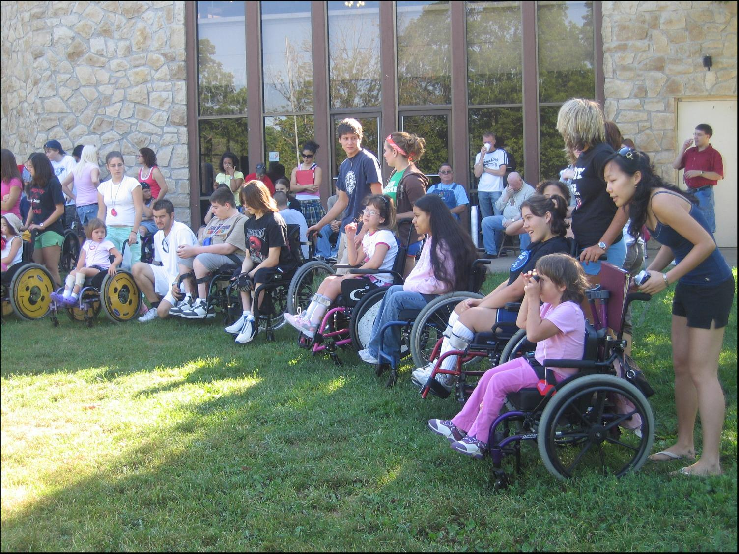
The primary expenses are campground rental and food costs, representing well over 75%of the annual budget. The Administrative Council and camp staff strive to obtain in-kind donations of supplies wherever possible.

Since the families of children we serve are often stretched financially due to high medical costs associated with Spina Bifida, MITIOG strives to provide its programs at very little or no cost to these families. We also recognize that MITIOG must reach a larger part of the Spina Bifida population in Greater Kansas City which is estimated to include over 200 children. Since MITIOG is the only camp of its kind in this part of the United States, were we to offer this service to other areas in a three to five state area, that figure would more than triple. The MITIOG program costs over $772.00 per child for a camping experience. The projected budget for the 2011 Camp is $44,000. As we strive to reach more children in the community and expand the programs offered, additional funding is needed.

Statement of Need

Consideration of this grant is urgently requested so the needed service might continue to offer a viable program in the development of Spina Bifida Children. Since the downturn in the national economy, we are finding it harder to fund this camp. These children have been dealt a lemon with which they must live for their entire lives. This camp helps turn that lemon into lemonade, if for only a short time.

2012 Budget

Contribution

Make check payable to:

Camp MITIOG

Mail to:
1080 Washington
Kansas City, MO 64105

2012 MITIOG Executive Council

Mike Windes(Chairman) Gary Libeer (Director – Camp MITIOG)
5308 W. 162nd Street 900 NE 67th Place
Overland Park, KS 66204 Gladstone, MO 64118
Stony Point North Elementary School Wholesale Food Distribution
Public School Principal
mikenancy@sbcglobal.net

Norman Bernauer (Chairman Emeritus) John Trinkl
427 West 70th Street 9917 Mastin
Kansas City, MO 64113-2022 Overland Park, KS 66212
Retired - Advertising Agent Real Estate Executive

John Canterbury Paula Anderson-Keller
4901 Wedd Street 6445 Ballentine
Merriam, KS 66203 Overland Park, KS 66063
Public Relations

Aaron D. Laughlin, MBA
1214 SE 4th Terrace
Lee’s Summit, MO 64063
Controller, Providence Medical
Center/St. John Hospital
ADLaughl@Yahoo.com

