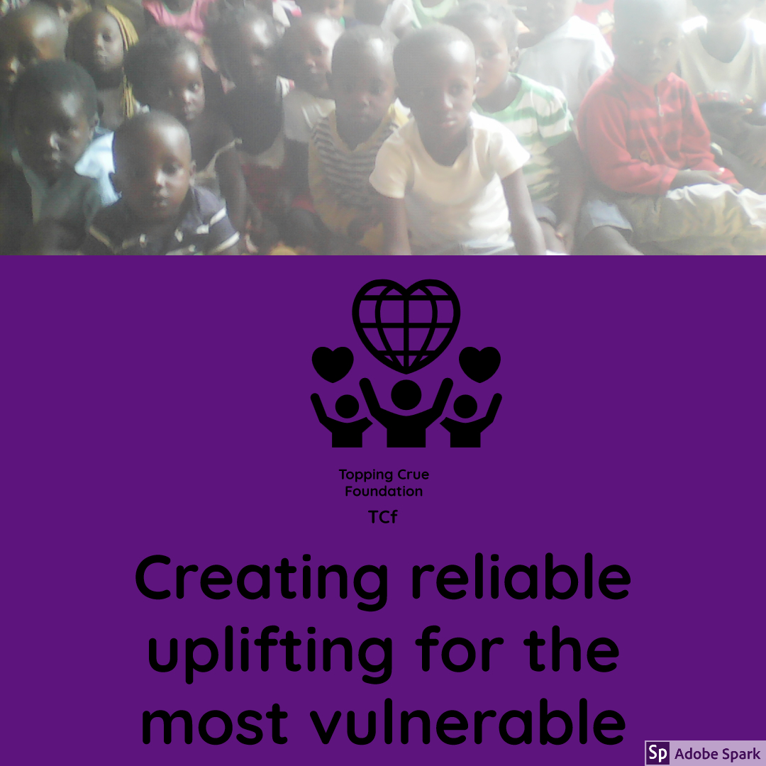
TOPPING CRUE FOUNDATION
2020
ANNUAL REPORTS
A NON-PROFIT COMMUNITY BASED ORGANIZATION
Working to end poverty and vulnerability through community education and community empowerment programs, creating evenly opportunities for the most vulnerable and disadvantaged people
TABLE OF CONTENTS

1.0 MESSAGE FROM THE BOARD CHAIR PERSON

1.2 MESSAGE FROM THE DIRECTOR GENERAL

1.3 OUR HUMANITERIAN PROGRAMS

1.4 TOPPING CRUE FOUNDATION ORGANIZATION STRUCTURE

1.5 EXECUTIVE SUMMARY

1.6 ORGANIZATION BACK GROUND

1.7 HOW WE ESTABLISHED OUR STRATEGIC PRIORITIES

1.8 WHO WE ARE

1.9 OUR MISSION

2.0 OUR VISION

2.1 OUR VALUES

2.2 WHO WE SERVE

2.3 OBJECTIVES AND KEY STRATEGIES

2.4 COMMUNITY EDUCATION

2.5 COMMUNITY EMPOWERMENT
2.6 SPECIAL MENTION
2.7 ORGANIZATION FINANCIAL YEAR 2019
2.8 CLOSING REMARK
2.9 CONTACT DETAILS

1.0 MESSAGE FROM THE BOARD CHAIR PERSON

BETTY BALEMOGENG:

With the vulnerability crisis deepening on a daily basis in our country especially this year 2020 due to Covid-19, many hardships lockdowns on both vulnerable children and their parents have created a larger gap than ever before between the rich and the poor. And with this impact being felt across the city, country and world at large, our work has proven to be more challenging. We have however completed remarkable work, executed ground breaking strides of educating the most vulnerable and disadvantaged children as well as empowering the most vulnerable and disadvantaged persons securing victories in these areas of our operations.
At the same time topping Crue foundation non-profit organization has dived into deeper analysis and discussion about changing our structures and procedures to match the challenges brought by covid-19 and fit in global humanitarian works in the world. While changes in governance and organizational structures are painful, they are vital to ensure that we are fit to meet new challenges and continue to stay on the front line of social change, by freeing our community from the slavery of vulnerability and poverty through community education and community empowerment programs. Therefore we decided as an organization to take a new directions in organizational management if we are to meet and manage the challenges we are facing. The agreed new direction is as a result of a very extensive consultative process and I would personally like to thank and sincerely acknowledge all the incredibly hard work of all who contributed to this process especially the roots to rise of Madam Beatrice Shulter. We have agreed that it is vital to strengthen our governance and strategic planning areas so that we may deliver even better services to our community. These changes will enable Topping Crue Foundation to be more agile and strategic in the execution of its programs. We will also decentralize our programs, with our target areas being villages where most vulnerable and disadvantaged live. Topping Crue foundation will focus more on coordination and will assist in capacity building of our staff so as to provide quality yet affordable services. We will become more integrated and more inspiring as an organization that can mobilize people and resources for the common good of society by kicking out vulnerability and poverty through community education and community empowerment thereby promoting a better world for all. I would like to congratulate our staff as well as the Topping Crue foundation including major partners like Madam Linda Radonor for their continued support as well as progressive thinking dedicating their finances and time to educate the most vulnerable and disadvantaged having an end endless passion of fighting to end poverty and vulnerability in our community through community education and community empowerment projects.I thank you all.
Yours Sincerely.

Betty Balemogeng

Topping Crue Foundation Board Chairperson.

1.1 MESSAGE FROM THE DIRECTOR GENERAL

ISAAC CHITENTA. DIRECTOR GENERAL.

Dear Friends it’s with mixed feelings that I sat down to write the introduction to our annual report. As Director General, it falls on me to sum up the year under review. In doing so, i alternate between pride and disappointment, between hope and despair. With Pride you can read this for yourself I can say that we are growing and getting better each year. A big thanks to our dear friends who throughout 2020 amid Covid-19 pandemic extended their hands and hearts to support us even on the shortest notice. May I specifically single out Madam Linda Radnor a private individual donor who has supported our most vulnerable and disadvantaged children to get educated under our community education program. She has throughout 2020 rendered her Technical and financial support to Topping Crue Foundation at the most critical time. The coronavirus disease 2019 (COVID-19) has profoundly affected life around the globe. Isolation, lockdowns, contact restrictions and economic shutdown impose a complete change to the psychosocial environment in all countries and communities including ours. These measures have the potential to threaten the mental health of our vulnerable children and adolescents whom we serve significantly. And even though the current crisis can bring with it opportunities for personal growth and family cohesion, disadvantages may outweigh these benefits. Thousands of kwacha have been spent on unplanned and unbudgeted for Covid-19 safety measures which has stunted the growth of small organization like our.
Our organization is having an impact on society and our reach is increasing day by day year after year but 2020 has been the most challenging year. And because everyone was affected globally it has not been easy to secure extra funding to fund the challenges brought by Covid-19.However despite the many challenges we faced we are adapting to rapid changing of the world such as the use of technology and remote working measure in our humanitarian community work as this seems so far is the only possible way to work in the world of Covid-19.

Iam happy to state that 2020, though with big setbacks we are still here

Looking back at 2020 I can proudly say that iam proud and happy at our

work as Topping Crue Foundation nonprofit organization. In 2020 we managed to continue running our community education open learning program for most vulnerable and disadvantaged children despite that this project has costed thousands of kwachas than budgeted for. We continued to provide food supplies to our children during the Lock down period. We managed to continue running our community empowerment program for the most vulnerable and disadvantaged poor communities in Libuyu Livingstone whom we are serving providing vocational skills training to 500 vulnerable community members at no cost in sewing, knitting, carpentry, building, plumbing, motor mechanics and electricians of which skills will capacitate them to find employment or start their own small enterprise and enable them to feed their families and support their children to go to school thereby reducing the current high levels of vulnerability and poverty in our community . We also managed to pay school fees successfully for our vulnerable children that we sponsor as part of our humanitarian effort. We enrolled a number of vulnerable student at our partnering community collect under our support, who as of today some have graduated and are working as waiters and waitress, assistant chefs, house keepers, front office operators among other jobs.
Our children at our community school had all the necessary stationary needed to learn properly as well as they had a great Independence and summer closing day with all of them going home with a Christmas present thanks to our special partner Miss Linda Radnor who has over the years spent thousands of to support these children. The list of success stories of 2020 goes on however despite these success on a sad note 20 20 ended with us not being able to find any additional reliable partners in implementing our great humanitarian programs of community education and community empowerment programs and we ended up spending more funds Due to covid-19. Covid-19 blotted our budget, it changed the way of operation demanding we do our work online even with limited internet and computers affecting which has greatly affected our growth. Going forward we continue to make all efforts of reaching out to any would be donors organizations as well as individual private donors more than ever before so that together we can continue put a smile on the faces of the most vulnerable and disadvantaged persons both young and old and free them from the slavery of vulnerability and poverty. Therefore as director general I must state that the real work continue for us all as we are still in the quest of finding potential partners who will partner with us in our 5 years strategic vision of creating a reliable upliftings for the most vulnerable and disadvantaged persons through community education and community empowerment programs which will provide a linkage between local and the international communities to touch lives even in the remotest places of our beloved country Zambia. I strongly believe I what we are doing and because of our work bring renewed hope, desire and demand that the vulnerable and disadvantaged poor communities deserve a better world than they are living in. In the eyes of those we have helped and those we intended to reach, they must know that there can be no better grass root organization to help them than ours.
This is so because our existing programs and services are important building blocks to continue to have maximum achievements towards achieving sustainable developmental goal. To this effect topping Crue foundation have been working so hard making hands on contribution towards alleviating poverty and vulnerability in our community by providing community education and community empowerment programs. In the next coming years we will begin to reach beyond our current programs to address community development opportunities and demand across the country. We fight poverty and vulnerability by working closely and in a holistic way with the Libuyu communities with many inhabitants included in our programmes. We make a hands-on contribution towards the Sustainable Development Goals (SDGs): 1) to end poverty, 2) to achieve zero hunger, 3) to ensure good health and well-being, 4) to provide quality education, 5) to achieve gender equality and 17) to establish partnerships for the SDGs. Therefore we have got strong commitment to specific universally recognized sustainable developmental goals already, with an eye on continued community development and community empowerment. As you read more about our plans, I hope you will imagine yourself as a future Topping Crue Foundation partner, in some capacity, and you just may be our next seed for change. May God bless you all.
Isaac Chitenta Director General

1.3 TOPPING CRUE FOUNDATION ORGANIZATION STRUCTURE
BOARD OF TRUSTEES: [BETTY BALEMOGENG: EVANS CHITENTA: DAVID MUBUKWANU KWALELA: ENOCK LAISH CHITENTA: RUTH NAMATAMA MUNYAMA: MAGRET BANDA: MATHEWS CHISHIMBA]
BOARD CHAIRPERSON : [BETTY BALEMOGENG]

CHIEF EXECUCTIVE OFFICER : [MISS PRISCILA SIMASIKU]:
DIRECTOR GENERAL : [ISAAC CHITENTA]
SECRETARY : [MISS JESSY CHITENTA]
PROJECT COORDINATOR : [ISAAC CHITENTA/PRISCA SIANTUMBULA]
STAFF : [3 COMMUNITY BASED OFFICERS:,1 CONNECTOR:,1
: ACCOUNTANT:,1 CLEANER/COOK:,1 TEACHER AND 1
: GUIDANCE AND CANSELING 2 STAFF]
BETTY BALEMOGENG: Betty Balemogeng is a content marketing professional at a Safari Lodge in Kasane Botswana and has an inbound marketing and sales Knowledge that helps companies attract visitors, convert leads, and close customers. Currently holds an advanced guidance and cancelling .Most importantly she has been a Gender based violence and in intersectional practices advocate.
MISS PRISCILA SIMASIKU : Throughout her career in community development, Miss Priscilla Simasiku has worked primarily in leadership positions in the non-profit sector. She has worked in both the social and health sectors with a primary focus on voluntary sector management and inter-sectional practice. And it is this progressive career path that has led her to this leadership position. Currently holds a bachelor’s degree in community development.
ISAAC CHITENTA
Isaac Chitenta is the current Director General of Toping Crue Foundation a Grass-root non-profit making organization that is fighting for equality, poverty and vulnerability through community education and community empowerment. Hold Bachelor’s degree in Social Sciences (Law, LLB) with excellence in human rights law, Gender issues, childrens’s, women right and disability rights. He also has a diploma in project management and provides guidance and cancelling for Teenager mothers, Gender based violence victims/couples, families and village community groups. As director general he is in charge of management and administration of Topping Crue Foundation.
PRISCA SIANTUMBULA
Prisca Siantumbula is a licensed social worker and project manager in private practice. She received her certificate in project management from the Celimu Milani Community development School of Social Work in Livingstone City. She provides guidance and cancelling for Teenager mothers, Gender based violence victims/couples, families and village community groups.
JESSY CHITENTA
Miss JESSY CHITENTA has worked as an Early Childhood teacher for 5 years. She has taught for many years, primarily in Early Childhood Special Education classrooms. She has also done secretarial at certificate level and is also a specialist in Special Education with endorsements in Cognitive Impairments and Learning Disabilities. She is the currently working as secretary/teacher at Topping Crue Foundation.

The others are new staff their profiles are not yet updated

1.5 EXECUTIVE SUMMARY
There are so many non-profit and for profit organizations operating in Zambia aimed at eradicating poverty so far. But the question is why our country still one of the poorest countries in the world is? And why is it that 90% of the population still lives in abject poverty? And do the poor people themselves have the potential to solve their own problems if educated and empowered? These questions fuel, the vision of Topping Crue Foundation and resides at the heart of our strategic plan. While we provide answers to these questions in the form of long term objectives and strategies, we know that the most effective community foundations in the twenty‐first century will continuously refine their strategies as the external landscape evolves and new lessons are learned. In this spirit, our strategic plan is intended to be a dynamic road map, defining a clear destination and where we want to be “which in this having an educated, nourished and a developed community by 2030 while encouraging flexibility and creativity throughout the journey over the coming years.
This plan is intended to drive positive change within Topping Crue Foundation and the people of Mapuloti in Kasiya ward while also embracing continuity. The plan provides a sharper focus to our work in the form of three community‐impact objectives, driven by the community’s needs and priorities. It requires us to rethink how we organize our time and talent, and where we invest our hard earned kwachas. At the same time, the plan strongly reaffirms the Topping Crue’s Foundation’s historical commitment to helping our community’s most vulnerable and poverty stricken residents have access to a high quality of life by providing them with the necessary developmental tool of quality community education and community empowerment programs. Finally this plan strengthens our commitment to donors, nonprofit organizations, and community leaders and community members themselves as essential drivers of innovation and positive changes in our community.

1.6 ORGANIZATION BACK GROUND
Topping Crue Foundation was established in Libuyu Township in Livingstone District Zambia Africa, on 10th, October, 2015 as a community based organization aimed at fighting poverty and vulnerability in general. The Words TO.P.P.I.N.G.stands,for TO. Together .P. people. P. Partnering,I. in, N.Noble, G. generosity. while C.R.U.E. stands, for C.creating, R.reliable U.upliftings, for E- everyone vulnerable. As you may know Zambia is one of the poorest countries in the world: 60% of the population live in poverty, 42% are highly vulnerable and live in extreme poverty. Topping Crue foundation https://wwwtcforg.page.tl/ is located in Kasiya ward which has a total population of 9,165 and 40% of this population are poor while 60% of them are extremely poor and highly vulnerable. And we topping Crue foundation have been working so hard making hands on contribution towards complete alleviation of poverty and vulnerability in our community by providing community education and community empowerment programs to the most vulnerable in this area. It was created to achieve a number of objectives among them fighting the high poverty and vulnerability levels of which Sixty percent of people in Zambia live below the poverty line and 42 percent are considered to be extremely poor. In both rural and urban households, poverty levels are highest amongst female-headed households with extreme poverty levels of more than 60percent in rural areas and 15percent in urban areas. The organization was also created to address the high unemployment rate standing at 42.1 it was also created to Contributing the fight against HIV-AIDS. The number of HIV and acquired immune deficiency syndrome (AIDS) orphans is estimated at 1.5 million which means that one in five children in the country is an orphan. Hence through its education and community empowerment projects the organization strives to address these challenges education, poverty, unemployment, Gender equality, climatic change, good governance, promotion of women and girls rights promotion of good health through palliative care projects, promotion of disabled rights and the fight against HIV-AIDs at grass-root level. The foundation is active in Zambia in Libuyu township of Livingstone District, endeavoring to alleviate poverty and vulnerability through education and general community empowerment rendered to the masses at grass root level. Topping Crue is able to realize its own programs/projects in collaboration with other individuals and organizations to achieve mutually desirable objectives. Topping Crue Foundation is neither a political nor a religious organization but is an organization that was solely established to help the most vulnerable and disadvantaged in community through its proposed projects.

1.7 HOW WE ESTABLISHED OUR STRATEGIC PRIORITIES
In January 2015 Topping Crue Foundation carried out a Listening Campaign involved nearly 800 individuals, including members of the public, donors, community leaders and the most vulnerable and poor community members themselves. We asked about the components that contribute to the high poverty levels experienced in the country as well as in the community we intended to operate and community members responded with a wide range of answers. The three areas of highest concern were Lack of education, lack of tangible community empowerment programs and lack of economic development. Based on these findings and furthered by our research on key local southern Africa regional and Zambia national trends, six strategic objectives were developed. Three of these objectives relate to the impact Topping Crue seeks to have in the community. The other three objectives relate to our key partners/donors, nonprofit organizations, and community leaders.
1.8 WHO WE ARE
Topping Crue Foundation foundation https://wwwtcforg.page.tl/ is a registered non-profit community-based organization located in Kasiya ward Libuyu Livingstone .We are fighting poverty and vulnerability in libuyu community through provision of community education and community empowerment programs with a number of goals that make hands-on contribution towards the Sustainable Development Goals. We work closely and in a holistic way with the Libuyu communities of from A section to G section as well as in three villages of Kalaluka, Samson and chileleko of libuyu Livingstone Zambia. Zambia is one of the poorest countries in the world: 60% of the population live in poverty, 42% are highly vulnerable and live in extreme poverty. And we topping Crue foundation have been working so hard to change the lives of our community members.
1.9 OUR MISSION
Our mission is to create evenly and reliable community education and community empowerment developmental opportunities for the most vulnerable and disadvantaged persons in Libuyu Livingstone Zambia at grass-root level through community education and community empowerment programs.
2.0 OUR VISION
We envision a community where all the most vulnerable and disadvantaged residents Libuyu community will have the opportunity for a high quality of life, including but not limited to: Education, Employment, Food, clothing, and shelter, Health, Rich cultural offerings, Safety, The ability to give of themselves and connect with their community. We also envision a day when all organizations with promising solutions will be equipped to successfully take on urgent social challenges of poverty and vulnerability. Our vision is to have a zero hunger, no poverty, educated, economically empowered and developed Libiyu community. That is why Topping Crue Foundation is and will lead the way by creating evenly and reliable education and empowerment opportunities for the most vulnerable and disadvantaged persons in Zambia at grass-root level through community education and community empowerment programs in our quest to make the world a better place for everyone.

2.1 OUR VALUES

Leadership :We listen to and learn from our community. We address the root causes of poverty and vulnerability and mobilize resources for the common good the most vulnerable and disadvantaged.
Equity :We strive for equity and we focus primarily and exclusively, on people who are vulnerable and disadvantaged.

Inclusiveness :We practice and champion inclusiveness in our community. We honor diverse strengths, needs, voices, and backgrounds of all members of our community.
Accountability : We serve as stewards for our community investments and honor the charitable intentions of our donors to meet current and future community needs. We hold ourselves to the highest standards of ethics, integrity, service, and fiduciary responsibility.
Pragmatic : We believe it takes audacity to try to change the world and effective management to follow through.
Impact-Oriented : We believe effective and excellent community service is to put the needs of the most vulnerable and disadvantaged first.
Progress : We believe people, organizations, and societies must always progress by constantly moving forward to survive.
Playful Professionalism: We believe in team work for best results and we believe that believe when people integrate their personality and values into their work, they have the greatest impact and are most fulfilled.

2.2 WHO WE SERVE:
Our primary and direct beneficiaries are the most vulnerable and disadvantaged persons of Libuyu community of from A section to G section as well as in three villages of Kalaluka, Samson and Chileleko of libuyu Livingstone Zambia.

Championing the cause
- Through our community programs/projects we make hands-on contribution towards the Sustainable Development Goals. (SDGs) specifically goal: 1) to end poverty, goal2) to achieve zero hunger, goal 3) to ensure good health and well-being, goal 4) to provide quality education, goal 5) to achieve gender equality and goal 17) to establish partnerships for the SDGs. Therefore we champion through the following aims:
- We aim at helping the poor, most vulnerable and disadvantaged persons realize their potential and we support them in making changes so as to bring their potential into the world to make it a better place.
- We aim to promote community, regional and national development by alleviating poverty and vulnerability through community education and community empowerment projects which provide education, training and empowerment resources at grass root level to the most in need who not only do they develop themselves and their communities but contribute to national development.
- We aim to reduce the current high poverty, vulnerability and unemployment levels in the communities through provision of open learning community education and community empowerment programs/projects.
- We aim at leaving no one behind that is why our community education and empowerment programs includes both disabled and non-disabled community member. By empowering the community members both disabled and none disabled with Education, self-help/self-employment, volcational skills and entrepreneurship opportunities as key alternatives to formal employment. We have realized that once well empowered with knowledge, skills and startup capital disadvantaged community members especially the disabled, girls and women who are the most vulnerable will become self-sustenance thereby creating a permanent solution to poverty and vulnerability. Under our Educational projects we strive to provide a direct inclusive kind of education, training and empowerment at grass root level.
• We aim at reducing the current high levels of early marriages and teenage mothers especially in the three identified villages, by ensuring that the Teenage mothers who were married off are back in school, and also cases are reported to the law enforcement agencies. Under this program we sensitize the community on the importance of girl child education as the expense of marriage. Teenage pregnancies and early marriages have deprived many Zambian girls an opportunity to be educated and realize their full potentials. That is why we advocate for girls and women’s right at grass-root level.
• We aim to promote gender equality by empowering girls and women through community education and provision of survival skills having realized that girls and women are the most side-lined as per African traditional norms and customs perspective which is still deeply rooted in these vulnerable society and is a large contributing factor to vulnerability and poverty in these societies.
- We aim at Investing in children and young people as these are the future leaders and think tanks of tomorrow. We assist the vulnerable youths to realize their dreams by educating and empowering them through provision of inclusive community education nad community empowerment programs. Our Strong focus is on educating and empowering the women, girls and disabled having identified them as the most vulnerable and disadvantaged persons.
- We aim at creating employment for the masses of youth who are currently unemployed through our projects which will provide self-help group, self-employment skills, training and workshops on income generating activities as well as corporative training on livestock raring which in turn will fight the current high rate of vulnerability and poverty. We believe workshops and inter face training lessons at grass root level are the quickest way of providing knowledge and training which can produce almost instant response to the agent needs of the community such as poverty and vulnerability.
- We aim to contribute to the creation of an AIDS free society through our Zero New HIV-AIDS infections project proposal.
- Embrace and advance Topping Crue Foundation’s mission, vision, and core values.
- Address needs identified by the community as a “high priority.”
- Maximize impact in Libuyu community where the most vulnerable and disadvantaged live.
- Take on issues that are broadly resonant with our partners including donors, community leaders, village headmen and staff.
- Provide a realistic opportunity to make meaningful progress on the issue over a 5‐year time horizon.
- Focus on the most disadvantaged and vulnerable residents in the community. Provide opportunities for multiple points of engagement and partnering, particularly with nonprofit organizations, community leaders, donors, and fundholders.
- Address systemic issues and root causes of poverty whether based on local, regional, or national trends.
- Be achievable within the constraints of Topping Crue Foundation’s resources.
- Align well with the Foundation’s current strengths, staff expertise, donor interests, and relationships.

2.3 OBJECTIVES AND KEY STRATEGIES
To the extent that a strategic plan is a “road map,” our objectives stated here in describe our desired “destination” that is where we want to be by 2021.Our strategic objectives translate our long range vision into a more focused, actionable set of outcomes. To this effect, our long range aspirations are organized into three broad themes of:
2.4 COMMUNITY EDUCATION:
- This is one of our major programs as a foundation and we live our vision and mission by ensuring that the most vulnerable and disadvantaged children and adults have access to education. That is why Topping Crue Foundation is providing community education at grass root level in the heart of the community and right at the door steps where vulnerable and disadvantaged people live.
- Under our community Educational project we strive to provide a direct inclusive kind of community education by enrolling both disabled and non-disabled most vulnerable and disadvantaged Libuyu community children.
- We promote education for all by providing quality formal community education to both boys and girls in different grades at our community education as well as full sponsorship/scholarships for the most vulnerable and disadvantaged children who are at secondary level of education
- We help increase high performance of the most vulnerable and disadvantaged children in mathematics and science subjects by providing free community extra lessons specifically in these two subjects at our community education center. We picked on these two subject because of their importance to both community national development as well as the fact that many students/pupils at grade 9 and grade 12 fail these subjects.
- We promote girl child education by providing the biggest community sponsorship to girls and teenage mothers thereby reducing the current high levels of early marriages and teenage mothers especially in the three identified villages. We also ensure that the Teenage mothers who were married off are back in school getting formal education, and also cases are reported to the law enforcement agencies. Under this program we sensitize the community on the importance of girl child education as the expense of marriage. Teenage pregnancies and early marriages have deprived many Zambian girls an opportunity to be educated and realize their full potentials. That is why we education, provide scholarships and advocate for girls and women’s right at grass-root level.
2.5 COMMUNITY EMPOWERMENT:
- We Help foster interconnected and culturally vibrant communities in which the most vulnerable and disadvantaged Libuyu community residents have the tools and opportunities necessary to alleviate poverty, get educated and have jobs and careers that lead to economic self-sufficiency. We connect those with available resources to those who need them the most to change their world. We create economic opportunities for the most vulnerable through provision of skills, training and funding of community income generating activities.
- Topping Crue Foundation has translated its vision where all the most vulnerable and disadvantaged residents Libuyu community will have the opportunity for a high quality of life three community‐impact objectives. These objectives describe the positive change we seek to advance in Libuyu community over the coming 5 years. This adjustment in focus is based on the needs that the community clearly expressed through the Listening Campaign and our research‐based determination of how the Foundation can best address those needs.
- We believe education and community empowerment are among the most critical issues many developing nations are dealing with, while governments work hard to develop their nations and provide employment. They lack capacity to create jobs for many school leavers, college and university graduates who are offloaded on the labour market each year. As a result people everywhere in Zambia people are looking for jobs. They have the right qualifications, but there is no one to employ them. Hence day after day year after year they go about looking for jobs and they have been at it for such a long time with little or no success. Government alone cannot manage to employ every graduate. It is for this reason that at Topping Crue Foundation we believe we have tangible solutions to this problem, we have tried it and it has worked. We help the job seekers to look beyond their limited education career and think outside the box. We make them realize that if they are not employed, then they can become employers themselves. Better still we show them the assets a vailable in them, their families and country we help them build their employment. And once the community empowerment project is fully implemented in 2021 we will be able to provide community empowerment service by providing quality training skills to 500 more vulnerable community members at no cost in sewing, knitting, carpentry, building, plumbing, motor mechanics and electricians of which skills will capacitate them to find employment or start their own small enterprise and enable them to feed their families and support their children to go to school thereby reducing the current high levels of vulnerability and poverty in our community.
- 2.6 SPECIAL MENTION
Topping Crue Foundation has not been alone in facing the covid-19 pandemic challenges in 2020 as well as achieving its 2020 objectives there has been royal and ever hard working partners who deserve a special mention of the great financial support and technical work they provided for the foundation. Therefore dear readers allow us to make a special mention to the following persons:

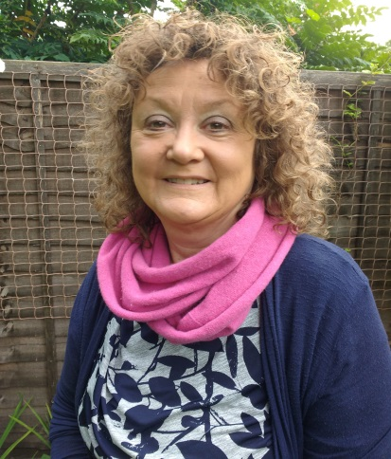
Linda Radnor
Linda Radnor co-owns an Agricultural Testing Business in the UK and visited Zambia in 2013/2014 and met Isaac Chitenta the current director general of Topping Crue Foundation at Tongabezi Lodge in Livingstone. Linda fell in love with Zambia and its people and hopes to return one day. Since then she has, on occasions, provided modest financial support for Isaac’s activities and is now involved with support for Topping Crue and its endeavours.”Linda Radnor has been a private individual donor supporting Topping Crue Foundation’s who has supported the foundation financially from transportation of donated community development tools from UK to Zambia to community children’s day to day stationary. Linda Has touched the lives of many most vulnerable and disadvantaged adults in Zambia especially our most vulnerable and disadvantaged children. And this year 2020 she went out of her way and provided all extra funding for Covid-19 safety equipment, food supplies during lockdown and to purchase Christmas presents for our 200 vulnerable and disadvantaged children. Topping Crue Foundation has run out of special words to tell you but kindly accept our big thank you very much To you Madam Linda for being the biggest funder of Topping Crue Foundation in the year 2020.

Beatrice Shulter
Through the use of internet and his networking Knowledge the director general of Topping Crue Foundation, Beatrice Shulter was found and approached in 2019 and has since been very helpful and a source great information on how a Community Based organization like Topping Crue can provide its services better. Indeed Beatrice since knowing her, she has rendered credible and reliable technical and strategic advise on how Topping Crue Foundation can govern itself, strategize, move forward and provide even better services to the communities it is serving that is why this annual report cannot be complete without her mention, thank you very much Beatrice Shulter for your support to Topping Crue Foundation especially this year 2020 she went out of her way to provide advise on how to stay safe amid Covid-19.

Isaac Chitenta
He is the current Director General who has worked tirelessly volunteering his time and energy to bring Topping Crue Foundation to where it is today. Without him Isaac Chitenta our partners wouldn’t have known that in this world there is a foundation called Topping Crue Foundation. And that this foundation is working hard to end poverty and vulnerability through providing quality community education and community empowerment to the world’s most vulnerable and disadvantaged persons. Sir to you Topping Crue Foundation will forever remain indebted.

2.7 ORGANIZATION’S FINANCIAL REPORT FINANCIAL YEAR 2020

The financial report for 2020 has been prepared separately this time and is available on demand.
2.8 CLOSING REMARKS
Despite the many challenges brought by covid-19 and despite 2020 being a tough year it has finally come to an end and we are Looking forward to a better 2021. Therefore Topping Crue foundation Limited would like to wish you a prosperous 2021 as we strive to serve the most vulnerable and disadvantaged mankind. Because we care and believe that they too are humans and just like every human being they deserve a better world than the one they live in. Your support matters, please come on board and partner with us.
Yours in Service
Topping Crue Foundation
Working to end poverty and vulnerability through community education and community empowerment programs, creating evenly opportunities for the most vulnerable and disadvantaged people
2.9 CONTACT DETAILS
Please feel free to contact us on:
Topping Crue Foundation
Non-Profit making organization,
P.O. Box 60375,
Plot No. E 28 Libuyu Township,
Southern Province,
Livingstone Zambia,
Phone Number: 260977140612/ +260969442522
Email Address : toppingcruefoundation@yahoo.com
Facebook page : https://www.facebook.com/www.tcf.org/
Website : https://wwwtcforg.page.tl/

