TITLE : AGRICULTURAL PRODUCTION

SECTOR : FOOD SECURITY
LOCATION : KAJOKEJI COUNTY
(CENTRAL EQUATORIA STATE)

SUBMITTED BY: RAPID FARMERS DEVELOPMENT COOPERATIVE CENTRE (RFDCC-SOUTHSUDAN)
E-MAIL : rfdcc.southsudan@gmail.com

BANK NAME : BARCLAYS BANK
BRANCH : MASINDI-UGANDA
ACCOUNT NO: 6004620842
SWIFT CODE : BARCUGKX

CONTACT PERSON: LOMERI NICKSON
EXECUTIVE DIRECTOR
TELEPHONE : +211955057864

BUDGET REQUISTERED: US DOLLARS $124,930

PROJECT DURATION: 18MONTHS
How to Get Involved
If you are interested in partnering with us in this project, please contact Lomeri Nickson at: rfdcc.southsudan@gmail.com
All financial contributions from well wishers, good Samaritans, individuals, churches and private organizations can be deposited to the Barclays Bank of Uganda , Account Number:6004620842,Branch Name: Masindi-Uganda, Swift code :BARCUGKX
Thank you for your consideration

1. EXECUTIVE SUMMARY
The civil war in the Sudan which was fought between the Sudanese Peoples Liberation Army (SPLA/M) and forces of National Islamic Front (NIF) led to untold human suffering. The signing of the CPA on January 9th 2005 by the co-partners –National Congress Party (NCP) and Sudanese Peoples Liberation Movement Army (SPLM/A) has resulted into relative peace. The Republic of South Sudan became independent on July 9th 2011 following the successful conduct of the Referendum for South Sudanese on January 9th 2011 where over 98.8% voted for secession. South Sudan is endowed with plenty of untapped natural resources – livestock, fisheries, forestry, oil, minerals, water, and land amongst others.
Kajokeji County is subdivided into five (5) administrative units referred to as Payams. These are as follows; - Nyepo, Lire, Kangapo 1, Kangapo 2 and Liwolo respectively. Kajokeji town is approximately 20 miles from Moyo Town, Uganda. However, it is estimated at 75 miles from Juba, Kajokeji County is inhabited by the Kuku who are an industrious and agrarian community.
The Rapid Farmers Development Cooperative Centre abbreviated as (RFDCC) shall work in Close collaboration with RainLink Foundation Initiative as a contracted implementing agency with expertise in agricultural production modernization programs for improving the livelihoods of southsudanese free from food insecurity syndrome by 2017.
The project entitled “Agricultural Production” will be implemented in five payams in Kajokeji County.

The project being proposed aims to address people’s livelihood needs for income generation, fuel wood, timber, fruit, Cereal Crops, Vegetables Crops, root tubers crops, fodder and other non-timber forest products while halting and reversing the trend of the forest loss, food security and related environmental degradation in Kajokeji district through promoting vegetable, fruit, root tubers crops, tree growing and agro-forestry systems.

Despite their potential as a food security, poverty alleviation, environmental conservation and sustainable livelihoods strategy, fruit growing, Cereal Crops Agronomy and agro forestry practices are currently a relatively low-key economic activity in KajoKeji County

Moreover, although trees and forests being a critical resource for people’s livelihoods, environmental conservation and national economic development, tree and forest resources have significantly diminished in recent years due to an increase in the number of people depending on them for survival as well as a lack of alternatives.

This is partly because of the current low productivity levels and relatively high pre- and post-harvest losses due to pests and diseases and poor produce handling. Production is constrained by the low soil fertility and lacks access to improved high-yielding crop varieties, and essential inputs. Furthermore, farmers have limited knowledge and skills in modern technologies, appropriate farming practices, proper post-harvest handling and quality control, and effective marketing skills. Other barriers include: low technical and organizational capacities of farmers partly due to the limited institutional government support and extension services for many rural farmers and a lack of access to relevant information (including market information), credit/capital and essential farm inputs and tools. The challenge is to support specific changes that will lead to a greater role for forests and tree resources in the livelihoods of the poor .This project will assist in addressing some of these barriers.

The long-term goal of the project is to contribute to the eradication of poverty, food insecurity and fostering a lasting high quality of life for the local people in Kajokeji County while safeguarding long-term environmental sustainability by growing fruits (including fruit and multi-purpose trees) and promoting agro forestry systems. Its mission is: “planting fruit trees for healthier populations and better environment”. The medium-term development goal of the project is to enhance the ability of farmers in Kajokeji County to increase and sustain agricultural production for improved household food security, nutrition and income generation while at the same time safeguarding the environment by adopting sustainable agricultural practices and appropriate technologies. This will be achieved through fostering increased fruit and vegetable growing (including fruit tree and tree planting) production for enhanced household food self-sufficiency and increased income generation and enhancing the ability to conserve and protect the environment. The project will encourage and support farmers to transform the current smallholder subsistence farming into economically viable agro-businesses including: market-vegetable gardening, and others. The project will also ensure sustainable agricultural production and safeguard the environment.

2. TARGET GROUP
The target beneficiaries are rural farmers, particularly women who are poor and most vulnerable, including single mothers, widows, HIV/AIDS affected persons and the disabled with farming Land including community Lands in kajokeji county Central Equatoria State. The nationals living in and around those areas will also benefit directly or indirectly,
3. OBJECTIVES

The Primary objectives of the project are:

(i) To assist at least 600 farmers, particularly poor and disadvantaged women, to engage in fruit and tree growing and increase vegetable and Cereal crop production for improved food security and income generation by among other things, enabling them to access improved or high-yielding seeds; improve their soil fertility; and minimize pre- and post-harvest losses due to pests, disease and poor crop husbandry.

- To promote awareness among local communities of the value and importance of planting trees(including fruit tree and tree lots) for different purposes; how to raise and tend tree seedlings and ways of integrating trees into farming systems through the production and dissemination of public awareness materials.

- To enhance capacity of farming households in Kajokeji County and surrounding areas to apply appropriate technologies and sustainable farming practices (including: composting, soil and water conservation, integrated pest management, environmentally sustainable application of agrochemicals, etc) through awareness and training workshops, information dissemination and extension services.

- To assist farmers to acquire the necessary tools and equipment (e.g. spray pumps, watering cans) and establish proper farm infrastructure, including post-harvest and storage facilities and transportation means.

- To mobilize and assist the project beneficiaries to organize themselves into Farmers’ groups to manage and sustain the activities initiated under the project and take advantage of the economies of scale in purchase of farm inputs; processing, transportation and marketing of agricultural produce; increase their market share and facilitate better access to credit and other financial services.

4. PROBLEM STATEMENT AND PROJECT RATIONALE

Over the last few years, the Agricultural Production in Kajokeji County has significantly reduced. According to the Local Representative of Kajokeji County, local people reported that many parts of the Payams had extensive forest and tree cover but now most of it is gone. This has resulted in loss of biodiversity (including medicinal plants and wild animals in the former hunting areas) and severe land degradation due to soil erosion and loss of fertility. The local people note that many areas which used to be very fertile are now barren and the overall agricultural productivity in the area has declined dramatically which is pushing people deeper into poverty. Moreover, pressure on the remaining forests and trees is high as the proportion of people depending up on them for firewood and non-timber products is quite high.
Further, despite its potential contribution to the food security, nutrition and income for the rural population in Kajokeji County, Cereal Crops, root tubers Crops and fruit growing is a relatively low-key economic activity in five payams and many other areas in Lire Sub-county. Many farmers in the area are oblivious of its economic potential and are generally reluctant to engage in it partly because of the current low productivity levels and relatively high pre- and post-harvest crop losses due to pests and diseases and poor handling. Production is constrained by the low soil fertility and lack access to improved high-yielding crop varieties and essential inputs. Furthermore, local small farmers have limited knowledge and skills in modern technologies, appropriate farming practices, proper post-harvest handling and quality control, and effective marketing skills.
There are also a number of other inter-related constraints and barriers to sustainable fruit growing in the project area including: low technical and organizational capacities of farmers and limited institutional government support and extension services for the local people. The local people in Kajokeji, especially women, lack extension services and access to relevant information, including market information. They also have no access to credit; they lack capital and essential farm inputs and tools.
There is a need to sensitize, empower and assist the rural farmers to increase agricultural productivity and address potential environmental risks associated to tree destruction and poor unsustainable small subsistence agricultural practices. This project will assist farmers to address some of the above-mentioned constraints and other emerging issues and needs so that people in the project area can derive maximum benefit from fruit growing and agro forestry practices as a strategy for improved food security, poverty alleviation and sustainable livelihoods. It will encourage and support the local farmers to transform the current smallholder subsistence farming into economically viable agro-businesses. The project will, inter alia, facilitate access to improved seeds; promote the adoption of modern agricultural technologies by farmers; provide training in appropriate sustainable farming practices (including: soil and water conservation, integrated fertility management, composting, crop rotation, mulching, intercropping/use of cover crops, sylvopastoral systems and integrated pest management); facilitate the establishment of farmer producer-groups and foster competitive marketing of locally produced fruit products, including through training in harvest and post-harvest handling and quality control skills.
The project is expected to improve the livelihoods of more than 600 farmers in the project areas. This will be achieved in a number of ways, including: enabling the beneficiary farmers to increase production of fruit and other vegetable crops for sale in the local markets in order to increase their incomes and to achieve domestic food self-sufficiency and improved nutrition, which will in turn result in better health and increased economic productive capacity. The project will also act as a catalyst for the local beneficiaries to engage in other off-farm economic activities, community development initiatives and social networks that would further improve their well-being and self-esteem. It is hoped that the project will serve as a model in Kajokeji County and that a follow-up project will be developed building on the experience, best

5. JUSTIFICATION
- Facilitate access to improved seeds and seedlings including fruit tree seedlings
- Facilitate access to agricultural inputs (including fertilizers, pesticides and farm tools);
- Promote the adoption of modern agricultural technologies by farmers;
- Organize workshops and other training activities (farm visits, study tours and dissemination of information and technical training materials) on appropriate sustainable farming practices, including: soil and water conservation, integrated fertility management, composting, sylvopastoral systems and integrated pest management);
- Offer on-farm extension support and advisory services, upon request;
- Train, equip and deploy five local agricultural extension workers/ animators (change agents);
- Foster competitive marketing of locally produced agricultural products (including through training in harvest and post-harvest handling and quality control skills and technologies);
- Facilitate farmers’ access to relevant information, including market prices and credit opportunities;
- Facilitate the establishment of farmer producers and marketing groups including a Community association.

6. LOCATION

The project is located in Kajokeji County- in South Sudan as a central point for easy reach by all the members from different five (5) payams in Kajokeji County in Central Equatoria State.

7. PROJECT PERIOD

The project period is 18Months with effect from 21st/05/2015

8. PROJECT ACTIVITIES

- CURRENT
The activities, currently being implemented by the members are;
  - Agricultural Production and marketing
  - Canteen catering (Food Tea and soft drinks)
  - Local Hand crafts and marketing
  - Retail trade on agricultural produce.
  - Adult literacy and spiritual development

PLANNED

The following activities have been identified as priorities to promote and strengthen the current activities to generate additional income, to sustain the project when the funding comes to an end.

    - One Massey Ferguson Tractor with full Accessories to be procured in order to support the 600 Farmers in the Five Payams in Kajokeji County in Central Equatoria state, Southsudan.
    - The Crop Production/Community agro forestry Projects should be promoted strengthened and production increased.
    - Cash credit and loans scheme for direct purchase of agriculture tools, seeds and local farmer’s produce and sales to boost food production.
    - Agricultural extension services to be delivered to the rural farmers in Kajokeji County in Central Equatoria.
    - Apiary projects to be established to support households with Bee Hives for boosting honey production in Kajokeji County whereas improving on the livelihoods of beneficiaries.

9. PROJECT IMPLEMENTATION $ MANAGEMENT
A. Project phases
The project will be implemented for 18 months in three main phases, namely: the preparatory phase, the implementation phase and the evaluation and reporting phase.
The preparatory phase (1-2 months) will involve establishment of the project steering committee, recruitment of the Project staff, procurement of project equipment and, community mobilization and initial awareness-raising and the selection of the direct project beneficiaries.
During the implementation phase (2-16 months), a series of activities will be undertaken, including assisting farmers to: access improved seeds, seedlings; acquire the necessary farm inputs; establish home gardens, and other agro-enterprises; and to adopt modern agricultural technologies and farming practices. The second phase will also include most of the awareness and capacity-building activities including: the production of awareness materials; the seminars and training workshops; the organization of short intensive course and on-job training for the local extension workers; establishment of the demonstration sites; farmer-to-farm visits; and the on-farm extension support including assisting local people to establish tree nurseries and plant trees on their farms. The last phase will involve evaluation and reporting.
The final phase (17-18 months) of the project will include evaluation and reporting activities, including the compilation of case studies, the shooting of the final documentary video about the project and the preparation and dissemination of the final evaluation report of the project

A Project Steering Committee will be established to provide overall oversight, guidance and direction for the project. It will consist of seven members, including: one local authority official (i.e. the LC 1 Chairperson or any other selected LC member), two community representatives (two ladies), two Rapid Farmers Development Cooperative Centre members, a donor representative and the project Coordinator (Ex-official/Secretary). Members will choose a chairperson amongst themselves. The Steering Committee will meet community forestry and a part-time at least twice in the year to review progress of the project implementation, consider and approve work plans, review financial reports and address any project issues that require policy-level direction and guidance.

A project management unit will be established in Kajokeji County to undertake the day-to-day implementation of the project. The unit will be composed of a full-time project coordinator and Food security& Livelihood officer/Community forester Assistant with experience in organic agriculture practices/ Administrator/Accounts Assistant, Security guard, office cleaner and Cook

The project will also benefit from the support of more than 5 volunteers. In addition, Rapid Farmers Development Cooperative Centre has a facilitators and volunteers comprising with extensive experience and expertise in different fields who will provide guidance to the project.
At the end of the 18 months of the project, it is expected that the beneficiaries will be able to sustain their efforts without Rapid Farmers Development Cooperative Centre direct support. Major training and awareness interventions will be aimed at creating primary beneficiary and community level independence and cooperation.

10. MONITORING AND EVALUATION (M&E)

The progress of the project will be monitored through periodic assessments against the project outputs and indicators set out in the monitoring and evaluation plan contained in Annex II. Semi-annual progress reports will be prepared by the project coordinator and submitted to the Steering Committee, the donor(s) and relevant government authorities. The reports will, inter alia, outline the activities undertaken, the achievements made, the constraints encountered and the lessons learned. An annual financial and management audit report will be undertaken as part of the normal internal process of the project.
A participatory monitoring and reporting system supported will be used to assess the progress and impact of the project. The project beneficiaries will be asked to provide feedback to the project management team regarding positive aspects and any shortcomings in the project implementation. Anecdotes from the project beneficiaries about their experience in fruit growing and agro forestry practices and overall perceived benefits (e.g. changes in lifestyle/ quality of life and in households’ incomes, improvements in nutrition and food security, etc) will be compiled through informal interviews.

On the basis the progress reports and the feedback received from the community, necessary adjustments to the project will be identified and recommended to the Project Steering Committee for consideration. The final evaluation of the project will be undertaken by an independent consultant during the last two months of the project.
Information about the progress of the project will be published in the semi-annual newsletter produced by Rapid Farmers Development Cooperative Centre or the community groups. A video documentary about the project, featuring aspects of the implementation process, the results and impact of project on the community and the general lessons learned will be produced for both reporting and outreach purposes.

ANNEX I: MONITORING AND EVALUATION LOGFRAME

Objective/ Outcome | Verifiable Indicators | Means of Verification | Assumptions | Frequency of reporting
Goal: The goal of the project is to contribute to the eradication of poverty, food insecurity and fostering a lasting high quality of life for the local people in Kajokeji County while safeguarding long-term environmental sustainability by growing fruits (including fruit and multi-purpose trees) and promoting agro forestry systems. Its mission is: “planting fruit trees for healthier populations and better environment”. | - Change in average poverty levels in project area compared with non-project areas | - Welfare monitoring reports (every 1 year)  - Beneficiaries survey reports | - Intentions of the project with regard to poverty alleviation and natural resources use realized. | project end
Midterm objective: The medium-term development goal of the project is to enhance the ability of farmers in Kajokeji County to increase and sustain agricultural (fruit) production for improved household food security, nutrition and income generation while at the same time safeguarding the environment by adopting sustainable agricultural practices and appropriate technologies. | - Agricultural (fruit) production increased by 25% of land for 100 household. | - M&E reports  - Ground surveys | - Community willingness to implement agriculture best practices. | - Yearly
To assist at least 100 local farmers, particularly poor and disadvantaged women, to engage in fruit and tree growing and increase vegetable crop production for improved food security and income generation by among other things, enabling them to access improved or high-yielding seeds; improve their soil fertility; and minimize pre- and post-harvest losses due to pests, disease and poor crop husbandry. | - Number of farmers engaging in project and receiving tangible benefits from project supported activities.  - 80% of beneficiaries with practical skills and knowledge best farm practices. | - M&E reports  - Farmers survey reports | - Community willing to learn and participate in the project. | Mid term review
Increased productivity, diversity and quality of fruit products leading to increased food availability and balanced diet for beneficiary households. | - Number of beneficiaries with active gardens and related practices. | - participatory households interviews | - Community willing to learn and participate in the project. | Mid term review
Improved farmers' skills and institutional capacities for marketing of crop products (including: vegetables, fruits, etc). | - Participating beneficiaries experience and have greater access to input and output markets. | - Monitoring reports  - Marketsurvey reports | - Traders willing to buy beneficiary products | Quarterly
To promote awareness among local communities of the value and importance of planting trees(including fruit tree and tree lots) for different purposes; how to raise and tend tree seedlings and ways of integrating trees into farming systems through the sensitisation, training, production and dissemination of public awareness materials. | - Proportion of local people that demonstrate increased knowledge about relevance of fruit tree growing and agro forestry practices | - Participatory households interviews  - Counting of households with active gardens and the total number of people in those households.
Sensitized and inspired local people with increased knowledge, skills, positive attitude and enthusiasm to engage in sustainable fruit growing and agriculture. | - Cumulative number of people inspired and active in relation to the project. | - Copies of workshop materials disseminated to participants | Community members willing to participate in project. | Quarterly
Local council administrations formally integrate fruit growing practices in their plans and are in use as basis for development. | - Action plans drawn relevant and supporting project best practices | - Copies of Action plans | End of year
To enhance capacity of farming households in Kajokeji County and surrounding areas to apply appropriate technologies and sustainable farming practices (including: composting, soil and water conservation, integrated pest management, environmentally sustainable application of agrochemicals, etc) through awareness and training workshops, information dissemination and extension services. | - Number of farmer households adopting best and sustainable agriculture practices, 20% increase in acreage and yields, change in cropping pattern by mid-term year 1. | - Household members willing to learn and practice best practices. | Beneficiaries adequately equipped with necessary skills.
Beneficiaries with access to high value planting materials and basic tools by mid first year. | - Quantity of crop materials and tools facilitated to beneficiaries  - Number of households directly benefiting from project. | Counting of households with active gardens and the total number of people in those households. | - Beneficiaries willing to utilize planting material facilitated. | Quarterly
To assist farmers to acquire the necessary tools and equipment (e.g. spray pumps, watering cans) and establish proper farm infrastructure, including post-harvest and storage facilities and transportation means. | - Beneficiaries have tools and equipment to support them in establishment of farm infrastructure. | - Counting of beneficiaries with established farm infrastructure
To mobilize and assist the project beneficiaries to organize themselves into Farmers’ groups and a Community Association to manage and sustain the activities initiated under the project and take advantage of the economies of scale in purchase of farm inputs; processing, transportation and marketing of agricultural produce; increase their market share and facilitate better access to credit and other financial services. | - Functional groups formed and operational  - Functional community association | - Minutes of meetings | Beneficiaries willing to participate in group activities. | Quarterly

11. Project Sustainability
The sustainability of the project rests upon several key factors. Firstly, the project design places major emphasis on capacity building and process strengthening. Overall, the objective is to ensure that at the end of the implementation period, all major project stakeholders including beneficiaries and local council administrations have all increased their capacity to support fruit tree growing and planting of trees including agro forestry practices. This objective renders the success of the process aspect of the project of almost as great importance as the immediate project development objective of poverty reduction.
Secondly, the project design does include a project implementation strategy, for example: The project management will encourage and facilitate the beneficiaries of the project to form groups and constitute themselves into a Community Association, which provides opportunities to further manage the project after its official closure. Beneficiaries will be encouraged to participate in selecting what kind of fruit, vegetables and trees they would like to grow to ensure sustainability. Further, beneficiaries are contributing United States Dollars (US$ 10) each towards the costs of the project.
Thirdly, project funds will be used to ensure productivity of key resources more so land, which results in objectively verifiable benefits. This will, in turn, provide a long term basis for vulnerability reduction among the poor and strengthen their ability to focus beyond immediate subsistence needs.
Project staff, community leaders and members, including beneficiaries and volunteers that will participate in baseline surveys will contribute to enhanced local capacity to continue to apply and refine project methods and extend results and lessons learned to other areas.
By involving the community in all stages of the project from planning, designing, and finally operation and maintenance will help ensure sustainability of the project. To guarantee suitability and sustainability, the Project will pay special attention to assessing and meeting

RAPID FARMERS DEVELOPMENT COOPERATIVE CENTRE EXECUTIVE DIRECTOR MR. LOMERI NICKSON IN DICUSSION WITH MR .NAGGI DAVID AND MR .BOJAN VULVOKIC OF UNITED NATIONS MINE ACTION OFFICE (UNMAO) IN SOUTH SUDAN ABOUT THE STRATEGIES OF IMPLIMENTING AGRICULTURAL PRODUCTION PROJECTS IN THE FIVE PAYAMS OF KAJOKEJI COUNTY IN CENTRAL EQUATORIA STATE .
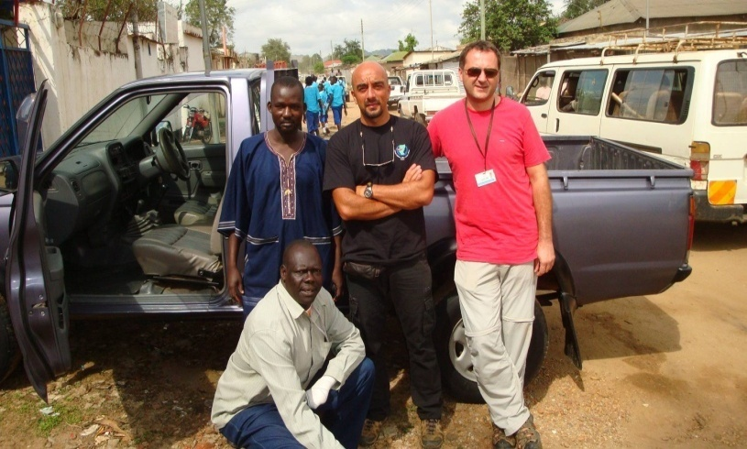

12. RESPONSIBILITIES OF IMPLIMENTING PARTNER
Rapid Farmers Development Cooperative Centre will contract RainLink Foundation Initiative as lead implementing partner responsible for assisting the participating beneficiaries to identify and purchase, at their cost the desired farm inputs and equipment such as farm ploughs, spray pumps, wheelbarrows, and refrigerators, One Massey Ferguson tractor procurement among others. RainLink Foundation Initiative will also organise all the training activities, procure the training materials, mobilise the resource persons, organise the study tours and offer extension services upon request.
The project management team will adopt a community-based, demand-driven approach where community members will be involved in all stages of the project from planning through choosing crops to grow and trees to plant; and, become fully responsible for operation and maintenance (O&M) of their undertakings. Local people from the community will be mobilized and assisted to form farmer groups or a community association in order to sustain the project activities and undertake relevant community development work.

ANNEX II: DETAILED BUDGET FOR THE PROJECT OF AGRICULTURAL PRODUCTION PROJECT IN KAJOKEJI COUNTY (MAY2015 - OCTOBER 2016)
NO | BUDGET ITEM | UNIT | QUANTITY | UNIT COST | TOTAL COST IN  US$ DOLLARS
5.1 | PERSONNEL
 | Project Coordinator | Months | 18 | 400 | 7,200
 | Food Security &Livelihood Officer | Months | 18 | 350 | 6,300
 | Community Forestry Assistant | Months | 18 | 300 | 5,400
 | Administrator/Finance Officer | Months | 18 | 320 | 5,760
 | Office Cleaner | Months | 18 | 150 | 2,700
 | Driver and Mechanics | Months | 18 | 300 | 5,400
 | Cook | Months | 18 | 100 | 1,800
 | Security Guard | Months | 18 | 150 | 2,700
 | Sub-Total |  |  | 2,070 | 37,260
5.2 | AGRICULTURE MACHINE/ TOOLS
 | Massey Ferguson Tractor, Head 65hp and Disc Plough | Machine | 01 Tractor | 25,000 | 25,000
 | Fuel and Lubricants | Months | 18 | 300 | 5,400
 | Spares and Repairs | Months | 18 | 250 | 4,500
 | Hand Hoes | No | 200 | 270 | 270
 | Rake | No | 200 | 250 | 250
 | Watering Cans | No | 200 | 3,000 | 3,000
 | Spray Pumps | No | 100 | 2,500 | 2,500
 | Slashes | No | 75 | 1,000 | 1,000
 | wheel barrow | No | 20 | 2,500 | 2,500
 | Sub-Total |  |  | 35,070 | 44,420
5.3 | TREES SPECIES For Agro forestry
 | Pines for planting | No | 1000 |  | 1,200
 | Eucalyptus Trees | Seedlings | 400 | 250 | 250
 | Teak Trees | No | 300 | 300 | 300
 | Sub-Total |  |  | 1,750 | 1,750
5.4 | PREPARATION AND DISSEMINATION OF AWARENESS MATERIALS
 | Printing of brochures and T-Shirts | No | 1500 | 100  600 | 1,000  600
 | Production of the video documentary | No | 200 | 1,200 | 1,200
 | Sub-Total |  |  | 1,900 | 2,800
5.5 | FRUITS
 | Oranges Grafted | Seedlings | 250 | 700 | 700
 | Avocado Budded | Seedlings | 250 | 700 | 700
 | Mangoes Grafted | Seedlings | 250 | 1,000 | 1,000
 | Guava Grafted | Seedlings | 900 | 1,500 | 1,500
 | Papaya/pawpaw | Seedlings | 1000 | 1,000 | 1,000
 | Pineapples Suckers | Seedlings | 1200 | 1,500 | 1,500
 | Banana Suckers | Seedlings | 300 | 1,000 | 1,000
 | Passion Fruits | Seedlings | 1000 | 1,000 | 1,000
 | Sub-Total |  |  | 8,400 | 8,400
5.6 | 3-COMMUNITY AWARENESS SEMINARS AND 2-TRAINING WORKSHOPS FOR LOCAL BENEFICIARIES-2DAYS
 | Venue hire | Days | 2 | 1,000 | 1,000
 | Materials assorted | Days | 2 | 700 | 700
 | Workshops facilitators fees and transport | Days | 2 | 2,000 | 2,000
 | Meals for Participants and organizers | Persons | 100 | 3,000 | 3,000
 | Sub-Total |  |  | 6,500 | 6,500
5.7 | ROOT TUBERS CROPS/ASSORTED VEGETABLES
 | Cassava Stocks | Stocks | 10 | 1,000 | 1,000
 | Sweet potatoes’ vines | Bundles | 10 | 500 | 500
 | Irish potatoes’, Yams |  | 18 | 600 | 600
 | Assorted Vegetables | Sackets | 30 | 900 | 900
 | Sub-Total |  |  | 3,000 | 3,000
5.8 | CEREAL CROPS
 | Maize | Kg | 200 | 1,000 | 1,000
 | Rice | Kg | 200 | 1,000 | 1,000
 | Sorghum | Kg | 100 | 500 | 500
 | Millet | Kg | 100 | 500 | 500
 | Sub-Total |  |  | 3,000 | 3,000
5.9 | TRAININGS OF LOCAL VOLUNTEERS/ANIMATORS
 | Course fees and cost for the training materials | Persons | 5days | 1,000 | 1,000
 | Costs for meals during the course | Persons | 100 | 1,500 | 1,500
 | Transport and upkeep in juba for a-5days course | Persons | 5days | 2,000 | 2,000
 | Sub-Total |  |  | 4,500 | 4,500
 | PROJECT OFFICE EQUIPMENT & OPERATIONAL COSTS
 | Telephone, fax/Email/internet charges | Months | 18 | 200 | 3,600
 | Travel for project staff(to the project site and meetings) | Persons |  | 600 | 600
 | Office supplies(Stationery) assorted | No |  | 1,000 | 1,000
 | Motorbike for the local technicians | No | 1 | 1,500 | 1,500
 | Computer and Printer | No | 2 | 1,500 | 1,500
 | Office Rent | Months | 18 | 1,000 | 1,000
 | Office furniture | Sets |  | 200 | 3,600
 | Steering committee meetings(transport refund, meals) | Months | 18 | 1,000 | 18,000
 | Sub-Total |  |  | 7,000 | 13,800
 | MONITORING AND EVALUATION
 | End of cycle evaluation consultant | Days | 15 | 100 | 1,500
N.B | Procuring of Bee hives |  |  | 2,500 | 2,500
 | Sub-Total |  |  | 2,600 | 4,000
 | GRAND TOTAL |  |  | 67,290 | US$124,930

LAMENT OF THE MANGO TREE

Dear Children

I am a big sad mango tree,
My shade I give to you for free,
And flowers and fruits grow well on me.
Why then, when my first fruits you see,
Do you begin to batter me?
Throw sticks and sticks, bricks and stones at me?
My branches break and ruin me
What have I done to all of you?
When big and ripe my fruits shall be,
I will drop it for you generously.
Much better for you, too it will be
When sweet it is and most juicy.

Please children, then
Just let me be
A mango tree
A lovely tree
A shade tree
A useful tree
A fruitful tree 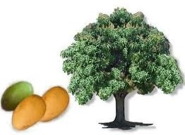
A happy tree

For all to see
My Lush beauty

TAKE CARE OF ME
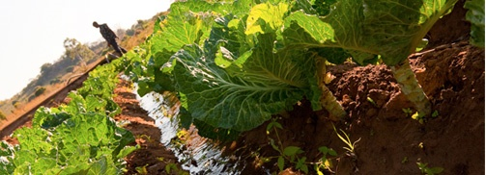
Brassica Oleracea (Horticultural Management) Farmer Field School

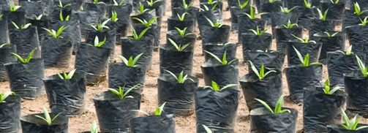
Community Empowerment in Nursery Bed Management in Kajokeji County

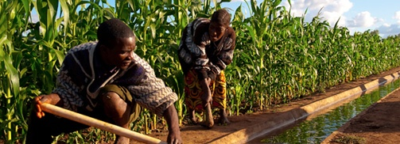
Maize (Zea mays) Agronomic Practices Farmer Field School (FFS)

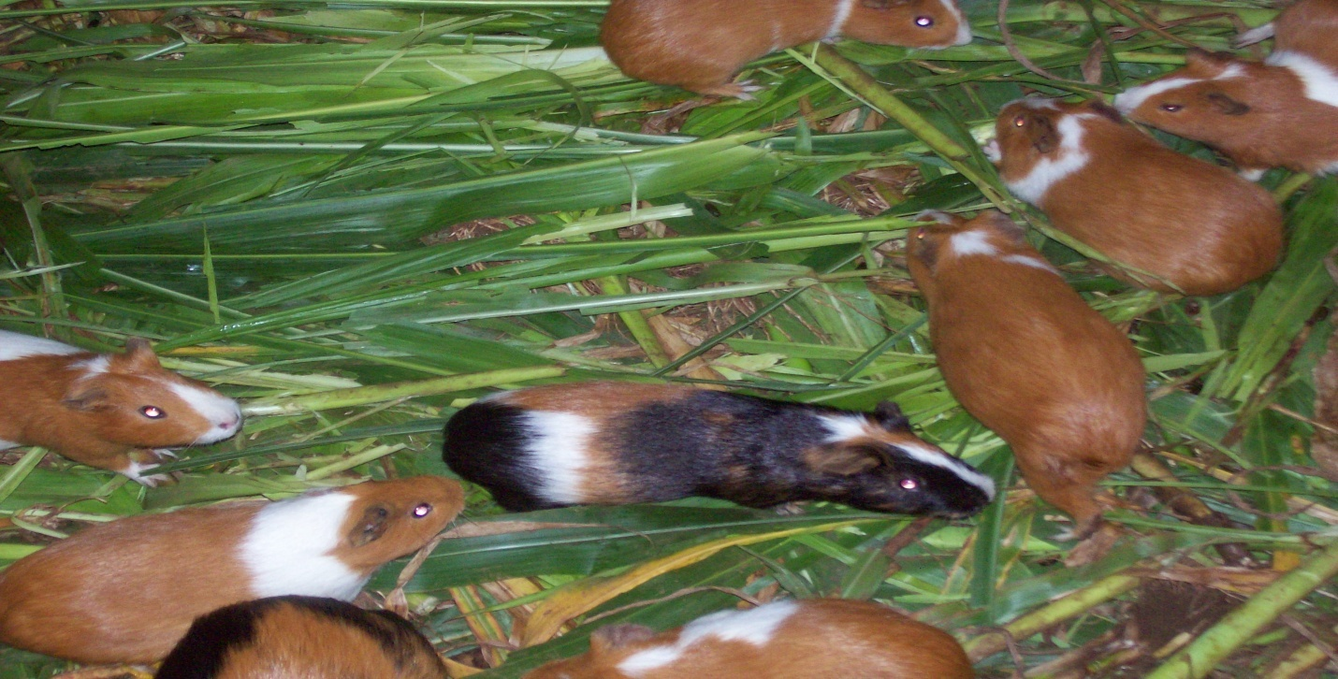
Guinea Pigs production Farmer Field School (FFS) in Kajokeji County

