LOIC

2012 ANNUAL REPORT

GENERAL INFORMATION

Name of organization: Liberia Opportunities Industrialization Centers, Inc. (LOIC)
Year founded September 1977
Physical Address: Sinkor, New Matadi Estate, Monrovia, Liberia
Postal Address: P. O. Box 3596
Telephone: +231-0886515999
Contact Persons: Hon. Joseph K. Duwor, Chairman of the Board
Solomon D. King, Sr., National Executive Director
e-Mail liberiao@yahoo.com
Report Title: LOIC 2012 Annual Report
Reporting Period: January 1, to December 31, 2012
Author of the Report: J. Clarence C. Blapooh, Program Officer
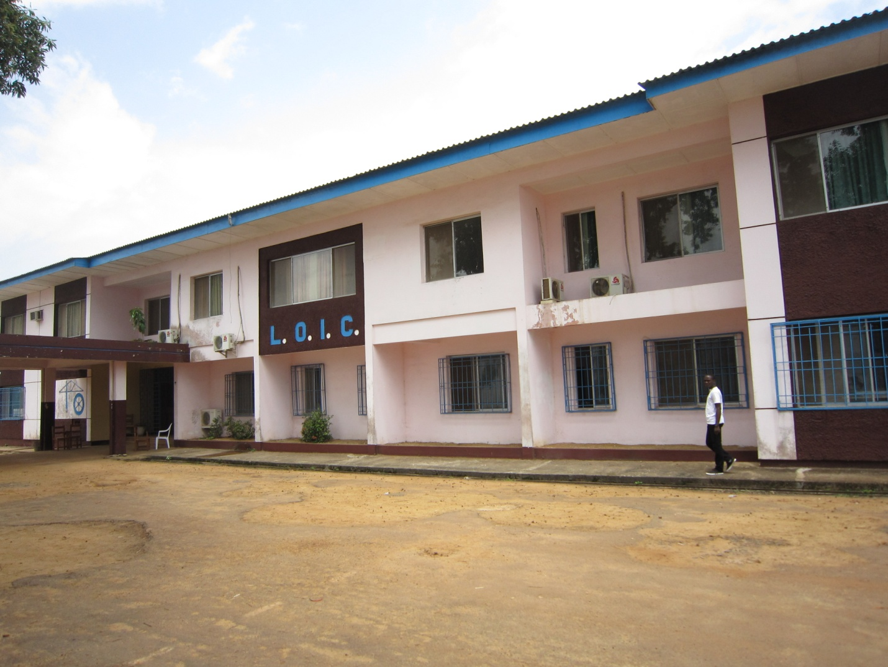

Acrobatic display by LOIC Trainees

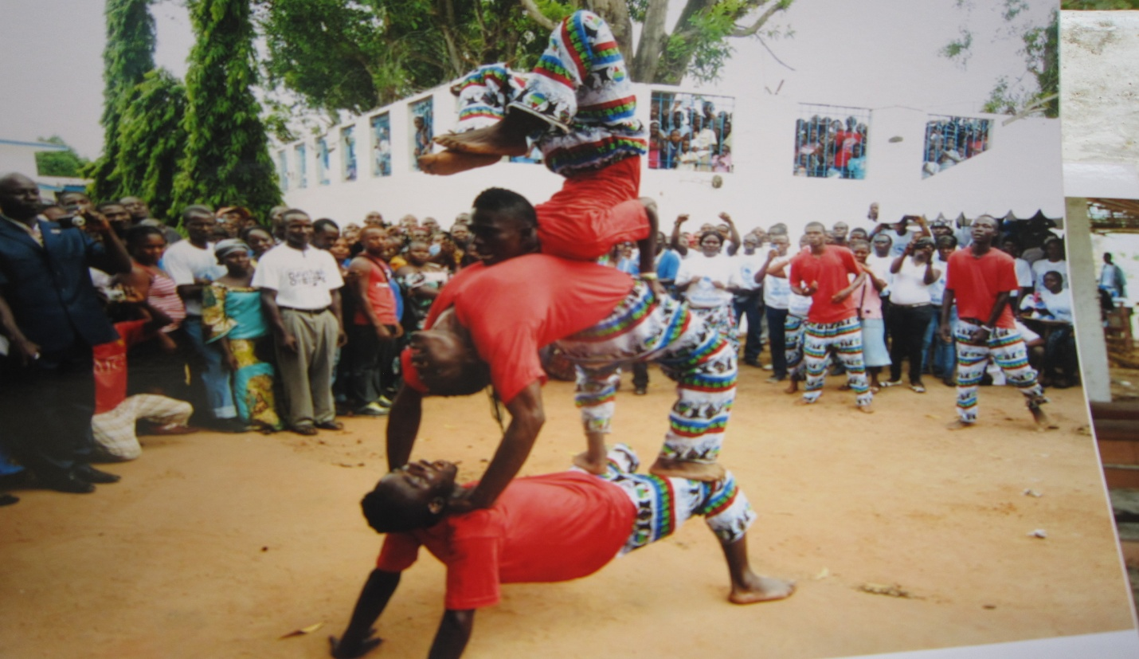

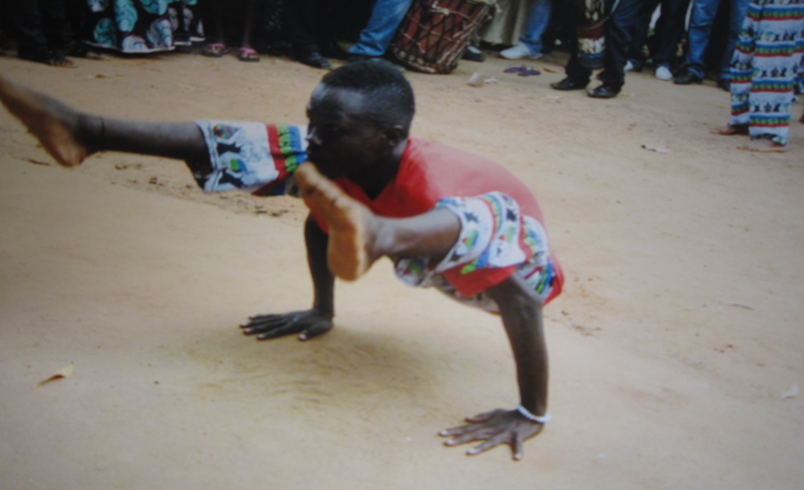

“Too much of work without play makes Jack a dull boy”

MESSAGE
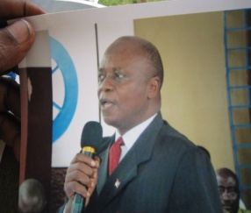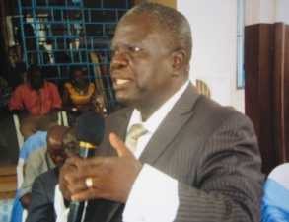
Hon. Joseph K. Duwor Mr. Solomon D. King, Sr.
Chairman of the Board National Executive. Director

I
n consonance with the unceasing march of time, we have completed a full period that has closed one program year and ushered us unto another. Predicated on the policies of LOIC, this period to report on program activities has been set aside to review our activities of the past, analyze our program’s goals and appraise our accomplishments and challenges with a view to formulate new plans for the next program year.

W
e are mindful of the challenge that a viable organization such as LOIC, has a unique role and responsibility to build in its lifetime those infrastructures that make for lasting foundations upon which succeeding generations may build to maintain a consistent progression in development. The mission of LOIC is to empower the youth with marketable skills and put them to work, in order to contribute their quotas to national development. In our society today, too many individuals are sitting idly, waiting for hand-outs from others in order to survive. We at LOIC have a different approach; while people await hand-outs, we give them hand-up to eke out their own livelihood. We teach them how to get bread and butter on their tables for lifetime. This is the bottom-line, the purpose for which LOIC was established. We are actively seeking to accomplish this goal now as we have been for 35 years. LOIC believes that with skills and positive attitudes, the youth of Liberia can pursue their dreams as well as rekindle their hopes and aspirations for a better future. We sincerely believe that with the right skills and positive attitudes, individuals can automatically have a stake in society thus minimizing many of our social ills.

A
s we present this report to our stakeholders, we salute our trainees who have chosen the road to a better future. We also extend immense thanks to the Liberian Government, most especially the National Legislature, Ministries of Youth and sports, and Education; International Relief and Development (IRD), EED of the Federal Republic of Germany, OIC International, and the local communities for their laudable contributions to the LOIC Program. Further, we wish to express special thanks to members of the Board, management and staff for their hard work and unselfish dedication to the program.

M
ay God bless the work of our hands.

OUR BACKGROUND AND CAPABILITIES

T
he Liberia OIC is a non-profit organization whose efforts are directed at relieving both the social and economic problems which result from unemployment and underemployment. LOIC provides counseling, career guidance, motivational and attitudinal training, pre-vocational and vocational training, job placement and follow-up services to less-fortunate individuals who without LOIC’s assistance, would have little or no chance of reaching their full potential and making a meaningful contribution to society. With funding from various donor organizations including United States Agency for International Development (USAID), ICCO of the Netherlands, EED/Bread for the World of the Federal Republic of Germany; United Nations Development Program (UNDP), UNHCR, European Union, as well as the Government of Liberia and other institutions, LOIC had since 1977, trained approximately 50,000 individuals, most of whom are now making meaningful contribution to society. Currently, LOIC is actively engaged in training activities in the following communities: Monrovia, Gbarnga, Sinje, Zwedru, River Gee and Buchanan.

R
ealizing that LOIC training services are in great demand all over the country, the LOIC Management is lobbying with the Government of Liberia for financial inputs in order to reactivate its training centers that have been closed due to the lack of funds. We refer to LOIC Centers in Foya, Bopolu, Ganta, Tubmanburg, Harper and other areas. As Liberia recovers from the devastating effects of war, many individuals whose education and livelihoods had been seriously affected due to over 14 years of war, now face depression and hopelessness; despite government’s efforts to rebuild the country. The psychological effects of war and the lacked of skills, continue to prevent young Liberians from improving their livelihoods, as well as reclaiming their sense of self-worth and hope. The Liberian Government is currently reinvigorating the economy and improving social services, in order to place the country on a long-term path for peace and prosperity. Accordingly, key activities that will enable Liberians to address their own needs for holistic reintegration and rehabilitation and to restore livelihoods and hope are a critical component of Liberia’s overall reconstruction process. Thus, the aforementioned LOIC Centers, when reactivated, will compliment government’s effort to empower the youth and make them serviceable in their communities.

T
he strategy of LOIC is to provide marketable skills and job creation services to youth and young adults in order to empower themselves to become totally involved in the rebuilding of their communities. LOIC believes in giving hand up and not hand out; because it said that if you give a man a fish, you feed him for a day, but when you teach him how to fish, you feed him for a life time. LOIC has the capacity to seek positive ways to meet the changing needs of society by empowering the youth with the requisite skills and motivational training to become productive individuals. LOIC came into being to minimize the shortage of skilled manpower to undertake the task of nation building. This is our primary focus and we crave the support of donor organizations and the Government of Liberia.

THE PROGRAM

W
e are pleased to report that the National Office administered all program activities as planned during fiscal year 2012. A total of 123 employees, including 23 females provided services at the various LOIC Centers. A breakdown is as follows: National office - 21, Monrovia – 35, Sinje – 19, Gbarnga – 22, Zwedru – 14 and Fish Town -12. Regular monitoring activities at the various centers were successfully executed and the employees participated in staff development initiatives to enhance their capabilities. We also wish to note that LOIC continues to maintain cordial relationship with its key partners including OIC International which has projects in Grand Gedeh and River Gee, EED with Projects in Gbarnga and Sinje, the Government of Liberia which provides funding for the Monrovia Program as well as IRD which had just concluded its project in Montserrado and Margibi. We also anticipate the partnership of Chevron for the Buchanan Program.

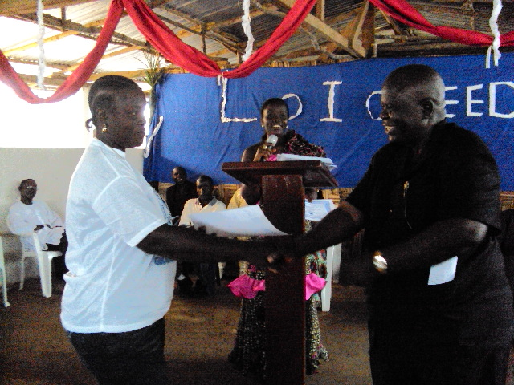
Female graduate receives certificate from the National Executive Director in Gbarnga

OUR ACHIEVEMENTS

TRAINING SERVICES

- Monrovia and the Satellite Programs

V
ocational skills training activities were conducted at Monrovia, Gbarnga and Sinje training centers. Of the total of 622 trainees that enrolled, only 490 including 139 females completed the required studies during the period under review. The training activities covered both theoretical and practical as well as on-the-job training in the areas of carpentry, masonry, electricity, weaving, computer literacy, auto mechanics/small engine, general agriculture, cosmetology, home arts and plumbing. Also, Small Enterprise Development (SED) was taught as a major course for all trainees in order to expose them to business establishment, management, record keeping, obtaining of loans, etc.

A
dditionally, in order to analysis the training conducted during this period, a post training assessment was conducted to ascertain whether or not the minimum levels of training was attained, and to measure both the impact, and result of the training as well as the methods used. During interactions with the trainees, they indicated that the methods used were good. The result of the training indicates that trainees are immensely delighted for the skills acquired at LOIC and they have begun applying their skills productively in the community. A breakdown of the statistical details per center is as follow:

Monrovia Training Center

No... | Trade | Male | Female | Total
1. | Electricity | 59 | 5 | 64
2. | Computer | 46 | 15 | 61
3. | Plumbing | 39 | 13 | 52
4. | Tailoring | 2 | 7 | 9
5. | Carpentry | 24 | 2 | 26
6. | Masonry | 27 | 4 | 31
7. | Shoemaking | 4 | - | 4
8. | Weaving | 1 | 12 | 13
 | Total 202 58 |  |  | 260

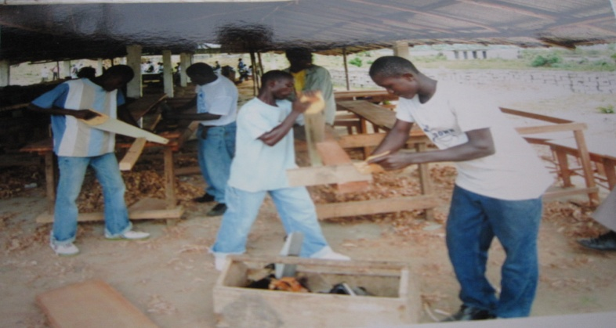

Gbarnga Training Center

Trade area | Female | Male | Total
Agriculture | 1 | 5 | 6
Cosmetology | 10 | 0 | 10
Auto mechanics | 0 | 15 | 15
Electricity | 0 | 9 | 9
Home economics | 15 | 0 | 15
Masonry | 0 | 26 | 26
Computer science | 13 | 17 | 30
Plumbing | 2 | 20 | 22
Total | 41 | 91 | 132

Sinje Training Center

Trade area | Female | Male | Total
Carpentry | 0 | 22 | 22
Hair dressing | 15 | 0 | 15
Small Engine Repair | 0 | 13 | 13
Tailoring | 18 | 8 | 26
Home economics | 7 | 0 | 7
Masonry | 1 | 14 | 15
Total | 41 | 57 | 98

W
e wish to also report that the program has made some headways in achieving some placements for the trainees. We referred to the followings: Total Number of trainees who completed and are generating income with their newly acquired skills through job/self employment is 272, which includes 106 individuals who started their own businesses and 166 who are formally employed and have employment contracts. The overall total includes 125 females. Keen observations are made in regard to the positive impact of the program as trainees demonstrate their talents by producing various products; rendering services to generate incomes to sustain themselves and their families. Trades such as cosmetology, small engine, home economics, and the building trades are key in this endeavor.

- OICI/USAID Hands Program

T
he OIC International HANDS Program being partly implemented by LOIC has made enormous progress in both Grand Gedeh and River Gee Counties. During this period, LOIC conducted training in the rehabilitation of swamps in 7 communities with each community consisting of 40 farmers with 25 hectors. Meanwhile, during the period of April 2011 to May 2012, the following achievements were made:

- Agro-business, Small Entrepreneur development and Micro grant training completed a total of 742 trainees including 531 females.
- Gari processing and agro business/Small enterprise development completed 27 trainees including 20 females

- Entrepreneurship/vita goat component completed 80 trainees including 73 females.

- Entrepreneurship/fruit process completed 46 trainees, all of whom were females.

- Participatory farm management training completed a total of 1,640 trainees including 851 females.

- Community agriculture promoters - trained 195 persons including 11 females.

- Swamp rehabilitation training: a total of 273 individuals completed including 156 females. The program targets 304,589 beneficiaries within five years, ending June 2015.

- LOIC/Chevron Partnership

W
e are pleased to report that a grant agreement for US$250,000 from the Chevron Oil Company, is expected to be signed within a few days for the reactivation of the Buchanan Program which had been closed for almost three years. Program set up activities including sensitization, hiring of staff, recruitment of trainees and cleaning of the facilities are being pursued. However, because the training building, administrative quarters and storage facility are in a deplorable state, management has already commenced doing ground work as regards to the renovation and/or reconstruction of these facilities. Meanwhile, in order to give opportunity to some of our staff to develop their administrative capabilities, we have promoted Mr. Donald Okai, former Business Instructor at the Monrovia Program, as Manager of the Buchanan Program. We hope that he would prove himself worthy of the consideration.

L
OIC/Chevron Project goal and objectives: Goal: To significantly enhance livelihood capacities and quality of life of marginalized youth through the acquisition of marketable skills and employment. The objectives are as follow:

- To increase employment opportunities for 150 male and female youth between the ages of 18-35 in Buchanan, Grand Bassa County within 12 months.
- To increase income-generating opportunities for 150 male and female youth between the ages of 18-35 in Buchanan, Grand Bassa County within 12 months.

- To build the capacity of the communities for participation in the implementation and management of the program and for enhancing its sustainability.

The dilapidated Training facilities in Buchanan

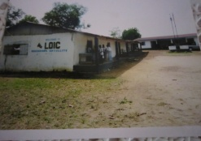

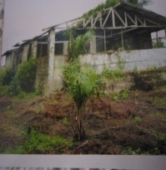

- International Relief and Development (IRD)

We are pleased to report that during the period under review, LOIC completed the second and third phases of the IRD Project in Montserrado and Margibi respectively. The accomplishments for the second phase are as follow: Rehabilitated 28 schools; constructed 18 school-annexes and 13 gender-segregated latrines. Also, constructed 38 new hand washing stations to address the issues of hygiene and sanitation in selected schools as well as 12 wells and hand pumps. Further, during the third phase which ended December 31, 2012, the total achievements include 60 hand washing stations, 16 latrine, 13 wells and 14 school-annexes. A total of 35 schools were assessed and 8 schools projects were turned over. These projects were executed by 304 workers, including 89 females. Following the completion of the third phase on December 31, 2012 and the submission of a comprehensive end-of-project report, all project assets were turned over to IRD.
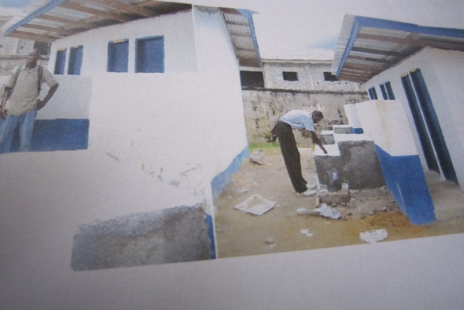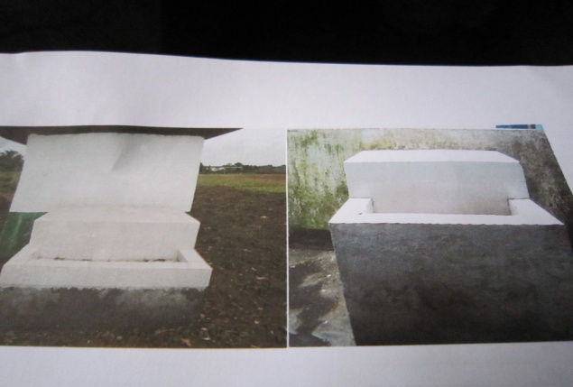
PARTICIPANTS WORKSHOPS

D
uring this fiscal period, LOIC Management and staff participated in various workshops to build their capacities and enhance productivity. Two Consultants from EED – Mr. Seth Oteng of Ghana and Ms. Arian Gruszczynski of the Federal Republic of Germany conducted a three day workshop which focused on the following: Reflection of LOIC over the years and the Key success factor for LOIC Journey. Issues identified for management to work on include program sustainability, GOL funding, renewal of relationship with past donors, reactivation of dormant program facilities; pension benefits for employees, resource mobilization, among others. Issues for the Board to work on include development of policies for capacity building, program sustainability; motivation for management and staff; renew relationship with traditional partners, among others. Issues for management and staff to work on include revision of existing policies; annual staff vacation, policies on personnel attractive compensation and benefits, provide expenditure ceiling for management approval among others. It was decided that future staff development should focus on curriculum development, quality training, quality services and quality equipment/tools.

F
urther, we wish to report that LOIC participated in one day workshop the Ministry of Public works to identify areas which NGOs can help in training road construction workers especially for the rural communities. Presentations were made by LOIC and the Monrovia Vocational Training Center. It was decided that LOIC will be considered as one of the partners when funding is made available. The LOIC staff also participated in several workshops conducted by IRD, a partner of LOIC on activities of the on-going project. Also, the World Bank sponsored a series of workshops which were attended by the National Executive Director, Program Officer, Monrovia Program Director, Personnel Director, Finance Director and other accounting staff.

T
he International Finance Corporation through the Ministry of Youth and Sports conducted a workshop which brought together TVET institutions to identify projects and concretized linkages between TVET institutions and the private sector. Companies invited were Malta Steel, Sime Darby, Firestone, NOCAL, Chevron Oil Company as well as USAID, European Union, Ministry of Education, among others. During the deliberations, the private sector identified skills such as carpentry, masonry, auto mechanics, heavy duty mechanics, operators for yellow machines, welders, electricians and train operators.

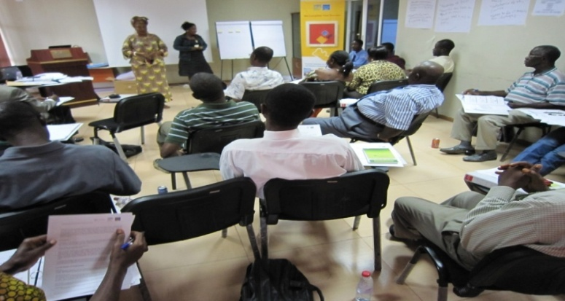

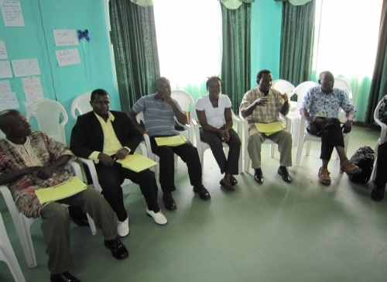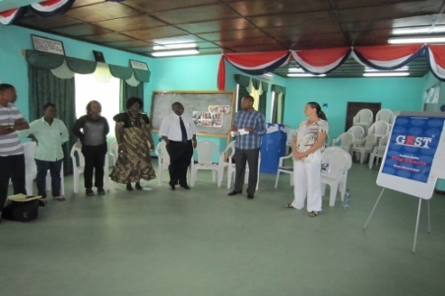

Award ceremony

We wish to report that during this reporting period, the West Africa Newspaper honored the National Executive Director as Outstanding Executive Director of the Year for 2012. The selection was done after a competitive vetting exercise among a list of distinguished individuals involved with vocational and technical education.

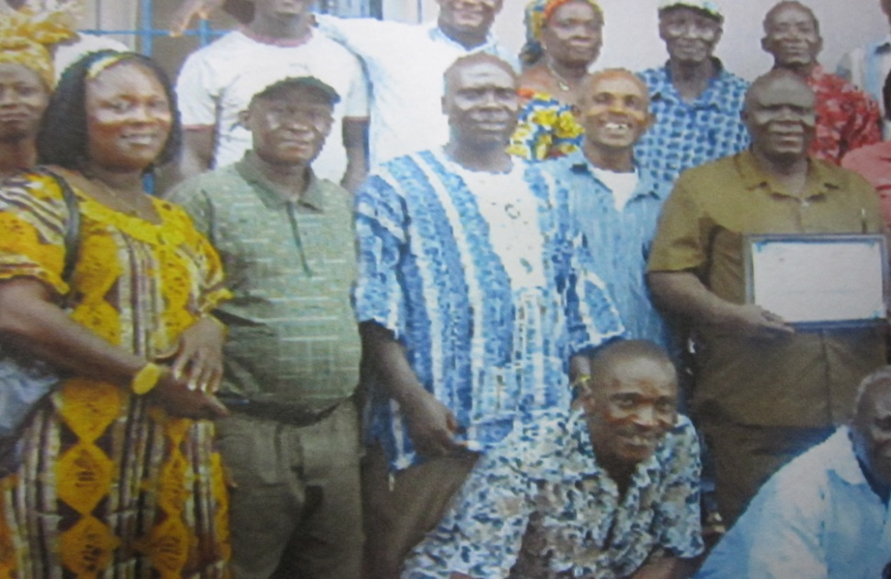

Personnel

The vacant position of Deputy National Executive Director was filled during this period by Ms. Marie Kolenky. The post which was previously held by Mr. Solomon D. King, Sr. was made vacant when he was promoted in August 2008 to the position of National Executive Director, succeeding Mr. George F. Kpawulu whose services were terminated by the Board. The post of Deputy National Executive Director was created in 1999 due to the expansion of LOIC into the rural areas of Liberia. Mrs. Kolenky is the second female appointed to the position. She has since commenced frequent travels to monitor the activities of the various Satellite Centers in rural Liberia.
Additionally, we wish to report that owing to administrative reasons, a restructuring of the senior staff at the Sinje Satellite was executed. A new manager was employed and the former Manager reassigned as Training Officer. The Salary of the current Manager is being paid from the subsidy given to LOIC by the Government of Liberia.

Resource mobilization

During the period under review, several proposals were developed and sent out to donor sources which included Chevron Oil Company and the Ministry of Youth and Sports for the reopening/reactivation of the training centers in Foya, Ganta as well as the upgrading of the centers in Gbarnga and Sinje. The proposal submitted to Youth and Sports is estimated at US$800,000.00 for the training of 1000 individuals within 12 months. The proposal has been accepted in principle and a formal agreement will be signed before the transmittal of funds.

Board of Directors

The LOIC Board of Directors is the principal policy-making body of the organization. During the period under review, the Board held its regular quarterly meetings as well as one emergency meeting and made some policy decisions in regard to the smooth operations of the program. The Board also met with several dignitaries including the President and CEO of OIC International, Mr. Crispian Kirk; Dr. C. L. Mannings, Mr. Leon Seklo, Mr. Seth Oteng of Ghana and Ms. Arian Gruszczynski of the Federal Republic of Germany, among others. The current LOIC Board is comprised of 15 individuals who represent a cross section of the community.

- Hon. Joseph K. Duwor, AITB & chairman of the Board (Agriculturist)
- Cllr. Robert G.K. Freeman, Liberia National Bar Association & Vice Chairman of the Board (Lawyer)
- Mr. Solomon D. King, Sr., LOIC & Secretary of the Board (Administrator).
- Rev. Fr. A-Too Williams, Liberia Council of Churches & Chaplain (Clergyman)
- Hon. An Dora Gbormie, Ministry of Internal Affairs & Treasurer of the Board (Lawyer and Administrator)
- Hon. Yonton B. Kesselly, Ministry of Education (Lawyer)
- Hon. Andrew K. Kear, Ministry of Public Works (Administrator)
- Hon. Edwin Kennedy Tetteh, Ministry of Youth and Sports (Economist)
- Hon. Pius W. Sie, Liberia Water and Sewer Corporation (Administrator)
- Mr. Jimmy B. Dennis, LOIC Alumni Association (Electrician)
- Hon. Sampson T. Varpalah, Ministry of Youth and Sports (Administrator)
- Cllr. Charles Karmoh, Stubblefield & Associates (Lawyer)
- Mr. Benedict Anamoh, OIC International (Programmer & Administrator)
- Mrs. Florence V. Chesson, Civil Society Organization (Educator)
- Mr. Langley NyaKialain, Technical Vocational Education & Training (Trainer)

Visitations

During this reporting period, several personalities visited the LOIC Program to conduct official business and acquaint themselves with the operations of the LOIC Program. We refer to the following persons and organizations, just to name a few:

- Delegation from the Western Cluster, Limited.
- Delegations from Chevron Oil Company. Ltd.
- Delegations from the National Oil Company of Liberia
- Mr. Crispian Kirk, President and CEO of OIC International
- Mr. Leon Seklo, OICI West Africa Chief Representative
- Dr. C. L. Mannings, Senior Advisor, OICI
- Mr. Seth Oteng, MEL, Ghana
- Ms. Arian Gruszczynski of the Federal Republic of Germany

Key plans for FY 2013

- Mobilization of financial resources for the reactivation of the centers in Foya, Ganta, Bopolu, Harper, among others;
- Reconstruction of the Buchanan Training facility
- Completion of the Monrovia Program auditorium project
- Re- equipment of the current training centers in Monrovia, Gbarnga and Sinje
- Job placements for LOIC Graduates
- Development of auto mechanics and welding curricula

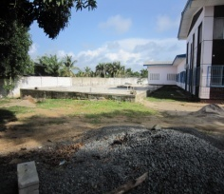
Monrovia Program auditorium project
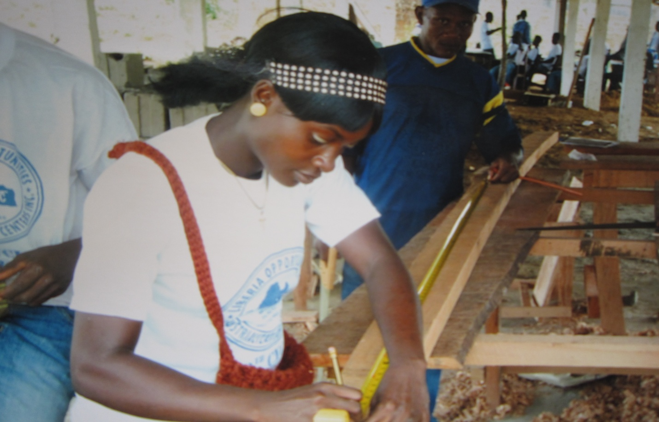

L
OIC believes that before you can produce a good skilled workman, you must first produce a good man. The trainee must believe in his own worth and possibilities and must view his or her future with reasonable optimism and social awareness.

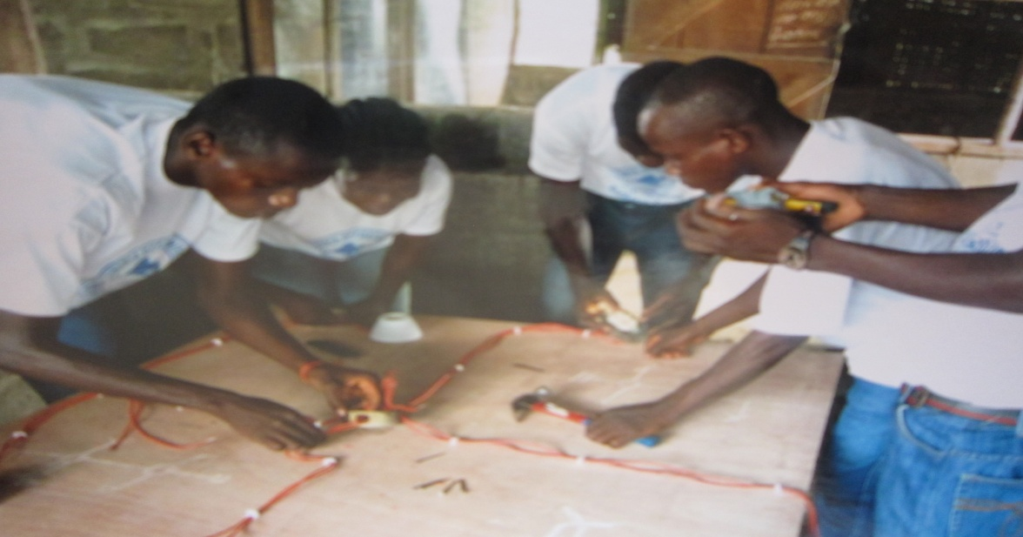

CURRENT STATUS OF VARIOUS LOIC CENTERS

- HARPER TRAINING CENTER:

The Harper Center was located in a building donated by the community and has been closed since 2001 due to financial constraints. The center was previously funded by USAID and can accommodate 200 trainees.

- TUBMANBURG TRAINING CENTER;

The Tubmanburg Center was located in a building donated by the community and the center has been closed since 2008. The center was previously funded by UNDP and the European Commission for the training and rehabilitation of former combatants of the Liberian civil war.

MONROVIA TRAINING CENTER

- The Monrovia Vocational Training Center located in New Matadi, Monrovia is situated on 3.5 acres of land provided by the Government of Liberia through the National Housing Authority. The facility was constructed by the United States Agency for International Development (USAID). The Monrovia Center was established in April 1984 as a model program for the implementation of vocational skills training activities in the Monrovia area by the LOIC Board of Directors and has successfully worked with many local and international partners to provide skills training and psycho-social services to disadvantaged youth. Currently, the center has an enrolment of 360 trainees and is being funded by the Government of Liberia.

- SINJE AND GBARNGA TRAINING CENTERS:

A total of 230 trainees completed studies in 2012 from these two centers in various agro-based vocational trade areas. Additionally, 248 trainees are currently enrolled at Sinje and Gbarnga. The center in Gbarnga was established in 1997 with funds from EED and is being operated at a facility donated by the community. However, as this is a permanent program, a facility is currently under construction at the site donated by the community on the Gbarnga - Ganta highway. Unlike Gbarnga, Sinje Program is operating at its own permanent facility. The center was established in 1998.

- GANTA TRAINING CENTER:

A pilot project sponsored by ICCO/Kirkinactie of the Netherlands, is being implemented by LOIC graduates of Ganta Training Center. The training facility was established in 1997 on 10 acres of land with funds provided by USAID. Following years of operations, the center was severely destroyed in 2007 by a thunderstorm.
However, some renovation work was done and training activities are being conducted at low capacity due to insufficient funding. The center can accommodate approximately 250 trainees at full capacity.

- ZWEDRU AND RIVER GEE TRAINING CENTERS:

In collaboration with OIC International, the Liberia OIC is currently engaged in the implementation of OICI/USAID HANDS Program in Grand Gedeh and River Gee Counties. The program aims at reducing food insecurity in the two counties is being implemented for five (5) years, June 2010 to May 31, 2015, targeting 304,589 beneficiaries.

- FOYA CENTER:

The LOIC Young Farmers Training Center is a permanent facility established in 1983 and has been shut down since 2008 following the termination of a grant from UNHCR to train Liberian returnees from Guinea and Sierra Leone. The Building located on eight acres of land, was constructed by funds provided by EED of the Federal Republic of Germany. It was destroyed during the war but was renovated twice; the most recent being in 2008 when training was conducted for returnees and IDPs. The people of Foya donated 900 acres of land in 1984 through Chief Tamba Taylor, to be utilized for the support of this center but the lacked of funds to develop the land had been a major handicap. The facilitate can accommodate 300 trainees.

- BOPOLU TRAINING CENTER

This center is a permanent facility constructed by LOIC with some funding from UNHCR. Since 2008, there had been no major activity taking place at the center by LOIC. The facility can accommodate 250 trainees.

- BUCHANAN TRAINING CENTER;

The Buchanan Training center was established in 1995 with funding from EED of the Federal Republic of Germany. The center is a permanent facility constructed by LOIC on a self-help basis. It is located on a parcel of land (8 acres) and last conducted training in early 2011 but was shut down following the expiration of the grant from EED. Currently, funding is being sought from the Chevron Oil Company in order to reactivate the center which activity is to commence early January 2013.

F
inally, as we conclude this report, it is our fervent hope that by timely sacrifices during FY 2013, LOIC will bring more comfort to the saddened, opportunities to the destitute and under-privileged, in order to improve their livelihood.

