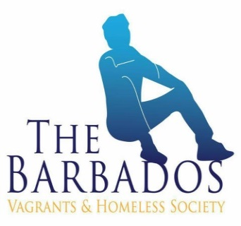

BVHS “AT THE CROSSROAD & AFTER-CARE” PROJECT PROPOSAL
THE BARBAOS VAGRANTS & HOMELESS SOCIETY
[Barbados]
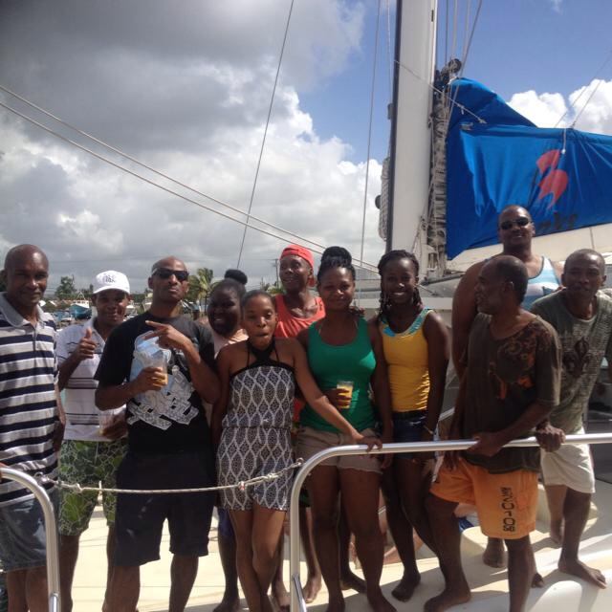

I. PROJECT PROPOSAL COVER SHEET
Project No.
Project Title: Comprehensive proposal plan of overall project

Contact Information
Name of Organization: The Barbados Vagrants & Homeless Society
Mailing Address: 62A Tudor Street, Bridgetown, St. Michael
Telephone: 434-2480
Email: bvhscare@gmail.com
Principal Officer: Mr. Kemar Saffrey Chairman/President
Project Contact: Ms. Leslyn Cummins

Projects
Projects Category
At the Crossroad (ATC)
This programme focuses on vagrants and persons who are living on the streets for over 1 year.

Proposed Starting Date: January 1st 2015
Proposed Project Duration: 12 months

Banking information
Please see below the organizations banking details:

Account Name : The Barbados Vagrants & Homeless Society
Account Number: 0009011389
Bank Name: Bank of Nova Scotia
Bank Address: Lower Board Street Bridgetown Barbados

Account Name : The Barbados Vagrants & Homeless Society
Account Number: 1001094340
Bank Name: FCIB/CIBC
Bank Address: Board Street Bridgetown Barbados

Contents
I. PROJECT PROPOSAL COVER SHEET i
Figures iii
Tables iii
Section A. 1
II. PROJECT PROPOSAL OUTLINE 1
1.1 Project Summary 1
1.2 Organizational Background 2
1.3 Project Objectives 2
1.4 Project Activities and Time Frame 4
1.5 Success of ATC 7
Section B 9
1.6 Evaluation Plan and Indicators 9
1.7 Sustainability 9
Section C 10
III. PROJECT BUDGET INFORMATION SHEET 10

Figures
Figure 1: Clients in the ATC programme 7
Figure 2: Stability of Graduates 8
Figure 3: Success Rate 8

Tables
Table 1: At the Cross Road Work Plan 5
Table 2: Rehabilitative Programme Targets 6
Table 3: Aftercare Housing Programme Targets 7

Section A.

PROJECT PROPOSAL OUTLINE

1.1 Project Summary
BVHS seeks to address the issue of vagrancy and homelessness in Barbados. The “At the Crossroads” (ATC) project is the vehicle that BVHS will be utilizing to realize this aspect of the organizational mission. As part of BVHS’ rehabilitation programme into society, the socialization and empowerment of participants will be of paramount importance to reduce recidivism. The focus will be on behavioural modification, so as to rehabilitate these persons, who are homeless and have found themselves without a purpose. Counselling will be provided in an effort to strengthen their capability to cope with life with a view to making them more empowered citizens. In previous cycles of this programme, more than 40 men have been reintegrated into mainstream society over the past 3 years. They have secured homes, jobs, bank accounts and have re-united with their families. The rehabilitative programme is comprised of individual, group and family counselling sessions, outings, mentorship and life skills and social skills classes. An aftercare programme is also proposed. The aftercare programme seeks to provide a stable environment, where participants will have the opportunity to sustain themselves and apply what they were taught in the ATC programme. The aftercare programme will provide housing to participants for six months. Participants will have more autonomy than if they were in the rehabilitative programme; where they will supervise themselves. They will have access to, group counselling, coping skills and social classes. The programme will be monitored by the case manager and a summative evaluation will also be done. The overall programmes will be sustained by collaborating with various organisations and communities to provide financial resources, food, clothing and other necessities. While BVHS will contribute to the funding of the programme by selling produce reaped from its farming programme.

1.2 Organizational Background
The Barbados Vagrants and Homeless Society (BVHS) is a charitable organisation which provides services to vagrants and homeless persons in Barbados. The organisation was officially launched on February 20, 2010 but has been operational since 2008. The mission of BVHS is “to re-integrate vagrants and homeless persons into mainstream Barbadian society by providing a holistic rehabilitative housing programme that would enable them to develop into healthy productive citizens. The organisation has managed the following programmes successfully: At the Crossroad (ATC), Direct Care Ministries, (DCM), On the Road Ministries (ORM), Life Opportunity Superseding Tomorrow (LOST), Adopt the Homeless (AH), Community Management Programme (CMP), Temporary Night Shelter, Meal a Day (MAD) and a daily Breakfast programme. These programmes provide food (hampers), clothing, counselling, hair-cuts, temporary shelter, jobs, farming, beneficial rehabilitative homecare housing and life skills to the homeless and vagrant persons across Barbados. Consequently, the organisation has successfully re-integrated 78% of ACT programme participants into society, while 22% of individuals reverted back to living on the streets.

BVHS is governed by a Board of members, trustees and managed on a daily basis by the president/founder Mr. Kemar Saffrey with six full- time staff members. The organisation also has a cadre of volunteers who assist with activities in the various programmes it undertakes.

1.3 Project Objectives
Barbados as a country has sought to maintain an acceptable standard of living for its citizens through a number of social programmes as it works towards achieving the millennium development goal (MDG) of eradicating poverty. Nonetheless, the country still experiences pockets of poverty and indigence. To combat this, the country has pursued a number of poverty alleviation programmes, among them National Assistance and Relief-in-Kind Programmes. However, these programmes do not adequately service the needs of those who are vagrant or homeless. Consequently, BVHS seeks to address the issue of vagrancy and homelessness in Barbados. With the assistance of individuals and civil society, the organisation has implemented measures which fill these gaps in the delivery of services to these vulnerable persons.
ATC is a home care rehabilitative programme which seeks to empower and motivate individuals towards positive change; so that they will gain insight into the possibilities that can exist for their future. The aim of the programme is to provide vagrants and homeless persons with the necessary life tools to re-enter mainstream society. Behaviour modification techniques will be used to rehabilitate the participants. The programme will provide participants with housing, food, money management sessions, individual, group and family counselling, mentorship and job opportunities. Individual and group counselling will allow participants the opportunity to develop coping skills. While the family sessions will seek to reunite the programme participants with their families. Each participant will be assigned a mentor, who provides on-going support. It is expected that this programme will aid in reducing the number of vagrants and homeless in Bridgetown.
AFTER-CARE
Additionally, it is proposed that the programme will include a six month aftercare programme. This component was conceptualized because some of the participants were repeating the ATC programme. In some instances, six-months of rehabilitation were inefficient for some of the participants to rehabilitate. Some clients returned to using alcohol and drugs after the completion of the programme. The aftercare programme is a follow-up programme which seeks to prevent recidivism among ATC participants. In a stable environment, the programme will afford participants the opportunity to sustain their selves and apply what they were taught in the ATC programme. The aftercare programme will provide housing to participants for six months. Participants will have more autonomy than if they were in the rehabilitative programme; where they will supervise themselves. They will have access to individual counselling, group counselling and other helpful classes.
Thus, the programme objectives are as follows:
- To introduce and rehabilitate 24 persons through the ATC programme over a 1 year period by procuring housing for 24 participants.
- To assist participants with the development of coping, social and life skills by providing bi-weekly individual counselling sessions over a period to 6 months period.
- To assist participants reunite with family by providing family counselling sessions over a period of three months.
- To provide participants with on-going support by assigning each client with a mentor.
- To provide participants with a six month aftercare programme this will help to reduce recidivism.

1.4 Project Activities and Time Frame
The work plan gives details of the organizational arrangements. It illustrates programme activities, persons responsible and timeline for the activities (see Table 1,Table 2 and Table 3). In the initial phases of the project, technical assistance will be provided from various stakeholders. Listed below are the technical persons and the task they will perform during the programme:
- A steering committee has been formed to guide the work of the project. The committee is comprised of experts from various sectors in society and Government. The committee will meet regularly to review the milestones as set out in the work plan of the project.
- A full time project manager will liaise with the president and the steering committee. The president will supervise the daily work of the project manager and will be providing guidance as directed by the board of members and trustees.
- Public relations will be the responsibility of Veoma Ali and Co., the president and the management team.
- Financial matters will be supervised by the Kirk Smith Consultancy and audited by Ernst & Young.
- Negotiations will be the responsibility of the president assisted by the Kirk Smith Consultancy and the project manager.

At the Cross Road Work Plan
BVHS Focal Area: |  | BVHS Operational Phase: 7 |  |  |  | Project Start and End Dates: January 1st
Activities list with responsible persons |  |  | Activity chart for October to September
Activity | Responsible Party | Indicator | 1J | 2F | 3M | 4A | 5M | 6J | 7J | 8A | 9S | 10O | 11N | 12D
1.1 | Volunteers and Co. | Training of clients
1.2 | Qualified counsellors & psychologist | Personal counselling sessions
1.3 | Counsellors | Coping skills
1.4 | Counsellors | Family counselling sessions
1.5 | Counsellors | Church Educational Programme
1.6 | Tour companies | Educational tours
1.7 | Counsellors | Anger & Conflict management
1.8 | Volunteers | Maths & English Classes
1.9 | Psychiatric hospital | Conduct baseline assessments
1.10 | Counsellors | Group/Indivi-dual Counselling
1.11 | Businessmen, family | Attachment to mentors
1.12 | Counsellors | Family Counselling Sessions
1.13 | Qualified accountant volunteers. | Financial Management and Motivational session
1.14 | Kirk Smith Consultant Co. | Budget monitoring and preparation
Indicate Person responsible for Monitoring and progress reports: Mrs. Kimberley Harewood |  |  | Monitoring Frequency / Reporting
Monitoring and Record keeping | Case Manager
Progress Reports: Case Manager & Counsellors
Table 1: At the Cross Road Work Plan

ATC Targets for the Rehabiliative Programme

TARGETS | April to September | January to June | July to December
Introduce 24 persons to the ATC programme over a one year period. | 8 clients will be introduced to the programme. ON-GOING | 6 clients will be introduced to the programme. | 6 clients will be introduced to the programme
Provide bi-weekly individual counselling sessions for 24 men. | 8 clients would have successfully undergone group and individual counselling. ON-GOING | 6 clients will be introduced to the programme. | 6 clients will be introduced to the programme
Provide bi-weekly family counselling sessions for 24 men. | This will take place in the final three months of the programme. Clients will connect with their families in a safe environment. ON-GOING | 6 clients to be provided with counselling | 6 clients to be provided with counselling
Procure housing for 24 participants in the programme. | 8 participants to receive housing by September 2014. ON-GOING | 6 participants to receive housing by early June 2015. | 6 participants to receive housing by early December 2015.
Provide mentorship programme for the 24 participants. | 6 participants to receive housing by August 2015 ON-GOING s. | 6 participants to receive housing by May 2015 | 6 participants to receive housing by November 2015
Table 2: Rehabilitative Programme Targets

AFTERCARE HOUSING PROGRAMME TARGETS
TARGETS | January to June | July to December
Reduce recidivism of ATC participants. | 6 clients will be introduced to the programme. | 6 clients will be introduced to the programme
Provide continuous coping skills. | 6 people will be reached. | 6 people will be reached.
Provide continuous drug group counselling. | 6 people will be reached. | 6 people will be reached.
Provide continuous work on BVHS farm until employment is found. | 6 clients will be reached. | 6 clients will be reached.
Provide family re-unite programme. | 6 clients will be reached. | 6 clients will be reached.
Table 3: Aftercare Housing Programme Targets

1.5 Success of ATC
There were a number of highlights throughout the years in the programme. The organisation excelled in the number of persons assisted and successfully completed ATC. Clyde Mayers, Kemar Chase and Mark Gill were among some of the participants who completed successfully in the rehabilitative programme. These clients were provided with employment and are still working. They also reunited with their families. The organisation used recreational activities for these men such as educational tours every 2 weeks. Some of the attractions they visited were the Barbados Museum, Atlantic Submarine, Farley Hill and the Barbados Horticultural Society. BVHS also hosted a number of awareness activities, where clients spoke about their past experiences on the streets to audiences at the University of the West Indies and HM Dodds, also as mentioned in the previous report. BVHS staff has grown and has continually contributed to the success of these men. To mention one person in particular, Mrs. Kimberly Harewood, case manager. Mrs. Harewood has worked tirelessly with every client to make sure they reach their goals. She has competently worked to provide services to her clients. She worked with a team of case manager assistant, counsellors, teacher, mentors, motivational speakers. Some clientshave stated that she was very compassionate towards them. Mrs. Harewood is the most valuable asset to BVHS.
The charts below shows that since BVHS started the ATC home-care rehabilitation programme, that 78% of its participants have successfully completed. However, 22% of participants have reverted to their previous lifestyles. 94% of graduates remained stable after the completion of the programme.
Figure 1: Clients in the ATC programme

Figure 2: Stability of Graduates

Figure 3: Success Rate

1.6 Evaluation Plan and Indicators
A summative evaluation will be completed at the end of 2015 to determine whether the programme objectives were met and how satisfied were participants with the programme. The programme will be monitored by the case manager and counsellors.

1.7 Sustainability
In order to maintain the sustainability of the programme, BVHS has proposed the following measures:
- Collaborate with the hotel sector to supply food
- Acquire financial support to offset cost
- Obtain monthly sponsorship of food, clothing and other essentials
- Utilise the income generated from the farming programme
- Seek Government, Corporate and Covenant Funding
- BWU Credit Union, FCIB/CIBC dollar drive (predicting to raise $20,000.00 monthly)
- Seek grants from regional and international countries/UNDP/IADB/IDB etc.
- Thrift shops
- Fundraisers

