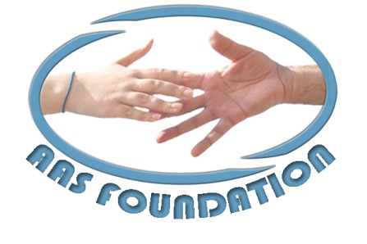

|  |
| --- |
| AAS FOUNDATION |
|  |

**INSTITUTIONAL PROFILE**

**November**

**2011**

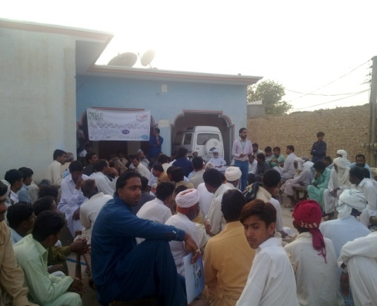

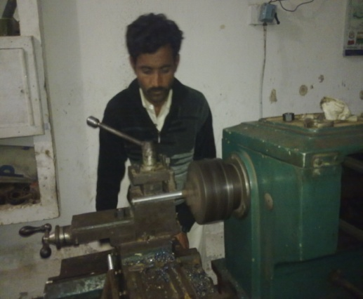

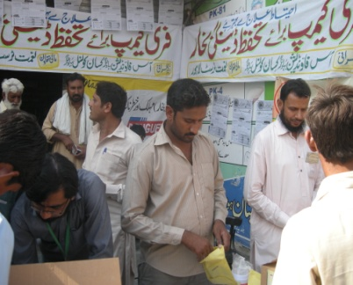

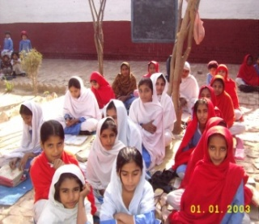

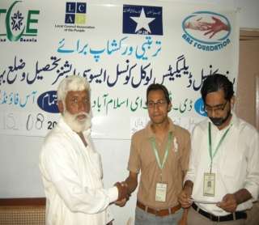

***Bahawalnagar Tehsil & District. Bahawalnagar***

***Ph: 92 63 2277488, Email: aasfoundationpk@gmail.com***

**Acronyms**

VDP Village Development Partnership

VDB Village Development Bank

PDI Population and Development International

CO Community Organization

VDO Village Development Organization

CHC Community Health Center

VSDC Village Social Development Committee

VADC Village Agriculture Development Committee

VHC Village Health Council

VEC Village Education Committee

VYC Village Youth Council

LCA Local Council Association

CPI Community Physical Infrastructure

PPI Progress out of Poverty Index

KC Kisan Council

**Contents**

# Inception 4

# Vision 5

# Mission 5

# Objectives 5

1. AAS Foundation Core Values 5
2. Running programs 5

# Program Execution Methodology 6

## A. Model of VDP 7

## 8. Social Development 8

### 8.1 Economic Development 8

### 8.2 Community Physical Infrastructure (CPI) 9

## 8.3 Environment 9

## 8.4 Health 10

## 8.4.1 Health Micro Insurance Scheme for poor 10

## Education 10

# 9. Core Departments 11

* 1. Human Resource and Administration Departments 11
  2. Evaluation Research and Development (ERD) Unit 11
  3. Finance and Accounts 12

10. Core Team 13

11. Consulting Services 13

# 12. Support/Partner Organization and Networks 15

13. Governance and Management 16

14. Management Structure 17

15. Achievement at a Glance 18

# 1. Inception

Pakistan is a developing country and rich in human and natural resources. Pakistan’s economy is agriculture based and contribution of agriculture sector towards GDP is 21.6% and employees more than 50% of the civilian labor force (GOP) 2010. This population is living in rural areas and works in fields without having basic facilities, especially rural women are more marginalized and vulnerable. Although, Government planned different development plans and implemented but poverty increased day by day. Because of improper planning, undemocratic governments, neighboring countries destabilized the peace processes, heavy defense budgets and feudal systems.

Civil Society play an important role in the development of country and help the public and private sector to implement policies according to the demands by the communities. Furthermore, it helps governments in public policy making and development of country.

These third sector development organizations played an important role in the development of country and supported governments in poverty alleviation. Many volunteers and development activists at organizational or individual capacities are struggling to change the lives of poor in urban and rural areas.

In 2004, a group of development activists formed an organization named as “AAS Foundation” in District Bahawalnagar of the Southern Punjab and started activities to solve the problems.

AAS Foundation is founded in 2004 under Societies Registration Act 1860. AAS Foundation is first organization that implementing a unique and innovative integrated rural development model in district Bahawalnagar, of the Southern Punjab, Pakistan. The organization’s programs are based on the belief that local people are best suited to shape and sustain their own development. AAS Foundation is a grassroots growth that is marked by extensive villager involvement not only as beneficiaries, but also as planners, managers, and leaders.

Since that initial focus on social development through village development organization (VDO), AAS Foundation’s programs now encompass a variety of development sectors such as integrated rural development, community physical infrastructure, local institution building, education and health services, income generation and occupational training, and forestry and environmental conservation. AAS Foundation has established itself as an innovative and effective development NGO with an integrated development approach.

The development of a nation can be achieved only when the quality of life for all rural people of the country is improved to an adequate standard. One of AAS Foundation’s prime tenets is that the community as a whole, in all sectors of society - private, public, and non-profit - can join together in a new push for social improvement. AAS Foundation is proud to have contributed to improving the standard and quality of life in District Bahawalnagar with its limited resources; however, we endeavor to continue our struggle in rural areas where government efforts at the local and national levels have not yet been able to effectively address a growing disparity in quality of life.

# 2. Our Vision

A socially, economically, and politically sustainable peaceful society, where all its citizens avail their potential and opportunities on equal basis

# 3. Mission

To organize the communities for address their economical, social, political and environmental issues and challenges, to build a better and prosperous future

# 4. Objectives

* Social Mobilization and awareness rising, a tool for community organization.
* To provide microfinance services, including lending, savings, insurance and transformational training, to people in need for economic uplifting
* To provide better livelihood enhancement opportunities to the neglected and marginalized rural communities
* Awareness campaigns and networking to save environmental contamination
* Improve the human and technical capabilities of the poor through certain capacity building initiatives
* To contribute to strengthening the social and physical infrastructure
* Women empowerment through their increase access to better health and education facilities
* Initiate, establish and participate in collaborative advocacy and other activities with like-minded organizations in and outside the country

**5. Core Values**

**We believe in:**

* Team orientation & team work
* Respects individual strengths and diversity
* Learning, adapting and growing
* Being part of the solution not of the problem
* Partners satisfaction
* Empowerment of its employees

# Development of marginalize and deprived communities especially in the rural areas through integrated development approach

**6. Running Programs Under Village Development Partnership (VDP) Model**

AAS Foundation majorly addresses issues in the seven development areas under Village Development Partnership (VDP) model:

* Social Mobilization
* Local Council Association, Union Council Extension Plan
* Islamic Microfinance (Qarz-e-Hasna)
* Modern Agriculture & Livestock Development through Kisan Council
* VDO Saving under Village Development Bank
* VDO base Physical Infrastructure
* Community model girls primary school
* VDO Dispensary
* Community Capacity Building and trainings
* Technical Training through skill development center (male and female)
* Dengue Fever Awareness Campaigns
* Advocacy and Linkages Development

# 7. Program Execution Methodology

**Phase I: Institutional Development and Planning**:

* Area Identification
* Base Line Survey/Village Profile/Poverty Profile
* Dialogues and Meetings
* Building a common understanding
* Forming the Village Development Organization (VDO)
* Training workshop of VDO
* Community Needs Assessment (CNA) and Preliminary Planning
* Eye-opener Trip
* Finalizing Village Development Plan
* Submitting Development Plan

**Phase II: Implementation of Development Activities**:

* Saving, microcredit or grant through establishment of the Village Development Bank (VDB)
* Local Council Association (LCA)
* Islamic Microfinance (Qarz-e-Hasna)
* Small scale physical infrastructure development
* Agriculture and livestock development
* Health and education
* Skill center
* Environment and youth promotion

**Phase III: Monitoring and Evaluation**

* Regular 15 days meetings with CO/VDO
* Regular Monitoring System
* Effective Daily Reporting Mechanism
* Effective Programmatic Documentation
* Case studies development
* Impact studies

**Village Development Partnership (VDP) Model**

* One Village Development Organization will be formed at village level
* These will represent the 75% population (Castes) of the village
* These will have President, Manager and Secretary besides the members
* VDO consist of seven committees including:
  + Village Development Bank (VDB)
  + Village Social Development Committee (VSDC)
  + Village Agriculture Development Committee (VADC)
  + Village Health Council (VHC)
  + Village Education Council (VEC)
  + Village Environment Council (VEC)
  + Village Youth Committee (VYC)

Every development committee has its own roles and responsibilities

# 8. Baseline Survey (Poverty Profile)

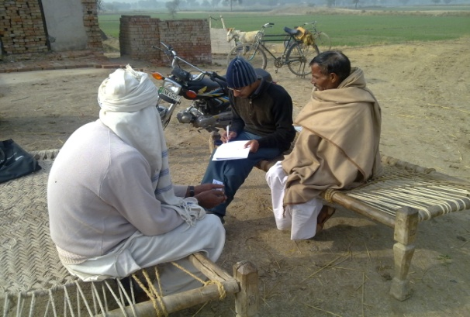

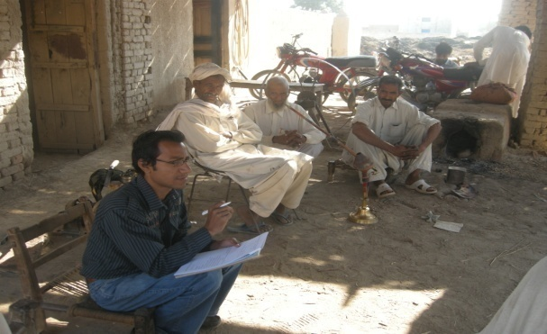A baseline study simply defines the 'pre-operation exposure' condition for the set of indicators that will be used to assess achievement of the outcomes and impact expressed in the program's logical framework. When compared with the condition of the same indicators at some point during implementation (mid-term evaluation) and post-operation implementation (final evaluation), the baseline study forms the basis for a 'before and after' assessment or a 'change over time' assessment. Without baseline data to establish pre-operation conditions for outcome and impact indicators it is difficult to establish whether change at the outcome level has in fact occurred.

Baseline Study in a core and basic component of organization for analyze and identify the actual condition of the community. The organization is currently conducting baseline study in two union council of tehsil Bahawalnagar through Poverty Profile to identify the neglected, destitute and poorest of the poor (widows, orphans) community the union councils.

# 8.1 Social Development: Community Empowerment through Social Mobilization

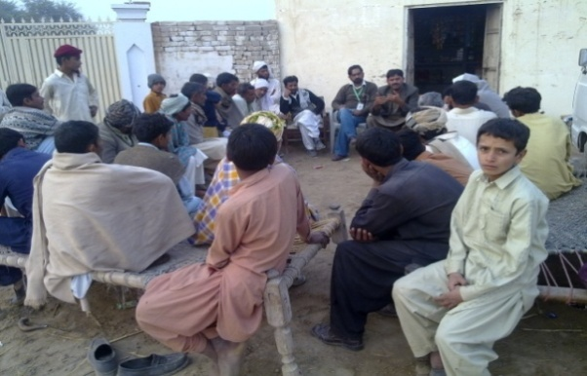Through its experience in rural development, AAS Foundation has learned that effective and sustainable poverty reduction programs must begin through the engagement of the involved communities. Communities must have full ownership and have every opportunity to participate in the planning and implementation of development projects; AAS Foundation’s role is to guide villagers in how to articulate their needs.

The organization effectively creates this engagement by helping the community establish an elected Village Development Organization (VDO) at the very beginning of the process. The election ensures that the whole village community participates and takes ownership for the project right from the start. The elected individuals generally come from various backgrounds and act as representatives, allowing every villager to articulate his/her needs. The Village Development Organization consists of one or more community organizations (COs) which represent whole village.

Villagers are involved at every step of the development. They are responsible for carrying out their own Community Needs Assessment and for generating ideas. This is effective as the villagers know their specific needs better than AAS Foundation or the sponsoring partners. Every rural community exists within different surroundings and different circumstances. This means that while the general areas of development (e.g. economic, physical infrastructure, health, education, and environment) are consistent from village to village, the particular needs and priorities of each community are unique and the organization’s process must be tailored accordingly.

Village meeting

# Economic Development: Saving mobilization, Providing Credit & Business Skills

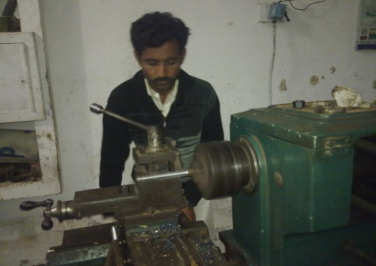Many poorer villagers do not own land and therefore do not have collateral for credit. The lack of access to credit at the village level is a significant inhibitor to the ability to increase income. This can deny individuals the opportunity to borrow money at market rates to begin and/or expand business activities. Borrowing through existing informal channels can often only be done at exorbitant interest rates, resulting in restrictive loan repayments.

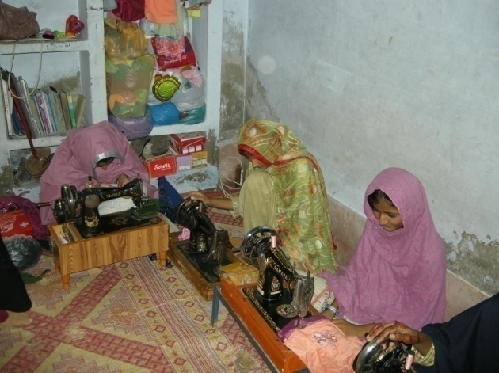A central component of the model is the Village Development Bank (VDB). It is an important source of credit for income generation activities as well as a system that encourages the practice of saving. The initial capital for the bank is established through the community regular compulsory saving, whereby funds from the partner are contributed as capital for the VDB.

The communal nature of the bank means that all villagers have the opportunity to benefit. Default on repayments is often lower than in conventional systems since there are social pressures that arise from depriving fellow community members of the right to borrow, as well as personal “face and image” issues. In many existing VDPs, community savings quickly exceed the initial capital with which the VDB was started, indicating the success the program has had in changing villagers’ saving behaviors.

AAS staff also provides villagers with basic business skills training, and we encourage partners to share their expertise, skills, and advice, to help villagers ensure that their micro-businesses are a success.

# Islamic Microfinance Program

Islamic Microfinance is a development tool to involve communities in positive change and uplift the community. Commercial Banks and MFIs are providing loans with highly mark up rate and access of rural and semi urban poor are a minimum level because of difficult processes. Literacy rate in rural areas is also low and people avoid time taking processes. Islamic Microfinance institutions (IMFIs) were established to fill gaps and providing access the poor to avail credit opportunities with no interest for real development. AAS Foundation started Islamic Microfinance Operations with the financial support of his board members; AAS Foundation is providing Qarz-e-Hasna to small farmers and rural entrepreneurs for livestock, agriculture development, and crop production and enterprise development.

AAS Foundation providing microfinance facility by developing different products based on the community demands. These products are:

Products of Islamic Microfinance Program

* Qarz-e-Hasna
* Client Death Coverage
* Trainings & Capacity Building
* Social Development package

Capacity development is a competitive edge to the development sector organizations. In microfinance program a comprehensive training program exists at different levels to build the capacities of community groups for effective utilization to resources and increases in their production. Groups meetings are also a major aspect in which field teams hold sessions on social development issues to further strengthen group cohesion and social harmony.

Specific to microfinance program, AAS Foundation has provided the credit of Rs. 1.1 million to 110 beneficiaries. The Islamic Microfinance program is being executed in district Bahawalnagar.

# VDO base Community Physical Infrastructure (CPI)

The organization strives to develop the small scale physical infrastructure through the regular saving of CO/VDO and by line agency like Agriculture Department, Water Management and Punjab Irrigation and Drainage Authority (PIDA).Some CO/VDO small scale physical development initiative for their rural village. The small scale physical infrastructure development will leads the water course lining, small bridges, and sewerage and sanitation system. This type of small physical infrastructure development project has been implemented 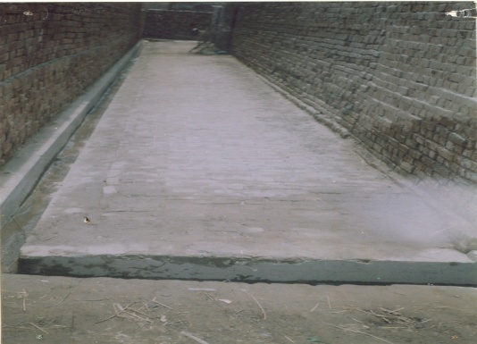with the saving of CO/VDO and with the coordination of line agencies. The Bahawalnagar district was called the 'land of princes' once upon a time, but now a day, due to its politicians negligence and disinterested attitude, it is considered as a backward district of Punjab Province. The politicians did not contribute in the development of this area.

**Soling and Sanitation**

# Sustainable Agriculture Development through Bio-Technology

Since 2010, the organization got experienced of sustainable agriculture development through Bio-Technology with the coordination of “The First Biotechnology Company” limited. The experienced was very successive and its results was very fruitful for small as for as big farmers. Through this technology, the farmers get maximum crops in sugar and cotton as compared to traditional agriculture. In 2011, the organization has established 60 model farm of rice in tehsil Bahawalnagar. So that the production of rice will be get maximum in very cheap cost. Furthermore, Bio-Technology is also support the agriculture land in the form of bacteria and also further fertile the agriculture land.

# Environment

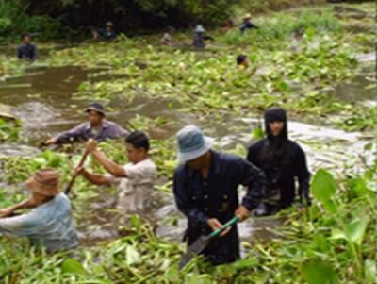The integrated model strives to enforce a culture of self-sufficiency and environmental sustainability amongst its partnered villages. The organization will build sanitary latrines, canal recovery, waste collection and garbage recycling, bio-diesel production and building of piped water systems. These activities will beneficial to the local ecosystem as well as for the villagers.

This is a flexible model which allows the inclusion of environmental community activities, as well as green income generating initiatives, that focus on ways to improve the local environment while simultaneously being helpful to the general health and well-being of the partnered villages.

# Health

Health is still a major concern in rural areas. In 2010, AAS Foundation carried out a baseline survey in 7 rural villages / bastti in district Bahawalnagar and found that the majority of children 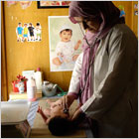had health problems including dental problems, lice, or malnutrition. Activities carried out as part of the baseline study for analyze the situation of medical care facilities in the respective union council. If communities with the target area have any prevalent medical problems, such as HIV/AIDS, diabetes, or hypertension, skin disease or other waterborne disease, in this situation, the organization will establish a community health center (CHC), with the financial support of VDO and organization.

# Health Micro Insurance Scheme for the Poor

One of the most practical problems one can face while implementing a user fee-based healthcare service to the [community](http://www.fundsforngos.org/tag/community) is that many [poor](http://www.fundsforngos.org/development-dictionary/poverty/) people would seek healthcare in credit because they will not have cash to pay, despite the lowest price offered to them. To counter such a situation, the organization will introduce a [micro insurance](http://www.fundsforngos.org/development-dictionary/what-is-microinsurance/) scheme where the poor are mobilized to save money to cover their [health](http://www.fundsforngos.org/tag/health) expenses.

The scheme will cover simple health problems like diarrhea, anemia, malnutrition and small injuries can be part of the micro insurance program because in this way, there is no need a full-time doctor to treat them; a qualified VDO member can manage recovery for these problems. It can be publicized within the other community that the AAS Foundation would cover treatment costs to such problems for those who would contribute small sums of money regularly to the scheme. In the long-term, when the number of micro insurance users increases, the organization can gain to have some income from this program.

# Dengue Fever Awareness Campaign

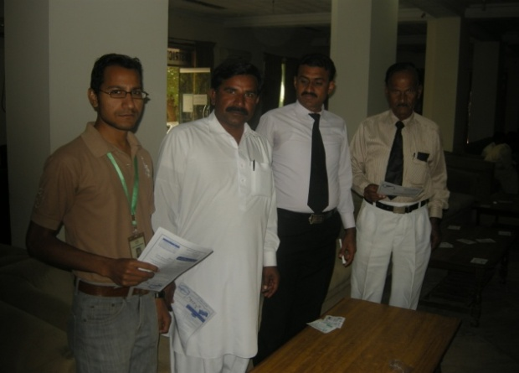Nearly 75% of all dengue cases worldwide occur in Asia and the Pacific. This threat has been recognized by countries throughout the region that have taken action to protect their populations. National leaders also have acknowledged that they must act regionally in order to protect people within their own borders.

The dengue epidemic has affected many areas of Pakistan. The condition is getting worse and large numbers of cases are reported on daily basis. The Government of Pakistan is making all possible efforts to tackle the situation. Lack of awareness about the disease has caused great fear and uproar amongst the people.

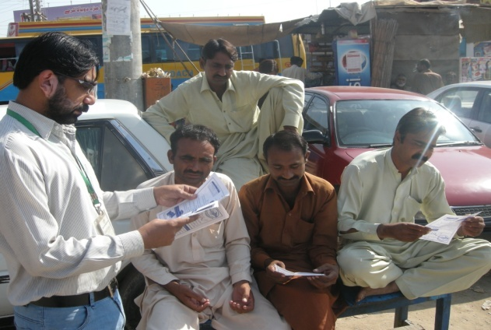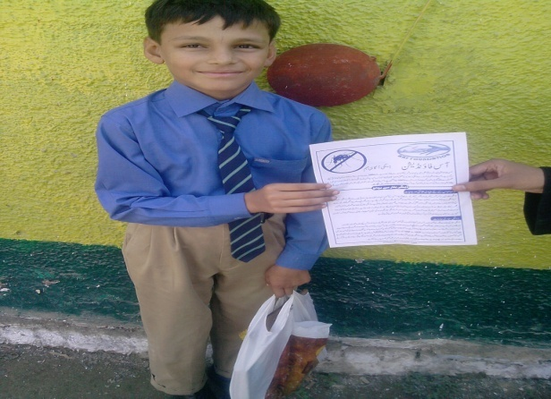Keeping in view the emergence and spread of Dengue fever and subsequent fright among people, AAS FOUNDATION and, Naziran Yousaf Memorial Trust, for emergency response and preparedness, has initiated a month long social mobilization campaign for the prevention and cure of Dengue from 15th September till 15th October 2011 in Bahawalnagar District covering rural and urban areas. The major focus is to benefit the vulnerable people especially slum areas.

The campaign aims to contribute in awareness generation about the precautionary and preventive measures among masses, reduction in new incidence of Dengue fever and also to create responsibility in the community to maintain clean and Dengue-free environment through social mobilization efforts. The organization has distributed the Dengue Awareness on the following places:

* Key points on roads
* In Schools
* In District Bar
* In Rural areas
* In Free Dengue Camp

# Dengue Fever Free Medical Camps

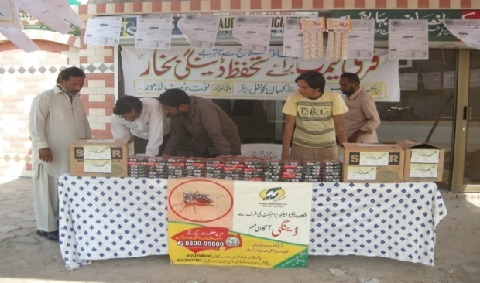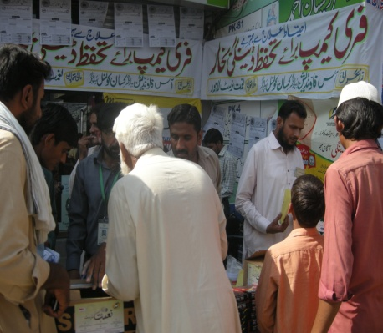AAS FOUNDATION has distributed approximately 4,000 Brochures containing basic information on dengue and its prevention on busy roads/squires, markets and public places, schools and District Bar to reach common people. More than 6000 people benefitted from the AAS FOUNDATION awareness campaign approximately. Two of the forces driving regional preparedness for health threats such as dengue are the AAS FOUNDATION Bahawalnagar and NAYMET Trust Lahore.

The AAS FOUNDATION has developed a powerful partnership with the NAYMET Trust in an effort to achieve a shared goal: a healthy and secure population. The organization has distributed the following items for prevention of Dengue fever in Bahawalnagar:

1. Awareness materials Broachers/Pamphlets

2. Paracetamol Tablets

3. Mosquito Coils

14. Lotions/creams for dengue

# Kisan Council

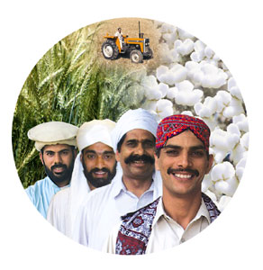Pakistan’s economy is agriculture based and contribution of agriculture sector towards GDP is 21.6% and employees more than 50% of the civilian labor force (GOP) 2010. In the past, various governments initiated many projects / programs to strengthen the agricultural sector and as a result of these initiatives, agricultural production increased many folds. However, due to lack of access to market information, inadequate post harvest processing facilities (such as grading, preservation, use of produce for agri-based industrial or food products) and a few agribusiness opportunities have many times created glut-like situation causing loss to farmers or inadequate supplies forcing consumers to pay more for agricultural products. These situations have neither helped the farmers to improve their economic conditions nor the ultimate consumers to receive the standard grade supplies at reasonable and affordable price.

Kisan Coucnil is a plate form of small farmers. Kisan Council will address the issues and problems of farmers faced by line agencies, capacity building, and other market related problems. This plate form will provide opportunity to farmers to share their experiences with other farmers and learn the lesson to boost up their agriculture production

# Education

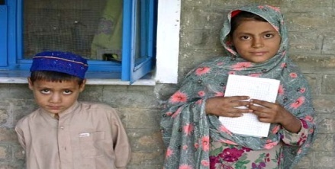As a community develops economically, one effect is an increase in the rate of primary school attendance. To keep pace with economic improvement in a community, the organization can target developmental programs related to education such as: improvement of local primary and secondary schools, scholarship for children from poor families, Information Technology training for children.

# Local Council Association (LCA)

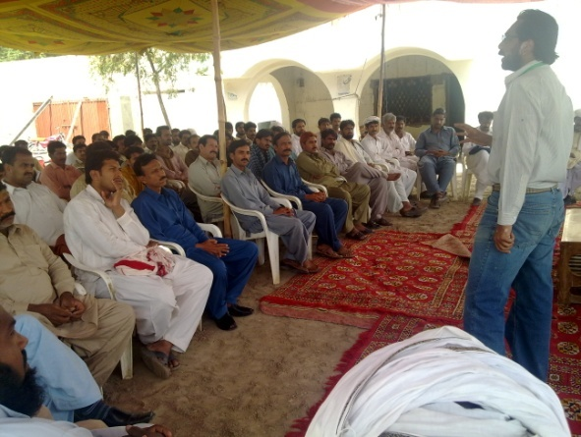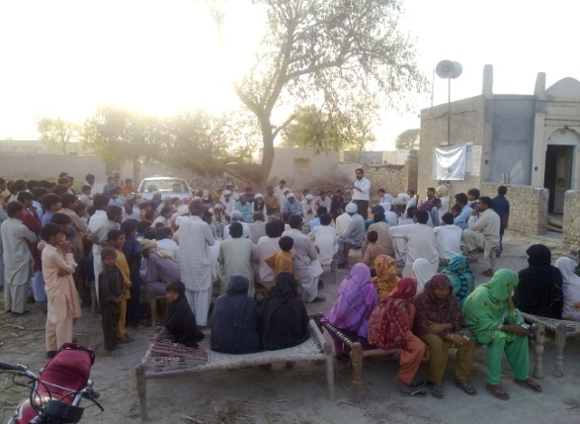A holistic strategy to organize the local council associations (LCAs) at each UC of tehsil Bahawalnagar through existing COs and VDOs. With the coordinated efforts of COs and VDOs, mass mobilization is aimed to attain the objective of 100 plus members in each UC, who whould be tasked to achieve the consensus-based formation of 17-members UC Delegates in eahc UC. The leadership of these delegates will be finalized by them again through a consensus based approach, having Chairman, Vice Chairman and Secretary for the each UC which will be called executive committee.

This formation process for the each UC whould be evolved from the active and vibrant youth, female activist and notables, through one day session at the UC level by inviting all categories noted below inclusding proactive citizenry representing most of the villages in the UC, while ensuring following major steps by the organization.

* To conduct mobilization and registration of membership in each village of the UC
* To conduct one-day gathering for consensus based formation of 17-members UC delegates, 3-members Executive Committee and registration of 100 plus General Body members.
* To ensure that during the one-day session is split into two parts, i.e, public gathering plus orientation of all 17-members UC Delegates specified capacity building, MoU, work Planning with the UC Delegates
* To collect data and added information for the dissemination on the same day and afterwards as well.
* To assist implementation and monitoring of UC Delegates quarterly work plan with the help of AAS Foundation

The basic objective to organizte the LCA is to resolve the UC level issues and problems with local resources.

# Capacity Building and trainings

Among the major reason of the rural population deprivations, lower level of awareness and consciousness and lack of trends of concerted thinking and action stand at the top of the list. They have a very little access to useful knowledge and information and that they seldom find 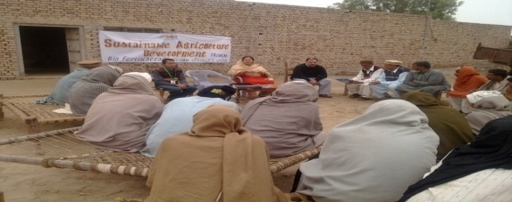chances of share their problems, issues and experiences with each other with a spirit to give them a permanent end. AAS Foundation besides incorporating other poverty reduction strategies focuses its prime attention on building capacities of the poor, developing an appropriate institutional infrastructure at grass root level, building networks at different levels and advocating for the rights of the people.

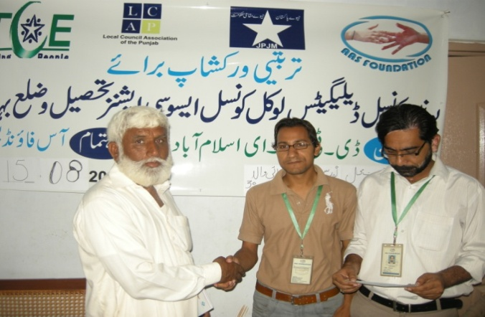Furthermore, the organization is capacitating the UC Delegates of LCAs with different trainings and capacity building initiatives for sustainable development at union council level. AAS Foundation has also disbursed grants of Rs. 7,500 with the coordination of DTCE for development purposes at union council level.

# 9. Core Departments

1. **Human Resource and Administration Departments**
2. **Evaluation Research & Development (ERD) Unit**
3. **Finance and Accounts**
4. **Human Resource and Administration Departments**

HR development play a pivotal role in further strengthens the organization. Organization can develop only if the existing human resources are optimally managed and capable to take challenging assignments. AAS Foundation incorporated HR and Admin Department to meet the future human needs and their development. HR and Admin department is fully functional and supporting the programs by providing professional HR and helping the existing to develop at the desired level.

HR and Admin Department provides strong coordination and ensures organization is functioning smoothly.

Presently, HR and Admin Department has following roles in the organization:

* + Ensures HR and Admin Policies and Procedures
  + Recruitment and Selection
  + Job Descriptions and Specifications
  + Periodic appraisals
  + Training Need Assessment
  + Staff Training and Development
  + Compensation System
  + Personnel files
  + Transportation
  + Support services

## Evaluation Research & Development (ERD) Unit

The core team of ERD unit and associates of the organization have carried out the following research projects and develop other documents for different programs.

|  |  |
| --- | --- |
| Baseline Surveys & Situational Analysis | AAS Foundation has conducted Baseline survey & Situational Analysis *“Socio-Economic Fact Findings and Scope for Micro financing, Agri Livestock Development, CPI, Health & Education, Livelihood and Environmental Promotion”* of district Bahawalnagar. |
| Monitoring Process | Monitoring Process for VDP Model:   * 1. Social Mobilization   2. Capacity Building   3. Village Development Bank (VDB)   4. Village Social Development Committee (VSDC)   5. Village Agriculture Development Committee (VADC)   6. Village Health Council (VHC)   7. Village Education Council (VEC)   8. Village Environment Committee (VEC)   9. Village Youth Committee (VYC) |
| Case Studies & Training Reports | 1. Case Studies on VDB 2. Case studies on VSDC 3. Case studies on VADC 4. Case studies on VHC 5. Case studies on VEC 6. Case studies on VYC |
| Templates/Documents Designed | 1. Community Organization Meeting Register 2. Record Keeping for Community Organization Expenses Register 3. VDO saving record 4. Planning and progress format of VDO 5. Branch/CO Level Projection Plan |
| Progress Reports/Statistical Updates | 1. AAS Foundation statistical brief for the Year 2010-11 2. AAS Foundation  Quantitative/Narrative QPR for different projects (MFP, Capacity Building, CPI, Health) 3. AAS Foundation Project updates |

**C. Finance and Accounts Department**

No organization can run with finance and accounts systems. AAS Foundation Finance and Accounts Department is function actively by providing day to day services, Furthermore the planning to ensure financial sustainability and effective reporting systems. AAS Foundation has developed Standard Operating Procedures for Finance and Accounts and strictly ensuring transparency in financial transactions.

The major functions of finance and accounts department is as follows:

* Financial resources are utilized in accordance with the approved Project Budget;
* Financial projections;
* Procurement;
* Evaluate quotations by vendors/contractors;
* Banking issues and transactions;
* Monitor and review the work program and budget by conducting regular and special reviews to assess progress of actual work versus the program plan;
* Cost effective utilization of program resources;
* Financial administration and management information issues and practices;
* Organizational legal financial matters, tax deduction, contracts and agreements, legal areas and activities,
* Budget analysis;
* Organize and release funds, financial processes and transactions in accordance with financial policies
* Cost-effectiveness of activities;
* Respond and follow up Books of Account enquiries according to policies and procedures
* Communicate, liaise, and negotiate internally and externally according to policies and procedures.

**10. Core Team**

|  |  |  |  |  |
| --- | --- | --- | --- | --- |
| **Nr** | **Name** | **Designation** | **No of years served** | **Qualification** |
| **1** | **Mr. Syed Mujahid Hussain** | **Chief Executive Officer** | **16** | **MA Political Science** |
| **2** | **Mr. Muhammad Qasim Qazi** | **Program Manager** | **6** | **MBA (Banking & Finance)** |
| **3** | **Mr. Aftab Mahmood** | **Project Coordinator** | **8** | **MA Economics** |
| **4** | **Mr. Usman Safdar** | **Finance Manager** | **7** | **MBA (Finance)** |
| **5** | **Ms. Shagufta Naz** | **Manager Admin** | **6** | **M.Sc (Psychology)** |
| **6** | **Ms. Mahwish Aqeel** | **Manager IT** | **5** | **MCS** |
| **7** | **Mr. Qamar uz Zaman** | **Manager ERD** | **4** | **MSC Economics** |

**11.** **Consulting Services**

**AAS Foundation profession has been providing expertise and consulting services in the following areas.**

* Field surveys, baseline and socio-economic surveys, health base line survey
* Project Planning
* Project Design
* Project Management
* TORs Development
* Identification of Performance Indicators
* Monitoring and Evaluation
* Capacity Building in Women Empowerment/Gender and Development
* Capacity Building of the Farmers Group
* Project Reviews
* Policy Analysis
* Advocacy
* Institutional Development
* Event Management-Training, Workshops and Conferences
* Organizational Development
* Change Management
* Staff Development
* Communication Strategy
* Awareness Campaign
* Social Mobilization and Community Participation
* Feasibility Studies

**Furthermore AAS Foundation has been providing consultancy to the following organizations:**

* Jinnah Welfare Society (JWS)
* Farmers Friend Organization(FFO)
* Rural Community Development Society (RCDS)
* Chenab Development Foundation (CDF)
* Association for Gender Awareness & Human Empowerment (AGAHE)

# 12. Support/Partner Organization and Networks

**Support and Partner Organizations:**

* Devolution Trust for Community Empowerment (DTCE)
* Plan Pakistan
* Trust for Voluntarily Organization (TVO)
* Naymet Trust
* FARZ Foundation
* Population and Development International (PDI) Thailand
* The First Biotechnology Company Limited
* Coalition For Tobacco Control-Pakistan (CTC-Pak)
* Stop TB Partnership
* District member of Price Control Committee of District Bahawalnagar
* Water Supply & Sanitation Collaborative Council (WSSCC)
* Commonwealth Foundation

**13. Governance and Management**

**Legal Status**

AAS Foundation registered under Societies Registration Act 1860.

**Governance**

AAS Foundation has a general body comprising of citizens from Nankana Sahib, Sheikhupura and Bahawalnagar districts and from other parts of Punjab province.

The general body elects a board of directors for three years and board elects from among themselves a chairman and appoints executive director to manage the affairs of organization.

AAS Foundation has a leadership comprising of directors that guide the operations and assist the board in policy making and implementation.

|  |  |  |  |  |
| --- | --- | --- | --- | --- |
| **Sr. #** | **Name** | **Position** | **Qualification** | **Occupation** |
| 1 | Mr. Waheed Ahmad Shah | Chairman | B.Sc | Development Professional |
| 2 | Mr. Syed Mujahid Hussain | General Secretary | MA Political Science | Development Expert |
| 3 | Mr. Rai Salah u Din Ahmad | Member | Master in Public Administration (MPA) | Agriculturist |
| 4 | Mr. Muhammad Hassan Shuja | Member | Master in Social Sciences | Businessman |
| 5 | Mr. Imran Aslam | Member | MBA (Finance) | Private job in (UAE) |
| 6 | Mr. Rana Naeem Ul Hasan | Member | M.Sc Economics | Govt. Employee |
| 7 | Mr. Rauf Ahmad Khan | Member | MA Social Science | Doctor |

**14. Management Structure**



# 15. AAS Foundation-Over all Key Performance

**(Updated November 30, 2011)**

* District coverage 01
* Tehsil coverage 01
* UC’s coverage` 31
* Outreach (No. of Villages) 248
* Total No of Branches 01
* Beneficiary HH’s of Social Mobilization Program 3720
* Beneficiary HH’s of Islamic Microfinance Program 1100
* Community Model School for girls 01
* Beneficiaries of Girls primary school 250
* Current students in girls primary school 50
* Technical training through skill development center 01
* Beneficiaries of technical training through skill development center 65
* Current students in skill development center 10
* Total No. of model agriculture farm through Bio-Technology 60
* To No. of beneficiaries of Awareness Campaign on Dengue Virus 6000
* Beneficiary HH’s of Capacity Building Program 90
* Beneficiary HH’s of Modern Livestock Management Techniques (Trainings) 90
* Beneficiaries of Sustainable Agriculture Development through Bio Fertilizers (Training) 90
* Beneficiaries of CMST, LMST, Village Development Plan, CNA etc. 290
* Beneficiaries of LCA trainings and capacity building 527
* Grant to LCAs for UC Development (Rs.) 232,500
* VDO Basic Health Unit 01
* Beneficiaries of VDO Basic Health Unit 350
* VDO Saving (Rs.) 130,000
* Total No of CO and VDO 150
* Total No. of Local Council Association (LCA) 31