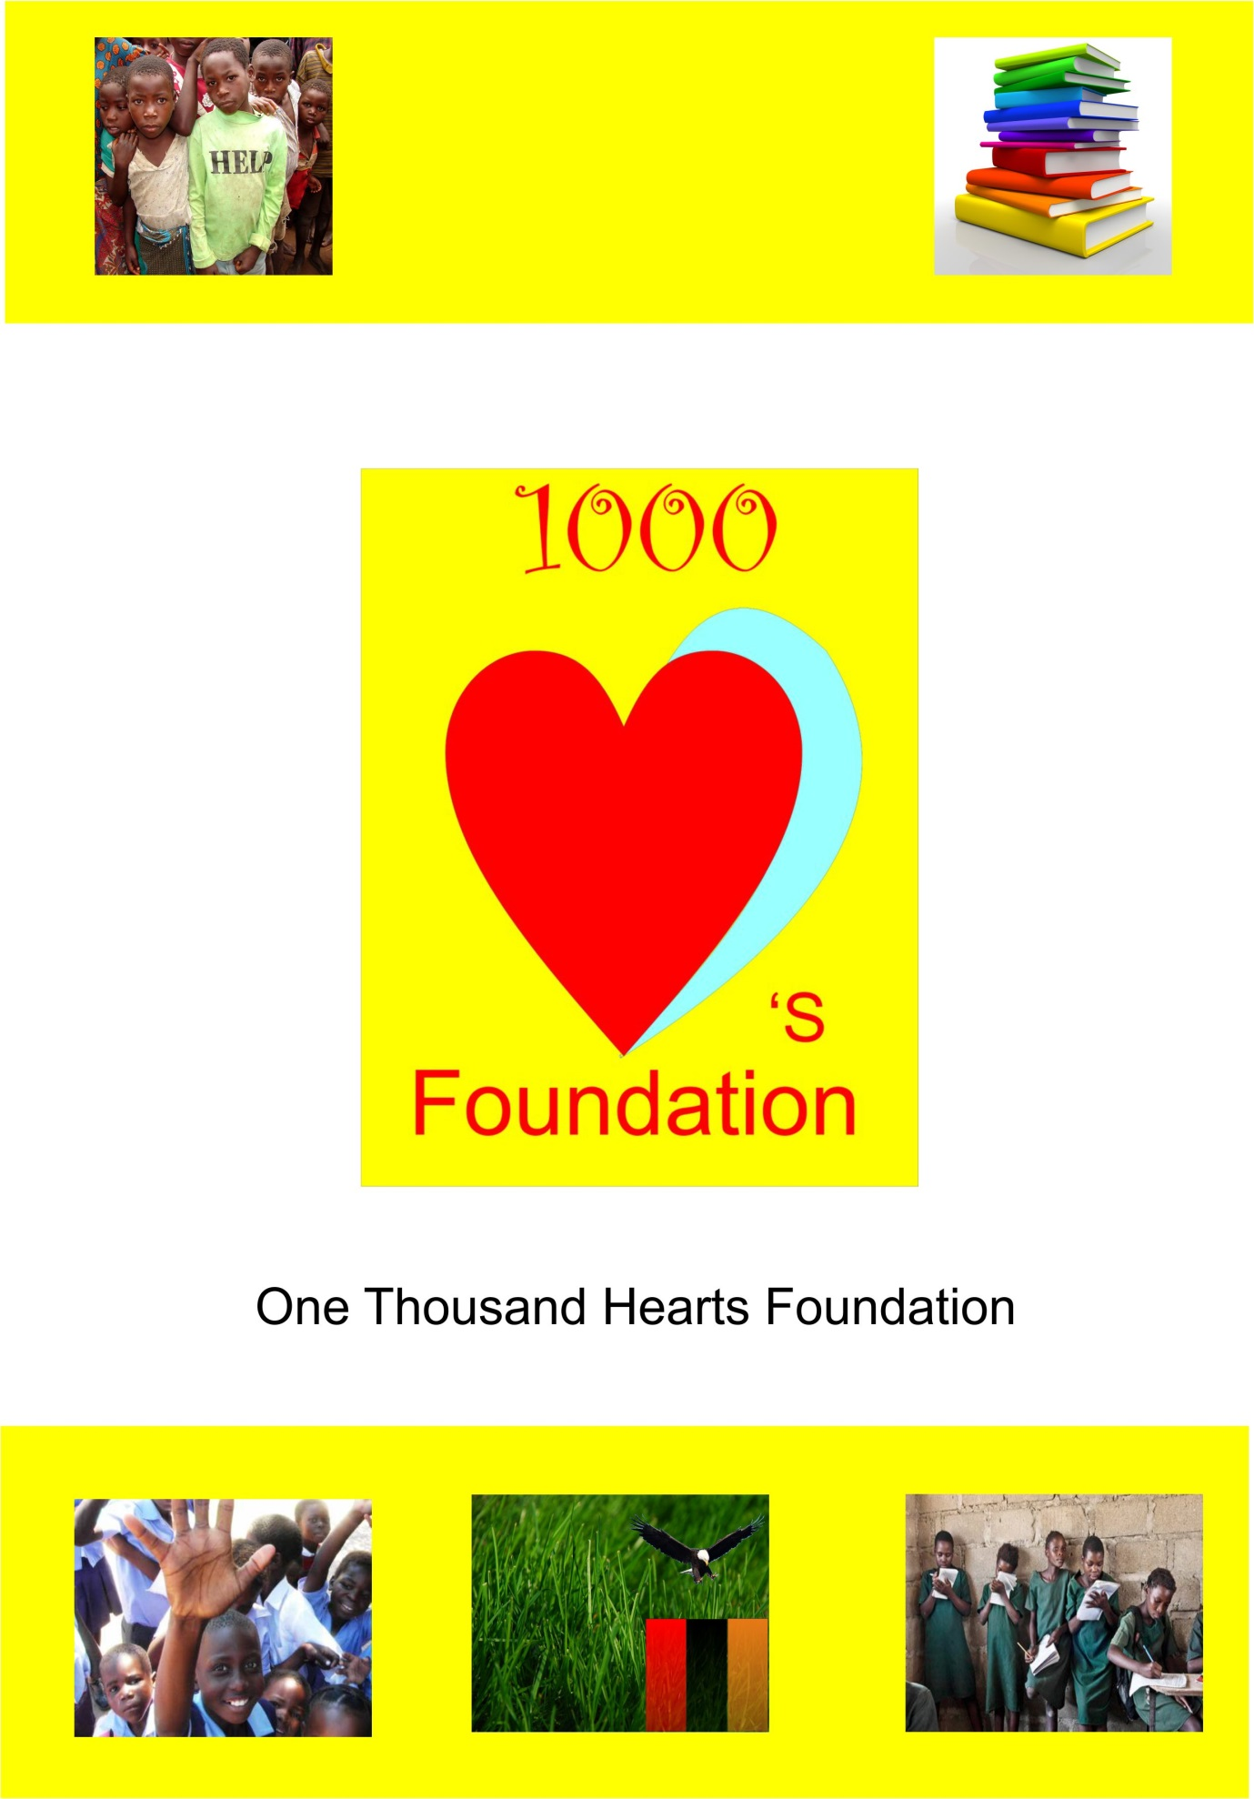

Profile

CONTACT DETAILS

POSTAL ADDRESS
P.O BOX 33997,
LUSAKA,
Zambia.

CONTACT NUMBERS
+26O 973178030
+260 977779692

EMAIL ADRESS
Onethousandhearts@live.com
CON

Introduction
One Thousand Hearts Foundation is a youth driven organization circled on changing the mind-set of the African youth in terms of ideal/project development and improvement as well as support for one another. One Thousand Hearts supports youths in being innovative in today's world.
Being a retrospective community interest organization we take into consideration the children and the youths in society in order to see to it that the organization’s goals and objectives are carried out effectively.
As is a youth driven ingenuity we aim to help the youths in terms of empowerment, skill training, fighting stigmatization and educating the youth on various issues affecting the society and economic growth. One Thousand Hearts Foundation operates as professional youth non-governmental organization.
MISSION
Uniting the youths towards developmental goals through informative youth initiative and education
Organization Overview
One Thousand Hearts Foundation is a youthful organization circled on changing the mindset of the African youth in terms of ideas, project development and improvements as well as support for one another, by means of expanding widely in Zambia to the horizons of Africa. ONE AFRICA ONE WORLD
Vision
- To unite people together by fighting against discrimination, tribalism, racism and gender equalities.
- To build and support partnerships and networking locally, regionally and internationally in order to enhance and sustain the empowerment of orphaned disabled and HIV/AIDS infected people.
- To bring about the youth empowerment schemes which supports the national development plan.

Objectives
- To go into all the provinces of our country and unite youths in view of imparting them with the knowledge of responsibilities towards National development in spite of the regional barriers.
- To influence positive behavior and attitudes of the youths through various mediums of sensitization.
- To lobby the government to implement the ratified principles and MDGs in order to reduce poverty levels and mitigate the spread of HIV/AIDS.
- To create partnership with relevant government departments, civil society organizations and various stakeholders.
- To have 10 000+ of both the vulnerable youths empowered by the year 2015 in of attaining the Millennium Development Goals (MDGs).

Education
Lack of access to quality education is preventing millions of people from escaping the cycle of extreme poverty in Zambia. Most of the children still out of school are some of the poorest and hardest to reach. More than half of them are girls and most are living in the underprivileged population. Although many governments have eliminated the biggest obstacle to enrollment by abolishing school fees, other financial barriers such as uniforms and exam fees still prevent many of the poorest children from enrolling. In addition, for many poor families the long-term benefits of sending their children (especially their daughters) to school are outweighed by the immediate benefit of sending them to work or keeping them at home to help instead given responsibilities.

The Opportunity
By equipping a child with necessary knowledge and skills, education delivers society-wide development returns. Additionally, education is one of the central building blocks of a strong, unified society.

Initiative Learning and Research
This offers the youth opportunities of being exposed to the modern day world giving the youth an environment to utilize their intellectual thinking. This also shapes up room for the exploration of the new methods of doing various activities.
Uniqueness
One Thousand Hearts Foundation has the uniqueness of forming close business relationships which in the nut shell enables the clients easily monitor the finances of the organization, by appointing individuals who are directly linked to the organization from funding bodies. One Thousand Hearts Foundation seeks to empower the youth through grants, donor funding and income generating projects that will support the continuity of the organization and add to the economic growth of the country.
Services
- Youth education and initiative
- Fight against discrimination
- Sensitization against illicit vices
- Educating the people on HIV/AIDS and other illnesses
- Educating people on the disadvantages of some medical practices such as amputation of diabetic patients
- To help and work on income generating projects to see to it that continuity goes on at all levels in terms of empowerment and other services
- Will also work on projects beneficial to economic development and hygiene.
Creative Arts and Crafts Services
- Creative arts and crafts are also used to help the youths in exploring their mind set limits by way of using creative ideas in passing information.
- This is also helps our organization in talent identification.
- It also paves ways for the youth to put to attention something over looked or introduce the all new concept of addressing matters

Management Structure

- Board Chairman
- TOP MANAGEMENT
- Chief Executive Officer
- Secretary General
- Research and Development Director
- Information and Technology Director
- Projects Development Director
- Finance Secretary
- MIDDLE MANAGEMENT
- Administrations officer
- Program Officer (Health Research)
- Program Coordinator (Creative Arts & Crafts)
- Programs Officer (Social Welfare)
- Programs Officer (Education)
- Monitoring Evaluation Officer
- Marketing Officers
- Accounts Assistant
- Gender Development
- LOWER MANAGEMENT
- Drivers
- Janitors
Human Resources Goal
To create an environment that fosters positive communication and mutual understanding.

Human Resource Objectives
- Periodically conduct competitive salary and benefits survey in order to identify methods to employ and retain quality staff and reduce turnover. (Priority)
- Continue to provide development and training to staff and board for continued capacity building and quality improvement.
- Continue to implement “Best Practices” standards for staff and board.
- Continue to utilize consent agendas in board meetings in order to allow time for board education, training, decision-making, etc.
Funding Goals
To develop funds that allow for stability and growth of the organization’s vision and its continuity.
Growth Objectives
- Develop staged growth plan for next five years.(Priority)
- Continue to evaluate current financial needs of One Thousand Hearts Foundation and to anticipate growth needs.
- Grow revenue from fundraisers and sponsorships.
- Develop capital campaign program to meet resource needs of our organization
Facilities Goal
To provide appropriate facilities to serve the staff and programs of One Thousand Hearts Foundation
Management Objectives
- Public Relations (Public Awareness Goal)
To improve brand recognition of One Thousand Hearts Foundation in the country
  - To continue using a marketing approach that strengthens the brand “One Thousand Hearts Foundation” through media printed materials, communications and public education.
  - To develop long-term relationships with community leaders and corporate sponsors to strengthen the public image and position of One Thousand Hearts Foundation.
  - To improve corporate sponsor incentives and increase local sponsorships to create long-term community relationships.

Board Development
To develop and utilize a list of supporters and leaders to establish potential board member developers
- To seek and follow up on potential board members through an active enlistment campaign which encourages community participation in One Thousand Hearts Foundation through the implementation of this plan.
- To provide meaningful and appropriate board development orientation to new board members.
- To provide educational opportunities to board members to further develop the knowledge base of supporters about people with highlighted sicknesses and disabilities.

Operational Goals
To build infrastructure through the use of cash flow with the goal of significantly strengthening the long-term viability of One Thousand Hearts Foundation
- To build a skillful team that brings talent and vision to One Thousand Hearts Foundation
- To establish expectations, reporting and communication.
- To develop a quality donor database.
- To become a funder to other NGOs
- To provide update technical needs as identified to improve staff productivity.
- To ensure that all records and accounting are in order and the agency operates within budgeted guidelines.
- To manage accounts within grant requirements and provide documentation to funding entities that supports the financial requests.
Conclusion
The youth as our main focus we plan to work hand in hand with the Government departments, the international bodies, non-governmental organizations and individual entities in order to add value to the economic growth of our country. We also impart relevant trainings, skills of promoting entrepreneurship and poverty eradication. The organization concentrates on the making the dreams of youths come to reality as they are the future leaders of tomorrow.

