**IKONGO RURAL DEVELOPMENT ASSOCIATION**

**ANNUAL REPORT 2018**

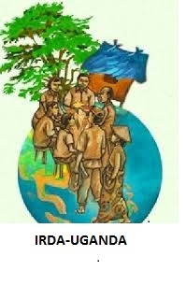

HEAD OFFICE

Opposite Bwera Market,

48Km from Kasese - Equator road

P.0.BOX 513 Kasese

Tel 0785537744

Email: [ikongo.2000@yahoo.com](mailto:ikongo.2000@yahoo.com)

**LIST OF ACRONYMS**

CBF Community Based Facilitators

IRUDA Ikongo Rural Development Association

CORPS Community Resource Persons

FFLG Farmer Family Learning Group

FFS Farmer Field School

Kg Kilo gram

MFA Micro Finance Association

BIC Bwera Information Centre

RPO Rural Producer Organization

SATNET Sustainable Agriculture Trainers Net work

SACCO Savings and Credit Cooperative Organization

VSLA Village Savings & Loan Association

**ANNUAL REPORT FOR THE YEAR ENDING 2018:**

**INTRODUCTION**

On behalf of the executive of Ikongo Rural Development Association .I thank all the members for their support and commitment towards organization activities. I congratulate all of you present here and other stakeholders for completing the year 2012 and for working towards improving the life style of community in this area.

The Executive committee is hereby committed towards developing this organization to suit your needs and promote sustainable development with your support which everyone should be proud of.

Our commitment and dedication is deeply rooted to our life styles and is intended towards changing peoples’ attitudes and behaviors towards the youth. While we advocate for respect and recognition, we have also obligations which needs to be fulfilled to support the advocacy strategies.

Our development depends on how strategic we are to tap resources amidst us and this will demonstrate our abilities to break the negative barriers against us.

I thank very much Government for providing conducive environment for our operations in the district. Hoping the year 2019 will be for improved service delivery and increased cooperation amongst our stakeholders.

F:\DCIM\101NIKON\DSCN0341.JPG Massage from the Chairperson.

On behalf of the board of Directors and Staff of Ikongo, Igreet you. I wish you informative time as you read our 2012 Annual Report. Our program Activities in 2012 reflects Ikongo commitment to working and partnering with the small scale farmers in Bukonzo West with the overall goal of increasing the incomes and bettering their livelihoods. I am glad to see the 32 groups graduating as VSLA groups, women empowerment, mainstreaming cross cutting issues. .These Achievements clearly signal that the organisation has continued to grow and reach out to even more rural farmers and the farmers appreciate the services rendered.

Our Major challenges in the last year was mainly resource constraints which negatively impacted on the operations of the organisation at different levels and may continue to the coming year. Ikongo management and Board of Directors have to work extra hard to develop strategies for raising more income through diversification of funding sources.

As Board, we register our sincere gratitude to all our partners and the community we work with. We further appreciate the and feedback provided by all stakeholders to contribute to our successes in 2018 please keep it up and we wecome all positive inputs into our work to push us on to greater heights.

Thanks Yours

MR.Bwambale Godwin

**EXECUTIVE SUMMARY**

This annual report covers the period from January 2012 – September 2013 hoping that it will give you a summary of the activities done.

It is always our tradition to hold Annual General Assembly at the end of each year to inform members of what has happened in the previous year and what has been planned the following year to measure progress.

Members, as people suspect us to be responsible for wrong acts, I request that we should become exemplary in the way we implement our activities so as to clear this image. With the increased prevalence rate in Kasese District (11.4%, I appeal to all of you to desist from activities that promote the spread of HIV / AIDS. This will assist us to save the lives of those who not informed to about the disease to cope up with the changed behaviors shown. Acts of drunkard ness and idleness should be stopped.

Operational environment

We shall continually address for our rights until attitudes and behaviors to suit our interests and to assist the young to emulate our characters which can be manifested through understanding the concepts human rights. This struggle can not happen overnight but a positive process achieved through continued efforts by concerned people should be maintained. This process is of a long term aimed at causing positive impact on the lives and that of our young brothers and sisters. Different needs will be met during this protracted visionary interventions basing on different situational concerns at different times. A lot of improvements should be realized in the social economic, cultural and political set up of this country which is centered on transforming our lives for a better living. So this requires commitment, patience, love for one another, active participation and net working. We should work towards overcoming the debilitating effects of poverty, illiteracy, exploitation, diseases and hunger. We should complement Governments efforts to address these situations.

Our interactions with Government put us at a level understanding its operations and how human resource can be tapped to effect our situation. A lot of sensitization and mobilization is needed to organize the youth community into meaningful development groups that are ready to promote meaningful development. Lobbying and advocacy should take a big portion of our time at different levels to speak for ourselves for the rights of the young so that their voice can also be heard.

I appeal to you all to continue initiating development project that generate income to facilitate your concerns at your homes to preach the gospel of development. Non formal education should be every one’s wish as we were deprived of the right to education.

In all our endeavors we should recognize gender equality as aspect of sustainable development. Gender inequality should be history we should co exist and learn how to live together harmonious.

**Legal operations:**

Ikongo has since 2011 intensified and strengthened Ikongo farmers cooperative to provide technical assistance to small holder farmers in Bukonzo County. The cooperative targets the productive poor farmers and micro entrepreneurs providing linkages services in the form of marketing and business training alongside consumer education to help members achieve a better quality of life. Since the products are geared towards increasing production especially the agricultural products, create local employment across the county. After a thoroughly consultation Ikongo worked with the cooperative to champion both the individual and group and this have worked very well as exempted below.

Presently the farmers cooperative, have over 764 individual Farmers, 32 Rural producer groups using the solidarity group lending approach. Ikongo have given assistance to the cooperative support in form of capacity building especially

policy development, mobilization & sensitization of members in Agronomic practices and we have seen the cooperative come up with agricultural policy, and strategic business plan. We have worked together in simplifying record keeping system. The credibility and status of the cooperative have been built and its one of the trust worthy institution in

Bukonzo. There has been increased demand for services as evidenced by the increased farmers joining the cooperative

**Legal operations:**

This organization operates basing on policies you consented on for the smooth running of organization activities effectively and efficiently. I am happy to inform you members that this organization has been permitted by the District to operate under the District Community Based Services (DCBS) but National registration has expired and we need to renew our registration at national by ministry of internal affairs .

The executive of this organization have remained focused to the mission during all operations in all processes of development. We have tried to make this organization community based deriving its mandate and powers from its members.

**Planned activities for 2019:**

Few of the activities planned for the year 2018 were not implemented due to lack of funds. I thank you for your financial support through your contributions, Support from the local leaders, prompt payment of your annual subscription fees, and hired labour which sustained office work as it was not enough to meet the planned activities.

**(i) Meetings**

Executive meeting were being conducted every after two months. I thank very much the members of the executive for their tiresome efforts to uphold the development of this organization. A lot has been planned but not implemented due to lack of resources.

Monitoring and Evaluation was also conducted through visits to your organization and through reports you submitted to the head office.

**Seed Bed Management training:**

The Organisation started to train the youths to acquire knowledge and skills to effect their situations as they were deprived of the right to education. I am happy to inform you that this year 2012 we managed to train 13 youth in seed bed management. We have retained best performers in our group and others have gone to start their own way of living and we will follow them up from time to time. This will empower the youths sustainably manage their lives well.

**The project**

Since the project started, we have trained 30 youths. Females are 10and male are 20. We need more youth to come for the training. I thank Kabarole Research and Resource Centre for the support .

**HIV/AIDS**

I thank the district local Administration for their support in training members of the executive as in HIV/AIDS prevention which I believe the knowledge will be passed on to all the youths in this area and the general community.

**HUMAN RIGHTS and Domestic Violence PROJECT**

As you suggested, I am happy to inform you that we need request for support for human rights awareness amongst the disabled community to be empowered to claim for wherever violated/ abused. We shall train 20 community focal persons in the sub counties for proper information flow, guidance and education on human rights. The project is for two year from Feb. 2014 – Jan -2016.

**Malaria Control**

This project being the foundation of our resource mobilization, members are involved very well. I appeal to all our members to encourage everyone to get involved as away to reduce children deaths which has been at high rate than ever. ,.let us all with the local leaders join hands make awareness about all killer desises in the area. to compete with the able bodied persons since we have market for our products.

**Net working**

Our Net working with other organizations has improved greatly and publicity is on the increase both at local levels for information and experience sharing, linking and coordinating.

These include;

1. KRC - 3-Kasese District Development Net work
2. KALI 4-SATNET

5--NGO FORUM 6-Bwera Information Centre

**Planned activities 2012**

Since most of the planned activities were not implemented due to lack of resources, I appeal to all of you to look forward to mobilizing resources to support our cause.

1. Comprehensive needs assessment will be conducted to establish more facts about the activities and crucial needs of each group.
2. Health education should be taught regularly for change of attitudes for equal service delivery.
3. Health education will be continuous to sensitize and educate people about HIV/ AIDS, Malaria prevention and on other health diseases.
4. Introduction of income generating project at individual homes and at members organization level e.g., Youth Skill Training, Enterpruanship Training ,chill growing, coffee growing
5. The organization needs an income generating project to support its running costs in a sustainable manner to benefit many community members and keep the organization.

**Monitoring and Evaluation**

This has been an ongoing exercise by the organization board to continue assessing the progress of the activities and measuring the success. Both qualitative and quantitative approaches were used to establish the growth of the organization. It was conducted through meetings and reports the open dialogue.

Challenges

Despite our efforts to carry out the planned activities, we were challenged by a lot of problems like;

1. We lack resources to handle the volume of community who wants to be trained.
2. Communication facilities like computers and internet services.
3. Unrealizable resources for continuous implementation and also limiting human resource Recruitment
4. Lack of resources to carry out activities.

Recommendations

1. Boost resource mobilization strategies to increase organization income to carry out all the planned activities.
2. Mobilization and training
3. Continuous capacity building to empower our members to stand challenges ahead of them and to break the social barriers for improved livelihood.
4. Members should be encouraged to start income generating activities to support their well being.
5. Study tours be encouraged for change of attitudes and learn from others.

.

|  |  |  |  |  |  |  |  |  |  |  |  |  |
| --- | --- | --- | --- | --- | --- | --- | --- | --- | --- | --- | --- | --- |
| PERFORMANCE OF FARMERS cooperative IN 2018 | | | | | | | | | | | | |
| Month | **Jan** | **Feb** | **March** | **April** | **May** | **June** | **July** | **Aug** | **Sept** | **Oct** | **Nov** | **Dec** |
| Share capital | 6,216,000 | 7,146,000 | 8,126,000 | 8,821,000 | 9,733,000 | 10,882,000 | 12,405,000 | 13,791,000 | 14,461,000 | 14,928,000 | 15,328,000 | 15,404,000 |
|  |  |  |  |  |  |  |  |  |  |  |  |  |
|  |  |  |  |  |  |  |  |  |  |  |  |  |
| Groups | 21 | 21 | 24 | 24 | 25 | 25 | 27 | 28 | 30 | 31 | 31 | 32 |

WOMEN ECONOMIC EMPOWEREMENT THROUGH VILLAGE SAVINGS & LOAN ASSOCIATION PROGRAM

Ikongo in Kasese has piloted the promotion of the Village savings and loans association ( VS&LA methodology ) in an economic empowerment project with support from BTC (Ikongo SACCO) for the last two years and has been used as an entry point for any intervention in Bukonzo and beyond . Ikongo has worked and continuing to work in the above areas by implementing a livelihood program using the VSLA and targeting the poor households to access credit services through their own mobilized savings a result, 32 VSLA groups , members have been formed giving a total number of 764 clients of whom 58.7% are women and 41.3% men.

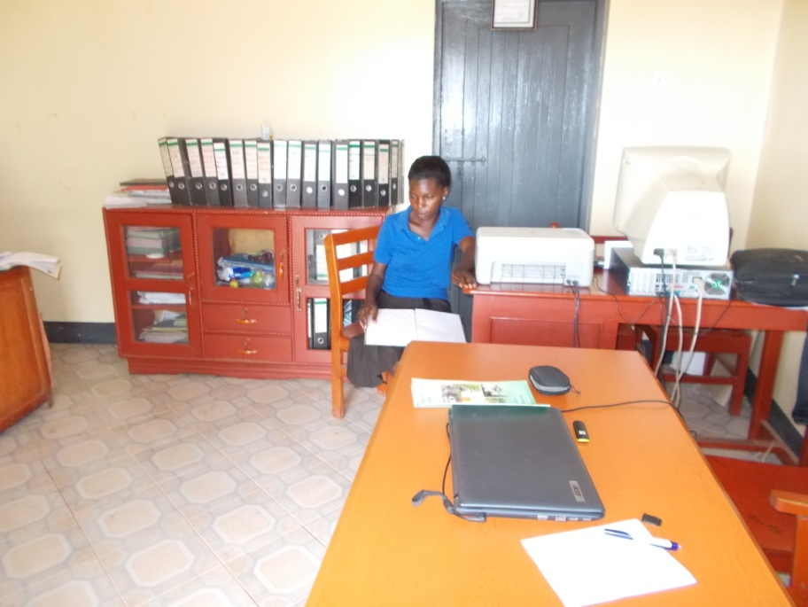

These groups have mobilized savings and accessed loans amongst themselves and utilized the welfare fund to improve their family incomes with a cumulative value of savings, at an average of 56,753 per member . money from the VSLAs to pay school fees to their children and engaged in business venture at trading centre’s and have acquired skills in record keeping at that level and active participation in decision making level

Ikogo provides each VSLA with one-year of intensive group-based saving and lending training. At weekly meetings, members make deposits to the group's savings lock box, as well as small loans to each other to start small businesses, pay school fees or meet household needs. Loans are repaid with interest which, in turn, is passed on to group members as earned interest on their deposits. At the end of 2012, 32 VSLA groups had successfully graduated (completed their first cycle) and have continued saving out of which only four groups had started saving with SACCO .

**MICRO ENTERPRISE DEVELOPMENT OF VERY POOR INDIVIDUALS AND ENTREPRENEURSHIP DEVELOPMENT**

Ikongo has since 2008 implemented an action research intervention targeting the poorest of the poor household s on attempts in micro Since inception, this intervention has directly benefited 19 poorest of the poor households in BUkonzo in 2007 supported by Kabarole Research and Resource Centre (KRC) to the tune of 13,300,000ugx. The grants are mainly managed by Ikongo NGO who are increasingly becoming bread winners of most rural households. The above individuals were selected in the groups performing very well.

**Savings among the individual from the proceeds**

Promotion of savings was very low with most of them not saving in any of the group, they lacked self esteem and confidence and most of them still have domestic violence in their households, however 25% have been able to join Ikongo NGO supported VSLA, saved as agreed and accessed loans, two have already bought shares and are saving with the SACCO Ltd.

The profit have been re invested in the business, some have started small projects like poultry rearing, goat keeping , started kitchen gardening for food security and are able to meet their basic necessities like paraffin, salt, scholastic materials for their children.

***BEING POOR IS NOT BEING POOR IN MIND- THE SUCCESS STORY OF Mbambu JULIET IN Kyogha***

*Mbambu Juliet a mother of one child lives in kyogha Village, Kyogha parish was verified as one of the very poor individuals Ikongo is working with in Bwera Sub County.*

*During the identification stage, Juliet used to eat once a day, had 4plates, 5cups, one jerrican, two hoes, and her house was not in a good state where by a family of 6 people could not fit in. getting food to eat was a problem however, this could not stop them from struggling to ensure that they get something to eat and they therefore used to work for others whereby from morning to noon each could be paid Ush 1,500/= despite of being poor Juliet has a good relationship with her husband*

*During my interaction with Juliet I discovered that Juliet had a very small land where she managed to put up the small house and there was no more land left for cultivation and had no money to hire land.*

*On top of Juliet working for others and at the end of the day earn something she also used to sell peoples produce in market and after, take all the money she collected to the owner of the produce and they share the profits which she did for some good time and it gave us confidence that Juliet lacks capital but knows who she wants to be in future and it convinced the organization to give her support via the enterprise development for the very poor program which started after conducting trainings like business plan in October*

*According to Juliet’s Business plan, she was given a grant of Ush 90,700/= as her first installment and decided to implement a sell of beans business. After one month, Juliet used the little profits she had got and later to cassava & G nuts depending on the demand of each in the market. At that stage Juliet managed to join VSLA because she could also afford to save between 1000/= and 5,000/= per week in the VSLA and by june 2012 she had a total savings of 141,000/= with a loan of 169,050/=*

*Juliet started buying hens which she later sold and bought 2 iron sheets in December and in January she was given her second installment of 109,300/=. She currently have 7 hens, joined a business group in Rusese market where she saves 10,000/= Juliet a mother of 4 children is now able to provide food twice a day, can buy books, uniform for the children, also bought more plates and cups, planning to put up a house which she have started and pay medical bills*

*Juliet’s next plan is to increase her shares in VSLA and get credit to add in her business in order to earn more profits and buy land for cultivation. Juliet’s main challenge is drought and sickness*

MAINSTREAMING GENDER BASED VIOLENCE-BY IKONGO RURAL DEVELOPMENT ASSOCIATION

In the mid of the year (June) Ikongo partnered with SATNET in strengthening livelihoods of women and human rights, the project was supported to the tune of 4,040,000/=, this is a model project that will inform donors on decision in funding domestic violence project in Uganda.

The project has since trained 40 local council leaders in local court system two days training, referring gender based violence cases , human rights and livelihood support,enhanced the capacity of combating violence against violence women in their respective communities, conduct referral. A team of 6 community members have come up to back up in community activism against domestic violence, which is bringing up a number of cases and conducting referral. The team have been supported by the police officers in community activism, music dance and drama presented by drama, which have continued to make strides as it moves crowds to tears

The project have moved further to sensitizing young girls and boys in school on children’s rights and responsibilities, sexual abuse(rape and defilement)have been selected to benefit from the project because of it being exemplary and reaching many at a time.

We continue to observe increased number of people reporting cases of domestic violence to community structures as it can be seen from their reports. This means that the community attitude towards seeking support continues to rise with increasing effort of not only our work but also other stakeholders. This requires putting in place structural arrangements within institutions reported to in order to ensure that survivors receive the much desired response to their cases.

Ikongo together with Bwera Sub county local government launches a campaign against domestic violence during the 16 days of activism against gender based violence. With key theme of ***from peace in the home to peace in the nation let’s fight violence against women***

All discussion during the 16 days rooted for the problem and discussing the possible way out, Community resource persons already trained lead discussions at group and village level, initiated debates of discussion with members and participated in the activities. This occasion was attend by over 500 people in Bwera and outside Bwera including different dignitaries who blessed the occasion

From the project; We have noted that low economic status of women characterized by weak control of resources by women