REPORT ON 2013 INTERNATIONAL VOLUNTEER DAY CELEBRATION

ORGANIZED BY:
THE NET ORGANISATION FOR YOUTH EMPOWERMENT AND DEVELOPMENT (NOYED-GHANA)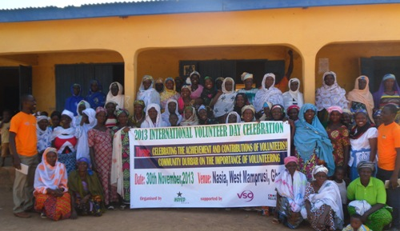
IN COLLABORATION WITH:
THE GHANA RED CROSS SOCEITY, TAMALE

SUPPORTED BY:
VOLUNTARY SERVICE OVERSEAS (VSO) &
COMIC RELIEF

FROM:
30TH NOVEMEMBER TO 6TH DECEMBER, 2013

- Introduction:
International Volunteer Day (IVD) is an international observance day designated by the United Nations since 1985. It offers an opportunity for volunteer organizations and individual volunteers to make visible their contributions at local, national and international levels to the achievement of the Millennium Development Goals (MDGs). It is celebrated on the 5th of December each year and seeks to acknowledge and show appreciation to all those people who dedicate their much needed time and skills to the many community organisations across the world.

Volunteers should be acknowledged for the important contribution they make to the community. Many not-for-profit organisations would find it impossible to carry out their work without volunteers. Recognition, lets volunteers know that others appreciate what they do. It gives them a feeling of accomplishment and motivates them to continue volunteering.

International Volunteer Day (IVD) is the perfect time for an organisation to express gratitude to its volunteers. Designed to thank volunteers and stimulate a greater awareness of their contribution, IVD is already marked in more than half the countries of the world including Ghana.

- NOYED-Ghana and The IVD Celebration:

The Net organisation for youth Empowerment and Development (NOYED-Ghana) for the past three (3) years has been very active in the celebration of the IVD. The celebrations have been very visible in Talinsi/Nabdam district of Upper East, Jirapa of Upper West and West Mamprusi District of Northern Region where NOYED-Ghana leads on the implementation of Tackling Education Needs Inclusively (TENI) component of volunteering which is “Promoting Local Volunteering Initiatives in Support of Quality Basic Education in the TENI Districts”, supported by Voluntary Service Overseas (VSO) and Comic Relief.

NOYED-Ghana has placed 27 community volunteer teachers in these three districts while carrying out other initiatives at motivating many young people, women groups and SMCs to continue committing to volunteering towards achieving accessible and quality basic education for the people of northern Ghana. NOYED-Ghana has also carried out a number of research studies in the three districts that revealed the enormous role of volunteers in filling-in the gaps of teacher shortages in the education sectors as well as other wonderful initiatives carried out by women and community youth groups to promote community development. A key example is the performance of local dance by women groups in schools to show their appreciation to their children for being in school. These initiatives in consonance with the United Nations reasoning have motivated NOYED-Ghana to join in the celebration of the IVD each year to show appreciation to the volunteers for their effort.

Each year, series of activities including community durbars, clean-up exercises, Community Outreaches and presentation of certificates to outstanding volunteers, and symposia are held to mark the day. The focus often is also to motivate the volunteers to continue to do more while getting others on aboard to volunteer. NOYED-Ghana adopts the international theme each year and sometimes modifies it to suit local content and targets. The media is always part to help increase publicity. The support for the celebrations has been single handedly done by VSO and Comic Relief.

- Theme for this Year’s Celebrations:

The theme for this year’s celebration is “Celebrating the Achievement and Contributions of volunteers”.

- Objectives:

The objectives for the year’s celebrations within the local settings as set by NOYED-Ghana under the support of VSO are coined, guided by the theme set for the year’s celebrations. They include:
- To increase awareness on the importance of Volunteering among the local people within the three northern regions of Ghana with emphasis on the three TENI districts ( Jirapa, Talinsi and West Mamprusi)

- Motivate existing volunteers and mobilize more people into volunteering for improved quality basic education in Northern Ghana with emphasis on the girl child education.

- Encourage the spirit of recognition and reward in host organization and communities for volunteers as a way of motivating volunteers to do more for communities.

- Activities Carried Out to Mark the Year’s Celebrations:

NOYED-Ghana carried out four (4) key activities to mark this year’s celebrations. The Activities include; Community Durbar, Radio Talk Show, Symposia and Blood Donation:

- Community Durbar:
Community Durbar was organized on the 30th of November, 2013, in Nasia, West Mamprusi District in northern Region of Ghana. The Community is one of the beneficiaries of the TENI Project and NOYED-Ghana has been interacting with key stakeholders in the community to promote voluntarism and quality teaching and learning towards community development. NOYED-Ghana has placed community volunteers in the community who have gone extra mile to organize remedial classes for the pupils in the community at no cost of the pupils or their parents.

The essence of the durbar was to engage with the community leadership and members on the need for them to rekindle their promise of supporting their children to regularly stay throughout school. Problems mentioned by the volunteers that impede academic work in the community were also discussed and resolved paving way for renewed energy in the volunteers.
The following were some of the challenges presented to the community for attention;

- Pupils do not regularly attend remedial classes due to parents sending them on petty trading, farms and other house chores.
- Parents do not visit the classes to see the attendance of the pupils as was promised.
- Home work given to pupils are often not done at home but carried back to school to be done.
- Limited community motivation for the volunteer teachers in the community school and those doing the remedial classes.

These issues were discussed and in the presence of the chief’s representative, commitments were made again to fulfill the part of the community to lead to increase education delivery in the Nasia community.

As part of joining NOYED-Ghana and the world at large to celebrate the day on the 5th of Decembers, the community members led by the women groups agreed and on that day, came out in their numbers and carried out a cleanup exercise on the day to mark the IVD in their own small way. They were given some souvenirs to help them in the process.

Please see selected pictures of the durbar below:

A Group Picture Women Groups in the Nasia Community After the Community Durbar.

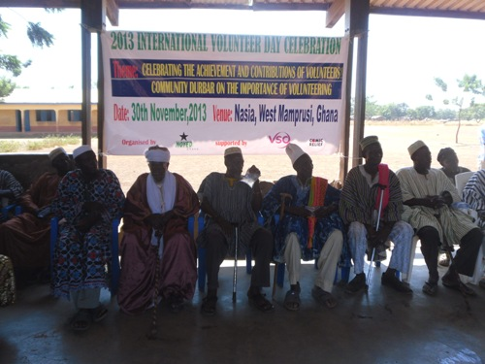
Chiefs and Imams in the Nasia Community Participating the Community Durbar.
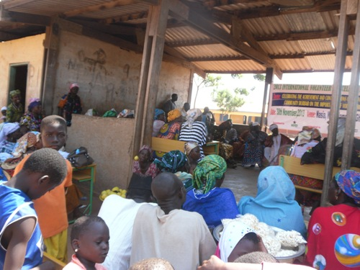
Some Participants at the Durbar Grounds
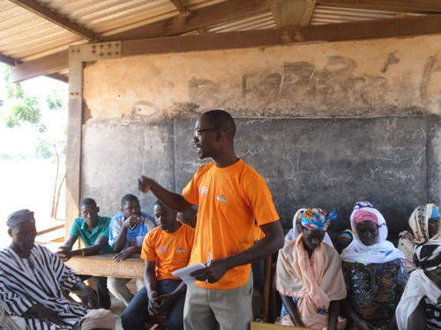
Director of NOYED-Ghana Addressing the Durbar

- Radio Talk Show:

The Radio Talk Show was held on the 4th of December, 2013 at Kesmi FM Station, Tamale. The panel constituted a representative from the Ghana Red Cross Society and NOYED-Ghana. Issues discussed included the involvement of the organization in volunteering, the importance of voluntarism, the need for young people to join in volunteering, to mention but a few. Credit was also duly given the VSO and Comic Relief as the donors and supporters of the programme. A recorded CD of the talk show is also available.

- Symposia:

The symposia were held in the other two TENI Districts (Jirapa and Talinsi) on the 5th of December, 2013 under the same programme line up simultaneously. Participants to the programme included the following; Representative from VSO, Representative ProNet and Link Community Development (LCD), Ghana Education Service (GES), District Assembly, National Service Scheme (NSS), National Service Personnel Association (NASPA), Volunteer Teachers Association (VOTA), Community Volunteers, Media and Other Community Based Organisations.

Some selected stakeholders/institutions that have key roles to play in promoting voluntarism and improving on quality basic education were invited to make presentations on the following topics:

- “Motivating Volunteers for Improved Community Development: The Role of District Assembly” Presented by the District Coordinating Directors.

- “An Enabling Environment for Volunteering; the Perspective of National Service Scheme.” Presented by the NSS Directors.

- “Motivating Volunteer Teachers for Quality Education Delivery: The Role of the Ghana Education Service” Presented by GES Directors.
The presentations highlighted what these units can do to promote the work of volunteers in the districts.
- Presentation By GES, Jirapa
In the presentation of GES, the representative of the Director of Education of Jirapa, noted that the district has a teaching staff capacity of Six Hundred and Sixty Seven (667) and out of this, Two Hundred and Two (202) of them are volunteers serving in various parts of the districts without salary or any clearly defined support package for them. He noted that the District Directorate has been very attentive in identifying and placing volunteer teachers as ‘Pupils Teachers’ any time the opportunity comes.
Currently, under the Ghana Partnership for Education Grant (GPEG), many of the untrained teachers including some selected volunteer teachers were identified and placed to pursue the Untrained Teachers Diploma in Basic Education (TUDBE). The number the district is sponsoring should have been more than what is being done now but the process is highly regulated. One major limiting factor is that, before a teacher can benefit from the programmes, he should be on the pay role of Ghana Education Service.
It is an undisputable fact that without the volunteer teachers, teaching and learning would have been very worse. Many class rooms would have been empty. He remarked.

- Presentation By National Service Scheme Director, Jirapa
The District Director, in his presentation gave historical and legal perspective of the NSS and went along with the significance, challenges and suggested solutions which in his view, serve as the enabling environment for volunteering. He noted that the NSS is a public Organization under the Ministry of Education and was set up by NLCD 208, 1973. The responsibility of the NSS is to provide manpower for the public service, educational institutions and the urban oriented industrial and commercial establishments.
Talking on Voluntarism, he said is a service to a neighbor, a community, a nation, to mankind and for self; to share pain and skill, to understand, appreciate and identify with the life and suffering of fellow human beings, a community, or a nation to improve lives and joy for all. He added that the guiding principle of voluntarism is that nobody is under any obligation to do anything.
On the significance of volunteering, he mentioned among others that volunteering increases self-confidence of the volunteer and combats depression, it helps you stay physically healthy; it helps you make new friends and contacts. Also, volunteering increases your social and relationship skills, volunteering can provide career experience, and can teach valuable job skills

He argued further that volunteering has lots of prospects for the development of Ghana. It was mentioned that young people in Ghana have high interest to serve as volunteers in deprived districts or communities in Ghana and for that matter will thrive if given the necessary attention. Voluntarism reinforces and encourages community service among Ghanaian. It also exposes the development challenges facing the country to the youth and proper solutions offered to salvage the situation, the director stated.
The following were highlighted as the challenges of volunteers especially those within the teaching domain face:
- Lack of professional teaching skill by service personnel and volunteers,
- Absence of career development in teaching profession.
- Low numbers of intake
- Poor remunerations for volunteers
- Lack of accommodation for personnel serving in deprived communities
- Lack of cooperation of some community members etc.

Suggested Solutions:
The following were mentioned as suggested solutions to addressing the above named challenges. He mentioned further that, these immediate mentioned factors are what he perceives as conducive environment for volunteering with the context of teaching.
- GES should assist in putting a teaching – career development plan in place to support those willing to remain in the teaching professions as teachers.

- Regular organization of teaching skills training for volunteers through INSET.

- Encouragement of females to participate in voluntarism by way of reducing their appointment requirements and making their stay female friendly.

- Motivational package should be instituted for personnel who accept postings to deprived and hard to reach communities.

- Encourage head teachers, SMC/PTAs to assist personnel posted to their communities in getting accommodation, etc.

- Presentation By the District Cordoning Director,Jirapa
The Coordinating Director was very brief in his submission. He remarked that whatever the decentralized institutions are doing in support of voluntary work is the DA’s contribution towards the promotion of voluntarism. It is the responsibility of the Assembly to provide conducive environment that will attract both local and international volunteers into the community to support in the community. In some instances, based on need, the Assembly has supported some volunteers with office space free of charge and provided some other logistical support to some volunteers.
The nature of the operation of the community volunteers makes it difficult for the Assembly to take a decisive action to support in improving their situation. They operate across the district and in most instances in a much loosed form. He mentioned. He added that, however, his attention has been drawn to the existence of the Volunteer Teachers Association in the District support by NOYED-Ghana in partnership with VSO. This I think is just a cohort of those into community volunteering out of the lot supporting health, education, construction, agriculture to mention but a few.
In summing up, he mentioned that the Assembly’s Doors are opened to new ideas and approaches at helping to promote voluntary work and to use that as a source towards community development.

- District Coordinating Director’s Presentation, Talinsi

In his presentation titled ‘motivating volunteers for improved community development, the role of the District Assembly’ the District Coordinating Director, Alhaji Mahmud Issahaku was full of praises for NOYED-Ghana, organizers of the event for making the volunteer a central ally in their work. He recounted the contributions of volunteers in the district and wondered how things would have been without the work of the volunteers. He further indicated that the National Youth Employment Programme is one such avenue that the government through the District Assembly is seeking to address some of the challenges the youth in the area are faced with.

The biggest obstacle however is always the limited funds available to carry out projects at the time they are seriously needed. He therefore admonished volunteers to always strive hard and explore other legal avenues and not rely on the assembly to offer them employment since they are not able to do that.

He challenged volunteers to come out with innovative ideas on how they can change their communities so that the assembly can help. He bemoaned the attitude of some youth who, instead of helping like the volunteer teachers, sit idle and engage in illicit activities or waiting to receive hand outs from government. He ended by thanking all volunteers for their wonderful contribution to society and mankind as a whole.

- GES Director’s Presentation, Talinsi
On his part, the District Director of Education for Talensi, Mr. Faara Joachim, speaking on the topic ‘motivating the community volunteer teacher for quality education delivery: the role of the Ghana Education Service’ outlined the role of volunteers in community development. He stated that volunteers continue to be the life blood of most organizations and that almost every community benefits from the services of volunteers. These services he noted included among others; teaching, tree planting, cadet corps, coaching youth sports teams, serving of meals etc.

This demonstrates volunteers’ willingness to change lives, build social cohesion, enhance civic participation and mitigate conflicts not to talk of filling empty classrooms as teachers for the underserved communities. He further stated that volunteer teachers need to be motivated in our schools and the community to encourage them to do more and also attract more. This can be done by making them feel part of the school system and also organizing community sessions to celebrate such individuals for their invaluable contribution to society.

He called on NOYED-Ghana to go beyond the symposium and organize an exciting trip for site seeing and increase the support for the active volunteers. The director also noted how the directorate has been able to recruit some of the volunteers as pupil teachers and recommended others for the UTTDBE programme. He encouraged volunteers to re-sit their papers to make them competitive since the guidelines for recruiting new staff onto GES is always strictly based on quota system. He urge all volunteers to be active in the activities of their association since that was the only way they can deal with the duty bearers to fight their course.
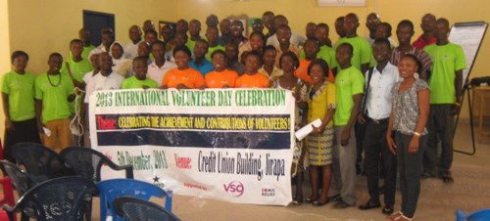
Group Picture by Some Participants After the Synposia in Jirapa
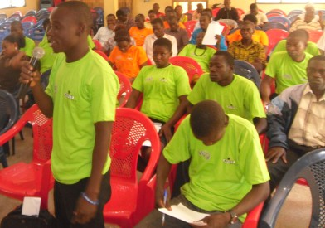
A Participant making a contribution during the symposia

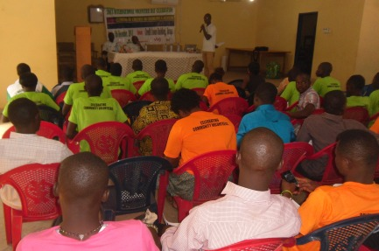
A Cross Section of Participants at the Symposia
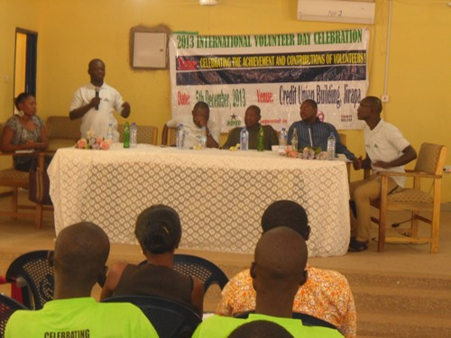
The NSS Director Responding to a question.

- Blood Donation:

The Blood Donation was organized in collaboration with the Ghana Red Cross Society, which is also a well known organization when it comes to volunteering and voluntary work in Ghana and the world at large. The collaboration was in the form of radio talk show to highlight the significance of volunteering and that of the blood donation exercise. Through the collaboration, the school based Red Cross members and out of school youth groups associated with the Ghana Red Cross Society and NOYED-Ghana were brought together for the exercise. In all, Eighty Seven (87) volunteers (53 boys and 34 girls) came together for the exercise. Of This number, 62 constituting 38 boy and 24 girls were deemed fit to donate and hence donated.

In his remarks to the commencement of the donation, the regional Manager of Ghana Red Cross Society, Mr. Yussif, welcome the donors to the grounds. He noted that, the donation was to help mark this year’s International Volunteer Day Celebration under the Theme, “Celebrating the Achievement and Contributions of Volunteers”. This day was set up in the year 1985 by the United Nations to recognize the efforts of volunteer across the world who are doing so many wonderful things to help make the world a better place to be and to put smiles on the faces of people. This day is celebrated on the 5th of December each year. He added. He encouraged them to continue with the high spirit that they have and they will not regret it someday to come.

The Health Promotion Officer of NOYED-Ghana, speaking on behalf of the Executive Director, welcomes the donors to the exercise grounds.

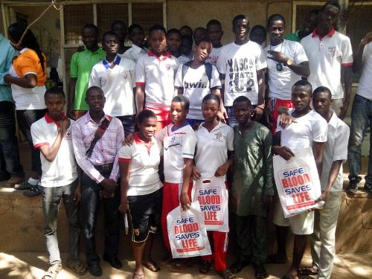
A Group of Some of the Nonors
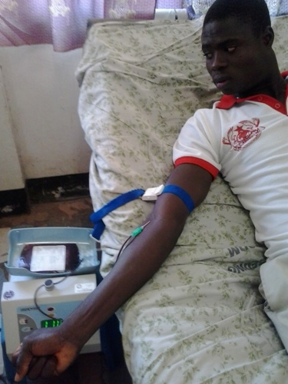
A Donor Donating Blood
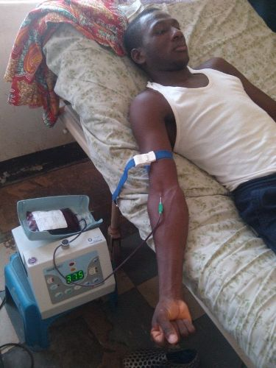
A Donor Donating Blood

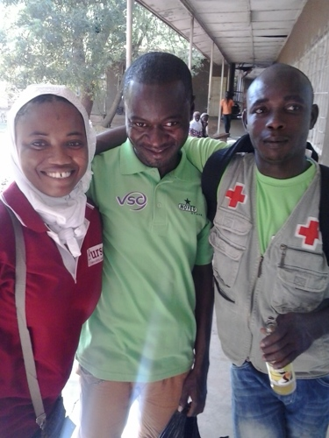
Staff of NOYED and Red Cross in a Picture
- Conclusions and Recommendation:
Guided by the successful conduct of the celebration through the series of activities carried out, the following recommendations are made in the spirit of promotion of voluntarism:
- There seem to be very little attention from the community members in supporting provide accommodation and other logistical support for volunteers and service personnel posted to the communities. More sensitization is needed in getting community members to understand that anybody holding chalk in the classroom does not necessarily mean is on salary. Hence, the need for them to support in providing for volunteers and service personnel to motivate them to do well to teaching the children.

- The Ghana Education Service District Directorate of the TENI districts should try as much as possible to encourage the head teachers/masters to apply part of the Ghana Partnership for Education Grant (GPEG) to renting at least single unit accommodation around their schools to help accommodate volunteers/service personnel posted to the schools. This move is highly recommended in the hard to reach areas where volunteers find it hard in getting accommodation. It is however recommended that GES regulates this idea very well to ensure that some head teachers do not take undue advantage to abuse the system.

- Volunteers should not see the work they are doing as a waste of their time but rather take it as a learning process to build their capacity. Though the process of volunteering, they will acquire invaluable skills that will help them in sailing through life.

- The District Assembly should also try and assist through the GYEEDA Coordinators and recruit the community volunteer teachers under the GYEEDA-CETA Module so as to help in motivating the volunteers. It is also expected that through that programme, the volunteer teachers who do not have some passes will be able to do some savings towards rewriting those subjects.

In conclusion, this year’s celebration will not have been successful without the support of VSO/Comic Relief. The focus of the celebration was on increasing community awareness and motivating the volunteers to do more while getting others aboard to join in volunteering. NOYED-Ghana is quite hopeful that we have been successful in this regard. We call on the duty bearers to support in anchoring volunteering in our developmental strategies since it has proven to be useful in driving sustainable changes in communities.

School Management Committees
National Libration Council Decree 208 of 1973
In-Service Training
Parent Teacher Associations
GPEG- The GPEG is a three year grant for US$75.5 million, implemented by the Ghana Education Service in 57 deprived districts in 8 out of 10 regions (Note: revised due to the creation of new districts). The project development objective is to improve the planning, monitoring and delivery of basic education services in the deprived districts of Ghana. A focus of the project is to strengthen decentralized decision-making and systems of school-based management and accountability. The GPEG grants will be used to address the strategic priorities defined in the country’s Education Strategic Plan: access, quality, bridging the gender gap and management of education service delivery.
GYEEDA - Ghana Youth Employment and Entrepreneurial Development Agency
CETA- Community Education Teaching Assistance

