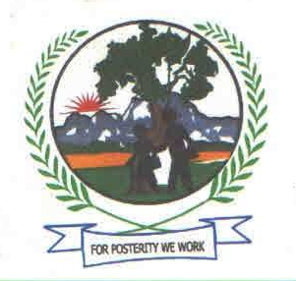
KIBOGA FOUNDATION FOR COMMUNITY DEVELOPMENT (KIFCOD)

WHO WE ARE
Kiboga Foundation for Community Development (KIFCOD), is a voluntary registered rural nonprofit and non-political, Community Based Organization indigenously inspired and oriented working towards community development in Kiboga district.
It was formed in December 2012 by Kasenyi Pentecostal Christian Revival Church members, with the endeavors of alleviating the common problems of poverty, disease, ignorance & backwardness that are so rampant in the district.

Vision
- A Centre for poverty reduction and environmental protection through community empowerment with the skills, knowledge and resources in Uganda.
Mission
- To provide excellent channels for community development and environmental management. We are not merely after implementing projects, but implementing projects in ways that will perpetuate best positive long term/sustainable and remarkable impact on the lives of the target groups. We at all times struggle to ensure that our work and that of our partners tackle the root causes of the problems in question and produce sustainable Community development.

Broad aims
To promote community based development, intercultural Understanding and community participation in development through voluntary work.

Broad objectives
- To promote social and economic well-being of orphans and vulnerable children
- To promote gender equity, girl child education and women economic empowerment
- To empower young people take a leading role towards development
- To contribute to the development of community based social services
- To contribute to the protection of natural environment
- To promote sustainable Livelihoods
- To promote HIV/AIDS awareness, care and prevention.

Core values
- Accountability
We highly treasure the time, effort, resources and advices given to us by all our stakeholders including the government, funders, political & religious leaders, and the Community at large. Therefore we from time to time produce systematic and comprehensive accountabilities portraying how the mobilized resources are spent.

- Team work
At KIFCOD we know that together we stand, divided we fall. Therefore when implementing any project we work as a team towards success, irrespective of departments or responsibility within the organization.
- Openness
We highly believe that to always be successful in our work we need to be frank to everyone. Therefore, we are always open and direct to all our stakeholders including funders and to only stick on nothing else but the truth.

- Integrity
As a team at KIFCOD we highly respect uprightness as one of the major guiding principles for any successful project/program. So we decided to always keep reliable and honest to all our stakeholders at all times as one of our core values.

Management
The management of the Organization is composed of; the Executive Board, Administration staff, and some committees struck by the organization from time to time for either advisory or administrative purposes.
The Executive Board consists of eight members including; the chairperson, vice chairperson, organizing secretary, Treasurer, General secretary, two members plus the Executive Director(a non-voting member) who is appointed or recruited by the Executive Board for a period specified in the organization’s terms and conditions of employment. Board members are elected at general meetings.

WHAT WE DO
Just as our Lord Jesus Christ, we believe in a just society where all people irrespective of their backgrounds and religious affiliations enjoy life equally to its fullness. For us we look at the poor as innocent people who never did anything bad to God, but only lack knowledge, opportunities and resources. So, our work intends to reduce human suffering of any kind, income inequality and social injustice.
We struggle to improve lives of the disadvantaged and more so for the poorest of the poor communities. We provide them with practical employable skills, basic necessities of life and contribute to development of community basic social services.

Our major intervention areas are;

- Children and Youths
- Women economic empowerment
- Water and Sanitation.
- Environmental protection

- OUR ORPHANS AND VULNERABLE CHILDREN’S SUPPORT PROJECT
Our major community interventions are on Orphans and vulnerable children in the district. We continuously struggle to see that they acquire primary, secondary and vocational education so that they can later on live a better life, and more so, strengthen their faith in Jesus
We mainly target those children who either lost their parents or come from very poor families, which such families at most rejoice for getting even a single meal in a day. Such children usually have little chances of going to school (if any) and usually find life so difficult and unbearable.
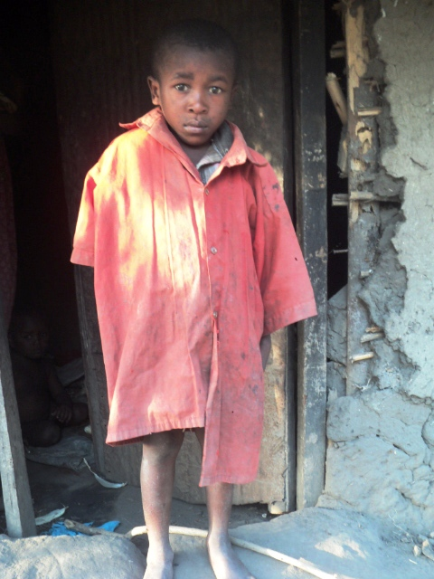
The likes of Kizza below;
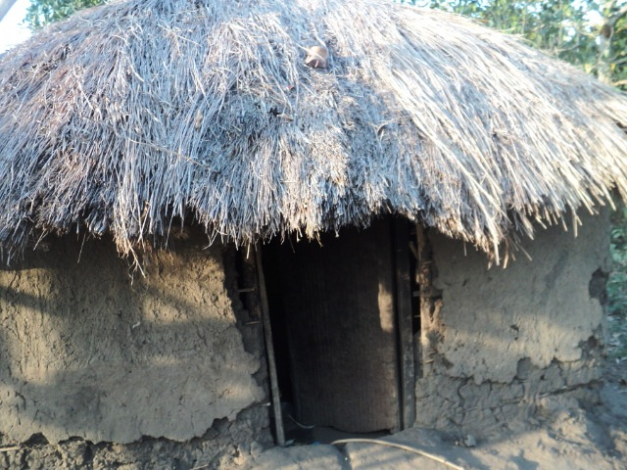

He is called Kizza Zadodi and is one of the Orphans we work with. On left is their home. Both of his parents died of HIV/AIDS. The guardian (uncle) never had any hope of taking him to school because there was no money and life was so difficult and almost unbearable at home. Zadodi has two other young brothers.

Through church contributions we are currently able to assist only 50 OVC whom we have supported to stay in school mainly through provision of scholastic materials. However our support this is far below the required both in number being supported and the kind of support.
Our orphans and Vulnerable children’s support program has attracted attention for many people around the district (as they are many needy and helpless children), forcing even some guardians to move as far 30 kilometres on foot to our offices to come and ask for support of their children.
Below is a picture of one lady called Nakamya Robina, a grandmother to Lwere Julius whose father also died of HIV/AIDS six years back and came from Kyamukweya village to our office a distance of over 30km to KIFCOD office, to be registered under the programme.

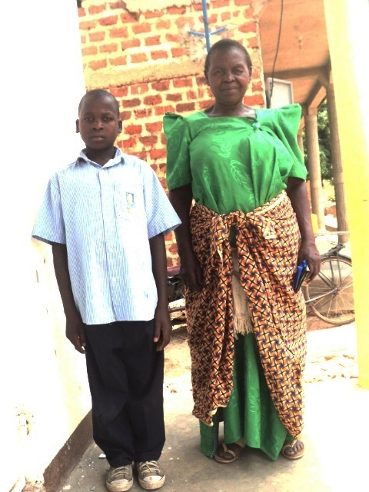

We monitor these children both at school and home and this has helped us to discover many things. For example, during our project monitoring visits we found out that, many of these OVC need to be supported with clothing and beddings as well (mattresses and blankets). Very many of them almost sleep naked without blankets and on bear ground, one of the factors we believe directly affect even their learning at school.

Below is Namuddu Ruth one of such children with almost no blankets. That is her blanket.
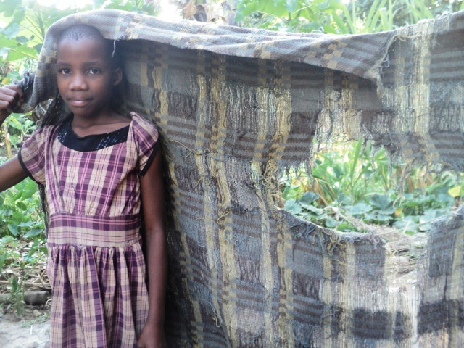
The little support we have been able to offer to the 50 OVC has enabled them to stay in school and reduced on their absenteeism as they now get the required scholastic materials. Consequently, the supported OVC have improved their academic performance because, lack of scholastic materials is one of the major factors hindering children’s attendance and performance in most primary schools in Kiboga district but this has been met. Again the morale of these children has been boosted, as they are now sure of being at school all the time and not being sent back home every now and then due to lack of scholastic materials.

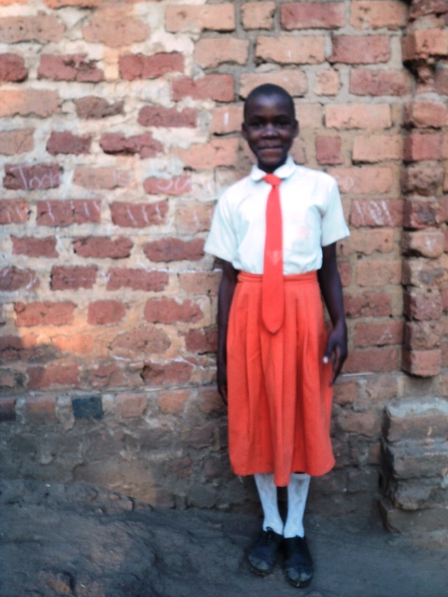
During the Previous year we purchased 375 dozens of 96 page exercise books, 12 packets of BIC pens, 35 mathematical sets and 23 dozens of pencils which were distributed to the 50 OVC under the program. In addition, we bought uniforms for 5 children under the project that were badly off.

On left is Nanyunja Marion of Royal Junior School in P.5 outside her class, fully dressed in the school uniform bought for her by KIFCOD.

Most of these OVC were able to present their academic reports to us and we have them in our records/in their files

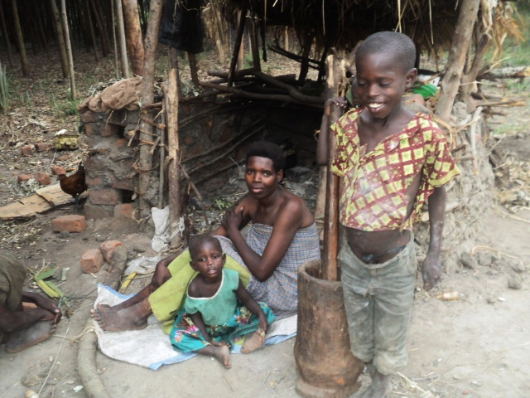
- There is massive poverty in the district which really calls for help of these children. Many children around the district hardly get clothes, beddings, or even a single meal in a day besides some of them failing to attend school.
Below are Mr. Musoke’s family members at their home in Kakunyu .B. village-Bukomero Town Council (Kiboga) He has four children, three of whom are of the school going age but none is schooling due to financial problems.

Though Peter (above) is aged 8, he is not schooling because his parents cannot afford his Scholastic materials and the family hardly gets something to eat. In the far background is their house.
Though we are currently able to support only 50 children, we have identified and registered 800 more others in dire need around the district. Below is a photo Album for some of these;

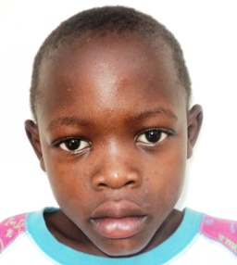
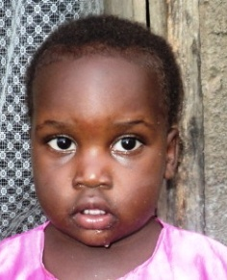
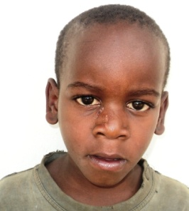
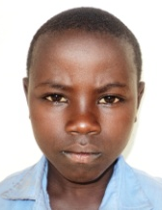
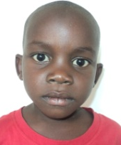
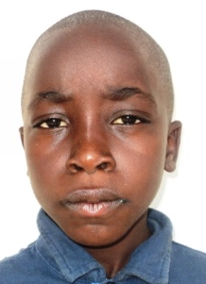
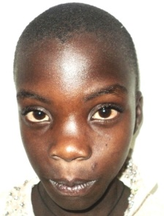
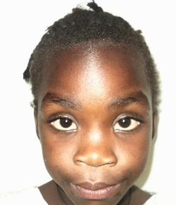
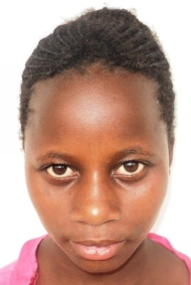
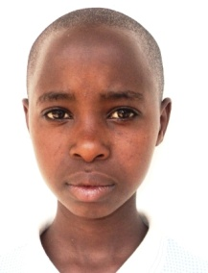
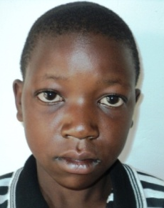
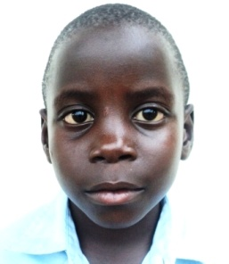
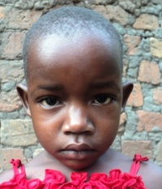
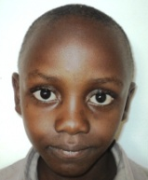
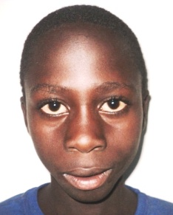
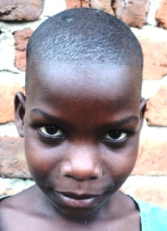
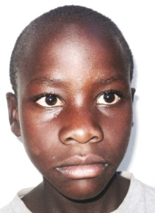
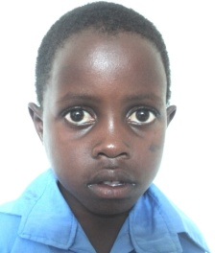
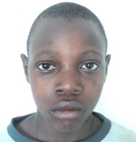
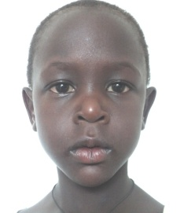
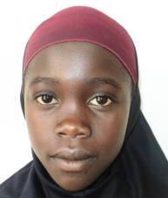
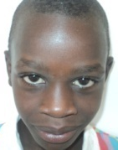
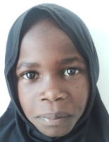
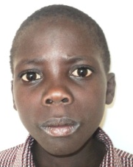
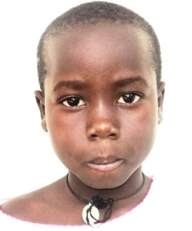
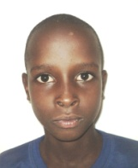
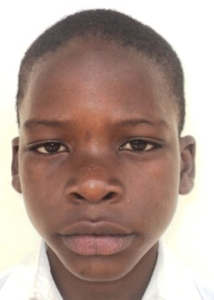
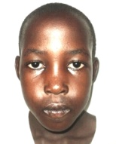
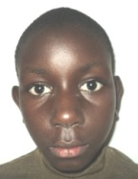
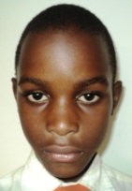
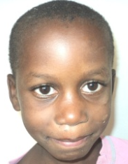
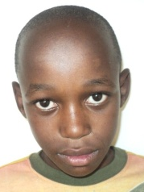
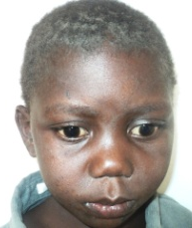
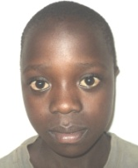
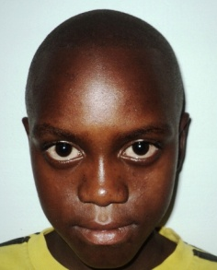
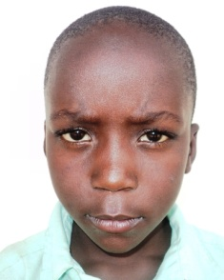
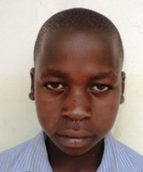
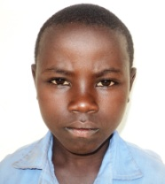
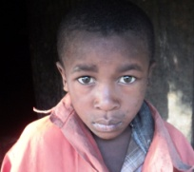
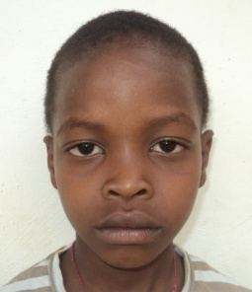
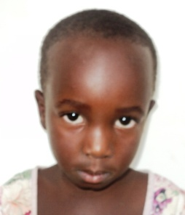
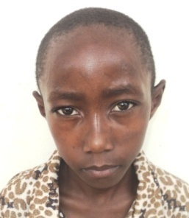
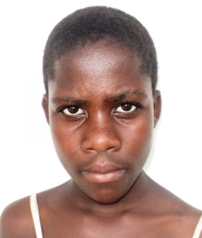
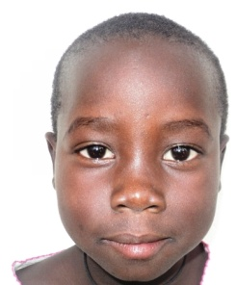
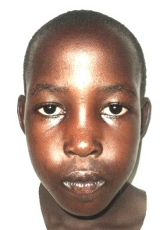
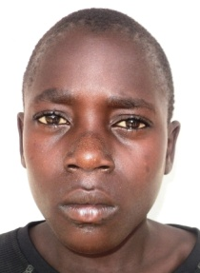
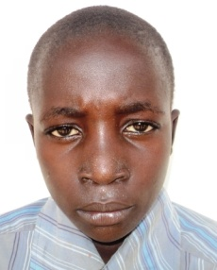
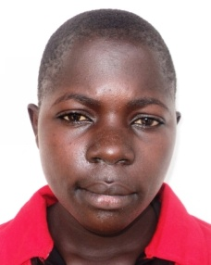
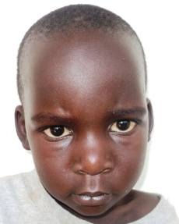
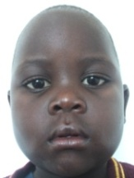
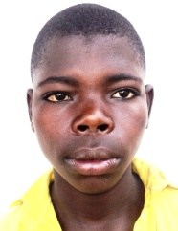
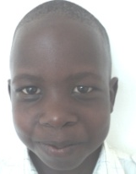
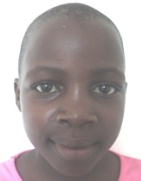
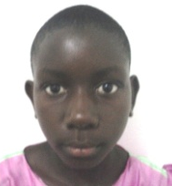
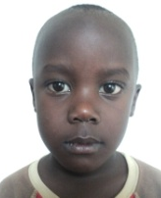
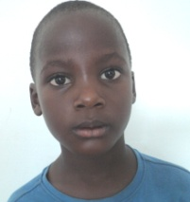
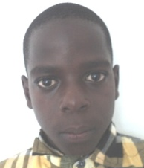
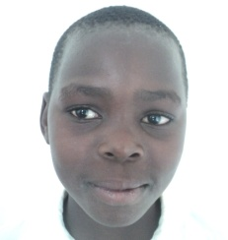
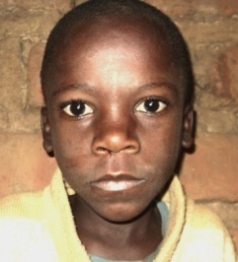
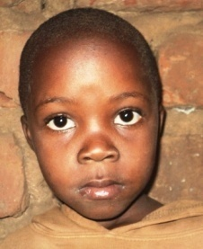
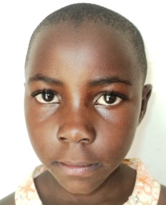
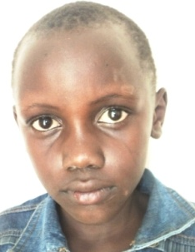
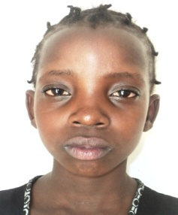
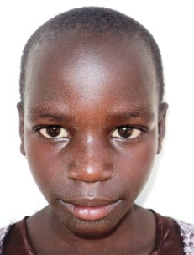
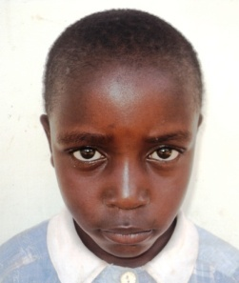
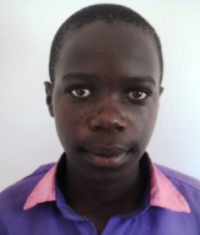
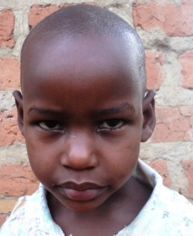
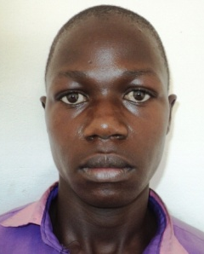
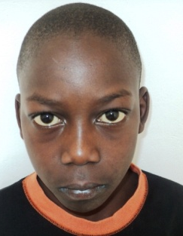
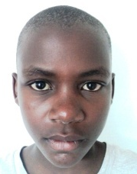
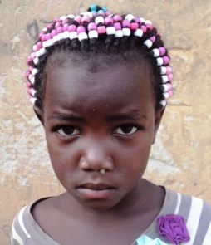
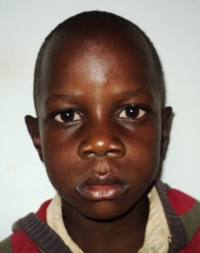
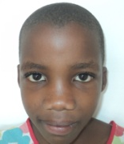
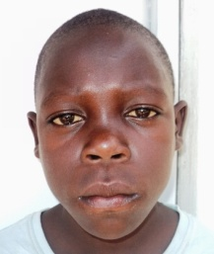
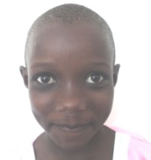
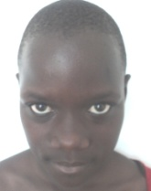
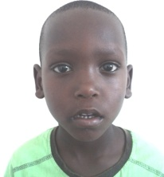
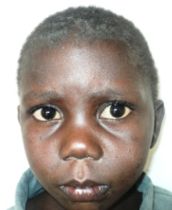
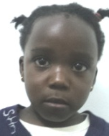
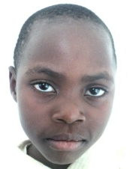
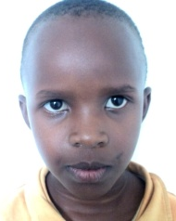
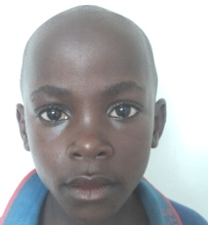
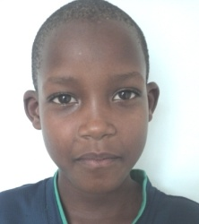
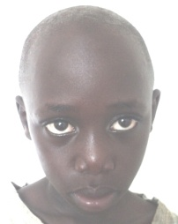
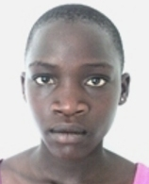
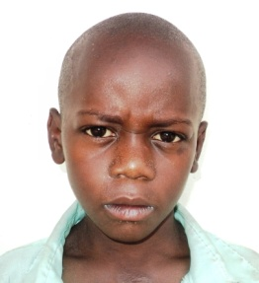
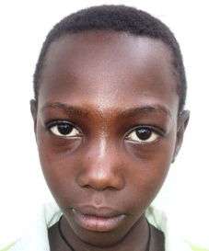
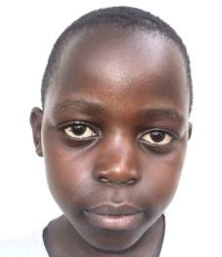
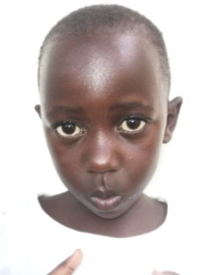
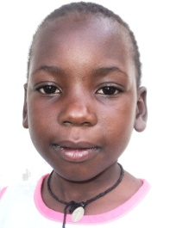
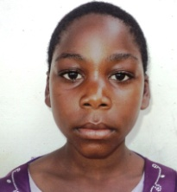
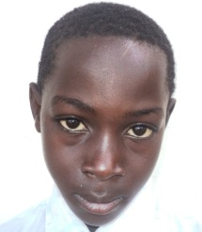
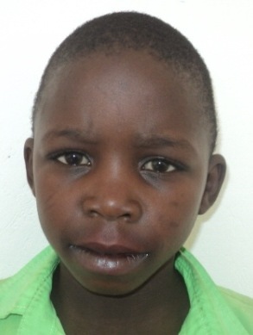
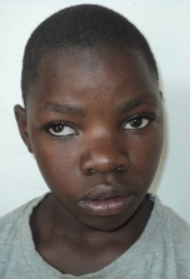
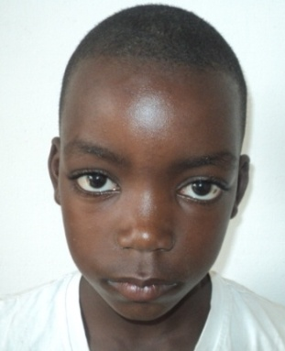
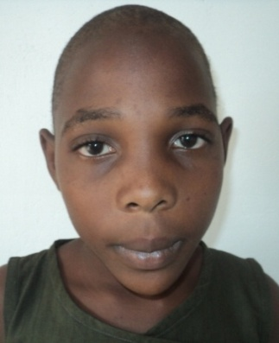
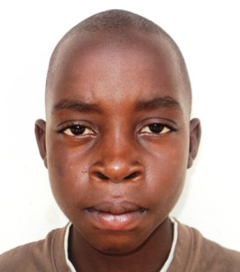
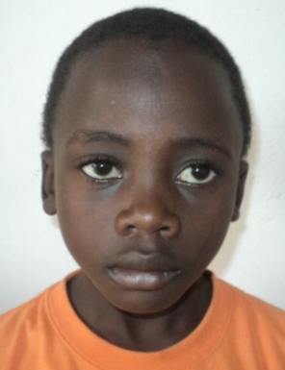
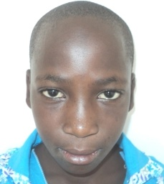
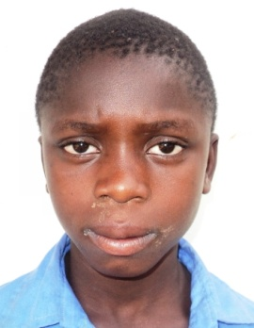
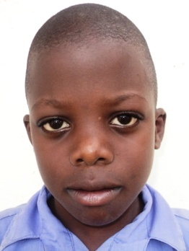
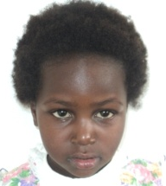
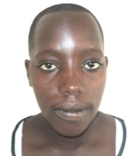
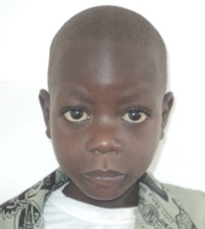
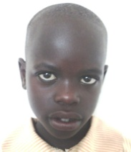
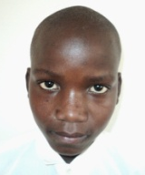
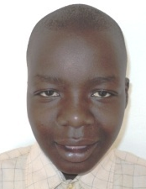
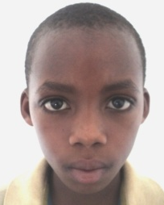
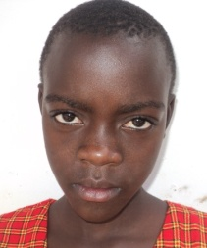
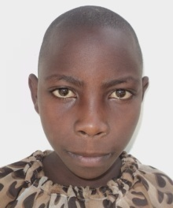
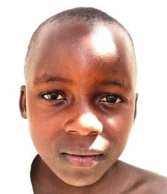
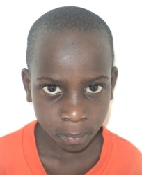
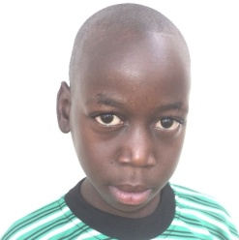
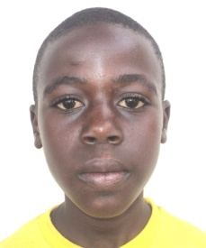
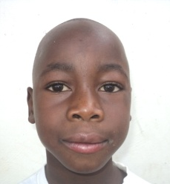
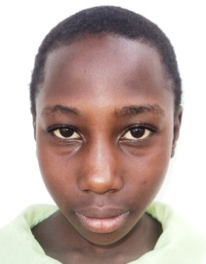
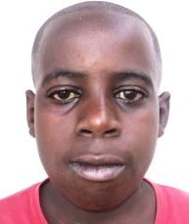
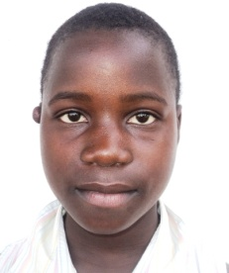
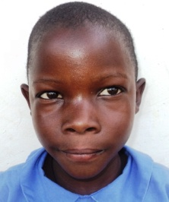
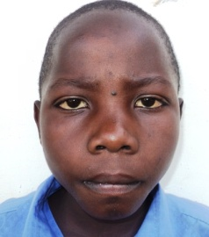
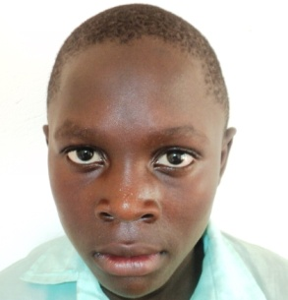
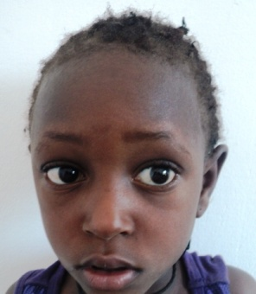
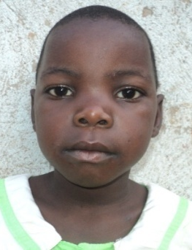
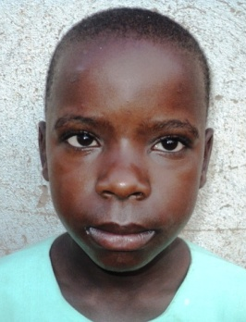
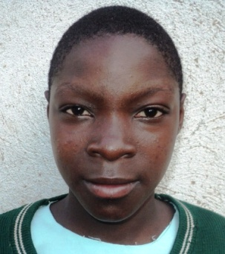
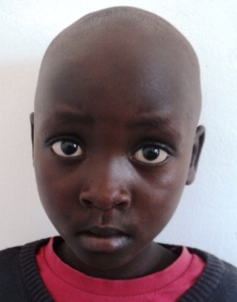
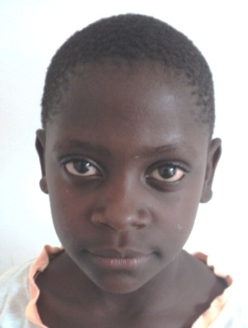
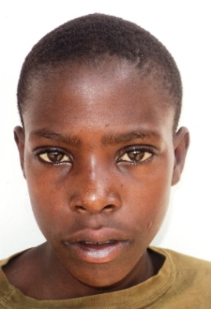
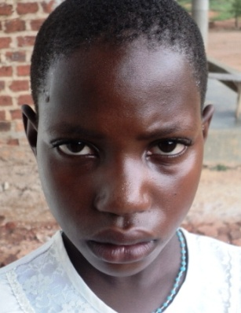
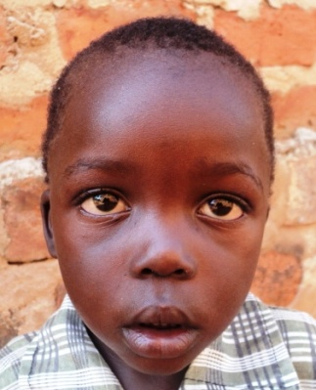
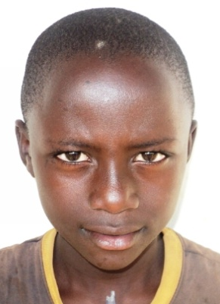
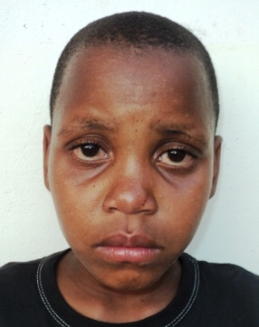
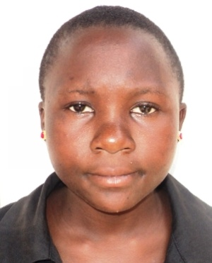
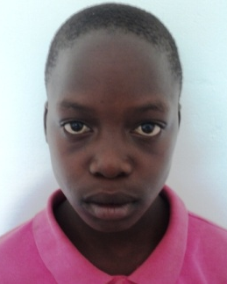
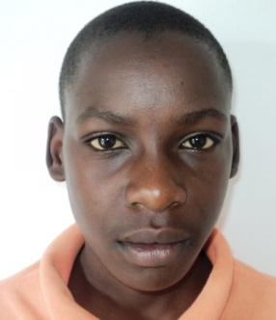
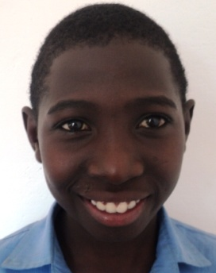
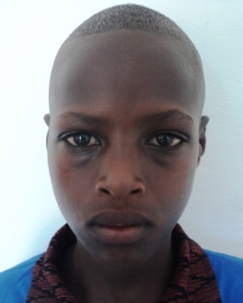
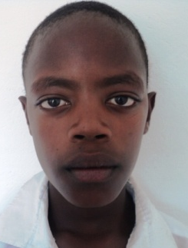
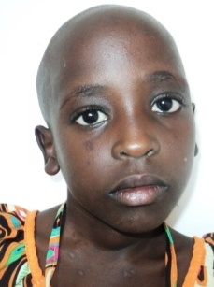
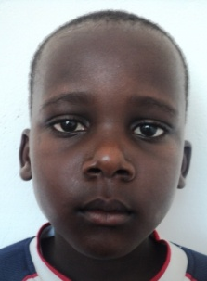
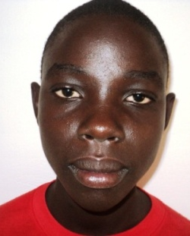
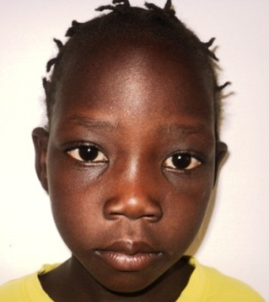
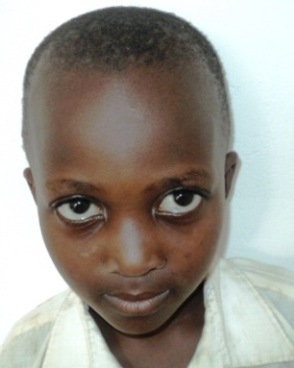
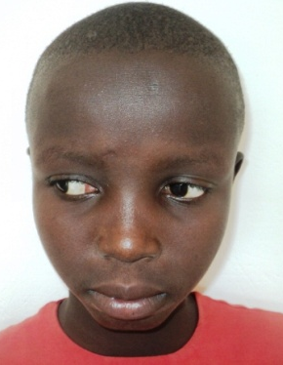

- More so, some of these OVC need to be offered medical assistance (occasionally) by meeting costs of drugs that are prescribed in Government Health Centres but are not available at the time of treatment and are supposed to be purchased by the guardian from private clinics or pharmacies/drug shops. There is also need for OVC counselling on HIV/AIDS prevention, care, and carrier guidance, as well as raising child rights awareness amongst the community.

MAJOR PROJECT CHALLENGE
- We always look for alternative sources of funding (both local and international) to supplement on our locally raised revenue, but our organization being new, small and poor we have found it so challenging. It is as if many donors only want to associate with big organizations with very big projects, decades of working experiences, multi-decades activity reports, multi- year audited financial statements and high annual turnover which we do not have yet would also like to contribute to the development of our community in the district.

WHERE WE WORK
We work in Kiboga district, Uganda. Kiboga district is indeed one of the poorest districts in central Uganda, let the country alone being of the poorest Nations in whole world because according to the recent UNDP report about Human Development Index of 2014, Uganda was ranked 164th out of the 185 countries considered worldwide.
The district is characterized by a great number of orphans and vulnerable children particularly due to HIV/AIDS epidemic, high rate of unemployment among the Youths due to low levels of education and lack of practical skills, high birth rates due to early school drop outs mainly perpetuated by failure of many guardians to meet school requirements for their children, and a very high rate of environmental degradation due to severe cutting down of trees mainly for charcoal burning since in many parts this seems to be only income generating activity.
WHAT WE WANT
To help us establish a primary and secondary school from where we can cater for these children.
CONTACT:
KIBOGA FOUNDATION FOR COMMUNITY DEVELOPMENT Physical Address: Bukomero Trading Centre, Bukomero Town Council,
Kiboga district – Uganda (East Africa)
Telephones: +256 777 311 854, +256 753 843 111
Email: kifcod@gmail.com

