FLARMIC CARE CENTRE & SCHOOL (FCC)

The flarmic care centre & school (FCC) is a non-profit charitable organization serving as a Faith based organization for the local communities in Kenya and was formed as a project of Flaming River Church for the following purposes:

The FCC shall have at heart the religious cultivation, spiritual growth and development of the needy people, enabling them to stand firmly in their Christian faith, to devote themselves to Christian mission and to uphold the following purposes as the basis of all the activities of the organization:
- To act as a Faith Based organization within the family of the gospel preachers ministries and the universal Church of Jesus Christ.

- To encourage by all means the education interests of and religious educational, literary and philanthropic work of local Churches, organizations and individuals throughout the world right from the childhood stage.

- To promote fellowship among the local churches and the Evangelical-Protestant people throughout the world.

- To do everything necessary or incident for the accomplishment of any or all of the foregoing purposes, including the establishment and management of trust funds and the acquisition of bequests, consistent with the law and within the principles of Christianity.

- The prevailing circumstances is ripe for this project because of numerous factors ranging from abject poverty, declining pupil enrolment in schools, ravaging HIV/AIDs leading to increasing numbers of orphans and vulnerable children. We are therefore intent upon offering hope in the face of cruelty of the real life situation and experiences. Our assessment reveals that these children lack support system for them to learn and become reasonable and helpful members of the society when they grow up. This will therefore be an intervention measure to complement government efforts in education. Our concern is driven by an open secret that the government efforts is faced by numerous challenges like the reasons cited above. Most public schools do not have a mechanism to assist OVCs (orphaned and vulnerable Children), and therefore such children naturally get locked out of the educational system.

- What is the spiritual impact of FCC?

As Christians we believe and cherish the concept of sharing and giving. We, however, are incapacitated financially to be able to match our aspirations and desires with positive and pragmatic actions. It is therefore our belief that with this project, we shall be able to reach the souls of many children, parents and guardians whose aim is to better their lot through education but who are faced by challenges that inhibit this realization. In our plans, we intend to bring on board without discrimination all deserving cases as we take cognizance of the levels of poverty and increasing numbers of destitute children in our society, and the cost implications against the number of children to be assisted.

- Who is FCC trying to help? What issue is FCC trying to address?
Our project focuses on helping children from poor families in local churches, including those affected or infected by HIV/AIDs. Community education for behavior change is also being addressed to minimize the spread of HIV/Aids and to reduce stigma, promoting the wellbeing of neglected children from the slums. Provision activities shall also be conducted at the centre, acting as a model for other projects within the community. It is intended, on a long term scale, that the school shall be modified to act as a center of excellence facility for the community to promote the best interest of the children and the society at large. 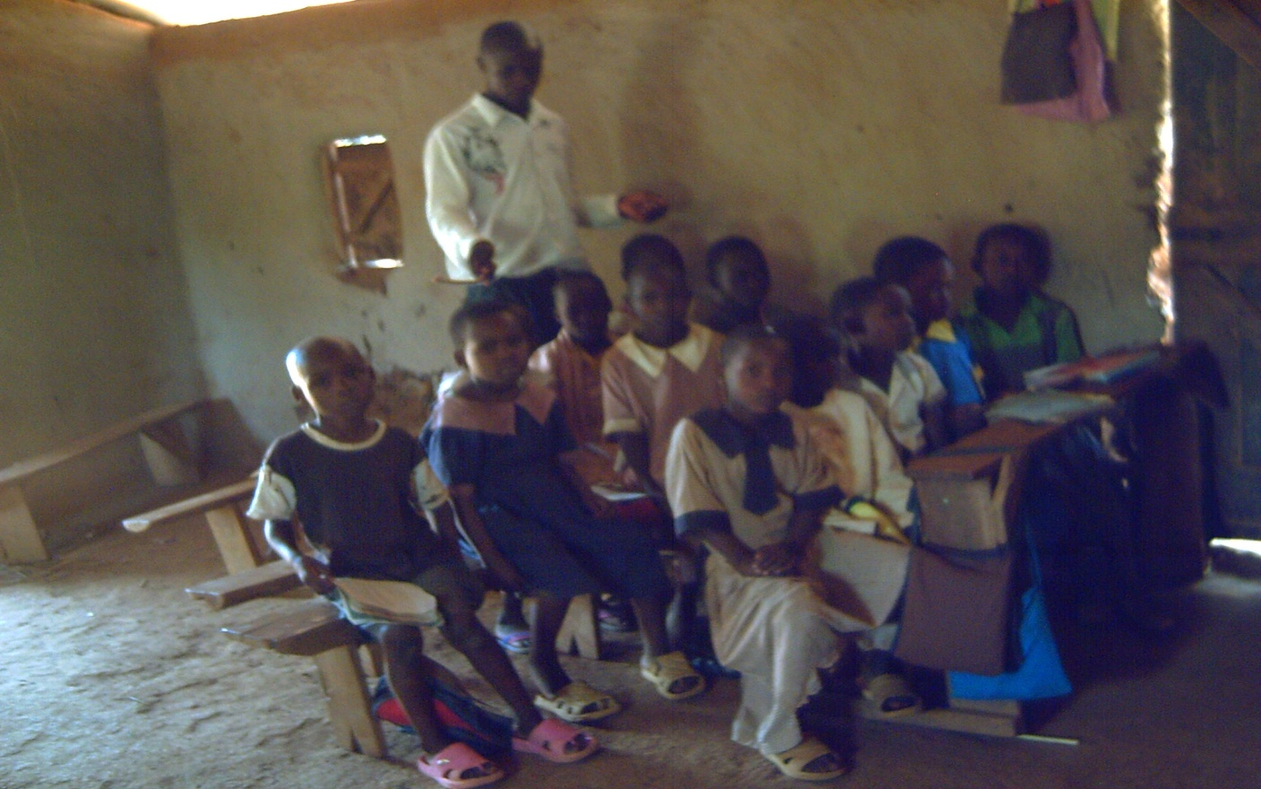Standard I learning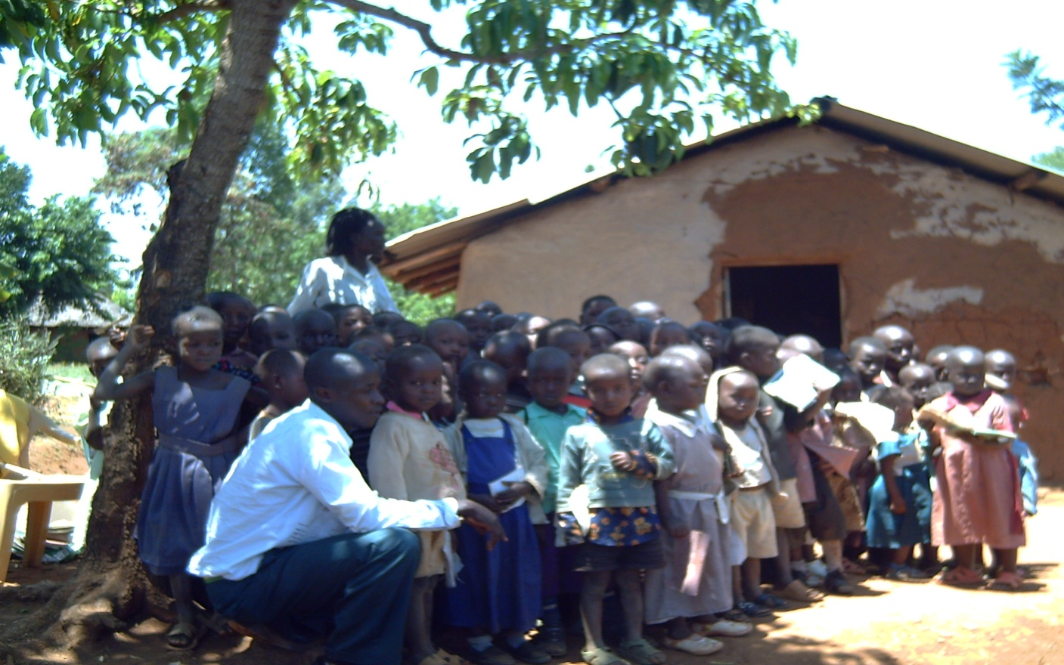
Pupils assemble with their teachers outside the church hall which also doubles as a classroom.
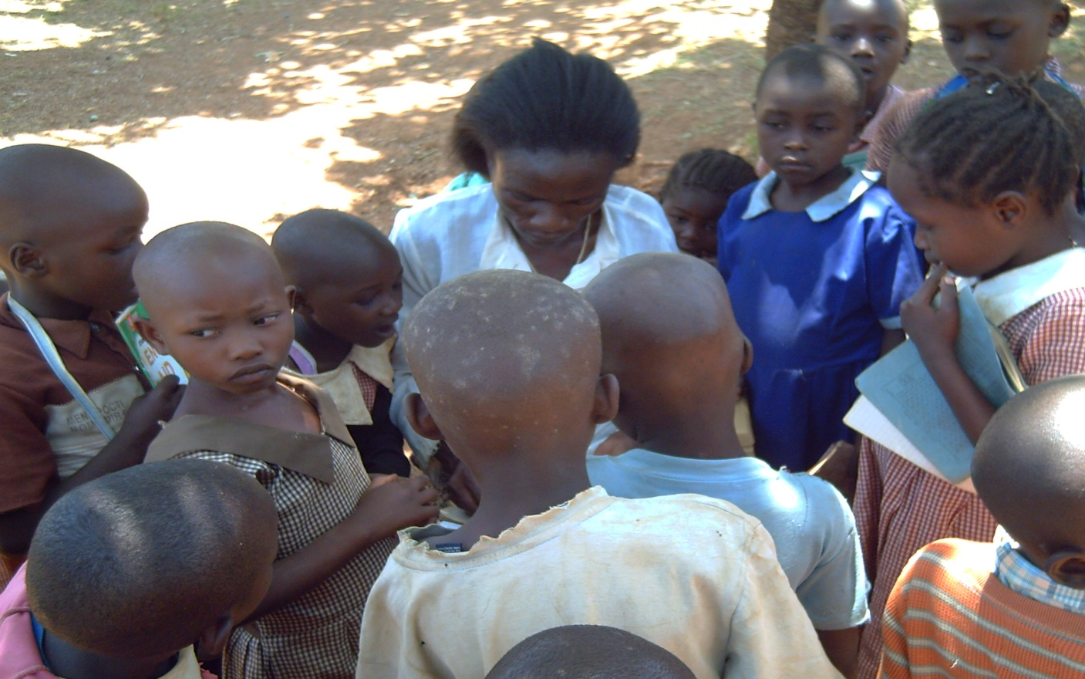.
A teacher assessing pre-unit class work
- What is FCC and how will it help?

FCC is focused on the provision of education to the less fortunate children in the community. The centre will help by mobilizing the needy Christian children to receive education and in long term also to improve their life standard. We focus to provide meals, books, medication, counseling and other support services that would go along in providing both short and long term support for children in the local churches and communities. Our centre focuses on community empowerment projects for sustainability. Improvement of environmental protection, water and sanitation are also being addressed to counter the documented challenges that affect children in poor neighborhoods.

In general, the school and learning project through the church shall constitute a paradigm shift in value systems; this actually is the core of the project as it is our aim to nurture and bring forth children with good Christian values that will ultimately cascade down to the entire locality and by extension the whole Kenyan society. This prediction is based on the fact that after their schooling, they will end up in various corners of the country and even beyond in search for gainful opportunities. In essence we are forestalling such vices as drug addiction, alcohol abuse, promiscuity, indiscipline and the like. 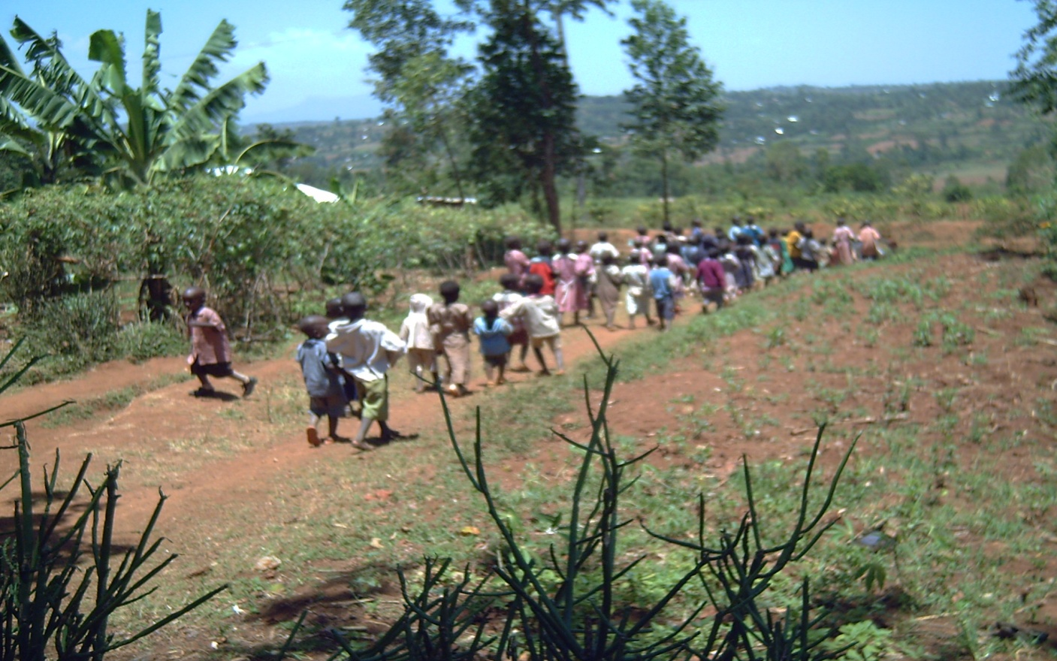

Pupils leav

Pupils leave school for their homes

- How can other people partner with us in our project?

The interested individual or organization can collaborate and partner with us by providing financial or material support. Volunteers for the project would also be appreciated, as well as support in the objectives of the project. Organizations willing to conduct trainings and provision of food are welcomed for the purpose of the project development. FCC projects will be documented for future references. 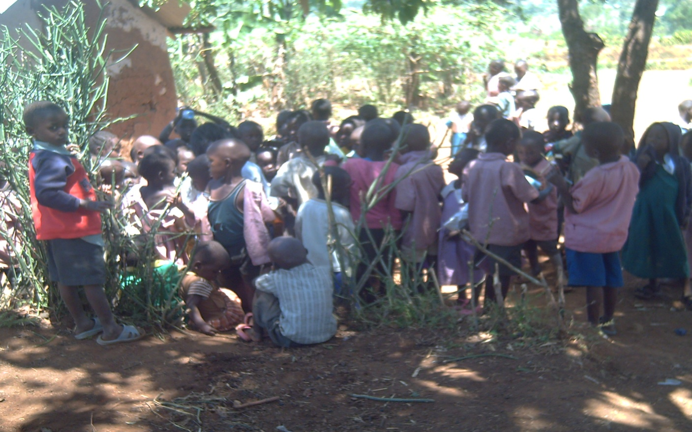

CC
Pupils break off from their classes outside the church compound
Location: Homa-Bay County
Nyanza Province
P.O. BOX 22-40309
Asumbi.
Kenya, East Africa.

Further information Contact:
Project coordinator: Lawrence Adera- loadpastor@yahoo.com; jakadera.kuj82@yahoo.com
General Information: flamiccarecentre@yahoo.com
Directors:-
Bishop Peter Odede pastorotieno2007@yahoo.com +254(0)728 825 304
Pastor Lawrence Adera loadpastor@yahoo.com +254(0)723 093 729
James Otieno +254(0)711 279 338
Jacqueline Adoyo
Beatrice Atieno

