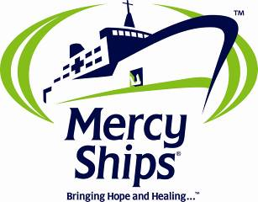

A Mercy Ships Proposal

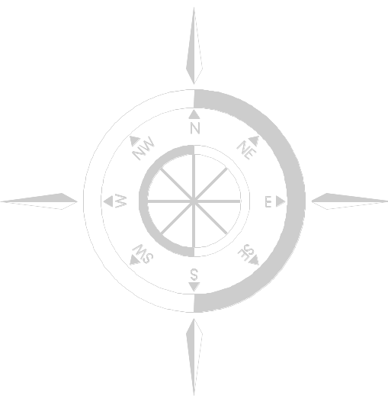
The Africa Mercy Project

Powering the World’s Largest
Private Hospital Ship
Serving Western Africa

For more information, contact:

Bryce Wagner
Director
Mercy Ships Switzerland
bryce.wagner@mercyships.ch

Diane Rickard
Foundations and Grants
Mercy Ships Switzerland
diane.rickard@mercyships.ch

Project Code: AFMOC11

Executive Summary

Mercy Ships is an international faith-based organization which seeks to increase access to health care in the developing world. The organisation deploys the world’s largest private hospital ship, the Africa Mercy, to host nations in western Africa. Mercy Ships provides surgical and medical professional training with infrastructure development while providing curative surgical interventions. The organisation accomplishes these goals by working with local health authorities to build capacity and support sustainable facilities. Collaborating with qualified local and international partners, Mercy Ships programmes offer holistic support to developing nations striving to make health care accessible for all.

Since 1978, Mercy Ships has directly served almost three million people in the Caribbean Basin, Central America, the Pacific Islands, and sub-Saharan Africa. As an international non-governmental organization (NGO), Mercy Ships collaborates with local partners to target the nations listed by the UN Human Development Index (UNHDI) as some of the world’s poorest countries.

Commissioned in May of 2007 to serve the continent of Africa – and in particular western Africa – the 152-meter Africa Mercy is a state-of-the-art floating hospital containing six operating theatres, a 78 bed ward, an intensive care unit and accommodation for over 450 multi-national crew and personnel. Most countries in the West African region rank among the lowest in the world in quality-of-life indicators such as child mortality rate, life expectancy, access to essential health care, basic education and clean water and sanitation. The Africa Mercy is serving this region, helping to address fragmented health and infrastructure systems. The lack of trained health care workers and inadequate resources combine to prevent millions of children and adults from receiving life-saving treatments and vital medical services.
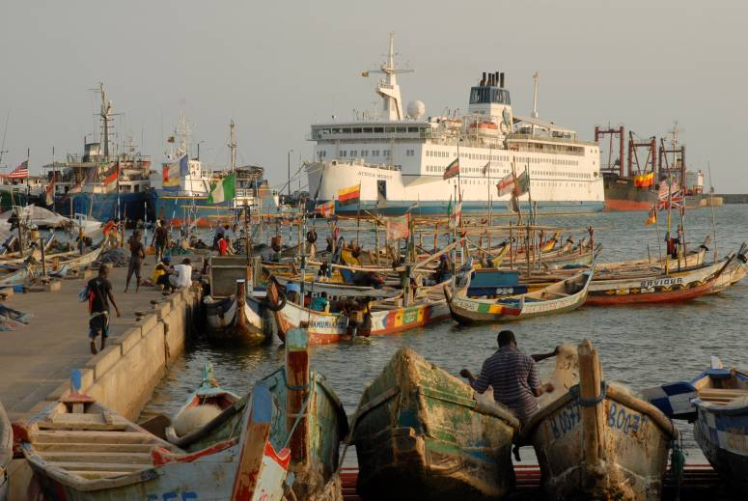
To provide delivery of cost-effective programmes, this proposal requests funding support for a portion of the operational costs of this unique floating hospital. Partnership in the ship’s operational costs equates to partnership in all the programmes that are delivered to host nations and their peoples.

The annual budget for these costs is estimated to be $ 6,104,991. Mercy Ships will contribute funds of $1,783,668. The funding balance required is $ 4,321,323.
Project Code: AFMOC11
Project Goal: The goal of the Africa Mercy is to strengthen the capacity of the least developed countries in the western Africa region to increase access to health care.
Project Objectives:
- Maintain a world-class hospital setting that increases local capacity by providing medical training in surgical techniques, hospital management, and other health care areas.
- Maintain a world-class hospital setting to provide thousands of curative surgical and dental interventions annually.
- Strengthen the capacity of local organisations, clinics, hospitals, and other stakeholders through community development projects and infrastructure support.
- Increase the cost efficiency of the Africa Mercy program delivery by providing ship operational costs, further increasing the number of beneficiaries that can be served each year.
Total Project Duration: January – December 2011
Project Manager:
Jim Paterson
Senior VP International Operations
+1 903 939 7085
jim.paterson@mercyships.org

Contact Person:
Bryce Wagner
Director
Mercy Ships Switzerland
+ 41 21 654 3210
wagnerb@mercyships.ch

Budget Summary
Operating Revenues | $1,783,668
Operating Expenses | $6,104,991
Total Request | $4,321,323

* Revenue does not include Gifts-in-Kind or Contributed Services
** Expenses do not include Gift-in-Kind distribution, spoilage, or Contributed Service Expenses

The Project at a Glance

Organisational Background

Mercy Ships was founded in 1978 with a vision to use ships as mobile bases of operation to improve access to heath care in some the world’s most destitute nations through providing capacity building programs partnered with meeting the urgent surgical needs of the poor. First launched in Lausanne, Switzerland, the Swiss office now collaborates with offices in 15 nations and remains a core office for the organisation. In addition to immediate assistance offered through the specialized onboard surgeries, the focus includes long-term programmes that promote sustainable change. Over the past 32 years, Mercy Ships programs have improved the quality of life of the poor in 53 developing countries.

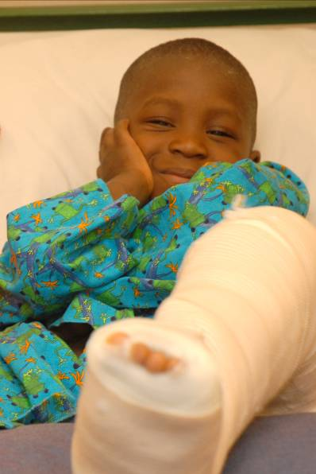
The former flagship vessel, Anastasis, was converted from a passenger vessel into a hospital ship in 1978. Health care and community development teams have performed thousands of surgeries and implemented programs increasing access to clean water and sanitation, basic education, income generation, and food production. In 2007, after over 28 years of service, the 159-meter Anastasis was decommissioned. In its proud service history, the Anastasis was a leading international medical centre for treatment of diseases prevalent in the developing world including noma, vesicovaginal fistula (VVF), and life-threatening tumours.

The 80-meter Caribbean Mercy was added to the fleet in 1994 and deployed in the Caribbean Basin and Central America. The Caribbean Mercy provided eye care services and cataract removal for more than ten years. The fifty-year old ship was retired in 2006 as a result of its age and rising maintenance costs.

The 152-meter, 16,500-ton Africa Mercy is the newest ship in the fleet and was deployed to Liberia, West Africa, in 2007 for its first year in service. With six surgical suites and a 78-bed hospital ward, the Africa Mercy has twice the surgical capacity of the Anastasis.

As a result of its initiatives, Mercy Ships has performed services in developing nations valued at more than $834 million and impacting almost three million people. Listed below are samples of completed projects:
- Taught over 29,000 local health care and professional workers, who have in turn trained many others.
- Completed over 1,095 community development projects focusing on water and sanitation, education, infrastructure development and agriculture.
- Performed more than 56,000 free operations, such as cleft lip and palate, cataract removal, straightening of crossed eyes, orthopaedic interventions, facial reconstruction, and fistula repair.
- Treated more than 520,000 people in village medical clinics.

The field personnel onboard the ship are primarily volunteers, including doctors, nurses, community development technicians, and more. Ship-based staff members do not receive a salary for their services and even contribute monthly fees to cover room and board expenses. This significantly reduces the organisation’s operational costs. In a typical year, Mercy Ships has more than1,200 volunteer crew from over 40 nations.

Mercy Ships also has well-established relationships with numerous business entities that offer gifts-in-kind support, dramatically offsetting programme costs. Corporate partners such as Johnson and Johnson, Alcon, BD, and others contribute donations of medicines and medical supplies, enabling the sponsor to contribute to the global community.

Needs Assessment

Availability of health care services in Africa is extremely limited. Basic health indicators show that the majority of the population in sub-Saharan Africa does not have access to safe and reliable health care. Life expectancy for most of the continent is only 52 years. Additionally, quality-of-life indicators – such as infant mortality and morbidity rates, maternal mortality, and literacy – are among the lowest in the world, according to the UNHDI. The absence of qualified medical personnel, reliable access to medicine, and adequate health infrastructure creates a critical gap affecting millions of the most vulnerable populations who do not have access to basic health care.

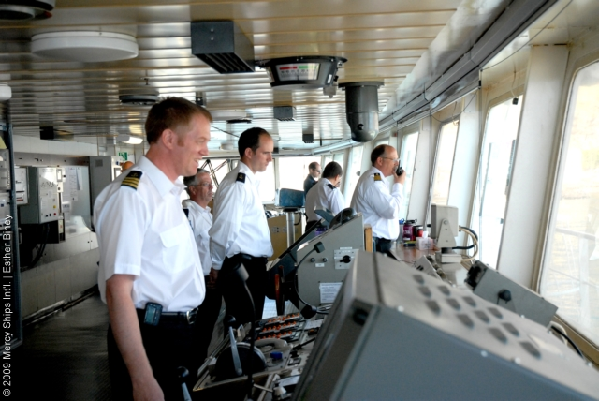
The need is overwhelming: every day, African children die from diseases linked to poverty and malnutrition and from readily correctable birth defects, such as cleft palates and lips (UNICEF – 2004). Most of these deaths are preventable. Those that survive diseases, physical defects, or injuries often become outcasts from society, rejected by their parents and communities and denied even basic schooling because of their condition. This marginalisation only perpetuates and deepens their poverty.

Recent statistics show an estimated 400 million Africans live in poverty today; a sharp increase over the past decade. Although ambitious efforts on behalf of governmental and non-governmental organizations have resulted in the decrease of extreme poverty in other parts of the world, Africa is the only continent where the poverty level is actually rising.

For example:
- More than 50 percent of Africa's 800 million people survive on less than $1.25 a day.
- Nearly 40 percent of sub-Saharan adults remain illiterate.
- Before they reach the age of five, 166 of every 1,000 children die.
- Average life expectancy is 52.1 years.

Goals and Objectives

Goal: The goal of the Africa Mercy is to strengthen the capacity of the least developed countries in the western Africa region to increase access to health care.

Objectives:
- Maintain a world-class hospital setting that increases local capacity by providing medical training in surgical techniques, hospital management, and other health care areas.
- Maintain a world-class hospital setting to provide thousands of curative surgical and dental interventions annually.
- Strengthen the capacity of local organisations, clinics, hospitals, and other stakeholders through community development projects and infrastructure support.
- Increase the cost efficiency of the Africa Mercy program delivery by providing ship operational costs, further increasing the number of beneficiaries that can be served each year.

Project Description

The skills of many medical volunteers in Africa are limited by the tools they have to work with and the conditions of local facilities. These limitations are largely removed by the use of state-of-the-art hospital ships. Mercy Ships staff who have worked in Africa through land-based operations note that up to 50% of their time and energy was spent maintaining the basics of living, all of which are provided for on the ship. The organisation’s ship-based platform provides “first world” surgical and living conditions. This safe working and living environment allows highly qualified volunteers to more fully maximize their skills, while giving patients and their care givers safe, clean facilities for their surgeries and recovery.

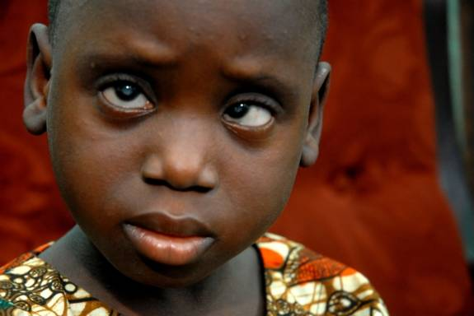
In addition, the state-of-the-art hospital can be delivered to areas of great need to fulfil the mission regardless of local infrastructure constraints. The vessel can also be removed from a program site if instability reaches critical levels – meaning that valuable investment in hospital technology can be protected and staff safety assured.

The acquisition of the Africa Mercy represented the culmination of a thorough process of analysis and research into the best possible platform to utilise for the construction of a hospital ship. The feasibility study included complete analysis of recent vessels in the Mercy Ships fleet, input from all programme sectors of Mercy Ships, outside professional counsel, and onsite inspections of various vessels on the market. The Africa Mercy’s original design as a roll-on/roll-off vessel displayed a key advantage to Mercy Ships: the large cargo decks presented a clean, open area for installation of the hospital unit and program staff accommodations. The hull, engine room equipment, and navigational equipment were also in prime condition upon purchase. Furthermore, the basic ship construction and outfitting complied with current safety codes creating a clear advantage over older style ships.

The ship design allows the Africa Mercy to dock in shallow ports because she draws less than six meters – meaning she could potentially dock in a port that is only 7 meters deep. The Africa Mercy is also very manoeuvrable because of side thruster engines which are very beneficial when tug boat availability is limited or lacking. All of this translates into the Africa Mercy being able to dock in spaces that are less accessible to other ships allowing cash-strapped countries to keep more desirable docks open to commercial vessels.

Deployed in 2007, the Africa Mercy will have an estimated service life of 30 years and remain in each host nation for approximately ten months out of the year. The Africa Mercy is deployed to countries based on UNHDI rankings, invitations from local governments, ongoing needs and safety assessments, requests from the NGO community, and consultations with African leaders.

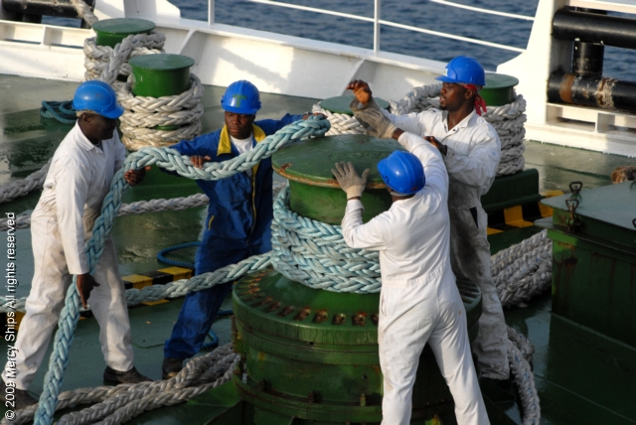
Within a regional focus, Mercy Ships establishes partnerships with host governments and their health care agencies, other NGOs and local agencies to address local and national needs. Programme delivery is designed to strengthen existing heath infrastructure systems and maximize the long-term impact of medical and professional training initiatives. The weight of overwhelming needs, particularly among the poor and underserved, are addressed through the provision of surgical interventions in order to decrease backlogs. Patients are accepted via a publicised screening process without regard to religion, culture, gender, or financial status. Services are provided free of charge.

Training programmes, such as surgical fellowships, surgeon training and mentoring, biomedical technician training, hospital administration training, and other health care worker programmes increase local capacity for the long term. Again, the secure environment is particularly conducive to medical training. Trainees do not have to worry about the day-to-day necessities involved in running a clinic, including the availability of clean water and electricity. Each trainee is able to focus on the instruction, maximizing the quality of the sessions. Increasingly, Mercy Ships is working to improve and expand medical training and instruction.

In addition to training, Mercy Ships increases access to health care through clinic, ward, or hospital infrastructure improvement projects and through health summits and conferences.

The operational costs of the Africa Mercy include marine fuels, dry dock expenses, maritime licenses and insurances, etc (see budget). A portion of operational costs are addressed through crew fees paid by volunteers and ship overhead costs apportioned to each medical or health programme through additional funding proposals. Currently, these operational costs are not fully met through these sources and the balance is accommodated by the Mercy Ships general funds. This places a strain on the annual budget and specific support for the balance of operational costs is sought through this proposal. Partnership in the operational costs of the Africa Mercy equates to partnership in EVERY PROGRAMME delivered through this vessel. The programme portfolio is based on the successful model established by the Anastasis in Western Africa since 1990:
- Health infrastructure development
- Education of health care professionals
- Health care facilities construction and/or renovation
- Technician training and equipment repair
- Health care workers training and mentoring
- Hospital administration training
- Mental health training and mentorship

- Curative medical/surgical interventions
- Specialised Surgeries
    - Obstetric fistula (vesicovaginal or VVF fistula)
    - Cataract and specialized eye surgeries
    - Noma, maxillofacial, and cleft lip and palate
    - Orthopaedic and burn reconstruction
- Dental treatment

- Partnership-based preventative health strategies
- Agricultural productivity and land-use projects
- Well rehabilitation and construction
- Sanitation/latrine construction

Reporting/Accountability
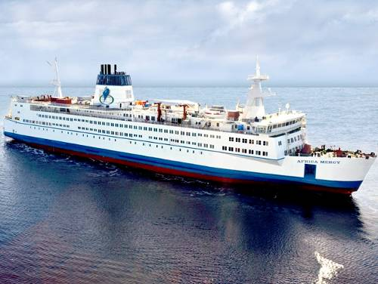
Mercy Ships is registered as a charity in 17 nations. Key coordinating offices are located in Switzerland and the US with European offices in the UK, Netherlands, Germany, Spain and Scandinavia. Mercy Ships complies with all auditing and tax laws of those countries. Mercy Ships is also a signatory to the International Red Cross Code of Conduct. Mercy Ships complies with all auditing and tax laws of those countries. Mercy Ships is also a signatory to the International Red Cross Code of Conduct.

External reporting is accomplished in Mercy Ships through a comprehensive annual report. Customized individual reports are produced for major partners, such as foundations and corporations, on an agreed upon basis as related to specific programme funding.

Budget

Description | Budgeted Total for 2011
Fees - Staff/Crew | 1,653,000
Net Sales Revenue | 60,000
Miscellaneous Revenue | 70,668
Total Revenue | $1,783,668
Insurance - Ship |  | 312,000
Marine - Dry-docking Expense |  | 0
Marine - Port & Chart Expense |  | 400
Marine - Fuel Expense - Diesel |  | 1,880,000
Marine - Fuel Expense - Lube Oils |  | 65,000
Marine - Port Agency Expense |  | 90,000
Marine - Ship Survey Expense |  | 110,000
Repairs & Maintenance Expense |  | 592,750
Supplies Expense |  | 521,264
Total Ship Operations |  | $3,571,414
Contract Labour and/or Services |  | 264,588
Food Purchases |  | 1,108,607
Staff Expense - Staff Care & Training |  | 49,910
Total Contract Help/Crew Care and Feeding |  | $1,423,105
Automobile Expense |  | 165,800
Bank and Debt Expense |  | 10,065
Freight & Customs Expense |  | 117,220
Seminars & Conferences |  | 6,200
Educational Text, Materials & Subscription Expense |  | 72,307
Internet Access Expense |  | 102,600
Office Expenses |  | 46,230
Rental Expenses |  | 33,000
Telephone Expenses |  | 103,195
Travel Expenses |  | 156,780
Utilities (Electric, Gas & Water) |  | 46,000
Other General & Administrative Expenses |  | 251,075
Total Ship General & Administrative Expenses |  | $1,110,472
Total Ship Operating Revenues | 1,783,668
Total Ship Operating Expenses |  | 6,104,991
Net Ship Expense |  | $4,321,323

All donations to Mercy Ships are completed gifts that will be used, directly or indirectly, to advance the charitable purposes of Mercy Ships. Funds received in excess of project needs may be used where most needed. Donor designation will be honoured to the fullest extent possible.

Africa Mercy Technical Specifications

Africa Mercy Fact Sheet

- Navigation: The eight-deck vessel is fully up to date with all required navigation systems including GMDSS (Global Maritime Distress Signalling System), ARPA (Automated Radar Plotting Aid), VDR (Voyage Data Recorder – the “Black Box”), AIS (Automated Identification System), GPS (Global Positioning System), Electronic Charts for plotting ships position, and an extremely manoeuvrable machinery control system which includes two bow thrusters and twin controllable pitch propellers and twin rudders which enable the ship to move sideways under its own power if required.
- Safety Systems: The vessel is fitted with automatic sprinkler systems throughout the accommodation and hospital areas. The Africa Mercy also has an addressable smoke detector system which pinpoints the exact location of the source of any potential fire. The machinery spaces are covered by CO2 gas flooding system as well as a “Hi Fog” system which can be very effective in controlling localized fires in the machinery space.
- Security Systems: The tenuous security of many countries visited by the Africa Mercy make it very important to keep people and assets safe. Ghurkha (elite Nepalese soldiers) security guards man the gangway 24/7. They are supported by a ship security crew and closed-circuit TV (CCTV) around the vessel, as well as locked entries to critical spaces such as Bridge and Engine Room. When in-country, the vessel also has a metal detector and other screening devices placed at entrances.
- Accommodation: The Africa Mercy has berths for 474 people. These can be broken down approximately as follows: 26 family cabins and 25 couple cabins with the balance being made up of one-, two-, three-, and four-berth cabins for singles. All cabins have their own “wet unit” – shower and toilet. For a typical field service, an estimated 450 crew will be housed, with 24 additional guest berths.
- Hospital: The hospital covers most of the original rail deck – approx 1200 square meters. It is divided in to four quadrants containing: supply/services; six operating theatres; recovery/intensive care; and low dependency wards. The Africa Mercy expects to perform approximately 7,000 surgical interventions annually. The hospital contains aCT scanner as well as X-ray equipment, laboratory services, and a Nikon Coolscope which allows for remote tissue diagnosis almost instantaneously via the onboard satellite communication system.
- Cargo Capacity: Capable of carrying 20 containers with 375 tons of medical and essential supplies for distribution during field assignments.
- Programmes Ashore: In addition to the surgeries onboard, teams work in local communities providing a wide array of services including: dental clinics, medical clinics, community health education, remote screenings, water and sanitation projects, infrastructure development, and agriculture projects.

Mercy Ships in Switzerland

Mercy Ships is registered in Switzerland as an association of public utility according to Swiss law with domicile in Lausanne (VD) and governed by a Board of Trustees. The Association is exempted from tax and responsible for all Swiss funds solicited for this project.

The nations served by Mercy Ships rank at the bottom of the Human Development Index (HDI) as measured by the United Nations. This index is a composite scale that has three dimensions: life expectancy at birth, adult literacy rate and mean years of schooling, and income as measured by real gross domestic product per capita. Like all one-dimensional scales that attempt to measure multiple complex variables, it is flawed by inherent inaccuracies, but it is nonetheless a useful comparative measure of the well-being of a population.
UN Department of Public Information (UNDPI)

