Christians in Pakistan:
It has been in debate from past decade that Christians in Pakistan are suffering discrimination being the largest minorities in this piece of land. Christians are facing all the threats, consequences, sufferings, pains and death for being the followers of Christ. They believe what Bible teaches us, "Be thou faithful unto death, and I will give thee the Crown of Life."--Verse 10.
One has to contextualize the continuing violence, overt victimization, marginalization and discrimination against the minorities in Pakistan, through a critical look at its history. This is best expressed in the debate on the reasons for founding Pakistan. The essence of the conservative stance is that Pakistan was made for Islam. This resurfaced violently and with vigor during the Zia period, ending up in the slogan Pakistan ka matlab kya? (What is the meaning of Pakistan?) La illa ha illalah! (Allah is only one, 1st Islamic Rule) This of course excluded the minorities completely. The ‘liberal’ side of Pakistan, or should I say the relatively more authentic side of the debate, argued that Pakistan was made for Muslims, not for Islam. The problem with this position is the high level of subtlety and differentiation which escapes the majority. Thus the sloganeers, playing on a common sentiment and simple line, are able to control the discourse. It is apparent that each time the Islamic identity is emphasized in the larger political and policy discourse, it threatens the minorities’ existence deeply; the more Islamic Pakistan becomes the less secure is the status of the minorities in it. Therefore the Christians remain under the closest scrutiny of these fundamentalist groups. The state is either not powerful enough or unwilling to protect these minorities in general and the Christian minority in particular, against these conservative elements. Any protection provided to these Christians is immediately classified as being based on the dictates of the West, and particularly at the behest of the hateful United States.
However, despite this picture, there still lies a deep-seated arrogance towards the Pakistani Christians because a large majority of them comes from what the Hindus classified as the unclean and untouchable classes (dalit). The prejudice of un-touch ability of the caste-based Hindu ethos remains a very strong operational residue in Indian and Pakistani Islam. It is applied particularly towards Christians, not only because of their origins, but rather because quite a large number among them are in the cleaning industry, and belong to this untouchable class even today. The very conservative Muslims who want to follow the strict religious rules of Islam and want to live out their lives in imitation of the Prophet at this point become quite Hindu in their caste-based attitude towards the Christians. So there is a fundamental contradiction in Pakistani society vis-à-vis Christian-Muslim relations. One the one hand, the Christians are all seen as being dalits (untouchables), and therefore totally irrelevant and of no consequence whatsoever. On the other hand, whenever something goes wrong between Islam and the West, the first people to feel the full brunt of reactions are the Christians who face the threat of mob violence against which the state is either unwilling or unable to protect them. What happens as an intermittent reality becomes an ever-present sword of Damocles and makes the Christians of Pakistan extremely insecure.

Consequences for being Christian:
So there is a fundamental contradiction in Pakistani society vis-à-vis Christian-Muslim relations. One the one hand, the Christians are all seen as being dalits (untouchables), and therefore totally irrelevant and of no consequence whatsoever. On the other hand, whenever something goes wrong between Islam and the West, the first people to feel the full brunt of reactions are the Christians who face the threat of mob violence against which the state is either unwilling or unable to protect them. What happens as an intermittent reality becomes an ever-present sword of Damocles and makes the Christians of Pakistan extremely insecure. The past few years have witnessed a string of attacks against Christian groups across Pakistan highlighting not only the victimization and persecution of minority Christians, but pointing to a catalogue of suppression against religious and individual rights on a wider scale. Unless the forces of liberalism are felt and religious freedoms are protected, the future for minority groups across all Pakistan and Islamic states in all over the region of Asia will be uncertain and fraught with danger. An illustration of religious harassment is found in relation to Pakistan’s blasphemy laws, the assassination of Christians, and the persecution of Christians in different forms. The Hudood Ordinance and the blasphemy laws, especially those covering blasphemy against the Quran and the Prophet of Islam, while playing on the emotions of these issues, were slid through as draconian laws to be used cynically against those groups which stood for democracy and rights, and were to be victimized by the state. That was the intention of a repressive state. Now, however, after the events of 9/11 where the same fundamentalist Muslims who were once an ally to the United States and Saudi Arabia and are now clearly the Frankenstein enemies, are either using these laws or aiding and abetting their use both to victimize the vulnerable minorities as well as to destabilize the progress in good governance and in the growth of participatory and just democracy. So the state, which has been historically the producer of these draconian laws, now finds itself the victim of these laws, because of the regular events taking place at the grassroots levels. The state is clearly not strong enough to meet both the external threat of the Islamic forces in Afghanistan and the Tribal Area (and parts of NWFP) and the internal threat of the Islamic sentiments that keep erupting regularly to eat at the sinews of the current democratic dispensation.
The highly documented case of Asia Bibi, a Christian woman held on death row for insulting the Prophet Mohammad, has been reignited following the assassination of Punjab Governor Salman Taseer on 4th January. Despite Taseer’s death for promoting reform, and the fact that he himself has received death threats, Pakistan’s Minorities Minister Shahbaz Bhatti has vowed to continue the campaign to overhaul the discriminatory law. To be sure, it is legislation that has affected not only Christians, but has also been used to settle personal vendettas against individuals from within Muslim communities.
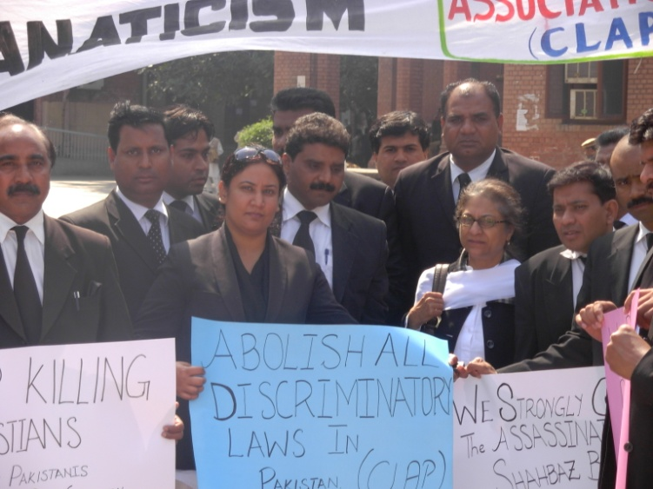
A protest organized by The Voice along with the Christian Lawyers in Pakistan at High Court Lahore
Role of Government in supporting Christians:
The Government of Pakistan is failed to protect the minorities especially Christians in Pakistan. Normally constitutionally it is state that is responsible for the safety, security and prosperity of its people. But Pakistani state has failed even to give Christians the status of Pakistani in Pakistan. We Christians are categorized as Aliens, kafirs, dalits and it is the duty of each and every Muslim to kill the kafirs and not to maintain any relationships with the Dalits in Pakistan. The parallel Legal system of Taliban is much stronger to implement the Islamic law in the country by hook or by crook. Therefore what our state Government has failed to provide us Christians in Pakistan is the right to be Pakistani, the right to live, the right to speak and the right to practice our religion.
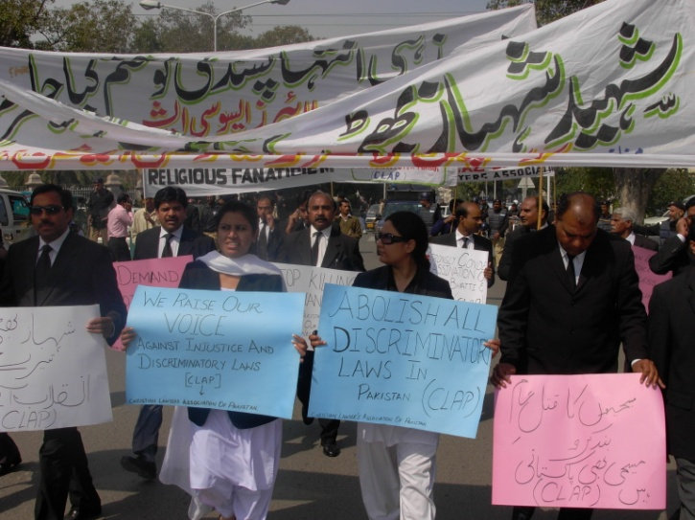
Christian Children in Pakistan:
Christian parents in Pakistan are terribly afraid for their children. Some do not want even to let them out of the house.
Pakistan is no longer a safe place for Christians. Violent incidents against individuals and churches have increased recently, as part of a growing campaign of violence by Islamist militants against the country's religious minorities.
In this climate of persistent volatility and insecurity, Christian children are especially vulnerable. Not only are they easy targets for violence, unable to protect them or to flee, girls in particular may also be kidnapped and forcibly converted to Islam. All the leading Militant Islamic organization based in Pakistan are funding their activities through the sale of Christian children into slavery, The militant Islamic organizations use to abduct children between the ages of six to twelve from their homes in remote Christian villages in the Punjab and incarcerate them in awful conditions until they are sold. The Voice whenever it is possible or accessible use to buy the children and try to locate whether their parents are alive, otherwise they are kept in the custody of the Voice and most of the time the Voice find suitable parents for their children so that the deprived children may also find a family.
Christian pupils frequently face discrimination, and they may be publicly ridiculed or even beaten by teachers because of their faith. The curriculum in non-Christian schools strongly emphasizes Islam. Christian children may be required to study it - even though the law says that they should not be - and they are not given parallel instruction in their own religion. They may be marked down in their examinations simply because they are Christians, and they face many difficulties in obtaining university places. It is not surprising that Christian parents would prefer to have their children educated in Christian schools.
We try to support as many of these people as possible, to help many more young members of our Lord's family in to prosper despite all the difficulties that they face. Our brothers and sisters in Christ have been suffering through insufferable and volatile pressure from the past decade and are looking forward to a savior that can relieve them from the constant threat of violence. Our brothers and sisters in Christ are facing attacks on the churches, villages, and schools. Moreover they are facing persecution under discriminatory laws by false imprisonments, charges of murder, theft and blasphemy. They are tortured, raped, beaten, abducted and exploited for being Christians only. Please help the Voice, in raising Voice against all these Social and religious Evils.

Future of Christian Children in Pakistan:
In the light of the circumstances stated above there is no future of Christian children in Pakistan, no prayers are working, and no pressure of West is helping them. The future of the Christian children in Pakistan is evidently dark and hopeless. There are a number of Ngo’s and organizations working for this Noble cause in Pakistan. But still they are like salt in the flour. There is a dire need for the Christian based organizations and churches to work together to save the future of Christian children in Pakistan.
The voice is working for the uplift of such children that are deprived of their rights in this inhumane society of Pakistan. The Voiceis busy in helping such children who are in jails thus saving them from being exploiting and being used for a suicide attack or any Islamic militant organization. The Voice find the Christian children in jails and help them out legally and socially to restart their lives in spite of getting spoiled by the hands of criminals and Mafia in jails.

