Join us in the Fight against Environmental Degradation, Poor health and Social Injustice

ANNUAL REPORT 2018
DECEMBER 2018
Table of Content
Forward. ……………………………………………………………………………………………………………………………… 3
Organization’s Mission, Structure and the organization chart. ……………………………………………… 4
Management Executive. ……………………………………………………………………………………………………… 4, 5
Organizational chart of Globalminder Cameroon. ………………………………………………………………. 6
Activities carried out in 2018. ………………………………………………………………... 7
Agriculture, livelihood and community development. ………………………………………. 7
Global Objectives. …………………………………………………………………………… 7
Specific Objectives. ………………………………………………………………………… 7,8
Beneficiary Groups. ………………………………………………………………………… 9
Analysis and assessment of real results. ……………………………………………………. 10
Results and activities.………………………………………………………………………… 10
Material and equipment distributed to the female farming groups during the project. ……. 10, 11
Food security through fast food crop tree multiplication. …………………………………. 12
Food security and sustainable soil fertility ………………………………………………… 12
Natural resource Management………………………………………………………………. 12
Health Sector ………………………………………………………………………………. 12
Overall results obtained in this project in 2018 are summarized in the table below ………. 13
Project Title: Performance Based Financing to strengthen the health system.…………………… 13,14
Health and water sanitation ………………………………………………………………………. 14

FOREWARD

The earth has a given level of non-renewable resources. Once they have been depleted, spent or wasted, they are gone forever. Thus, the genetic diversity of an ecology, forest or vegetation cannot be reconstituted once it has been destroyed by the removal or burning of nature or species.
Sustainability has become a very fashionable phenomenon and is currently used when either referring to Conservation, Biodiversity Management, Forest Resources Management, Agriculture or other forms of development.Whereas our natural vegetation and forests provide us with an indispensable source of multipurpose services and products;
By virtue of the fact global human existence, species habitat, healthcare, shelter, water, agriculture, nutrition and socio-economic development largely depend on our natural environment and forest ecosystem; (Natural Resource Base) in one way or the other.Considering that nature and species are a major concern in the promotion of Biodiversity and the Management of Environmental Ecosystem.
To overcome the increasing hands of physical and man-made degradation /destruction of economically important genetic and forest resources and other health related challenges, Globalminder Cameroon, and partners are working in good faith, with the limited resources at their disposal to ensure, regardless of the many variations amongst Environmental Degradation, Poor Health, Social Injustice and poor farming practices nationwide, a sound natural resources and health Management system.
However, we, as a non-profit organization faced with financial, material and moral constraints has inhibited our programs and projects. I am so happy that despite these constraints Globalminder Cameroon is ferrying well, expanding its program of activities to other localities and fields. It is our fervent wish to keep the flag of Globalminder Cameroon flying for the rest of the years to come.
I sincerely thank all our members, partners that supported us to attained our 2018 plan of action
TABANGMUA DANISIUS

GENERAL COORDINATOR

ORGANIZATION’S MISSION, STRUCTURE AND THE ORGANIZATION CHART

Globalminder Cameroon is an apolitical, non-profit making civil society organization which started in 2003 under the name Forestry and Environmental Conservation Society (FOECONS) with registration number G39/10/014/5/113/04 and legalized under country laws in 2004 and recognized under the law NO 90/053 of 19th December 1990 governing freedom of Associations in Cameroon. In 2017, a General Assembly (GA) resolution 16(a) changed its name FOECONS to Global Minder Cameroon, with the same vision, mission and values.
We specialize in working with people and communities to resolve their environmental and social concerns. It has established a unique portfolio of projects and set new standards of working in education, health, agriculture, community development and environmental concerns.
Our Vision: Achieve an empowered, healthy and sustainable society void of poverty and Injustice in harmony with its environment.
Mission: To create a long lasting positive and community –led change that improves the lives and livelihoods of vulnerable communities
Goal: To empower communities towards the improvement of their well-being through participatory management of their natural resources and health.

MANAGEMENT EXECUTIVE
No. | Post/Title | Name | Qualification
1 | General Coordinator | Mr. TABANGMUA Danisuis | Senior forest engineer
2 | Programs Officer | Mr. FORJI MORFAW Sixtus | PGD ICT Education
3 | Finance and Accounting Officer | Ms. NKWETTA Charlotte CHAPNKENG | B.sc on accounting
4 | Projects Supervisor | Mr. LEBEUBEH Eric | BTS in Agriculture
5 | Coordinator Health | Dr. NKEZEA Peter | Dr in Medicine
6 | Coordinator Agriculture,Livelihood and Community Development | Ms. ATABONG Thecla | Diploma Comm. Dev
7 | Coordinator Natural Resource Management | Mrs. TefackPirre Marie | Forest Engineer and management
8 | Coordinator Gender Education and Training | NkwettaAwung Vivian | HND Marketing/M.sc Gender and Development studies
9 | Secretary | NGWA Racheal LUM | Bachelor of Laws

ORGANISATIONAL CHART OF GLOBALMINDER CAMEROON
GENERAL ASSEMBLY
ADVISORY BOARD
GENERAL COORDINATOR
PROGRAM OFFICER
ACCOUNT OFFICER/FINANCE
COORDINATOR
HEALTH
COORDINATOR
ARGRICULTURE, LIVELIHOOD & COMMUNITY DEVELOPMENT
COORDINATOR
GENDER, EDUCATION AND TRAINING
BOARD OF DIRECTORS
COORDINATOR
NATURAL RESOURCE MANAGEMENT
FIELD WORKER
FIELD WORKER
FIELD WORKER
FIELD WORKER
FIELD WORKER
FIELD WORKER
FIELD WORKER
FIELD WORKER
FIELD WORKER
FIELD WORKER
FIELD WORKER
FIELD WORKER
ACTIVITIES CARRIED OUT IN 2018
In 2018, Globalminder Cameroon and its partners carried out various projects towards the Natural resources management, Agriculture,Environmental protection, Poor Health and Social sectors.
- ARGRICULTURE, LIVELIHOOD AND COMMUNITY DEVELOPMENT

  - TITTLED <THE EMPOWERMENT OF FEMALE FARMERS AND FOOD SECURITY STRENGTHENING IN LEBIALEM>
The empowerment of female farmers and food security strengthening in Lebialem is a project conceived to solve the problem of the rural women from Lebialem Division who were worried about their poor productivity and low monetary revenue from the growing, processing and marketing of their cassava products like cassava tubers and Garri which is their only source of livelihood. Such revenue estimated at 50000 XAF per hectare of cassava tubers farm was far behind the national average which is comprised in between 450 000 and 810 000 XAF. This problem was as a result of the following:

- Poor productive cassava species grown in the farms.
- Poor cassava farming system.
- Very local processing method of cassava.
- Inadequate access to the cassava market information.

This problem affected these women who are the beneficiaries and bread winner of their families in the following ways:
- Increase of the rate of diseases (malaria, typhoid) on men and women because of the lack of money for paying hospital bills and drugs.
- Increase in number of school dropouts within children because their parents don`t have enough money for paying their school fees.
- Permanent food insecurity.

The global objective:
To reduce the incident of extreme poverty within the women of Lebialem.

Specific Objectives:
To improve access and use of a sustainable, productive and profitable chain of cassava production, processing and marketing in Lebialem.

FOECONS decided to resolve the problems above by coming up with a project proposal to improve the cassava production chain sustainably which consisted of enabling women to increase their cassava productivity through the use of the improved cassava cuttings on quality soil fertilized by themselves. It also enabled them to have access to the hygienic means of cassava processing and packaging. By the end of the project, they were able to have access to the market with their products. This solution was adopted because at the end of the participatory meeting organized by FOECONS for solving the problem, 99% of rural Women from Lebang expressed their interests to use improved cassava cuttings, micro cassava grinding machines, market information and to manage theircassava business properly.

This pilot project was intended to support 14 women groups from Lebialem to improve their cassava tuber and Garri production and their farm revenue in order to improve their living conditions. Such supports consist of:
- Training them on high productive farming techniques on cassava, hygienic processing of cassava tubers into Gari, use the Market information System to negotiate good prices for their products.
- Providing them with farming tools and equipment, improved cassava cuttings, package of Gari processing machines and tools, package of market information tools and network.
- Accompanying them throughout the processes of cassava tuberproduction,processing, packaging of Garri, marketing and recording the results.
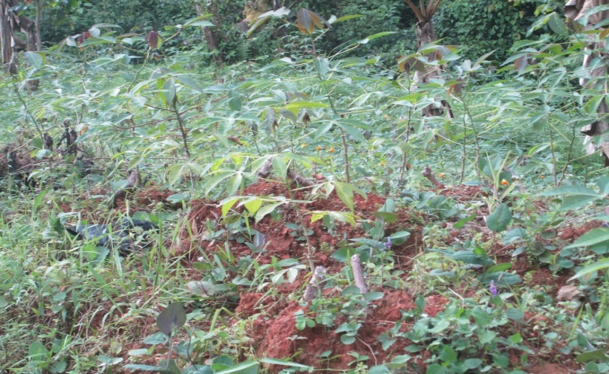
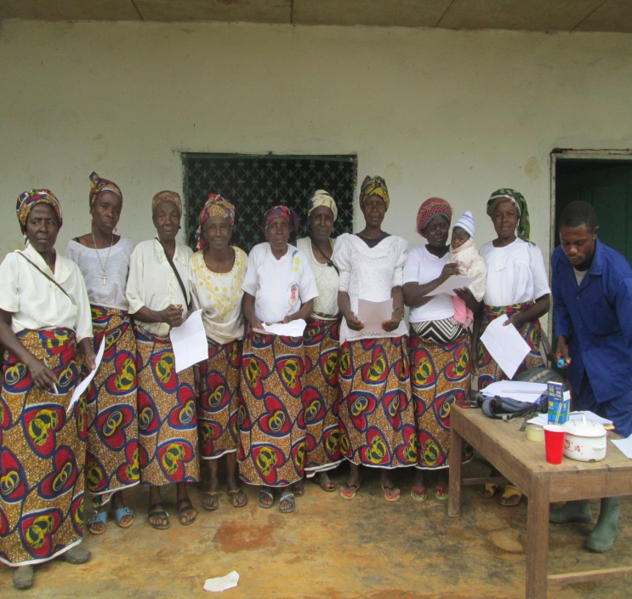
Fig 2: Training Workshop
Fig 3: Cassava cutting species

Names of Communities | Number of Beneficiaries | Number of  Men | Number of Women
MbehMbong | 25 | - | 25
Aginmenda | 23 | - | 23
MbahMbong | 25 | -- | 25
Ready Sisters | 25 | - | 25
Loving Sisters | 24 | - | 24
Ndah/Atunieh Women | 25 | - | 25
BellahNgeh Women | 26 | - | 26
Nteseh Unity Women | 25 | - | 25
Nsoko Powerful Women | 21 | - | 21
Upper Lebang Youth | 22 | - | 22
Minka Multipurpose Farms | 23 | - | 23
Njah Women Group | 25 | - | 25
Mfembetuih Women Group | 25 | - | 25
Tabroh Christian Women | 26 | - | 26
TOTAL | 314 |  | 314
BENEFICIARY GROUPS
Table 2: Beneficiary Groups

ANALYSIS AND ASSESSMENT OF REAL RESULTS
A). Results and Activities
Anticipated results
Result 1: Net production of 30 tons of cassava tubers, 40 000 new cassava cuttings and 4000kg of cassava leaves per hectare of land and per women group.
Result 2: Net processing of at least 7.5 tons of Garri per women group per hectare of cassava farm land
Result 3: Net profit of at least 1650000 XAF per hectare of cassava farm land per women group.

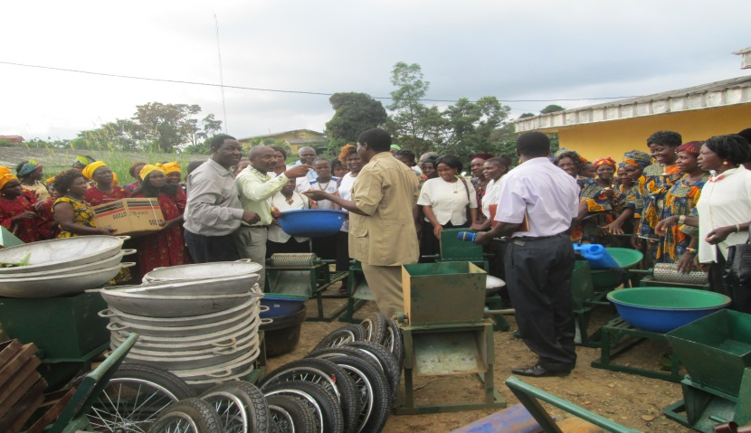
Fig 5: Testing cassava hauling machine
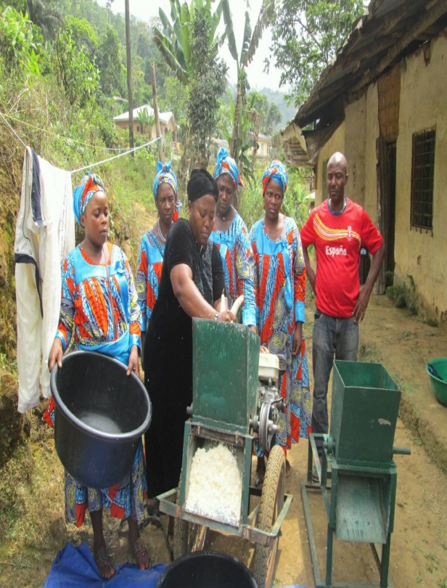

Fig 4: Distribution of Processing Tools

MATERIAL AND EQUIPMENT DISTRIBUTED TO THE FEMALE
FARMING GROUPS DURING THE PROJECT
No | NAME OF GROUP | QUARTER | ITEMS RECEIVED
01 | MbehMbong | Nkah | 2 Cassvava Machines,1 Gari Press,1 Cell phone,1 sprayer,2 gari roasting pots,5 Basins,10 meters Tapoline, 10.000 improved Cassava cuttings
02 | Agimendah | Fonge | 2 Cassvava Machines,1 Gari Press,1 Cell phone,1 sprayer,2 gari roasting pots,5 Basins,10 meters Tapoline, 10.000 improved Cassava cuttings
03 | Ready Sisters | Azi | 2 Cassvava Machines,1 Gari Press,1 Cell phone,1 sprayer,2 gari roasting pots,5 Basins,10 meters Tapoline, 10.000 improved Cassava cuttings
04 | Loving Sisters | Nchenfem | 2 Cassvava Machines,1 Gari Press,1 Cell phone,1 sprayer,2 gari roasting pots,5 Basins,10 meters Tapoline10.000 improved Cassava cuttings,
05 | BellahNgeh Women | BellahNgeh | 2 Cassvava Machines,1 Gari Press,1 Cell phone,1 sprayer,2 gari roasting pots,5 Basins,10 meters Tapoline, 10.000 improved Cassava cuttings
06 | Nteseh Unity Women CIG | Nteseh | 2 Cassvava Machines,1 Gari Press,1 Cell phone,1 sprayer,2 gari roasting pots,5 Basins,10 meters Tapoline,10.000 improved Cassava cuttings
07 | MbahMbong | Atoaangeh | 2 Cassvava Machines,1 Gari Press,1 Cell phone,1 sprayer,2 gari roasting pots,5 Basins,10 meters Tapoline, 10.000 improved Cassava cuttings
08 | Minka Multipurpose Farms | Minka | 2 Cassvava Machines,1 Gari Press,1 Cell phone,1 sprayer,2 gari roasting pots,5 Basins,10 meters Tapoline, 10.000 improved Cassava cuttings
09 | Njah Women Group | Njah | 2 Cassvava Machines,1 Gari Press,1 Cell phone,1 sprayer,2 gari roasting pots,5 Basins,10 meters Tapoline, 10.000 improved Cassava cuttings
10 | Upper Lebang Youth | Nkah | 2 Cassvava Machines,1 Gari Press,1 Cell phone,1 sprayer,2 gari roasting pots,5 Basins,10 meters Tapoline, 10.000 improved Cassava cuttings
11 | Efembetuih Women Group | Efembetuih | 2 Cassvava Machines,1 Gari Press,1 Cell phone,1 sprayer,2 gari roasting pots,5 Basins,10 meters Tapoline, 10.000 improved Cassava cuttings
12 | Nwehchen Women | Fossung | 2 Cassvava Machines,1 Gari Press,1 Cell phone,1 sprayer,2 gari roasting pots,5 Basins,10 meters Tapoline, 10.000 improved Cassava cuttings
13 | Nsoko Powerful Women | Nsoko | 2 Cassvava Machines,1 Gari Press,1 Cell phone,1 sprayer,2 gari roasting pots,5 Basins,10 meters Tapoline, 10.000 improved Cassava cuttings
14 | NdahAtunieh Women | Ndah/Atunieh | 2 Cassvava Machines,1 Gari Press,1 Cell phone,1 sprayer,2 gari roasting pots,5 Basins,10 meters Tapoline, 10.000 improved Cassava cuttings
Table 3: Equipment and material benefits to Groups

  - Food security through fast food crop tree multiplication
Globalminder Cameroon has organized a training workshop to build the skill of 200 youth from Lebialem on grafting technology. As result, they used the knowledge and skills gained to carryout domestic tree multiplications.

  - Food security and sustainable soil fertility
Globalminder is promoting a technique calledInga alley cropping as a replacement for slash and burn farming in tropical rainforest areas. Currently we work with civil society organizations,communities and schools in the south west region of Cameroon. In this respect, Globalminder Cameroon has organized a series of training workshop where the skills of fivecivil society organizations with their one hundred communitymembers on how to use Inga trees for soil fertility and for improving food crop productivity.
2. Natural resource Management
  - We carried out a tree planting campaign in partnership with school children within Meme Division. As a result of the action, 321 school children participate to the action and one thousand trees were planted along the streets, in schools, in the reserve and other degraded areas.
  - In collaboration with Municipal councils, Globalminder Cameroon carried out a Feasibility study of the Urban forestry in Lebialem, Manyu Divisions of the south west regions. All this Divisions have strategy to start implementing their projects in 2020.

- HEALTH SECTOR
  - Scaling up of HIV prevention to help reduce mortality and morbidity by 2020
This project is carrying out the following activities to attain its objectives
- Organizing through community stakeholders (peer educators and supervisors) activities of community mobilization and population at risk service through activities like, educational talks, personal interview, voluntary counseling and testing of HIV, STIs, counseling, Therapeutic education etc.)
- Organizises capacity building activities;
- ensure the collection of communication data activities for behavior change;
- Organize and participate in coordination meetings with local health facilities / partners involved in the implementation of activities;
- Organize advocacy activities organized under the program;
- Work with health facilities in the treatment of HIV
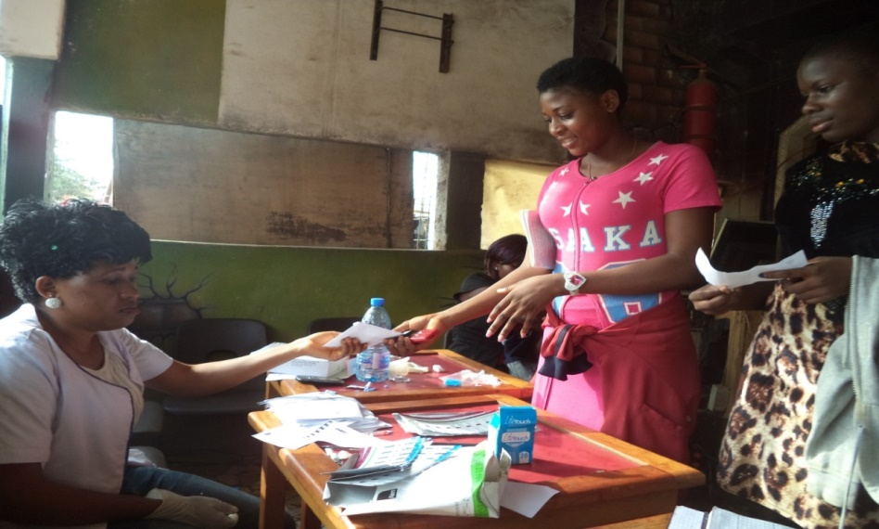
Fig 6: HIV testing and Counseling

Overall results obtained in this project in 2018 are summarized in the table below

INDICATORS | Number of people screened for HIV | Number of positive cases HIV | Number of STIs cases treated | Number of female condoms distributed | Number of male condoms. distributed | Number of lubricant gels dispensed | Number of people reached with Educative
TOTAL NUMBER | 18824 | 110 | 718 | 10110 | 8714 | 18824 | 25600
Table 4: Summary of 2018 results obtained

Management of HIV Positive case:
Out of the 110 positive cases tested, those who collected their results were sent to CMA Kumba town and St John’s Catholic Health Centre FiangoKumba and District Hospital (UPEC) Mundemba for treatment. For follow up, while we keep the register of positive cases in our officeto always find out if all the positive cases are following up with their treatment.

Management of STIs
All the positive cases of STIs were identified and treated.

3.2. Project Title:Performance Based Financing to strengthen the health system.
Globalminder is working with Health Sector Support Investment project (HSSIP) as one of the execution or implementation partner. The objective of this project is to use Perfomance Base Financing mechanisms to improve health seeking behaviour of the community and reinforce community participation and involvement.
In this project we carried out the following activities:
- Verified the existence of patients that consulted or visited the health facility
- Assisting health facilities users toprovide estimated average user fee paid and the user perception of fees and payment mechanism,
- Sampling patients opinion (satisfactory survey) concerning the services provided by the health facility
- Encourage users of health facilities to provide suggestions for improvement

- HEALTH AND WATER SANITATION
This project supported the 1000 inhabitants ofKobavillage in Konyesubdivisions with a portable drinking water source so as to improve their lives and health for better living conditions and that of the household as whole. This project provided them with a borehole financed by “The pollination project”. This borehole serves the inhabitants with fresh and portable water source. The absence of portable water has pushed this population to doubtful water which threatens their health.

The following partners supported us financially to realized this projects in 2018
- MANOS UNIDAS Spain
- The Pollination Project USA
- CAMNAFAW Cameroon
- Press JeuneDeveloppement Cameroun
- And the Municipal councils of Manyu and Lebialem Divisions

General Coordinator

TABANGMUA Danisius

