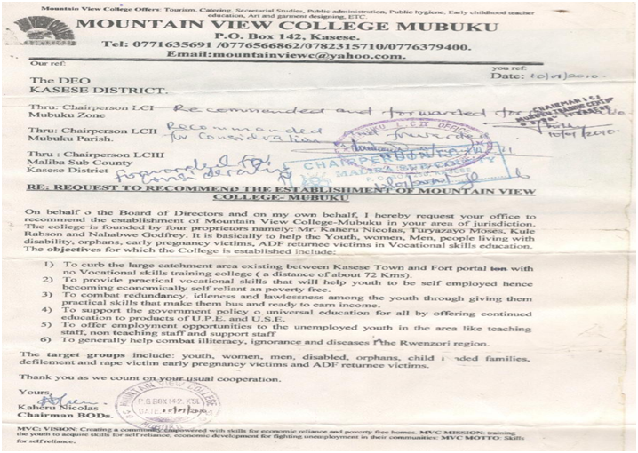

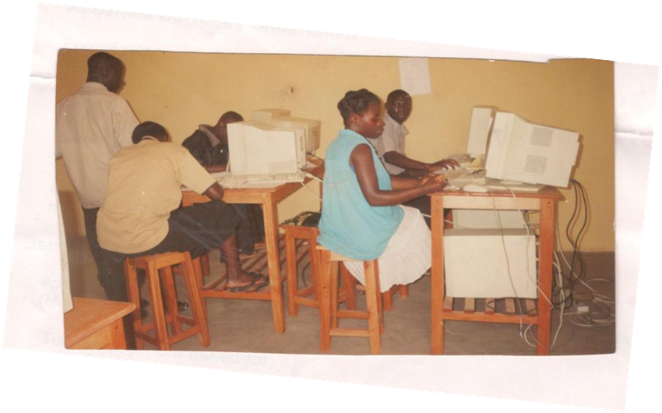

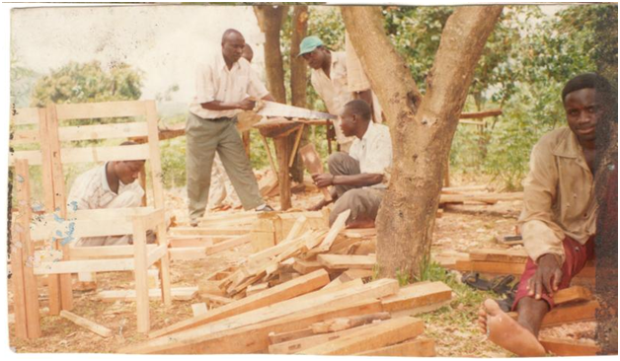

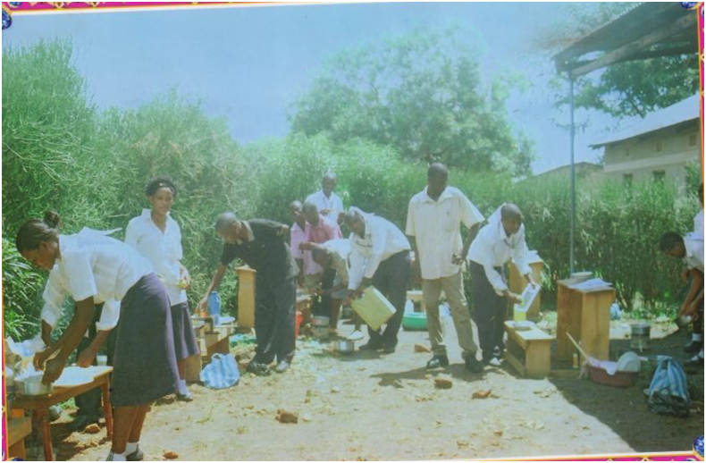

**COLLEGE ADMINISTRATIVE STRUCTURE**

**BOARD OF DIRECTORS**

**BOARD OF TRUSTEES**

**PRINCIPAL**

**DEPUTY PRINCIPAL**

**ACADEMIC REGISTRAR**

**DEAN OF STUDENTS**

TUTORS

**BURSAR**

**STUDENTS’ GUILD**

**COUNCIL**

**H.O.DS**

**TUTORS**

**COMMUNITY**

