VALAMPURI FOUNDATION
3/64 Kanakku Appusamy Street,
Mandapam, Mandapam Post,
Ramanathapuram District,
Tamilnadu, India
Email: valampuri2010@gmail.com
Cell: 9442942753

Annual Report for the year 2010 -2011.
Origin
Valampuri Foundation is a voluntary organization working for the development of rural workers, women, children, and for the environment. It was established in the year 2010 with the aim of to work for the poor and to contribute to environment cause. It has been working with children and women.
Legal Entities
- Valampuri Foundation is registered under Indian Trust Act on 02.06.2010 with the registration number 474/2010.

Vision:
Our vision is to strive for a decent and dignified life for the tiling masses in the villages ensuring their rights to livelihood and their basic human rights
Mission:
- To create awareness on social, economical, cultural and environmental issues that affects our target group.
- To launch campaign on the aspect of integrated development such as right to education, health and livelihood issues.
- To form Forums and associations to strengthen the campaign and to involve the entire community in the process.

Project Area:
We are working in Ramanathapuram and Mandapam blocks of Ramanathapuram district, Tamilnadu. in which around 100 families from 7 villages are covered.

Activities and Achievements:
1. Women’s Day celebration
We have organized the International Women’s Day Celebration 10th March 2011 at Ramanathapuram. More than 200 women were participated in the rally and conference. The conference presided by Mrs. Kavitha Kathiresan, president, Pattinamkathan Panchayat. Mr. Ravichandran Ramavanni, President, District Panchayat, Mr.A.Sadagobal, LDM, IOB and Mrs.Maglin, President, NCWM, were the chief guests of the conference and delivered their valuable lectures.
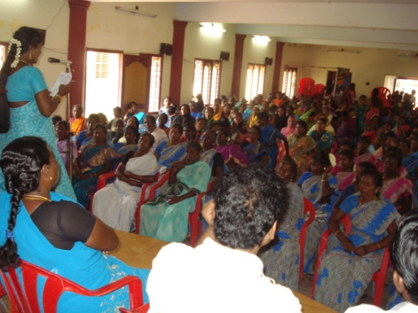

2. Seminar on Global Warming and Climate Change:
The coastal areas of Ramanathapuram district are longest and face several environmental problems due to the climate change. The “Pavalaparai” (coral reef) the birth place of fishes are totally in dangerous position and it affects the fish workers livelihood. We organized a one day workshop for the fishermen on the issues of Pavalaparai and disseminated the information.
The workshop was organized on 30.04.10 on the theme of usage of fuel, electricity, water, plastics, forests, rivers and coastal ecosystem to improve the climate in the coastal area. More than 70 women around Rameswaram were participated. Mr. K.R. Raju, Director, VDC, Tiruchy and Mr.J. Prabakaran, PAD, were resourced the participants. Before the workshop a rally was organized at Rameshwaram. Mr.V. Kannan, Inspector of Police, Rameswaram Town begins the rally and ended with lecture of Mr.V.Jeyachandran, Head Master of Govt. Hr.Sec.School, Rameswaram.

3. Palmyra Tree Plantation Programme
Save the environment is one of the main objectives of Valampuri Foundation. To mitigate global warming and to prevent disasters, we had organized Palmyra tree plantation programme jointly with RWDS, Ramanathapuram. This programme was organized on 01.12.2010 at Kalimankundu village. Mr.M.Rasu, president, Kalimankundu panchayat had inaugurated while Mr.D.R.Chandran, Director, IRWO, Ramnad, Mr.S.Sathaia, Director, RWDS, Ramnad and K.Periyakaruppan, State General secretary, Manila Panai Thazhilalar Sangam, Ramnad were also participated. 1000 Palmyra saplings were planted in sea shore of Kalimankundu.

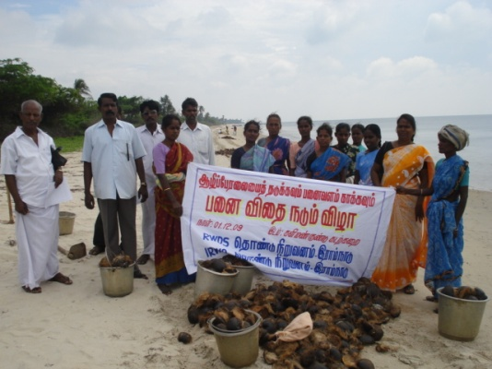
4. Rally on Alcoholism
The women of rural areas had strongly opposed the alcoholism, because they are the direct victims of it. As per the women’s wish Valampuri Foundation had jointly organized with Tamilaga Latchiya Kudumbam, Ramanathapuram district and some other NGOs a mega rally on 15.09.2010 at Ramanathapuram. The rally was started from New Bus stand and ended at Aranmanai vassal, Ramanathapuram. Mr.D.R.Chandran, Director, IRWO had flag off the rally in the presence of Ms.Saroja, District convener, Tamilaga Latchia Kudumpam, Mr.Sasikumar, State Member, Tamilaga Latchiya Kudumapam, Mr.Ilango, Director, Dr.Annebesent Health and Social Service Trust, Sundaramudiyan and D.Arockiaraj, Valampuri Foundation, Mandapam. Around 100 women from various villages had took part in the rally.

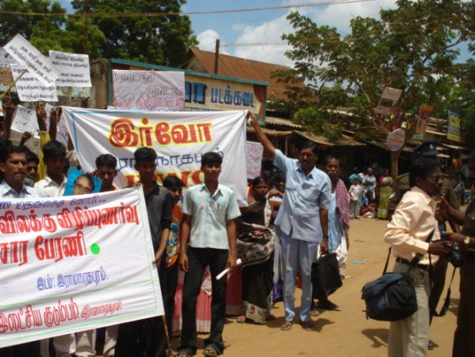
5. HIV/AIDS – village level awareness programme
To aware the rural people on the issue we organized village level programme in 7 villages of Ramanathapuram district. The programme was took place by an expert team consisting of one technical person and two social workers. The team had conducted village level awareness programme especially for rural women. Around 200 women were covered and pamphlets explaining the issue had also distributed.
6. Training on Traditional Medicine.
Training on Traditional medicine was organized at Rameswaram. Dr.Poomayil, B.N.Y.S had facilitated the training in which 60 youth from various villages of had benefited. The objective of the programme is to popularizing the traditional medicines to the younger generation. The facilitator had leaded the trainees to the field where she identify more than 35 medicinal plants that available in the island Rameshwaram.

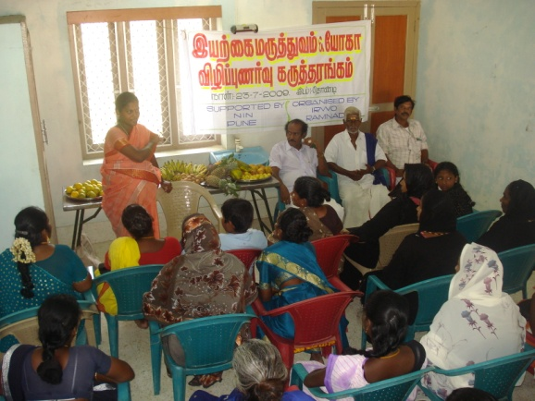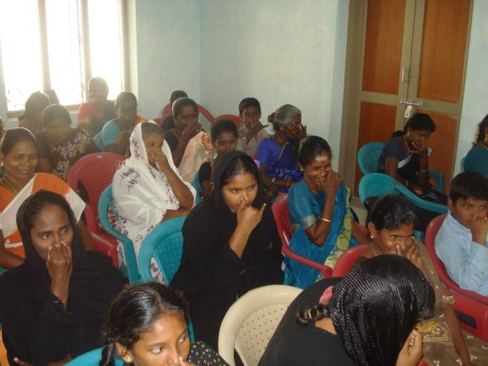

7. Workshop on Organic farming
The abundant usage of Chemical fertilizers and pesticide had worst affected the agriculture, soil and water. The poor and marginalized farmers are being vulnerable due to the cost of agriculture external inputs. To aware the farmers we organized a workshop on organic farming at Thondi. Mr.Sivaprakasam, expert in organic farming had leaded the workshop. 60 farmers from various villages of Tiruvadanai Taluk had got scientific information on chemical farming and had intense to promote organic farming.

8. Support to Computer education
To support the young educated poor girls we have provided cash support for computer education. During this reporting period 4 poor girls from Mandapam and Therkkuvaniveethi had completed their computer education with the support of our foundation.

Membership with Networks:

Valampuri Foundation has maintaining membership with the following networks.
- Southern Initiative Federation for People Association Development – SINFPAD
- Joint action for Sustainable Livelihood - JASUL
- Social Action Movement - SAM
Board Members:

Mr. D.Arockiaraj, M.A. | Managing Trustee
Mrs.M.Rakkamma, | Finance Trustee
Mrs. G.Radha | Trustee
Mr.M.Arumugam, D.M.E. | Trustee
Mrs.H.Malar | Trustee

The board approved the activities, financial statement and annual report. We circulated the minutes of the board meetings and recorded it. The Managing Trustee Mr. D.Arockiaraj is the chief functionary of the Organisation and he was paid no remunaration.

Conclusion:
We express our sincere thanks to our board members, donors, networks, NGOs, government officials, and CBOs for their support. Valampuri Foundation expects the same support in coming years too.

