Tekhsmart Zambia profile
(REGISTERED NON-GOVERNMENTAL ORGANIZATION ®)
Be tech smart. Always think before you click.
Cell No.0964993857/0973150999/0975585959/0978156776
Email:tekhsmartzambia@gmail.com
Web address: https://sites.google.com/view/tekhsmartzambia/home
Facebook page: fb.me/tekhsmart

INTRODUCTION:
This project is inspired by the national information and communications technology (ICT) policy of Zambia which was published by the ministry of communication and transport in April 2006.
The policy states the following:
“Therefore, civil society is encouraged to undertake the following initiatives in coordination with the Department of Communications, private sector and other partners:
- Exploit the potential of ICTs in the development of society, dissemination of information and knowledge;
- Use ICTs as a vehicle for the transmission and dissemination of information In development programs;
- Incorporate an ICT component in community development programs, and in programs supported by international organizations;
- Create institutional mechanisms (NGOs, CBOs etc.) to spearhead ICT awareness including implementation of projects at national and community levels;
- Monitor and evaluate the performance of the ICT sector in achieving developmental goals especially in community based initiatives;
- Assist in capacity building of ICT awareness and literacy programs in the Country.”(p.62)
Tekhsmart Zambia is a Zambian non-governmental organization registered with the ministry of community development and social services, (RNGO/101/833/18). We are also recommended by the Ministry of Communications and Transport. The aim of the organization is to promote Digital access, digital literacy, digital etiquette, digital commerce, digital law, digital rights, digital responsibilities, digital health, and digital security in Zambian schools, colleges, universities and communities. The organization also focuses on educating the youth on issues concerning appropriate and smart use of digital technologies. We provide guidance to youths on how they should use digital technologies for educational purposes, personal development and empowerment. We also connect young people to online platforms such as Code.org, code combat etc. where they learn coding. Furthermore, we promote advocacy against cyberbullying and technology addiction. Lastly, Tekhsmart Zambia provides counselling services to tech addicts and cyberbullying victims and promotes digital access in rural communities.
The organization is based in Chongwe district of Lusaka province and is currently operating from Lusaka and Chongwe districts.
It was founded and established in 2015 by Chisanga Clive, the current chief executive officer. Other members of the executive are: Njekwa Rachael, vice chief executive officer,Mapulanga Brenda,the executive secretary,Mweene Ng'andu,chief financial officer Kalumba Edward,research director,Nawa Kalimukwa,projects director,Ng'andu Choobe, education director,Mweene Muyanga,digital citizenship director,Twaambo Muntanga,counselling director and Mulenga Anthony Chileshe, information and communications technology (ICT) director. The patron is Dr. Phiri William, the head of research, graduate school at Chalimbana University.(ICT expert)
Why Tekhsmart Zambia?
It is critical that as a country we address digital citizenship, because of the following reasons:
- Young people are generally proficient at basic usage of technology, but they are not necessarily critical users and many of them do not have the skills to be safe and responsible online.
- Young people are being exposed to online risks and bad online behaviour every day.
- Young people are starting to use the Internet at an early age, and they’re using it regularly. If we wait and ignore to address digital citizenship among young people now, we will risk having a disoriented society in future.
- If we want young people to be lifelong responsible users of digital technologies, we should not keep technology away from them, in the 21st century, it is impossible to separate digital technology use from real life.
- Technology is here to stay and it has become part of our daily lives. With the advancements of mobile technologies, there is a possibility that our lives will be dependent on digital technologies in future.
- Developing values of safe, ethical and responsible use of digital technologies among the people through education is more viable in cultivating positive online behavior.
- Communities need to prepare people to be successful in our digital world; teaching digital citizenship allows young people to develop the skills and competencies that they will need to be safe, responsible, considerate, analytical in decision making, innovative and productive members of our current and future society.
OUR SUCCESS:
Since the time we got registered, we have established clubs in four schools. These are Chalimbana primary, Chongwe primary, Mukamambo (ii) Girls and Chongwe Secondary schools. We also have an association at Chalimbana University. We have a website on google site where we provide a platform for young people to access free online learning from various institutions in different courses. We also have a Facebook page where young people access learning materials. We have been recommended by the ministry of transport and communication for being the first Zambian registered non-governmental organization to address digital citizenship in Zambia.

OUR TARGET GROUPS:
As Tekhsmart Zambia, our target groups are youths from the communities, schools, church, colleges and universities. We also target teachers and other educational officers. This is because we believe that education is an agent of change.
HOW DO WE INTEND TO REACH OUT TO OUR TARGET GROUPS?
Tekhsmart will implore various means of effective reach out such as the internet, newsletters, dialogue, group discussions, presentations, debates, drama/sketches, videos, text messages, e-mail, social media, person to person counselling and other communicable ways.
PARTNERSHIP: We work in partnership with institutions of learning such as schools, colleges and universities. ICT clubs, the church and other social organizations.
FUNDING: Currently the organization is not receiving funds from any organization. We are running all our programs using membership fees that are contributed monthly by members.
Mission statement: Imparting digital technology skills and values in the younger generation for the better society now and in the future.
Slogan: Be tech smart. Always think before you click.
Vision: To cultivate positive behavior towards the use of digital technology, develop digital literacy skills and access among the younger generation.
Advocacy: We advocate against cyber bullying, misuse of social media and the internet and generally the abuse of digital technologies. We also promote awareness on cybersecurity, social engineering and information security.
Our objectives:
  - To educate young people about the dangers of cyberbullying

  - To educate and train young people to be responsible users of digital technology.( This includes the use of: Smart phones, personal computers, the internet and social media)

  - To encourage young people use digital technologies for educational and other productive and constructive purposes.

  - To work with the youths and involve them in identifying and solving problems related to digital technology abuse.

  - To work with schools, higher institutions of learning, the church and other social organizations to promote the safe and responsible online behaviour.

  - To provide counselling and rehabilitation to victims of cyberbullying and social media abuse.

  - To help prevent social media addiction through educating young people about its effects and help the victims to recover from it by providing counselling and guidance to them.

  - To provide digital literacy and inculcate coding skills in young people.

  - To introduce young people to massive open online platforms and teach them how they can use such platforms to educate themselves on various academic, religious and social issues.

  - To encourage young people to take advantage of availability of various technologies and time to empower themselves with life and survival skills.

  - To encourage technological innovation and creativity among the young people.

  - To work with parents to solve problems pertaining to technology abuse amongst the young people.

  - To educate young people against social media abuse.

  - Work with Road safety agencies to educate drivers about the dangers of using smart phones, tablets etc. while driving.
  - Work with colleges and universities to conduct research about the use and misuse of digital technology among the young people in Zambia and use the findings to establish lasting solutions to tech abuse.
  - Train young people in coding using online platforms
  - Train teachers/lecturers to use google/G-Suite for education.

Photo profile:

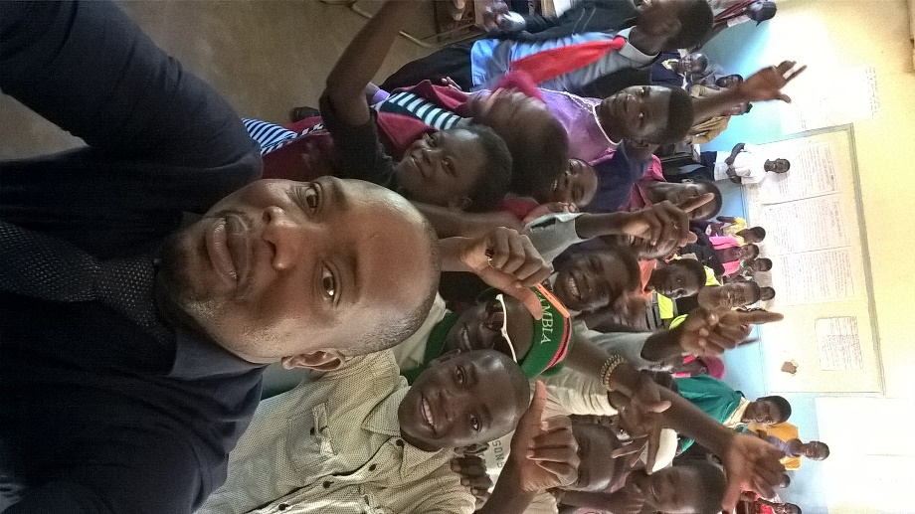

The chief executive officer and digital citizenship director with some Tekhsmart club members at Chalimbana Basic School.
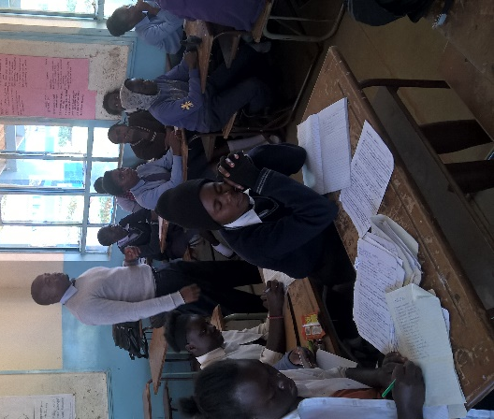

During member orientation program at
Chalimbana Basic School. Teaching digital citizenship at
Chalimbana basic school.

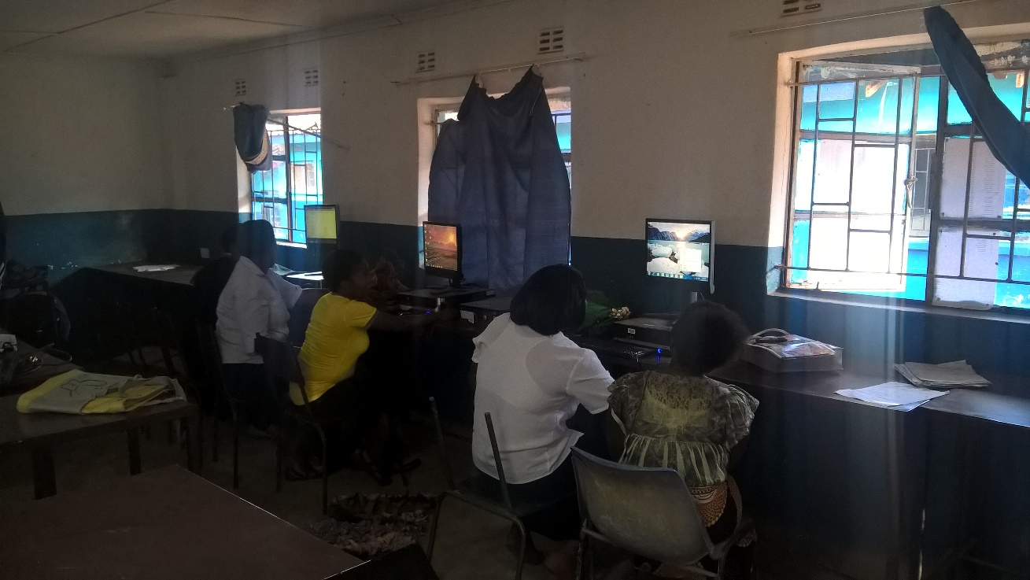

Adult digital literacy during a digital literacy class in the computer lab at Chalimbana basic school.
Our operations: We establish clubs in schools, universities, communities and colleges. We also train young and old people, teachers and tutors in digital citizenship. We support the running of clubs with learning materials and other things that are required to constantly run the clubs.
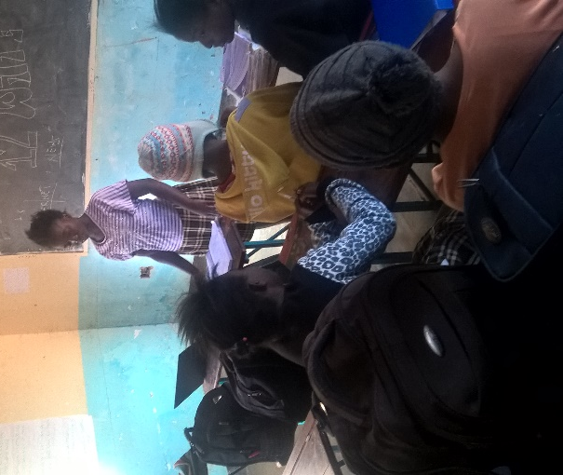
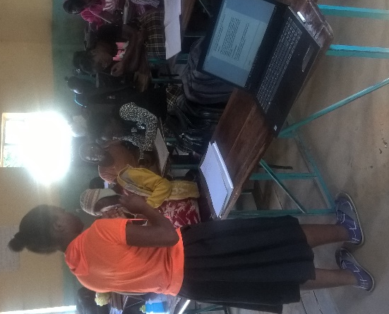
Members of Tekhsmart club at Mukamambo (ii) Girls Secondary School presenting during a discussion on the advantages and disadvantages of the internet.

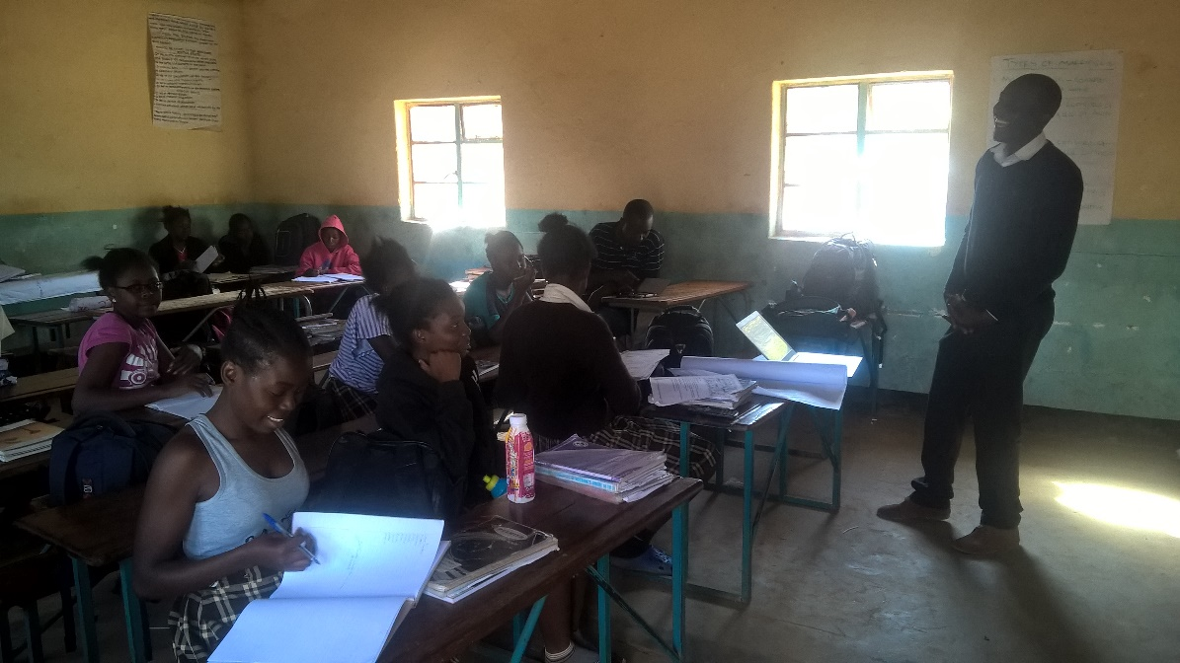
Digital citizenship director, Tekhsmart Zambia, Mr Mweene Muyanga leading a discussion during a digital orientation meeting.
Tekhsmart club members during group Involving young people in solving problems of digital
discussion on the effects of cyberbullying technology abuse.
on young people.

C.E.O with officials from the Ministry of Transport and Communication after a meeting.

