Lerne Adams Foundation
Organizational profile
Empowering communities towards prosperity!

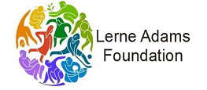
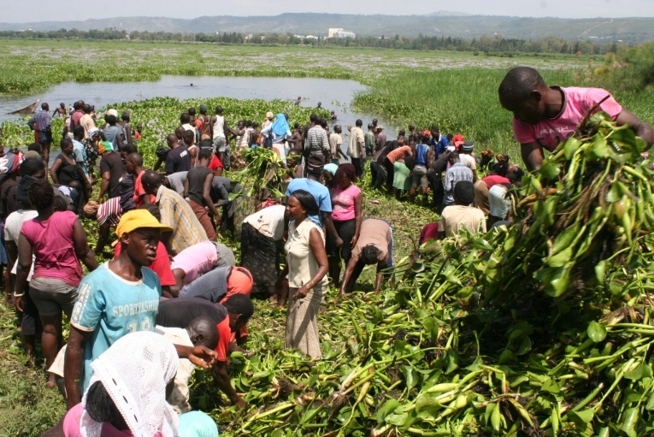

Republic of Kenya
Contact address I Project and operations manager
Lerne Adams Foundation (LAF)
Lake Victoria Region
P.O.Box1740 -40100
KISUMU
Tel: +254 713 736700/+254722116416
E:info@lerneadamsfoundation.org
www.lerneadamsfoundation.org

Lerne Adams Foundation (LAF)is an indigenous Kenyan NGO registered as non-religious, non-political and non-profit organization. The organization is registered under Kenyan laws as a foundation Instituted, staffed, and managed by group of professionals. The organization has its base in Kisumu and works with communities living around L.Victoria region. The organization was officially strengthened and founded in January 2016 has now taken up the challenges of articulation and contribution to the country’s development priority agenda.
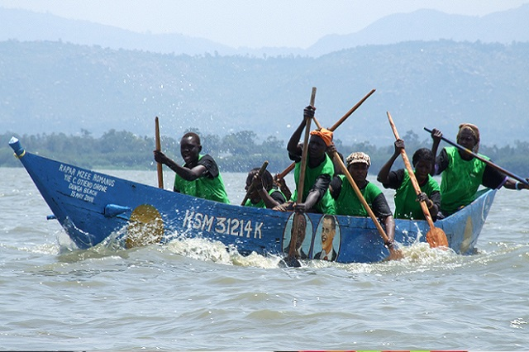
A professional service delivery organization national standing – African in spirit, conception and composition. Lerne Adams foundation exemplifies Kenya’s humanitarian initiative at the best. In a region that has lagged behind in socio-economic development, Adams foundation commitment is to transpose the standards of development in the regions of Green Growth ,Education & Youth mentorship, Community health & sanitation, Food security & Nutrition ,Water infrastructure development and Women empowerment &advocacy. These actors of change are firmly reflected in the organization’s philosophy, objectives and operational strategy, guided by the principle of asserting a defining role for the Lakeside communities.
The organization has the support from other partners. Lerne Adam’s foundation iswilling to implement projects in collaboration with development partners and county governments in achieving its vision We have the capacity and network to mobilize the right expertise and experience .

Come work with us! We are committed to
enhancing quality of life and ending
extreme poverty.

We spare no effort in offering livelihood transformation.
Every day, our team of professionals ensures better lives for the communities living around LakeVictoria regionby focusing on Green Growth ,Education & Youth mentorship, Community health & sanitation, Food security & Nutrition ,Water infrastructure development and Women empowerment &advocacy

OUR VISION

Sustainable development for the marginalized through integrated environmental and one health approach
while focusing on equity and human dignity

OUR MISION
To maximise productivity and self-reliance among the rural communities by availing opportunities for resource poor households through improved access to human development opportunities.

Let’s make the world better, together

Lerne Adams foundation partners with like-minded organizations and individuals in executing sustainable programs related to food security & nutrition, community health & sanitation, Education & youth mentorship and green growth

We are fulfilling this vision by employing latest technological innovations, participatory community approaches and collaborations with governments and research institutions. Join us today!
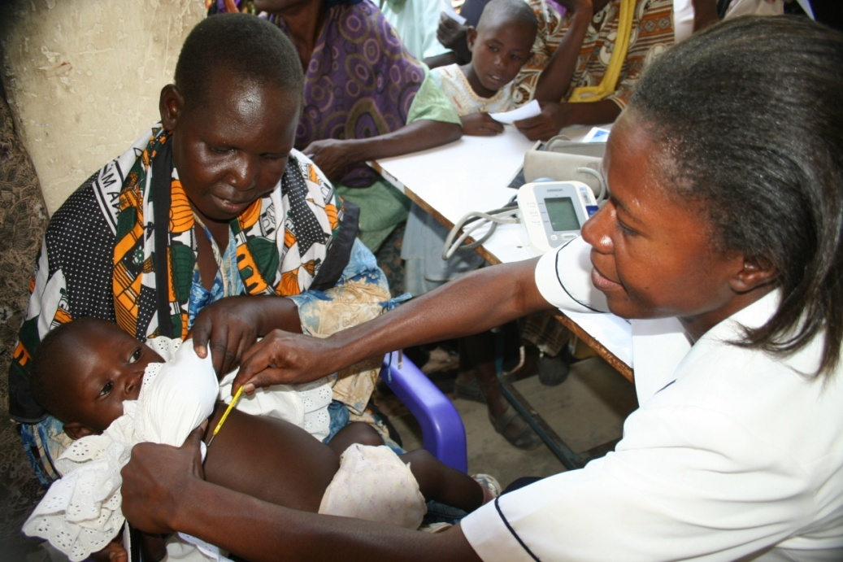
Community health restoration

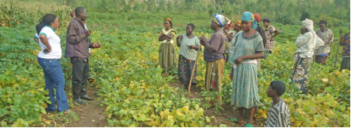
A food secure people is our key drive

Board of Directors

Meet our executive team, board, and advisory members.

Lerne Adams Foundation comprises of Board of Directors/Management Committee (Executive committee). The Board of Directors, being the paramount organ of the organization with the mandate of decision making in the organization. The board is made up of management committee team that implements the resolutions and decisions of the organization and executes the daily activities and decisions of the organization.

(Evelyne Awino)
(Chairperson)
Evelyne Awino brings several years of development experience to sustainable development; having supported the execution of various projects in Kenya both in the government and in private sector. .His passion and skills in community empowerment have brought a lasting impact to LAF’s SME support initiatives leading to sustainable livelihoods.

‘

Claire Aloo
{Board Secretary}
Claire has a strong drive for equitable community health and well-being, especially for children. She brings to our team rich experience in community health.She has a degree in community health and development.

(Grace Olando)
(Treasurer Board )
Grace has close to a decade experience in public and Community health .She spends most of her time in human development including hospital administration as well as tailored banking. She has a Master Degree in Public Health

What We Do
Lerne Adams Foundation is founded on an integrated six (6) pillar approach to sustainable development including Green Growth, Education& Youth mentorship, Community health &sanitation, Food security & Nutrition and Water infrastructure development and Women empowerment &advocacy

Green Growth
We seek to promote the sustainable use of natural resources among community members living around L.Victoria region. Our work responds to the threat of extreme degradation of arable land and water bodies around Lake Victoria .Our strategy is to cooperate with other agents of change in promoting strong awareness on the need to sustain natural habitats and linkage between the environment and culture. Working with these individuals, we seek to address the challenges by promoting climate smart green growth strategies including agroforestry, sustainable harvesting and conversion of water hyacinth into useful biomass, protection of water towers and promotion of carbon trade.

Education and youth mentorship
Lerne Adams Foundation (LAF) seeks to nurture youth to build livelihoods through acquiring skills, broadening their social networks and investing in interests. Our work responds to the high level of youth unemployment in communities living around Lake Victoria. Our approach is designed to tackle mushrooming youth challenges including indulgence in drug abuse, prostitution,gambling and crime. Our programs are therefore tailored to employ youth friendly approaches in disseminating positive influence and nurturing career ambitions. Key areas of interest that we focus include nurturing talents through events (boat racing music, dance, conventionalsports, cycling) and networking in earlier careers pathway to livelihoods through the acquisition of new learning and networking.

Working from a background of highest prevalence HiV and communicable diseases, We seek to promote public health by working with people in local contexts to raise awareness and build understanding about the health challenges that most affect their lives. Our work in this area covers a wide range of topics including behavioural changes amongst the youth and predisposed group including women trading around the L.Victoria beaches.
Handling of water, related illnesses and community lead total sanitation (CLTS). We place a very strong emphasis on facilitating engagement between marginalized communities and health practitioners. Our approach enables the targeted beneficiaries to be equal partners in knowledge sharing processes and to collaborate in the definition of meaningful change. The outputs created through these participatory visual methods provide platforms for dialogue and debate in diverse settings, from events held in community halls to academic institutions and policy making processes.

Community health and sanitation

Food security and Nutrition
Food and nutrition securityremains the single most important driver of development around the Lake region. We tackle the root causes of hunger by addressing problems of production, access, and income. Encompassing a wide array of activities customized to meet a community’s specific needs, our programs are designed to bolster agricultural production, jumpstart local market activity, support micro-enterprise initiatives, and otherwise enhance a vulnerable community’s access to sustainable sources of food and income. Lerne Adams Foundation collaborates with enablers to introduce innovations including solar irrigation, block-chain technology and exploitation of indigenous knowledge systems in maximizing impacts from value chain commodities.

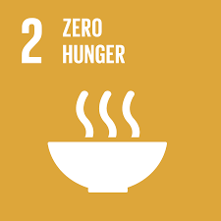

Water & Infrastructure developmentdespite living in close proximity to Lake Victoria, 3 out of 10 members of the communities living in this region do not have access to clean and safe drinking water from improved drinking water sources. Lerne Adams Foundation has therefore prioritised access to safe drinking water by collaborating with development partners and communities in exploring and implementing various approaches including spring water, boreholes, shallow wells, rain water collection. Our priorities are set towards reducing the number of hours spent by women looking for water as well as water-borne diseases associated with consumption of dirty water.

Women empowerment & advocacy We focus development programs that provides tailored empowerment initiatives to disadvantaged women or girls thus improving their potential to contribute to the prosperity and well-being of other women in the society. Community development initiatives around Lake Victoria region has demonstrated increasing responsiveness to the needs and contributions of women and therefore prioritized its agenda to target various classes of women affected by various forms of vulnerabilities. These include victims of domestic violence, early pregnancies, forced marriages, orphaned & vulnerable children (OVC), childbreadwinners, childlabour, women and children with disabilities and various forms of abuse.
Our approaches include accelerator programs to women in business, medical support, mentorships campaigns, and advocacy on women rights, girl rescue, counselling, education support and provision of basic amenities including sanitary pads to vulnerable girls. Our office works closely with children and county social departments/offices around the lake region.

Our Financials

Transparency & Accountability
Financial efficiency is one indicator of organizational health; a guarantee of effective programs is absolutely essential for a regional agency like Lerne Adams; and we insist on independent, external assessments of our programs as well: Our policy outlines procedure for regular external assessments to evaluate our program impact, coverage, coherence, relevance, sustain-ability, effectiveness, and efficiency, and we’ve developed quality management procedures and an internal auditing system designed to streamline our capabilities and optimize our resource use.

We are committed to a policy of transparency and disclosure by ensuring that key financial information is publicly available with guarantees of good management.

FINANCIAL INFORMATION

L
erne Adamstakes great pride in the financial efficiency and accountability. We work to maximize the value of every Shilling we receive from our development partners. More than 90 percent of our expended resources - among the highest of all philanthropic organizations - support our poverty-fighting projects around L.Victoria region. Less than 10 percent of expended resources go toward administrative and fundraising costs:Take a sneak preview of our financial policy

- Lerne Adams financial policymaintains separate records and accounts together with the relatedfinancial statements, imprest accounts, and statement of expenditures record of the project being carried out, will be audited annually by independent private auditors acceptable to development partners.
- Lerne Adams will also provide weekly reports with concise detailed monthly project performance reports, quarterly progress reports and comprehensive annual progress reports on project implementation within one month of the end of the reporting period that details physical and financial progress and summarize performance monitoring and evaluation results. Within 3 months of physical completion.
- Lerne Adams Foundation will provide financial reports with copies of the Project’s audited accounts and financial statements no later than six months after the end of the fiscal year to which they relate.
- Lerne Adams Foundation will prepare a project completion report in standard format for the development partner and complete financial guidelines will be available on request.
- Lerne Adams Foundation has a policy of financial accountability to the targeted beneficiaries that involves sharing project visions and expectations before the onset of every intervention.

Structure of funding and collaboration
Lerne Adams partnership with various development partners and donors through a common mission statement and shared core values. By signing the Covenant of Partnership, each of the parties agree to abide by common policies and standards. The parties hold each other accountable through a system of peer review.

L
erne Adams Partnerships with development partners

Lerne Adams National Board is open to partnerships with research institutions, authorities and local governments in disseminating technologies, inputs, capacitydevelopment or running of events. We continually seek collaborations with academic, business professionals, Investors, social service leaders, volunteers and consultants in disseminating services.

A
gents of change and institutions

Special sponsorship for youth education and community events accounts for significant portion of funding for Lerne Adams programmes. Individuals, families, religious organizations and groups often find our organization as an appropriate vehicle for channelling support to special groups and beneficiaries.

F
inanciers and Special Sponsors

Lerne Adams implementation organogram
