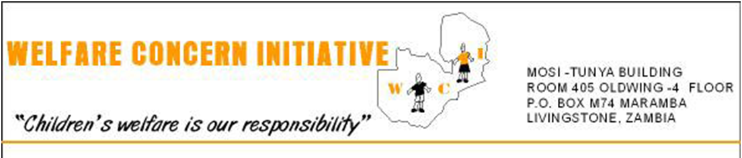
19^{h} OCTOBER, 2012

Dear Sir/Madam,
Greetings from Welfare Concern Initiative
I thank God today for the privilege of writing to you.
I am writing to you on behalf of Welfare Concern Initiative a faith based organization which is currently operating in the two rural districts of Southern province of Zambia namely, Kazungula and Livingstone.WCI.as it is commonly called, is a child centered Christian faith based organization, not for profit making but working to improve the welfare of orphans and vulnerable children and disabled children especially those who can not access education in primary and secondary schools. The organization was formed in 2004 and legally registered on 2nd March 2005 with the registrar of societies of Zambia.
The organization’s head office is in Livingstone.
WCI helps the vulnerable children and their care givers, grandmothers and widows we support to know Christ by sharing the gospel of our Lord Jesus Christ.
As an organization, we believe that every child regardless of race, religion or gender, has a right to education and other basic human rights that include food, water, sanitation, shelter and clothing. When a person is taught to read, to think and to respect others, that person is freed from primary causes of poverty.
Through education, we believe that a child can escape the vicious cycles of poverty, ignorance and exclusion.
Secondary, WCI lays emphasis on economic empowerment to women. We believe that a child cannot learn at school on an empty stomach. We identify parents or guardians who have skills and empower them with small soft loans so that they can sustain themselves. The youths are given entrepreneurship skills such as carpentry, tailoring, welding and bricklaying so that they can become self reliant.
WCI on the other hand, does not encourage handouts because they are not sustainable. Handouts generally encourage laziness and reduce the ability for people to plan and think.
WCI embraces transparency and accountability as one of its core values. We believe that all funds and other resources received from donors must be well accounted for.

ACHIEVEMENTS
- WCI was elected as secretariat for the District Orphans and Vulnerable Children Committee for Livingstone
- We have been able to support 55 children every year in primary and secondary schools with small funding from Firelight Foundation and Spirit in Action.
- We were recently given a building structure by the Livingstone City Council which we intend to use for youth skills entrepreneurship and women economic empowerment activities. This building however, requires renovations for it to be used.

CHALLENGES
- We have a fast growing number of OVCs who need spiritual, financial and material help.
- Many children are leaving schools because their guardians can no longer afford to pay school fees every term due to high poverty levels in Zambia.
- Many youth who complete school do not have anything to do and this has resulted in them engaging themselves in mischievous activities.
- Many children do not go to school because their parents cannot afford to provide three meals in a day.

LOCAL NETWORKING ORGANISATIONS
WCI does not exist independently but collaborates with other organizations and government ministries whose mandate is also focused on the welfare of children. These are: Ministry of Education, Ministry of Health, the Social Welfare Department, and Programme for Sustainable Rural Development, the local Government Authority, Ray of Hope etc.

REASONS FOR PARTNERSHIP
We are faced with big challenges in the area of orphans as WCI as well as a country (Zambia). According to the recent statistics from the central statistics office, Zambia is ranked 164 out of 189 poorest countries in the world. Zambia currently has 1.3 million orphans.

PROBLEM STATEMENT.
Livingstone and Kazungula are tourist districts and are bordered by three countries – Zimbabwe, Namibia and Botswana. The districts have populations of eight hundred fifty thousand people. The districts proximity to the three neighbouring countries have fuelled the HIV and AIDS infection rate due to commercial sex workers and cross boarder traders who have become established among the residents of Livingstone and Kazungula. Both local and foreign tourists who come to visit the famous Victoria Falls attract commercial sex workers who have made sex as an income generating activity to support themselves and their families.

The situation has been worsened by high unemployment levels.
Livingstone’s HIV and AIDS infection rate stands currently at 30.8% making it the district with the highest in Zambia. According to the sexual behavior survey report conducted in 2010, it states that there are 268 people who die in Zambia every day due to HIV and AIDS and other related diseases. This has consequently resulted in a high number of orphans in the districts.

As a result of this HIV/AIDS pandemic, many families have experienced untold sufferings and misery. Many families live on less than a dollar per week and survive on wild fruits and mangoes during the rainy season.
The unemployment levels are extremely high. Most of the industries which used to operate have since been closed down. Because of the increased poverty levels, many women –widows and other vulnerable community members cannot afford to raise money to buy shoes, uniforms, books, pens, pay school fees or even feed their school going children as most of the families live on less than a dollar per week.
There are over (800) eight hundred children who are failing to go to school due to lack of educational, nutritional and medical support. Many children have dropped out of school due to lack of support and long distances from their homes to schools. Many children learn in thatched classrooms and are taught by un trained teachers.

It is also sad to note that traditionally, the extended family in Zambia has been the first line of response in meeting the needs of orphans and other vulnerable children, but due to the large number of children, orphaned by the pandemic and poor economic situation, this social safely net has been weakened. More than two out of every three Zambian households live below the poverty – line. This means that most households are barely managing to take care of their own children while at the same time; many Zambian households have had to absorb orphaned children and redistribute their meager resources. This increases the vulnerability of even non – orphan children. There has been also a dramatic increase in the number of households headed by grandmothers or female children themselves and in the number of streets children.

We are therefore requesting your organization to partner with WCI to provide financial and material assistance to the less privileged children and poor community members we are supporting.

We look forward to your favourable response.

Yours faithfully,

MOSES K. CHIBANDA
DIRECTOR – WCI
LIVINGSTONE, ZAMBIA.

Tel: +260 978937905 , 950871321 Email : moseschibanda@yahoo.com

