Project Proposal
on
“ Live Strong program ”
Support Health Care Center (SHCC) for migrant labours, TB or other dieses and HIV affected children

AJIT FOUNDATION

AJIT FOUNDATION

Organization Profile

1. Name : | Ajit Foundation
Address : | Wani Plot,Agalgaon Road, BARSHI- 413401District: Solapur State: Maharashtra
Telephone Number : | 02184-220103 Fax Number: 02184-220203
Website : | www.ajitfoundation.com
E-Mail Address : | srujanonline@gmail.com spandanonline@rediffmail.com
Name & Address of Legal holder : | Mr.Mahesh Mahadeo Nimbalkar,(President)  Wani Plot,Agalgaon Road, BARSHI- 413401 District: - Solapur (M.S.)
Contact Person Mobile No. | 09822897382 / 09405024613

AJIT FOUNDATION

Legal Status of Organization

Registration & Tax Exemption Details | Registration No. | Year of Registration
Indian Societies Registration Act 1860 | MAH/1318/06/Solapur | 2/11/2006
The Bombay Public trust Act 1950 | F-18180/06/Solapur | 23/01/2007
PAN No. | AABTC2321B | -
Foreign Contributions(R) Act 1976 | 083980083 | 15/04/2011
Exempted Under 80G (5) (VI) | PN/CIT-IV/The/80G/AF/4/2012-13/180 | 11/04/2012
12AA | PN/CIT-IV/The/12 A/AF/1/2012-13/179 | 11/04/2012
A Login : www.ngo.india.gov.in | UNIQUE ID: MH/2011/0046576 | -

Genesis

Ajit Foundation is a non-profit voluntary organization established in the year 2004 and registered in the year 2006 under society Registration Act, 1860 and The Bombay Public TrustAct.1950.
It was established by group of likeminded social workers who are

AJIT FOUNDATION

working in the field of basic health, education, vocational training, employment generation and skill development training programmes, environmental protection, rural development, women empowerment and child protection, Social Justice and other social issues.
Vision and Mission the organization;

Vision: Creating Livelihood opportunities, striving for equal rights and participation of women, children, landless dalits and weaker sections of the society in the development processes.

Mission: To create and provide meaningful opportunities seeking holistic development of especially vulnerable groups of women, children, marginalized farmers, landless dalits and disabled and encouraging them to participate in the developmental processes as a active part by securing just and dignified living for them”.

Aims of the Organization

To effect positive changes in the socio-economic and educational conditions of Tribals and backward castes.

To provide relief to people affected by natural Calamities.

Promotion of agriculture, clean environment and economic development.

To initiate economic developmental programmes for Tribals, deserted women, sex workers, unemployed youths and to impart basic education to their children.
- Rehabilitation of orphans, blind, handicapped and aged persons.
- Organization of women through micro-credit groups, entrepreneurship development of women, etc.
- Awareness creation on social issues through street plays and other mediums.
AJIT FOUNDATION

- Promotion of non formal education , adult literacy reading rooms in villages etc
- To set up Health Centers, Sports Clubs, Gymkhana’s etc.
- To work at national and international levels to achieve the objectives of UN Convention on Rights of Child Education.
- To promote eco – friendly living and sustainable waste management practices as an innovative vocational opportunity for the Migrant Children.
Office Bearers of the organization

Name of office bearer | Designation of office bearer
Mr.Mahesh Mahadeo Nimbalkar | Founder Managing Trustee
Mr.Ramesh Laxman Kaswate | Founder Trustee
Miss. Vinaya Vijaykumar Jadhav | Trustee

Programs and Activities

1.Sevalaya orphanage – is a programme directed to the housing, education and socio-economic development of children of HIV/AIDS parents, mostly orphans from the nearby hamlets and red-light areas of Barshi City, Solapur district, Maharashtra State. This project which was initiated 2 years ago, with 10 orphan children form the area, now caters for 25 children (Mostly children from the age group of 4 – 17). The daily needs of the children are mostly met with contributions from the shg women and traders from the area.

AJIT FOUNDATION

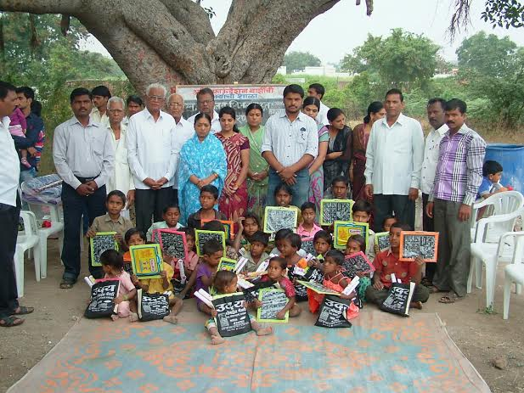 | In the field of Child education and women’s empowerment, the activities of Ajit Foundation merits special attention. “Vanchit Bal Vikas Manch & Bal panchayat” a network initiated and presided over by the organization is a movement – overseeing the proper implementation of government education schemes, for poor, tribal and backward children in all over
Marathwada & Vidarbha. Its relentless pursual of the poor and pathetic condition of student hostels for backward class children, ashram shalas and vastishals prompted government action – changing policies, allocation of more funds, proper infrastructure facilities, improved administration and accountability of officials. It also resulted in raising the matter in the State Assembly by the MLA’s, suspension of officials who were badly administering the hostels, exploitation of students, etc.
Years of educational promotional activities amongst the lamani tribals and other backward cast people has helped in bringing

AJIT FOUNDATION

their children into the mainstream of education. The Village education Committees and women self help groups plays a very proactive role in ensuring the proper running of government run educational institutions in the villages/vastis/ tandas.

2. Bhatkyanchi Shala (Nai Disha) - Education & Health for Migrant children:

Bhatkyanchi Shala (Nai Disha) - Education & Health for Migrant children:  Ajit Foundation initiated “Bhatkyanchi Shala” (Nai Disha) – a school for migrant children in year 2011. The beneficiaries are children who are not admitted in any school due to nature of the job/ employment of their family members. We are currently catering to around 250 children. | 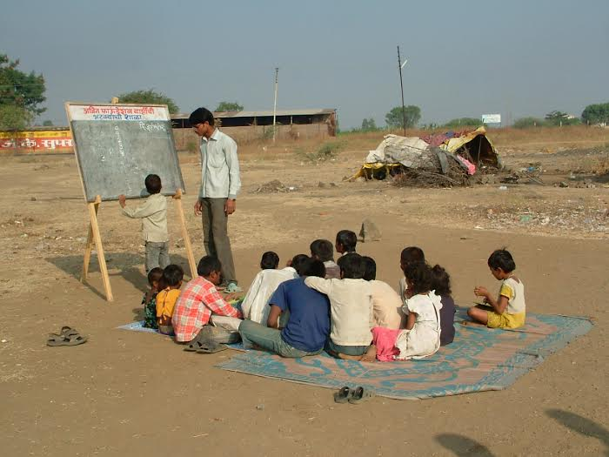
The families are mainly migrated from Bihar, Rajstan, U.P., M.P etc. We teach them where they live. This project when began in 2011 with the support of Volunteers from Ajit Foundation was such an experiment aimed at the

AJIT FOUNDATION

educational development of children of Sculptor - from Latur Road,Barshi, Pardhi vasti-Lakshyachi Wadi Pardhi vasti-Gadegaon,Bhoom,Hatlaidevi Tandha Osmanabad t*hrough a series of innovative and effective activities/programmes. Ever since the beginning of this project we have been gradually bringing the children of these communities from 10 villages into the mainstream of education.
The organization is working to address their primary education and health concerns. The organization constantly trying to develop and implement innovative and effective modules of teaching. The organization intends to give- Nai Disha an enjoyable, learning and encouraging engagement for the Children. The organization gives formal and informal Education to children in the Nature; like the concept of Ravindranath Tagore.
“We require not only right to Education but also right Education, so right to right Education should be our goal.”
3. The Feeding Program is served to the wandering an unsupported, mentally retarded persons.
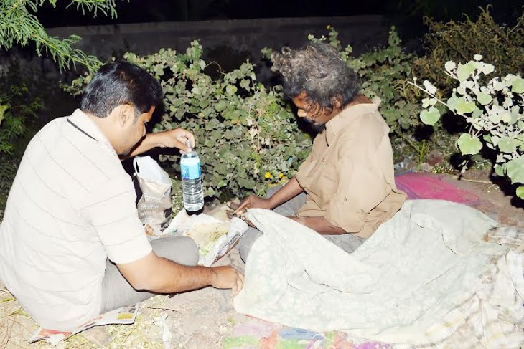 | The Feeding Program is served to the wandering an unsupported, mentally retarded persons:  The Feeding Program is served to the wandering and unsupported mentally retarded persons having less intellect every day during morning & evening session by way of

AJIT FOUNDATION

directly contacting their places of abode where they are living without any human amenities, without any protection, by Maruti Van, and every day during Noon hrs. They are served with meal like Rotli, Vegetables, dal-rice and thereafter, in the evening time they are served Bhaji- Bhakari, Milk. We provide them pure water to drink.
4. Festivals with Migrant families:

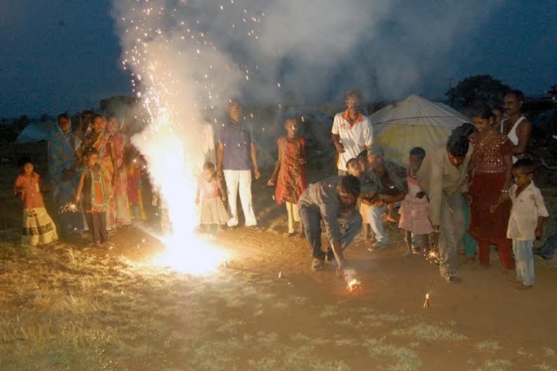 | AF celebrates festival with Migrants Families. They do not celebrate festivals because these families could not earn money. So  AF volunteer go with material of Festival and celebrates with full of joy. It will be a memorial day in their life.  AF arrange festivals like Diwali, X mass, Rakshabandhan ect.

AJIT FOUNDATION

5. Mid-day Meal Programme:

According to a UNESCO report, around 13.5 million children in the age group of 6 -13 years are out of school in India. Prevention of malnutrition
related disability, along with increasing literacy rate is the major task of this intervention.
Migrant Famillies In 2002 the
Government of Maharashtra had initiated a mid day
meal program to tackle this problem, to enable
more children to enroll and ultimately bringing down the rate of illiteracy and the concerned department had identified few nonprofit organizations with good track record to implement this program, and
SAMARTHANAM was one of them.
SAMARTHANAM has established an ultra modern kitchen in the outskirts of the city
employed by a well trained and efficient team who works with a lot of passion. Currently
the number of kitchens has increased to two and the areas covered have gone up from
Bangalore city and its suburbs. Total number of meals currently supplied is an astounding
figure of 35000 covering 125 schools of the above mentioned areas.

AJIT FOUNDATION

Home for Women in Distress:
In 2007 a home was started with the aid from Ministry of
Women and Child Development, Government of India. The
home caters to around 50 women from different parts of
Karnataka; this number includes women suffering from
various disabilities, destitute widows and those belonging
to economically backward classes.
Vividha:
Vividha is an initiative for Samarthanam to provide
massive employment opportunities to the Disabled
and Underprivileged people. Its intend to create a
successful enterprise which would generate revenue
for carrying out several social projects of
Samarthanam.
11. Parisara:
The whole idea has transformed itself into a revenue and employment generating model.
Spurred on by the encouragement and support

AJIT FOUNDATION

Live Strong program for migrant labours, TB or other
dieses and HIV affected children

Introduction:

The search for alternative development patterns to the mainstream of development trends has impelled individuals and groups in many parts of the world to launch experiments at micro-levels.
Ajit Foundation works with the children of migrant facilities. The parents of these children have migrated from different parts of the country and are engaged in making Plaster of Paris statues and selling them. In the off season they sell small cosmetic articles such as hair pins, bindies etc leaving their children in the care of older siblings. Children wander in villages in absence of their parents

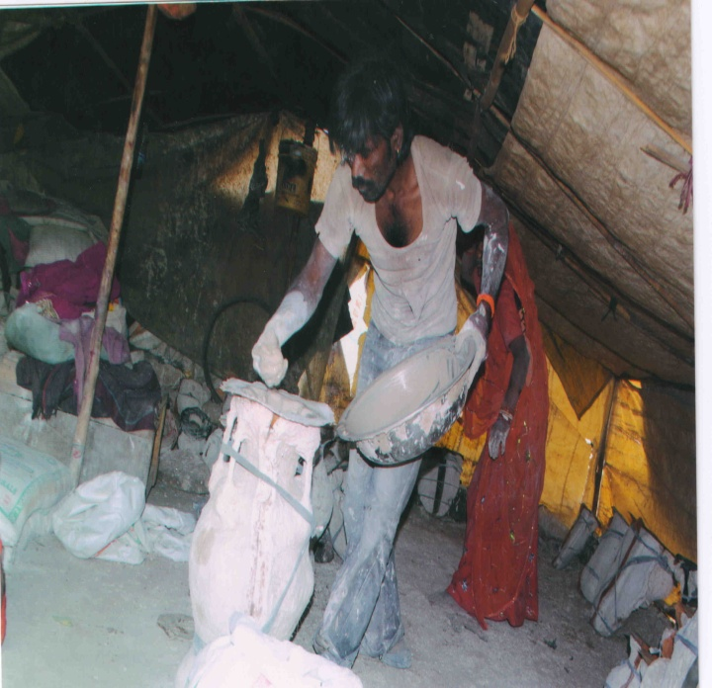 | 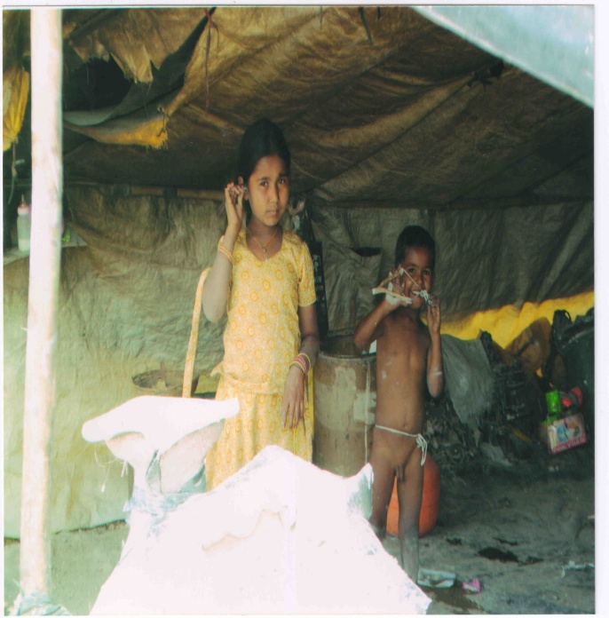

This project when began in 2011 with the support of Volunteers from Ajit Foundation was such an experiment aimed at the educational development of children of Sculptor - from Latur Road,Barshi, Pardhi vasti-Lakshyachi Wadi Pardhi vasti-Gadegaon,Bhoom,Hatlaidevi Tandha Osmanabad village of
AJIT FOUNDATION

Barshi Block of Solapur District and Bhoom nd Paranda Blocks of Osmanabad District Maharashtra through a series of innovative and effective activities/programmes. Ever since the beginning of this project from last two years, we have been gradually bringing the children of these communities from specifically identified 5 Village into the mainstream of education.

Ajit Foundation Experience and Current Operations
By addressing the issues of illiteracy, child labor and drop out from school faced by the underprivileged Migrant children in Maharashtra, Ajit Foundation started a program which provides nutrition and a safe haven along with quality education to the Disabled and underprivileged children in the urban and semi urban areas of Karnataka and its neighboring states.
The aim of the school with hostel facility is advantageous to the children because of the following reasons.
• Providing primary Basic education from 1 – 10th standard
• Better nutritional and medicinal facilities will be provided for the impoverished children.
• Safe shelter to the children
• Additional teaching
• Avoiding the distractions of an indigent family and focusing more on education

OBJECTIVES TO BE ACHIEVED

- To aware people about health issues and HIV related risk factors.
- Motivate people to use existing government health system.
- Establish link between people and government health system
- Create a easy replicable Day Care Model
- Impart value of good health in children
- Straighten ASHA, ANMs, VHND & VCDC functionaries
- Create a child friendly health care model

Project Goals and objectives:

Educational mainstreaming of 200 socially excluded children of dalit/tribal landless farm labourers community from five village of Solapur District.

Specific objectives:

- Development of a group of 5 (First Year – 3, Second Year – 4, Third year 5, i.e, One each edu. Promoter for 5 villages each) education
AJIT FOUNDATION

- promoters to ensure educational mainstreaming of all vulnerable children from the target areas.
- Admitting/re-admitting (dropped outs) 200 students (within a period of three years) to village schools/ashram shalas/hostels.
- Conducting recreational classes (once in a week) in every Village to inculcate a taste for education amongst the children.
- Formation of a community Education Development Committee in every Village to ensure participation of community and sustain the efforts of the organisation for a long term.

  - Area profile and Target Beneficiary profile:

The community with Ajit Foundation works is the migrated community. M P Shields and G M Sheilds 1993 in the World Migration Report 2008 states that family migration is neglected by the academicians and policy makers. Migration has severe consequences such as forgoing all benefits arising from social networks created by long years of association with the society in which the family had been living. The migrants with whom we work are mainly migrated from the Banjara, Marwadi communities. The main occupation of the community is to make sculptures/ Statues of God/ Goddesses. The entire family is involved in making of these sculptures. After making it the adults in the family wander in the surrounding villages to sell these statues made of Plaster of Paris and other similar materials. When parents are away selling these statues, the older children look after the household chores and their younger siblings. Migration may take considerable time for a migrant family to get assimilated into the new village/urban society into which it moves. The migrant families, especially long-distance migrant families, live in constant fear of insecurity of life. Moreover, it may be hard for a migrant family to claim equal access to common property resources and infrastructural facilities created by the local administration in the new location. This could also be one of the reasons why the children from these migrated families do not attend school. Children of a migrant family are likely to face problems in the process of socialization. These problems/risks are probably known to the heads of families and hence they are not very motivated to send their children in the local schools.

AJIT FOUNDATION

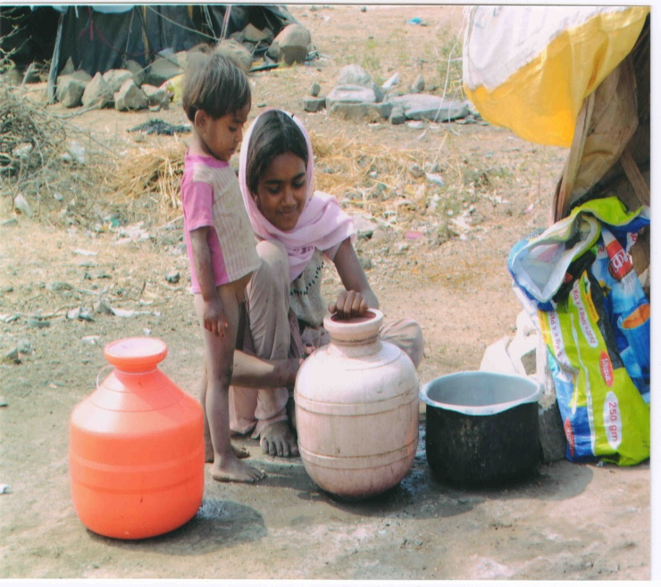 | 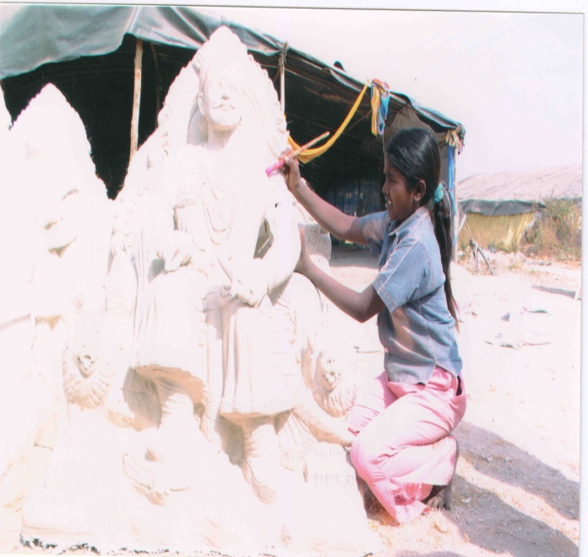

For years, the children of these communities have been deprived of education. Especially the girl child, just could not enter into the mainstream of educational system of the state. As a result most of them grow up as uneducated, unskilled, and unemployable, forced to be daily wage earners, farm workers and sometimes bonded labourers. Most of the child workers in and around the small and big cities in the region belong to this community. Moreover, lack of education has been the main cause of backwardness of these communities. One can see children wandering in the villages on any working day. The availability of the schools is not a constraint; constraint is the lack of motivation. to this effect a present Ajit Foundation is involved in creating awareness in the intervention areas on effects of the migration on the education and health. They are also informed about the need to keep back their children to continue their schooling and the various govt. schemes for the education development of their children.

Buoyed by the positive outcome of this pilot project and the urgent need to reach out to hundreds of such deprived children we propose to expand the scope of the present project in the coming three years.

AJIT FOUNDATION

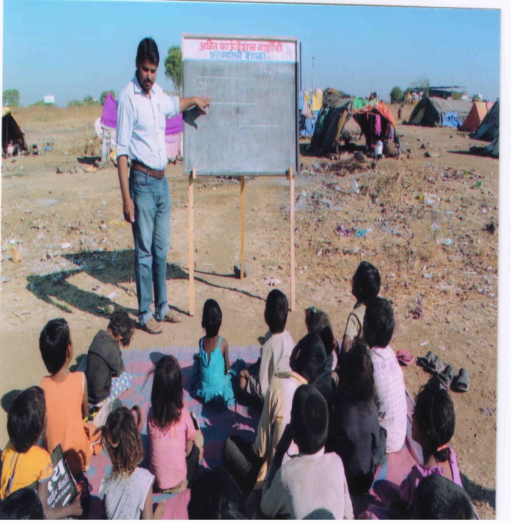 | 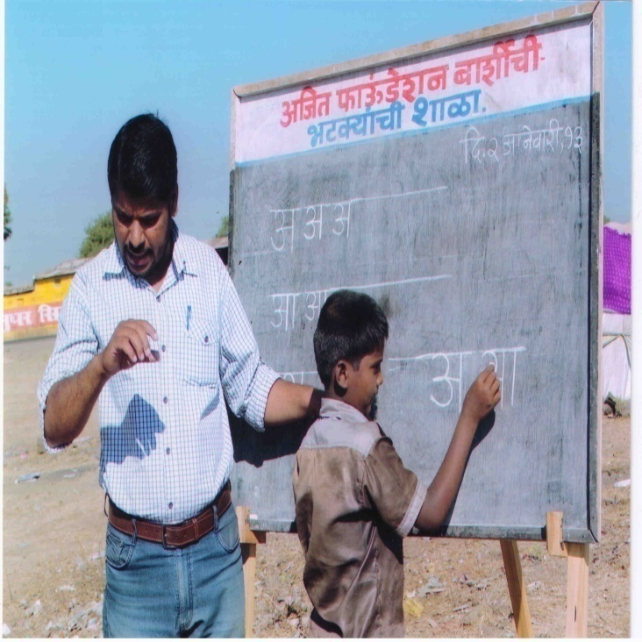

About the Programme:

The community with which Ajit Foundation works is the migrated community. These people are mainly from the
Banjara, Marwadi communities who have migrated almost 15- 20 years back. The main occupation of the community is to make sculpture/ Statues of God/ Goddesses. The entire family is involved in making of these sculptures. After making it the adults in the family wander in the surrounding villages to sell these statues made of Plaster of Paris and other similar materials. When parents are away the older children look after the household chores and their younger siblings. As a result children do not attend school. For years, the children of these communities have been deprived of education as there is no awareness about the importance of education. Especially the girl child just could not enter into the mainstream of educational system of the state. As a result most of them grow up as uneducated, unskilled, unemployable, forced to be daily wage earners, farm workers and sometimes bonded labourers. Most of the child workers in and around the small and big cities in the region belong to this community. Moreover, lack of education of the parents has been the main cause of backwardness of these communities.

At present Ajit Foundation is involved in creating awareness in the targeted areas about education and health.
We tried to convey them an important of education and health.

The direct beneficiaries of this project will be 1000 children (. They are basically vulnerable group of HIV infected
AJIT FOUNDATION

children, Migrant children, Deprived Children, more specifically street children, slum children, working children, children of sex workers, children of families ‘ at risk’, girl child.

Indirectly we can ensure participation of community children & parents, formal schools, local authority, staff of Government systems and other NGOs.

Ajit Foundation for the last 2 years is working with nearly 800 children for providing formal education as well as health check up. We are able to enroll 1000 children up to higher education. We are proud to say that due to intervention of Ajit Foundation we are able to create an opportunity to these children

APPROXIMATE No. OF BENEFICIARIES

One of the survey conducted by NGO stated that around 15800 people are noted as a HIV positive. In that around 2500 children are also noted.

As per Pratham survey in 2009, 9301 children are reported to be out of school children in age group of 6 to 18 years. 5621 children in age group of 6 to 18 are working in hazardous and non-hazardous sector. Out of that 1969 are female. That means 60% children from out of school is working children. 40% children are not going to school and also not working too.

Majority people are working in beedi making process. Women and girls of family are mainly engage in beedi making work. It`s affect on their health. Cases of TB, Allergies, Asthma and other breathing related health issues have been reported by health department.

AJIT FOUNDATION

Age | Total Working Children
 | Male |  |  | Female |  |  | Grand Total
 | Hazardous | Non Hazardous | Total | Hazardous | Non Hazardous | Total
6 to 8 | 23 | 38 | 61 | 30 | 21 | 51 | 112
9 to 12 | 150 | 290 | 440 | 266 | 91 | 357 | 797
13 to 14 | 193 | 421 | 614 | 340 | 97 | 437 | 1051
15 to 18 | 648 | 1889 | 2537 | 786 | 338 | 1124 | 3661
Total | 1014 | 2638 | 3652 | 1422 | 547 | 1969 | 5621

In first year of this project proposal organization decided to cover 1000 beneficiaries in four phase. Each phase divide in one quarter i.e. three months. 250 beneficiaries will be covered in each phase

Rationale for undertaking project activities:-

The target group with whom we work is the deprived section of the society. Most of them are migrant workers who work as agriculture labourers and in non agricultural season they are engaged in construction workers or work a sculptors or sell small cosmetic items in the nearby villages,

Ajit Foundation has been working with this group from last three years. During our interaction with the community we have observed that they live in very unhygienic conditions. In the absence of parents children keep playing in the dust of plaster of Paris with is used as raw material for making the statues. When the parents go out to earn the wages, children wander in the villages unattended. This leads to malnutrition and a lot of health ailments amongst the children. There are almost 8,000 Migrant children in Solapur.
Although the trend of HIV prevalence is constant it is still moderately high at 0.73% (PPTCT, 2008). A recent study by India Health Action Trust “HIV/AIDS Situation and Response in Solapur District:Epidemiological Appraisal Using Data Triangulation”,May 2010 reveals that Solapur district has a high current transmission among HRGs ( High Risk Groups) and a moderate transmission in the general population, with evidence suggestive of future potential to increase the prevalence in general population given

the large network of clients of female sex workers (19,143), female sex workers (7,107) and men who have sex with men (1,037) and (Children infected HIV )4,012. The prevalence has been high in the bridge population at 23.82% (ICTC walk‐in males, 2008) and among the high‐risk females at 22.57% (ICTC walk‐in females, 2008).

AJIT FOUNDATION

Barshi block has second highest estimated high risk groups i.e. 8.51 per 1000 adults.

Barshi is also falls in drought prone region. The block has been predominantly inhabited by socially and economically weaker sections of the community.. Due to scanty rainfall there is a very limited scope for agricultural activities.
Seasonal Migration for sugarcane cutting is very common. Parents migrate to Solapur for 4-6 months leaving their children with ageing grandparents. Lack of a caretaker during the day to feed the child at frequent intervals push the children in the malnutrition cycle. Also inappropriate child care and feeding practices amongst parent’s causes malnutrition in this area.

Infrastructural facilities in these areas are awfully inadequate leading to inadequate access to health and social services.
Due to its remoteness and inaccessibility the public health workers seldom reach out to these communities. With little say in demanding their legal rights such safe drinking water, sanitation facilities which have a severe impact on their health status.

In some of the villages ICDS centers are available but Children below 3 years of age are not looked after in the Anganwadi centres.. Integrated Child Development Scheme (ICDS) is mainly targeting the children after three when malnutrition has already set in.

Almost 70 % of children upto age of 5 years are undernourished from Jat block.
Thus in order to prevent these avoidable deaths, to make a dent into the poverty trap and to allow children to have optimal physical and mental growth, there is a pressing need to prevent, and treat under nutrition in the community.

Literacy status of the district - 72% of the district population age 7 years and above are literate. Male literacy is 82% and female literacy is 60%. Literacy is higher in urban areas (78%) than in rural areas (68%). Among the tehsils, literacy rate is the highest in North Solapur at 76%, closely followed by Barshi at 74%.

AJIT FOUNDATION

Health care facilities: Solapur district is served by 1 government hospital ‐ Shri
Chatrapati Shivaji Maharaj General Hospital under the Government Medical College, Solapur. In addition, there are a number of big private hospitals in the district including Ashwini hospital, Siddheshwar cancer hospital, Wadia hospital, Yashodara hospital, Lokmangal hospital, and the Nargis Dutt cancer rural hospital at Barshi. The district has a network of 10 community health centres (CHC)/rural hospitals (RH), 77 primary health centres (PHC) and 431 sub‐centres.
Despite this infrastructure there is substantial gap in the services available and its utilization. The utilization of these services will only increase when there is awareness of these services and the services also should become people friendly.
Ajit Foundation aims bridge this gap through our intervention of reducing the apprehension amongst the beneficiaries and service providers.

Activities to be undertaken:-

-The project will be divided into 4 steps i.e. Initial, implementation, monitoring and evaluation and feedback.
In the initiation stage
A rapid household survey to get the exact number of Households in the selected 10 village and to understand the demography and socio economic conditions

2, Awareness sessions will be conducted once a month in all ten villages.
- Crèches will be started in 5 villages so that in the absences of their parents children will be given nutritious food and necessary education.
- Villages will be selected on the basis of “most vulnerable villages’ criteria- VC (Refer to slide no 9 for VC).
- The crèches will be managed by a locally appointed woman. Two women per crèche. They will be trained in management of the crèche prior to srating the crèche.

- Advocacy to integrate the crèches within ICDS for vulnerable communities will be undertaken,.
- Liasoning with PHCs – sensitization of Health Care Providers to establish Referral Link will form an important part of the project.
End line survey will be conducted to assess the Nutrition status of children from the intervention area and its attributes

Convergence Factors :-

-Linakhes with ICDS, ASHA and ANMs ,
-Organizations staff of social workers and field workers.
AJIT FOUNDATION

-health experts and doctors
-Dieticians
-Lady social workers.

Anticipated outcome from project activities :-

- A model will be demonstrated to show that crèches are required to reduce malnutrition in the vulnerable villages/ communities. ( please refer to annexure 1 for Vulnerability Criteria)
- An advocacy with the concerned offices namely ICDS.
- The inbuilt research component will support to establish the need of crèches and avail the National Rajiv Gandhi Crèche Scheme .
- Reduced incidences of malnutrition and other communicable diseases in the intervention areas.
- Increased awareness of good health practices amongst parents and the communities.
- Good rapport between women and crèche workers and the link workers such as ANMs and ASHA.

Tentative schedule of the project:

Part 1 – Base line Survey:

To understand the socio economic profile and prevalence of malnutrition and other communicable diseases and also help to select targeted population
Major indicators – BMI (Body Mass Index), number of Grade II, III and IV malnourished children

Part 1.2- After baseline:

Training of crèche workers who will be selected from the same locality. The training programmes will have following contents:

- Our body and menstrual cycle
- Pregnancy and Delivery
- Child Health and Care
AJIT FOUNDATION

- Malnutrition amongst children
- Women health and routine deceases
- First Aid
- Health and Nutrition
- Water, cleanliness and women health
- Stages of Child Growth
- Child Health during 0 to 6 years of age
- Kitchen Gardens as Nutrition Gardens

1.3- Developing referral protocols for identified grade III and IV malnourished children and suspected cases
1.4- Refereeing suspected cases from the community to VCTC (Voluntary counseling and testing centers).
Developing referral protocols
1.5- Lessoning with PHCs – sensitization of Health Care Providers, To establish Referral Link

Part 2- Community Level Intervention

- To operate crèches for marginalized children, at any point 20 of the worst malnourished children in 100 villages will be identified for supplementary feeding. 100 Centers X 10 Children = 1000 children.
- Providing supplementary Nutrition to children and pregnant mothers through the crèches
- Provide referral services to malnourished and other women in need.
- Training of Panchayati members for health promotion
- Training of Health care providers on referral protocols
- Delivering awareness sessions in the community as per their availability.

AJIT FOUNDATION

Part 3- Awareness Generation

- Meetings with parents on good health practices to prevent malnutrition and better health outcomes.
- Formation of support groups of women and conduct group meetings with them to promote best practices and encourage mothers to send their children to crèches and older children to schools.
- Awareness programs i.e. rally, street play, poster exhibition for general public on the importance of personal hygiene and nutrition and ill effects of tobacco use
Part 4- Advocacy Program:

The government’s health services in the rural areas are worst. The Primary Health Centers are not providing the services up to the mark and therefore, need an intervention to start an Advocacy program with the government to ensure satisfactory service delivery at village level. Astitva will do advocacy with the following agencies/machineries:

- Primary Health Centre (PHC)
- Rural Hospital at Block level
- Civil Hospital at District level
- Print and electronic media
- People’s representatives i.e. Gram Panchayat Members, Block level Panchayat Members, Zilla Parishad Members, Member of Legislative Assembly and Member of Parliament.
Part 5- Monitoring and evaluation of the project activities:

. To determine the attributes of the difference in the health status of the beneficiaries and the community.

A detailed log frame analysis will be developed as and when the resources will be available.

AJIT FOUNDATION

Gantt chart

Activity | Year 1 |  |  |  | Year 2 |  |  |  | Year 3
 | Q1 | Q2 | Q3 | Q4 | Q1 | Q2 | Q3 | Q4 | Q1 | Q2 | Q3 | Q4
Base Line Survey
Selection of staff
Selection of Creche workers
Training of Creche workers
ASHA & Dai Training
Staff Training
Supplementary Nutrition support
Creche Centres
Nutrition Garden
Referral Service
Medical assistance
Health Library & IEC Material
Parent Meetings
Group formation of Anemic women & meetings
Group formation of adolescent girls and meetings & Melava
Get together in the community
Street Play & Rallies
Advocacy programmes
Monthly Review Meeting with staff
Monitoring
Quarterly Programme and Financial Reporting to Global Giving
Mid Term Evaluation
Final Evaluation

Success Indicators:

- Number of malnourished cases amongst children are reduced
- 90% people from targeted communities are aware about symptoms and effects of major disease including HIV
- 80% people will use existing health facilities
- Visit of Health workers of government system increased
- 90% children are enrolled in school and retain in school

Vulnerability Criteria for selection of villages:

- Villages generally located in remote areas
- Generally small in size (and thereby having little voice as a whole.
- Poor resource base like poor quality of soil or very little irrigation coverage.
- Predominantly inhabited by socially and economically weaker sections of the community especially by the SCs/STs or minority communities etc.
- Infrastructural facilities in these areas are awfully inadequate.
- villages have for long suffered very badly due to natural calamities like Droughts
- Inadequate access to health and social services

AJIT FOUNDATION

Geographical Coverage
The project provides Support Health Care Centre to Migrant labours, TB or other dieses and HIV infected and underprivileged children from Maharashtra and its surrounding states.

Items | Estimated cost  12 Months | 1 Month | Description
Personnel (Exclusively for this project) | 180000 | 15,000 | 1 Coordinator x 15000 x 12 Months
 | 360000 | 30,000.00 | 5 ORW's ( 100 Children x 1 ORW = 500 children ) x 6000 x 12 Months
 | 108000 | 9,000.00 | 1 Accountant x 9,000 x 12 Months
 | 36000 | 3,000.00 | 1 Office Boy x 3000 x 12 Months
 | 120000 | 10,000.00 | Honorarium to health  Faculties on visit basis Rs.500/visit
Conferences, Workshops, Meetings | 48000 | 4,000.00 | 1)Parents Meeting 6 Meeting x8000
 | 20,000 | 1,667.00 | 2) Work Shop 4 x 5000
 | 24000 | 2,000 | 3) Meeting with ORW's 12 x 2000
Travel | 60000 | 5000 | 1) Travel for ORW 1000 x 5 ORW's x 12 Months
 | 42000 | 3,500.00 | 2) Travel for Coordinator 3500 x 12 Months
 | 24000 | 2,000.00 | 3) Travel for health  Faculties 2000 x 12 Months
Printing and Publications | 60000 | 5,000.00 | 1)Printing & Stationery 5000 x 12 Months
Administrative Expenses | 180000 | 15,000.00 | 1)Office Rent 15000 x 12 Months
 | 24000 | 2,000 | 2)Electricity & Water 2000 x 12 Months
 | 12000 | 1,000 | 3)Xerox 1000 x 12 Months
 | 5,000 | 417 | 4) Audit Fees 5000 x 1 Time
 | 4000 | 333 | 5 ) Legal Fees & Bank Charges 4000 x 1 Time
 | 9600 | 800 | 6) Office Exp. 800 x 12 Months
SOffice supplies, Materials | 40,000 | 3,333.33 | 1)Office Supplies Material of Cupboard -1 , Table 2 , Chair 10, Colour T.V. , DVD, Toys for CLHA
 | 35,000 | 2,916.67 | 2) Computer & Printer
Telephone, Fax | 36,000 | 3,000.00 | Telephone, Internet & Fax 3000 x 12 Months
Postage, Shipping | 6,000 | 500.00 | Postage & Courier 500 x 12 Months
Nutrition & medicines to Children | 600,000 | 50,000.00 | 500 children x 100 for 12 months
Total estimated cost | 2,033,600 | 169,467

Impact of the Programme:
Over the years Ajit Foundation has gained vast experience in handling a Firata Dawakhana project like this
- To aware people about health issues and HIV related risk factors.
- Motivate people to use existing government health system.
- Establish link between people and government health system
- Create a easy replicable Day Care Model
- Impart value of good health in children
- Straighten ASHA, ANMs, VHND & VCDC functionaries
- Create a child friendly health care model

AJIT FOUNDATION

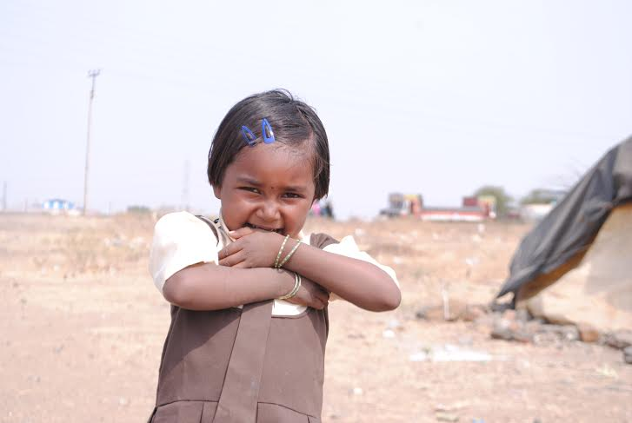

Give a little & Build their Future
Because they want to
“Live Strong”

