CARE FOR AFRICAN KIDS (CFAK)
ANNUAL REPORT
GIRL POWER PROJECT

P O BOX 26489 KAMPALA UGANDA EAST AFRICA,
WEBSITE: www.careforafricankids.org
KEY CONTACTS:
Robert Pool Director
Email: rpool@careforafrican.org
Tel: +256752509125 Skype: robertpool2
Kayemba David Treasurer
davidk@careforafricankids.org Tel: +25677282890
Registration Number for NGO.107991/ CBO 101-10
2011

Together we can renew hope where it is lost in vulnerable people here in CFAK $ girl power
2011

INTRODUCTION
The following report provides details on the programs implemented by care for African kids and the achievements registered in the year 2011. 2011 marked the beginning of the implementation of the CFAK strategic plan 2011-2020.Last year CFAK experienced growth in terms of diversity of programs and activities implemented by CFAK. This enabled the organization to move a step further in the realization of CFAK’S goals and objectives.

ABOUT CARE FOR AFRICAN KIDS
CFAK is a registered a NON-government organization founded in 2008 and registered in 2009. CFAK is mandated to contribute to the uplifting of the living standards of orphans and the underprivileged in Uganda with emphasis on promoting the welfare of children and women.

Vision
To be the leading contributor to the provision of good standards of living and education to the under privileged children and women and to offer orphans and widows a life full of hope in its fullness.

Mission
To renew hope in orphans and widows who have lost hope because of HIV/AIDS infection, wars, natural death and other incidences through working with the poor and the oppressed. We are to promote human transformation, seek justice and be witnesses when they are achieving their dreams once lost.

Core Values:

We are committed to the poor
We are responsive
We are partners
We value people

Objectives
The objectives of CFAK in accomplishing its mission are as follows;
- Empowering children and women through providing them with quality and practical education.
- To contribute to improved health standards for children and women.
- To contribute in eradicating poverty in homesteads since women and the youth have proved to be strong pillars in development and changing societies in general.
- Training people on how to become sustainable in life but also fit in society through creating a professional mentality in people to enable them enhance their image in society.
- To advocate for the welfare of orphans, vulnerable children, youth and widows.

- To increase the effectiveness and efficiency of Care for African Kids (the Board and the Secretariat) and to manage and grow the organization in a sustainable and significant manner.

Goals
Health: To contribute to improved health standards for children and women in Uganda.
Community standards of living: To directly contribute to improving the standards of living of women through increasing house hold incomes.
Education: To enhance improvement of education, through provision and access of education for disadvantaged children, youth and women.
Strengthening CFAK institution and organization capabilities: To increase the effectiveness and efficiency of the CFAK institution (The Board and Secretariat), to manage and grow the CFAK in sustainable and significant manner.

Table of Content
INTRODUCTION 2
ABOUT CARE FOR AFRICAN KIDS 2
Vision 2
Mission 2
Core Values: 2
We are committed to the poor 2
Objectives 3
Goals 3
Table of Content 4
1.0 MESSAGE FROM 5
1.1 THE DIRECTOR 6
1.2 INTRODUCTION TREASURER 7
2.0 Program achievements 9
2.1 Education 9
2.1.1 Bursary scheme 9
2.2.1 Vocational school project 9
2.1.3 The Resource Center. 10
2.1.4 Primary school project 10
2.2 Child nutrition boost projects 11
2.2.1 Poultry project 11
2.2.2 The diary project 11
2.2.3 Fruit tree project 12
2.3 Health 13
2.4 GIRL POWER PROJECT. 14
2.5 COMMUNITY EMPOWERMENT, 14
3.0 Membership to other organizations. 15
3.1 Governance. 15
4.0 Organizational challenges 16
5.0 Special thanks to those who have made us through 2011. 16
6.0 FINACIAL OVERVIEW 18
OUR BANK DETAILS 20
WEBSITE: www.careforafricankids.org/ www.careforafricankidsuganda.weebly.com 21
TOGETHER WE CAN 21

- MESSAGE FROM

1.1 THE DIRECTOR
Mr. Robert Pool
Director
CFAK Board of
Directors
It is indeed with great honour that I present to you our 2011 Annual report of Care for African kids (CFAK) NGO. CFAK views this tool as an accountability mechanism for its members, partners, friends, volunteers and communities among whom we are working with. We see this as an opportunity to check the work we have undertaken, the resources we have utilized and the challenges we have faced during the period under review.
As we take stock of our achievements in 2011, we are aware that CFAK has been operating for a good period of time of which a lot has happened during this time in advocacy to protect children and fight for human rights in Uganda. Therefore, CFAK 2011 is yet another important step in the organization`s growth curve as it looks forward to celebrate so many years in activism in Uganda.
Indeed, our interventions include engagement with other organizations and state organs on their child and women affair programs geared towards demanding for better services at the international, national and local levels. The starting of Girl power project on 20th November 2011 here at our orphanage center in Wakiso and Mpigi districts (Uganda) showed a great step we are undertaking in defending children as we try to make their lives better and sustainable.
In line with our constitution mandate, the Members of CFAK Board invested substantially in exploring and searching for practical solutions towards the sustainability of the organization. Although we have made some progress like the start the building our own school where our children are to study from, improving of Agricultural projects to commercial level, much more needs to be done and with this we would call on all possible support from the world.
Like in previous reports, we have highlighted several of our achievements recorded by the organization and where possible outcomes of our work. The reports have also shown the challenges that the organization still has, of which they went ahead and gave solutions to them.
In a special way I would like to recognize the support that is offered to children under CFAK of which include Mum. CATHERINE HISLOPE UK, MISS.ALISON ROSS USA, MR. JEAN-NOEL CHAZELLE FRANCE, MR. PAUL CHRISTENSEN CANADA, MR. SAM EDWARDS ANDMR. ANDREW PEACHER UK, MISS. AIMEE DUDAS USA and others as well mentioned the few but you’re many.
Special appreciation also go to CARE FOR AFRICAN KIDS Executive board members For their strategic guidance and to staff members for their professional commitment that enabled them to come up with several projects like girl power project idea under which girls are helped.
TOGETHER WE CAN
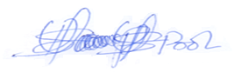
ROBERT POOL (MR.)
DIRECTOR,
CARE FOR AFRICAN KIDS AND PROJECT COORDINATOR

  - INTRODUCTION TREASURER
Mr. KAYEMBA DAVID
Treasurer CFAK and Girl power
As we look back at the growth of CFAK over the years since its inception, we are extremely proud of what we have achieved and even more excited about an equally but challenging future. We have successfully grown from a local organization to become a respected and operating entity garnering support and partnerships across the world while earning dear members, partners, donors, sponsors and well-wishers` cherished trust along way. It is also gratifying to know that we can still help the 165 orphans we have and the rest in the community in a possible way we can which has made their life to be better. Playing out part and working with similar organizations in shaping destiny of world child and to us it the reason we exist.
Although the global economic conditions are improving, they are not yet robust. And for Uganda the spiral down effects of this recession continues to be felt. Nonetheless, in this continue to evolving political, social and economic environments, we have in 2011 continued to keep children protection on top of our agenda and in doing so that is why we started in other projects like girl power.
With the wide spread economic problems we still need to sacrifice on the little we have for the better future of the children, youth and women.
I also thank all the people that came and visited us here in 2011, those who have given us countless support in our works, and also to individuals like MOTHER CATHERINE HISLOPE UK, MISS, ALISON ROSS USA, MR. JEAN-NOEL CHAZELLE FRANCE, MR. SAM EDWARDS, MR. ANDREW UK, MISS AIMEE DUDAS USA and MR. PAUL CHRISTENSEN CANADA FROM LIFT THE CHILDREN to assure you that together we shall meet our objectives members.
We still need as much help in terms of resources as much as possible since the more we raise the bigger the number of vulnerable people that are to be saved.
We still have a long way to go and we all need to join hands for the best from us towards them since they did nothing to live the kind of life that they are live and even to us that are somehow fine, we contributed nothing but it is just luck.
In this we are to build strong partnership with organization, governments, individuals through which we are to come together and help, we are also to conduct joint activities with friends from other countries.
As we look back in our operations, we are proud to re-affirm our commitments to the cause of child care in Uganda. Each new day offers us a chance to work together to improve the respect for child life for every child. Quality is our passion and success is our dream
TOGETHER WE CAN
KAYEMBA DAVID

TREASURER
CARE FOR AFRICAN KIDS AND ASSISTANT PROJECT COORDINATOR

2.0 Program achievements
In the period under review, the organization continued to implement activities in its program areas as indicated below;

2.1 Education
Under this program area the following activities were implemented;

2.1.1 Bursary scheme
CFAK managed to pay school fees for 165 at primary and secondary level fully, but for the rest it has been paying half as well as providing scholastic materials to them and this number is likely to increase this year because of the many orphans that have approached CFAK for Bursaries.
Under this scheme Kids were provided with scholastic materials such as textbooks, pens, pencils, Manila paper and special learning material for children with disabilities.

    - Vocational school project
Management through the girl power project initiated the idea of coming up with a vocational school to help in imparting practical skills to enable women compete favorably in the job market, to aid in training women to not only get jobs but also fit in society through creating a professional mentality in women to enable them enhance their image in society and to serve as an alternative educational opportunity. Thus to accommodate girls who drop out of school and the poor.

2.1.3 The Resource Center.
A resource center was established at the secretariat. It has a collection of books, reports, newsletters and documentaries. The resource center is open to researchers, students and those who need such information. CFAK still welcomes information materials for the center.
    - Primary school project
Construction of a primary school facility went underway last year and five classes haves already been half way accomplished and kids have started learning from this class rooms. We hope to get assistance from partners and friends this year to fully complete the project.
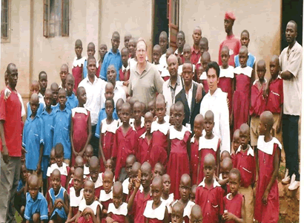
OUR SCHOOL IN GOMBA
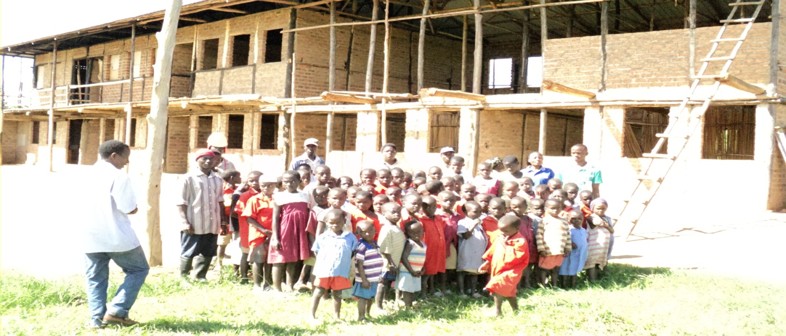

2.2 Child nutrition boost projects
Improving the nutrition status of kids under CFAK care is one of our strategic objectives .In order to achieve this CFAK decided to come up with the following projects;

2.2.1 Poultry project
The eggs laid by the chicken are consumed by the children at the Buwali orphanage which has helped in ensuring that the kids get a good and proper diet since proper feeding is essential in the bodily and mental growth of a human being. The waste collected from the chicken is used as fertilizers in the orphanage gardens
    - The diary project
The project has three diary animals which produce a reasonable amount of milk which is consumed by the kids at the orphanage hence improving their diet. Kids are also equipped with skills in taking care of the cows. The project however faces some challenges of cost of feeding the cows and the treatment.
The goats and sheep are also being added in since friends have advices us about the rich nutrition good for the children that are in them, even if it is still at its early stages and needs improvement.

2.2.3 Fruit tree project
110 out of the 150trees planted are growing and are about to bear fruits .Management intends to expand the project by planting more trees. Overall the project will be very useful to the orphanage mostly to the kids who will enjoy these delicious fruits. However the project needs more resources to expand so that it can be made commercial and the proceeds from the fruits are expected to aid in the running of activities at the orphanage.
In this we are also to grow pea nuts which are good for children nutrition to add on the diet that we have been feeding them, in general the agricultural sector has already started several changes here in trying to make more working, of which in this we have introduced in new projects like that of fish farming and bee keeping.
We even got more than 370 hectares of land in Mpigi district in Uganda where we are to set up several projects that are to help a lot in taking care of the children by giving them better life and also to make the organization sustainable,
- Home economics
- Agriculture.
- Brick laying and concrete practice.
- Carpentry and joinery.
- Motor vehicle engineering
- Art and craft.
- Basic English and mathematics.
- ICT programe.

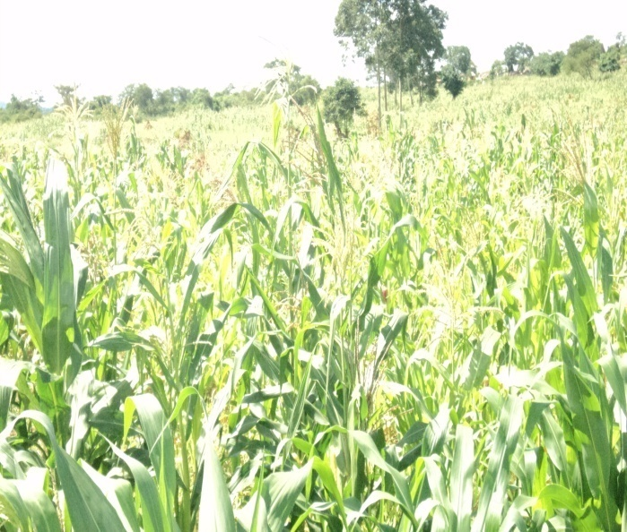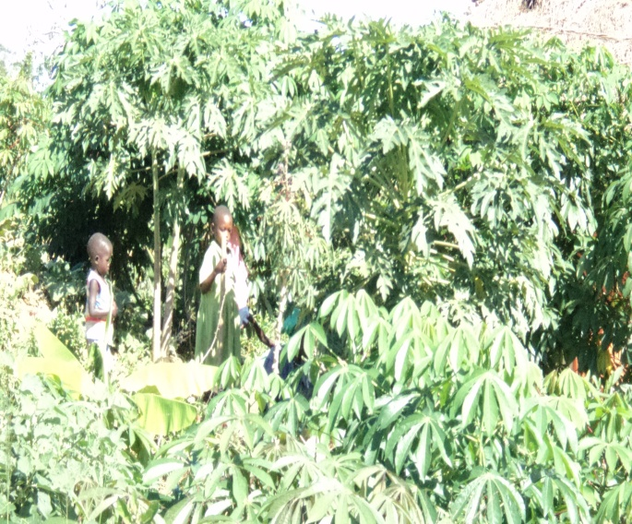

2.3 Health
Health services are provided at the orphanage and here diseases like malaria, cough among others are handled at the orphanage by a qualified staff. Complicated diseases like cancer, tuberculosis, Aids among others are referred to Mulago hospital which is a national referral hospital. Management also initiated fundraising for Mary Nakato Daphine who is a heart patient for surgery in India and Kyambadde Collins who has a mental disorder that even doesn`t put him in position to go to school, of all these issues of kids health here we have just mentioned the few but there other cases which needed immediate attention if we are to save them.
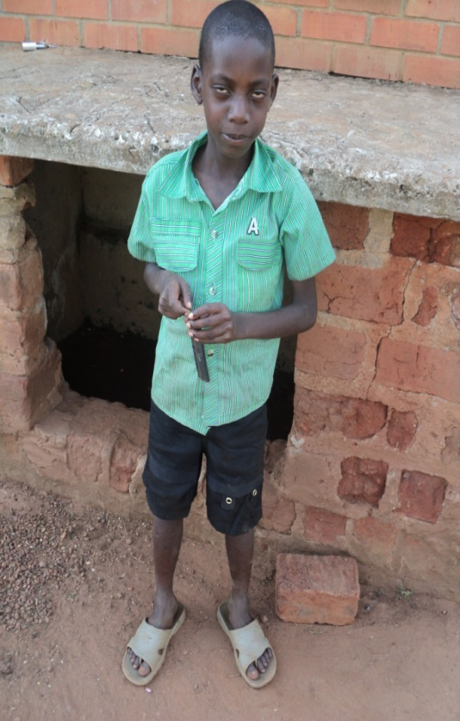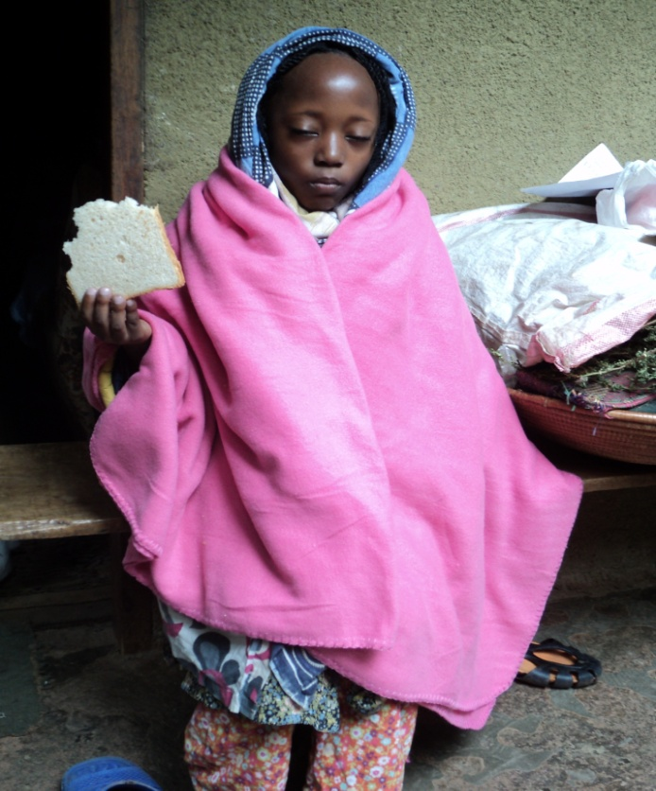
Canceling and guidance services are offered at the orphanage to offer guidance to children and women on how to go over challenges in life. Canceling to HIV infected people was emphasized regularly to renew their hope. We have also mobilized people to participate in government programs like immunization of killer diseases like polio, Measles, T.B among others.

2.4 GIRL POWER PROJECT.
Care for African kids on 20th November 2011 started a project called girl power project to help the poor girls and women in Wakiso and Mpigi district as well as Uganda and the world at large. In this we are to build a school and a vocational training center when we get money for the study of children at lower costs. We have friends from all over the have come in to push this project to all over the world.
PICTURE OF SOME GIRLS IN GIRL POWER PROJECT LIVING AT THE WAKISO ORPHANAGE CENTER
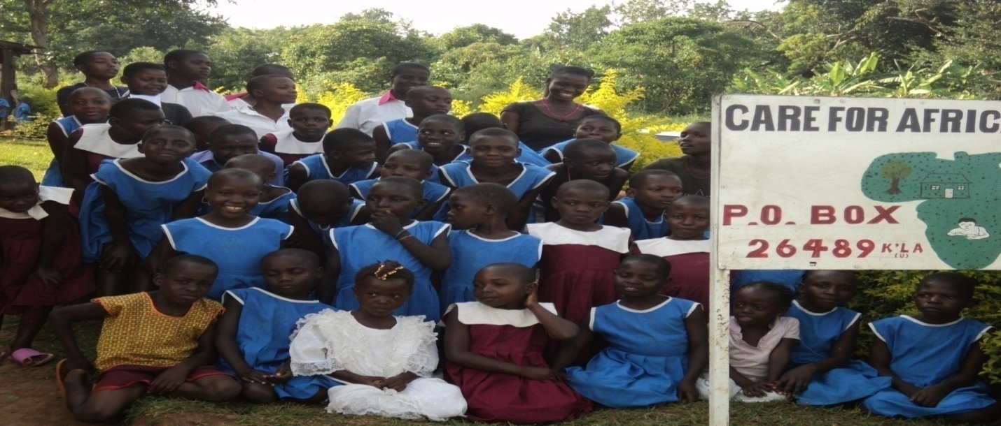
  - COMMUNITY EMPOWERMENT,
It has been handled in a number of ways which have been through village meetings, churches and way seen possible. In this we have also mobilized communities to do community work like cleaning of bore hole where we get our water for use every day.
COMMUNITY AT WORK OF GENERAL CLEANING MOBILIZED BY CFAK
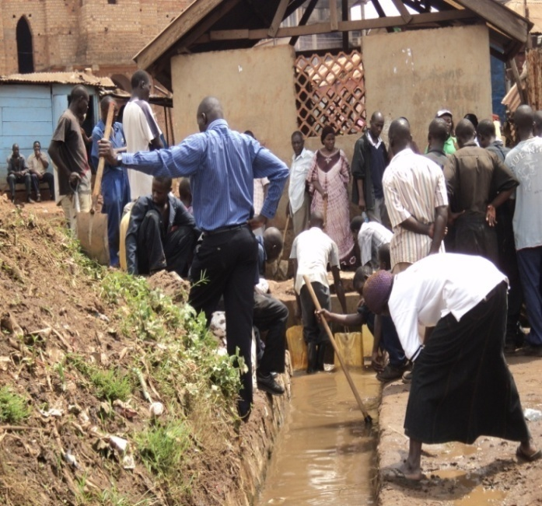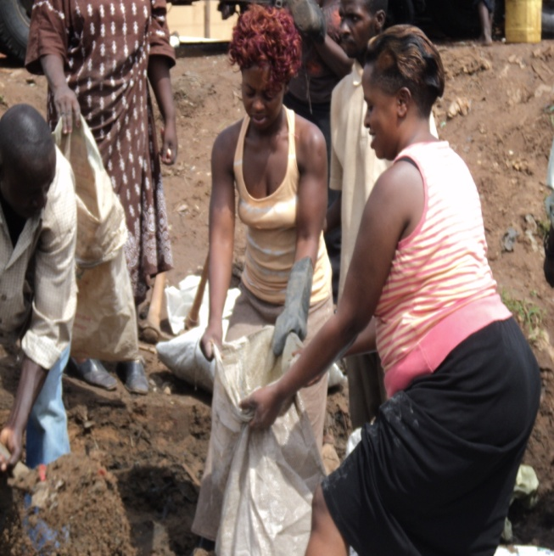

3.0 Membership to other organizations.
In order to enhance closer partnership with NGOs similar goals, CFAK registered as a member with national NGO coalitions involved in socio justice, and, women and child right advocacy. There are Uganda National NGO Forum and National Association of Women Organization in Uganda (NAWOU)

3.1 Governance.
The organization has a Board of Directors comprised of several members, who are professional in various fields and provide financial and technical guidance on policy issues and strategic direction. The patron is Robert Pool.
BOARD MEMBERS
Chairperson | Mr. Robert Pool
Vice Chairperson | Miss Nambejja Hellen
Secretary | Mrs. Nakanwagi Christine
Treasurer | Mr. Kayemba David Kironde
International Adviser | Miss. Catherine Hislop
International Coordinator | Mr. Jean-Noel Chazelle
Member | Miss Edith Nakasita
Member | Mr.Ssemanda John
Member | Mr. Musalirwe Mathias

4.0 Organizational challenges
CFAK faced numerous challenges in the period under review which challenges include; the increasing number of orphans who approach CFAK for assistance yet resources available could not cater for the extremely big numbers, limited resources to run project activities, lack of enough human resource with experience to aid in running the project, long distances between the orphanage and the clean water source, lack of a modern kitchen and dining facility, lack of a modern toilet facility, lack of modern agriculture equipment.
THE ORPHANAGE PIT LATRINE AND KITCHEN THAT NEED REPLACEMENT
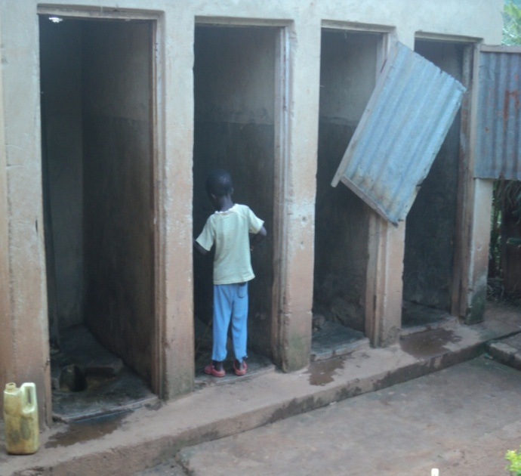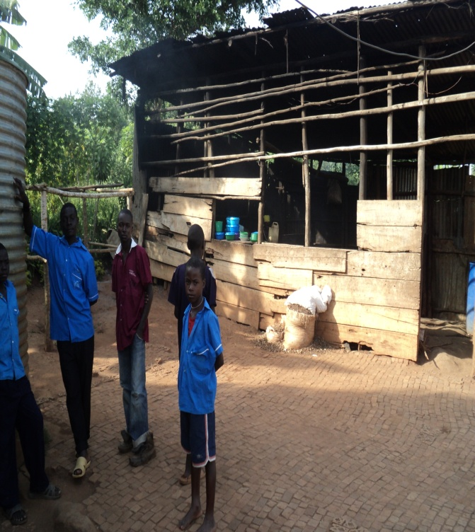

5.0 Special thanks to those who have made us through 2011.
We also end with special thanks to our partners, friends, volunteers all over the world that have made us through all this way. Organizations like Lift the children of Canada, Global Unity Harmony from UK but working global, One voice for the kids UK, National Organization for Parental Equality from Canada, Global Giving USA, Loving Catholic Network USA, Missionary of the Poor Uganda, Ndeeba Parish Youth Association (NPYA) from Uganda as we welcome more organizations and companies to come and work with us in changing vulnerable peoples` life in the world.
Individuals like Father Jean-Noel Chazelle,Miss. Alison Ross,Mum Catherine Hislop Brother Paul Christensen, Mother Aimee Dudas, Father Sam Edwards, Andrew Peacher, Brett Mikels, Amanda Moore, Tom Woznick, Nadir Malick,Ewanur, Ssemambo John, Jay Johns. Your courage wards and support has given 165 children a new family they never hard, you have created a thousand smiles in the faces of the kids at care for African kids two orphanages here in Wakiso and Mpigi Districts Uganda. As we kindly request you to extend your generous giving hart in this organization.
SOME OF THE GIFTS WE RECEIVED FROM FRIENDS IN USA
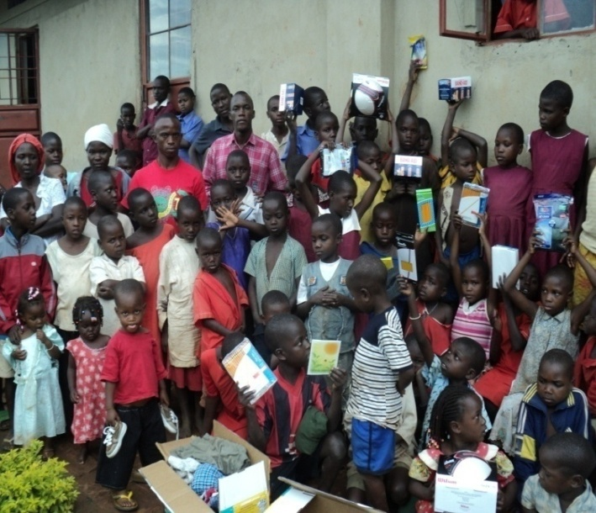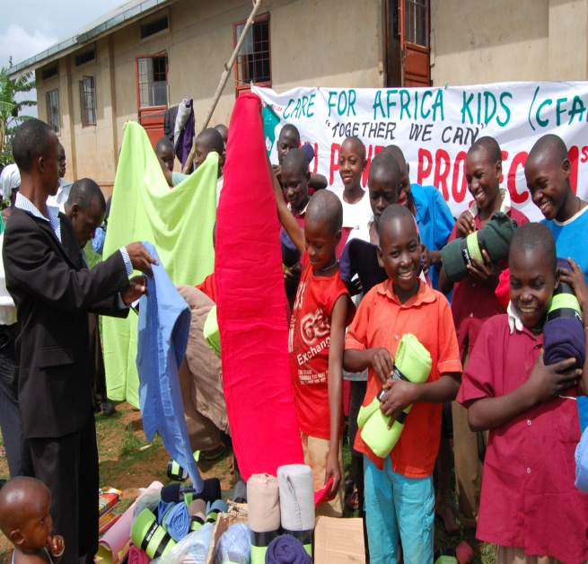We also thank neighboring communities and African countries as well as others like to Pakistan through Akneel, India through Dr.J.Christopher Daniel`s NGO where our influence has been expanded from. Still we request more partnership, Volunteers, Sponsors, Donors, Friends ship from Organizations, Companies, Governments, Schools, Associations all over the world because your help and wards of inspiration keep us moving for tomorrow.

6.0 FINACIAL OVERVIEW
This section looks at the financial performance of the project for the year 2011. Examining CFAK’s final accounts has been put into consideration.
CFAK-FINANCIAL STATEMENT
FOR THE PERIOD ENDED
31st DECEMBER 2011
BALANCE SHEET AS AT 31st DCEMBER 2011
NOTE | Amount | Amount
 | UShs | UShs
 | December 2011 | December 2010
NON CURRENT ASSETS | 70,010,000 | 30,760,000
CURRENT ASSETS
Cash at hand | 5,120,000 | 7,450,000
Cash at Bank | 13,381,400 | 17,495,000
Prepaid Electricity | 480,000 | 480,000
 | 18,981,400 | 25,425,000
TOTAL ASSETS | 88,991,400 | 56,185,000
ACCUMULATED FUND AND LIABILITIES
General reserves | 24,000,400 | 34,100,000
Payables | 49,090,000 | 16,033,000
Accumulated fund | 15,901,000 | 6,052,000
TOTAL ACCUMULETED FUND AND LIABILITIES | 88,991,400 | 56,185,000

CASHFLOW STATEMENT FOR THE PERIOD ENDED 31st DECEMBER 2011
 | Amount
 | UShs | UShs
 | 2011 | 2010
Surplus/(Deficit) for the period | (15,440,910) | (23,010,350)
Depreciation | 640,000 | 240,000
Decrease (increase) in payables | 45O,000 | 75,000
Net cash flow from operating activities | (3,450,100) | (5,000,000)
Cash flow from investing activities
Fixed assets acquisition | (9,187,000)
Net cash flow from investing activities | (9,187,000)
Net change in cash/ cash equivalent | (13,064,122) | (7,320,000)
Cash/ Cash equivalent as at 1st JANUARY 2011 | (1,810,210) | 532,400
Cash/ cash equivalent as at 31st Dec 2010 & 31st DECEMBER 2011 | (5,674,900) | (1,810,210)

INCOME OVER EXPENDITURE STATEMENT FOR PERIOD ENDED 31st DECEMBER 2011
 | Amount
 | UShs | UShs
 | 2011 | 2010
INCOME
Lift the Child from Canada | 16,523,000 | -
Local Donors | 11,160,000 | 7,730,000
Work Shop | 2,750,100 | 4,050,000
Poultry | 2,340,090 | 1,600,000
Diary Project | 1,850,000 | 900,350
Art and Crafts | 1,900,560 | -
Mr. Hans from Holland | 6,670,000 | 4,240,000
Other Incomes | 22,000,790 | 20,010,000
Total Income | 65,194,540 | 38,530,350
EXPENITURE
Bursary Scheme project | 24,450,000 | 21,050,000
Workshops & Seminars under taken | 1,050,000 | 2,700,000
Dairy Project improvement | 1,006,000 | 1,640,000
Poultry Project improvement | 950,000 | 730,000
Work Shop set improvement | 1,209,000 | -
Salaries & Wages paid | 10,800,000 | 11,000,000
Depreciation | 640,000 | 240,000
Exchange Loss | 530,000 | 170,000
Operating Expenses which Food, Clothing, Audit fees, Health, and rest. | 40,000,450 | 24,110,700
TOTAL EXPENDITURE | 80,635,450 | 61,540,700
Surplus/ (Deficit) of income over Expenditure. (transferred to accumulated fund) | (15,440,910) | (23,010,350)

OUR BANK DETAILS
TITLE OF ACCOUNT : Centenary Rural Development Bank Ltd
ACCOUNT NAME : Care for African Kids Ltd
ACCOUNT NUMBER …………………..
BRANCH : Corporate
SWIFT CODE : CERBBUGKA
FOR QUICK RESPONSE PLEASE CONACT US ON THE ADDRESSES BELLOW FOR IMMEDIATE ASSISTANCE.
- Robert pool
EMAIL: rpool@careforafricankids.org

WEBSITE: www.careforafricankids.org/ www.careforafricankidsuganda.weebly.com
TELEPHONE: +256752509125/ +256704509125
SKYPE NAME: robertpool2 / cfakngo
FACEBOOK: Robert Pool/ CFAK NGO
He is the Founder, executive director and heads the implementation team for any project operating under the NGO and is the link between the organization and the outside world. In addition he handles all matters of technical nature of the organization.
- Kayemba David
EMAIL: davidk@careforafricankids.org
TELEPHONE: +256775282890/+256701289090
FACEBOOK: CFAK NGO
SKYPE NAME: Kayemba.david16
He is the Founder, financial controller of the project and in charge of the day today running of the project, manages project budget, and coordinates the activities of the branches and plans for the whole organization.
P O BOX 26489 KAMPALA UGANDA EAST AFRICA

TOGETHER WE CAN

