P.O. BOX 5601 KAMPALA- UGANDA EAST - AFRICA
Web: www.futurefocusuganda.org E – mail: info@futurefocusuganda.org. phone : +256773702110

The Narrative Report for the year 2018

1.1.Introduction:
Future Focus Uganda is a registered 503(1) C, non-profit organization with mandate to work in Uganda in supporting rural and urban disadvantaged communities and special interest groups to improve their living conditions through supporting programs involving community in education, capacity building, innovation and empowerment for self-sustainability. The organization was established to handle issues related to end poverty among the community through supporting target communities to get access to income generating activities in order to improve household incomes.
On addition, we build the capacity of the community to work more effectively with and for the community in order to meet the basic human needs.
Our major aim is to support the community to create jobs for the community in order to improve on their living conditions through supporting communities to engage in income generating activities for livelihood improvement.

Our Vision:
is to create a community free from the burden of poverty and diseases for livelihood improvement.

Mission:
To facilitate a situation where the community have access to basic human needs through community support in education, health and livelihood improvement
2.0.Background of this narrative report.
2.1 Introduction
This narrative report gives a description of the realisation of accomplished planes activities in the year, including the positive and negative impacts and the positive and negative experiences associated with the activity implementation. It provides information on the objectives achieved, the measures carried out, the duration and the expected sustainable impacts, as compared with the objectives set out in the project strategic plan. The report can also shows the impacts of the organization plan by referring to particular case examples. It alsocontains informative photographs showing the supported activities.

2.2. Project implementation
Future Focus Uganda since its genesis has been extending support to clients through its various programs in the reporting period in different activities as a means of achieving its Mission realizing, its vision of serving the disadvantaged community to access basic human needs including, health support, education support, livelihood improvement and economic empowerment, climate resilience, human right and psychosocial support to community among the rest. Though support given has contributed to improvement of community living conditions in programs above, more is still wanting due to the fact that families still lack viable income generating activities to support improvement of their income, HH are still practicing sustainable agriculture rather than commercial agriculture, poverty being the underlying factor.
This situation compels the community to acquire a dependency syndrome, most of them coming to Future Focus Uganda For help, old people begging their children, and relatives begging those who seem to have some small money.The number of orphans and vulnerable children increases every day due to death of parents due different disease especially HIV/AIDS, after the death of the caretakers, the orphans are placed in the families of relatives mostly grandparents, as per t African extended family set up. The added number of children adds pressure on the resources of the family.
Although the Government introduced free basic services to the community, there are still other services to be met by guardians e.g scholastic and other education related requirements which some families still cannot afford. As far as education is concerned some guardians opt for private schools because the standards in free schools is still poor (Shown by PLE results). However, private education in Uganda is very expensive so families in care for orphans and vulnerable children have a challenge of paying fees for their children thus coming to for support to Future Focus for Support.

Our target groups are vulnerable to present development infrastructure and environment problemsand cannot meet the developmental needsgiven the fact that their income are susceptible to poverty related issues. Other family heads have chronic illness and have orphans in their careand cannot go to gardens to dig, others have no land to cultivate food thus leading to food insecurity in their families.

2.3. Target group:
Our target community/ groups supported through FUTURE FOCUS UGANDA include but not limited to:
- The orphans, vulnerable youth and children,
- The elderly, mainly the caregivers to the orphans.
- People living with HIV/AIDS
- People living with disability.
- People with chronic illness such as diabetes, sickle – cells and the like.
- People with other social special needs
- the Health Unit. More so with the newly received medical equipment the services were greatly improved. The clients also gladly participated in the cost sharing medical bills.
- The youth were happy because they acquired Vocational skills which were to help themcreate jobs for self-sustenance. In addition the youth that were supported graduated and acquired documents which would help them in acquiring employment and upgrading to higher levels of education.
2.4. Measures and activities carried out in theyear
During the twelve months, the following activities were carried out;-

2.4.1.Education Support
1. Direct school payment to schools ( Burseries)
During the period under review i.e.January - December 2017, the organisation through its programs managed to directly support143Children and youths at different levels of education from primary to University. The 3academic terms according to Uganda Education System have been financially by supporting Bursaries to the children from primary – University.
Supported number by level 2018
Level | F | M | Total
Primary | 30 | 20 | 50
Secondary | 36 | 24 | 60
Colleges | 17 | 11 | 28
University | 19 | 12 | 31
TOTAL | 90 | 67 | 169
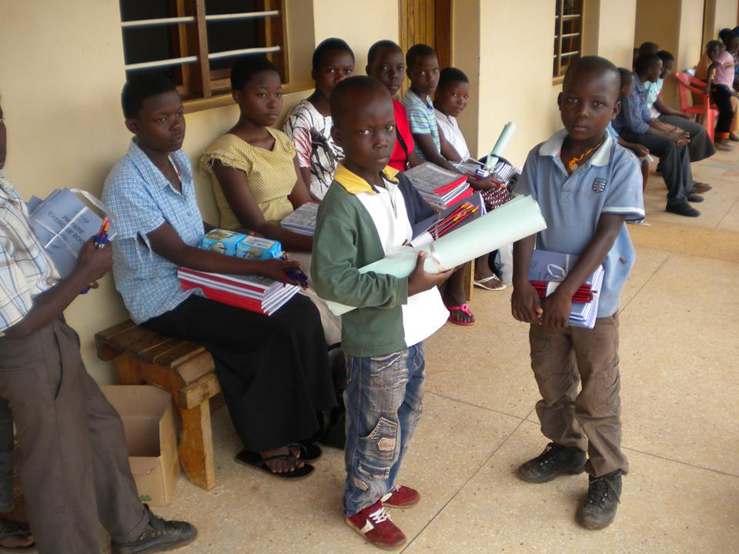
Some children receive scholastic materials

Supported children with life skills ,Motoring& community empowerement
- LIFE SKILL DEVELOPMENT IN SCHOOL
Through children sensitization children are sensitized about becoming responsible citizens , through adherence to all necessary behaviors , being focuses on their dreams, obeying the elders , being religious among the many topics.
The following school we sensitized.
- STELLA MARIS NSUUBE,
- Kijaguzo Secondary School
- . Mityana Secondary School,
- Kampala University

The fo;;owing photos shows the activity in photos
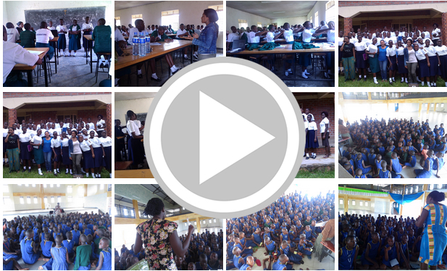
- MENTORING:
- Kikyusa Primary school,
- MityanaSecondary school
- Kijaguzo Primary schools
- KmapalUnivervistyLuweero campus
- COMMUNITY EMPOWERMENT- Kikyusa Primary school
- SOAP MAKING
- Bakery :
- Hand craft making
- Vocation skill based training to the youth :
Youthwere supported to acquire vocational skills on cost sharing atotalling to 120including 45 students on a special programme for apprenticeship to different workshops including , tailoring , motorcycle repair, hair dressing, bakery services,
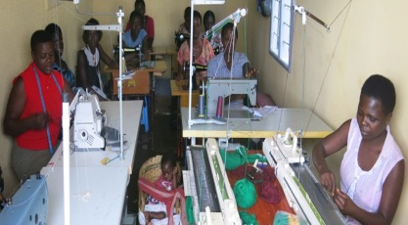Young women are empowered to learn swaeter making from our training centres
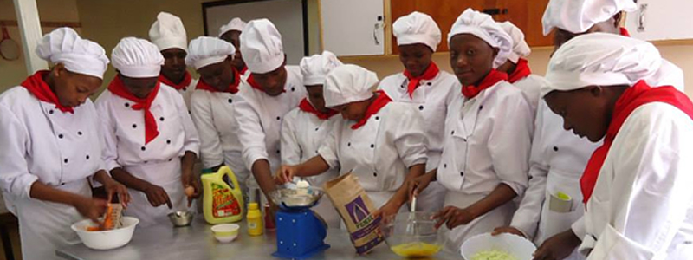
Young girls are trained in bakery skills

2.4.2.Entrepreneur
There are also other entrepreneurship activities dome like drum making, local furniture making, bitengi making, and general craft making.

2.4.3.Out of 143 children and youths who were supported directly 123 Children benefited from scholastic material support and boarding requirements due to their vulnerability.567 children/youth from the families supported through social service department benefited indirectly from the support child receives from different partners.
2.4.4. HealthSupport
In the period under review medical support was administered under the following categories;

- Health camps to communities; This was in favour of sensitizing the community in prevention, and the following activities were done free HIV/AID testing, Blood donation, Dental training, child immunizations and vit A supplement, among the rest
- Bark yardgarden to people living with HIV/AIDS through supporting with seeds, fertilizers, Pesticides, small garden preparation.
- Procurement of drugs for treatment of opportunistic infections.

2.4.5. Economic Empowerment
During the period under review i.e. January –December 2018, the organisation through its programs managed to support.10formal groups through;
- Generating the bi-laws(constitutions)
- Electing leadership
- Preparing andevaluating the business proposals
- Opening bank accounts in the bank

2.4.6Social Welfare
We continued supporting7families headed by people living with chronic withshelter.

These families house a total of 15children under their care.
We also supported 250 families with food hand-outs on Easter and Christmas and managed to renovate 3 homes which were in a bad shape and constructed 1 house to an elderly lady in care of 3 children.

3.0. Positive and negative experiences

3.1. Positive Experience

  - 100% of the children, who were supposed to benefit from Education support, were supported. All fees and necessary school requirements were given to them within the three Academicterms. Some of our children who werebenefiting from education scheme completed in the year and await graduation/ confirmation.

  - Due to availability of funds, we managed to support all health education related activities, paid staff salaries and all running costs of the organisation in time.
  - Out of the Students that were supported with school fees, 8 pupils sat for Primary leaving Examination, 10 students sat for their UCE Exams and 5 students sat for UACE Exams. 7 students finished craft part 1 at St. Theresa VTC, 7 students graduated from tertiary institutions with 3 Registered Nurses, 1 Enrolled Nurse and 1 with Cert. in ICT & 2 with Bachelor degrees.

  - Clients who benefited from income generating fund improved in their way of living and this was evidenced in reduction in the number of visits to the social service office to ask for basic assistance.

  - Due to availability of funds we were able to carry out general repairs and maintenance of the organisation’s assets which led to increased efficiency in the implementation of organisation activities. This also led to improvements in the performance of staff.

  - The development of a three years (2017-2019) running costbudget plan for all the departments of Future Focus Uganda including the development budget in the organization.

3.2.Difficulties encountered

3.3.Activities not carried out as planned and consequences

- Installation of accountingsoftwareby Finance and Administration was not realized in the reporting period this was because there was need for more training and money to procure the service. Thiswas put in the budget of the following financial year.
- Annual audit was not carried out in the reporting period due not enough funds. Arrangements were made to ensure that the audit for a full year is carried out in the 1st quarter of the following year.

- Submission of reports and the financial budgets for the next three financial years in time as expected.

3.4. Psycho-social Support and Gender mainstreaming
- Counseling and creating awareness on sex education, lifeskills, drugabuse, early marriages, HIV/AIDS and early pregnancies were done through the Social Service department during the period under review
- The organization continued not to discriminate against sex, tribe and religious affiliations in execution of its activities
- We have continued with the practice of separating Boys dormitory from the Girls dormitory and also prohibited students from visiting staff premises
- We have continued to work hand in hand with the Child & Family Protection Unit under the Uganda Police in different matters concerning Child Rights, Child Abuse & Protection.

4.0 .Schedule of activities

4.1. Finance and Administration work plan for 2018
 | ACTIVITY | TARGET | MEANS OF VERIFICATION | RESPONSIBLE PERSON | Q1 |  |  | Q2 |  |  | Q3 |  |  | Q4 |  |  | SOURCE OF FUNDING
1 | Health support to the community | Supported communities | Number of camps held  Periodical reports  photos | Staff of Future Focus Uganda | J | F | M | A | M | J | J | A | S | O | N | D | Local Income  and  Partners
 |  |  |  |  | X | X | X | X | X | X | X | X | X | X | X | X
2 | Education support to the clients | Supported communities in selected districts | Number of students supported,  Reports, Bank statements, bank slips, periodical reports | Staff of Future Focus Uganda | X | X | X | X | X | X | X | X | X | X | X | X | Local Income  and  Partners
3 | Entrepreneur support to the community | Supported communities in selected districts | Number skills applied  Number of people who created jobs  Reports | Staff of Future Focus Uganda | X |  |  | X |  |  | X |  |  | X |  |  | Local Income  and  Partners
4 | Economic empowerment to the community | Supported communities in selected districts | Number of people with income in the community  Vouchers | Staff of Future Focus Uganda | X | X | X | X | X | X | X | X | X | X | X | X | Local Income  and  Partners
5 | Social welfare to the community | Shelter. Water and sanitation | Number of houses constructed, number of pit latrine constructed | Staff of Future Focus Uganda | X | X | X | X | X | X | X | X | X | X | X | X | Local Income  and  Partners
6 | Supervise and support Future Focus Uganda income generating activities/projects | Youth and women groups | Number of support visits conducted  List of beneficiaries | Staff of Future Focus Uganda | X | X | X | X | X | X | X | X | X | X | X | X | Local Income  and  Partners
9 | Support running administrative cost of the organization | Staff and boardof directors | Staff environment improved and the office moving on well. | Staff of Future Focus Uganda |  |  |  |  |  |  |  |  |  |  |  |  | Local Income  and  Partners

Photos of houses

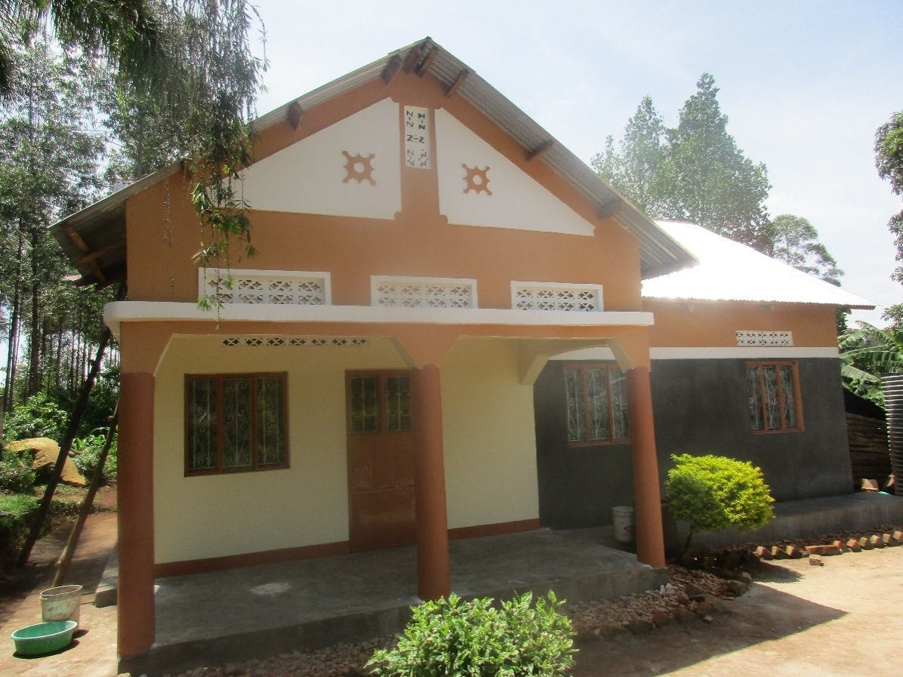

5.0 Monitoring and Evaluation
- Through social service departmentfollow-up visits were made to clients’ homes and schools where children go for education to ascertain if there is value for money and evaluation forms were filled and filed and this was done by Field Officer.

- Monthly Head of Departments meetings were carried out at different levels in different departments to ascertain progress of activities and these were championed by the Heads of Departments with the help of the Head Office.

- Visits by the Board of Directors to oversee the general progress of activities and projects through the organization at large.

- Monthly and quarterly reports, budgets and work planswere submitted to the Head Office as a means of evaluation and assessing the progress of activities of different departments.

- We held quarterly committee meetings composed of members from the Board of Directors and Heads of Department to assess the progress of the planned activities

6. 0 Sustainability

6.1. Role of beneficiaries
- Members who benefited from the revolving fund managed to run small business and saved some money for returning to the social service office also members supervised each other to ensure there is no miss use of funds to enable others to benefit from the fund.

- The caregivers provided fortheir children whom we supported under the social service department with scholastic materials and psychosocial support so that they can benefit from their education.

- The clients under the social service department were given the opportunity to choose which projects they could take on as their income generating activities for sustainability purposes and to reduce on dependency syndrome.

- The students in the schools managed to avail themselves with willingness to study and with the basic scholastic materials they needed to acquire learning which supplemented the teacher’s efforts of teachings.

7.0. Future Funding of Future Focus Uganda

- Continuous good relationships and meetings with other stakeholdersand other partners whom we offer services with an objective of exchanging ideas concerning the services we provide and ideas for better service delivery.
- We revisited the procedures of giving out the Capital development fund whereby we realised many clients found the procedures abit not comfortable. With this in place clients will comfortably borrow the fund and be able to attain some level of self-sustenance.

- We plan to increase on the number of visits and support supervisions to Ongoing ensure the groups manage the funds well and be able to sustain themselves. With this activity emphasized, more clients shall be able to benefit majority clients not a few thus reduction in the dependency syndrome.

- Through in-depth monitoring and evaluation of projects that were funded to ensure that they are run strictly on a profit motive so that they can be able to support in the local incomes.
- Improve marketing strategies with human craft. Visits to radio stations in the community like local radio FM- radio stations are to be continuously done. As a follow up, we shall put some resources (human and finances) for the radio programs and other marketing avenues such as posters.

8.0. CONCLUSION
In conclusion, since the inception of this project, FutureFocus Uganda registered remarkable achievements especially the sense of ownership of the project activities by the FUTURE FOCUS UGANDA management, staff and the community at large. Planninghas become easier than before because we are aware of the sources of funds and we can allocate these resources depending on planned activities.

During the period we had not budgeted for its human resource development inform of in-service trainings. This continued to pose a challenge on the quality of our services to the community. Training programmesexpose staff to new ways of performing their duties and help them to cope up with organizational changes.
The organizationwas relying on external training of staff organized by other partners and government. Normally such trainings are specific and only benefit a small section of staff like medical workers. Internally organized trainings like customer care, report writing, financial education would add more value on both the individual staff the organization at large.
We continue thanking Partners for all the support and we promise our cooperation and commitment to our partnership for the successful completion of the two years project.

9.0 Annexes: PHOTOS
The photos showing some of the clients supported in the year
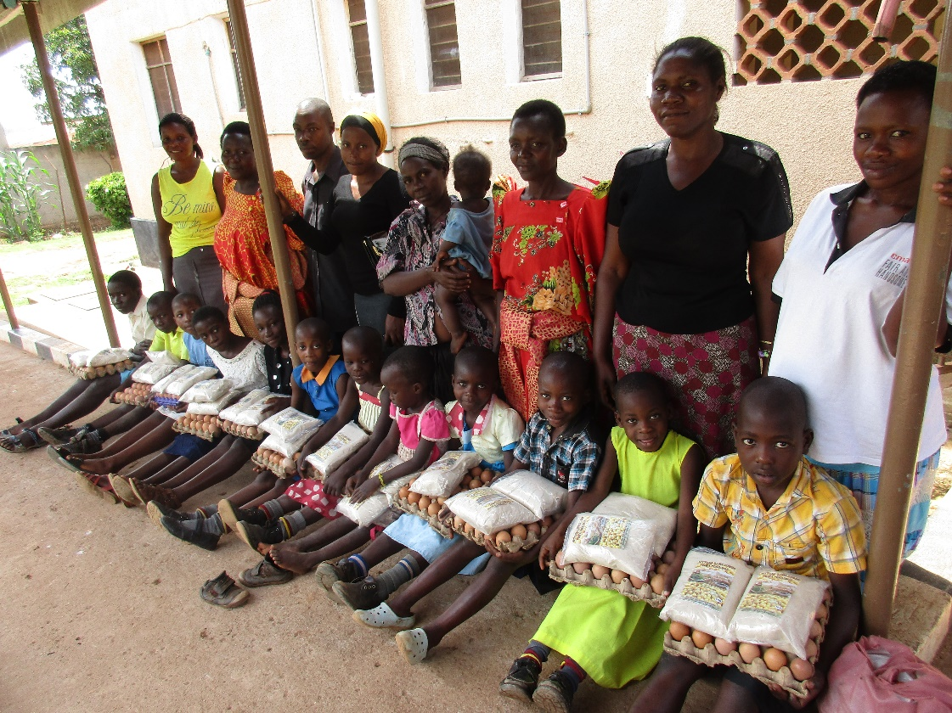
Children living with HIV/AIDS after receiving food supplements
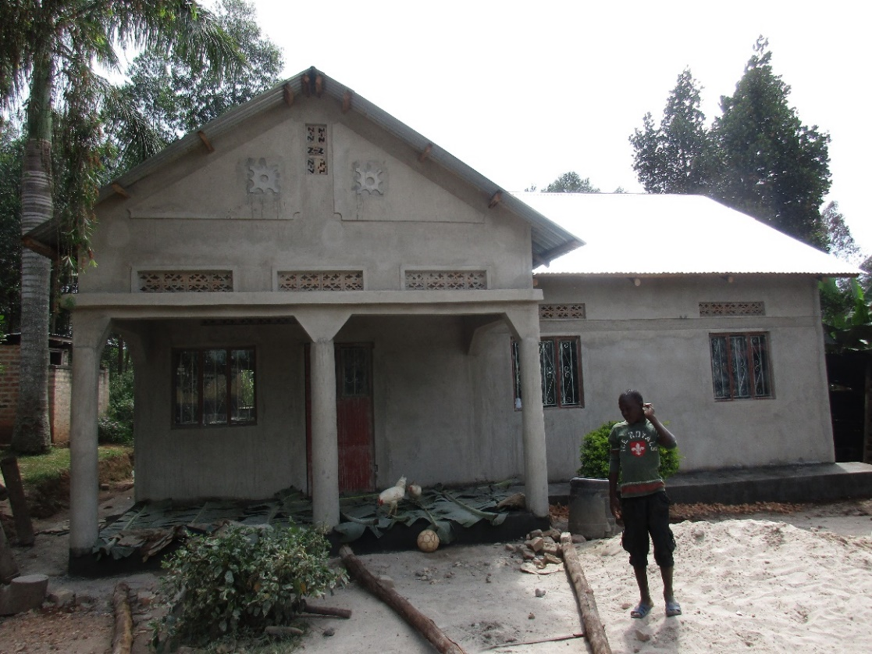

One of the houses renovated in the year

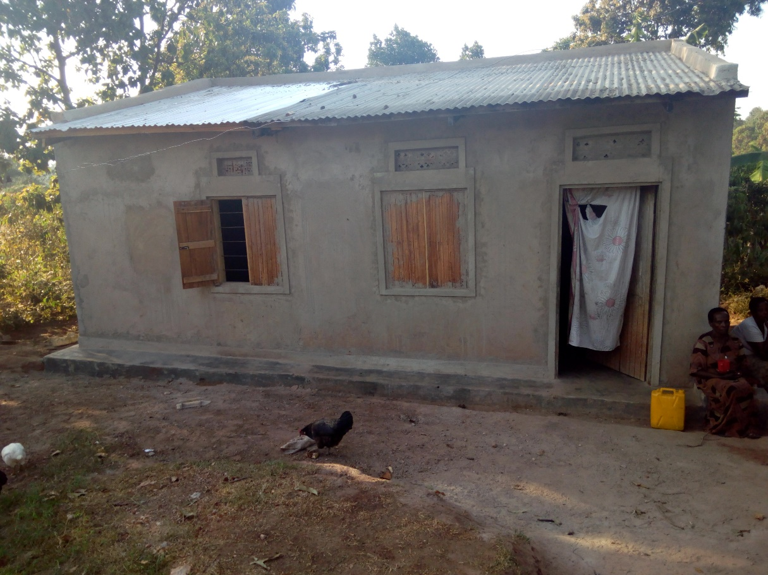Renovation of MzeeNantale’sHouse in progress

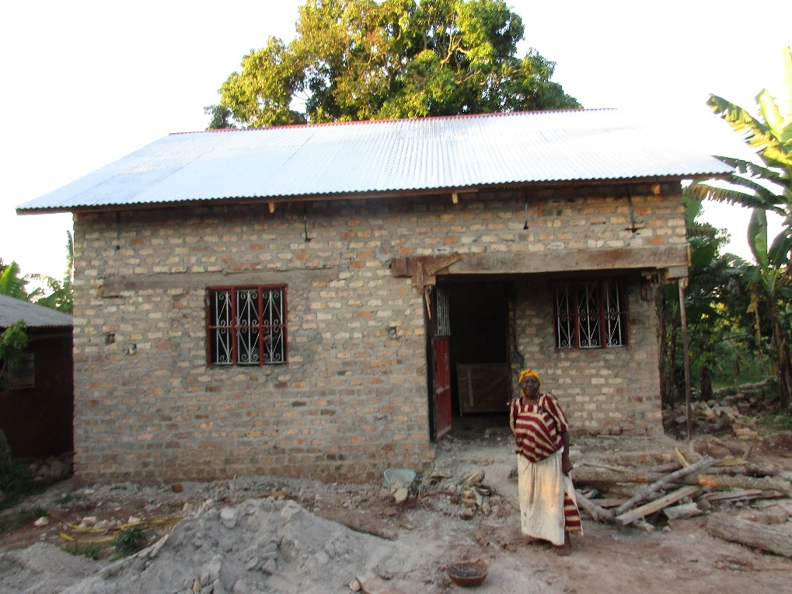Construction of a house to MzeeStaphaniaNabbuto in progress

