11/20/2017
“Skills Development and Care we reach” |

P.O.Box 26772, Kampala – Uganda

COMMUNITY BASED ORGANISATION BUIKWE AND WAKISO DISTRICT

TATCO Uganda | ORGANISATION REPORT 2013- 2018

A MESSAGE FROM THE EXECUTIVE DIRECTOR
Over the years, TATCO Uganda has continued to establish strong linkages with district and local communities especially working with Local Government, NGOs and CBOs with the main objective of transforming the communities that we live in, creating a sense of responsibility and social accountability on the side of duty bearers and rights holders. As a result of the different interventions by TATCO Uganda i.e Community Sensitization workshops, Community Needs Assessment programme, we have seen local communities demand for action from relevant authorities both at district and Sub county level. Networks have been born and, actions taken at the different levels, inspite of the challenges of lack of funds, information and ignorance of civic rights among the residents. At institutional level, TATCO Uganda continues to grow from strength to strength.
I would like to sincerely appreciate members of TATCO Uganda and the communities that we operate in, allies at national and district level, Njeru Town Council C.D.O Office, Uganda Martyrs Shrine- Namugongo, Creamland School- Kireka, Classrooms for Africa, Local Governments, Star Nursery & Pri. School- Bukerere, Eng. Pican Philip, Mbiko Brass Band, and any other person or group that has been with us and hope for your continued support. All the above steps taken could not have been possible without your support, collaboration, network, partnership and team spirit.
Last, but not least, special thanks go to my mother Nabbanja Deziranta who has helped me so much in mobilizing the communities and encouraging me to never loss hope if it comes to community development
“Skills Development and Care we reach”

Kato Andrew
Executive Director- TATCO Uganda
TATCO UGANDA AT LARGE
ORGANIZATION: The Andtex Training and Care Organisation (TATCO Uganda)
VISION: A community where most people have practical skills, living a healthy and improved life.
MISSION: To enable the community members have skills which can create for them employment, spread the word of God and have a spirit of togetherness.
GOAL: To train the local persons into skilled persons, improve their standards of living and create a community of God fearing people.
TATCO UGANDA VALUES
1. Honesty
2. Gender Equality
3. Accountability
4. Voluntarism
5. Mutual respect
6. Unity in diversity
7. Participation
TATCO UGANDA PRINCIPLES
1. Equal opportunity
2. Respect for all
3. Time consciousness
4. Innovation and continuous learning
5. Service oriented
OBJECTIVES

Promote and sensitize parents/guardians about the value and benefit of educating children mainly girl child in Uganda and Africa at large through workshops and building schools and classroom to provide a favourable learning environment.

Promote and provide practical training skills to the people through training them in tailoring, computer, art and craft, music which will help in creating employment within the rural communities and by that, contributing to bridging the urban-rural, gaps in Eastern-region and also as long-term means to poverty reduction.
- Develop the catholic church through Bible teaching and priesthood training where we will increase on the number of priest born of our community.

Reduce illiteracy in the youths and children through collaborating with local schools to give affordable education services to the vulnerable children, and youths in the community.

Sensitize the community members about their social and development rights through career guidance and counseling.

Conserve the environment through setting up projects mainly in agriculture which are income generating and environmental friendly to the community of Njeru Town council.

Starting up community livelihood support projects for economic development.

To increase public awareness of killer diseases like malaria, HIV/AIDS Tuberculosis.

To sensitize policy makers about the needs of the community through workshops and seminars.

To build a life skills base for individuals especially the youths in order to enable them handle the challenges of life.

To empower rural women with income generating activities to enable them access the basic needs for their lives and families.

To provide clean water and sanitization to the people in Buikwe District and Uganda as a whole through our partner organization.
ORGANISATIONAL BACKGROUND
TATCO Uganda is a Community Based Organisation carrying out its work in Buikwe District in Uganda. Started as a small group in 2010 by two members who wanted to see community transformation and basing on the passion they have for community development and unity. It was later registered as a CBO under Buikwe District Civil Society Organisation guidelines in 2013. Its purpose is to promote practical skills and people’s awareness about the economic, social and religious behavioral change in the community. Kato Andrew and Nabbanja Deziranta of Njeru Town Council are the original founders and the continuing Directors of the Organisation.
TATCO Uganda’s founding members overwhelmingly agreed on the need to form an oragnisation where skilled and experienced persons from within the community, agencies, government and any other volunteer elsewhere come and employ their skills to organized groups of people in Buikwe district community and train them, sensitize them in the identified fields.
TATCO Uganda’s main objectives are to train people in practical skills, environment conservation practices, agricultural modernization practices, Children’s welfare, women and youth livelihood projects development and our goals include:
- Increase practical skilled persons in the community
- Develop Catholicism in the community.
- More agricultural out.
- Education of an African child
- Improve conservation awareness in the community.
- Reduce unemployment and poverty
- Community cooperation and unit
With the partnership with sister agencies which understand our goals, government and local leaders we hope to change the world.
TATCO Uganda is entirely managed/run by the community. The Annual General Meeting elects a committee to represent the community. Membership subscriptions are ploughed into community projects such as agricultural farms, livelihood projects. Most of the staffs are from the community except in cases where there is a need for special skills.
PROGRAM INFORMATION
1. Training program
TATCO Uganda set up tailoring, music, computer training and art and craft centers in Njeru Town Council- Buikwe District community for the free training to the people who wish to have these practical skills training programs.
a. Tailoring:
In this 1-year certificate program, students (women and youths) learn basic tailoring skills including sketching, stitching, pattern cutting, pedal sewing machine operation and machine maintenance. During the course of the program, students learn to sew a sport shirt, standard tunic shirt, Kaunda suit shirt, butterfly shirt, fashion blouse, trousers, sport shorts, pleated shorts, nursery uniform, school uniform, wrapper skirt, pencil skirt, choir gown, Gomesi, apron and overalls. Upon completion, graduates are prepared to work in a tailoring workshop or teach tailoring in a limited capacity
b. Computer:
In this certificate program, students receive a complete introduction to the computer and the Windows operating system. They learn several software packages, including Microsoft Word and Excel. Students learn basics of computer maintenance and how to use the Internet. Finally, students apply their knowledge and skills by creating business letters, advertisements, and identity cards. Upon completion, graduates are prepared to work in secretarial bureaus, offices, or begin their own business.
c. Art and Craft:
This also a 1-year certificate course with students learning the elements of art, principles of design, color theory, and basic drawing. They will also learn painting, collage, mosaic, ceramics, sculpture, and graphics. Students will produce several forms of crafts, such as hats, mats, bags, and wall decorations, from local materials like banana fibres, natural dyes, bark cloth, sisal, etc. Upon completion, graduates are prepared to work as artists in their own capacities.
d. Music
With the coordination with local and already established music training centres nearby our area of scope, we have patterned with them and we take our young musicians for a free training where they get skills in playing musicals instruments, writing and reading music, music composing and production, we train them also in stage performance , MCs and Djs. This at the end creates them employment by becoming Club DJs, music producers, band trainers and music composers hence their income levels increased.
2. Children Education
This program is aimed at sensitizing parents/guardians on the need and value of educating their children and partnering with other like mind organization to build/construct or renovate classrooms in order to create an environment that attracts the children to be in school and perform better. Sponsorship of the vulnerable children and providing the basic scholastic materials is also part of our objective where need be.
3.Catholic church development and Bible teaching program
In this programme, we identify persons who desire to spread the word of God to children and adults at a voluntary basis and we give them the necessary support and platforms to carry out their work effectively.
We partner with secondary and primary schools in our community and start up Scripture union clubs, Bible societies and among the students we select leaders who at the end of S.6 we want to enroll them in seminaries for further studies on the bible and if possible they become priests and nuns to continue spreading the word of God their entire life.
We also under this project give assistance to catechists who are locally located at churches to only donate their little time to church work which increases on the number of church followers and why they need God.

4. Agriculture Modernization Practices
Agricultural projects are set up to provide employment, income and also projects which are environmental conservation. Demonstration farms are set up for the community to study from better ways of farming and research on which crops are better for the available land. This makes the community people to fully utilize the available and fertile
COOPERATION/MEMBERSHIP
We consider cooperation as necessary tool for development processes. Therefore, we
maintain partnerships with different stakeholders, being aware of the importance of
every single pillar: local communities, authorities, other organizations and individuals at local, national and international level.
As for now TATCO Uganda has received support from several organizations and some of its partners are;
- Class Rooms for Africa
- Buikwe District Community Development Program.
- Mbikko Parish (Brass Band)
- Hope World Wide International – Uganda
- Namungona Initiative for Sustainable Development
- St. America Vocational Training Institute
- Creamland Education Support Services
- Malangha Youth Soccer Project Limited
- Star Nursery and Primary School- Mukono
The inputs from these organizations and institutions have enabled TATCO Uganda to achieve some of the set objectives.
DESCRIPTION OF PROJECTS REALISED IN THE SCOPE OF PROGRAMMES
- PROJECT TITLE: Renovation and Upgrade of Cremland School- Kireka
PROJECT DURATION: October 2015 – December 2016
DONOR: Classrooms for Africa
APPROVED FUNDS: 95,000,000/=
THE AIM OF THE PROJECT
To develop and upgrade the school class room and play ground so that it creates a good environment favourable for children education.
- PROJECT TITLE: Livelihood Support project for the women
PROJECT DURATION: February 2016 to date
DONOR: Members contribution and well wishers
APPROVED FUNDS: 7,000,000/=
THE AIM OF THE PROJECT
To create employment to the vulnerable women and increase their home income so that to reduce on poverty and dependency.
- PROJECT TITLE: Community senstization and awareness programme
for the youths and women in Njeru T/c
PROJECT DURATION: December 2016
DONOR: Uganda Martyrs Catholics Good Samaritan Group- Namugongo
APPROVED FUNDS: 3,000,000/=
THE AIM OF THE PROJECT
To make the community members aware of their social- economic issues that they need to know for development.
- PROJECT TITLE: Visiting and giving care and support to vulnerable persons
PROJECT DURATION: April and December every year
DONOR: Uganda Martyrs Catholics Good Samaritan Group- Namugongo, Organization funds and well wishers contribution
APPROVED FUNDS: 10,000,000/=
THE AIM OF THE PROJECT
To make the vulnerable persons enjoy and celebrate Easter and of year Christmas in the local communities of Buikwe and Wakiso and make them have hope.

TATCO UGANDA ACHIEVEMENTS
- We have managed to set up our headquaters at Lugazi II in Njeru Town Council with a sign post
- Opening up an E-mail and a website.
- Acquiring some computers and their accessories.
- Registering the organization with the District.
- Getting membership and affiliation with some other non-for-profit organisations.
- We got a number of volunteers.
- We have managed to open up a bank account for the organization
- Since 2010, TATCO Uganda has managed to group women and youths into various groups of 50-80 members and make them work for a common goal.
- Livelihood support projects for women in Njeru Town Council like Outside catering, Saving and credit scheme project and agricultural farms have been started and as for today, the members in the group have started realising some income which they later save for with the organisation for future use and even borrow it to start up their small enterprises which we hope with the trainings and business management skills that qualified voluteers are give them, alot of economic change is going to be seen.
- TATCO Uganda has managed to train atleast 100 youths in computer and art and craft which has made them skilled personels and as for today some have started up their small businesses to fully utalise the skills got for example Video libraries in Jinja town, Secretarial work places in the nearby towns, and some can now send their applications to jobs related to computer fields for jobs with the acquired skills.
- Youths and young children between the age 15-25 years have trained in music production where with Mbikko Brass Band, they train in music instrument playing, music writing and recording which we hope it will avail them with some income because music today is seen as an income generating, uniting and community development activity.
- We have organised various community meetings/workshops to make the community members aware about children health, social change and economic changes which creates a free and transformed society.
- We have also managed to grow by setting up another branch and register with Wakiso District as local C.B.O and have an office in Kireka.

CHALLENGES
TATCO Uganda however encountered a number of challenges during the year. A list of major ones is as follows:
- In the departments of computer, tailoring, hair dressing and motor vehicle repair and maintenance, there is an increasing number of students every semester, yet there is not enough equipment to use like a tool box, computers, sewing machines, dryer, sink, chairs, mirrors, plate stands and others which are used in hair dressing. The activities above are used to equip the youths wnd women train in practical skills.
- The demand for care and support for the orphans is ever increasing because of the many killer diseases, wars, general poverty and many others yet, the organization lacks funds to meet such problems.
- There is a very high demand for TATCO Uganda to expand it’s counseling, mobilization and sensitization in the different societies and communities yet there is a lack of the public address system, transport and facilitations of the counselors and staff of TATCO Uganda.
- TATCO Uganda has registered a number of bright but needy children who need scholarships to continue with theur education in primary and secondary schools yet the funds to run all these are not there and some of the organizations that we work with like Creamland Education Support Service and others who would help us, also have got a number of clients to serve.
- There is an increasing number of staff and volunteers who would like to assist in carrying out the organisation’s activities but there is little funding which results into poor feeding and little pay.
- Lack of finances to give to staff as allowences to motivate them to work hard.

BOARD OF TRUSTEES
Members | Post Held | Professional Experience
Mr. Kato Andrew | Executive Director | Art and Craft designer
Ms. Nabbanja Deziranta | Treasurer/Director | Finance controller
Ms. Namiro Suzan | Secretary | Social Administrator
Mr. Arinaitwe Alex | Board of Director | Education Officer
Mr. Ekudot John Francis | Board of Director | Civil Engineer
Babirye M. Madrine | Head of staff | Human Resource Manager
Mr. Biryomunda Emmanuel | Project Coordinator | Public Administration
Mr. Muhumuza Edson | Project/Finance Manager | Business Administration
Ms. Nagawa Sylivia | Member | Business woman
Ms. Nyirabagambe Sarah | Researcher | Stastician
Kibirige Misisera | Field Advisor | Engineer

ROUTINE ADMINISTRATIVE ACTIVITIES
These mainly include the ongoing activities that support TATCO Uganda programmes and include:
    - Ensuring internal policies are implemented
    - Spearheading of lobbying activities
    - Ensuring information flow to all relevant targeted groups
    - Ensuring implementation of planned activities
    - Supervision of staff and all volunteers
    - Membership recruitment and outreach
    - Writing progress reports
    - Ensure proper accountability of funds
    - Ensure Secretariat is functional
    - Keep close liaison with all partners
TATCO UGANDA SOURCE OF FUNDING
The funds of TATCO UGANDA are got from the following;
a. Membership fee.
b. Monies acquired from fundraising activities.
c. Donations from donors and beneficiaries.
d. Self reliance programs and projects.
e. Grants and gifts.
f. Sister CBOS and NGOS or through any other source as the governing board may decide.
TATCO UGANDA FUTURE PROSPECTS 2018-2019
TATCO Uganda will continue to address issues of both social and economic standards of Buikwe and Wakiso district by introducing programmes which include:
- Community senstization and Training Workshops on Health, Educaiton, Economic Activity Development and Livelihood sustainability.
- Building of a multi Purpose Hall for training and Recreation purposes for the youths in Buikwe District.
- Setting up an Organisaiton strong Practical Skills Training center on the 2 acre piece of landed donated by one of the organisaiton member at Lugazi II.
- Finding sponsors for the ever increasing needy children who need education scholarships.
- Finding donors to fund the Youth and Women Livelihood support projects in Buikwe and Wakiso district to create employment and increase on the family daily income of the members.
- Organise games and sports galas as a uniting programme for the youths in the community.
- Setup atleast 1 demonstraiton agricultural farms in every village in our areas operation for practical training of the community farmers.
- Renovate and construct a Nursery and Primary school in Bukerere.
- Start up more livelihood support project for the youths and women

STATEMENT OF FINANCIAL POSITION AS AT 30 NOVEMBER 2018
TATCO Official contacts and Social Media Links
E- mail: tatacoug@gmail.com
Telephone: +256 774 997722
Website: http://tatacoug.wix.com/tatacoug
Facebook Page: https://www.facebook.com/TATCOUganda
Twitter Page: - TATCO Uganda
LinkedIn Page: TATCO Uganda
Whatsup number: 0774 997722 (TATCO Uganda)

Notes
Financial Year
Financial Year
2017
2018
UGX
UGX
Income Received
Cash in Hand / Saving
500,000 ($143)

350,000/= ($100)

FINANCED BY:
Donations, Members Contribution and Grants from the Local Government and Classrooms for Africa Grants

_____________________
________________________________
CHAIRMAN
EXECUTIVE DIRECTOR
TO THE BOARD
BOARD OF GOVERNORS
TATCO UGANDA
TATCO UGANDA
45,000,000/=
= ($12,857)
95,000,000/=
= ($26,285)

NB. Therefore, the funds of TATCO Uganda are utilized in fulfilling the objectives for which TATCO Uganda was set up and this is done by the executive committee and the board of trustees of TATCO Uganda as in the images below.
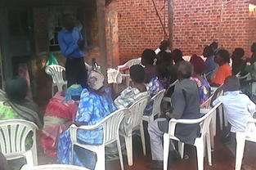
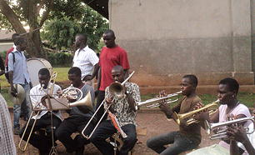

Conducting a workshop at Lugazi II
Music training with the boys
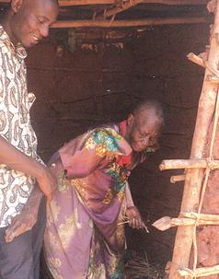
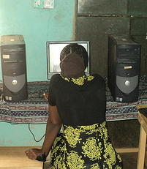
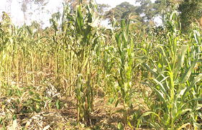

Maize demonstration plantation
Computer training programme
Elderly Support in Buikwe
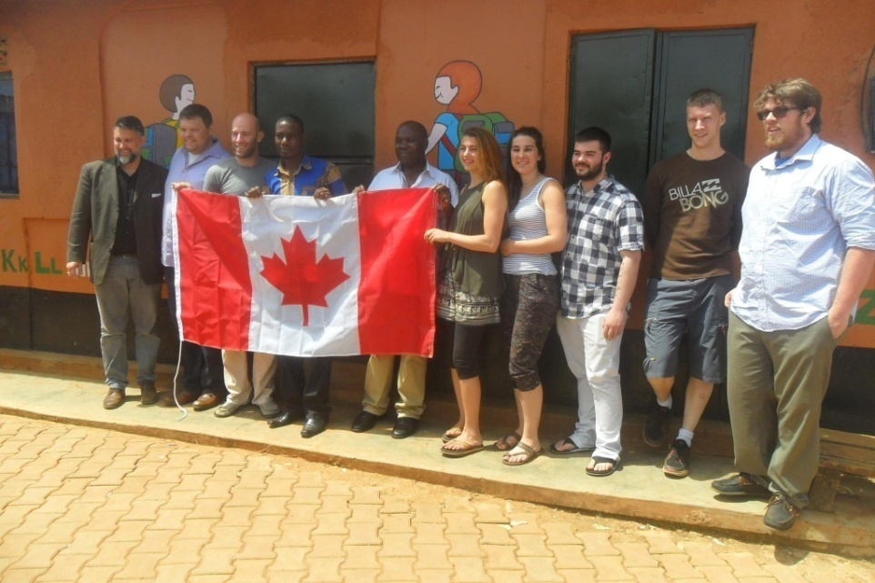
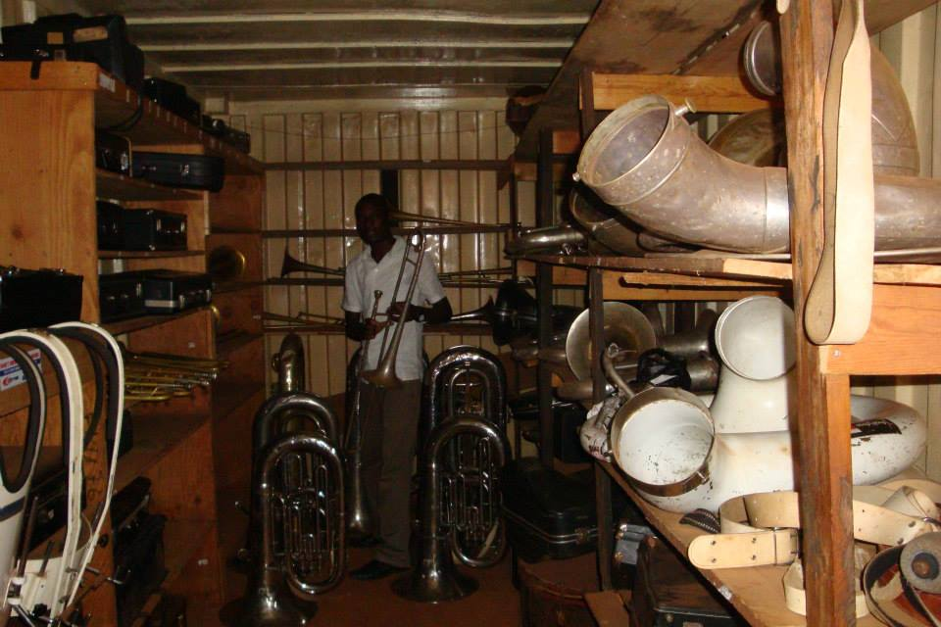

TATCO Uganda Brochure Publication
Project Completion certificate to our donors
Classroom for Africa Donors to TATCO Uganda
Director Inspecting Brass Band Instruments at Mbiko
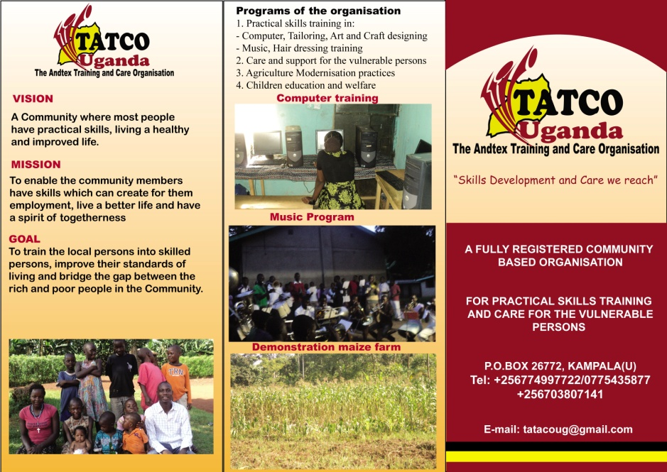
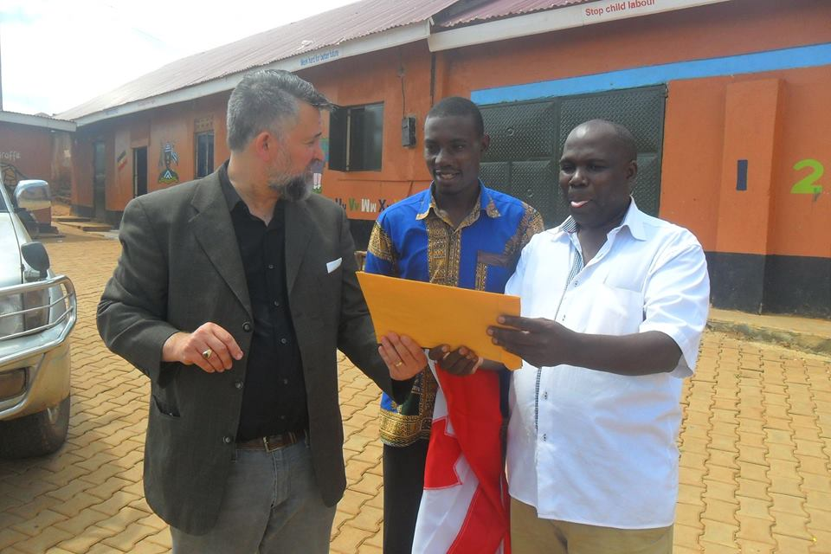

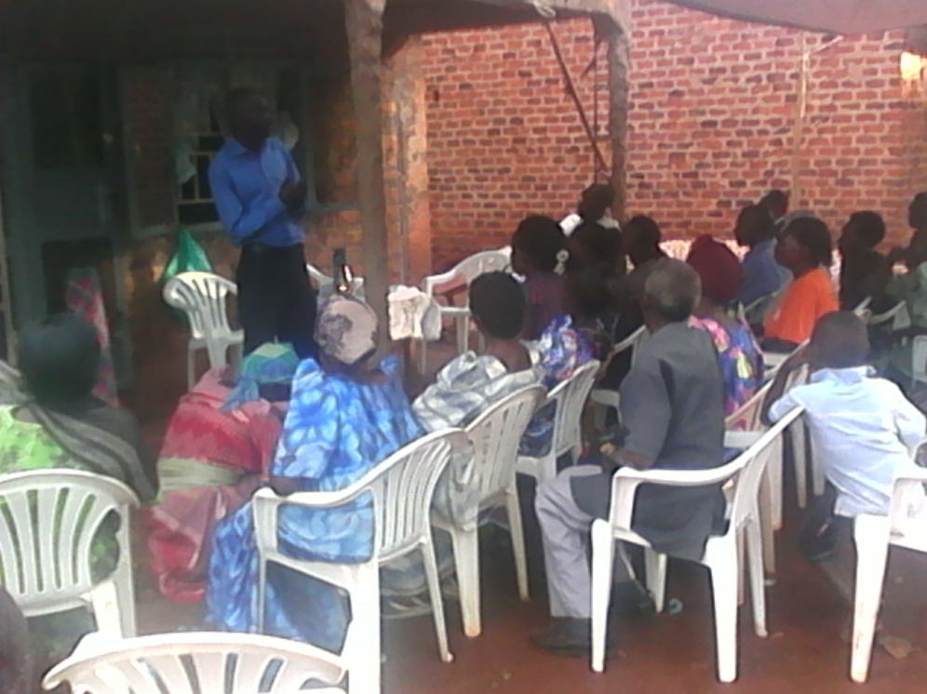
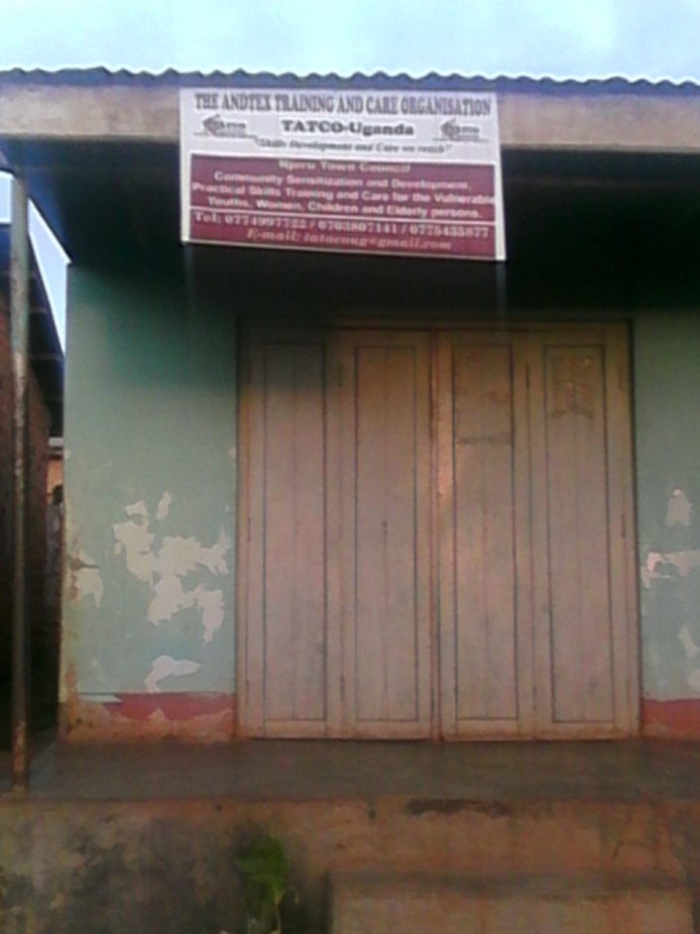

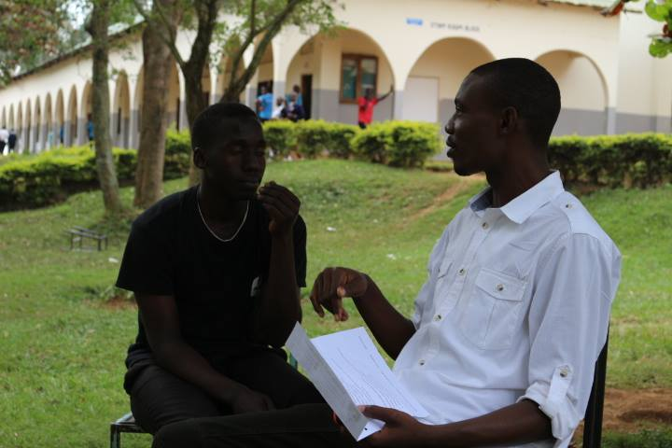
Student Career Guidance at Loards Made Sch- Njeru
Community Training Workshop
TATCO Uganda Founding office at Lugazi II

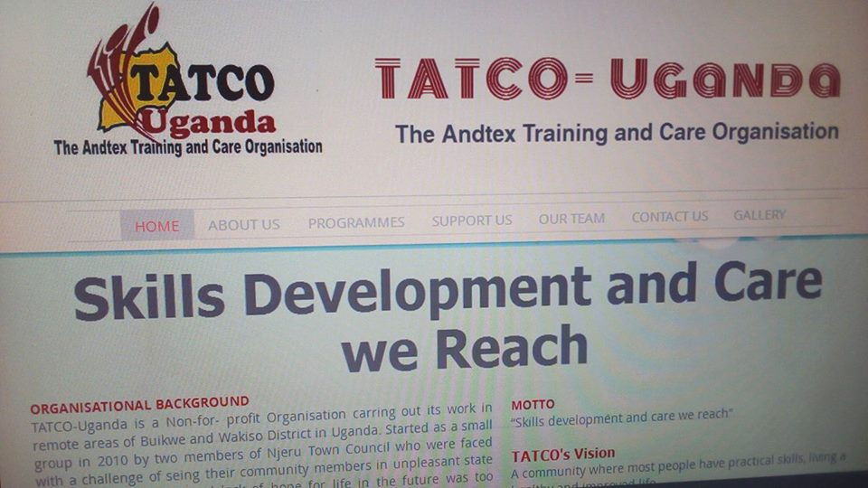
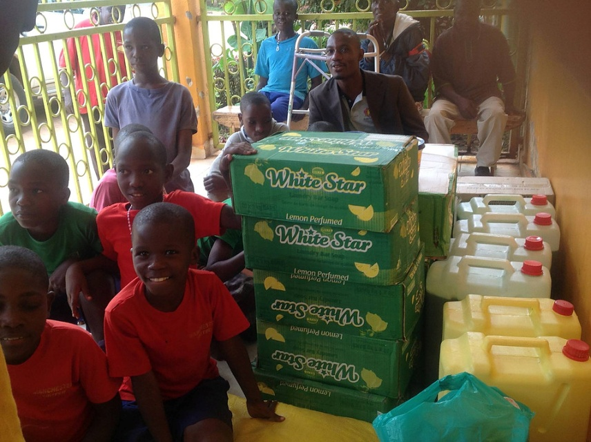
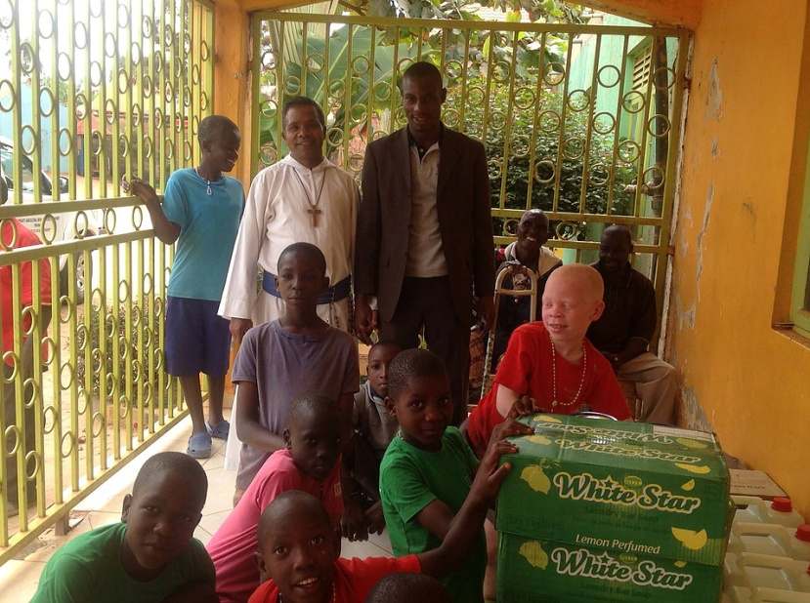
TATCO Women savings and Credit Group
TATCO Charity giving to Orphanage Home
TATCO Charity giving to Orphanage Home
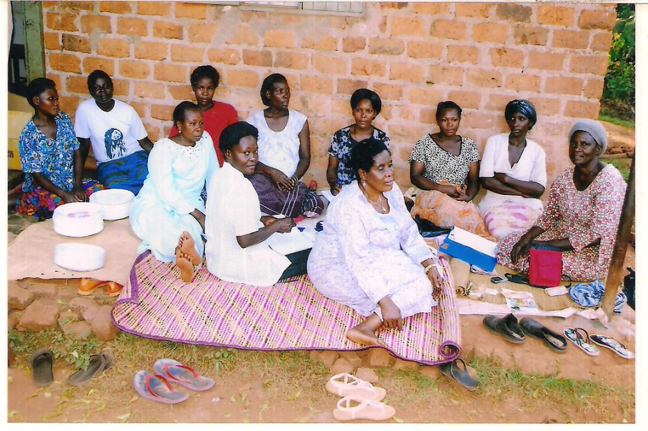
TATCO Official Website
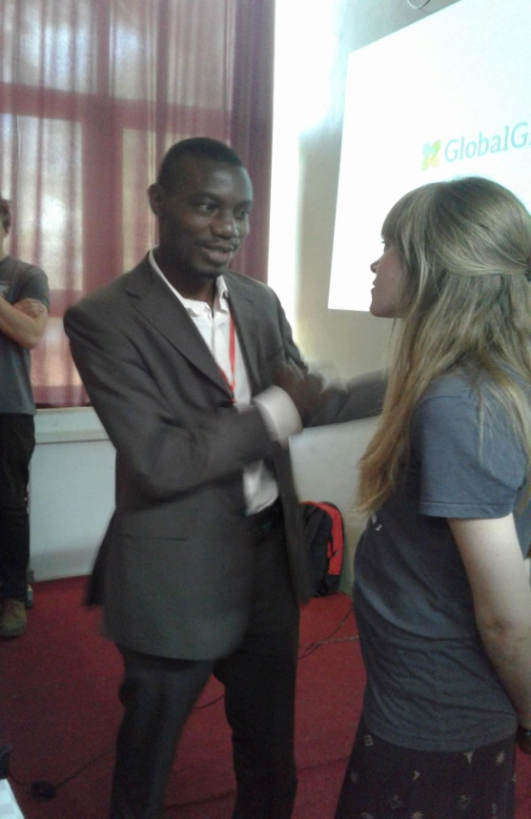
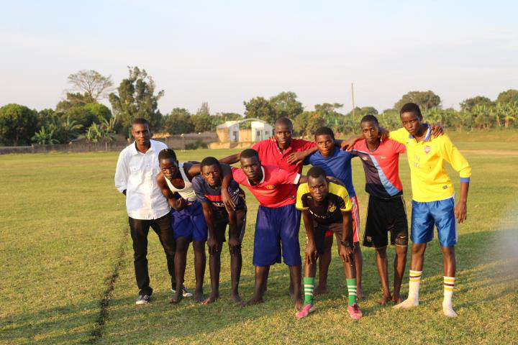
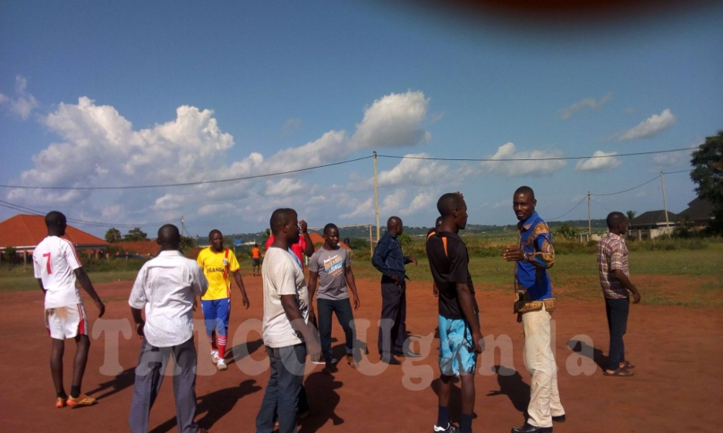
Consultation meeting with Global Giving
TATCO young star soccer training
TATCO youth soccer training
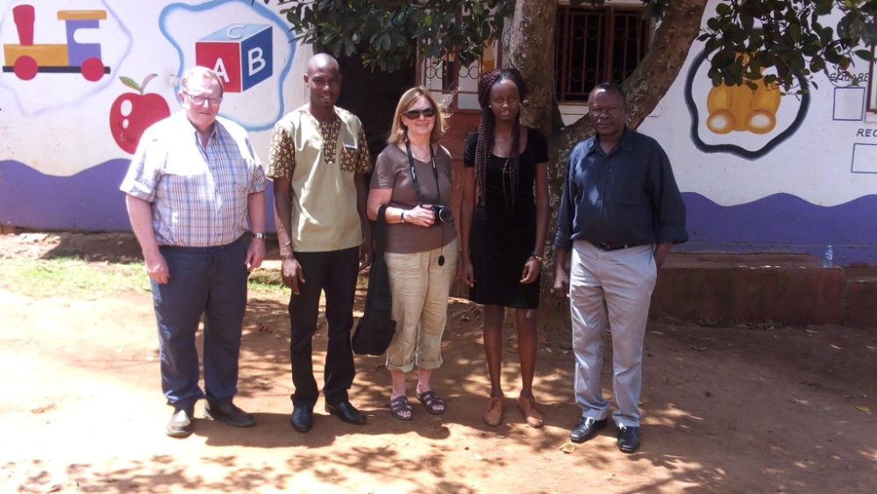

TATCO with some of the school development donor group

