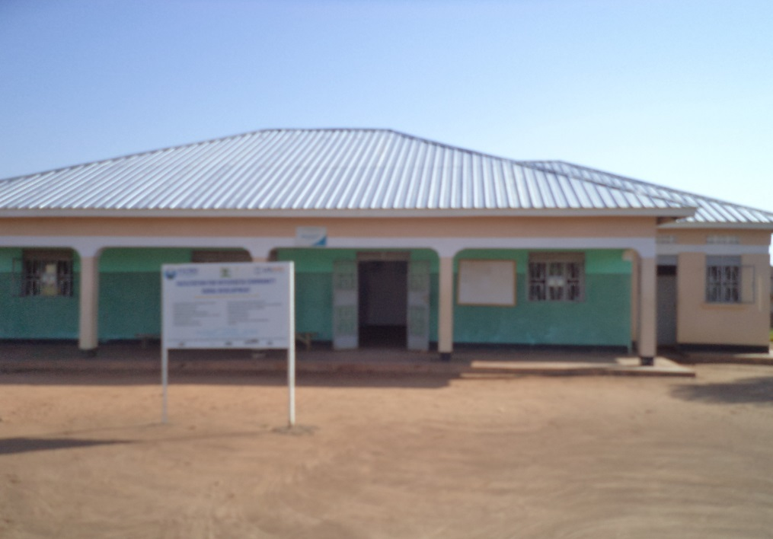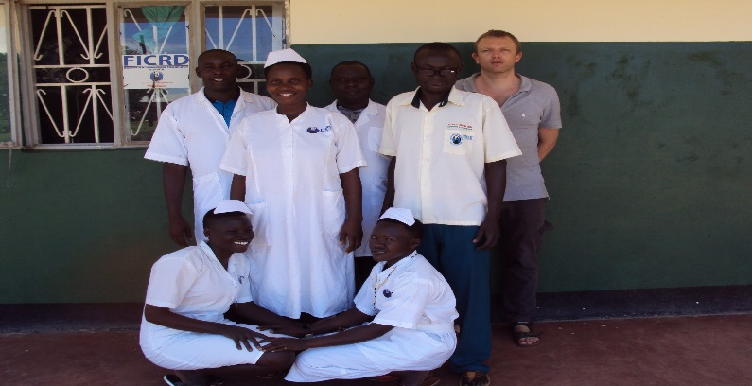**Organizational Profile**

**FICRD ADMINISTRATION STAFFS OF FICRD MATERNITY HOME AND CLINIC – AKIA, LIRA**

**HEADQUARTER:**

5km Lira – Alebtong Road, Akia, Lira

P.O. Box 448, Lira, Northern Uganda

Telephone: +256776191303/+256753191303

Email: [ficrduganda@yahoo.com](mailto:ficrduganda@yahoo.com)

[ficrduganda@ficrd-ug.org](mailto:ficrduganda@ficrd-ug.org)

Website: [www.ficrd-ug.org](http://www.ficrd-ug.org)

**Full Name**

FACILITATION FOR INTEGRATED COMMUNITY RURAL DEVELOPMENT

**Acronym**

FICRD Uganda

**Law under Organization has registered**

**FICRD Uganda** is an indigenous not-for-profit volunteer-based grass root level organization that was established in July 2006 as a charity voluntary CBO, Not for Profit Organization, and registered in April 2010 as a Company limited by Guarantee. Registration number: 119174 and LDLG/4020/11. It’s duly recognized and permitted to operate in Uganda by Law. The organization plays a major role in complimenting government development programmes at national and local levels.

**Contact Details**

**Contact Person 1:**

**Moses Ogwang Adonyo**

Executive Director

**Phone:** +256 776191303

**E-Mail:** [**ficrd@ficrd-ug.org**](mailto:ficrd@ficrd-ug.org) **or** [**mosesficrduganda@gmail.com**](mailto:mosesficrduganda@gmail.com)

**Contact Person 2:**

Mrs Apio Catherin Opio

Board Chairperson

Phone: +256786583764

Email: [chairperson@ficrd-ug.org](mailto:chairperson@ficrd-ug.org)

**Bank Account Details**

Account Title : **FACILITATION FOR INTEGRATED COMMUNITY**

**RURAL DEVELOPMENT**

Account Number : **1029200375527**

Swift Code : **EQBLUGKA**

Branch : **Equity Bank, Lira Branch**

Name of Bank : **Equity Bank (U) Limited**

**Introduction and Background**:

Facilitation for Integrated Community Rural Development (FICRD) is an independent registered non-government and nonprofit civil society organization based at Lira, northern Uganda. FICRD prime motto is capacity building and services delivery to the deprived and marginalized people of the society.

In 2006 a group of women, youth and disabilities got together to establish an organization, for addressing the most urgent and pressing needs of formally abducted women and children during the two decade insurgency in northern Uganda.

Considering their association with the development sector the group was cognizant of the plethora of problems plaguing the region. Consequently, the organization’s focus was not kept limited either in in terms of geography or sector. Whilst operating in different districts of the region, FICRD has been carrying a range of interventions in the areas of education, health & hygiene, youth & women empowerment, emergency response & preparedness, governance, free legal aid, human rights, etc.

The type of activities undertaken by the organization range from capacity building to service delivery, with focus remaining on the deprived and marginalized segments of the society. Whereas in terms of operations what characterizes FICRD’s functioning are its efforts to (a) enlist involvement of the locals when initiating activities at the grass root level; and (b) mobilize women including women with disabilities for sexual reproductive health, maternal and child health, and development in society.

FICRD gained solid experience and understanding of the ethnic differences and the complexity of issues they face especially the women, girls, children and youth. FICRD has supported women and girls’ rights since its inception, working with both the district local governments and NGOs through Participatory Learning Approach (PLA) and Community Empowerment and Right Based Approach on social service delivery such as educational projects, healthcare service and information, family planning and sexual and reproductive health rights. FICRD have led successful advocacy campaigns and by doing so secured 46,150 school drop-outs and, reduced SGBV, child protection, child marriage in schools and communities. We empowered them with skills that have enabled many to fend for themselves and participate in local decision-making processes. Generally, FICRD has economically empowered many youths in Lango sub region and Uganda at large.

**Mission Statement:**

**Mission:** To excel in providing accessible and affordable quality SRH services to rural poor community in a sustainable manner.

**Vision:** Uganda where everyone has access to better SRH and provided without discriminations.

**Goal:** To contribute to poverty reduction and improve the quality of life for young people (10 - 30 years) by increasing access to SRHR.

**Strategy**

A sustainable strategy is devised to achieve the maximum, a need based and right based approach initiated ascertains the problem with fully community involvement and mobilizing all indigenous and local resources. The program goal are materialized with a helping hand from members donor agencies, Philanthropists;

**Thematic Programme / Areas of Focus**

* Health
* WASH
* Youth Empowerment
* Education
* Emergency Response and Preparedness
* Women Empowerment
* Free Legal Aid and Education
* Democracy

**Overall Objective**

The overall development objective of FICRD is enhanced ability in the target communities to tackle their own economic, social and environmental problems for sustainable community development.

1. To enable the community in development of local level institutions and assist them in undertaking community based welfare and development interventions.
2. To Provide quality legal assistance to juvenile victims of sexual abuse, exploitation and trafficking, especially street children in conflict with law and children in detention, vulnerable to sexual abuse.
3. Promote Gender equality.
4. To devise and organize for women and children particularly to their rights to acquire educations and improve their health and earnings.
5. To ensure full participation of local level grassroots organizations in decision making process including problem identification, planning, management, implementation, monitoring, and evaluation aimed at sustainability
6. To facilitate easy access to credit and motivate communities for group saving leading towards small enterprise development and income generating activities aimed at economic empowerment.
7. To work for environmental protection, pollution abatement, water supply and hygienic sanitation.
8. To fight against drug abuse and launching programmes aimed at rehabilitation of drug addicts
9. To establish a resource centre aimed at facilitating target communities and local level institutions through information, education and communication.
10. Assisting communities in disaster prediction and mitigation through various relief and rehabilitation programmes.
11. To develop effective linkages with government line agencies, nongovernment organizations, and donor agencies working for community development.
12. Human resource development and training aimed at skill enhancement and knowledge up gradation in order to ensure better implementation of participatory rural development programmes by community partners.
13. Conservation of natural resources, bio-diversity and environmental protection.
14. Implementation of programmes aimed at basic health care services (preventive and curative) including maternal health, child health, safe drinking water, hygienic sanitation, management of waste disposal, population welfare, immunization, etc. leading towards reduced mortality.
15. To establish new community schools and upgrade the existing ones in order to provide education facilities to those most in need with special focus on female child.
16. Implementation of women welfare and development programmes aimed at socio-economic empowerment of women through their participation in all developmental programmes.
17. Raising awareness of environmental issues through advocacy, networking, public interest litigation and education.
18. Organizing issue-specific and objective-oriented campaigns building social pressure to influence decision-making at national and international levels in favour of deprived, marginalized and vulnerable segments of the community.

**Our Specific Objectives Includes:**

1. To Provide quality legal assistance to juvenile victims of sexual abuse
2. Increased household income and economic activities.
3. Establish youth Group different area in Uganda.
4. To expand and continue supporting FICRD Maternity Home and Clinic – Akia.
5. To establish and registered medical training institutions in Uganda to order to provide cheap and affordable training to youth girls in northern Uganda.
6. Promote Gender equality.
7. Humanitarian assistance in natural and manmade disaster.
8. To devise and organize for women youth, and children particularly to their rights to acquire educations and improve their health and earnings.
9. To increase the education of the target community for the betterment of their own subsistence.
10. To establish working relations amongst provincial government, bar councils and like-minded non-government organizations
11. Improve health conditions by providing basic health and hygiene education and services to the communities residing in neglected areas

**What FICRD Does?**

Influenced by the new development paradigm, which puts people before things, FICRDfollows a rights based approach (RBA) and participatory learning approach (PLA) in every sphere of its work. The traditional knowledge of the rural poor is valued and respected, and there is confidence that rural people are capable of self-reliant organization. On a practical level, the fundamental thrust of this approach is decentralization and empowerment.

For a community to be able to work for its own development and reduce its dependency there is a need for full involvement at all stages of the development cycle. The participation of communities in identification, planning, management, implementation and evaluation of projects is a key factor in FICRD work. Internally a participatory approach is adopted in managing the affairs of FICRD.

Externally, FICRD role as a “change agent” helps to develop community management structures that are capable of managing their own development. This increases the ability of the community to demand accountability in all their affairs, from leaders and officials. It reinforces the community's belief in the value of their own development choices and efforts. These community management structures are not parallel structures, but are built upon traditional institutions, promoting equitable representation and participation

Human resource development is an essential part of our development work. This means ensuring that the community is trained and skilled, as well as organized, to maximize the potential of the community to take hold of its own development.

FICRD strongly believes in maximizing its impact by transferring field experiences into knowledge to influence the development policies and practices of NGOs, donors and government agencies. This is important for working towards the long-term goal of eradicating poverty.

**Approach**

During the process of social mobilization, FICRD adopted a participatory, self-help, self-sustainable approach through community involvement and formation of volunteer groups in remote rural areas of Uganda.

**Philosophy**

Sustainable rural development is a dynamic process posing various needs at different phases of time. These can be dealt with continuous interventions based on designed frameworks that incorporate the requirements projected by the communities and with the help of the communities by strategizing for public-private partnership.

**Scope of Work**

FICRD has strong linkages with major NGOs and funding agencies working in Uganda. It has undertaken initiatives Ugandan through collaboration with local CBOs including the Union of Person with Disabilities and activists. FICRD enjoys a rich experience of working in the diverse socio-cultural environment of Uganda and an extensive networking with the District Local Governments, civil society institutions, media and political parties.

**Organizational Values**

* Honesty
* Respect for individual
* Integrity
* Participation in communal activities
* Transparency in all transactions
* Accountability to all the actions/deeds performed by an individual
* Creativity
* Cost efficiency
* Gender sensitivity

**Values guiding our work**

* **TRUE**: Ensuring transparency at all levels of our work
* **PROFICIENCY** : Providing creative expertise and strong commitment
* **SOLIDARITY**: Within our NGO and with the people we aim to support
* **JUSTICE**: Within our NGO as well as in society
* **INTEGRITY**: To act according to the values we wish to promote
* **FLEXIBILITY:** Showing our willingness to change and learn

**Guiding Principles:**

Facilitation for Integrated Community Rural Development (FICRD) follows the below mentioned guiding principles in implementation of its projects/programmes:

* Use of indigenous knowledge
* Making efforts to achieve highest quality standards
* Promoting a culture of innovation and creativity
* Meeting deadlines
* Enhancing networking and coordination
* Facing challenges

**Professional Strength**

* Highly qualified, experienced and devoted professionals and board members and staff;
* Adaptability to cope up and meet the requirements of diverse socio cultural environment of Ugandan;
* Overwhelming support of local people and communities
* Acceptance as a representative of common people of the area.
* Extensive network to undertake initiatives at grassroots;
* Availability of state-of-the-art modern equipment and tools;
* Strong partnerships for undertaking innovative initiatives;

**FICRD Donors/ Partners**

* USAID
* Empowerment Voice, Oxfam International
* Reproductive Health Uganda
* International Planned Parenthood Federation (IPPF), Regional Office, Nairobi –Kenya
* Uganda Health Marketing Groups (UHMG)
* Joint Clinical Research Centre (JCRC)
* Civil Society Organization Funds (CSF)
* Marie Stopes International – Uganda
* GIZ – Uganda

**Memberships:**

* + - * Member of District Health Management Committee
      * Member of District Education Committee.
      * Lira NGO Forum
      * Uganda National Network of AIDS Service Organizations (UNASO)
      * Lira District Network of AIDS Service Organizations (LIDNASO)
      * Most At Risk Persons (MARPs)
      * Malaria and Childhood Illness NGO Secretariat (MACIS)
      * WASH, Health, Education, Protection Clusters Member at Regional and National Level
      * Civil Society Budget Advocacy Network (CSBAN)
      * Uganda Human Rights Networks Organizations (UHRNO)
* Affiliations with Uganda National Network of AIDS Organization and Gender Based Violence Working Groups

FICRD follows the following strategy in implementation of its programmes and projects.

**Community/Social mobilization:**

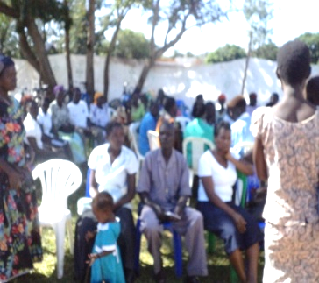**FICRD** while implementing its programme/projects as a first step undertakes community mobilization so that to raise awareness in community on health and hygiene, importance of education in modern day affairs, gender related issues, socio-economic development and environmental protection. For this purpose FICRD management holds meetings with the community members, conducts training/capacity building sessions and also launched campaigns.

**Fig.1: Community consultation and Advocacy Meetings of the stakeholders in Lango region on SRHR, SGBV and Family Planning Services provision and utilization funded by IPPF Global, and RHU**

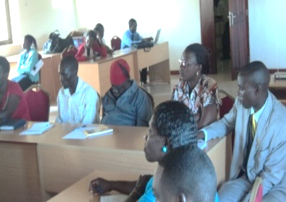

Fig.2: Capacity Building training of District Officers and Bank Loan Officers on Integrate HIV/AIDS into Microfinance, GBV and family planning in Lango and Acholi regions at ALPHA HOTEL – Lira, project funded by GIZ .

**Advocacy:**

**FICRD** advocacy is achieving better results in the field of social/rural/community development, FICRD also believe in advocacy and therefore, the management has always strongly advocated for the issues related to FICRD. For achieving this objective, FICRD through its strong advocacy as approached the line departments of Government of Uganda, NGOs, CBOs, Civil Society Organizations (CSOs), members of the community, notables and FICRD has always promoted the right based approach and supported the dialogue as an important tool for achieving the above mentioned objectives.

Engagement of CSOs in EPI activities supported by MACIS/UNICEF – GAVI

****EPI programs within the districts.**

* Monitoring Immunization activities
* Mobilization & Sensitization of community on EPI programs.

Fig3: The FICRD Executive Director and Senior Midwife Officer - Lira Medical Centre, during an advocacy visits on essential medicine utilization and availability at all health facilities in northern Uganda, project supported by MACIS/UNICEF – GAVI fund

**Advocacy and Strategic Information Sharing and Dissemination**

****FICRD is the centre of coordination networks of all ASOs, CSOs in HIV and AIDS working in Lango region. Its is supported by UNASO through LIDNASO a district HIV & AIDS network organization engage in information sharing and coordination.

***Fig4: Advocacy meeting of CSOs working in northern Uganda at FICRD – Lira office, project funded by Civil Society Fund.***

**Service delivery:**

**FICRD** is staunch believer in a very strong and efficient service delivery in the fields of health, education and environment. For this purpose, FICRD management has always delivered services in the communities in a transparent manner taking care of quantity and quality. It is only because of this very reason that the FICRD interventions have always helped in meeting the community needs and achieving the desired objectives.

**Fig 5: FICRD professional staffs conducting HIV Testing Services at Lira Mayor Garden, Lira District, project funded by USAID.**

**The Knowledge rooms and Female Sex Workers (FSWs) outreach clinics:**

****We continued to use the knowledge rooms to provide reproductive health services and information for both FSWs and Long Distance Truck Drivers. Dialogue meetings, HCT, condom promotion and health education sessions take place in the knowledge rooms. Special STI clinics set up for CSWs also continued with over 200 CSWs and their partners accessing HCT and STI syndrome management and treatment services. The clinics were thought important because of the nature of business the CSWs are engaged in which exposes them to greater risks of contracting STIs.

**Fig 6: FICRD professional staffs and researcher volunteer at Lira Mayor Garden, project funded by USAID.**

**Condoms distributed to key population (FSWs) within the supported district Establish Condoms Banks;**

****10 wooden boxes were made. FICRD volunteer staffs provided 10 services point for condom banks. Key strategic public point of view like Bars and Boda-boda places were put. Every day a team from FICRD including FICRD volunteer staffs visited all established condom bank. Some boxes were strategically put in CSWs places of operation; others target places were bars for bar attendants who end up with CSW, and places where truck drivers park their cars. Condom distributed to the youth out of schools; Conduct facilitation and support of VHTs, & PHAs to distribute condoms in the communities where they live.

***Fig 7: Senior FICRD Counselor providing condom education and distribution during outreach services at Central division, Lira Municipality, Lira District.***

**Net Working:**

**FICRD** has always promoted the networking with other NGOs, CBOs, CSOs, media groups and concerned stakeholders for achieving the goal of sustainable development. Networking with other organizations has always proved very productive by playing as medium between the service providers and those at the receiving end. Networking basically provides opportunity for looking at the issues from different angles i.e. from local, national and finally at regional level. At every level the perspective of issue changes, which then helps in comprehending the issue.

**Target groups**

FICRD basically works mainly for the poorest of the poor in the rural areas of the province. Its target groups include the men, women and children in the rural communities of the province who are still living in miserable conditions and deprived of very basic necessities of life. Besides, FICRD also focuses upon the urban populace living in slums and other such area. For achieving its goal and objective, FICRD target groups also include health workers, paramedics and other staff related to health issues, teachers, students, environmentalists and stakeholders in the field of health, education and environment.

**Reproductive Health and HIV Prevention**

* This thematic area entails following important features for development:
* Establishment of community health centers at remote areas where people don’t have access to the health facilities.
* Develop awareness campaigns for HIV prevention, reproductive health; life skills based education and sexual rights.
* Develop immunization programs for venereal diseases and epidemics.
* Organizing events for public health along with government.

**Child Protection**

* Under this theme FICRD focuses on holistic development of children its protection and rights, following interventions are planned over the time:
* Child rights education and protection awareness at different levels and different stakeholders.
* Development of safe learning places for children at schools, hospitals, and community centers.
* Children confidence building programs, walks, sessions, campaigns, and trainings.
* Development of children groups and developing leadership skills in them.

**Women Empowerment**

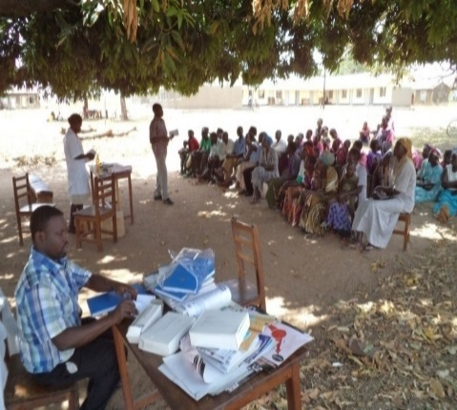Women Empowerment aims at promotion women to take lead role in democratic norms and culture in the operational area. Two types of activities are undertaken in this theme: one aim at building capacities of women and communities and their groups to engage effectively with government and other stakeholders for getting their constitutional and legal social, economic and political rights, the other aims at working directly with state institutions for creating an environment that can guarantee the rights of women citizens. It also focuses on enhancing women income generation skills through capacity building and micro credit. Under this program following sub activities are also conducted:

* Formation of local women groups and their capacity building.

**Fig8. Community meeting of empowerment of women at Bar sub county, Lira district, northern Uganda, project funded by USAID.**

**EMPOWERMENT VOIVE PROJECT; Lango Girls with Disabilities Rights to Education in Lango Sub region.**

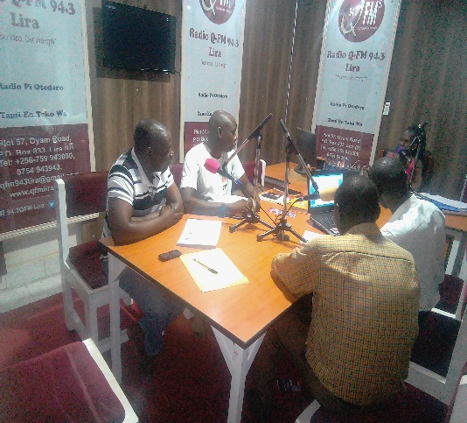During the radio talked prgrammes, the project identified that girls with disabilities still faces a lot of challenge in their communities not only in Lira but across all northern Uganda. The community do not recognized children with disabilities education and health as something very importance to them, they are given less attention and support towards children with disabilities especially in secondary schools. According to community leaders as well as political leaders who participated and made phone calls during the project advocacy radio talk shows programs, they have raised concern about girls with disabilities in secondary schools; parents are less willing to support this girls in school, not taking them to school, not providing necessity like sanitary pads, books, pens, uniform and pay for their school fees which at end point make this girls to be more vulnerable and abuses of their rights. To make it worst many are left at home and regarded as drop girls whom no one consider taking to schools. Therefore, there is need to engage parents and cultural leadership in advocating for girls child especially girls with disabilities in Uganda. About 40 – 50 people are contributing their voices through phone calls on monthly radio talk by civil leaders, political and individuals concern in support towards girls with disabilities.

**Fig9. The Executive Director –FICRD and team from Lira District Union of Person with Disabilities (LDUPD); for advocacy monthly radio talk shows on Girls with Disabilities in Secondary Schools, Access to Health and Education in Lango sub region, at Qfm radio station in Lira. The project funded by Empowerment Voice, Oxfam International.**

**EMPOWERMENT VOICE PROJECT;**

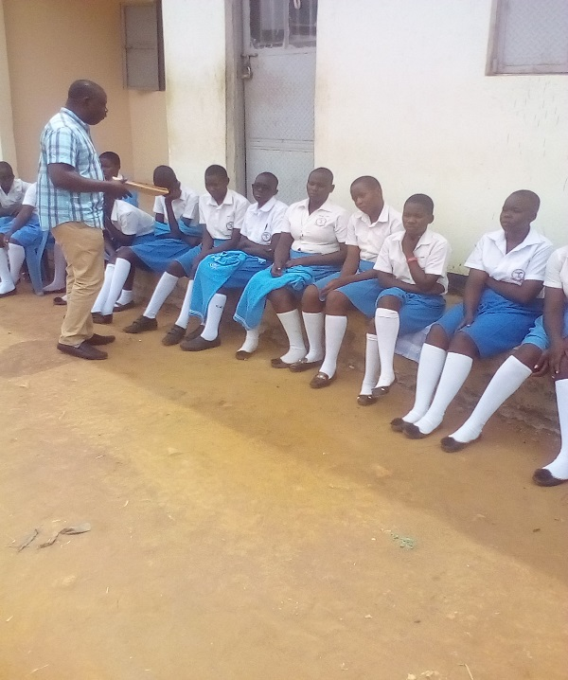During the school advocacy meeting in school and the baseline survey, indicate that 80% of girls with physical disabilities are not send to secondary schools, few than as 25% were either both eyes blinds or partially ear. The survey estimated the 60% of girls with disabilities in secondary schools, needs medical attention especially those with partially ear deaf, eye problems and slowing learners**.** 25% of those girls who needs medication but their parents couldn’t afford or unwilling to take them to health facilities.

**Fig10: The FICRD Project Officer at the Community meeting advocacy of Girls of Disabilities in Rapha Girls Secondary school during school girl’s formation and selection of clubs. The project support and funded by Empowerment Voice, Oxfam International.**

**Activities with Schools:**

****6 school based girls with abilities rights and behaviour change peer educators clubs were supported through training workshops and support for peer activities. School clubs are normally 15 to 25 members strong and closely work with school patrons who are teachers in the very schools. Most club patrons have been trained by FICRD in reproductive health and child rights and are trainers in most cases. These have supported the clubs in their school based activities which include club meetings, sensitization of fellow students on child rights and reproductive health

**FIG 11: Girls with Disabilities at Bar Primary School, Bar Sub County, Lira District.**

**Free Legal Aid and Education**

FICRD is providing free legal aid and education through its partnership with CLAP-Uganda an NGO established law firm of senior lawyers to vulnerable and marginalized victims of society particularly to women and children.

**Board of Directors:**

|  |  |  |  |  |  |  |
| --- | --- | --- | --- | --- | --- | --- |
| **S. No** | **Name** | **Sex** | **Designation** | **Person nature** | **Professional** | **Work experienced** |
| **1** | **Ogwang Moses Adonyo** | **Male** | **Executive director** | **Physical Disability** | **Public Health** | **17 years working in public and NGOs experienced** |
| **2** | **Apio Catherine Opio** | **Female** | **Board Chairperson** | **Physical Disability** | **Social Workers** | **35 years of working in community based project** |
| **3** | **Okello Caxson Otile** | **Male** | **Vice Board Chairperson** | **No. disability** | **Social Workers** | **40 years** |
| **4** | **Achola Susan** | **Female** | **Treasurer** | **No. disability** | **Social Workers** | **9 years experienced** |
| **5** | **Wakello Dorcus** | **Female** | **Program Advisor** | **No. disability** | **Public Health** | **24 years experienced** |
| **6** | **Awor Lonah Recho** | **Female** | **Member** | **No. disability** | **Social Worker** | **5 years experienced** |
| **7** | **Adongo Caroline** | **Female** | **Member** | **Physical disability** | **Social Worker** | **12 years experienced** |

**Organizational Organogram**

**General Assembly**

**Executive Director**

**Finance/ Procurement committee**

**Training and Program Committee**

**Program Manager M & E and IT Manager**

**Project Coordinators Education, Health, Wash, and advocacy**

**Boards of Director**

**Finance Manager and Admin Officer Finance**

**Program Manager**

**Project Mobilizer /Trainers/ Facilitators**

**Support Staff**

**M & E and IT Section**

**Executive Committee**

**Internal Auditor**

