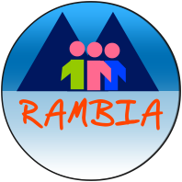

Rwenzori Mountains Baghuma Integrated Association

Annual Report | 2016- 2017

Healthcare |  | Letter from the Board
Dear Supporters of RAMBIA,
Thank you so much to each and every one of you who supports the work of RAMBIA. We particularly want to thank our regular givers who ensure the sustainability to our work.
We’ve had yet another amazing year supporting health, education and livelihood projects in Katebwa, Uganda. A huge highlight in 2016 was seeing the continued expansion of RAMBIA Community Health Centre and RAMBIA Orphanage School. An additional structure to house our health centre staff was achieved and a new friendship with Wereld Missie Hulp was found to improve the much needed infrastructure at the orphanage school. Improved staffing at both institutions continued to strengthen the delivery of quality and timely support our community desperately needs. With your tireless support, our faith to contribute to the development of our community is confirmed. We look forward with greater hope to transform as many lives of destitute children and the households where they come from.
On behalf of the entire RAMBIA community allow me to say thank you.
Kule Yowasi
Board Chairperson.
Education
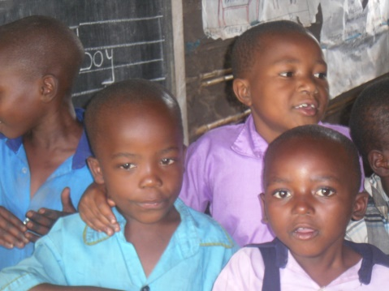
Livelihoods
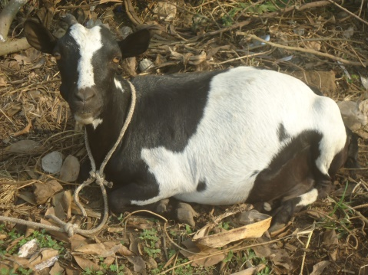

Message from the Director
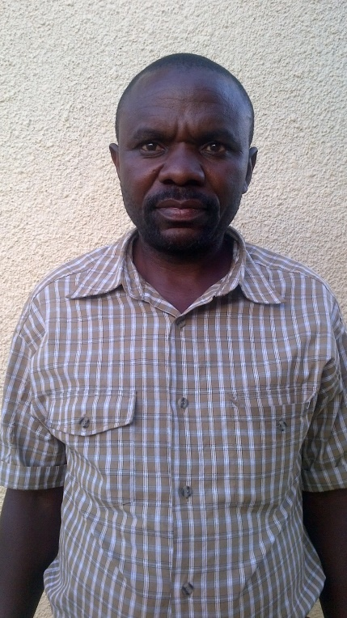 | Dear Friends of RAMBIA,  I am especially delighted to present to you the report on our work for the year 2016/17. Together with my team, the board and the relentless effort of you our partners, I want to acknowledge the financial and material support you extend to RAMBIA.  I am glad to report to you on the account of the work that you support the increasing uptake of our services to the community.  Overall enrollment to the orphanage school is over 400 children and over 7,260 people reached with health services. Our community livelihood work supports 150 poor women with a goat revolving project.  With your continued support, I am optimistic that in the coming year our team and our facilities will be further strengthened to face the difficult challenges that infest our communities. Allow me invite to an insightful update of RAMBIA work.  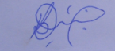  Bwambale Daniel,  Director
 | About us  RAMBIA is a Uganda based indigenous non-profit organization founded in 1993, reflecting the desire of the rural population to initiate and implement strategies for improving their standards of living. The organisation has its headquarters in Kyamukube Town Council and serves the sub counties of Katebwa, Buhesi, Rubona Town Council, Mugusu, Kabonero and Karangura in Kabarole District.  For more information about RAMBIA, visit our website  www.rambia.com  or write to us  rambia263@gmail.com  P.O Box 263, Fort Portal, Uganda  We will be glad to hear from you. | Our programs  Pro-poor health services  RAMBIA operates a health centre and conduct community health outreaches targeting the vulnerable and poor in places distant from healthcare services.  Targeted Education for OVC  We have established an orphanage school serving orphans and vulnerable children (OVC) from some of the poorest households.  Sustainable Livelihoods  RAMBIA works with the most vulnerable farming households through a visioning and planning process aimed to achieve living.

Our Operating environment

RAMBIA majorly serves a mountain community with least access to public services. The physical nature of the area naturally presents a mobility challenge, and as such health centres, schools and markets are not accessible to majority people.
The vulnerability of mountain ecosystems to effects of climate change has as well demanded us to work with poor households to adapt and put in place resilient farming systems, and minimize pressure on mountain forestry resources.
All these concerns prevailing in our community impact on the social and economic vitality of countless households.

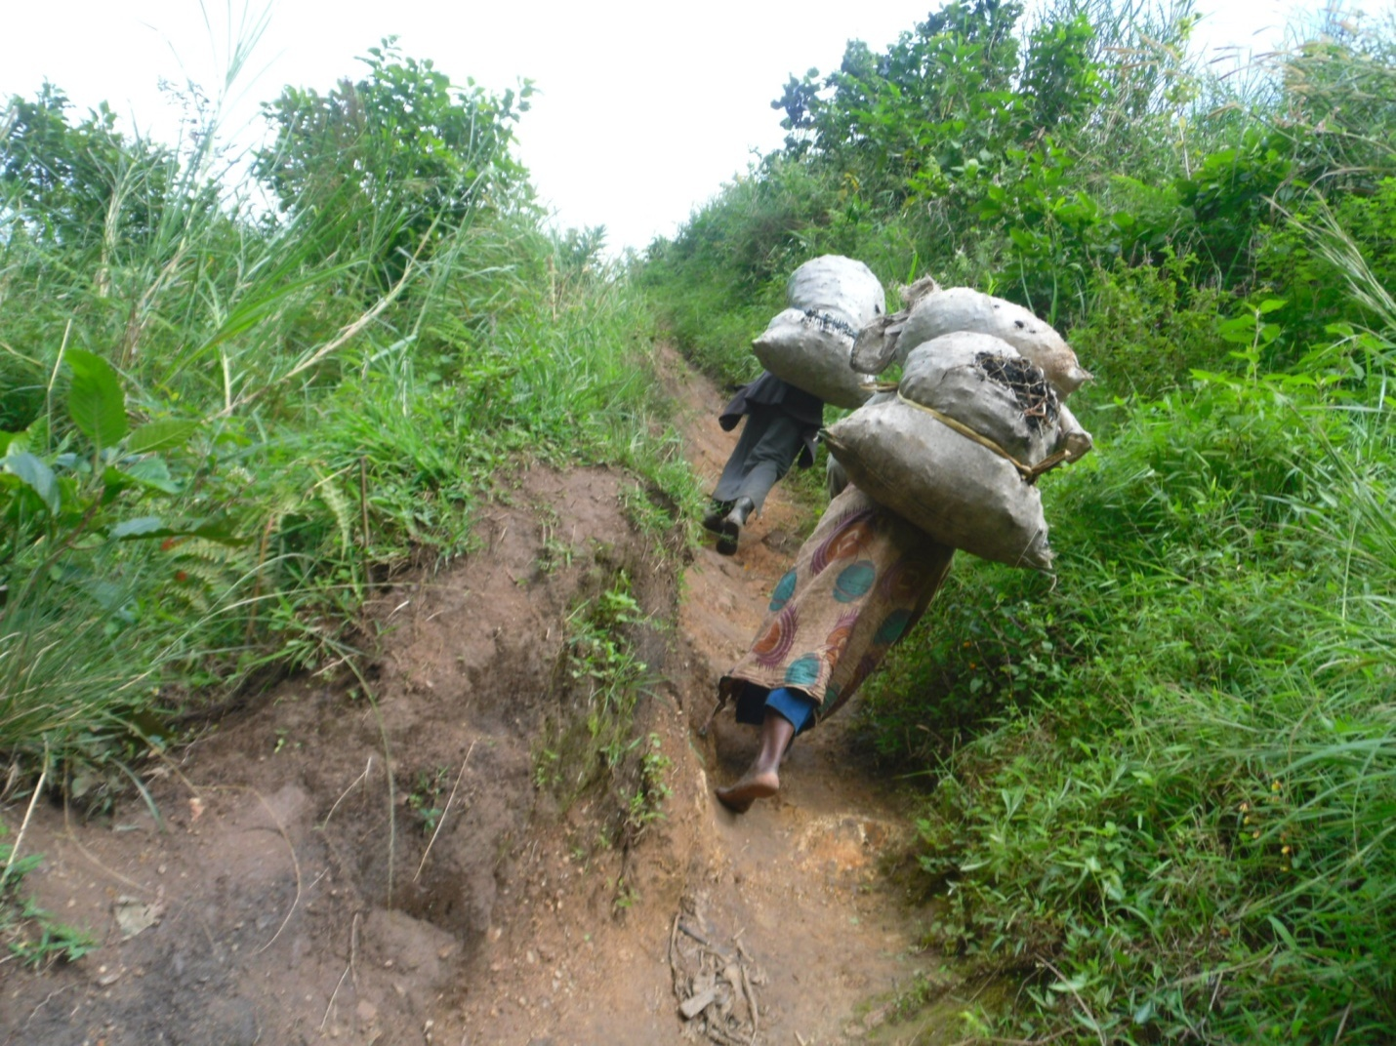

Our program outreach

Healthcare
General Community Health
617patients attended to through our outpatient clinic, treating common illnesses, including malaria, pneumonia, intestinal worms, cough, diarrhea, flue | 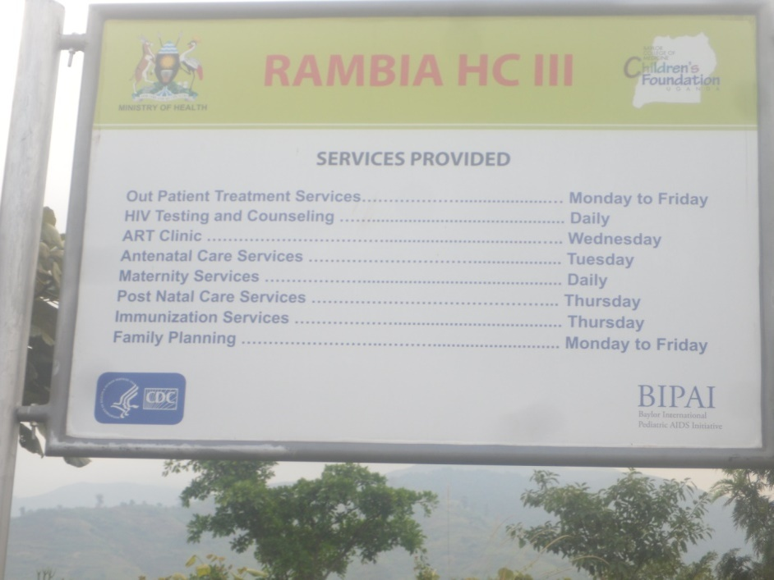
Our 10 bed inpatient clinic attended to 510 patients | 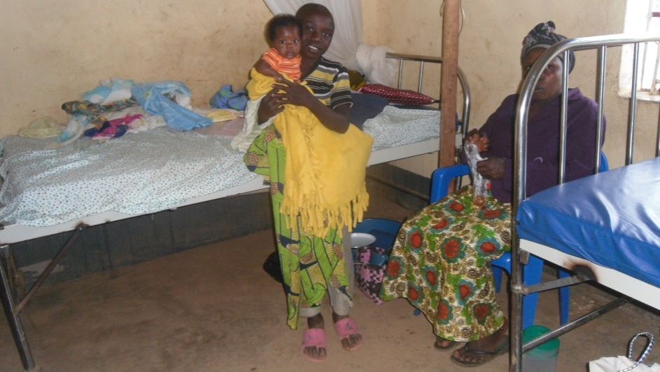
Our carpentry school training for the youth drop outs.we have trained over 65 dropouts | 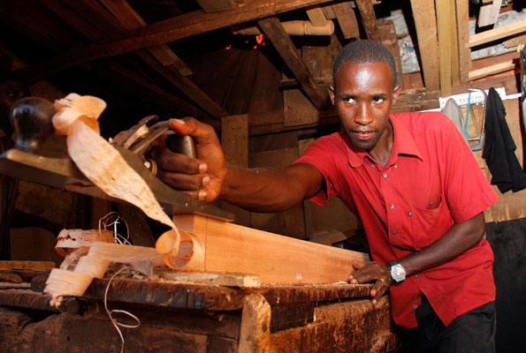

Maternal and Child Healthcare
RAMBIA Health Centre provided specialized maternal and child healthcare targeting women, children with a stimulated involvement of men. Our dedicated team was able to attend to
4101clients, summing up
t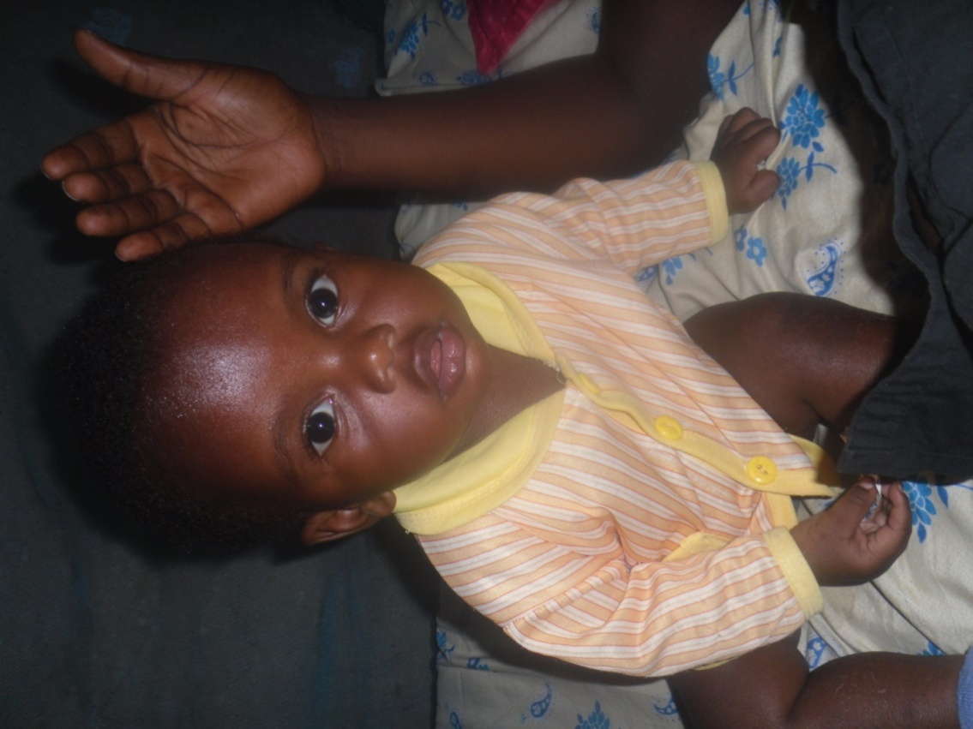he following services.

319 | Antenatal care
232 | Maternity services
213 | Post natal care services
391 | Family planning
783 | Immunization services
2,379 | Vitamin Supplements

HIV&AIDS care
RAMBIA HIV Testing and Counseling services and ART Clinic fill a critical service delivery gap in the fight against the epidemic.
Reaching 6885 clients with this vital service was not mean feat.

4913 | HIV testing & counseling
1972 | ART clinic

Education
Rambia Orphanage School enrolls an annual average of  400 orphans and vulnerable children. Our goal is that the school offers a deserving learning and growing environment for children would have otherwise lost it on education and appropriate nutrition for growth. | 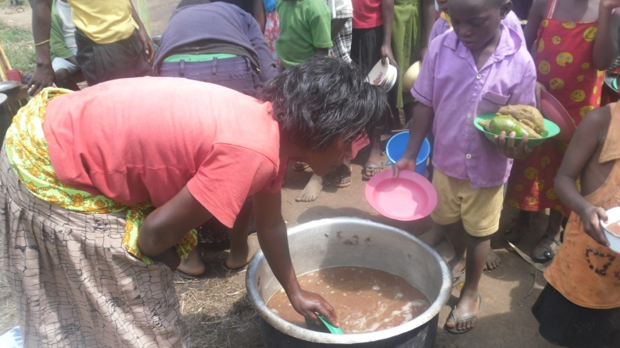
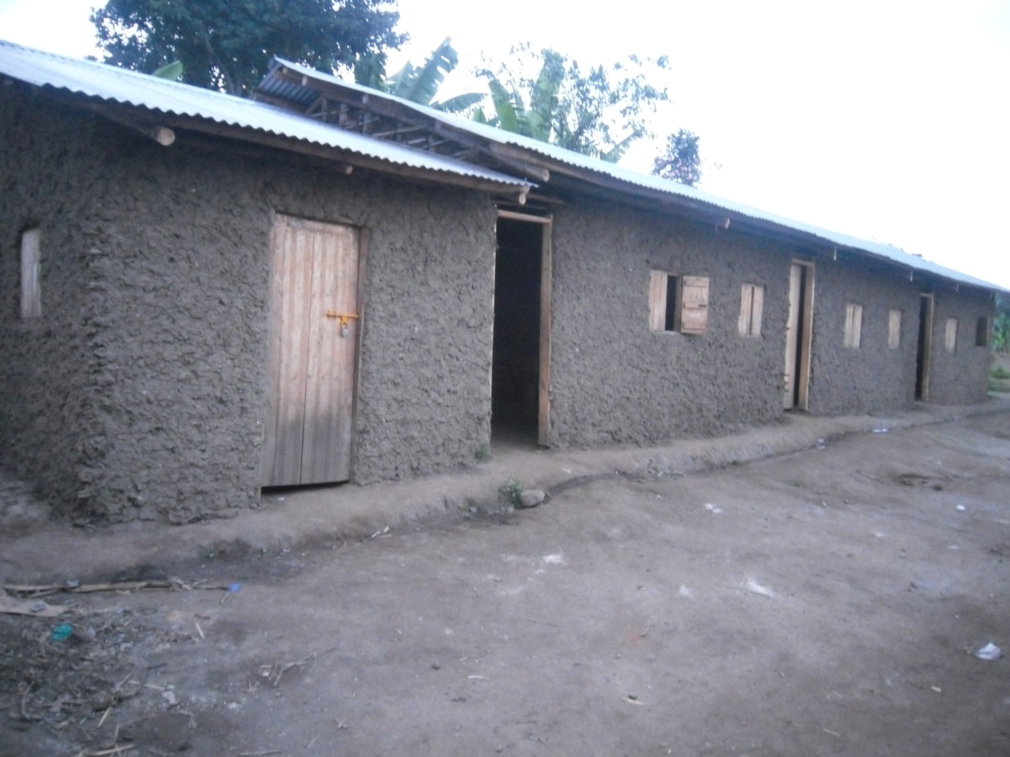
Academic performance
In 2016, we had our first Primary Seven Leaving Sitting and we emerged the second in the entire Kateebwa Sub County with four first grade and the rest pupils passed in division two.

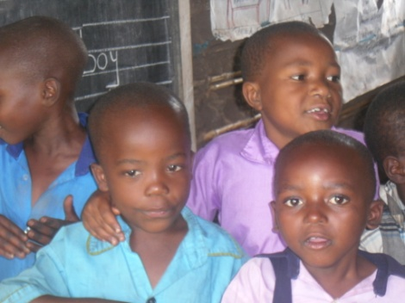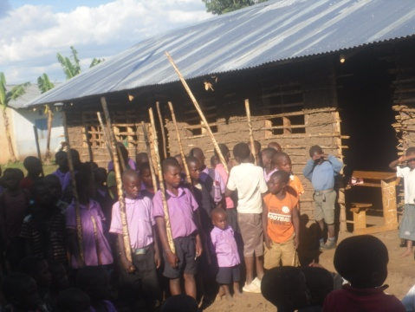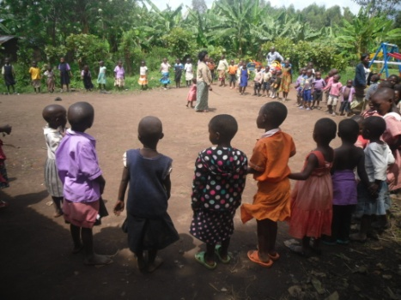
Sustainable Livelihoods
Family farming
RAMBIA operates a goat resolving fund for poor women with the aim of building their stock of productive assets. Specifically, in our context goats are special livelihood assets that provide safety nets against vast forms of shocks. This revolving fund that started in 2014 with 50 goats targets to reach 150 poor women beneficiaries.
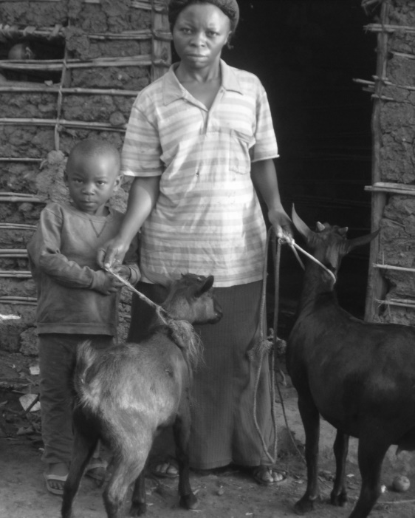 | 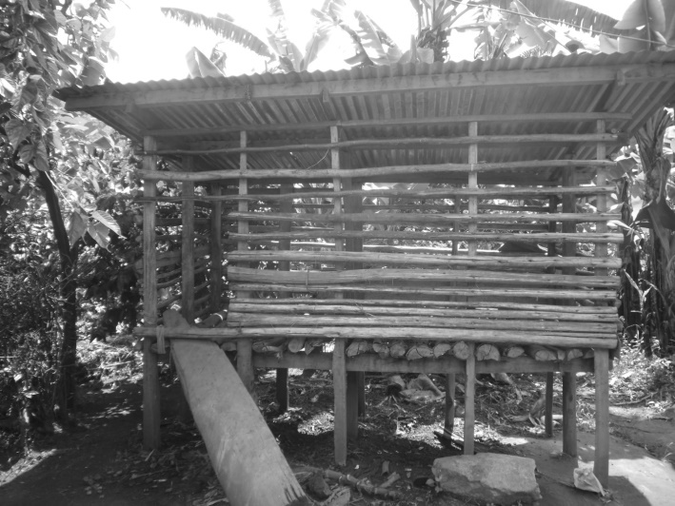  Photos: Poor women manage revolving goat fund. They have been trained in sustainable goat farming.

Environmental Conservation
Environmental conservation is an integral part of our family farming initiatives. RAMBIA promotes conservation agriculture and this justifies our goat resolving fund initiative. In promoting sustainable goat farming, we encourage farmers to develop grazing management plans, creating Riparian Forest Buffers and increase forage and biomass planting | 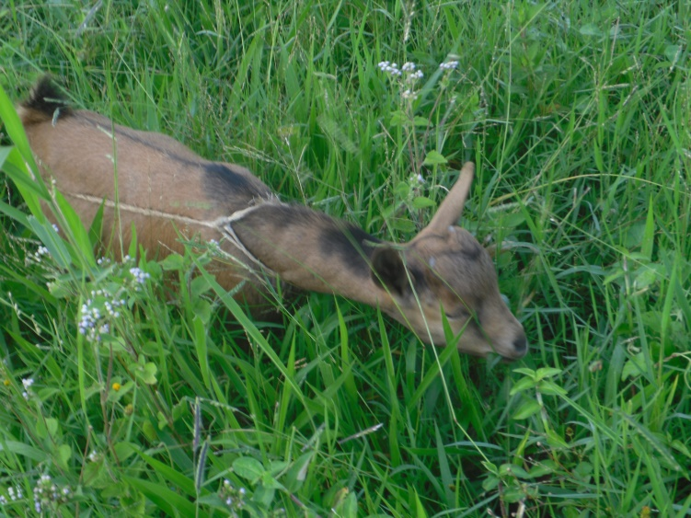

Infrastructure development
Our health centre and school infrastructure received a huge boost from our partners. We thank Wereld Missie Hulp and Jan Standaert for putting up a standard sanitary block for the orphanage school. In the same spirit we are grateful to Medical Access for the solar power system that ensures a 24/7 supply of lighting power and running of equipment in the medical and maternity wards. We are happy that our medical staff will now be accommodated within reach of the health facility. Thanks to Memisa Belgium and Wereld Missie Hulp Projecten Belgium that funded the construction of the staff quarters.

Our new supporters, METS – MUK, also supported the strengthening of our soft infrastructures, the electronic medical records for the HIV/AIDS support unit.
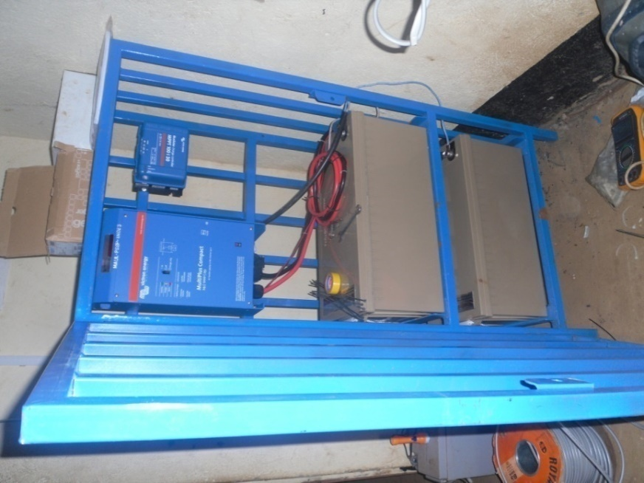  Solar power system | 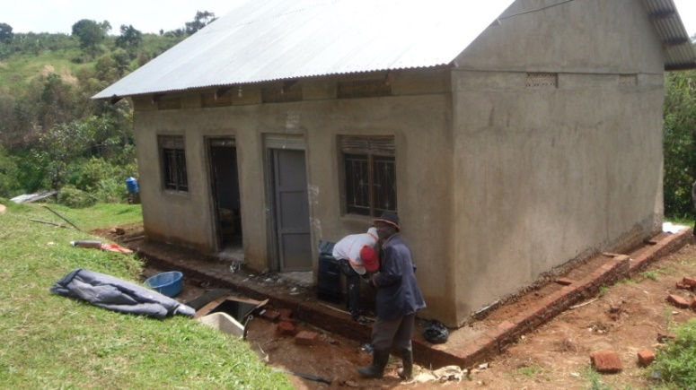  Medical staff quarter at Rambia Health Centre
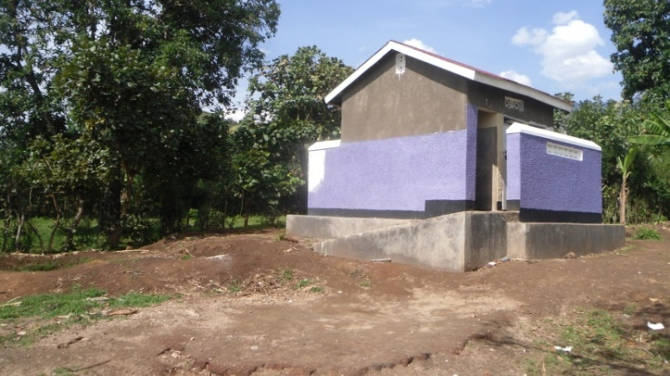
Sanitary Block at Rambia Orphanage School

Challenges
- Our commitment to deliver quality and but affordable healthcare and education to orphans and vulnerable children is usually challenged by inadequate infrastructure and equipment.
Health Centre | Outpatient department block, medical ward, kitchen for patients, ultra sound machine and x-ray
Orphanage School | Library and books

- The second major challenge is staff retention because most of our health services are free and others nominally subsidized to be accessible by the poor. Our strategic response to this challenge is to lobby our supporters for support towards establishment of income generating projects as a means for sustainability.
Organisational Management
Staff
Senior Management | Health Centre | Orphanage School
- Bwambale Daniel (Executive Director)  - Masaba David (Accountant)  - Musinguzi Francis Programs Manager | - Baluku Juma (Lab Assistant)  - Jackline Masika (Enrolled Midwife)  - WamaraBurafiki (Clinical Officer)  - Black Zacheus (Enrolled Comprehensive Nurse)  - Mudama Fred (Nursing Assistant)  - KuleJosephat (Nursing Assistant)  - Kithahire Jackson  - Asaba Kanyabwoya (Records Officer)  - YeremiyaMuhindo (Security Guard) | - Giman Joseph  - Adam Robert (Deputy Head Teacher  - MurangaHawa (Teacher)  - MasikaScovia (Teacher)  - Didas Jocknus  - Rashid  - Musinguzi Robert  - Clovis

Board
- KuleJoash (Chairperson)
- Mbambu Jolly (Vice Chairperson)
- Matsipa Emmanuel (Treasurer)
- Bwambale Daniel (Director/ Secretary)
- Masika Esther (Member)
- Mbabazi Rebecca (Member)
- Musinguzi Francis Member
- Kithahire Ezekiel
- Musoke Justus Member

Our Supporters
Win Smit – Wereld Missie Hulp | Jacques & Theresa Sauboin
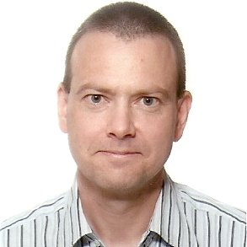 | 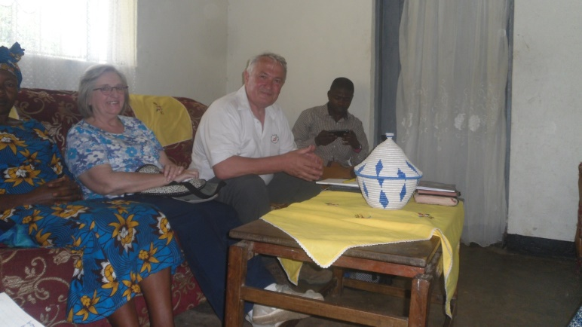
Michael Wills, Canada
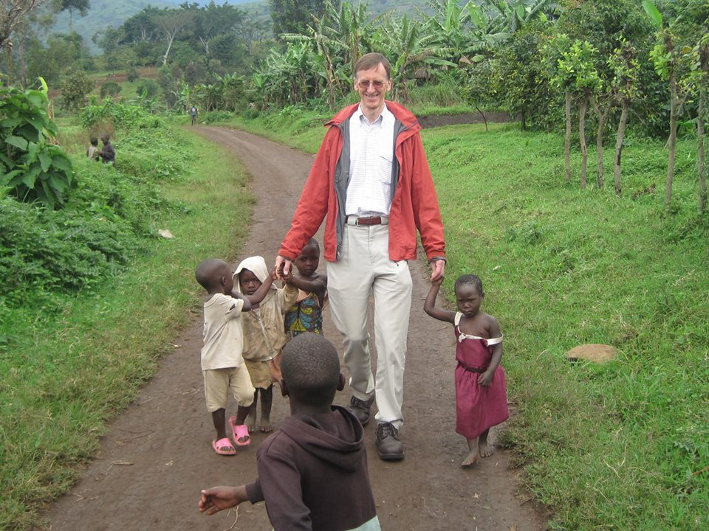 | 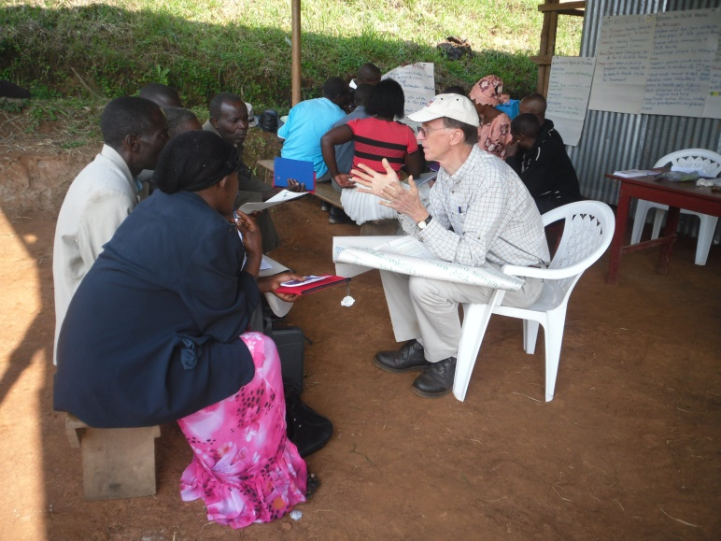
Michael Willis, training women groups in managing Villages Savings and Loan Associations
Emas Canada | Memisa |  | Tetherdown School | Wereld Missie Hulp
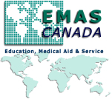 | 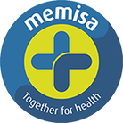
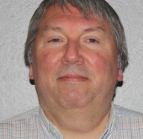 |  | 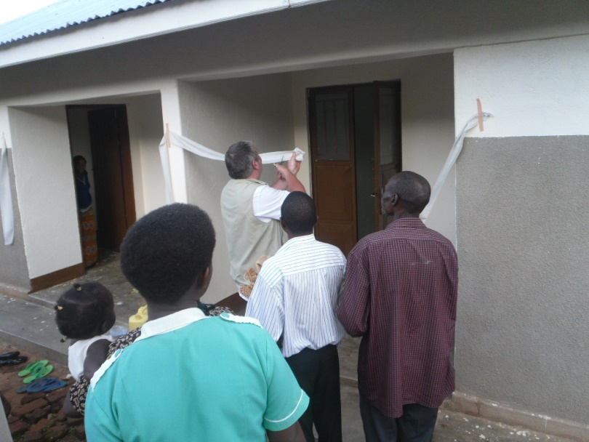
Jan Standaert, Belgium |  | Jan commissions a medical staff house at Rambia Health Centre
 |  | 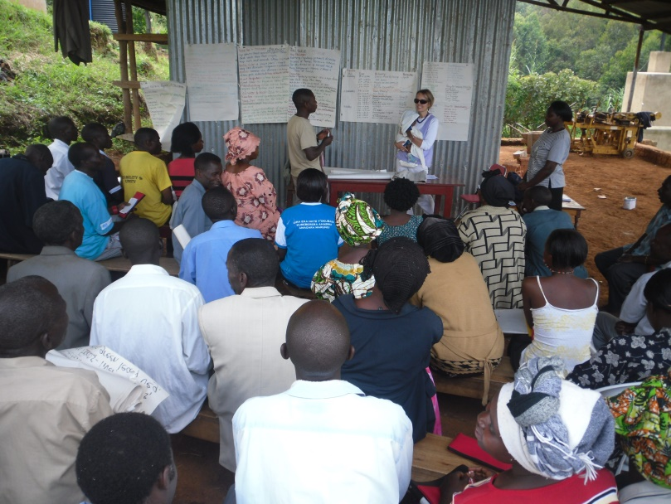
Lynda Audia, Canada |  | Lynda training Village Health Teams (VHTs) at RAMBIA

MOH Uganda | METS-MUK | Baylor Uganda | Medical Access
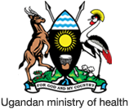 |  | 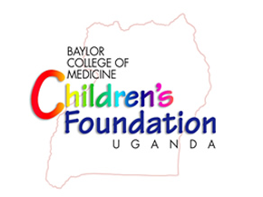
Vitamin Angels

