RESEARCH SYNOPSIS

ROAD ACCIDENTS IN URBAN AREAS

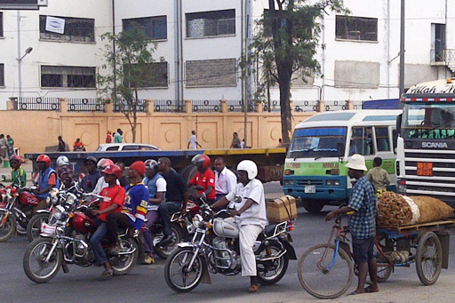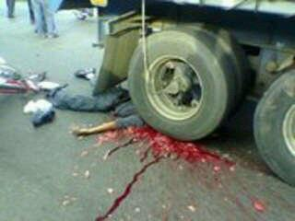

A Case study of accidents involving Motorcycle or “BODA BODA” in
Dar es Salaam – Tanzania

By
Bruno Kinyaga- HLTF & CILT Tanzania

ABSTRACT
Motorcycle transport commonly known as “BODA BODA” has become the most popular means of transport in both rural and urban areas in Tanzania. Many young people who were jobless are now engaged in providing motorcycle transport services and it is becoming a reliable source of their income.
The increase of motorcycles has been accompanied by an increase of motorcycle crashes causing deaths and injuries to passengers as well as riders. According to the data collection I have made, the statistics shows that from January to June 2014, the total number of 3170 motorcycles involved in accidents in the country. That is 15 percent, 2402 accidents that is 20 percent causing 423 deaths and 622 injuries. Compares to the report of January to June 2013 whereby the total number of motorcycles involved in accidents were 3720, the number of accidents were 3016 causing 457 deaths and 2963 injuries. According to the report given by the Road safety chief commander in Tanzania, commissioner (DCP) Mohamed Mpinga, Kinondoni district is the leading one on motorcycles accidents having 25.5 percent followed by Ilala having 18.6 percent and Temeke 16.1 Percent.
Results will be disseminated to participants and transport stakeholders, CILT, Ministry of Transport Tanzania and SUMATRA (Surface and Marine Transport Regulatory Authority).
INTRODUCTION
The study is being conducted in Dar es Salaam City, where most of people use this mode of transport. The population of Dar es salaam 4,364,541 according to the official 2012 census, increasing at 5.6 percent per annum from 2002 to 2012, making it the third fastest growing city in Africa and (ninth in the world) after Bamako and Lagos respectively. The metro population is expected to reach 5.12 million by 2020.
Urban public transport users in the city mainly depend on road transport services. Reliance on road transport coupled with high growth of transport demand has led to inadequate supply of transport services and increased dependence on the use of private cars and consequently road congestion and poor traffic flow management (Kumar et al,2008). Provision of urban public transport services by private sector is underlined at policy level (Ministry of Infrastructure Development, 2003). Motorcycle transport service has emerged as one of the major means of road transport service used by many people in urban and rural areas including Dar es Salaam due to the nature of road infrastructures in the city.

POPULATION IN DAR ES SALAAM REGION
DISTRICT | AREA Km² | POPULATION (2012) | POPULATION DENSITY
Ilala | 210 | 1,220,611 | 5,813
Kinondoni | 527 | 1,775,049 | 3,369
Temeke | 656 | 1,368,881 | 2,087
Total | 7,393 | 4,364,541 | 590.36129

RESEARCH QUESTIONS
Questions will assist in establishing;
- Major causes of road accidents involving motorcycles transport service.
- Percentage of accidents involving motorcycle transport
- Contribution of motorcycle transport on solving unemployment in the country
- What should be done to minimize accidents involving motorcycles?
SOCIAL-ECONOMIC BENEFITS OF THE STUDY
The major social-economic benefit of the study is to find out causes and measures of reducing the number of accidents associated with motorcycle transport service in urban and rural areas in Dar es Salaam and Tanzania as a whole.
METHODOLOGY
The study will be undertaken by using both qualitative and quantitative methods of research by conducting physical surveying of sample areas and literature review. The study will follow descriptive cross-sectional study design whereby, people engaged in the activity and the users of the mode of transport in three locations, Tegeta in Kinondoni district, Buguruni in Ilala district and Kigamboni in Temeke district will be interviewed.
The study will cover 289 people (N) obtained through sampling techniques calculated by using single population proportion formula, N = Z²p (1-p)/E² Whereby:
Z= 1.96 at 95% confidence interval,
E = is a margin of sampling error rate 5%,
P = Proportion of motorcycle crash accidents victims (25%)
Standard structured-self-administered open and close ended questionnaires will be used to obtain data. The questionnaires will be translated into Swahili language.
The team will comprise the author and two research assistants all CILT members who will be trained for one week before data collection. The training will cover research topic clarification, objectives of doing the study, appropriate use of data collection tool (questionnaire).
The process of data collection is being conducted to the users of the mode of transport, motorcyclist, hospitals, police stations, regulatory authorities, insurance companies, sellers of motorcycles, associations for motorcycles transport service operators.
The field questionnaire will be checked for quality, coded and entered into the Statistical package for Social Studies (SPSS) program (Version 15). Frequency distribution will be used to describe categories, variables and mean standard deviation for continuous variables.

REFERENCES
Urban Transport Service Indicators : Tanzania Country Report, September 2012, Shedrack Willilo in collaboration with Paul Starkey, Peter Njenga, Guy Kemptson, Musyimi Mbathi and KenethOdero.
Motorcycle Crash: Injuries patterns and associated factors among patients treated at Muhimbili Orthopedic Institute (MOI): Bryson Mcharo MD (DAR), September, 2012.
The National Transport Policy for Tanzania; URT (2002)
Nantulya VM RM. The neglected epidemic: Road traffic Injuries in developing countries. BMJ 2002; 324:1139-41.
Tanzania Police. Road Traffic Injuries (RTI) 2010.
Makete Integrated Rural Transport Project, May 2007; Camilla Lema (Consultant Rural Transport and Development) Dar es Salaam Tanzania.
“The Management of Roads in Tanzania: A Daunting Task”, the paper presented in ERB special meeting; I.N Kimambo, January 2013.
10Year Transport Sector Investment Program (TSIP) Phase I (2007/08-2011/12), Main Report, URT/Ministry of Infrastructure Development, January 2007.
Lateef F. Riding Motorcycles: is it a lower limb hazard? SMJ. 2002; 43(11):566-9.

TIME SCHEDULE OF ACTIVIES (work plan)
PHASE I (Conducting Research)
TIME FRAME | ACTIVITIES | BUDGET | PERSON RESPONSIBLE
2nd week June to 4th week June 2014 | Research proposal development. | - | -Researcher  -Supervisor
1st week July 2014 | Refining research proposal and submitting it with research questions, objectives and hypothesis. | - | -Researcher  -Supervisor
2nd week July to 3rd week August 2014 | Pre – testing the questionnaire.  Field work (Data collection & Analysis). | Stationary &Interview costs = £ 350  Transport  costs £100@3= £300  Meals and Accommodation costs £100 @3 = £ 300  I Pad/Camera costs =  £ 400 | -Researcher  -Research Assistants (2)
4th week August to 3rdweek September 2014 | Data processing, data analysis, report writing and submitting the first draft. | Typing costs = £ 50 | -Researcher  -Supervisor
4thweek September 2014 | Final revision and Final submission of the draft. | - | -Researcher  -Supervisor
Duration=4 months |  | Total Budget =  £ 1400
PHASE II Dissemination of study results
1st week October 2014 | Conducting seminar/workshop in Dar es Salaam region | -Laptop costs = £ 400  -Projector costs = £ 100  -Meals allowances £10@3 = £ 30  Venue £ 100@4 = £400 | -Researcher  -Research Assistants (2)  -Participants (30)
2nd week October 2014 | Conducting seminar/workshop in Mbeya region | Travelling costs £40@3 = £ 120  Meals& Accommodation costs £100@3 = £ 300 | -Researcher  -Research Assistants (2)  -Participants (30)
3rd week October 2014 | Conducting seminar/workshop in Tanga region | Travelling costs £30@3 = £ 90  Meals& Accommodation costs £100@3 = £ 300 | -Researcher  -Research Assistants (2)  -Participants (30)
4th week October 2014 | Conducting seminar/workshop in Arusha region | Travelling costs £40@3 = £ 120  Meals& Accommodation costs £100@3 = £ 300 | -Researcher  -Research Assistants (2)  -Participants (30)
Duration= 1 month |  | Total Budget = £ 2360

