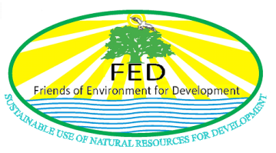
,

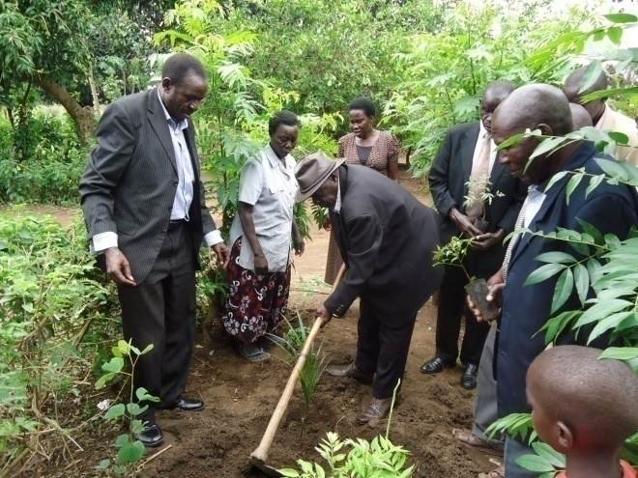
[Hon. Opio Bunga Atedero (Chairman Local Council V -Apac District) plants a palm tree at the launch of the Community Tree Planting Initiative in Agali Subcounty, Lira District in April 2011.]

BACKGROUND
Friends of Environment for (FED) is a local non-governmental organization that was formed in 2009 and registered with the ministry of internal affairs in 2010 as a company limited by gurantee under registration certificate N0 No.124535 and is registered with Lira District Local Government and is also a member of Lira NGO Forum. FED is committed to serve the under privileged communities through an intergraded approach to community development for the empowerment of the people of Northern Uganda in particular and Uganda at large.

FED is headquartered on Ayer Road, Plot 11B, Blue House (opposite Mayor’s Garden) in Lira Municipality, Lira District, Northern Uganda.
FED is run by a team of competent VOLUNTEER personnel with experience in development work, with specialties in areas of environment and natural resource management, agriculture, education, conflict resolution,
Infrastructural development, water and sanitation and HIV/AIDS.

Vision:
To live in harmony with an environment that is sustainably friendly for development and with a prosperous, food secure, healthy and economically empowered communities.

Mission:
To help unlock people’s potential so as to empower them to secure sustainable incomes, food security and improved quality of life while protecting the environment.

Core Values:
FED believes in accountability, transparency, professionalism, team work and Community participation as their guiding principles.

OBJECTIVES
- To initiate and promote sound environmental protection and management practices geared towards environmental sustainability.
- To promote modern agricultural practices amongst the rural poor communities aimed at improved production for better incomes and sustained livelihood.

- Introduction of appropriate technologies such as solar photovoltaic, biogas and rainwater harvesting geared towards rural development and transformation.

- To carry out water and sanitation programmes in support of the rural communities’ access to clean water and better health for all.

- To promote youth development and wellbeing through promotion of pro youth educational programse, employment creation and vocational and life skills in Northern Uganda.
- To empower communities through training and provision of advisory services tailored to their needs.
- To promote good governance, advocacy and networking for the sustainable development of our communities and to develop Partnerships for development and resource mobilization with other likeminded development actors.
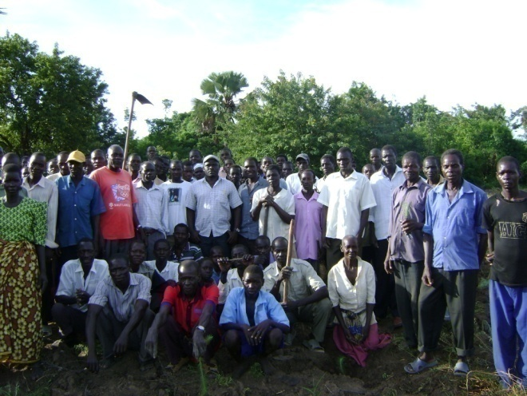
[Farmers from Okile Parish, Agali Sub county, Lira District pose for a photo after completing a training on the role of agroforestry in a changing environment in June 2012 organised by FED].

ORGANISATION STRUCTURE.
FED has an advisory board composed of 7 members who are unimpeachable characters and professionals in different fields and it reports to the general assembly. The board develops policies and gives strategic direction to the organization as well as approval of budgets, financial and audit reports, and takes on contract agreement decisions.
FED’s secretariat is run by volunteers and is headed by the Chief Executive Officer who is supported by a team of technical and support staff specialized in different disciplines relevant to its operations..

PROGRAMMES
FED’s interventions are structured under the following programs:-

1-Environment & Natural Resource Management: FED has formulated interventions that seeks to moblise communities, sensitise and create awareness on issues of environmental rights, protection and conservation, enhance the capacity of communities to build resilience towards disaster risk reduction, climate change mitigation and adaption , use of renewable energy, promote agro forestry practices and tree planting and management of other natural resources.
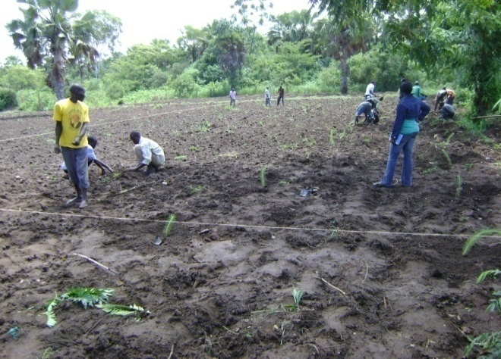
[Farmers participate in community tree planting in Abwong Village, Adyaka Parish-Lira District at one of FED’s Community Tree Demonstration Sites].

2-LIVELIHOOD (Food & Income Security): The livelihood intervention seeks to promote households food and income security for better livelihoods in the region. Our work concentrates in ensuring that communities have better access to food and income through provision of startup farm imputs, improving agronomical practices, provision of skills and knowledge in entrepreneurship, identifying, mobilizing and organizing farmers in to enterprise farmer groups, setting up farmer field schools and effectuating technology transfer, promoting kitchen gardening, mobilizing group savings.
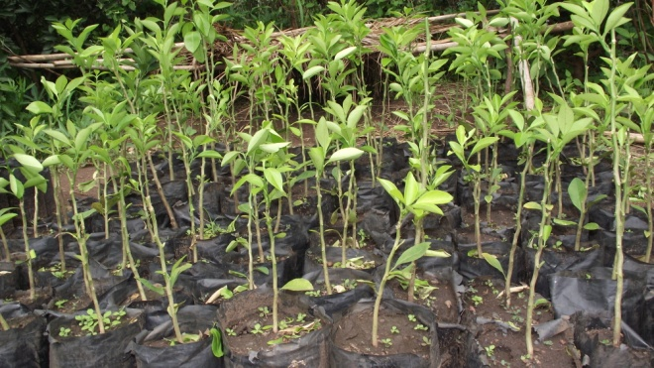
[Improved/Grafted oranges for distribution to beneficiary groups under livelihood support Project].

3-Water, Sanitation & Hygiene: FED focuses on alleviating inadequate access to Water, Sanitation and Hygiene services.

4-LOBBY & ADVOCACY: Under this intervention; FED seeks to empower communities to positively influence both local and national policies and practices towards improvement of their living conditions.

CURRENT PROJECTS:
1. Community Tree Planting Initiative- [Agali Sub County, Lira Distrcit]
This is a project that aims to restore peoples’ livelihoods and the environment. Through this initiative, the communities in Agali Subcounty, Lira District are being moblised to plant trees of different species (both fruits & woodlot) in every homestead. Everyhousedhold is encouraged to plant at least 20 trees or more in their homesteads, along boundaries and in the farms.

The Community have also been trained in basic tree planting and management, agro forestry practices and Tree Nursery Establishment and Management.
With support from the ITF, FED has so far distributed and planted over 200.000 tree seedlings in the Parishes of Alyet, Okile & Adyaka in Agali Subcounty, with a survival rate of 70%.
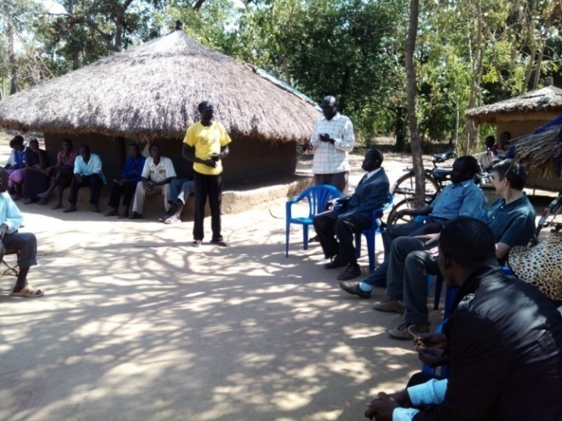
[FED ‘star farmer’, Odyang Bosco (in white) addressing a village meeting to discuss the Community Tree Planting Project with FED and ITF during a monitoring visit in Okile Parish Agali Sub county in February 2013]

PROJECTS REQUIRING FUNDING:
1. The School Orchard Project: This is an eighteen month project that aims to establish a Fruit Orchard in 10 government aided primary schools in Lira District with the objective of improving academic performance in schools by improving pupils nutritution and retention in school during class hours.
Project Cost:. : US$ 40000
Available Funds: US$ 4000
Deficit : US$ 36000

2. Enhancing Community Resilience to Combat Environmental Degradation. This is a two year project to be implemented in Agali, Aromo, Cegere & Adwari Subcounties of Lango Subregion IN Northern Uganda.
Project Cost:. : US$ 45000
Available : US$ 5000
Needed : US$ 40000
CONTACT:
The Chief Executive Officer
Friends of Environment for Development.
P.O. Box 89, Lira (U)
Tel: 256 - 0473-422237
Mob: 256 - 0753396467
E: mail: fedtrees@gmail.com
Skype: friends.environment

