EX-OFFENDER REHABILITATION AND REINTEGRATION PROJECT (ERRP)
Home
EX-OFFENDER REHABILITATION AND REINTEGRATION PROJECT (ERRP)
The Ex-Offenders Rehabilitation and Reintegration Project (ERRP) is a project currently in two correctional facilities namely Nyeri and Nanyuki prisons. It aims at helping the Ex-offenders regain their social and economic standing in the society upon their release. This is done through the involvement of the victim, the offender and the community in restorative justice approaches.
- Project Goal
- Activities
- Interventions
- Achievements
- Challenges
Project Goal
Promotion of restorative justice mechanisms to the victims and the ex-offenders for effective reintegration.
Objectives
- To enhance social reintegration of the ex-offenders and monitoring of their progress.
- To enhance economic re-integration of the ex-offenders by December 2015.
- To facilitate an effective sustainability/exit strategy for 55 beneficiaries under the programme by June 2015.
Target Beneficiaries
Ex-offenders drawn from Nyeri and Nanyuki Prison recommended through the Prison Discharge Boards.
Focus Area
Nyeri and Nanyuki Prisons.

SUCCESS STORIES
- Charity Mumbi
- Susan Wangui
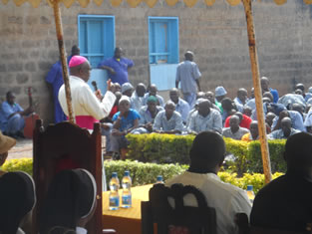
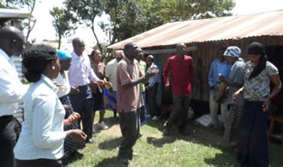
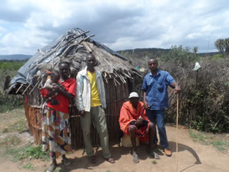
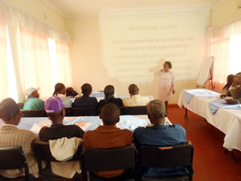

CLIMATE CHANGE ADAPTATION PROJECT
Home
CLIMATE CHANGE ADAPTATION PROJECT
This is a partnership between Fastenopfer and Caritas Nyeri. The project aims at reducing the emission of Carbon dioxide into the atmosphere – hence saving Carbon. The saved carbon will be calculated in tons and will be sold to earn carbon credits. To earn carbon credits, the project must qualify to be registered by Gold Standard – the body that regulates the voluntary carbon market.
The project has 3 lead artisans and 30 trained artisans. Each artisan is paid Kshs. 1,000/= by the beneficiary upon construction of the cook stove, 10% of this is ploughed back to the project to help the less fortunate within the same society. Construction of the stove takes a day by 1 skilled artisan and 3 unskilled laborers. A well maintained stove will last for about 10 years and saves 50% of fuel wood as compared to the traditional cook stove. Every cook stove constructed is issued with a GPS coordinate and a serial number that will be used during monitoring.
- Project Goal
- Activities
- Interventions
- Achievements
- Success Stories
Project Goal
The Project purpose is to promote and disseminate energy efficient, clean and affordable cooking technologies among households in rural communities.
Objectives
It seeks to construct 15,000 cook stoves within 7 years.
Target Beneficiaries
All members of communities in which we implement the project regardless of their religion, status, sex or race.
Focus Area
The areas of implementation are in Nyeri County and Laikipia County. The 1st phase of construction will be done in Karemeno, Mugunda, Gatarakwa, Mweiga, Mukurweini and Sirima which is in Laikipia County.
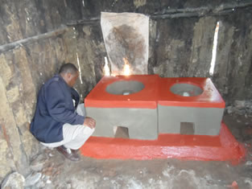
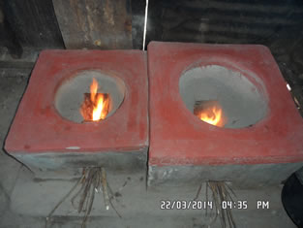
Energy Saving Rocket Cook Stove.
Benefits
- Emits Less Smoke, The Air Inlets Allow For The Circulation Of Air And The Fuel Wood Burns Effectively Thus Reducing Respiratory Related Diseases.
- Cooks Faster, The Technology It Uses Ensures That Heat Is Not Lost To The Sorrounding And It Is Directed At The Cooking Pot.
- Retains Heat For Longer Periods, The Technology It Uses Ensures That Heat Is Retained In The Stove.
- Safe; Reduces Fire Related Accidents In The Kitchen, Firewood Burns Inside The Combustion Chamber And The Fuel Magazine Holds The Firewood Making Sure It Does Burn Out Of The Stove.
- Hygenic; Reduces Cases Of Food Contamination. Ash And Dirt From The Kitchen Floor Cannot Contaminate The Food Since The Cooking Pot Is Enclosed.
- Easy To Clean And Maintain.
- Durable For 7 Years.

DISASTER MITIGATION & REHABILITATION PROJECT (DMRP II)
Home
DISASTER MITIGATION & REHABILITATION PROJECT (DMRP II)
DMRP II Project started in August 2014 and will run till July 2015. The Project is being implemented in Tigithi Location, Laikipia East Sub-County in Laikipia County. Caritas Nyeri is implementing the project with support from Caritas Germany.
The aim of the project is to assist members of 500 households who are poor and vulnerable to build resilience to frequent drought by mobilizing them to adopt practical drought mitigation and adaptation initiatives.
- Project Goal
- Activities
- Interventions
- Results
- Achievements
- Challenges
- Success Stories
Project Goal
Self sufficiency in food and income generation for 500 project beneficiary households in Tigithi location by July 2015.
Objectives
- Promotion of Drought Escaping Crops (DEC’s) by free provision of seeds of suitable and zone specific crops to project beneficiaries for on farm establishment to achieve 100% adoption by the end of the project period.
- Rain water harvesting: We mobilize individuals and groups to excavate and construct 500 farm ponds and then we provide 32,000 M2 dam lining material to 500 beneficiaries. We encourage all the beneficiaries to establish kitchen gardens under micro irrigation in each of the project beneficiaries’ homesteads
- Enterprise diversification by promoting pasture establishment and rearing of KARI kienyeji chicken.
Target Beneficiaries
Households who are poor and vulnerable.
Focus Area
Tigithi Location, Laikipia East Sub-County in Laikipia County.
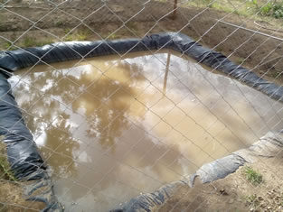
Beauty Wairumus’ Farm pond in Male Village Tigithi. The farm pond is for harvesting of water for the Kitchen Garden.

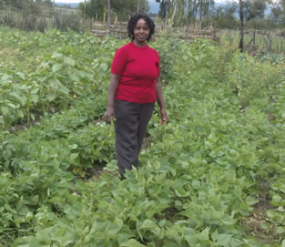
Dolichos Lablam (Njahi) plants in Mrs. Ann Wairimus’ home in Ichuga D
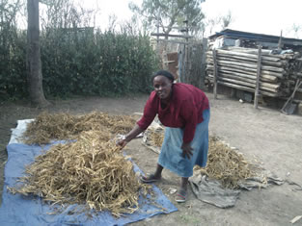
Madam Lucy Kinyua displaying her harvested ready to be threshed B9 beans

RURAL WATER PROGRAMME
Home
RURAL WATER PROGRAMME
The current programme covers a period of 3 years up from January 2012 to December 2014.
- Project Goal
- Activities
- Interventions
- Achievements
Project Goal
The project contributes to improving the general living conditions and the health and hygiene status of the local population and their livestock in the predominantly semiarid catchment area of the Archdiocese of Nyeri
Objectives
- The supply of the target group with safe water has been ensured. About 4,700 people living in the rural areas of the Archdiocese of Nyeri use safe water.
- The incidences of water related diseases have been reduced. The communities participating in the project register fewer cases of illness in their families.
- The self management of water sources and installations has been improved. The project participants in charge have a better knowledge of water economics and management. They know all operational procedures and are able to do maintenance work.
- The water procurement has become much easier for women and children.
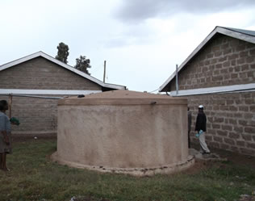
Institution rainwater storage tank at Narumoru secondary school
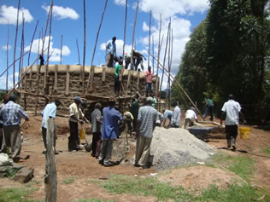
Community members participation in construction of a water tank.
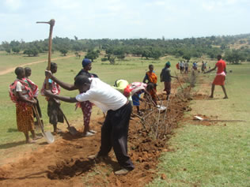
Beneficiaries of the water project participate in digging trenches to Lay pipes for a gravity flow water project.

COMMUNITY PREVENTION WITH POSITIVES (CPWP)
Home
COMMUNITY PREVENTION WITH POSITIVES (CPWP)
Community Prevention with Positives (CPwP) and Orphans and Vulnerable Children (OVC) program is one of major programs at Caritas funded by USAID through Aphia plus. The project mainly deals with people living with HIV, the infected and affected and children from the households while addressing social determinants of health.
The program entered its 2nd phase in the year 2011 from APHIA II to APHIA plus and will exit in September 2015. The program works with trained Community Health Workers (CHW) to provide services through support groups.
Currently, the program supports 3511 PLHIV and 6100 OVCs in 2,155 households.
- Project Goal
- Activities
- Interventions
Project Goal
The goal of the program is to minimize suffering of people infected and affected by HIV/AIDS by providing palliative care and support services and OVCs in their households ensuring sustainability at all levels.
Objectives
- To provide quality home and community based care to 3500 PLHIV and their families in Laikipia County.
- To provide integrated and comprehensive care and support services to 6000 OVCs in Laikipia County.
- To integrate social determinants of health within the HCBC/OVC program in line with the USAID implementation plan.
Target Beneficiaries
- The project targets PLHIV (People living with HIV) and OVC
- Orphans and vulnerable children from the households (Infected and affected).
Focus Area
The project draws its beneficiaries in Laikipia East, Central and North Sub-Counties.
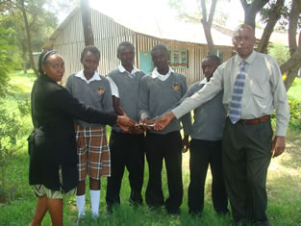
provision of school fees to secondary schools students

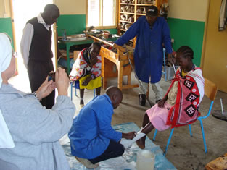
OVC treatment

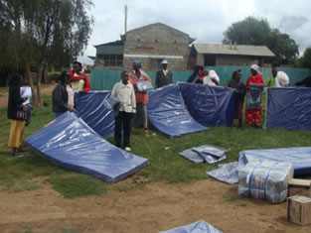
provision of beddings

KEURIG-SMALLHOLDER COFFEE LIVELIHOODS DIVERSIFICATION PROJECT
Home
KEURIG-SMALLHOLDER COFFEE LIVELIHOODS DIVERSIFICATION PROJECT
Coffee livelihoods diversification project is funded by an American company by the name Keurig Inc. this company buys coffee from Kenya, Ethiopia and Rwanda. In Kenya, the focus area is Mukurweini Sub-county in Nyeri County in 5 locations namely Muhito, Githi, Rutune, Giathugu and Gikondi. The project however ventured into Thanu and Gakindu locations recently with a component on Saving and internal lending communities (SILC). All target beneficiaries are small holder coffee farmers.
The project started in June 2010 targeting 1000 farmers and later expanded by targeting an extra 500 beneficiaries in the year 2011. The current direct beneficiaries stand at 1500 and 18000 indirect beneficiaries.
- Project Goal
- Activities
- Achievements
- Challenges
Project Goal
The livelihoods of vulnerable smallholder coffee growing households in Nyeri County of Kenya improved.
Objectives
- 1,500 vulnerable smallholder coffee growing households have increased their food security.
- 1,500 vulnerable smallholder coffee growing households have increased their access to financial services.
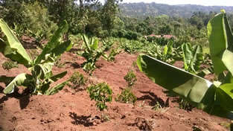
coffee banana intercrop démonstration Garden at Karuoro
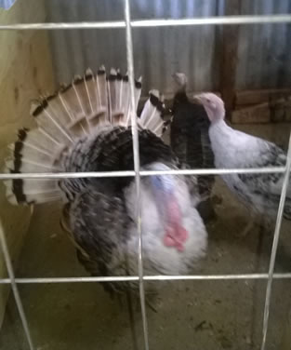
enterprise diversification using loan from SILC

