AWAZ-E-ROOH NGO 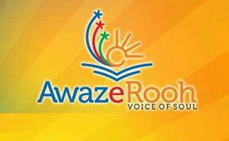

For Health, education and Human Rights.
INTRODUCTION:
AWAAZEROOH NGO is started on, 26th September, 2011, for the Welfare of the local people. The NGO got its permanent registration in JUNE 2012.
- Location:
Jhang Syedan is an area consisted of ( ) residents. There are three categories of people living here, who are migrated from the villages of Pakistan. Most of them belongs from tribal areas, Gilgit Baltistan and Kashmir. some people belongs to high class some middle and some lower class, but the high and middle class have their good source of earning, but the lower class who is the most sensitive class have no proper source of income and they are working on daily wages. They have no proper residence they are living in huts without the facility of gas and electricity, and proper sanitation. There are ( )schools English and Urdu medium, private and government and the ratio of school going children are 65%.35% children were deprived from education, however many organizations are working.
Awaz-e-rooh NGO took imitative and started here a project on education on 26 September 2011.initially it was difficult to gather the children on one platform but ;later on with the help of AWARENESS PROGRAMMES it was easy to convince and persuade the parents to let their child be educate. As the children were begging and doing some work to earn as a income source and after two years we get the response that students have now ability to communicate with others and they know their rights and becomes civilized.
- MISSION STATEMENT:
We will save you, educate you, and fight for you.
- VISSION STATEMENT:
A healthy, educated and peaceful world.

ANSAR SCHOOL SYSTEM:
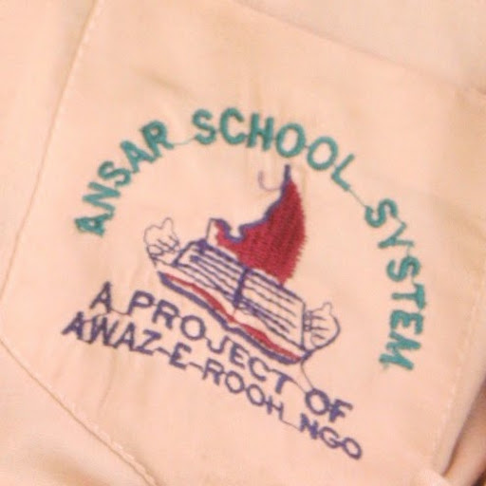
Awaaz-e-rooh NGO is Running ANSAR SCHOOL SYSTEM free of cost for the welfare of poor and needy students. It is registered from PIERA. The main purpose of the school is to provide education to the deserving students. Most of the students in the school are freed from childhood labor like paper picker, beggars etc.
The School was started by President of NGO Mrs. Sajida Haroon on SELF finance. The School Was started on 26TH September, 2011.There is 81 students that are currently studying. THE SCHOOL focuses on the confidence & nature building of the students, so that they can get a reputable position in future. We are giving them confidence to make this nation peaceful. The school has three class rooms and a central Staff room. The school has plastic chairs and white boards.
- 2 bath rooms
- 50 chairs
- 3 fans
- 6 seater sofa set
- 4 tables and 8 staff chairs
- Water cooler

The NGO is providing free Uniform to the students. The NGO conduct several workshops and create awareness among the parents about the need of education for their future life and save them from Childhood labor. The School is getting free books from PEERA that are distributed among the students. There are 6 teachers, a Principal and a working woman that are currently running the school. The Students belong from the labor families who are unable to earn the daily livelihood. The school also arranges several adventurous and educational trips for the mental relaxation of the students.
The NGO is also providing free food items to the student families so that they can remain free from Childhood labor.
AIM
Our aim is to facilitate the students and make them civilized, and a responsible citizen who know their rights.
- Location :
The location of school is Ansar school system, lehtrar road, jhung syedan commercial area Islamabad.
Contact no: 0092-51-2618277
AWAZ E ROOH FREE VOCATIONAL INSTITUTE: 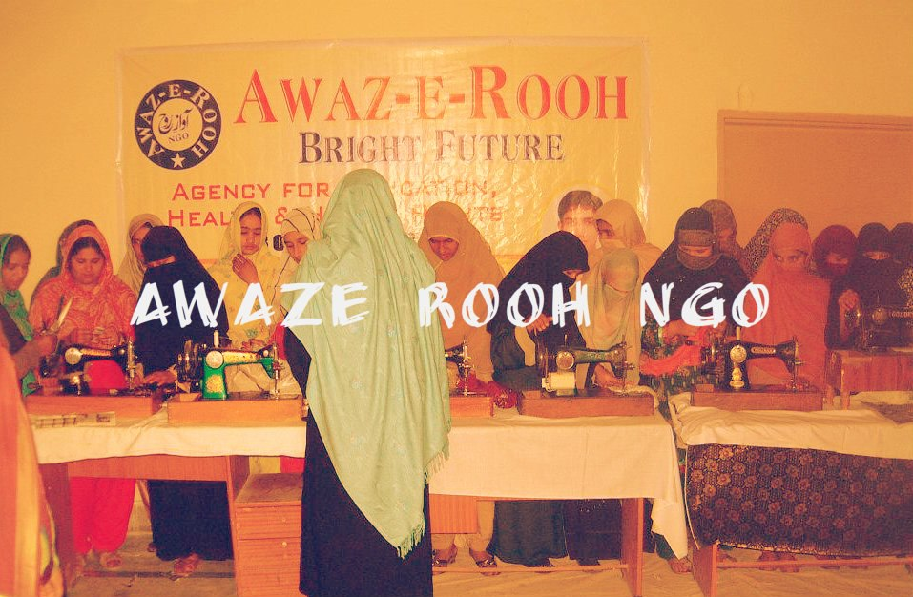

Awaz-e-rooh NGO is running FREE VOCATIONAL INSTITUTE for the welfare of poor and needy Women. The main purpose of the centre is to provide Stitching, beauty and other courses to the deserving women.
The Centre was started on 26th September, 2011.Near about 150 women had completed the training from AWAZEROOH,and the current strength of institute is 50%. We are giving them confidence to earn their own livelihood. The centre has 2 rooms and 3 Teachers.

