**HOPE FOR WORKING CHILDREN AND YOUTH (HWCY) IN PARTNERSHIP WITH UGANDA YOUTH NETWORK (UYONET)**

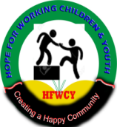 

**ACTIVITY REPORT**

**ON**

**COMMUNITY OUTREACH**

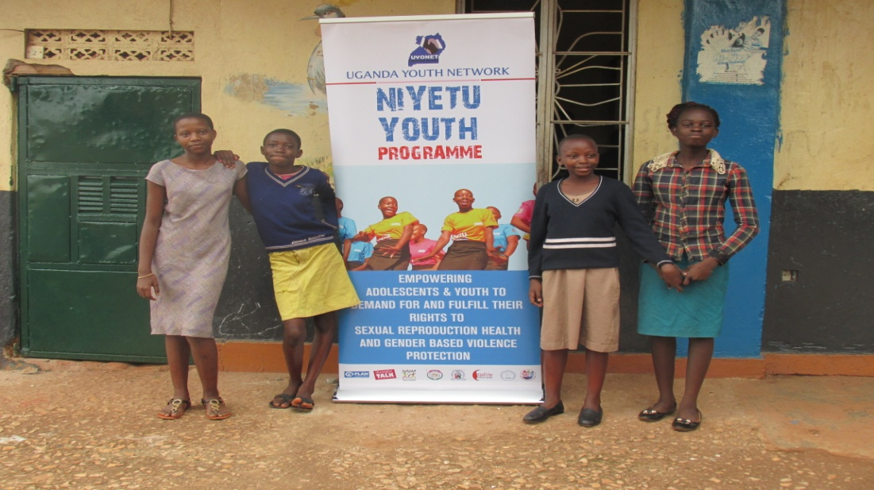

***12th/JUNE/2017.***

**ACRONYMS.**

|  |  |
| --- | --- |
| **HIV** | **Human Immune Virus** |
| **AIDS** | **Acquired Immunodeficiency Virus** |
| **STDs** | **Sexually Transmitted Diseases.** |
| **STIs** | **Sexually Transmitted Infections** |
| **HCT** | **HIV Counselling Testing** |
| **IEC** | **Information Education and Communication** |
| **KYADNET** | **Kampala Youth Advocacy and Development Network** |
| **HWCY** | **Hope for Working children and youth.** |
| **NTIHC** | **Naguru Teenage Information and Health Centre.** |
| **ASRHR** | **Adolescent Sexual Reproductive Health Rights** |
| **FGDs** | **Focussed Group Discussions.** |
| **MARPs** | **Most at Risk Populations** |
|  |  |
|  |  |
|  |  |

**Background of the activity.**

Given the high rate of HIV infection rates among the young people, Hope for working children and youth in partnership with Uganda Youth Network (UYONET) with financial support from World Vision Uganda (WVU) and Australian Aid organized a community outreach in Mbuya II parish, Nakawa division, Kampala district, this zone is a hub to children, youth and single young mothers. This zone surrounded by the slum of Bikere, Kitintale is characterised by drug/alcohol consumption, commercial sex i.e. “sex in exchange for money” due to unemployment among the youth. This poses great risks to the community and the young people residing in here given community due to the high rate of unemployment and vulnerability. In a bid to bring about positive behaviour change among adolescents and young people in Mbuya zone II, we developed the idea to conduct a massive a community outreach in the zone that would entail different activities. We also looked at taking services closer to the community so that the youth can feel free to interact and ask pressing questions where need be. This engagement would also give us a platform to fully engage our partners as a community based organization (CBO) and be able to report on actual to Uganda Youth Network (UYONET) and World Vision Uganda (WVU). We organised this in a bid to also popularise the **“UPLIFT”** youth program.

**Activity Objective.**

The objective of this activity was to extend sexual reproductive health services and information to the youth in Mbuya zone II and the surrounding communities of Mutungo, Bikere and Gizagiza.

**Target Beneficiaries.**

This activity targeted youth of productive age between the ages of 13 to 25 both in and out of school.

**Activity Expectations.**

This activity is meant to create awareness among the youth in the community through sensitization, distribution of IEC materials. These activities are also intended to bring about mind set change among the youth and bring about positive behaviour change this we believe will bring about better and improved communities and good future leaders. This activity is also meant to connect World Vision Uganda (WVU), UYONET and HWCY.

**Description of the activity.**

The above activity was held on the 12th/June/2017 at Mbuya II complex in Mbuya Kinawataka. This activity was organised by Hope for working children and youth (HWCY) a community based organization (CBO) in partnership with Uganda Youth Network (UYONET) with funding from Australian Aid and World Vision Uganda (WVU).We also partnered with other service providers like Naguru Teenage Health and Information Centre (NTHIC) who supported the activity. The activity successfully started at 09:00 a.m. with a mobilization drive around Mbuya and Kitintale to inform the community about the activity and was done by Naguru Teenage Centre in partnership with Hope for Working children and youth (HWCY) and was able to meet its set objective.

The above activity had sub activities which included but were not limited to;

* HIV counselling and testing.
* Health information talks.
* I.E.C distribution.
* Condom distribution.
* Focussed group discussions (FGDs).

**Total Beneficiaries.**

|  |  |  |  |
| --- | --- | --- | --- |
| **CATEGORY** | **MALE** | **FEMALE** | **TOTALS** |
| 0-14 Years |  |  |  |
| 15-19 Years | 05 | 03 | 08 |
| 20-24 Years | 20 | 25 | 45 |
| 25 and Above | 11 | 06 | 17 |
| **Sub-total** | | | **70** |
|  |  |  |  |
| **STATUSES** |  |  |  |
| HIV Positive | | | **00** |
| HIV Negative | | | **70** |
| Condoms distributed |  |  | **5,000** |
| I.E.C Distributed |  |  | **2,000** |

**Challenges Encountered.**

There was poor turn up by the targeted beneficiaries who were the youth and thus the activity did not meet its expectation of 100 people getting tested

The activity started a bit late which was 11:30 a.m. instead of the intended 09:00 a.m.

**Key learning’s.**

There is need for partners like Uganda Youth Network (UYONET) and World Vision Uganda (WVU) to provide more financial support to community rooted community based organizations (CBOs) so that services are easily trickled down to the community beneficiaries.

The activity was very successful and greatly supported by the youth and thus there is need for World Vision Uganda (WVU) and UYONET to plan on having at least one of the same activities per quarter so as to extend services to adolescents in the community.

**Other UYONET staff and political leaders attending.**

To ensure success of this community outreach we (Hope for working children and youth) worked closely with the Uganda Youth Network (UYONET) staff Penniel Rwendeire and Allan the male youth councillor for Nakawa Division who also graced the occasion..

**Facilitators.**

This activity was coordinated by Mr. Okiror James the E.D Hope for working children and youth together with his team i.e. Mr. Osede Martin and Okwalinga George. We also had the youth from the post-test club of Naguru Teenage Health and Information Centre (NTHIC) talking to the youth about the dangers of HIV/AIDS and positive behaviour change.

**Conclusion.**

In conclusion the activity is very good and directly youth engaging and thus there is need for more of the above so that we are able to further our aspirations for the youth and achieve our objectives in the line of Adolescent Sexual Reproductive Health and Rights (ASRHR) as KYADNET and UYONET. There is need for us to plan at least one of the kind every quarter because such activities also help us reduce on risky behaviours among the Most at Risk Populations (MARPs) who are the youth in this case and thus need for more of these community engagements.

**Report was prepared by:** Mr. Okiror James. **Signature:** ……………….**Date:**………………….

**Report reviewed and approved by:** _________________ Signature _______________ Date ___________

**Annex 1:** List of participants with:

Designation, sex, address, phone number, e mail:

See attached lists.

**Annex II:** Attach at least 5 photos of taken during this activity and if possible with 2 – 3 quotes from participants about the activity.

**ACTIVITY PHOTOS.**