EGLISE BAPTISTE

de GUINEE

PROJECT TITLE

EDUCATIONAL DEVELOPMENT

IMPLEMENTATION BODY

EGLISE BAPTISTE de GUINEEE

TYPE OF PROJECT
PRE-SCHOOL
PROJECT AREA
THE PROJECT WILL BE UNDERTAKEN IN KANSI-YIRAY, ISLAND OF KAKOSSA
CONTACT PERSON
Rev. JAMES .B. KHANU,
ginibaptiste@yahoo.com jameskhanu@Yahoo.com
BP 4652, Conakry, Guinea
Tel. +224 64598223 / 60594157 / 67598223
INTRODUCTION
The Eglise Baptiste de Guinée is an indigenous registered Non Governmental organization. It has been in existence for more than ten years. We are working in two islands of Kaback and Kakossa through our social and development arm (which aims at relieving pain, suffering and poverty by promoting children ministry, education, community development, HIV/AIDS assistance and prevention and Agriculture through partnership and or assistance.
The population of Kakossa is thirty six (3600) thousand inhabitants of which fourteen thousand (14000) are women, nine thousand (9000) are men. Children are about eighteen thousand (18000) ages 1-6 are about 5000.
The main economic activities of the parents of the target group are small scale manual farming and fish mongering which is prevalent among the women. Most women seek their livelihood through petty trading of assorted commodities.
Because of the poor performance of the country’s economy, the returns from their economic activities are inadequate to sustain or satisfy their wants. This coupled with large family sizes (about ten per family) majority are poor, illiterate living under poor housing and sanitation conditions and poor health facilities.
The majority of the parents of these kids (about 80%) were not sent to school so they disregard academic education for their children (boys as well as girls)
I remember introducing the idea of the village school to them and one man said “we are all here illiterates if our children follow in our steps we will all be in darkness but how? “You can hear the responses and applauds of all the others as they totally agree with him for the start of the now village school which we set up in the village of Kansi-yiray as you can see photo.
As photos can show it is this “HOW” that we are trying to address that together we brought up the idea to erect the coconut tree house school this year and successfully have seventy kids for a start. There are still more than twice this amount of children in the village who want to come if only we could get them places to sit this year.
As photos show, the rainy season has caused us immense trouble to end the school year 2009/2010. It is with these difficulties and sleepless nights of thoughts as to how to combat the end of year activities that I am putting forward this project for a four (4) classroom building from now to the start of the next academic school year which starts first week in October 2010.
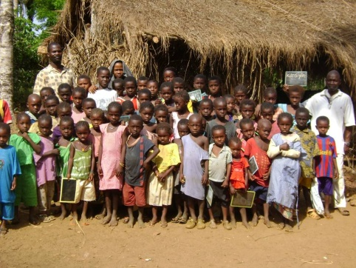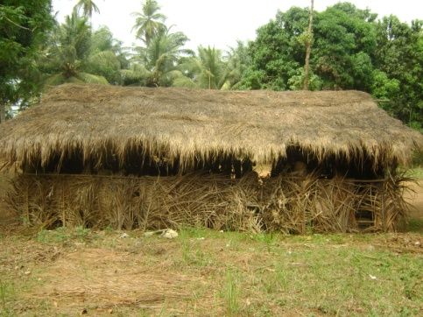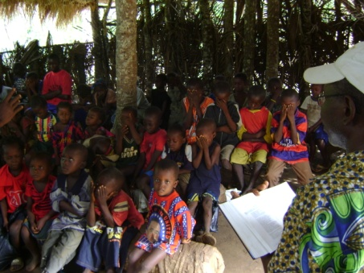
BACKGROUND
“You educate a woman you educate a nation”
“The output of a nation depends on the kind of education they received”
“Tant vaux l’éducation tant vaux la nation ”
The nation of Guinea can only boast of 3 out 10 of its population to be literate even though the idea of free education exists.
Education could be free but if it is of no value it is useless. The system of education in Guinea is very poor. There is no West African state to which you can compare our system of education especially among the French speaking West African states. I do not need to mention any English speaking West African country for that matter.
BENEFICIARIES
- Impoverished children
- Guinean children

We have adopted the Brazilian based children school system called “PEPE”. We are working in collaboration with the Coordinator/Representative in Conakry – Guinea to improve the lives of the poor by offering this rich practical schooling system to the remotest villages so that with your help and support we can together make elites from these villages who one day will bring development and progress to these people which will make life better for the future generation.
PEPE is a local pre-school education program, and it provides training and curriculum support from PEPE-Network, Brazil. It benefits children from deprived communities who would otherwise not be able to afford pre-school education, and would therefore find it very difficult to enter the local education system with any chance of success.
VISION: These children have the chance to enjoy an educational preparation that stimulates their best social and spiritual development, irrespective of any social and economic disadvantages.
Children enrolled on the program will benefit from a two years pre-school education. (Two years before they go to Primary school) usually when they are 4 or 5 years old.
Kansi yiray Pre-school is run from Monday to Friday in the morning. Each school day lasts for approximately (3) three to five (5) hours.
- A well coordinated and institutionalized atmosphere of understanding will be instituted between the teachers and the parent’s body.
- A conducive learning environment will be established for the pupils and parents.
- Moral education will be taught and impacted into the pupils.
- Bringing quality education to the most remote parts of Guinea where the government is not considering of any importance.

ACTIVITIES
Kansi yiray Pre-school curriculum is based on the national curriculum in Guinea. All the activities are developed in an integrated way. They include language, nature and society, music, Visual arts, movement and mathematics.

Attached is an estimated cost of the needed building materials to start and complete this building with tables and desks before the first week in October 2010.
Nº | DESCRIPTION | QUANTITY | PRICE | AMOUNT
 | FOUNDATION
1 | Beams Corrugated steel rod Diam. ½” | 30 | 78000 | 2340000
2 | Beams Corrugated steel rod Diam. ¼” | 16 | 25000 | 400000
3 | Cement | 59 | 70000 | 4130000
4 | Sand M³ | 12 | 120000 | 1440000
5 | Granite M³ | 10 | 185000 | 1850000
6 | Water M³ | 16 | 50000 | 800000
7 | Pillar Corrugated steel rod Diam. ½” | 12 | 64000 | 768000
 |  |  |  | 11728000
1 | BLOCK WORK
2 | Bricks | 3200 | 3500 | 11200000
3 | Sand M³ | 14 | 120000 | 1680000
 | Cement (Bags) | 140 | 70000 | 9800000
 |  |  |  | 22680000
1 | STEELWORK STRUCTURE
2 | Lintels and doors Diameter ½” | 12 | 78000 | 936000
3 | Tie beams diameter ½” | 30 | 78000 | 2340000
4 | Lintels and doors diameter ¼” | 11 | 25000 | 275000
 | Tie beams diameter ¼” | 6 | 25000 | 150000
 | Sand M³ | 22 | 120000 | 2640000
 | Cement (Bags) | 24 | 70000 | 1680000
 | Granite M³ | 15 | 185000 | 2775000
 |  |  |  | 10796000
1 | ROOF
2 | Zincs | 120 | 75000 | 9000000
3 | Rafters | 38 | 35000 | 1330000
4 | Pollens | 98 | 20000 | 1960000
5 | Ordinary Nails | 12 | 10000 | 120000
6 | Roofing Nails | 5 | 35000 | 175000
 | Transportation |  |  | 800000
 |  |  |  | 13385000
1 | FURNITURE
2 | Desks | 30 | 130000 | 3900000
3 | Benches | 30 | 105000 | 3150000
4 | Teacher's table | 3 | 150000 | 450000
5 | Teacher's chair | 3 | 85000 | 255000
6 | Blackboard | 3 | 80000 | 240000
 | Chalk | 40 | 7000 | 280000
 |  |  |  | 8275000
1 | FINISHING
2 | Windows | 11 | 350000 | 3850000
3 | Doors | 3 | 300000 | 900000
4 | Ceiling Hard boards | 26 | 45000 | 1170000
5 | Cover strips | 100 | 4500 | 450000
6 |  |  |  | 6370000
7 | PAINTS
8 | Interior Oil base | 200 | 25000 | 5000000
9 | Doors and windows oil base | 14 | 25000 | 350000
10 | Exterior water base (Liters) | 120 | 9500 | 1140000
11 | Ceiling Emulsion Paint water base | 40 | 9500 | 380000
 |  |  |  | 6870000
1 | TOTALS |  |  | 80104000
2 | LABOR |  |  | 15031200
3 | GRAND TOTAL |  |  | 95135200
 | TOTAL |  | 500 FG | $19,027:04
Estimate for a four classroom kindergarten school
6.50 M wide X 18.50M long at Kakossa is at Ninety five Millions one hundred and thirty five thousand two hundred Franc Guinéens.
 | Ninteen thousand and and twenty seven dollars four cents

Let me quickly state that though the Island is composed of very poor people, yet the church has already put in place a system of receiving school fees for these kids through their parents by paying in commodities such as: ground nuts, cleaned rice etc. For example: a kilo of rice per child per month is very minimal but at least we will complete it and try to pay all the Teachers every month as we and the parents cooperate to bring the light of education to this our beloved nation in this village.
Our priority is to give them free primary school education where it would have been possible. As time goes on we will be seeking donors or foundations that will help us pay the Teachers their salaries.
Sir, we hereby look forward to your approval of this project as we together help humanity again at this crucial time of need.

Faithfully submitted

Rev. James B. KHANU

