HEDECS

ANNUAL PICTORIAL REPORT OF THE DIVERSION PROGRAMME

JANUARY 2015-DECEMBER 2015
Part 1

PROJECT LAUNCH

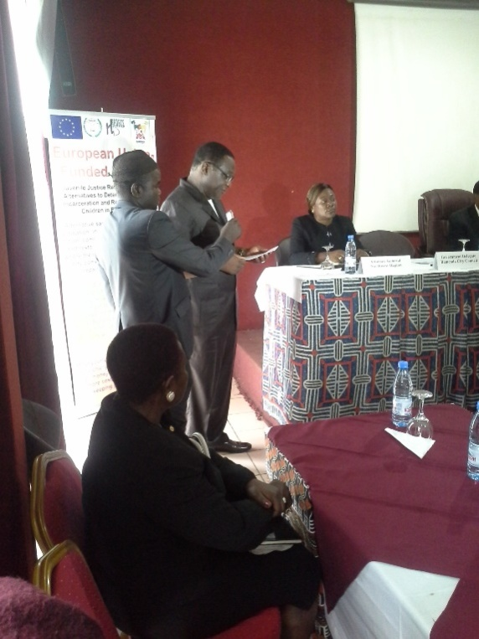
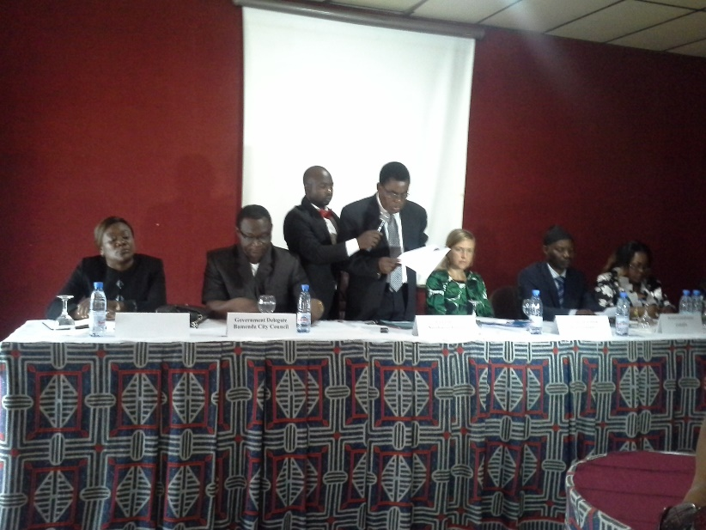

NW Governor’s representative lunches the project BCCGovernment Delegates affirms project

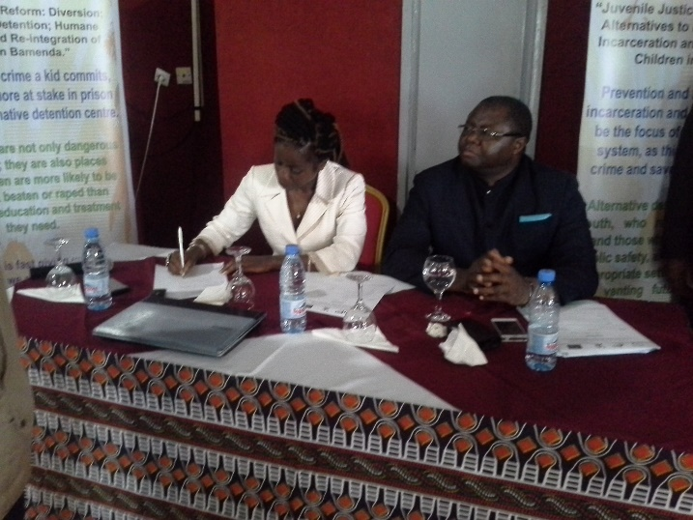
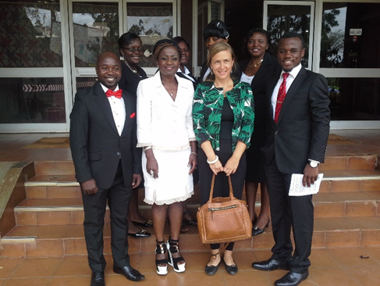

Ms Bolima Nancy (HEDECS), Mr Waindim Jude (BCC) The Diversion team pose with Mme
follow the speeches keenly Anne-Charlotte Sallman of the EU

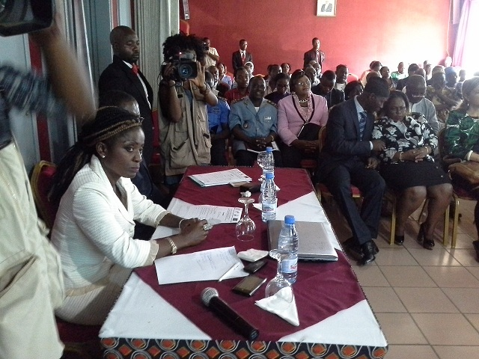
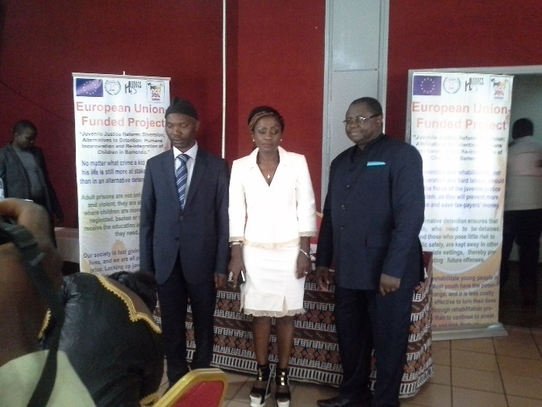

Mr. Chongsi (CHRAPA) Ms Bolima (HEDECS) Participants follow keenly the presentation
Mr Waindim (BCC) pose at the lunching on the entire project
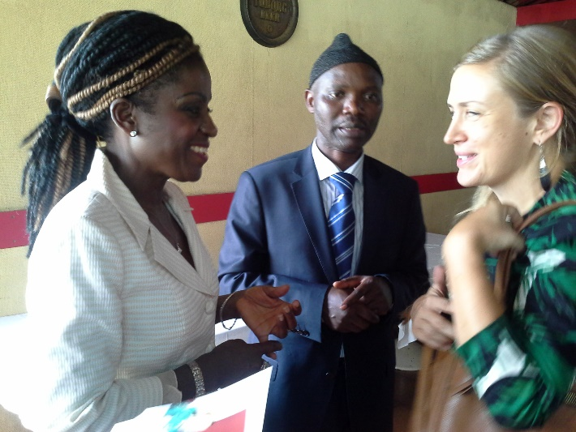

Ms Bolima (HEDECS) and Mr Chongsi (CHRAPA) discuss
on the side-line with Mme Anne- Charlotte Sallman of the EU

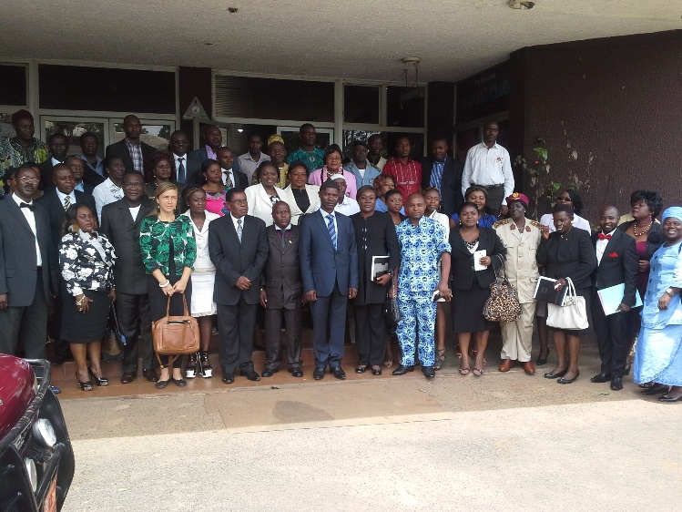

Participants at the lunch pose with the Governor’s Representative

DIVERSION TRAINING BY NICRO FROM SOUTH AFRICA
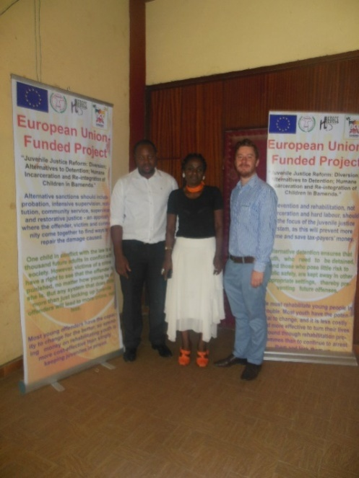

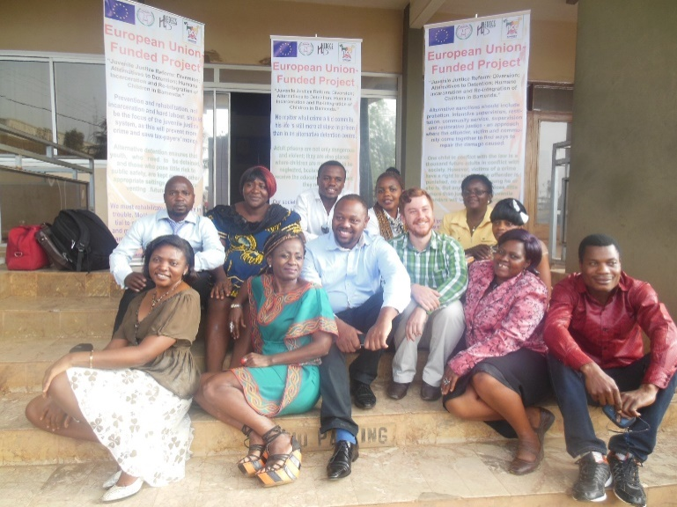

Trainers pose with trainees at end of workshop
Diversion Manager pose with Diversion NICRO trainers
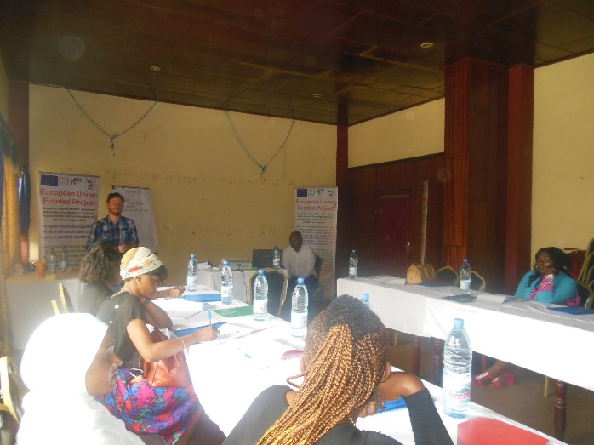
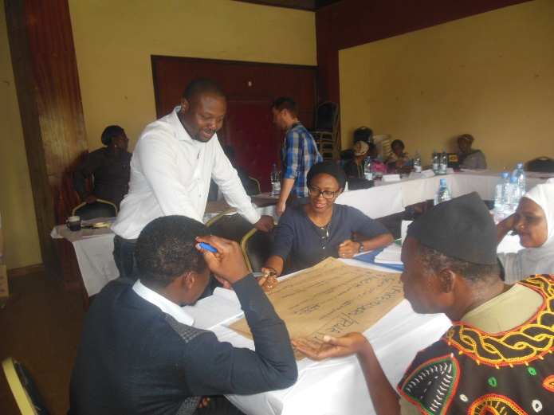

Diversion Training in process
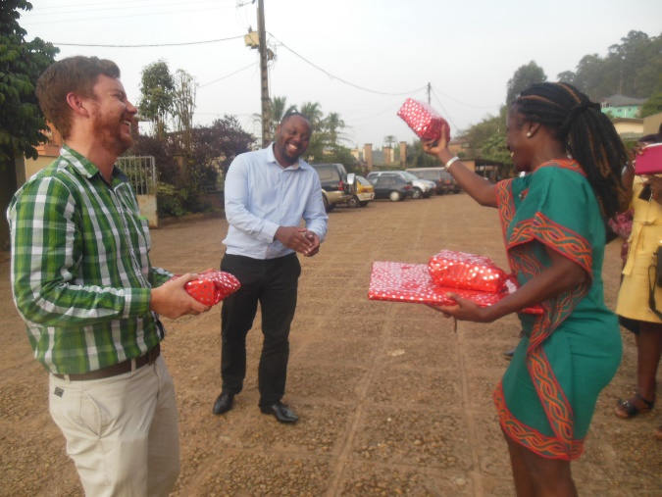
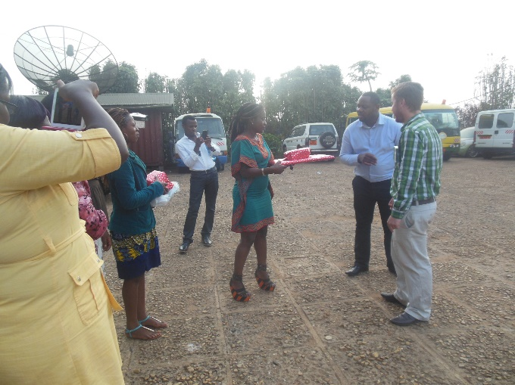

Diversion Manager offer gifts of appreciation to the NICRO Trainers
DIVERSION TEAM AT OFFICE ACTIVITIES (DEVELOPMENT OF TOOLS, BRAINSTORMING, MEETINGS, INHOUSE TRAININGS)
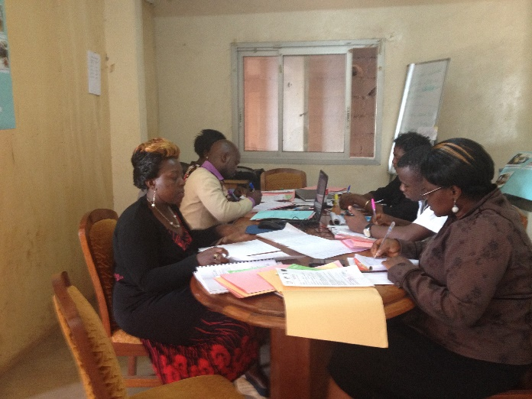
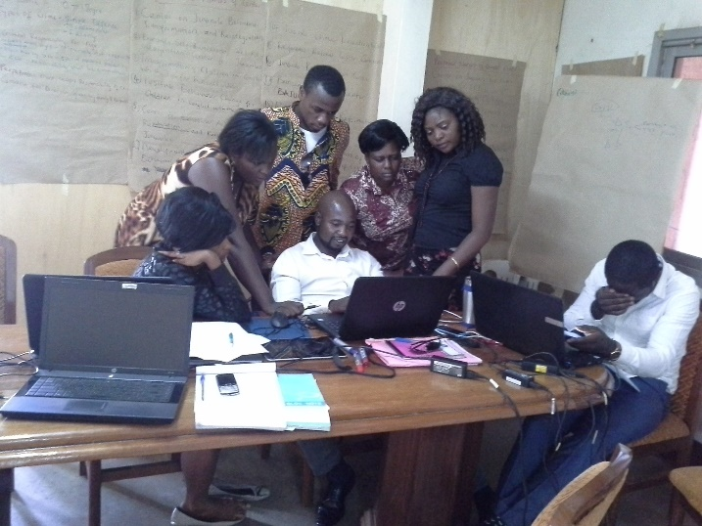

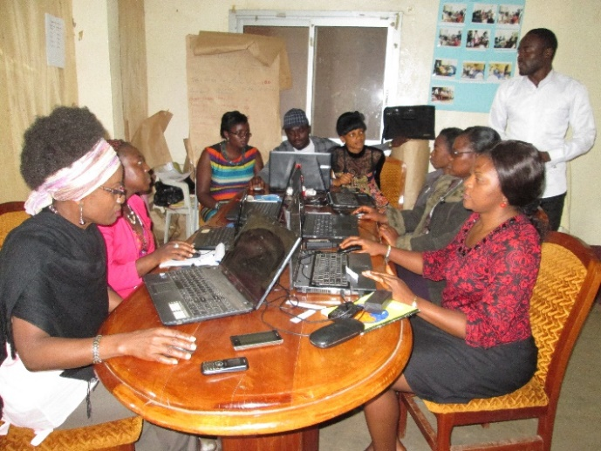
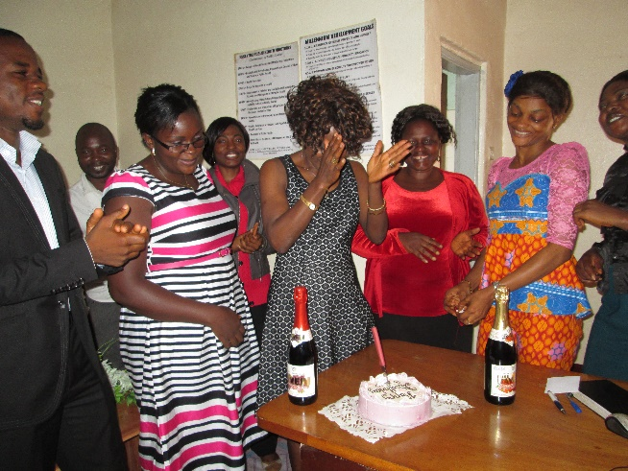

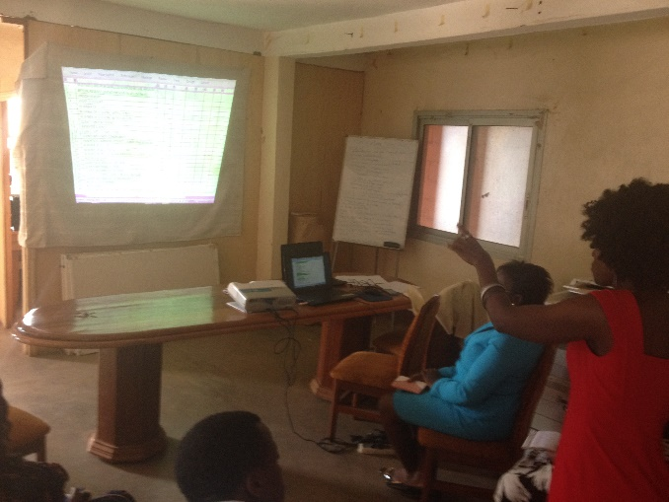
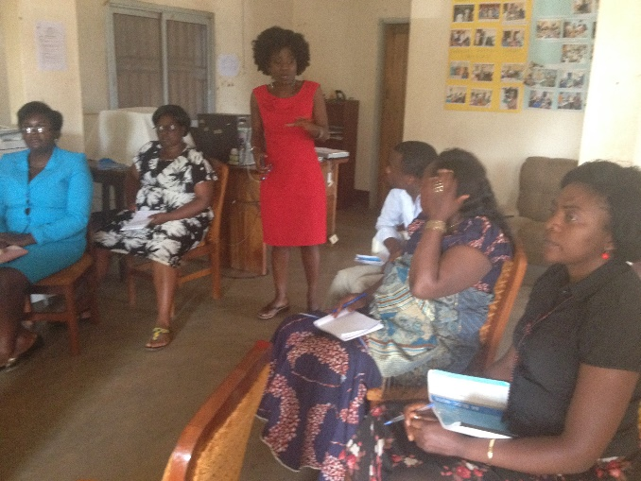

FOLLOW UP OF CLIENTS AT PLACEMENT SITES

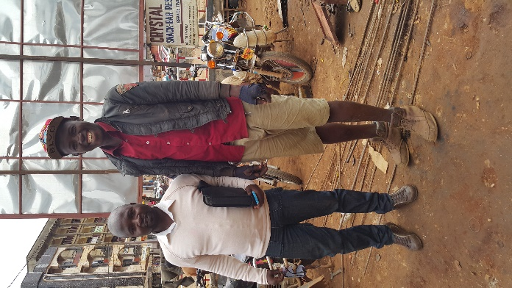
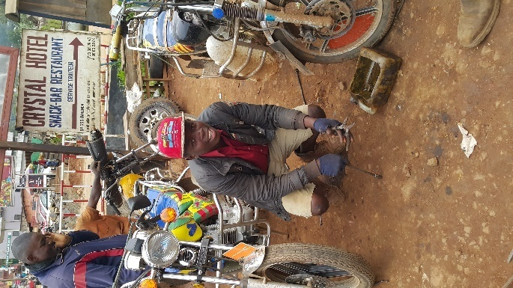

Counselor/Psychologist and Community Service Staff follow up client at placement site

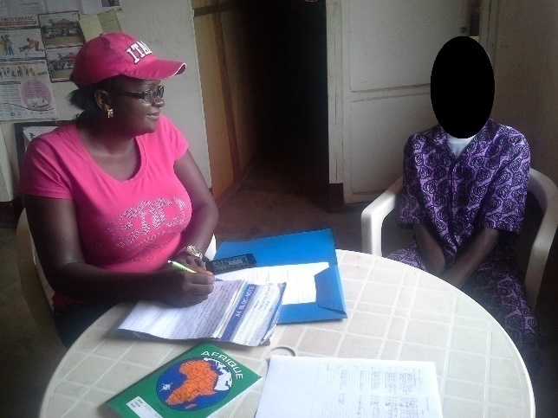
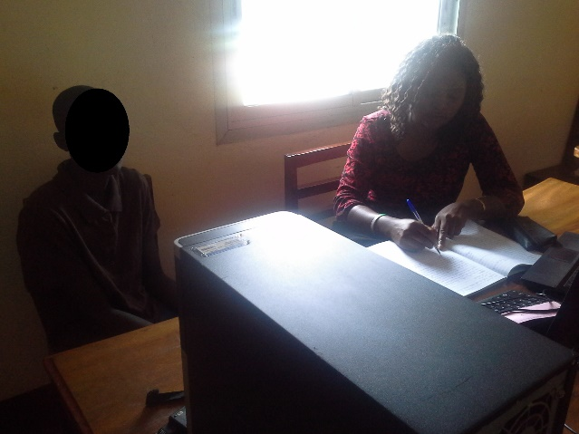

Counseling sessions in process
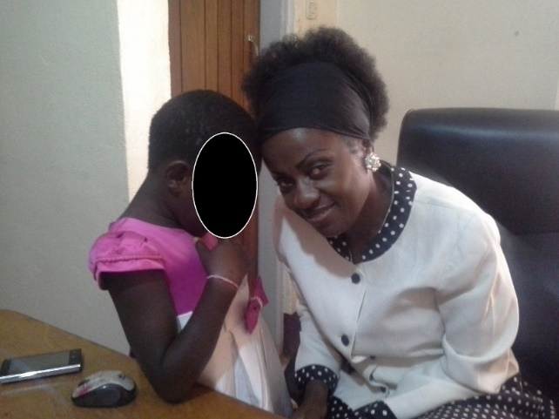
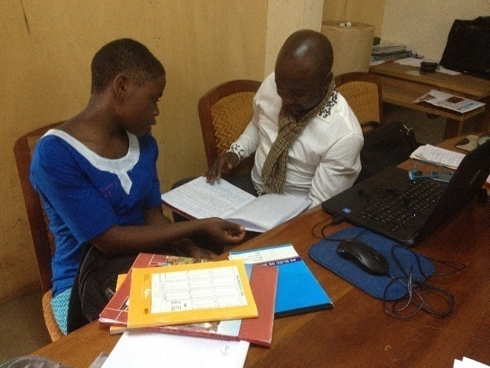

Community Service Staff continuous Bonding of Diversion Manager and Victim
follow up of client who was assaulted

MEDIA
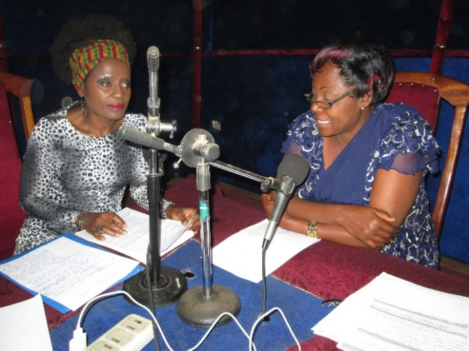
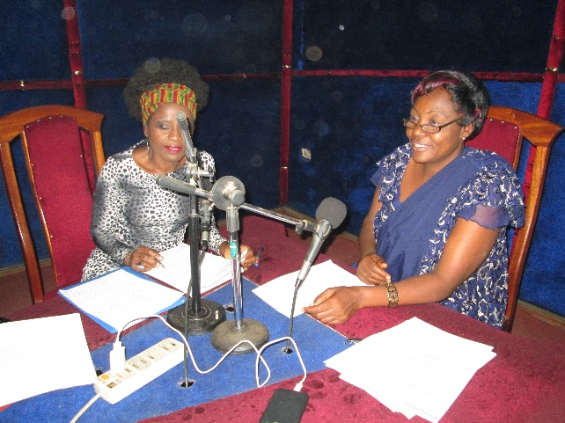

Diversion Manager at the media on Diversion
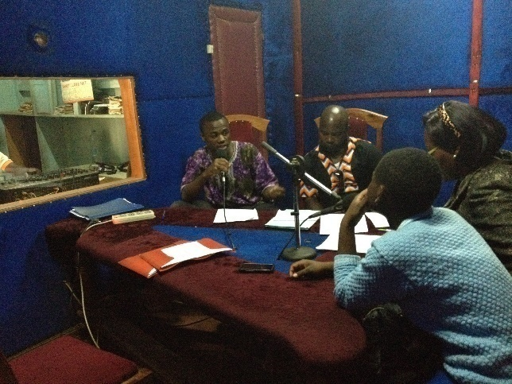
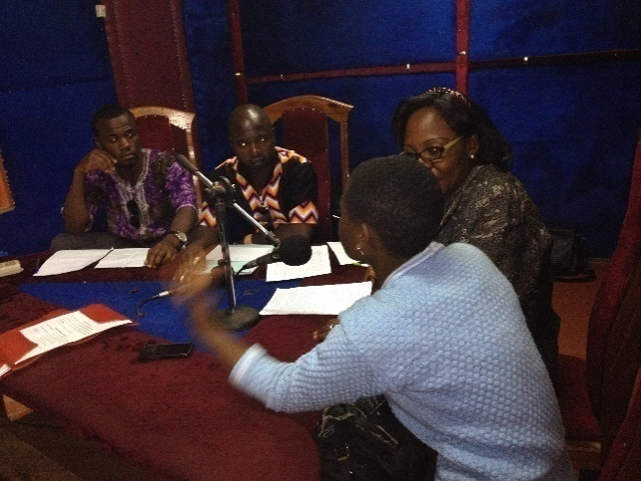

Counselor/Psychologist, Community Service Staff and client at the radio on Diversion

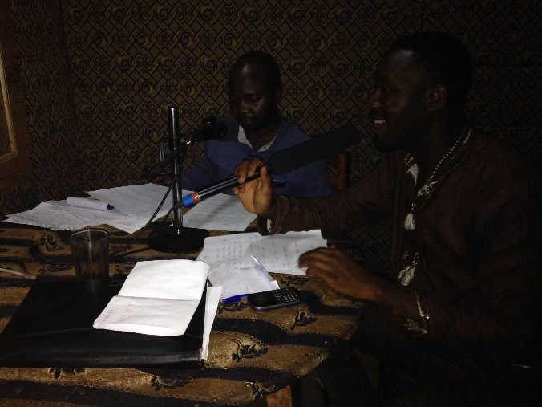
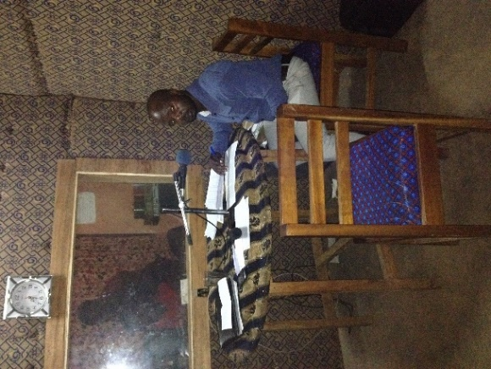

Community Service Staff talks on Diversion at another radio

