ORGANISATIONAL PLATFORM FOR RURAL AGRICULTURAL AND ENVIRONMENTAL DEVELOPMENT COOPERATIVE LTD

(OPFRAD COOP LTD)- CAMEROON

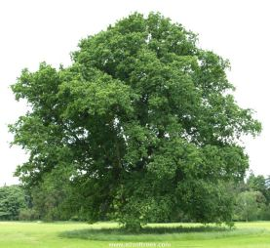

“Fighting against poverty through sustainable rural agriculture practices in Cameroon”

Head Office: Buea Road, Mutengene, South West Region, Cameroon
E-mail: opfradcameroon@rocketmail.com
Website: www.opfradcameroon.com
Tel: (+237)75 90 65 85

PEPPER CULTIVATION TO ALLEVIATE POVERTY AMONGST 500 WOMEN OF FAKO DIVISION, SOUTH WEST REGION OF CAMEROON.

Contact person: BINWI UNGWALLI VICTORINE .N
PROJECT MANAGER
E-mail: nashvicky2000@yahoo.com
Tel: +237) 75 90 65 85

ABSTRACT
Cameroon being a developing country, with the rural population and the vulnerable groups suffering from unemployment, and poverty, causes most of them to be faced with difficulties which limits their standards of living, death from illnesses, illiteracy as most poor parents cannot send their children to school due to lack of money, hunger etc Most of our community women lack the capacity to stand and face the challenges of the environment.
The objective of this project is to empower the women and build their capacities to enable them be versed with sustainable agriculture in order to be self employed, reduce poverty amongst these women and also raise the living standards of these women and the community at large.
Carrying out sustainable projects in our communities is the only way we can fight against poverty, unemployment and bring about development which raises the living standards of our communities and preserve a healthy community.
OPFRAD-CAMEROON with its goal of promoting sustainable rural agriculture and reducing poverty in our communities, through the implementation of this project stands to achieve this as goal.

BACKGROUND
With the head office being operational in Mutengene and from a research carried out showed that Mutengene is a rural community where most of the population is made up of farmers. About 80% of these population is made up of women who are needy and a hand full of them are widows who face life with a lot of difficulties like financial limitations which causes some of them not to send their children to school, have a low standard of living, and also inability to have access to quality health care when sick due to lack of money. Even though most of these women are farmers, they lack adequate capacities to efficiently cultivate their crops both for home consumption and for commercial purposes to raise income.
OPFRAD-CAMEROON has as goal to promote sustainable rural agriculture and capacity building to the rural women and looking for a ready market with a protected price for their farm produce to alleviate poverty and raise their standards of living and better livelihoods for their families. In line with its motive, this programme decided to come out with a project like this to help the rural women of this area know best practices and techniques of cultivating food crops to increase their yields which will be sold to enable them raise increase capital for continuous production and hence maintain sustainability of the pepper production.
Looking into it that OPFRAD- CAMEROON already has the experience in these rural agricultural activities like the pepper cultivation itself; as you will see from the photos attached, it stands best position to build the capacities of these rural women and even carry out the project over and over again.
OPFRAD-CAMEROON coming up with this project for the women will enable them to have a base for their growth. They will easily grow because there is a ready market for their produce as pepper is used for home consumption on a daily basis. OPFRAD-CAMEROON will look for a potential buyer who will buy their produce.

GOAL AND OBJECTIVES
The goal of this project is to reduce poverty and create employment amongst the 500 women in the Fako Division.
The main objective is to better the living standards and build the capacity and empower the 500 women in the Fako Division before 31st January 2015 through the sustainable pepper cultivation project.

BENEFICIARIES
The first group of persons to benefit from this project will be the 500 identified women of the Fako division as after farming the pepper, from the produce of this farm; they will have to cook food with the pepper directly. The pepper produce too on the other hand will be sold and these monies will be used as follows, the capital to be put back into production and the profit shared amongst the women to enable them carry out other cultivations on their individual farms to generate more income end add to the profit they will be having from the joint farm.
The second group of beneficiaries for this project will be the families of these women. The availability of funds into their homes will enable their children go to school; increase the standard of living and they will have access to quality health care and their social life will change.
The third class of beneficiaries is the existing communities. Firstly there will be development in the communities as poverty will be reduced, there will be increase supply of pepper in these communities, there will be reduced unemployment and prostitution as these women will now occupy themselves, there will be increase circulation of money in the economy as there will be increase purchasing power etc.
The economy will be upright as access to quality health care due to the presence of money will reduce mortality rate and keep a healthy population for the economy and country at large.

TARGETS AND ACTIVITIES
The implementation of this project entails inputs like cash, personnel and actions. Firstly the land will be prepared before the cultivation carried out. With the strategy of preparation, the farm land will be cleared and trees will be fell and cross cut by engine saw operators. Here the apportioned 30 acres of land in the farm will be cleared by some 20 laborers because the women themselves cannot do the clearing for it is a hard task. In this line too some 3 engine saw operators will do the felling of trees to allow sufficient sunlight into the farm.
After this stage of activity, the soil will be tilled to make mounts of about 30cm and manure will be applied. This will be done to enable the pepper nursery constructed and the pepper seedlings will be nursed.
After this phase pepper plantlets from the nursery, will be planted by the 400 women themselves. Since the farm on which the pepper cultivation is in the humid area, this activity has to be carried out between the 10th -30th of August 2014. The planting density will be 50,000 to 100,000 plants per acre as per the soil type.
After two months of the pepper being nursed, the plantlets will be transplanted to the farm. The holes will be dug and fertilizers put in the holes before planting the plantlets.
After planting, weeding of the farm will be carried out regularly by the labourers. After this stage, they shall apply fertilizers. At planting and always we apply insecticides and fungicides like DACOBRE 500 to fight pest and disease which destroys the pepper from growing.
After all these activities, 5 months after these, the first fruits from the pepper farm will be harvested. After harvesting the yields will be transported to the market for sale. It is worth noting that a pepper farm well catered for can be harvested 6 times a year

SCHEDULE
Work schedule for the pepper cultivation
No of workers | Period | Allocation
20 | Week 1 | -under brushing of the 30acres of land/ and felling of trees to let in sufficient sunlight
20 | Week 2 | -spraying of chemicals on the grass to prepare the area for planting
20 | Week 3 | - Tilling of the soil to make mounts and application of manure.
20 | Week 3 | - Nursing of seedlings
All the women | Week 4 | - Planting of plantlets
20 | Week 7 | Weeding of the pepper farm through application of herbicides.
20 | Week 8 | Application of insecticides and fungicides on the farm and dressing of the pepper.
All the women | Week 20 | Harvesting and transportation to the markets.
NB. We hire the 20 labourers to do those particular tasks because those tasks are very tedious jobs for the women and again the number is that much because there is a time limit for planting which we must respect.

ORGANIZATION
The organization and management structure of OPFRAD-CAMEROON is made up of the Board of Directors headed by the directress of OPFRAD-CAMEROON .This BOD oversees the affairs and activities of OPFRAD-CAMEROON.
Secondly we have staffs employed by the BOD who are as follows.
- MANAGER
As a manager, she implements policies and achieving objectives set by the BOD, She plans, organize, and control all company operations, establishes and monitors progress against productivity goals, oversees and plans all financial aspects of the company, responsible for all personal decisions, manages and establishes key objectives for senior staffs, communicates status of operation, progress towards objectives and issues encountered within the company to the BOD.

- CHIEF OF PERSONNEL.
-As chief of personnel, she organizes management meetings to evaluate project performance and make recommendations for action; conduct seminars and provide employees and member groups with suitable training, keep in touch with recruitment agencies, local organizations and educational institutions hence appointing qualified staff to contribute in the attainment of project objectives, deal with top management along with the staff and employees of the project; she acts a bridge between these sections in order to facilitate smooth functioning of the operations of the project, etc

ACCOUNTANT.
- She Prepares project’s income statement and monthly closing and cost accounting reports, Prepare and review budget, revenue, expense, payroll entries, invoices, and other accounting documents for the project, Analyze revenue and expenditure trends and recommend appropriate budget levels, and ensure expenditure control for the project, compile and analyze financial information to prepare financial statements including monthly and annual accounts for the project.
SUSTAINABILITY PERSONEL
In this position she carries out the following functions,
- Organize and schedule appropriate trainings on capacity building to women groups.
- Follow up groups at field level to make sure proper implementation of theories learned are done.
- Sensitize and present the organizational goals and total operations to community women.

ADMINISTRATIVE SECRETARY
- She manages correspondences in and out of the organization.
- She files the documents in the organization following subject heads.
- She takes care of the general secretariat.
OPFRAD-CAMEROON has the following as main activities:
- Capacity building to the rural community women on sustainable agricultural practices.
- Writing project proposals and seeking funding for community women groups to fight alleviate poverty.
- Searching and securing ready markets for community women’s farm produce.
- Implementing environmental practices to support good health of our rural communities.
COST AND BENEFIT
The cost of this project will include both local cost and external cost. For the local cost we shall have aspects like salaries of administrative workers, office running cost, land purchase, purchase of farm equipments and others which will be financed by the implementing organization who is OPFRAD-CAMEROON .This cost amounts to Eight millions, nine hundred and fifty-five thousand (8,955,000 FCFA) .The external costs will include payment for labour on the farm, purchase of the planting essentials etc which the organization expects from the donors. These costs amount to Seventeen millions, four hundred and fifty-five thousand francs (17,455,000 FCFA).
The project total budget is Twenty –six millions, four hundred and ten thousand (26,410,000 FCFA)
As regards to the benefit of this project, firstly the Fako Division is a rural area hence it will bring development in this community as people will experience increase supply of pepper and decreasing poverty amongst the population of this community. This project will reduce poverty as workers and the women will earn income to better the living standard of their families. The implementation of this project, creating employment amongst the women will reduce prostitution amongst these women and hence reduce diseases like HIV, and other sexually transmitted diseases, hence save guarding a healthy community.

MONITORING
Monitoring of this project will be done firstly by the Fako Division women committee through their leaders put in place to see that the OPFRAD-CAMEROON allow the project implementation to be carried out effectively on this land.
Secondly this project will be monitored by the implementing organization who is OPFRAD-CAMEROON to see that the targets are met and the output feasible for proper evaluation of success. Here weekly and monthly activity reports will be submitted by the sustainability personnel who supervises the farm activities to the management for ongoing evaluations, planning and programming for further activities. The report from the farm will have to show clearly the surface area covered per week, the specific task carried out and the general activity progress to enable management evaluate the level of output attained and its effects on the beneficiaries concerned. The accountant will also present weekly and monthly financial reports to the management to enable the management follow-up to see that budget lines are strictly followed to ensure proper management of funds. These two reports will enable management to follow-up proper implementation of the plan and budget to make sure that the objective of the project is attained. Management shall also look into the difficulties encountered and give the solutions recommended to make sure that the objectives are met. This reports will further be designed and send to the donors attached with photos to enable planning and programming for their whole scheme.
Lastly we shall have monitoring from the donors to make sure that their funds are properly used for the purpose due.
After this level the achievement of the project objectives will be measured through visiting the farm, measuring the surface area covered and the pepper planted on the farm with follow up treatments to allow the pepper yield good out puts and viewing the work done.

REPORTING
Here we shall have weekly and monthly activity reports from the farm by the sustainability personnel to the management giving the surface area covered, specific task carried out and other important statistics, stating the major difficulties encountered with proposed solutions. This report will further be sent to the donors.
In the same line we shall have financial reports from the accountants, stating how much funds were received from our donors, how much have been spent on a weekly and a monthly basis with justifications backing the expenditures, and what is left, the accounts heads will be followed from the budgets, and stating if there were difficulties, under-or –over expenditure, giving reasons for this in accordance with reaching the project goals. This is to enable the management and donors see the progress and accomplishments and the choices available for future actions.
These reports shall be ongoing and finally at the end of the project a final report shall be established stating the inputs, the actions undertaken, and the outputs obtained and its effects on the beneficiaries who are the 500 women of the Fako Division and sent to the donor.
The final report shall spell out the lesson learned from the implementation of this project. The impact of the project on the lives of the Fako Division women and its surrounding areas.

DETAILED BUDGET
ORGANISATION’S CONTRIBUTION TOWARDS THIS PROJECT.
ITEMS | SPECIFIC ARTICLES | QUANTITY | PER UNIT COST  (FCFA) | TOTAL  (FCFA)
Farm Land | - | 30 acres to be planted with the pepper | 100,000 per acre | 3,000,000
Administrative salaries for 6 months | - | 4 | - | 2,550,000
Farm equipments | Rain boots | 20 | 4,500 | 90,000
 | cutlasses | 20 | 5,000 | 100,000
 | File | 20 | 1,750 | 35,000
 | Chain saw | 3 | 875,000 | 2,625,000
Transport expenses to and from the plantation | - | - | - | 250.000
Repairs and others | - | - | - | 275,000
Purchase of buckets |  | 20 |  | 30,000
Grand total |  |  |  | 8,955,000

FUNDS EXPECTED FROM DONOR
ITEM | QUANTITY | AMOUNT( FCFA)
Felling of trees | 30 acres | 1,500,000
Purchase of fuel for engine saw to fell and cross cut trees | 1000 litres | 1,000,000
Labour( under brushing of grass) | 20 labourers | 1,750,000
Labour( spraying of grass) | 20 labourers | 1,750,000
Seedlings purchase | 1,040 sachets | 180,000
Purchase of fertilizers | 280 bags | 2,800,000
Labour( weeding) | 20 labourers | 1,750,000
Purchase of shovel | 20 | 260,000
Fertilizers for dressing | - | 1,600,000
Insecticides | - | 750,000
Purchase of metallic sprayers | 20 | 500,000
Purchase of hoes | 20 | 100,000
Purchase of wheelbarrows | 20 | 700,000
Transportation of produce from the farm to the market | - | 800,000
Labour ( holing/manuring) | 20 | 1,750,000
Purchase of rainboots | 23 | 115,000
Purchase of pick axes | 20 | 150,000
Total |  | 17,455,000

Appendix
Some photos of the previous activity carried out at a very small scale by the level of the organization with no donor funds and hence just a limited area covered and to promote the Fako Division women , large area needs to be covered.
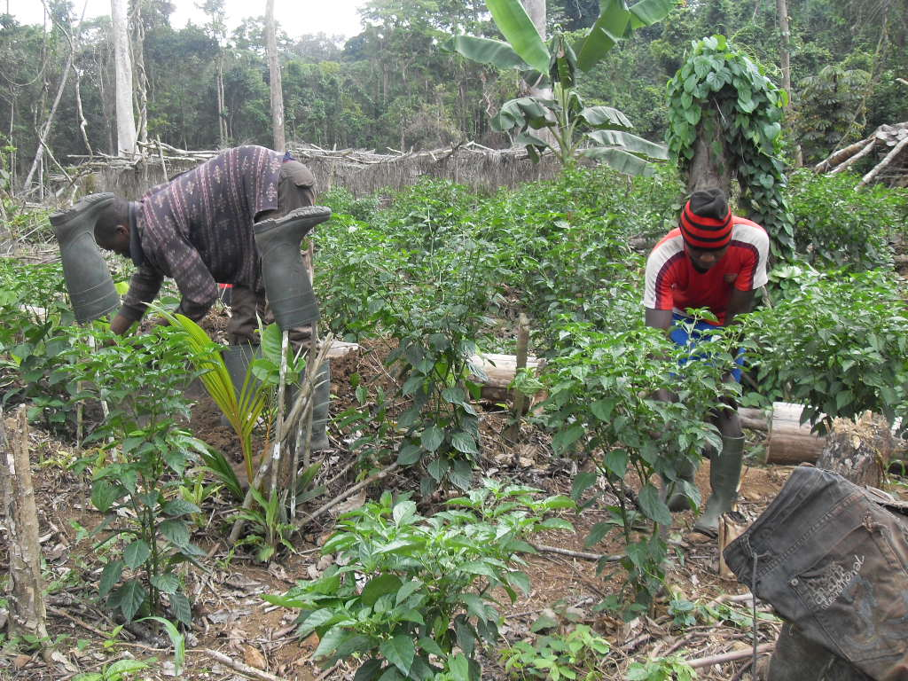
labourers pruning the pepper on the farm
second photo shows the pepper nursery being catered for
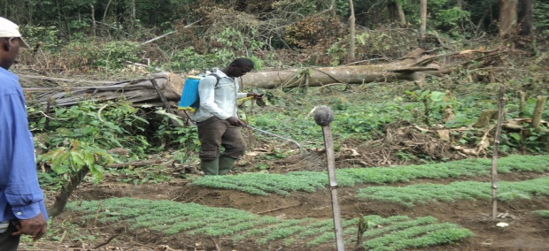

pepper harvested from the farm
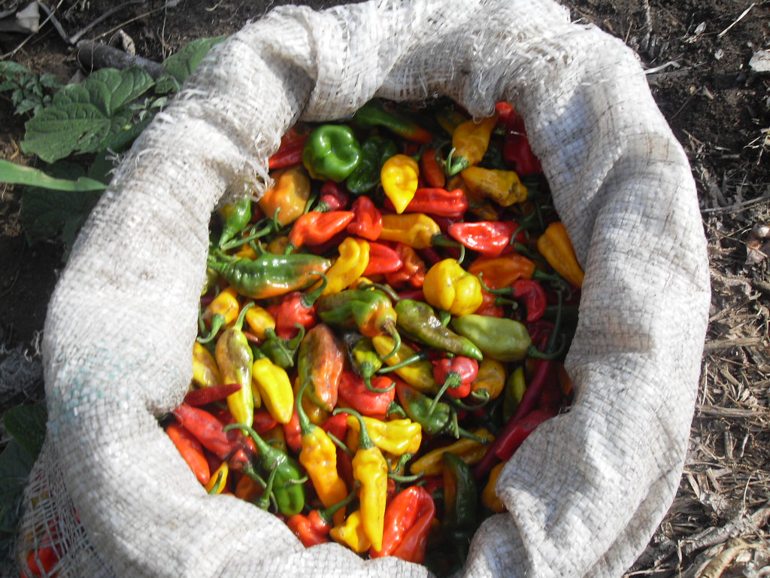

Still a view of the pepper farm with labourers

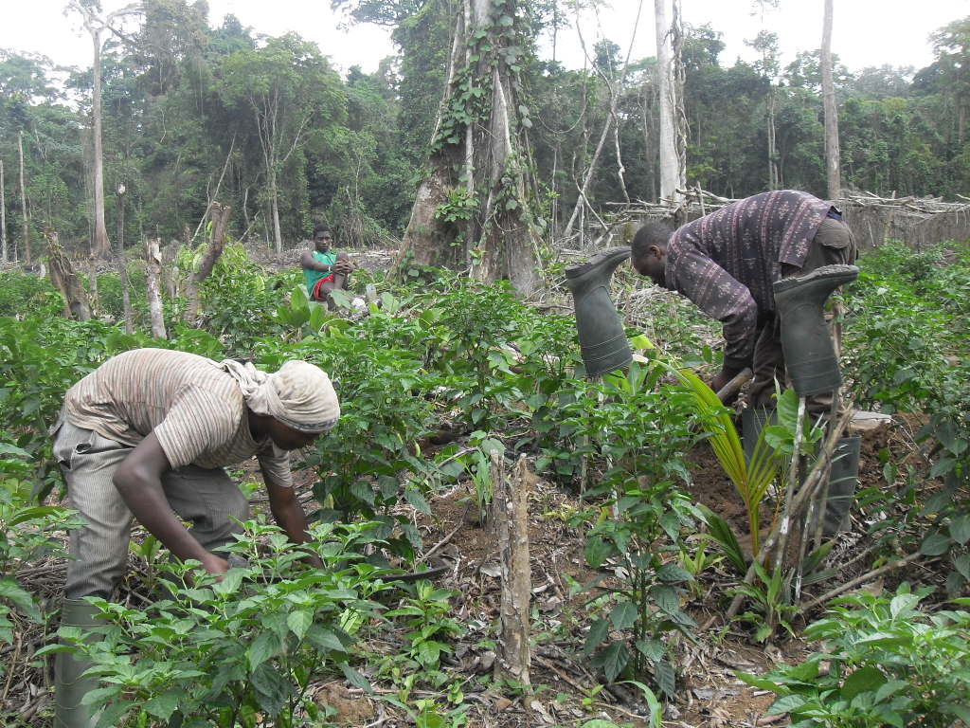

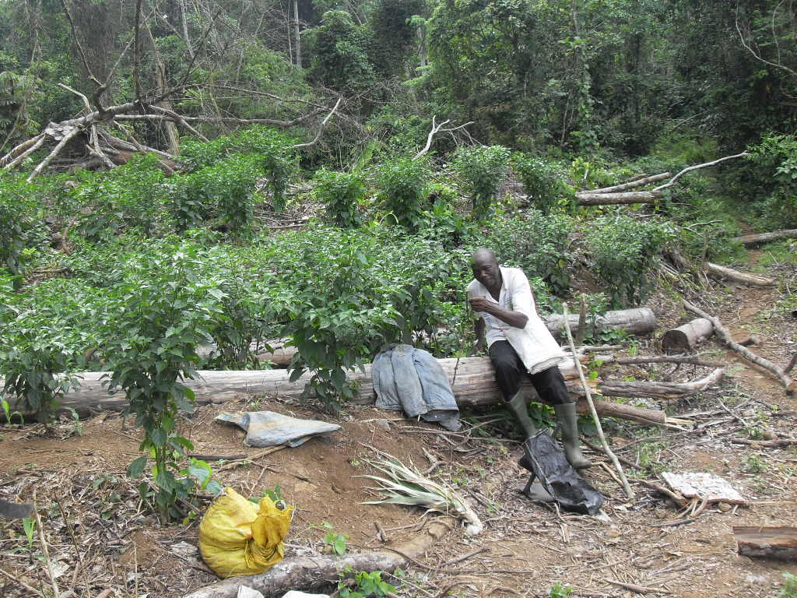

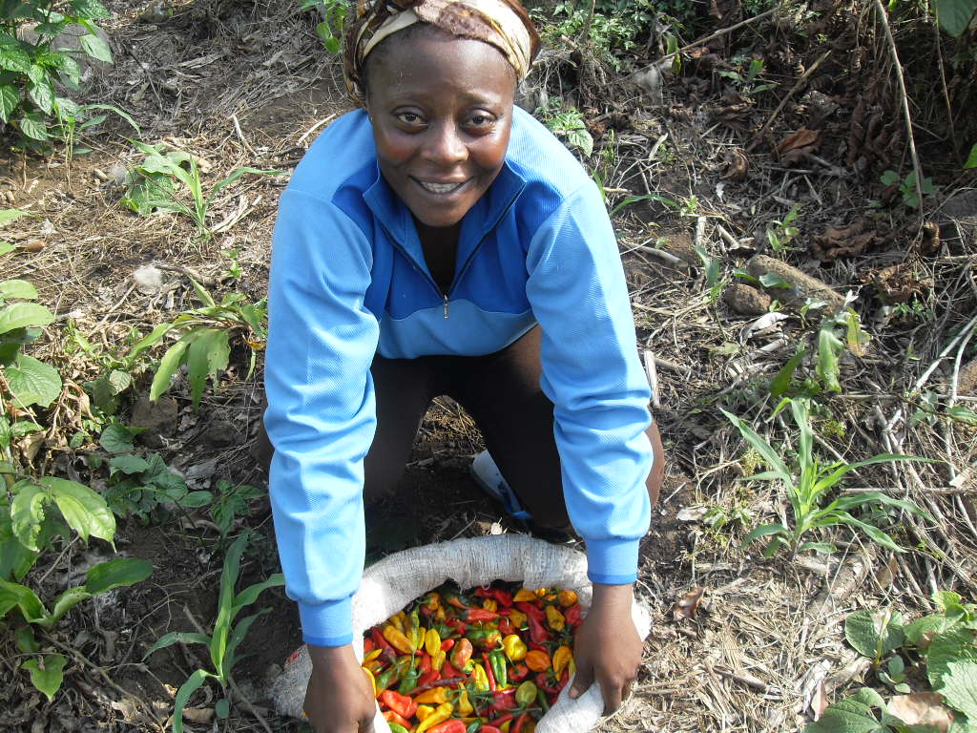
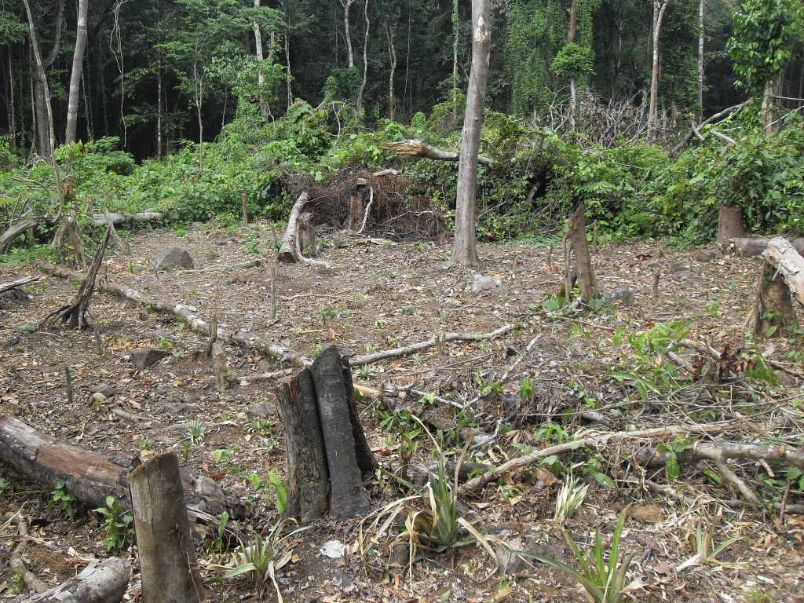

Area to be cleared and cultivated with pepper by the META women

