HEDECS
HEALTH DEVELOPMENT CONSULTANCY SERVICES

(Improving Health, Empowering Communities)
P.O BOX 798, BAMENDA
NORTH WEST REGION, CAMEROON
TEL: (237) 677673878 / 243051103 / 233362042

ANNUAL REPORT OF HEDECS

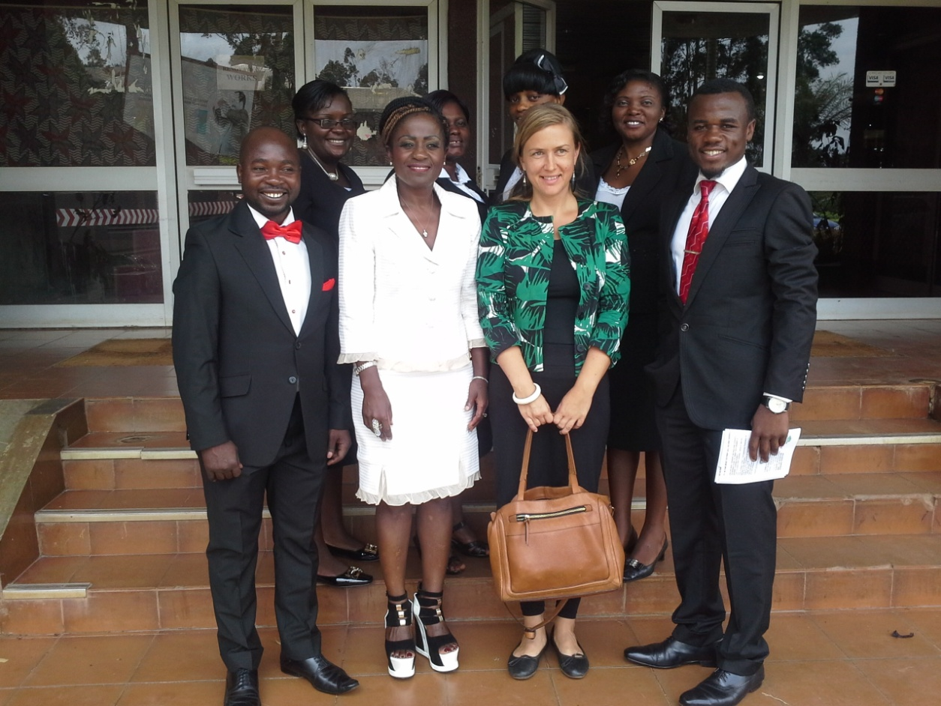

REPORTING PERIOD: JANUARY 2015- DECEMBER 2015

January 2016

Contents
INTRODUCTION 3
VISION 3
MISSION 3
GOAL 3
CORE VALUES 4
CORE STRATEGIC OBJECTIVES 4
PLANNING 4
INTERNAL MANAGEMENT ISSUES 5
FUNDRAISING INITIATIVES 5
NETWORKING 6
NWADO 6
PROVARESSC 6
PROJECTS 6
OTHER EVENTS 10
COLLABORTAION WITH MINISTRY OF HEALTH 11
OTHER COLLABORATIONS 11
CHRISTMAS CELEBRATION WITH JUVENILES INMATES 11
YOUTH EMPOWERMENT ACTIVITIES 12
Using football to enhance HIV/AIDS prevention amongst youths 12
Youth Empowerment through Agriculture 13
COUNTRY COORDINATING MECHANISM FOR GLOBAL FUND PROJECTS 13
VISIBILITY AND ADVOCACY 13
MAIN VISITORS 14
WORKSHOPS FACILITATED 15
SWOT ANALYSIS 16
CONCLUSION 16
SOME FIELD PICTURES 17

INTRODUCTION

The year 2015 had come and gone and HEDECS had remained committed to improving the health and livelihoods of her target groups and the population of the communities in Cameroon as a whole. For the past years, HEDECS had reviewed her vision and mission to align with the Millennium Development Goals (MDGs) that ended in 2015. With the introduction of the Sustainable Development Goals (SDGs), HEDECS had thus updated its mission statement to be more innovative integrating major components of health and development aligning with this global vision of development and the Cameroon’s Growth and Employment Strategy program (GESP) and Vision 2035. This process will continue in 2016 with the development of its new strategic plan that will contextualize HEDECS’ new mission, goal and strategic objectives into the present global and national dispensation.
HEDECS activities of 2015 involved internal planning, review of the management to make it more performing, fundraising, networking and partnerships, project implementation, internal and external meetings, workshops amongst others. Emphasis this year was also placed on the youth as football was used as a medium to build capacities and enhance knowledge on HIV/AIDS to young people in schools and other community members both in rural and urban settings. Other activities impacting on youths were farming where they engaged in cocoa nursery production to generate income and alleviate poverty. Regarding WaSH activities, we worked in project implementation in one community in Ndu while developing a WaSH project in another community in Ngie. We also engage in health system strengthening through capacity building workshops for dialogue structures in some health districts in the North West Region and community based organizations, engaged in the promotion of immunization activities and on quality assurance of laboratory practices on HIV/AIDS. We equally worked a lot in the pace setting project of diversion in the juvenile justice reform: Diversion project in developing tools, rehabilitating and reinserting juveniles who have been in conflict with the law while addressing the needs of the victims of crime amongst others.
However, some things were started and will roll over into 2016 such as focus was laid on the development of our research protocol and obtaining ethical clearance, geographical and thematic expansion of HEDECS, clearing from the ports a 40ft container of donated materials destined for the Bafut District Hospital in the North West Region.

VISION
A society where people have a better quality of life.

MISSION
To improve the health and livelihood of communities through sustainable interventions.

GOAL
To contribute to improved quality of life by enhancing knowledge, sustainable practices and services in the areas of health, governance, agriculture, climate change and environment.

CORE VALUES
- Commitment to Beneficiaries, Partners and Stakeholders
- Partnerships for Change
- Dynamic, Passionate and Visionary Staff

CORE STRATEGIC OBJECTIVES
- Promote disease prevention, reduce morbidity and mortality through our interventions
- Promote and defend the Rights and Freedom of disadvantaged and marginalized groups at the grassroots level
- Empower the disadvantaged communities for poverty mitigation, with knowledge, skills and resources for sustainable and viable secure livelihood
- Ensure greater involvement and visibility of the youths and rural woman in decision making
- Advocate for a change in policies through research and evidence based practices

PLANNING

Planning is a major component of HEDECS activities for proper planning leads to greater performance. These internal and external planning meetings serves as opportunity for capacity building for staff as they participates in project implementation, monitoring and evaluation and take turns to capture and produce the reports. Monthly plans of actions are being drawn up at the beginning of the month and a monthly report follows at the end of the month capturing actions and processes realized. External planning meetings with different partners and stakeholders including beneficiaries strengthens the partnerships and enhances project delivery and results

Objective:
To help coordinate the activities and to serve as a guide for monitoring realized activities throughout the months and year

Results achieved
- Over 30 weekly planning meetings have been held to evaluate activities and tasks carried out and to map out new activities and actions to be implemented.
- 12 monthly plans were drawn up for the year
- 12 monthly reports were written and filed

INTERNAL MANAGEMENT ISSUES

Within the year, the management of HEDECS was strengthened with the recruitment of new staff to boost up the HEDECS team. HEDECS website (www.hedecs.org) and social media made more dynamic as a web master was engaged to update the website of HEDECS. HEDECS decided to expand its activities and geographical area thus have offices out of the North West Region. General assembly and Board meetings were held
Objective:
To strengthen management and improve on HEDECS visibility
Results achieved
- I program Manager and 1 Administrative Assistant were recruited
- Five web mails were created for the office and staff (@hedecs.org)
- Board approved of HEDECS expansion
- Discussions and 3 mappings out of the Centre and East Regions were carried out
- 02 Board meetings were held
- 01 General assembly meeting was held

FUNDRAISING INITIATIVES

The year 2015 had been an energetic one for HEDECS in the domain of fund raising. As a not for profit organization, HEDECS had the arduous tasks of seeking for funding for its activities. This is done through concept notes and proposal development, building partnerships, linkages and networking with other organizations in the same thematic areas. Over 10 calls for proposals were responded with concept notes and project proposals written. HEDECS’ untiring efforts in fundraising were crowned within the early months with the approval of a 02 year pilot project on Juvenile Justice Reform funded by the European Union. Some other strides were made with the enforcement of a partnership with SHARE for the supply of medical equipments and supplies as well as becoming a local partner for VitaminAngels providing micronutrients and VitA supplementation to communities. HEDECS continued its activities in the domain of water sanitation and hygiene (WaSH) with EWB-DC and GHSS in quality assurance in HIV diagnosis and laboratory practices. HEDECS reinforced its partnership with the Ministry of Health and PROVARESSC in improving immunization and strengthening health systems. However, some projects were not funded and we are still committed to moving forward

Objective:
To mobilize resources to carry out HEDECS activities and fulfill its mission.
Results achieved:
- A new project proposal on Juvenile Justice Reform was approved and funded by the European Union Delegation in Cameroon
- 05 funding and collaboration ties were enhanced with the partners of SHARE, GHSS, EWB-DC, PROVARESSC and Ministry of Health.
- 01 new partnership was entered into with VitaminAngels
- Continuous partnerships was enhanced at the local level between the RDPH and all the health districts were HEDECS intervenes

NETWORKING
HEDECS is a founding member and member to many networks within the health thematic group at both local and national level.

NWADO
HEDECS is one of the executive members of NWADO and had been holding the position of secretary till later 2015 when fresh election where done for it to occupy the post of the treasurer.

PROVARESSC
HEDECS is a founding member of PROVARESSC - the national platform for the promotion of vaccination and strengthening the health system in Cameroon. This network focuses on promoting vaccination activities in Cameroon while it strengthens the health systems through capacity building workshops/trainings. Also, under the PROVARESSC platform, HEDECS staff has been busy throughout the year shuttling between the 11 health districts of 19 in the North West Region in their portfolio to train CBOs, monitor and supervise the different immunization activities that was going on in the country.

PROJECTS
Find below the different projects that have been on course throughout 2015 and their state of implementation.
PROJECT PARTNERS | DURATION OF PROJECT | OBJECTIVE OF THE PROJECT | RESULTS AND OUTCOMES
Engineers without borders (EWB)-DC Chapter | 2013-tilldate | To reduce waterborne diseases by providing the community with clean water, sanitation, and health education | 02 pre-assessment trips were conducted by staff from HEDECS to MBOKOP community in preparation for the November trip of the EWB-engineers to continue work on the Mangi water system.  So far, 5 trips have been conducted by the EWB team to Mbohkop community with the following realized in the Mangi community:  the Mangi water system which is composed of a water catchment, 2 pressure tanks, and 2 pressure valves with a pipeline of about 1km.
SHARE (Sustainable Alliance for Recycled Equipments) | August 2014- till date | Supply medical equipments and supplies to the hospitals | Donated a 40ft container of medical equipments to the Bafut District Hospital worth 22 million FCFA. The following departments; offices, medical, surgical, pediatric, theatre, laboratory, maternity/gynecological, dental and ophthalmology benefited from items including furniture, cabinet beds, aspirators, bedpans, wheels chairs, computer supplies respiratory machines, diapers, blankets crutches drip sets humidifiers x-ray films etc.
Global Health Systems and Solutions(GHSS) |  | Conduct quality assurance for HIV testing in hospital and treatment centres in the North West and Centre regions | The Q-Corps volunteers go to the field the field quarterly to carry out quality controls of the different hospitals laboratories and treatment centres
VitaminAngels | October 2015-Dec 2016 | Promote access to micronutrients supplementation(Vitamin A and Albendazole) to improve the health of undeserved communities | Provide Micronutrients to cover 4750 children from 6 months - 59 months in the health districts of Benakuma, Ndu , Mamfe and Batibo.
PROVARESSC  (A civil society national platform for vaccination) | January to December 2015 | Promotion of vaccination and strengthening the health system in Cameroon | Participated in 02 international trainings  Participated and facilitated 02 national trainings  Participated in 03 vaccination campaigns as independent monitors  -Trained 229 of participants (COSA members and CBO representatives) in 06 Health Districts during the 3rd round trainings to strengthen vaccination activities and the health systems in the different health areas.
EUROPEAN UNION,CAMEROON  (Juvenile Justice Reform Project) | Jan 2015- Jan 2017 | To strengthen capacities of civil society actors to make Cameroon more just, open and democratic. | For FY1, the diversion component that is managed by HEDECS recorded a lot of successes as there are about 38 juveniles registered in the diversion program. Over 200 counseling sessions have been held with these juveniles and with some of their parents. About 10 clients have completed their counseling sessions and have been placed in training centres which are vocational training centres of normal formal schools.  Also at the beginning if the project, HEDECS conducted a Baseline Survey to ascertain people’s perception of Diversion and how community members consider the whole idea of children in conflict with the law. The survey report is available with the findings and identifying action items where some recommendations are made.  Participated in NICRO from South Africa training in Cameroon of the Diversion team (15 persons were trained)  The full annual report on diversion is available
HEDECS  (Internal funding) | Jan 2015-June 2015 | HIV/AIDS prevention using football | Participated in 4 school health clubs  8 HEDECS Peer educators carried out education and sensitization campaigns  Participated in FENASCO school games carrying out HIV/AIDS prevention activities  Distributed IEC materials
 | Jan-December 2015 | HIV/AID Education and Sensitization in Communities | Carried out education and sensitization activities in Mbohkop community of Ndu  Carried out education and sensitization activities in Bamenda  Participated and made a stand at the during the Chantal Biya AIDS free holiday celebration  Participated in the World HIV/AIDS week celebration
 | Aug- December 2015 | Care and Support to OVC | Visited the vulnerable juveniles at the Bamenda Central prison  Gave gifts (books, rice, soap) to the vulnerable children in prison  Organized 1 Christmas celebration with OVC, parents and stakeholders

OTHER EVENTS
Meetings, workshops, seminars and project launches attended
- HEDECS participated in the development of the 5years (2015-2020) strategic plan of MBOSCUDA from the 16-20th of February 2015.HEDECS was nominated as the main health partner of Mboscuda.
- In April 2015, HEDECS attended the launching ceremony of the Australia Alumni in Bamenda under the auspices of the Australian Ambassador to Cameroon.
- Within the month of July 2015 there was a PASC Training Workshop on Financial Management for CSOs. The main objective of the workshop was to expose CSOs to the new finance law (reform). CSOs from the North and South West Regions had the opportunity to be acquainted with tenets of good governance, issues relating to public policy formulation and performance based budgeting amongst others
- Still by the close of July, Executive Director of HEDECS attended a PASC steering committee meeting in Yaoundé. It is worth nothing that PASC was phasing out of Cameroon and these were the last evaluation meetings for them to close their doors. However there was hope that new and other doors will be opened to continue accompanying the government of Cameroon and the civil society structures in their development endeavours.
- HEDECS staff followed up and participated in the Presbyterian Church “Prison week” celebrated from the 20-25th of August 2015.Staff took the opportunity to show their solidarity with the juveniles by offering them exercise books for school and a bag of rice as well as bought some of the craft
- On the 2nd of September 2015, the ED of HEDECS took part in the launching of the National Project on Decentralization.
- On the 14th September 2015, HEDECS was part of a Public –Private Partnership meeting held at the Regional Delegation of Public Health in Bamenda.
- While on the 16th of September, the ED of HEDECS attended a 2 days leadership workshop in Yaounde organized by SNV.
- On the 25th of September, the ED of HEDECS participated in an EU- PASC evaluation meeting held at INADES formation in Bamenda bringing together some of the beneficiaries of the just ended PASC programme.
- HEDECS attended and participated in the inaugural ceremony of the North West Farmers Organization Office Building at the Traveler’s neighbourhood
- On the 5th of December HEDECS participated in a partnership dinner hosted by GENESIS FOUNDATION KOB HILLS, an NGO that empowers people through capacity building on environmental health through education in the community.
- On the 9th of September 2015, the ED of HEDECS took part during the inauguration of the new ACMS office in Bamenda situated at Cow Street Nkwen.
- On the 10th of September, HEDECS staff joined in the celebrations marking the closing ceremony of the 2015 AIDS-free Holiday campaign that took place.
- On the 9TH of October 2015, the ED attended the National Ethics Committee sitting in Yaoundé. This is in connection to HEDECS’ submission in respect to the research activities she is engaged in with some of her partners.

COLLABORTAION WITH MINISTRY OF HEALTH

HEDECS is a major partner with the Ministry of Public Health. Throughout the year, HEDECS was also involved in the Meetings at the Regional Delegation of Public Health on the monitoring and supervision during the mother and Child Health Nutrition and Action Weeks of 2015. During these campaigns, a major novelty was the introduction of the injectable polio vaccine (IPV) to supplement and reinforce the oral polio vaccine.
On 20-25 April 2015 the executive Director of HEDECS participated in the National training of trainers workshop organized by the Ministry of Health and UNICEF. This training took place in Douala. Its purpose was to strengthen the nutrition, couching and counseling in children and emergency situations

OTHER COLLABORATIONS

HEDECS in its continuous efforts to strengthen networks and partnerships, succeeded to sign MoUs with
- Ministry of Social Affairs
- Ministry of Women Empowerment
- Jonathan’s House (a CSO)
- NACHO School
- MoUs with the Ministry of Youth Affairs and National Civic Agency for Participation in Development is still in process

CHRISTMAS CELEBRATION WITH JUVENILES INMATES
This celebration which held in the HEDECS Conference Hall was to mark one year of working with clients in the Diversion programme. It was also an opportunity for the various clients who have been undergoing counseling sessions individually at different times to meet with others.
Also, this is a forum for them to share their knowledge and experiences on, before and after the judicial chain.

During the celebration, one could read joy, happiness and hope on the faces of clients. The testimonies of clients boost the faith of those who did not and who they wish they were those standing in public to share their joy. Clients lid the Christmas candles which signified light to their lives followed by the harvesting of Christmas gifts from the Christmas tree. Parents on their part enjoyed the occasion to satisfaction. It was their joy to testify about the change in the lives of their children. Children they had given up on were restored back to them with the help of the Diversion programme. The turnout of the stake holders was fabulous. One could see real appreciation on their faces and their willingness to support this project especially as placement is concern. Every one present in the celebration loved and welcomed the Diversion Program. They promised to participate in one way or the other for this dream to succeed and gain sustainability

Present at the celebration were some invited stake holders, parents of clients and the clients themselves.
The stakeholders: Miss. Ngafor, Proprietor of NACHO, Pastor James of Weapon of Wisdom Television, Pastor Mrs. Forkwa of Jonathan’s House, State Counsel N⁰ 8, Representative from the National Civil Service Agency (NCSAPD), Divisional Delegate Women’s Affairs and the Family, Board President of HEDECS, Social Worker from the prison and other local entrepreneurs .

YOUTH EMPOWERMENT ACTIVITIES

Using football to enhance HIV/AIDS prevention amongst youths
As an organization that is focused on health promotion, education on HIV/AIDS is one of its primary activities. During the 2015 FENASCO Games (sporting season for primary and secondary schools) HEDECS seized the opportunity to sensitize the youths during football encounters between schools. Sports being an activity that pulls a lot of students and youths together, HEDECS distributed didactic material, brochures and flyers with information on HIV/AIDS. HEDECS trained peer educators within school health clubs keep sensitizing their friends to adopt positive attitudes and behaviour patterns towards persons infected with HIV/AIDS, management and prevention.
Objective:
To sensitize the youth on HIV/AIDS and inculcate in them positive attitudes and behaviours for prevention and management.
Results achieved
- Over 1000 secondary school youths in colleges around Bamenda town were sensitized
- 20 peer educators were trained
- 1500 brochures and didactic material on HIV/AIDS were produced and distributed

Youth Empowerment through Agriculture
To boost and promote self reliant initiatives in young people especially unemployed youths, HEDECS and her partners are engaged in cash and food crop production both geared toward income generation for poverty mitigation. As the backbone of Cameroon economy, the government is willing and ready to make the agricultural sector viable and conducive to offer employment opportunities to young people. Thus, engaging youths in agriculture and environmental protection activities will enhance their socio-economic well-being and independence
Objective:
To promote self reliance and improve the living standards of unemployed youths
Results achieved
- 25 youths were trained in modern farming technique especially on soil testing and contents to determine the type of crop that is good for which soil type.
- 10,000 cocoa seeds were produced and distributed to those who want to engage in cocoa production

COUNTRY COORDINATING MECHANISM FOR GLOBAL FUND PROJECTS
HEDECS is one of the global fund partners in the country coordinating mechanism put in place to share out information and promote and monitor the activities of the global fund in Cameroon. In February 2015, HEDECS through its CEO participated in one of the CCM Retro –information workshops in the Littoral Region

VISIBILITY AND ADVOCACY

Within this year, HEDECS undertook a lot of visibility and advocacy actions to valorize and show case her work in the field. This was done through the social media, radio sensitization on topical issues affecting the community and media coverage of events and the production of IEC materials.
Objective:
To make known HEDECS activities to the wider public to influence change
Results achieved:
-08 Radio talk shows on issues affecting the community (health, juvenile justice, rehabilitation)
-04 Newspaper publications of HEDECS activities and events in the field.

MAIN VISITORS

A total of 19 persons and partners visited HEDECS through the year 2015.the visitors range from individuals to groups of persons as well as institutions and related services that align with HEDECS’ mission. They came for varying purposes; while a few came in to drop job application, a handful came in to get more information about the structure and to explore avenues for collaboration and partnership. Others came for evaluation mission for past activities as well as assessment visits for future projects. Below are some major visitors worth mentioning:
- In July 2015, HEDECS received evaluators from Germany and Cameroon who came in to evaluate INADES-Formation within PASC framework for which HEDECS worked with INADES as an Associate.
- Hedecs also till in July 2015, HEDECS received Dr. Godian Nchinda who came in to discuss HEDECS collaboration on HIV/AIDS with the Chantal Biya research centre.
- HEDECS equally received the Teze Ngie President USA and discussed about the Teze WaSH project. Also explored ways of forging new partnerships.
- As a follow up of the KIDSS proposal submitted, in august 2015, HEDECS received CRS partners for the KIDSS Project who came in to conduct an assessment of the office capabilities to engage in the project
- In September 2015, HEDECS received a delegation from the ministry of public health from Yaoundé with whom they had a working session on the redynamisation of the public –private partnership sector to reinforce the relationship for better health service delivery to the public.
- In November 2015, HEDECS received Dr. Esther Gwan of Samaritan’s Purse who came in to explore networking possibilities with HEDECS following her collaboration with Jonathan’s House Children Association.

WORKSHOPS FACILITATED
- The CEO of HEDECS with COPSUD went to Nkum Council in Kumbo to initiate the participatory budgeting process with the stakeholders in the council. This was a follow up of the resolution taken during the PASC budgeting workshop in Kumbo
- On the 16TH and 17TH of October , the ED facilitated a workshop for community representatives on “Leadership Skills” organized by the North West Special Fund for Health.
- The ED as the Diversion Manager facilitated 02 workshops on Diversion with traditional rulers and the Judiciary.
- HEDECS within PROVARESSC, facilitated 02 workshops during the round 3 trainings with COSA and CBOs of 06 health Districts
- HEDECS organized and facilitated 8 internal workshops to strengthen project delivery and staff competencies
- On the 10th of December 2015, the CEO of HEDECS facilitated a workshop on “Strengthening the Agriculture Nutrition Nexus in Cameroon”, organized by the Technical Centre for Agriculture and Rural Cooperation(CTA) in partnership with Dschang University and other stakeholders.

SWOT ANALYSIS

STRENGTHS  - Obtain a bigger and larger office space for HEDECS  - Increase in staff strength and office equipment  - Obtain funding from the European Union on the project on Juvenile Justice Reforms as co-applicant implementing the diversion component.  - Manage and maintain partnership relations with previous and new donors  - Wider coverage of Q-Corps activities with the extension to the Centre region | WEAKNESSES  - Lack of a current strategic plan to give direction and orientate HEDECS expected outcomes for the year.  - Limited action and visibility in the field  - Limited funding to implement core programs of the organization  - Inadequate staffing
OPPORTUNITIES  - Building new partnerships with great potentials of creating and obtaining more funding for project activities  - Widening the scope of HEDECS actions with particular emphasis on social protection for the elderly and youths with social problems  - Potentials to expand geographical scope | THREATS  - Uneasy working relations with other project partners  - Non-conformity with partnership agreements  - Limited resources

CONCLUSION

From the above initiatives and actions of HEDECS in 2015, it can be said that the year was a very, intense, engaging and buoyant one. This needed very committed and devoted staff and a conducive working environment for all the above results to be achieved. Much effort was put in to create and maintain the new and old partnerships at both local and international levels. As HEDECS dives into 2016, the challenge is even bigger as it needs to embrace the new development visions for Cameroon (vision 2035 ), the provisions of the Global Development Goals and HEDECS thematic and geographic expansion. HEDECS is challenged to deliver and this cannot be achieved without the reinforcement of old partnerships while creating new ones.

SOME FIELD PICTURES

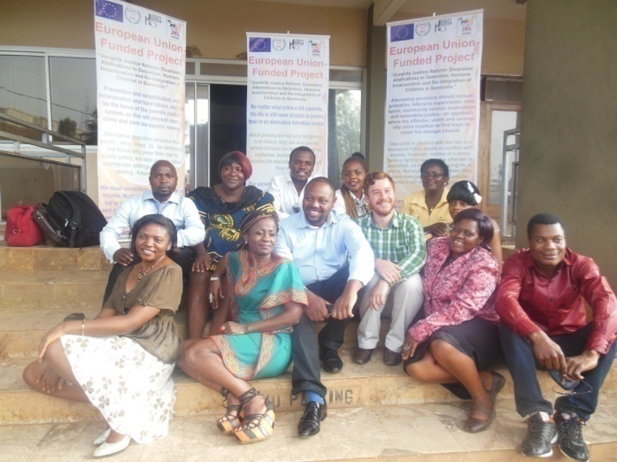
Diversion training pictures with trainers from NICRO South Africa
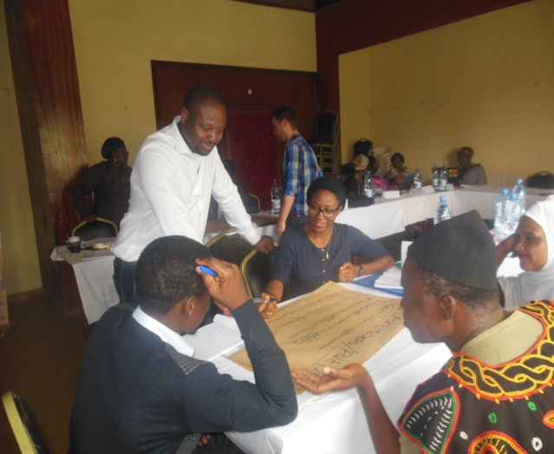

HEDECS gives back to juveniles in the Bamenda central prison
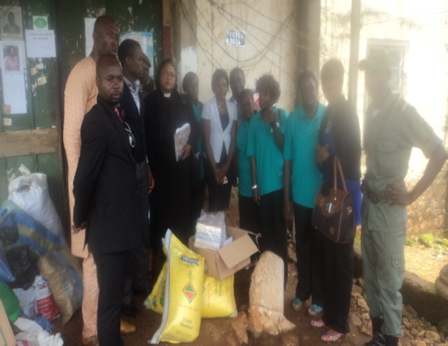
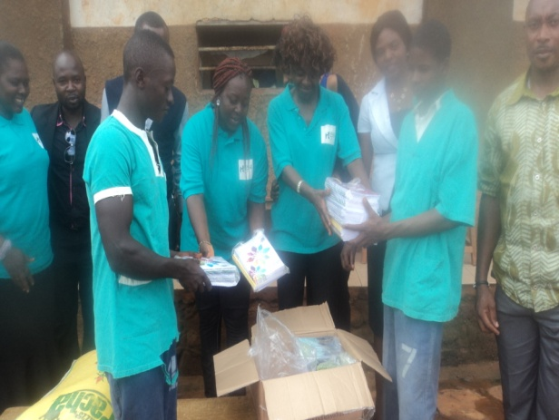

The Mbokop community water project and catchment protection activities
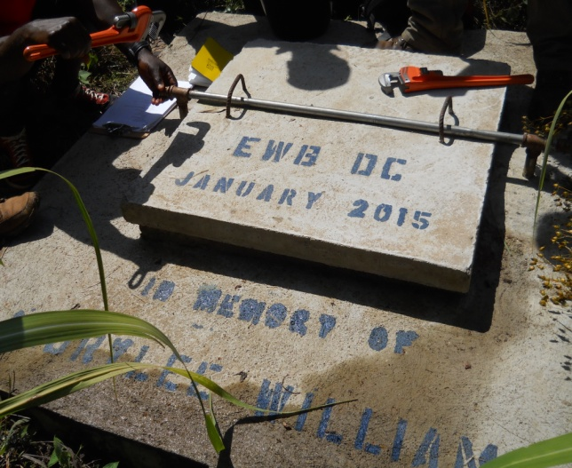
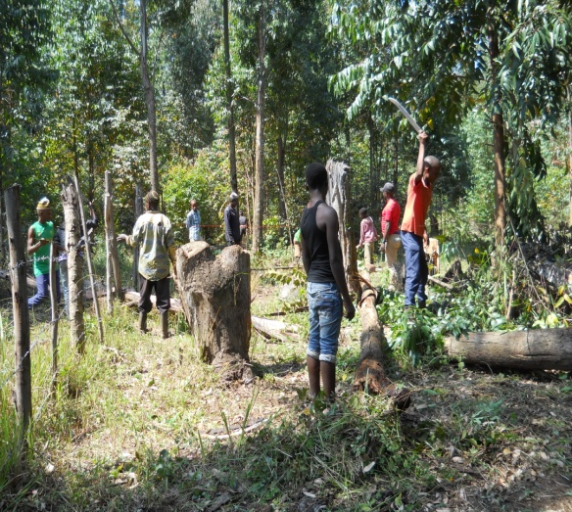

HEDECS celebrates Christmas 2015 with juveniles
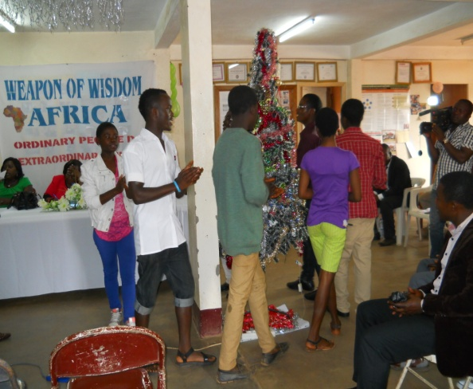
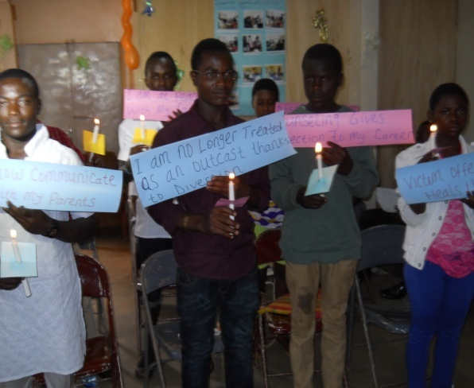

IT and web development training for HEDECS staff
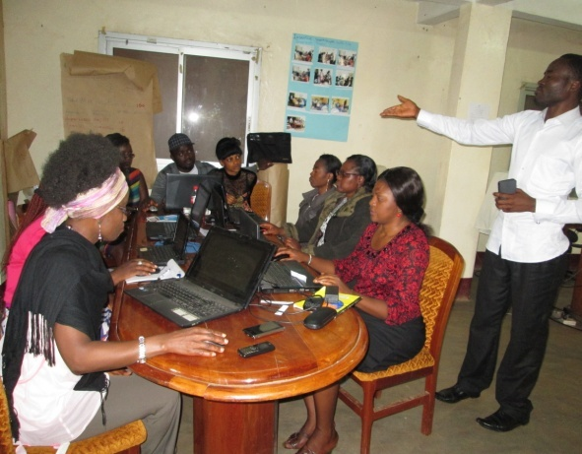
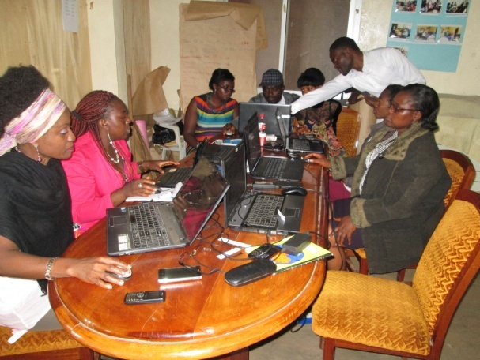

Visibility actions and media sensitization on the diversion program

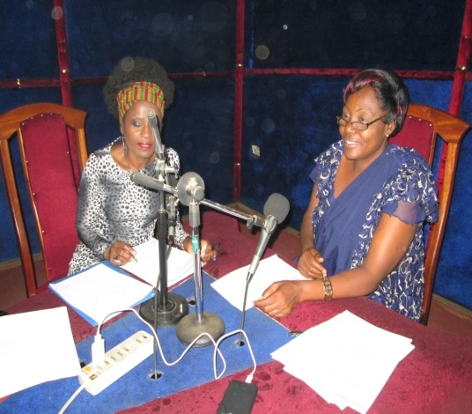
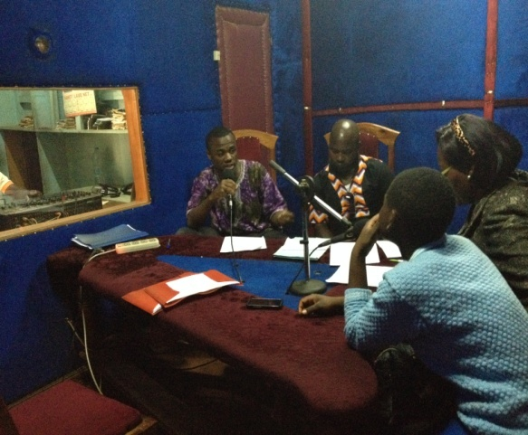

VITAMIN A /ALBENDAZOLE supplementation with the support of VitaminAngels
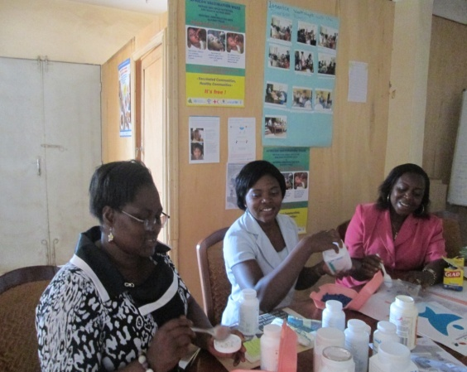
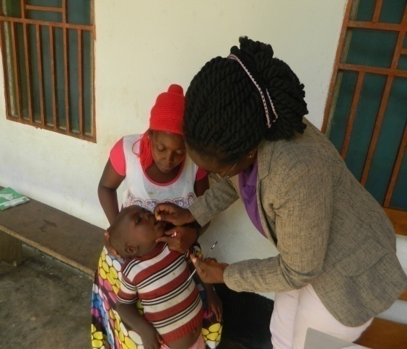

HEDECS within PROVARESSC training of CBOs in communities of the NW REGION
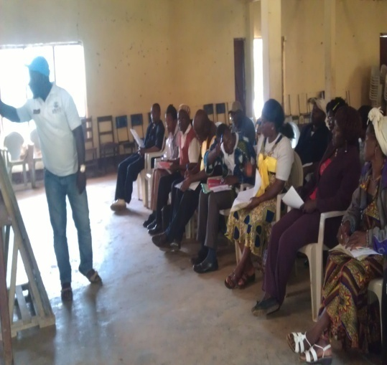
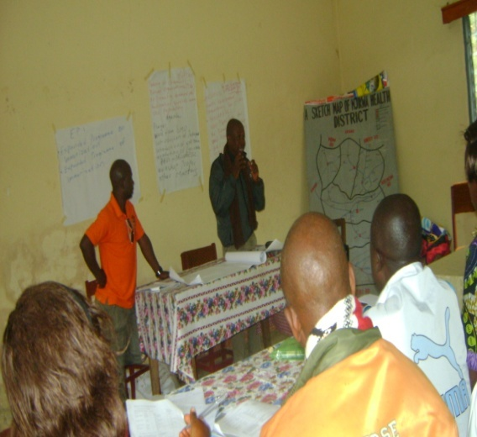

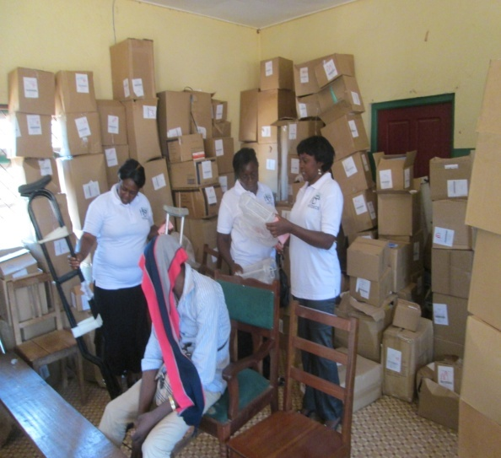
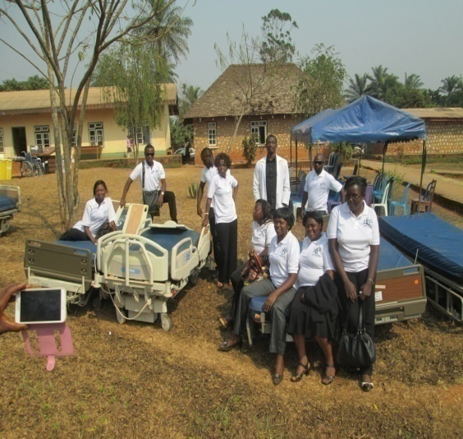
HEDECS donates medical supplies to Bafut Health District Hospital

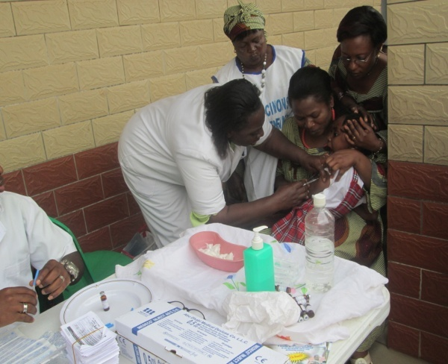
HEDECS monitors and reports on National Immunization Days
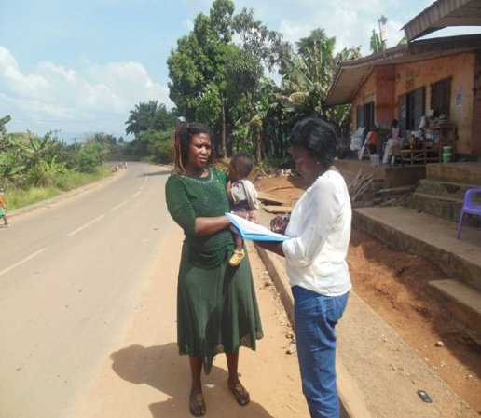

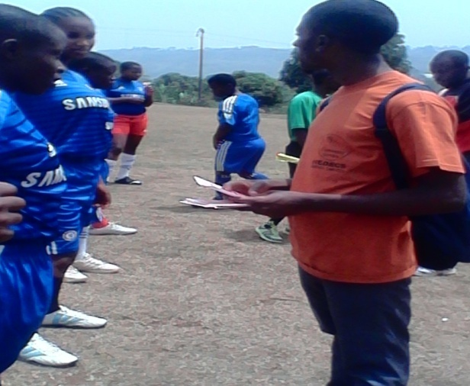
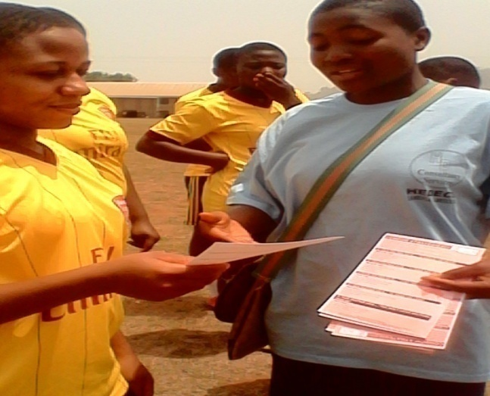
HIV/AIDS sensitization using football in Secondary Schools in Bamenda.

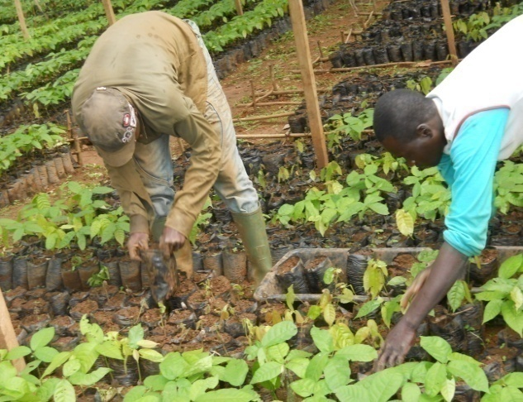
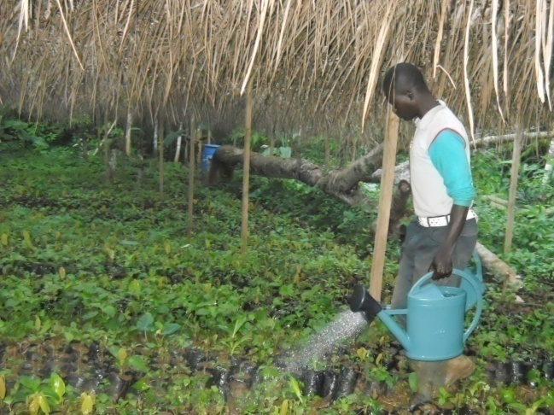
Youth Empowerment activities through cash crop Agricultural production

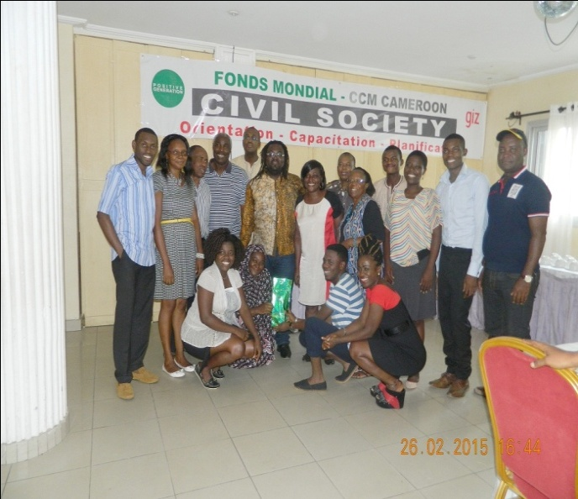
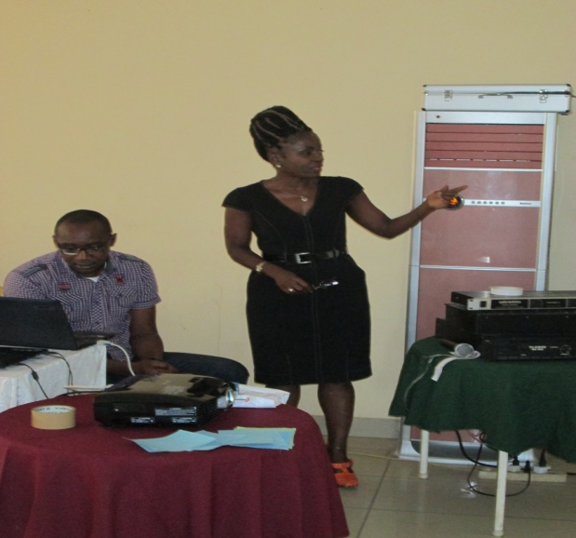
HEDECS CEO facilitating one of the retro workshops of the CCM

