NATIONAL NETWORK OF RETRENCHEES FOR SOCIAL AND ECONOMIC JUSTICE [KENYA]
{NNR-K}

STRATEGIC
PLAN
2011 – 2016

SUPPORTED WITH FUNDS FROM
CONTENTS:
List of Abbreviations and Acronyms 2
Word From the Chairman 3
Word From the Secretary General. 4

SECTION ONE: Introduction 6
1.1 History and Background of NNR-K 6
1.2 Organisational and Institutional Setup 7

SECTION TWO: Process, Mandate, Vision, Mission and Core Values 8
2.1 Strategic Planning Process 8
2.2 Mandate 8
2.3 Vision 8
2.4 Mission 9
2.5 Core Values 9

SECTION THREE: Situation Analyses 10
3.1 SWOT Analysis 10
3.2 PESTLE Analysis 11
3.3 Stakeholders Analysis 14

SECTION FOUR: Strategic Issues 15
4.1 Strategic Objectives 15
4.2 Logical Frame work for Implementation of the Strategic Objectives 16-17

SECTION FIVE: Overview of Planning, Monitoring, Evaluation, Reporting and
Learning 18
APPENDICES; Photos from the Strategic Planning Workshop 19-20

LIST OF ABBREVIATIONS AND ACRONYMS
AIDS Acquired Immune Deficiency Syndrome
CBOs Community-Based Organizations
COTU Central Organization of Trade Unions
CSOs Civil Society Organizations
FBOs Faith-Based Organizations
HIV Human Immunodeficiency Virus
ICT Information and Communication Technology
IMF International Monetary Fund
NGOs Non-Governmental Organizations
NNR-K National Network of Retrenchees for Social & Economic Justice [Kenya]
NSSF National Social Security Fund
PESTLE Political, Economic, Social, Technological, Legal and Environmental
SACCO Savings and Credit Co-operative Organisation
SAP Staff Adjustment Program
WB World Bank
WEF Women Enterprise Development Fund
YEDF Youth Enterprise Development Fund

WORD FROM THE CHAIRMAN
It is our great pleasure to have our first Strategic Plan and which shall cover the years from 2011 to 2016.This achievement is a demonstration that National Network of Retrecnhees for Social and Economic Justice-Kenya (NNR-K) is growing to serve.

The NNR-K started as an idea by one person, a Mr. Samuel Otenyo in the year 2002 out of a felt need. The idea has now grown into a giant organization whose development cannot be realized without a Strategic Plan to clearly steer the organization into the future.

Retrenchement in Kenya, in the public sector especially, started in the early 1990’s and the programmes show many people losing their Jobs. The victims coming from the public sector side were paid a paltry sum of Kshs. 40, 000, an equivalent to USD.476 as golden handshake. The retrenchment programme did not have a human face. The NNR-K was born to assist articulate the plight of the affected people and create a forum for them to share experiences. Retrenched workers are suffering as they lack Resilient Skills to manage tough lives after retrenchment among many others.

This Strategic Plan gives the organization a clear mandate, vision, mission and its values and hence acts as a reference document. It should provide direction to strengthen the organization’s many activities e.g. NNR-K Micro-Financing programme and the Sacco programme which meant to give economic empowerment to the members of the organization. We shall work within the defined mandate and mission to implement the strategic objectives.

In the period before the plan was developed, the Management and Staff worked on what they thought should be done. This ad hoc approach hindered the development of the organization. We at NNR-K are happy as things will be done differently now.

The organization has been active in demanding for the new Constitution in Kenya together with other civil society organizations like Citizens Coalition for Constitutional Change [4Cs], and the National Convention Executive Committee [NCEC] among many others. The interest that we had in advocating for the new Constitution in Kenya saw NNR-K provide civic education on the proposed constitution in the referendum of 2005. This organization will continue being in the forefront of advocating for complete implementation of the new Constitution and will seek to assist communities to understand the process and build the demand blocks at the county levels.

I also take this opportunity to thank our partners, donors, friends for standing by us in the development of our Strategic Plan. Special thanks go to Akiba Uhaki Foundation for their generous financial support without which this document could never have seen the light of day. We hope they will continue taking keen interest during the implementation process and ensure NNR-K stands to deliver the objectives therein. Let us all work together, Management Committee, Staff, stakeholders, consultants, and grant makers to change the lives of the retrenched workers.

Jimmy Wattuman,
Chairman

WORD FROM THE SECRETARY GENERAL
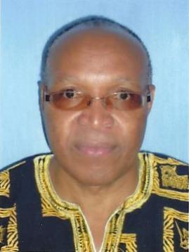
Samuel M. N. Otenyo
Secretary General.

Since the inception of the National Network of Retrenchees for Social & Economic Justice-Kenya (NNR-K) in the year 2003, the organization had not managed to develop her Strategic Plan. The absence of such document in any organization contributes to its failure to achieve the required growth and NNR-K is not exceptional. The organization did not have a clear focus on the way ahead hence could not strategically position itself on important national events which include the new Constitution.

This is our First Strategic Plan and we are not only excited about but also believe that it will lead us towards achieving our desired goals. The document we have prepared will be the guiding principle in the coordination of NNR-K activities, vision, mission and driven by its core values. The document should enable the organization to play an important role in articulating the plight of its members down to the county levels. The document has come in at an opportune time when we have just gotten a new Constitution that provides for the rights of the vulnerable in the society where the retrenches are included.

The document defines clearly the role of the NNR-K organization, Management Board, the Secretariat, and staff. It will assist in ensuring that the entire organization is issue based, goal –oriented, and should spur the organization’ s organic growth in a more efficient manner. The document, once properly implemented, will clarify roles of Executive, Staff and the activities that need to be achieved in a definite time frame and by whom. The implementation is the responsibility of the Management Board and the Staff. However we also look to partners to assist us to realize the dream .Clear communication of goals to the organization’s constituents and development of a sense of ownership, provision of space for the expression of divergent opinions, and building of consensus, and in-built and effective conflict management strategies are also key ingredients.

The views of members across the country have been considered as vital inputs towards finalizing this plan. Retrenchees, retirees and others have not been left out during the development of this document. There was ample focus on key issues affecting victims of retrenchment in Kenya, including advocating for their rights, capacity building and equipping members with various skills, setting up an education endowment facility for children and benefactors of members, strengthening of the NNR-K Micro-Financing and the Sacco Society, provision of legal aid and of course NNR-K shall also endeavor to engage in corporate social responsibility in relation to the environment and in matters such as HIV-AIDS.

Preparing this Strategic Plan has taken time and resources. I therefore wish to thank the Team who took part in the intense three day workshop. They sacrificed their time for this work. I also thank their families for their understanding. The Team includes:
Dr. Carey. F. Onyango of Rene Descartes Consulting, Catherine Gichohi, Angela Moraa, Susan Kimondiu, Joel Otwori, Michael Ogera, Ian Philip, Samuel Otenyo, Elijah Homa, Dorothy Karendi, Jane Karuri, Joseph Mwangi, and Patrick Kokonya. Thank you for playing that irreplaceable part in the realization of this Strategic Plan. I wish to sincerely thank Catherine Gichohi for the excellent work in ensuring that the participants were comfortable in terms of their welfare. Her availability within short notice helped the planning process to succeed.

I am so indebted to the great support from our Donor, the Akiba Uhaki Foundation for the financial and moral support. Their support towards the development of our first Strategic Plan is of great importance. We recognize and appreciate your work. You have made us great. Thank you again for agreeing to partner with us.

Last but not least, I wish to thank our consultant Dr. Carey F. Onyango of Rene Descartes Consulting for his untiring work for NNR-K. His assistance to us during this time of developing the Strategic Plan and previously is greatly acknowledged. He was so professional that participants think they are now in a position to help others prepare their plans. We at NNR-K hope he and Rene Descartes Consulting will continue standing with us during the implementation of this document.

Finally, every objective in our Strategic Plan is designed with the retrenched persons in mind, it would be our pleasure to serve and try fulfilling their needs as they endeavor to better their lives. I take this opportunity to thank all those who contributed directly and indirectly to the finalization of this Strategic Plan for 2011 to 2016. You are welcome to assist achieve the objectives as outlined in this Strategic Plan for NNR-K. Thank you.

Samuel Otenyo,
Secretary General
NNR-K

SECTION ONE

INTRODUCTION

History and Background Information of NNR-K:
With the advent of the end of the so-called Cold War, the unravelling of the Soviet Union, and the emergence of more democratic societies in Eastern Europe relations between the western world and much of the rest of world were drastically altered. Apart from putting pressure on non-western countries to be more observant of human rights and to adopt democracy, these countries were also being compelled to adopt neo-liberal economic policies under the name of structural adjustment programmes [SAPs]. The general idea was to do away with the “developmental state” or at least trim it to the neo-liberal “night watchman” size in the name of efficiency and cost reduction. One of the key planks in that was the reduction of the size of the public service entailing the retrenchment of its employees among other measures.

Under these auspices, the International Monetary Fund (IMF) and the World Bank (WB) advised the Kenya government to down size staff in the public service. The Coffee Board of Kenya (CBK), for example, retrenched its staff by 635 out of a workforce of 752 in 2002. The staffs was not compensated as required and took their case to court, a matter not concluded to date. This scenario was more or less the same with other corporations like the Kenya Railways and Telkom Kenya that has retrenched over 25,000 staff since 2006. Tens of thousands of others were laid off from other public corporations and government ministries. Retrenchement of Staff by employers is not the solution to myriad problems facing employers as there are organizations that have never retrenched since their inception over 100 years. There are better alternatives to retrenching of Staff.

The retrenchment was not carried out as properly as should have been the case. As a result of the retrenching of staff without preparing them and their families psychologically and in other ways, many of them suffered severely and others even lost lives as a result. Retrenched Staff were only paid US$476 as golden hand-shake package. The outdated labour laws in Kenya, especially the employment Act did not give protection to retrenchees. Among other ills, the retrenched workers are not represented at National Social Security Fund (NSSF) despite their huge investment in it. Such representation requires amendment to the Labour Act. The Bill of rights in the New Constitution could provide goodies once retrenchees understand and make use of it to demand for the right to work are included.

It is within this background that the NNR-K was formed in 2003. It is a registered with the Registrar of Societies, State Law Office, as a CSO organization that was born to create a platform for the retrenched workers. Its main mission is to promote the rights of retrenchees and potential retrenchees in Kenya. NNR-K seeks to mobilize and organize retrenched workers from the grassroots up-wards to be able to demand from the state and other decision makers their rights. This is through provision of advocacy skills; enhancing accessibility to information; empowering its members through capacity building. The organization seeks to influence policy so as to improve the lives of and give hope to the retrenched workers. NNR-K is the only such umbrella organisation in Kenya. The objectives of the society as set out in its constitution are:-

- To advance and promote peace among members the members as well as social and economic justice;
- For members to assist each other in case of difficulties;
- To subscribe to, support, and affiliate with any organisation;
- To engage in income generating activities;
- To create a forum for retrenchees to excel in the economic/social set-up with a view to create a happy family;
- All objectives are to be non-political, non-sectarian, and non-ethnic.

1.2 Organizational and Institutional Set-up
a. Executive Committee: - The organisation is managed by the Executive Committee. The committee may appoint sub-committees as necessary and is also responsible for disbursement of funds of the organisation. It consists of all Office Bearers of the organisation, i.e. Chairperson, Vice-Chairperson, Secretary, Assistant Secretary, Treasurer, Assistant Treasurer, and Organising Secretary.

b. General Meeting: - This is the highest organ of the NNR-K responsible for among other things, electing the office bearers. The general Meeting also appoints the Trustees as well as an auditor for the organisation. The general Meeting is also responsible for amendments to the enabling documents of the organisation.

c. Trustees: - In them are invested all the immoveable assets and all investments of the organisation. The Trustees are to be not less than five and are appointed for a term of three years and are eligible for re-appointment.

d. Membership:- This is open to any person who is at least 18 years old.

SECTION TWO
PROCESS, MANDATE, VISION, MISSION, AND CORE VALUES
  - The Strategic Planning Process
- The methodology for the development of this strategic plan entailed the following facets: -
- Literature review of relevant NNR-K documents [especially the constitution]:-
- Key informant interviews [KII] with NNR-K officials;
- A two-day [29th-30th April 2011] focussed group discussion [FGD] with NNR-K officials, members, and staff that was organised in the format of a strategic planning retreat session. A validation day to review draft.
- The objective of the methodology was to:-
- Identify/clarify mandate, Vision, mission, and core values;
- Carry our Situational analyses: SWOT, PESTEL;
- Do analyses of membership, partners, and stakeholders;
- Do risk analysis;
- Identify/clarify strategic issues/strategic objectives;
- Analyse resource issues;
- The methodology resulted in draft strategic plan that was then reviewed and finalised into the definitive plan.

  - The Mandate
The mandate of the organization shall include advocating for the rights of the retrenched, retired and aggrieved members by offering paralegal advice and support; engage government and other sectors in promoting the welfare of members and retrenched persons; offer access to social and economic justice of members.

2.2 Vision Be the preferred network for social and economic justice for retrenchees and others in Kenya.

2.3 Mission
To offer effective solutions to, promote the welfare of, and facilitate access to social and justice for retrenches, retirees, and others.

  - Core Values

- Solidarity.
- Commitment.
- Integrity.
- Team work.
- Respect.
- Transparency and accountability.
- Honesty.
- Hard work.
- Innovation.
- Responsiveness.

SECTION THREE
SITUATIONAL ANALYSES
  - SWOT Analyses

In discharging its mandate, the organization has had varied experiences that affect the delivery of services to her members across the country. The two-day [29th-30th April 2011] focussed group discussion [FGD] with NNR-K officials, members, and staff organised in the format of a strategic planning retreat session arrived at the following SWOT analyses for NNR-K
- Strengths
- Team work;
- Diversity in skills and competencies in NNR-K
- Dedication and commitment among members, and their willingness to offer their time and resources;
- Integrity of members;
- Persistence and resilience of members;

- Weaknesses
- Inadequate Resources including inadequate office space;
- Poor communication and information flow within the NNR-K, including little adoption of ICT;
- Organizational Name (is too long);
- Lack of/poor visibility/name recognition/branding/media strategies.

- Opportunities

- Entrepreneurship initiatives and potential for support through the government run Youth Enterprise Development Fund (YEDF) and Women Enterprise Development Fund (WEF);
- Re-employment;
- Partnerships and networks, e.g. linkages with grassroots country wide;
- Huge Membership base;
- Virgin territory for operation countrywide;
- Capacity building through training and retraining;
- High demand for the services i.e. paralegal support for retrenchees with court cases;
- Linkages with grassroots country wide;
- Existing and potential partnerships and networks – with government, civil society[ e.g. with Akiba Uhaki], private sector, and others.

- Threats

- Apathy among retrenches;
- Lack of or poor visibility/name recognition;
- Competition from trade unions.

3.2 PESTLE Analyses
The organization operates in a complex and ever-changing internal and external environment impacting on its delivery of services and meeting the urgent requirements of her members and stakeholders. The PESTLE (Political, Economic, Social, Technological, Legal and Environmental) analyses below assessed the internal and external factors that impact on the performance of the organization:-

Political Environment
The government continues to play a major role in the operations of the CSOs – NGOs, FBOs, CBOs, among others. Factors likely to impact on NNR-K performance include government policies such as change of laws and regulations and especially in regard to the new Constitutional.
In regard to the social environment, NNR-K has non-political objectives. Operation within this environment has always to be undertaken with lots of caution since even perceptions of partisanship can hamper the development of an organization.
- Economic Environment
- The National Development Plan 2002-2008, the Poverty Reduction Strategy Paper 2001-2004, and the Economic Recovery Strategy for Wealth and Employment Creation 2003-2007, Vision 2030 and the Medium Term Plan 2008-2012 outline various economic parameters such as poor performance, low agricultural productivity, unemployment and forced retirement, retrenchment, low income, HIV/AIDS, landlessness, insecurity, poor infrastructure, gender imbalance, SAPs and poor governance as the main factors that have slowed national development in the country. This indeed has had negative effect on the citizens including those represented by NNR-K.
The post-election violence and the global economic recession have caused economic difficulties in the country and made majority of citizens vulnerable. These occasioned a huge negative impact on the retrenches and those retired through high unchecked cost of living and high prices.

Social Environment
Perception of social status, education, consumer attitudes, disposable incomes, advertising and publicity determine the demand of services offered by the organization. Huge populations rendered jobless become a social and economic threat to the social fabric of society. Other social factors including HIV/AIDs levels in both public and private sector have led to declining productivity and loss of skilled and experienced staff; Drugs and substance abuse leads to absenteeism, low productivity and loss of institutional memory.

A key consideration for any organization in regard to the social environment is that of corporate social responsibility. The organization has a responsibility of skills of social care to contribute to the well being and stability of the society within which it operates.

- Technological Environment
The organization will have to focus on keeping abreast with current technologies, especially ICT, in order to meet the demands of her members and stakeholders, and to increase efficiency and productivity of quality services and products at low cost in real time. ICT especially has immensely contributed to improved management of organizations. It also promises great opportunities in realization of improved productivity.
- Legal Environment
The legal environment is defined first by the constitution, and then –The Labour Act, The Labour Institutions Act, The Work Injury Benefits Act, The Employment Act, The Occupational Health and Safety Act, and The Labour Relations Act - all in Laws of Kenya. Equally significant is the law governing the registration and regulation of societies under which NNR-K is registered, i.e. The Societies Act.
- Environmental
The duties of skill of social care, especially as corporate social responsibility would extend to promotion of care, conservation, and preservation of the physical environment within which the organization operates.

3.3 Stakeholders Analyses

Stakeholders | Roles | Competitive Advantages | Target | What they can do to assist the Organization
Government Ministries | Regulation of operations of CSOs through policies  Enforcers of labour related legislation. | -Provision of opportunities for empowerment such as YEDF and the WEF.  - Well versed with Labour and Employment Laws | -Enhance Organizational Operations to meet members’ demands | -Support in reaching out to members countrywide  -Ensure laws are adhered to  -Ensure justice for retrenchees and others
Political class/Parliament | -Review & enactment of legislation  - Review of/approval of executive policies | -Wide public audience  -Direct contact with the citizenry including retrenches | -Improve governance, transparency and accountability | -Fast track in the review of important legislation – the New Constitution  -Ensure that CSOs play a major role in the implementation of the new constitution  -Provide political and social goodwill
State Law Office | -Drafting bills and acts conducive for the operations of NGOs, CBOs - CSOs  -Enforcer/custodian of the Societies Act under which NNR-K is registered. | -Well versed with regulations of CSOs  -Government legal adviser | -Advice government on how to improve administration of justice  -Sound advice to government on legal matters effecting members retrenched or retired unfairly | -Advice on regulatory matters affecting/relating to NNR-K  -Advice NNR-K on courses of legal action affecting its members
Development and other partners | -Offer support in provision of financial and other resources  - Capacity building | -Mobilization of financial and other resources  - Sharing of best practices and experiences | -Enhance international and Local linkages | -Provide technical support
Public | -Participation in the national development and decision process  - Participate in the Implementation of the New Constitution | -Offer goodwill and due recognition | Public gains and socio-economic development. | -Feedback on quality of our services
Other CSOs, NGOs, interest groups, private sector | -Participation in national development and in decision making process  -advocacy, lobbying on, and implementation of various matters | -Close to the people being served hence important in evaluation | -Enhanced role in social, economic, and political development | -Participate in carrying out some activities through collaborative efforts
SECTION FOUR
STRATEGIC ISSUES
4.1 Strategic Objectives
- To lobby and advocate for the rights of retrenches, retirees among others as provided in the constitution of Kenya;
- To recruit more members and to ensure good presence in all counties;
- To always keep abreast through knowledge, including research, and information on retrenchees;
- To capacity build and equip members with various skills including in entrepreneurship;
- Set up and educational endowment facility for children and benefactors of members;
- To provide legal assistance to members;
- To promote the economic empowerment of members including through micro-finance and other kinds of investment;
- To promote and enhance the visibility and name recognition of the organization;
- To develop a media, information and communication policy, strategy and its implementation plan;
- To develop and sustain strategic partnerships;
- To engage in corporate social responsibility including engaging in matters of societal peace building, the HIV-AIDS, and environmental protection and care (climate change, etc.).
- To attain sustainability through the mobilisation of adequate resources.

4.2 lOGICAL FRAMEWORK FOR THE IMPLEMENTATION OF THE STRATEGIC OBJECTIVES

STRATEGIC OBJECTIVES | IMPLEMENTATION ACTIVITIES | OUTPUTS/RESULTS | INDICATORS | VERIFIERS | ADDITIONAL REMARKS
To lobby and advocate for the rights of retrenches, retirees among others as provided in the constitution of Kenya | -meetings of various kinds;  -information, education, and communication activities of various sorts;  -lobbying and advocacy related activities; | Government and other stakeholders better informed on the status and issues affecting retrenched persons and solutions thereto | -Numbers of meetings and engagements for lobbying and advocacy with the public, government, and other stakeholders  -Numbers of information, education, and communication activities undertaken | Statistics, data, and records of the lobbying and advocacy activities [meetings, and information, education, and communication activities]
To recruit more members and to ensure good presence in all counties | -meetings of various kinds;  -information, education, and communication activities of various sorts;  -actions oriented to recruitment | -more members joining NNR-K | -Numbers of members increasing | -data and statistics of members;  -returns of membership forms, cards, etc.
To always keep abreast through knowledge, including research, and information on retrenchees | -knowledge enrichment, information provision, fact finding, and research activities | -qualitative and up-to date information, data, statistics, and etc. on the status of retrenchees in Kenya delivered. | -Reports and other documents of information and fact finding activities delivered, reviewed, and adopted by NNR-K | Numbers of reports and other documents of information and fact finding activities delivered, reviewed and adopted by NNR-K
To capacity build and equip members with various skills including in entrepreneurship | Qualitative capacity building and training activities | -members of NNR-K are better skilled | -Numbers of qualitative capacity building activities undertaken and of NNR-K members participating | Statistics, data, and reports of the capacity building activities
Set up an educational endowment facility for children and benefactors of members | -Activities to set-up and mobilize resources for the educational endowment facility | -Educational endowment facility set-up Children and benefactors of NNR-K members benefit from educational endowment facility | -Level of support for the educational endowment facility  -Numbers of children and benefactors of members of NNR-K benefitting from facility. | -Agreements, pledges and commitments to support the facility.  - donations, grants, bequests to the facility.  -statistics, records, and reports of the facility.
To provide legal assistance to members | Activities oriented lo legal action-suits, courts cases, judicial review, etc. There may be need to engage/retain lawyers if need be. | Members of NNR-K assisted in legal matters | Numbers of NNR-K members assisted in legal matters | Statistics, data, and reports on legal assistance to NNR-K members.
To promote the economic empowerment of members including through micro-finance and other kinds of investment | -Strengthening the NNR-K SACCO  - Re-activation of the micro-credit finance programme | -more members of NNR-K join SACCO and benefit from its services.  -Micro-credit finance running. | -NNR-K SACCO and micro-credit are stronger and financially healthier  -numbers of members of NNR-K SACCO and of the microcredit benefitting from the services | -balance sheet, financial statements, audited accounts, data, statistics, and reports of the NNR-K SACCO and micro-credit scheme.
To promote and enhance the visibility and name recognition of the organization | -development of media/name recognition enhancement/brand development publicity strategies | publicity/visibility/media strategy and implementation plan(s) developed | publicity/visibility/media strategy and implementation plan(s) developed, reviewed and adopted | Records for publicity/visibility/media strategy and implementation plan(s) development, review and adoption
To develop a media, information and communication policy, strategy and its implementation plan | -Activities to develop the requisite strategies and implementation plans, including engaging consultants if resources allow | Media/communication/publicity/visibility strategy and implementation plan[s] in place. | Media/communication/publicity/visibility strategy and implementation plan[s] in place, adopted, and being implemented by NNR-K. | Documents and reports on the implementation of the strategies
To develop and sustain strategic partnerships; | -Meetings, lobbying, and advocacy.  -Information, education, communication, activities | More strategic partnerships in place | -Numbers of strategic partners and linkages. | Agreements, contracts, MoUs
To engage in corporate social responsibility including engaging in matters of societal peace building, the HIV-AIDS, and environmental protection and care (climate change, etc.) | -activities to set-up and implement corporate social responsibility programmes in various sectors. | -Various corporate social responsibility programmes and projects undertaken | -numbers and types of corporate social responsibility programmes implemented | -records, data, statistics, and reports on the programmes
To attain sustainability through the mobilisation of adequate resources. | -fundraising activities  -writing of proposals and sending them to multiple partner  -creating strategic partnerships | - more resources realised | -partners accepting to avail various resource to NNR-K | -Contracts, agreements, and MoUs.

SECTION FIVE

OVERVIEW OF PLANNING, MONITORING, EVALUATION, REPORTING AND LEARNING

This Strategic Plan has been designed to facilitate the attainment of the mandate, vision, mission, and objectives of the organization and support accountability in the delivery of services to members in liaison with partners.
The process of planning, monitoring and evaluation will begin by establishing M&E frameworks to ensure efficient implementation of strategic, annual, and other programmatic plans. These will also entail the preparation of annual work plans by the committee in charge of planning which will be appointed by the leadership of the organization to carry out this process. These work plans will prioritize goals, identify milestones, outcomes and allocated resources for each goal in every organizational financial year. Systematic and realistic monitoring plans that capture quantitative and qualitative data to report on all indicators in annual and other plans shall be developed.
The strategic planning committee will periodically monitor progress of the work plans and its head will brief the Chairman and team on the progress. Monthly, quarterly and other reports based on agreed indicators to guide decision making and programme implementation
In addition, the committee should be mandated to regularly meet with heads of Programs to have discussions on progress as well as incorporating prioritized goals in performance contracts and other proposed plans if any.
The committee shall also look into ways in which reform tools like Performance Appraisals and individual work plans can be employed if necessary to fast track the achievement of the objectives and goals. Members of this committee therefore need to undergo coaching and training to be familiar with monitoring and evaluation techniques and mechanisms as well as to have the ability to undertake to this process within the constraints of demanding work programs.
Monitoring and evaluation of this strategic plan will be the responsibility of the Organizational Leadership led by the Chairman, The Board and the Management Committee.
APPENDICES; PHOTOS FROM THE STRATEGIC PLANNING WORKSHOP
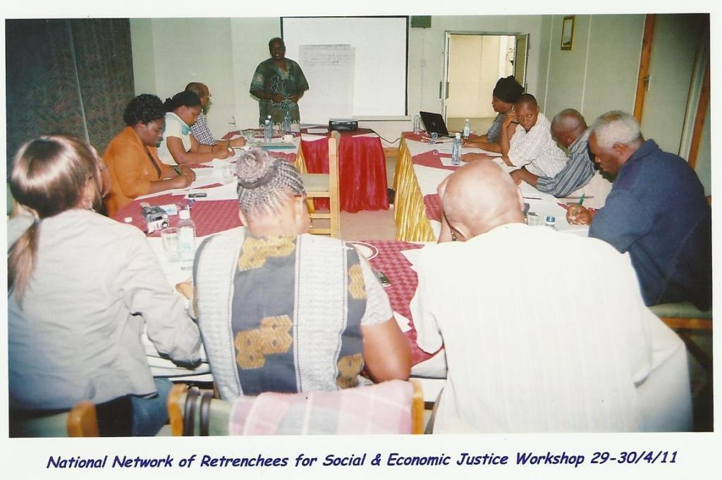

Members of NNR-K and the consultant during the strategic planning workshop.

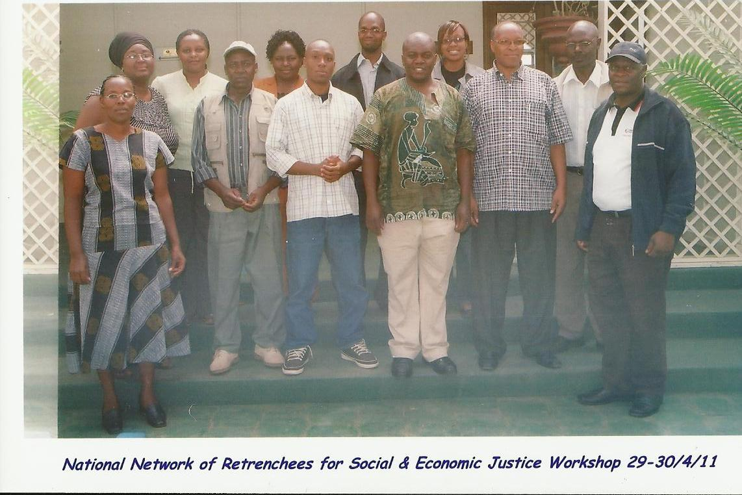

A group photo of the participants.
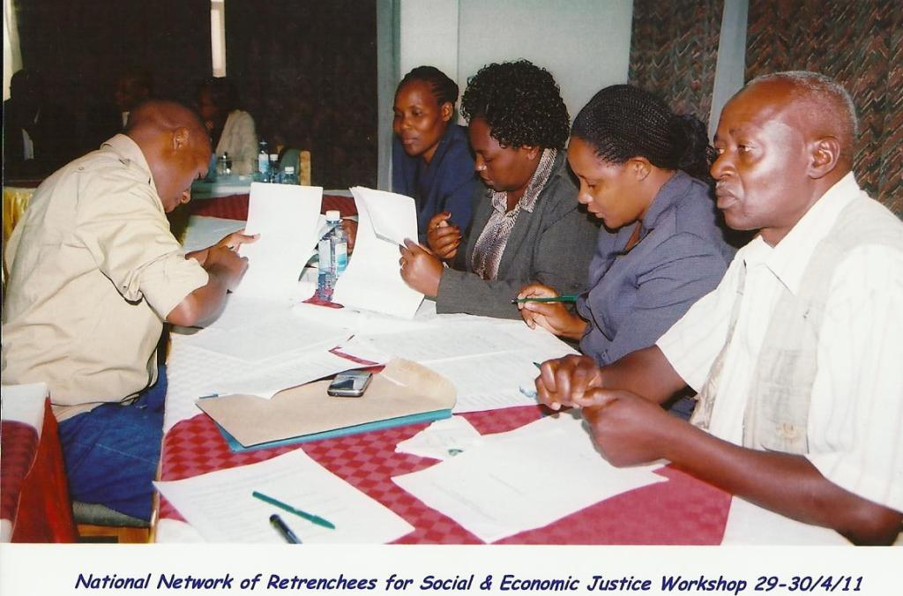

A group work session during workshop.

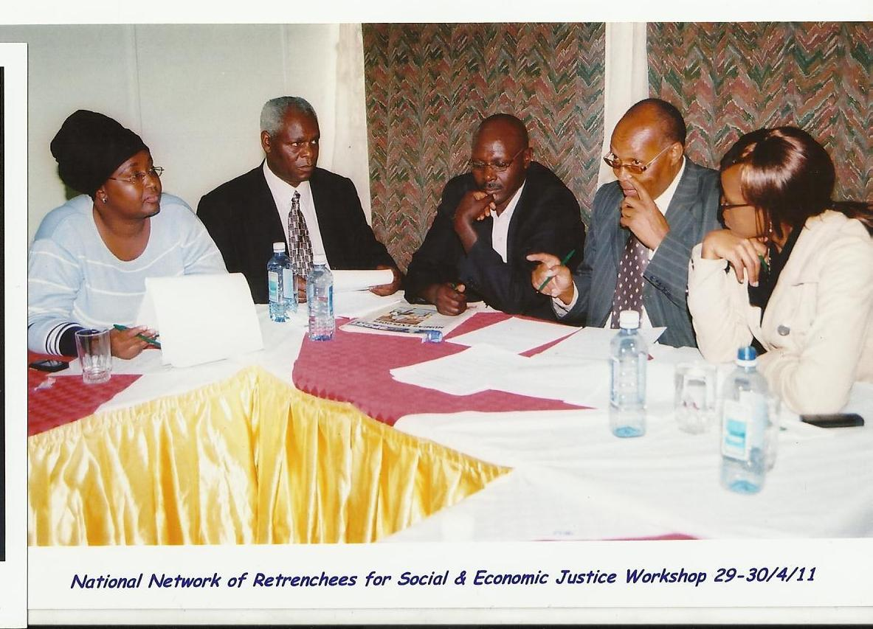

A second group engagement of the workshop.

