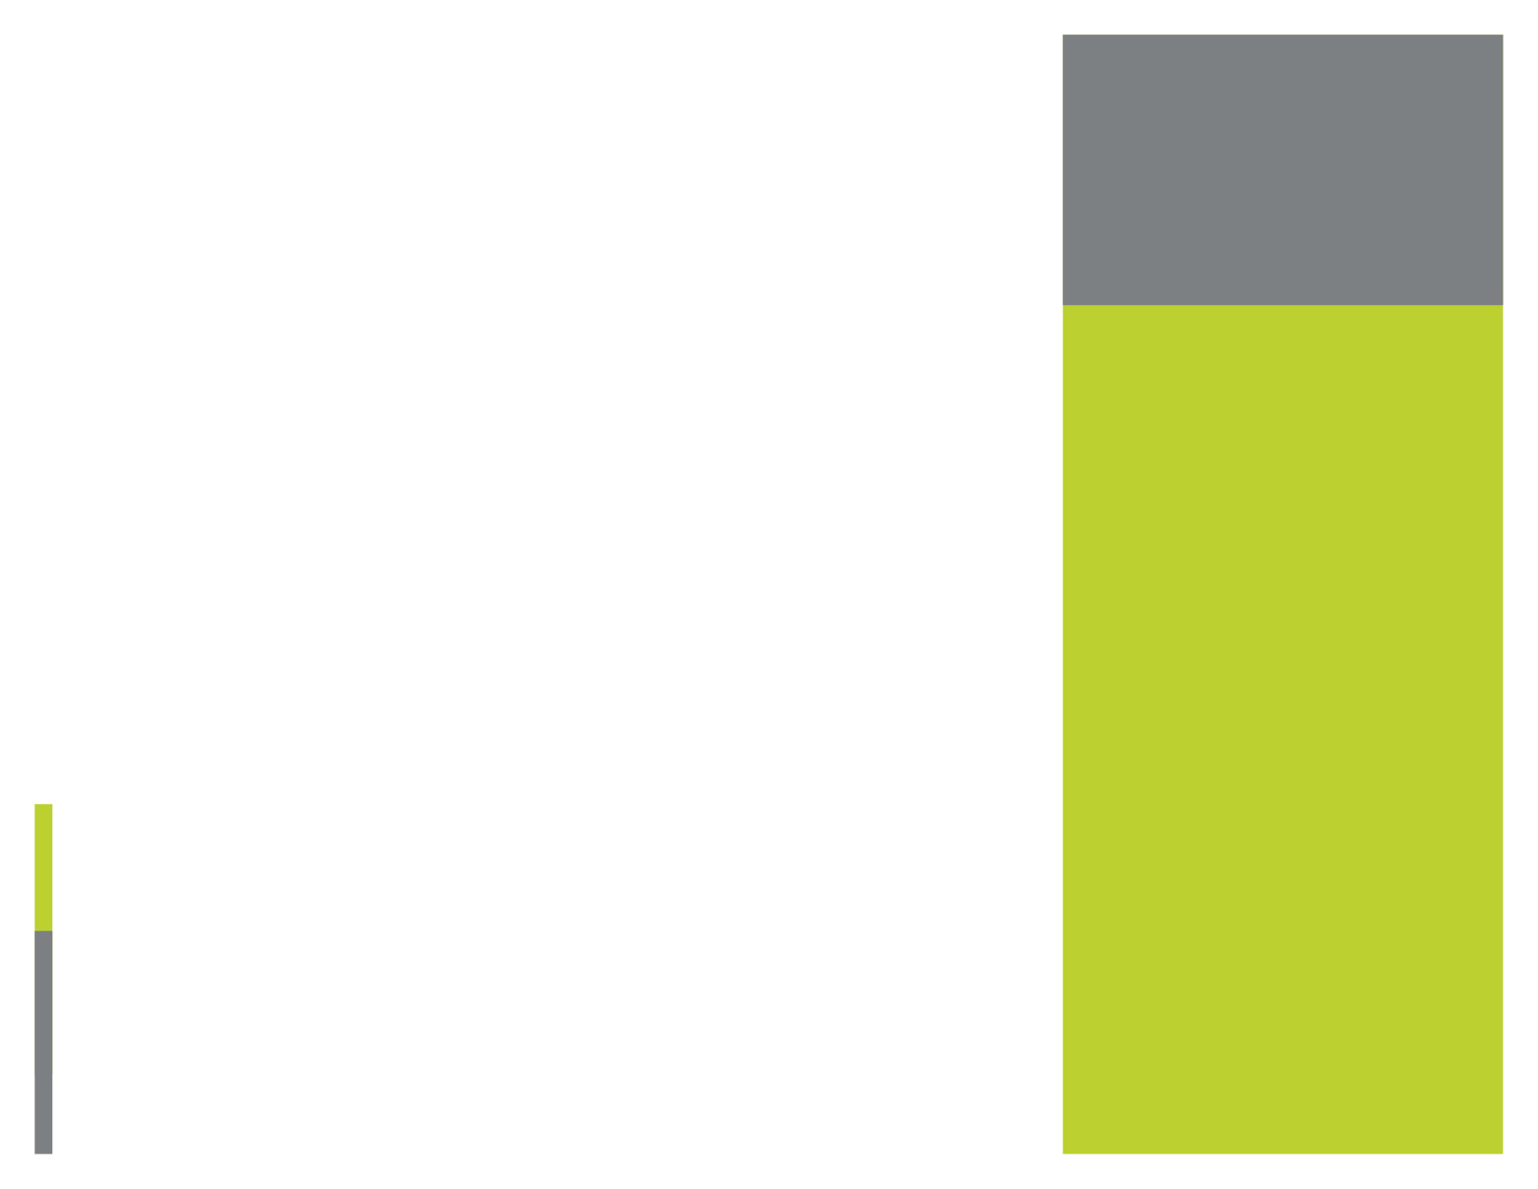

[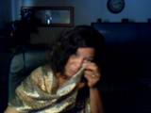](http://media.photobucket.com/image/weeping%20woman/SHARONSPIRIT123/121212.jpg?o=44)

WEEP PROGRAMME IN SOMALIA/SOMALILAND

Women empowerment is one of the key strategic programmes for the development of sustainable communities in Somalia/Somaliland. Empowering women will be key issue to the community development in Somalia.

SRDA has been supporting the marginalized and disadvantaged rural women in Somaliland/Somalia through the following key areas for the development women.

*Social and economic empowerment*

SRDA implemented a five year women economic development programme in Puntland and Somaliland through the years of 2005-2010. The women had an access for seed funds of 200USD for establishing small scale business enterprises. The project targeted the women affected by Tsunami in Puntland and around 300 women established businesses and benefited from the project during the lifetime of project.

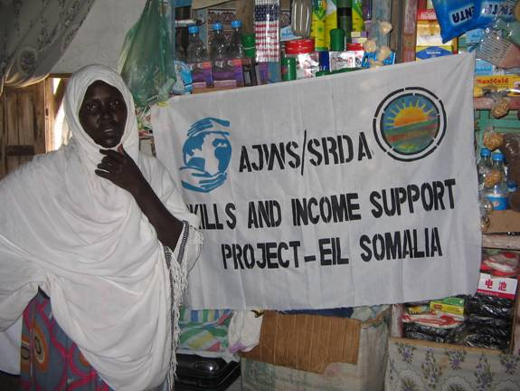

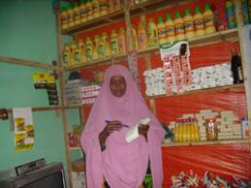

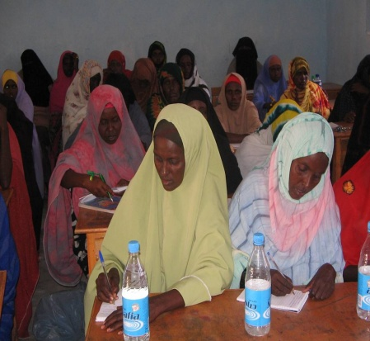

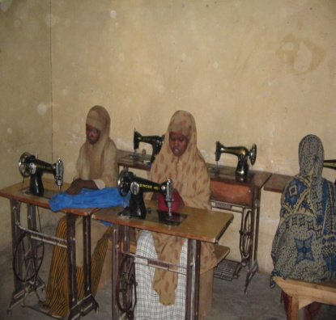

Social Relief and Development Agency (SRDA)



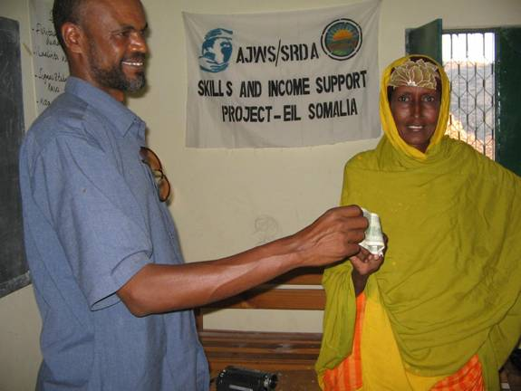

*Women receiving 200 USD seed for business*.

WOMEN ECONOMIC EMPOWERMENT PROGRAMME (WEEP)

Hargeisa

Somaliland

E: sreliefagency@hotmail.com

Tel: 252 2 4428347

Social Relief and Development Agency-Somalia

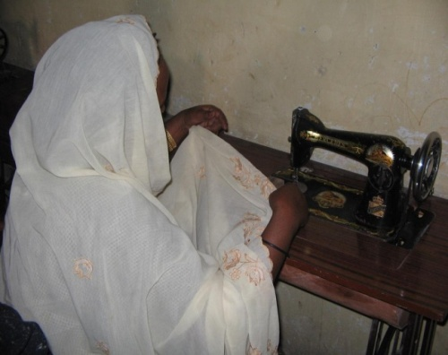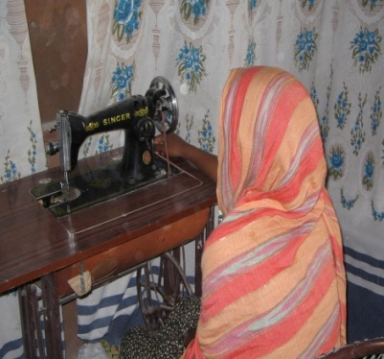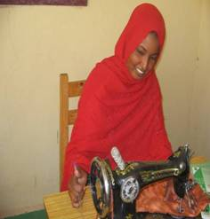 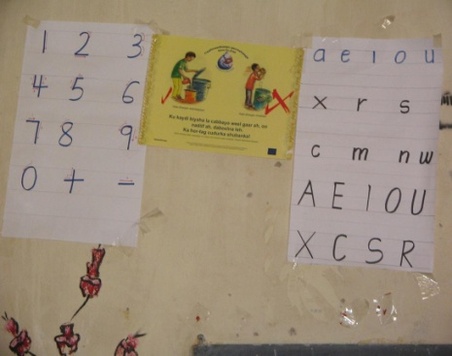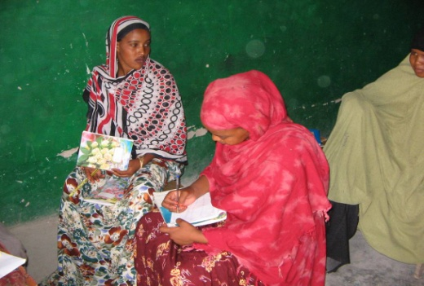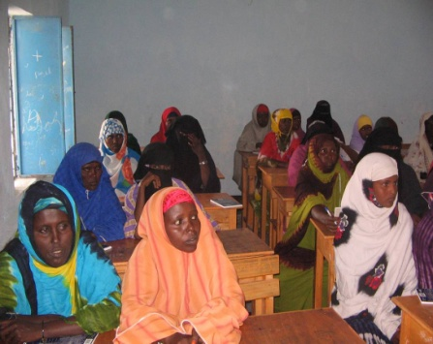

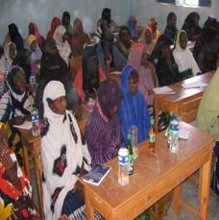

*Literacy and Numeracy Training*

The women empowerment programme has also a sub-component of Literacy and Numeracy for the women and girls who needs to learn how to read and write. The project provided literacy and numeracy training of six months for around 450 women and young girls out of schooling age.

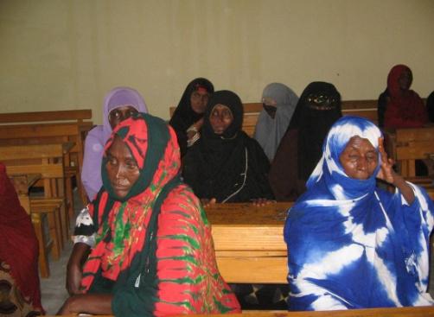

***Vocational Skills Training.***

The programme also provided opportunity for women and girls to get vocational skills development to increase the employment opportunities in order to help themselves and their families. 349 get vocational skills training in tailoring and handcrafts making

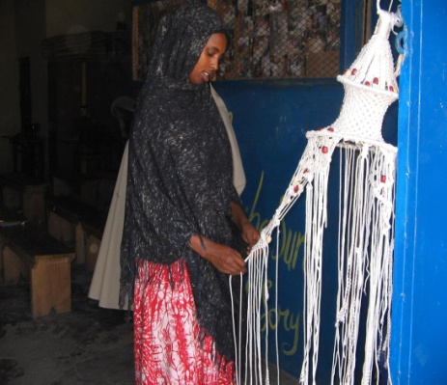

***Business Management Skills.***

Business management skills were provided to the women who had been selected for the seed fund to establish small scale business enterprises. Around 200 women and girls get access to business management skills training before they get started with the seed funding as a part of the process.

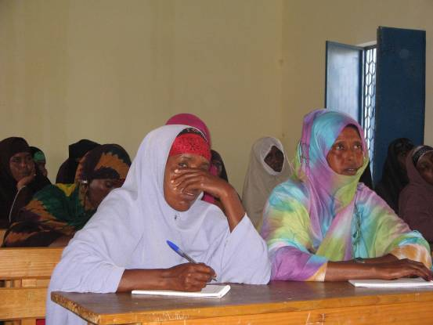

SRDA facilitated several workshops and activities towards advocacy on political participation of women and girls in Somaliland and Puntland. 135 women and girls participated in leadership and civic education training project and benefited from the project with skills to use for their future participation in leadership and their political participation rights.

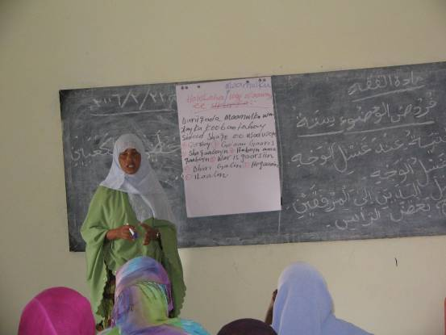

.

skills,

Literacy and numeracy training.

***Leadership and Political Participation Skills***



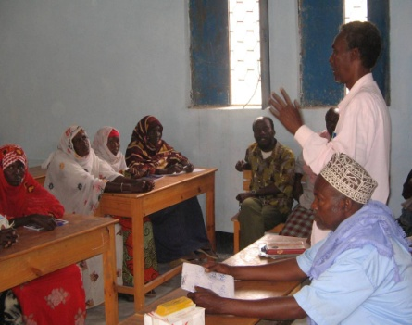

Photo Gallery