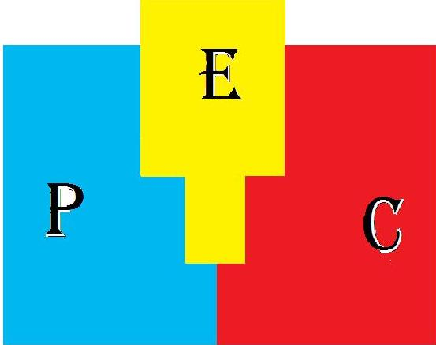

PEER EDUCATORS CLUB-GHANA
Peer Educators club-Ghana (PEC-GH) is a youth serving non-governmental organization on development and health. It is a group of youth who were trained at Bunso cocoa college as it steering group. It adopts holistic approach to help young people in making informed decision.

VISION
PEC-GH is a frontline Organization creating a platform for young people to support (counseling) the vulnerable in the society.

MISSION
PEC-GH seeks to invest in the youth and create a platform for them to pass on information through innovation programs, project and strategies in the southern sector and beyond.

Values
- Treat each other with respect
- Maintain confidentiality
- Non-judgmental
- Honesty and integrity
- Commitment and service to humanity
- Diversity and strength
- Non-discrimination.
PEC-GH seeks to achieve these stated missions by applying the following CORE VALUES in defining the quality of its service
- Privacy; the right confidentiality, personal space and personal time.
- Choice; to be given easy access to information with the opportunity to select in an informed way from a wide range of option.
- Dignity; to be respected as a valued person with space, individual; and personal needs.

OBJECTIVES
- To improve and build the capacity of sense of reliance in the youth.
- To enable young people make informed decision about their health through prevision of counseling and information.
- To improve the access of young people to leadership position.
- To create appropriate climate for policies and laws needed for meeting the needs of the youth.

Our programs

DIVERSE YOUTH HEALTH CONCEPT.
PEC-GH realized that young people are very vulnerable to sexual and reproductive health problem such as early engagement to unprotected sexual relationship, teenage pregnancy, unsafe abortion, sexual transmitted disease including HIV/AIDS, drug abuse and so on. Young people can make great difference in their schools, and their communities. Therefore the need to assist young people in acquiring skills for positive sexual behavior underlie PEC-GH’s effort in the provision of information and education on sexual and reproductive health. Youth-to-youth education, counseling, mentoring and service provision are the main approach employed in delivery these programs.

ACTIVITIES OF DIVERSE HEALTH CONCEPT.
- HIV/AIDS Education
- Mobile volunteering confidential counseling and testing for HIV
- Care and support for people living with HIV/AIDS
- Teenagers outreach to SHS
- Resettling and Rehabilitation of people with stigmatization.

PEC-GH YOUTH MEDIA ADVOCACY FORUM
The media advocacy affords the youth and the public the opportunity to make their contribution to the development of the society. It engages various guest; youth, parent, teachers, community leaders, etc in various discussion on topic such as health, youth development, leadership.
Saturday, January 19, 2013

