April 2015 – 30 June 2015 | compiled by Nkosinathi Sibanda-Gwanda District

Sibambene livestock development trust | Project Report

Summary of Activities and projects
The construction of feedlots is still in progress. Ntalale ward 11and Gungwe ward 12 is almost complete. Plumbing materials were procured for Ntalale feedlot.
DLPD and DVS are still continuing in training farmers on Pen fattening and giving them technical advice on livestock related issues.
We are in the process of partnering with various organisations to conduct Capacity building for smallholder farmers on market linkages, strengthening of farmer groups, contract farming for farmers who are into pen fattening projects and small stock production.
Sensitization of communities on establishment of Community Animals Vaccine Centres was done during this quarter.
Monitoring and field visits was done during the quarter in conjunction with key stakeholders (DLPD and DVS)
Achieved activity results
- Monitoring of feedlots projects was done during this quarter in ward 11, 12, 17 and 4. Farmers are actively participating in the construction of these feedlots, even though we have contracted builders to construct storerooms, Toilets and feed/water trophy. These projects have brought smiles to farmers who want to venture to commercial Pen fattening projects.
- The project is in the process of creating a database for farmer groups who are into pen feeding and small stock production. The main aim of this initiative is to empower farmers on Market Oriented Livestock Production and Management.
- We also managed to establish a solar powered refrigerator for Animal Vaccine at Veterinary offices in Ward 17. This project will help farmers to have access to animal vaccine at ward level.
- Look and learn visit was done during this quarter. Board members from Mwenedzi visited the district. Their aim of the visit was for learn what we have achieved as Gwanda District. We visited Nhwali warehouse ward 24, solar powered vaccine Centre ward 17, Tshongwe pre-fabricated warehouse ward 11 and Gungwe Feedlot ward 12.
Project Photos
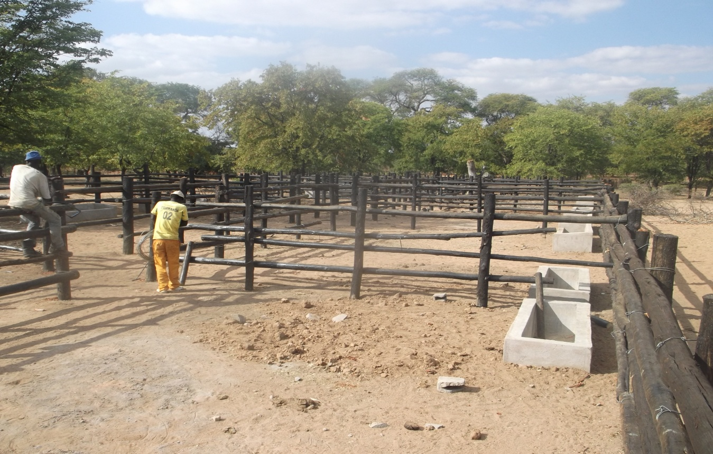
- Gungwe ward 12 Feedlot being constructed

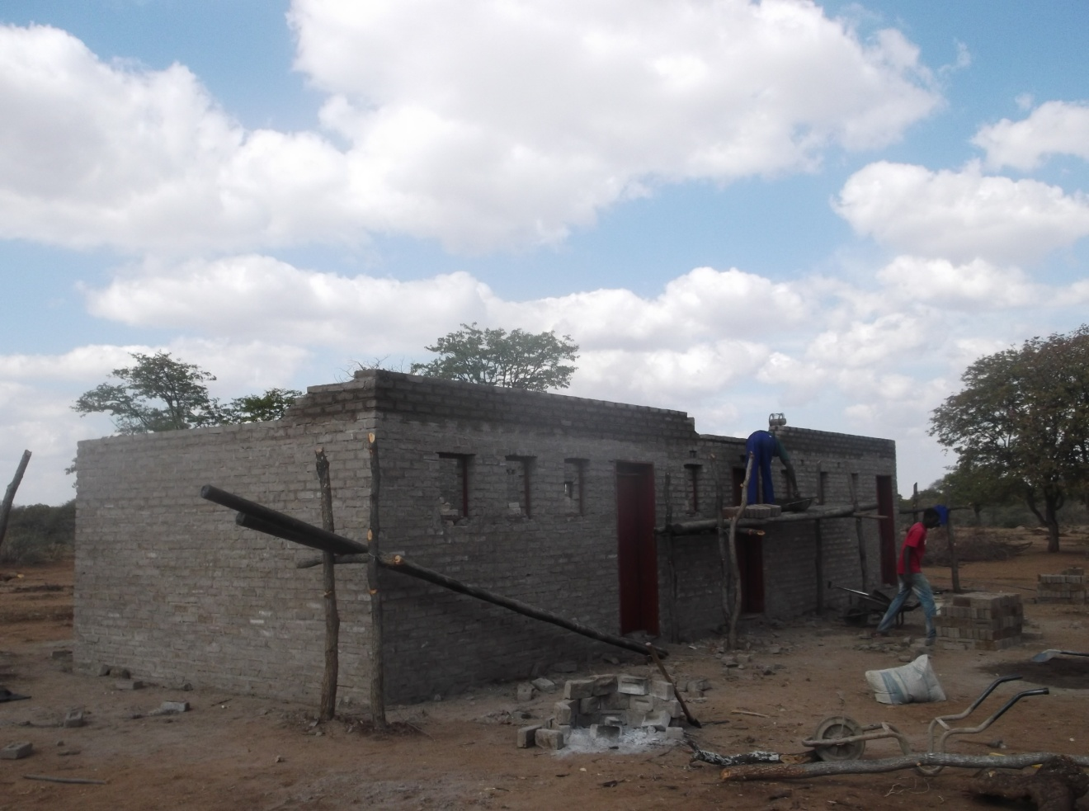

- Magaya Village Feedlot-Manama wards 17 storeroom constructions in progress.

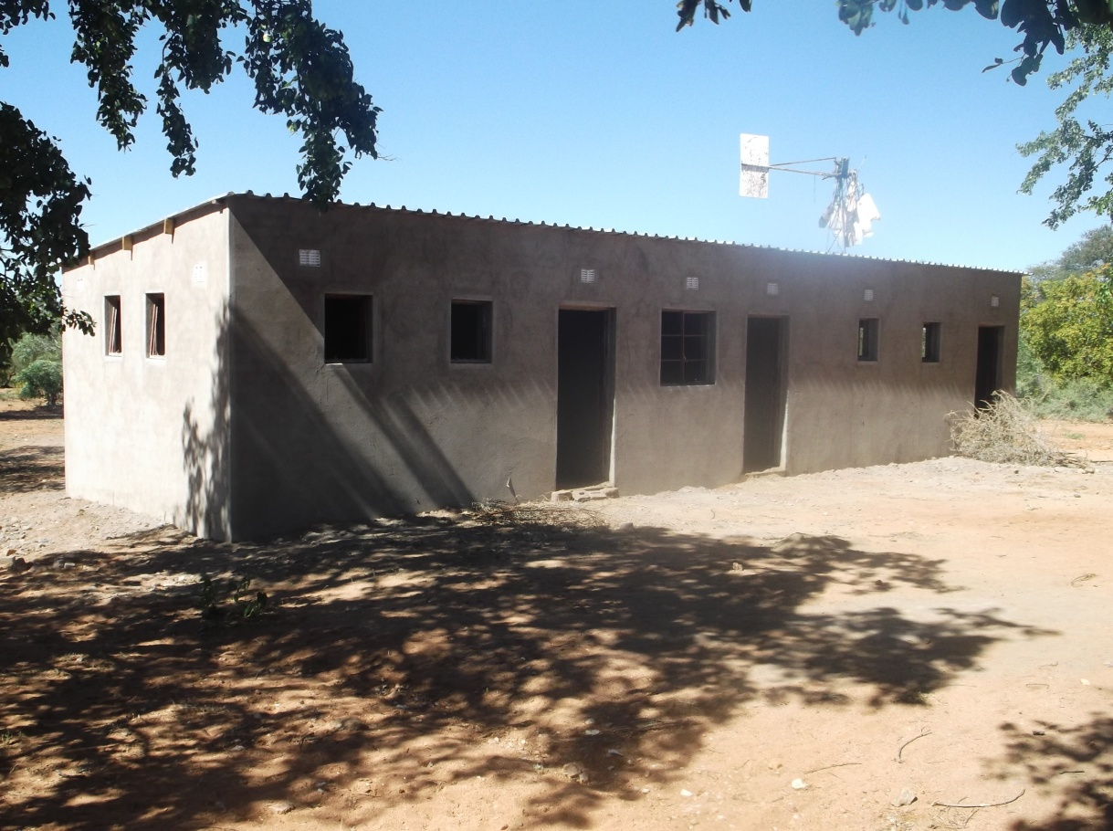

- Ntalale feedlot storeroom being constructed.

Project Challenges

- Met bank is still facing financial challenges and this has contributed to late payments of casuals and contracted builders for feedlots in ward 12 and 4 and 17
- The district is facing drought this year as the grazing lands is already deterioration.
- Debt collectors are not forthcoming and this has affected our effort to collect credits from farmers who loaned stock feed in 2013.
- Lack of Information sharing has created misunderstanding between livestock committees and community leaders.
- Power inventor was stolen from Manama Animal vaccine Centre. This was reported to CID for Investigations.

Action Taken and recommendations
Due to financial challenges faced by Met Bank we have agreed to follow up on all credits so that we can pay all our dues by the end of July.
Annual Project review meeting will be held with ward councillors, community leaders and livestock committees.
Plans for 3rd quarter – July to September 2015
- Purchasing of stock feed to strategic points- ward 11, 14 and 24
- Establishment of two more Animal Vaccine Centres in ward 1 and 16 by August
- Identification and establishment of paddocks in ward 3, 14 and 20. This will be done using the local available materials by August.
- Training of Farmers will be done on livestock production, management and Market linkages during this quarter.
- Establishment of Livestock information & Health Centre in ward 2.
- Support Division of Veterinary Services on establishment of their offices in ward 1
- Annual project review meeting will be done by August.
- Feedlot storerooms painting and glazing will be done this quarter
- Establishment of fodder gardens will be done to all feedlot sites.

