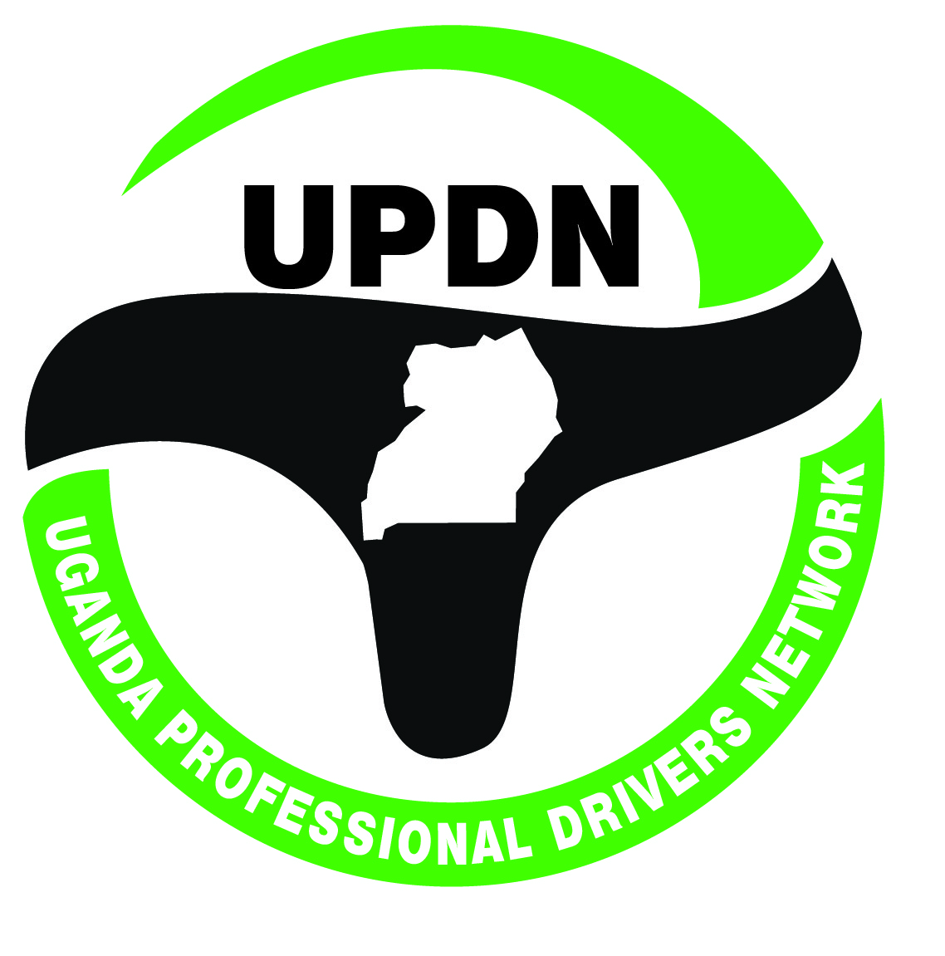
Empowered Drivers, Safer Roads

UPDN DRAFT STRATEGIC PLAN 2020 -2024

- BACKGROUND AND RATIONALE FOR THE STRATEGIC PLAN
Back ground
UPDN is an umbrella organisation for drivers’ associations/organisations. UPDN was established in 2015 at a time of when many drivers’ associations were characterized by limited organization which adversely affected coordination pursuit common objectives of better welfare, common voice and professionalism. UPDN was hence established to build skills for professional development, coordination for unified voice drivers on road safety agenda and to strengthen driver organisations for better welfare their members.
We work to work to stop the tragedy of road deaths and injuries make roads safer for every one and make driving a respected profession. Our work includes; capacity building of drivers to become road safety champions, raising awareness road safety in communities across Uganda, coordinating the national roadsafety week, campaigning for essential road safety policies and safe driving, running a membership for drivers, producing educational resources and conferences on road safety.
Rationale for the Strategic Plan
Road crashes continue to be a huge killer in Uganda often pushing families in poverty, creating a massive burden on the under-resourced health services and adversely affecting businesses and the economy as a whole. UPDN recognizes that through investments in professional development of the driving industry, and amplified advocacy for road safety with all key stakeholders, drivers can become safer and more risk aware, ultimately contribute to reducing the number of fatalities and costs to the economy.
As UPDN seeks to position as itself as a leader in professionalization of the driving industry in Uganda, the need for a strategy to deliver this aspiration has become a critical imperative. The strategic plan 2020-2024 has been formulated to cease current opportunity window of massive government investment in the road infrastructure and development of the oil and gas sector, address challenges of the future and propel UPDN to the next stage of development. The strategic plan has been developed through a process of self-assessment and broader stakeholder consultation.

- SITUATION ANALYSIS
Operational Analysis
In the last decade, road crash fatalities in Uganda rose by 25.9%. The accident severity index is 24 people killed per 100 road crashes. On average, Uganda loses 10 people per day in road traffic crashes which is the highest in East Africa. The annual cost of road crashes is estimated to be UGX 4.4 trillion representing 5% of the GDP. Whereas there are some efforts by the Government to address road safety, there is lack of a national focus. Even though this a national policy on road safety in place, the mechanism for its implementation is lacking. Additionally, Uganda lacks up to dare framework for monitoring and evaluating road safety on a regular basis.
A national road safety council exists within the Ministry of Works and Transport but is structurally underfunded and under resourced in terms of human resources and institutionally setting to effectively coordinate road safety efforts.
Uganda is yet to optimise the road safety awareness programmes. The only event championed by Government is the annual national road safety week. Child and youth safety programmes which could contribute to greater road safety awareness are lacking.
The driver licensing system (training, testing and certification) is weak. Many people acquire driving permits without undertaking the necessary training and testing. There many driver training schools which are not well regularity. There is no single institution in the country that trains drivers’ trainers/ instructors. Driving standards in Uganda are generally of poor quality and this coupled with poor drivers behaviour leads to a large number of road accidents.
Strategic Analysis
- Internal Environmental Analysis (SWOT)
STRENGTHS | STRATEGIC IMPLICATION
- Big office space in a strategic location  - Strong name recognition  - Committed volunteer staffs | - Utilise the existing space for paid training programmes
WEAKNESSES
- Inadequate skilled staffs in the organizational core business  - Limited presence of UPDN beyond the capital city  - Inadequate data on the driving industry and road safety  - Lack of harmonized and specialized competence based grading curriculum for drivers in Uganda | - Establish capacity building initiatives for staff development  - Establish offices in all the four regions of Uganda  - Establish a one stop data/resource centre on driving industry and road safety  - Strategise to participate in development and advocate for adoption of competence based driver curriculum according to market demand
OPPORTUNITIES
- High demand for professional drivers in the oil and gas sector  - Large informal driver workforce which needs skills to connect with employment opportunities  - Strong good will for road safety initiatives  - Government interest in organizing the transport sector  - Increasing partnerships for skilling drivers in the oil and gas sector  - There is no officially registered school for training of driver trainers | - Establish centre of excellence in professional drivers skills building  - Establish a flexible programme for driver continuing professional development and resourcing  - Establish partnership with Government and global road safety initiatives  - Negotiate for partnership with Chinese experts to establish a centre of excellence for skilling Ugandan drivers  - UPDN could strategise to specialize in training of trainers through its’ membership structure
THREATS
- Limited organizational capacity among UPDN member organisations  - Limited legitimate membership  - Weak financial base | - Establish capacity building programme for member drivers associations  - Undertake deliberate membership development among drivers associations /organisations  - Diversify resources through business, grants and membership development

- External Environmental Analysis (PEST)
POLITICAL | STRATEGIC IMPLICATION
- Government policy focus on skilling create a favourable environment for UPDN  - Growing progress towards the East African Federation may provide a wide market for UPDN programmes  - Weak legal enforcement of road safety related laws and policies will adversely affect UPDN programme outcomes | - UPDN will align drivers skilling programmes to government skilling Uganda policy  - UPDN will customize the EAC professional driving curriculum standards to UPDN driver certification programme  - UPDN will advocate for policy reforms in relation to roadsafety
ECONOMIC
Volatile inflation may affect costing of UPDN programmes | - UPDN will projects programme costs based on international currency
SOCIAL
Increasing middle class is an opportunity for business programmes | - UPDN will design flexible professional driving package for corporates middle class
TECHNOLOGICAL
Fast growing ICT and mobile phone technology which can be harnessed for driver training and community education | - UPDN will design e-driver training packages targeting elite middle class  - UPDN utilize the mobile phone technology for community education on

- Stakeholder Analysis
STAKEHOLDER | INTEREST IN UPDN | INFLUENCE | STRATEGIC IMPLICATION
GOVERNMENT AGENCIES
- Ministry of Works and Transport  - Ministry of Internal Affairs  - Ministry of Education and Sports  - Ministry of Trade | - High standard in driver training  - Community awareness on road safety  - Organisation of drivers into cooperatives | - Policy development  - Policy and legal enforcement  - Financial Resources | - UPDN will seek representation on government bodies for policy influencing  - UPDN will build positive working partnerships with Government agencies
PRIVATE SECTOR
- Companies in Transport business  - Driver training schools  - Driver sourcing companies  - Petroleum and gas production companies  - Large telecoms and other corporates  - Private Sector Foundation Uganda | Professionally trained and skilled drivers | - Business for driver assessments and continuing professional development  - Jobs for professional drivers  - Financial resources for road safety advocacy | - UPDN will proactively seek business partnerships with the private sector
CIVIL SOCIETY
- CSO on road safety  - Drivers Associations  - Vehicle owners Associations  - Trade unions | Road safety advocacy  Welfare and voice for drivers  Professional drivers | - Legitimacy of UPDN | - UPDN will pursue strategic partnerships with value adding CSOs  - UPDN will constructively engage with vehicle owners associations on issues of road safety and drivers welfare

Competitor Analysis
The major actors within the sphere of UPDN core business focus on training heavy goods (HGV) vehicles.

Comparative Advantage
Drivers are critical lever in the transport industry. UPDN being an umbrella organisation of drivers’ organisations gives it a competitive advantage. UPDN has access to large number of drivers and their leaders. UPDN can leverage these numbers in terms of mobilizing for professional trainings and policy influence.
- STRATEGIC DIRECTION
Strategic Issues
- Lack of professionalism in drivers training, assessment and certification standards
- Limited visibility of roadsafety on policy and public discourse
- Weak organisation and voice of drivers in labour markets and roadsafety
- Limited capacity of UPDN to execute in mandate.
Vision
To be a centre of excellence in development of professional driving industry in Uganda
Mission
To professionalise driving industry in Uganda for improved road safety
Strategic Goals/Objectives
- Skills Building for professional driving
- Advocacy for road safety
- Institutional strengthening for drivers organisations
- UPDN organisation strengthening

- IMPLEMENTATION OF THE STRATEGIC PLAN
Strategic Actions

- Promote continuing skills building among drivers
Overall strategy: (International collaboration)
Strategic Actions
- Seek accreditation status with Directorate of Industrial Training (MoES) for certification of informal drivers.
- Register and operationalize a professional driving institute/academy (focus on training of trainers and professional certification for truckers, public services drivers and drivers for corporate companies.
- Establish programme for specialized and continuous driver professional development

- Increase advocacy on road safety
Overall strategy (networking and coalition building)
Strategic Actions
Reform on driver training, assessment and grading of permits
- Standard and Accreditation system for driver training schools
- Independent driver competence assessment agency (not police)
- Driver permit grading to be based on training and competence
Community awareness and education ty on roads safety
- Inclusion of road safety in primary and secondary school curricular
- Inclusion of road safety in functional adult literacy
Visibility of road safety in public discourse/policy agenda
- Government implementation framework for the national road safety policy
- Representation of CSOs on the national road safety council

- Strengthen UPDN member driver organisations
Overall strategy
Governance and management of drivers’ organisations
- Review and strengthen leadership and management systems for UPDN member drivers organisations
- Design needs based capacity building programme to strengthen governance and management systems
Driver organisations voice in the road safety public discourse
- Provide technical assistance in advocacy capacity development
- Link drivers’ organisations to local, national and international road safety advocacy platforms
Driver organisations as catalysts for drivers’ welfare
- Review drivers organisations welfare and economic safety nets
- Strengthen leadership capacity to address workplace health and safety
- Strengthen capacity of drivers organisations to reclaim their space in the trade union movement
- Offer technical assistance in strengthening drivers savings and credit cooperatives

- Increase UPDN institutional capacity for sustainability
Overall strategy:
Governance and management
- Review governance and management policies, structures and systems to align organizational structure and resources with strategy
- Strengthen financial and staff management systems
- Establish a one stop data/resource centre on driving industry and road safety
- Expand organisations footprint through regional offices
Business development
- Establish a company to serve as business vehicle of UPDN
- Develop a business plan
- Establish business linkages with corporate organisations and companies in line with UPDN core business

- PERFORMANCE MEASUREMENT
The performance of the strategic plan will be monitored quarterly and annually against milestones set out in the performance measurement matrix. The achievement of targeted results will be assessed through the annual performance balanced score card. The organisation corporate score card will be used to track performance throughout the strategic plan period. Management will instutionalise the balanced scored performance management approach at all levels of the organisation. The UPDN corporate score card is presented as appendix 1.

- COST OF THE STRATEGIC PLAN
Mobilisation of resources to implement the strategic plan is a shared responsibility between the Board and management. Resources include human, financial and material resources. The Executive director will take lead in identifying business and grants opportinities as well as potential sponsors of UPDN strategic activities. A resource mobilisation strategy will be developed to guide all resource mobilisation and fundraising efforts. UPDN has estimated that it will require UGX. XX to implement this strategic plan. The budget projections for the strategic plan are presented as appendix 2.

