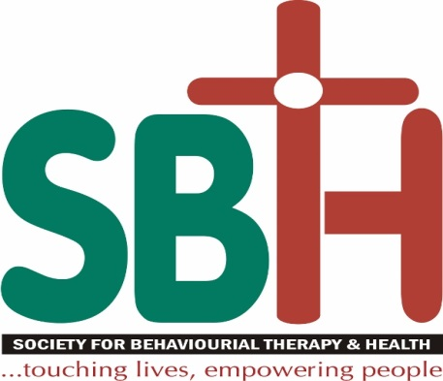

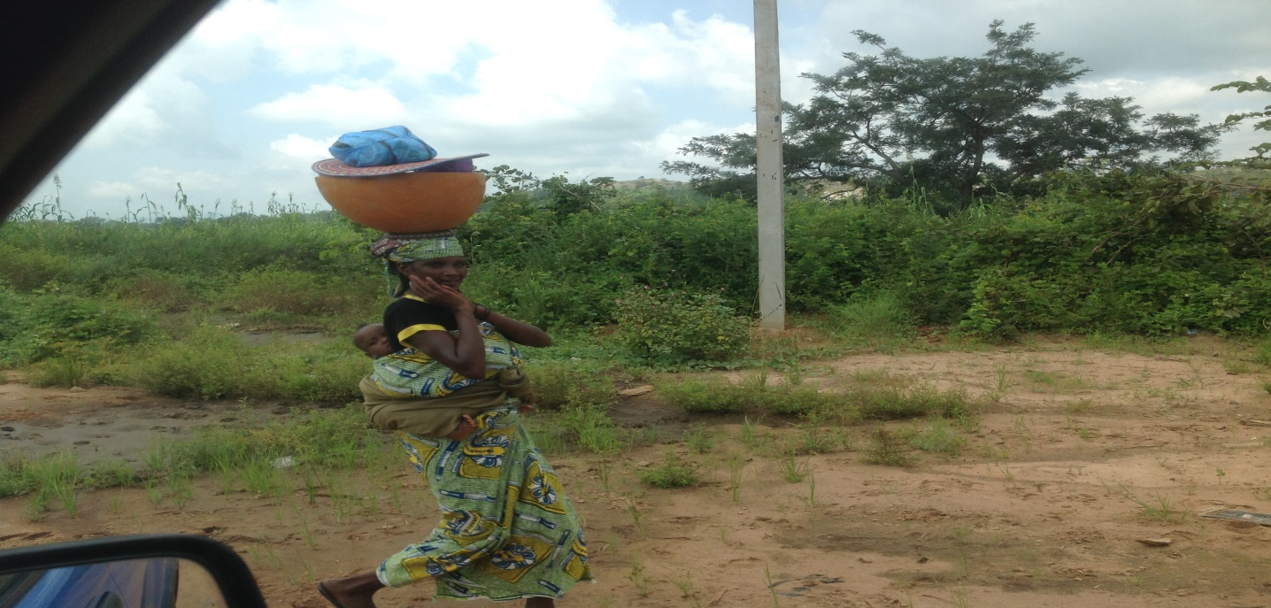 **2016 Annual Report**

**Contact:**

**Office Address:N0 120, Zone 3, Dutse Alhaji, Beside Qalbum Saleem Basic Education Centre Bwari Area Council, Federal Capital Territory, Abuja, Nigeria.**

**Telephone: +234 703 641 5679, +234 809 334 0615 Email:** [**sbth0016@gmail.com**](mailto:sbth0016@gmail.com)

**Website:** [**www.sbth.ng.org**](http://www.sbth.ng.org) **Twitter: @sbtn_ngo**

1.0 A**bout this Report**

This Annual Report provides an overview of the work of the Society for Behavioural Therapy and Health from April- December 2017. The Report covers details of work done by the Behavioural Therapy and Health Secretariat. Financial figures are provided for both the Members as a whole and for the Secretariat.

**SECTION 1: AN OVERVIEW OF SOCIETY FOR BEHAVIOURAL THERAPY & HEALTH**

**1.1 About Us**

Society for Behavioural Therapy and Health (SBTH) is a public non-denominational Christian non-governmental, not-for-profit making indigenous organization based in Abuja, Federal Capital Territory, North Central, Nigeria. It was established in 2016 registered with the Corporate Affairs Commission of the Federal Republic of Nigeria; registration number is CAC/IT/NO 89634.SBTH’s vision is to envisions stable communities that can develop effective institutions to provide for their people, enabling them to overcome hardship and live peaceful and fulfilling lives and its mission is to assist and support impoverished and disadvantage people – children, youth, men, woman and older person in a holistic manner by ensuring the right of all people to development, security and enhanced quality life.

We are motivated by the example of Jesus Christ to cherish, preserve and uphold the sacredness and dignity of all human life, foster charity and justice through His teaching as we act to promote human development by responding to major emergencies, fighting disease and poverty, and nurturing peaceful and just societies. We reach out in care and love to those who are poor and disadvantage, children, youth, men, woman, families and elderly person the in various aspects of:

1. **Emergency Response and Recovery**

Emergencies can cause extreme hardship. There is often destruction of homes and infrastructure, like roads and bridges, plus a breakdown in normal economic processes. As a result, people in disaster-stricken areas often lack access to food or are unable to earn money to buy food. Our vision is to promote social justice, solidarity and compassion through timely emergency and recovery actions that address the needs of the most vulnerable. We take a comprehensive approach to emergency response and recovery by providing lifesaving help to get survivors back on their feet.

1. **Education**

Society for Behavioural Therapy & Health promotes access to high quality education for the children of school age particularly the orphan and marginalizes children. SBTH also work side by side with ministries, communities, schools, teachers and families to create education systems that respond to the complex, dynamic and diverse needs of the people they serve.

1. **Health**

Improving the health of women, men, youth and children is core to our mission. Good health provides the foundation for community and economic development. Health is complex and multidimensional. We seek to understand what people need to be healthy and to generate the evidence needed to address their health challenge. Our focus is to reduce child mortality, improve maternal health and eradicate endemic disease like HIV/AIDS, tuberculosis, malaria and prevention and control of chronic non-communicable diseases.

1. **Nutrition & Agriculture**

Good nutrition is a cornerstone of well-being, particularly in the first 24 months of life. It provides a key foundation for maximizing human potential and national development. SBTH partner with international organizations, civil societies, Government Institutions and funders to design and implement strategies, policies, programs and systems that address nutrition emergencies and create sustainable change. SBTH also help the communities and famers to organize into group and build a sustainable agro business.

1. **Water and Sanitation**

The lack of safe water remains a problem for more than one billion people year; approximately 3 million children under five years old die from diarrheal illnesses, mostly acquired from contaminated water. As a response to need of the affected communities to have increase access safe water, SBTH mobilize resource from international organizations, civil societies, government institutions and funder for safe water with the aim of reducing childhood morbidity and mortality, while minimizing diarrheal disease among the general population as a whole.

1. **Poverty Alleviation & Microfinance**

Economic development programs help women and men create a sound economic future for themselves and their families. Our work is focus on increasing productivity, household food security, employment household incomes.

1. **Drug Prevention &Treatment**

SBTH identifies and promote effective new strategies to reduce the demand for illegal drugs. As non-partisan and non-political, SBTH serves as a catalyst for change by encouraging action by government agencies, non-profits, research institutions and grassroots community groups that works to reduce illegal drug use with the power of good ideas supported by effective policies and programs.

1. **Social and Behavior Change Communication**

Our experts use innovative communication and social marketing to promote positive social and behavior change among individuals, systems and communities. We develop strategies that address the interests of the people we are trying to reach, the obstacles to taking action and the many forces that influence behavior and choice.

1. **Capacity Developments**

We are committed to building an enduring capacity through collaborative effort with national and local governments, community and faith-based organizations, and private-sector entities to meet challenges, solve problems and improve lives in lasting ways. We build capacity into all aspects of programming, including strategic planning, needs assessment, program design and development, work planning, budgeting, implementation, and ongoing monitoring and evaluation.

1. **Research**

There is an art to improving lives. And it’s in our science. We will use research to respond to a wide variety of human development issues, including health, education, economic development and gender equality.

**1.2 Our Core Values**

We are one family that are committed to the pursuant of our vision and mission statement, while taking pride in our core value system. Society for Behavioural Therapy & Health’s core values are guiding principles and tenets that describe how the organisation strives to operate:

1. **Passion for God**

Our passion is to love the Lord God with all our heart, soul, and strength, striving to do His will and glorify Him by being His hands, feet, mouth and ears, as ambassadors of the living God. Our hallmark is to be unashamedly Christian and uncompromisingly Biblical (Deut 6:5).

1. **Faith**

We desire to not only know what God can do, but have the confident expectation of knowing what God will do (Heb 11:1)

1. **Love and solidarity**

We believe that we should clothe ourselves with compassion, kindness humility gentleness and patience (Col 3:12) Compassion is this: That we reach out in care and love to those who are harassed and helpless, stricken and rejected, the orphan’s and widows. We are called to love and care for one another in compassion and humility, as we stand alongside all those who struggle against poverty, powerlessness and injustice.

1. **Dignity and respect**

We are convinced that every human being has innate dignity. All people are of equal worth, which is why we place honesty and respect for others at the heart of what we do.

1. **Justice and equality**

We understand that where people lack power, poverty prevails, so we support work that empowers individuals and communities. We fight injustice and inequality with courage, hope and determination, challenging the structures and systems that prevent people from rising out of poverty.

1. **Cooperation and partnership**

Our work is rooted in a spirit of cooperation and we affirm the value of acting in partnership with others. We work with and for the churches, as well as with other faith and secular groups. We also engage with other key actors, including donors, civil society, government and the private sector, in various ways and on various levels.

1. **Accountability and stewardship**

We are accountable for how we use the resources entrusted to us, ensuring that our decision-making is open and transparent. We measure our impact and are always striving to improve our performance. We are committed to being effective stewards of the planet's scarce resources and caring for the earth for the sake of future generations.

**1.3 Our People**

|  |  |  |  |
| --- | --- | --- | --- |
| **Name** | **Qualification** | **Designation** | **Employment Status** |
| Daodu Olayinka Francis | Eng., MNSE, NICE, COREN, R. Eng | BOT Chair |  |
| Davies Olalekan | B.A Communication Art | BOT, Vice Chair |  |
| Olorunfemi Olusegun | HND Bus. Mgt, PGD Mgt Science, M.Sc. Social Work | BOT Secretary/Executive Director |  |
| Olorunfemi Eunice | R.N, R.M, PGD Social Work,M.SC Environmental Health Management | BOT Member | Volunteer |
| Egopija Dooshima | BA English, M.SC Development Studies | BOT Member | Volunteer |
| Samuel Oluwapelumi | BSc, Agric. M.Sc. Crop Protection | Program Associate | Staff |
| Ayodele Olatunde Michael | HND, Science Lab Tech. | Program Officer | Volunteer |

**SECTION 2: GOVERNANCE**

SBTH is officially registered with Bwari Area Council, FCT, Abuja Nigeria in June 2016 with registration 00472 and Corporate Affairs Commission (CAC) in August 2016 with registration CAC/IT/NO 89634. The process of registration with other relevant agencies and networks such as FCT Social Secretariat, Federal Ministries of Women Affairs, Education and Justice, Association of OVC NGOs in Nigeria (AONN), National Network of People Living with HIV/AIDS in Nigeria (NEPWHAN), Civil Society in HIV/ AIDS (CiSHAN), Civil Society in Malaria Control Immunization and Nutrition (ACOMIN). Civil Society on the Eradication of Tuberculosis is going. On the international level, SBTH is registered with Word Federation Against Drugs (WFAD) and International Substance Abuse & Addiction Coalition (ISAAC).

The policy framework of SBTH is guided by fully registered memorandum and articles of Association and regulated through the CAC. In extending development supports to its clientele, SBTH operates in organs which include:

1. The General Assembly: General Assembly is the highest decision making body whose decision on any matter is final. The General Assembly consist of the Board of Trustees, Registered members, Governing Council and Management. However, other staff members may attend and participate in deliberations but will not have voting rights at such meetings.

1. Board of Trustees: organization. Composed of (5) founder members. They include: Board Chairman, Vice Chairman, Secretary and 2 Board members, the Executive Director is the secretary to the board. The Board formulates policy and supervises implementation of programs.
2. Governing Council: The Governing Council consists of seven (7) persons including the Chair, Vice Chair and the Executive Director. The Governing Council is vested with the responsibility for the governance of the organisation and shall exercise the powers and functions assigned to it by the Constitution, by the Regulations made under this Constitution, or by resolution of the Assembly.
3. Management Committee: Headed by the Executive Director is responsible for overall programmes coordination, resource mobilization, advocacy/policy influencing and external engagements and provision of technical support for Governing Council and Board of Trustees over sight functions.
4. Standing Committees: appointed toassist the Board of Trustees/Governing Council in performance of its functions and other duties. The Committees comprise the following:
5. Programmes, Advocacy and Research Committee
6. Finance and Resource Mobilization Committee
7. Ethics, Governance and Networking Committee.

**3.0 OUR OBJECTIVES & ACTIVITIES**

**3.1 Our Objectives**

The organization is a non- denominational Christian Non-Government organization with the following aims and objectives: To facilitates the development of human capital and self-reliance within a caring and enabling socio-economic environment. This will be done by rendering service, to children, youth, men, woman, families and elderly person in an holistic manner ensuring the right of all to development, security and enhancement of quality of life. This we shall endeavor to achieve by:

1. Promoting social justice, solidarity and compassion through timely emergency and recovery actions that address the needs of the most vulnerable.
2. Supporting communities, local partners and governments in their efforts to ensure that all children including the most vulnerable and marginalized have the right to a quality education.
3. Mobilizing resources to ensure that the poorest and most remote communities have access to safer water, sanitation and hygiene services.
4. Running and working with organization groups in which young people will be encouraged to develop self-reliance by being provided with opportunity to build their own capacity and support network to act on their own choices and sense of responsibility. These groups shall be instructed in scriptural principle, health, nutrition, sexual education
5. Running and working with organization in the outlying areas to empower woman to enhance their quality of life by enabling them through lesson in the scriptural principle, health nutrition, preventive medicine and general education for life therapy promoting and protecting the stability of marriage and family life
6. Providing for the spiritual and material needs of the elderly and infirm.
7. Demonstrating Christian love and values through evangelism, outreaches and Christian activities.
8. Engaging civil society organization and the public and private sectors to foster inclusion, equity and accountability. Our programs will be conflict sensitive, aimed at minimizing potential harm and maximizing social benefits for all. They will be also gender sensitive, helping to reduce inequalities between women, boys and girls at the individual, household, community, national and international levels.
9. Strengthen local organizations, support grassroots advocacy, and provide strategic guidance that leads to sustainable change.
10. Partnering with international organizations, civil societies, Government Institutions and funders to design and implement strategies, policies, programs and systems that address nutrition emergencies and create sustainable change.
11. Actively assisting poverty relief in the community by creating sustainable employment and encouraging self-employment through developing entrepreneurial skills.
12. Raise the social consciousness and awareness of the general public through effective dissemination of information on civic, social, religious, political and economic rights.
13. Ensuring maximum efficiency with respect to the accountability and administration of funds.
14. Undertake other activities that may be necessary to attain the objectives of the organization

**3.2 Activities Undertook During the Report Period**

**3.2.1 Board of Trustee Inaugural Meeting**

The inaugural of the BOT of SBTH was held on 9th May 2016 after due consultation with the members. Through this meeting the Initiator, Mr. Olorunfemi Olusegun share is vision is to envisions stable communities that can develop effective institutions to provide for their people, enabling them to overcome hardship and live peaceful and fulfilling lives and its mission is to assist and support impoverished and disadvantage people – children, youth, men, woman and older person in a holistic manner by ensuring the right of all people to development, security and enhanced quality life. The aims and objectives, values and core program areas were present to the members. He solicited for the support of the member to work together. The members at the meeting applauded the initiatives and pledge their support for the success of the organization.

It was agreed by the BOT members to have 3 officers for the BOT considering the size and urgent need. The officers of the BOT agreed to by the members are: Chairman, Vice Chairman and the Secretary. The following names were nominated for the three position and members unanimously agreed to all the nomination and the position: Engr.Daodu Olayinka Chairman, Pastor Davies Lekan Vice Chairman Olusegun Olorunfemi Secretary.

**3.2.2 Development, Review and Adaptation of Policy Document**

The BOT during the period under review developed and adapted various policy document to guide the operation of the organization and for registration with the Cooperate Affairs Commission (CAC) and other relevant Agencies of government and Networks. The document developed and adapted includes SBTH Constitution and Administrative Policy, Personnel Policy, Financial Policy, Procurement and Travel Policy.

**3.2.3 Registration of SBTH with Corporate Affairs Commission & Relevant Agencies**

SBTH has being officially registered with Bwari Area Council, FCT, Abuja Nigeria in June 2016 with registration 00472 and Corporate Affairs Commission (CAC) on 8th August 2016 with registration CAC/IT/NO 89634. The process of registration with other relevant agencies and networks such as FCT Social Secretariat, Federal Ministries of Women Affairs, Education and Justice, Association of OVC NGOs in Nigeria (AONN), National Network of People Living with HIV/AIDS in Nigeria (NEPWHAN), Civil Society in HIV/ AIDS (CiSHAN), Civil Society in Malaria Control Immunization and Nutrition (ACOMIN). Civil Society on the Eradication of Tuberculosis is going. On the international level, SBTH was also registered with Word Federation against Drugs (WFAD) and International Substance Abuse & Addiction Coalition (ISAAC). The registration of SBTH with SCUMUL department of the Economic & Financial Crime Commission and Federal Inland Revenue Service was completed in the year under review.

**3.2.4 Opening of Bank Account**

A naira current account was opened with First Bank of Nigeria Plc., Gwarinpa Abuja for Society for Behavioural Therapy & Health in December 2016 and it’s operational. The process of opening the foreign account and account 2 with other bank as agreed the BOT.

**3.2.5 Office Accommodation**

Society for Behavioural Therapy & Health was able to secure a one bed room flat as office accommodation in Dutse Alhaji, Abuja. The office is located at N0 120, Zone 3, Dutse Alhaji, Beside Qalbum Saleem Basic Education Centre Bwari Area Council, Federal Capital Territory, Abuja, Nigeria.

**3.2.6 In Kind Grant from Vitamin Angels**

Vitamins Angels in December 2016 donated-500 doses of Vitamin A 100,000 IU - Children 6-11 Months (1 bottles, enough for 500 beneficiaries); 1,000 doses of Vitamin A 200,000 IU - Children 12-59 Months (2 bottles, enough for 500 beneficiaries); 1,000 doses of Albendazole 400 mg - Children 12-59 Months (1 bottle, enough for 500 beneficiaries) to Society for Behavioral Therapy & Health for Distribution at No cost to children less than 5years of age in communities in Federal Capital Territory, Abuja Nigeria.

**3.2.7 Meetings attended**

* The launch of the FCT Children Service Directory at Art & Culture Centre, Area 10 Abuja Nigeria
* 1st Annual National Vulnerable Children Conference organized by the Association for Orphans and Vulnerable Children in Nigeria on 3rd August 2016 at Sharon Ultimate Hotel Area 3 Abuja.

3.3 Next Quarter Results and Related Tasks

* Completion of SBTH registration with Relevant Agencies & Network
* Development & Setting up SBTH Web Site & Other social Media platform
* Procurement of office equipment & Setting up of Office
* Recruitment of Project Staff
* Advocacy visit to major stakeholder in Project Communities, LGA & States
* Orientation Workshop for SBTH BOT members & Staff.
* Capacity Building & Training of SBTH Management on Resource Mobilization & Other Program Areas including Monitoring & Evaluation.
* Development of SBTH Strategic Plan, Policy Document and Reporting Templates
* Identification of Project Communities & Beneficiaries
* Identification & Training of Volunteers in Project Communities
* Mobilization of resource for project activities- RFP, Donation. Etc
* Attendance at seminars, workshops, and trainings
* Service Delivery at Community Level
* Participation in Networks & Technical Working Group meetings
* Conduct of project Weekly/quarterly review meeting

**4.0 OTHER IMPORTANT INFORMATION**

**Acknowledgement & Thank You**

**4.1 Our Supporters**

Society for Behavioural Therapy & Health is deeply grateful for continued and generous support of all our Board of Trust, Donors, Partners and Individual supporters. Their commitment and passion is an inspiration.

**4.2 Partners & Donor**

****Vitamin Angels (VA) makes in-kind grants of Vitamin A supplements and chewable Albendazole to qualified non-governmental organizations (NGOs) able to deploy micronutrients through their existing health and community based programs to children less than 5 years of age who are at risk for vitamin A deficiency (VAD).

Vitamin Angels currently works in 54 countries with a network of over 300.NGOs to deliver vitamin A to more than 30,000,000 children less than 5 years of age, and is eager to expand this network in Nigeria. By making in-kind product grants available to support grassroots NGOs in alleviating micronutrient deficiency or hidden hunger in Nigeria, VA seeks to enable Nigeria to achieve Millennium Development Goal 4. VA supports local NGOs, health clinics, eye hospitals, orphanages, and community based organizations to incorporate sustainable micro- nutrient distribution programs for children less than five who are residing in hard to reach communities. Vitamin Angels’ approach therefore compliments the efforts by the Government of Nigeria and is consistent with accepted best practices adapted for local use.

Vitamins Angels in December 2016 donated**-**500 doses of Vitamin A 100,000 IU - Children 6-11 Months (1 bottles, enough for 500 beneficiaries); 1,000 doses of Vitamin A 200,000 IU - Children 12-59 Months (2 bottles, enough for 500 beneficiaries); 1,000 doses of Albendazole 400 mg - Children 12-59 Months (1 bottle, enough for 500 beneficiaries) to Society for Behavioral Therapy & Health for Distribution to children less than 5years of age in communities in Federal Capital Territory, Abuja Nigeria

**WFAD** is a multilateral community of non-governmental organization and individual that shares a common concern that illicit drug use is undercutting traditional values and threatening the existence of stable families, communities, and government institutions throughout the world. Its main aim is to work for a drug-free world  
the work of WFAD is built on the principles of universal fellowship and basic human and democratic rights and believe that working for a drug-free world will promote peace, human development, democracy, tolerance, equality, freedom and justice. In line with one of core area of drugs prevention and treatment to identifies and promote effective new strategies to reduce the demand for illegal drugs, Society for Behavioural Therapy & Health in 2016 apply for membership of World Federation Against Drugs and this was approved by the board of WFAD through a mail sent to us 30th day of November 2016 with the certificate of membership attached

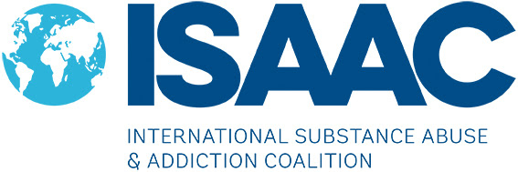Is an international network of Christians, working in the tough field of addictions and recovery across the world. It members work with people with drug and alcohol problems as well as people with other forms of addiction – like eating disorders, relationships and codependency. ISAAC International aims to connect, encourage and equip all its members through small regional groups, conferences, regular mailings, social media and personal contact. Society for Behavioural Therapy & Health in the year under review apply for membership with ISAAC and it was granted by the board of ISAAC through mail send on 14th day of November, 2016 to confirm ISAAC organization Membership Certificate has been posted to us. We have also be able to get some resources from ISAAC resource Centre on addiction with aim of equipping SBTH members to be better position for task ahead in this regard in the coming year.

**4.3 Individual Donor**

* Mr. Amosu Olayemi, a Quantity Suyevor based in Lagos,
* Dr. Seye Lojede, A Dentist at National Hospital, Abuja
* Pastor Tokubie Alaye-Ogan of the Redeemed Christian Church of God, The Everlasting Covenant Parish, Gwarinmpa, Abuja, Nigeria for allowing us to use the church for Administrative use and his donation
* Dr. (Mrs.)Evelyn Alaye-Ogan also of the Redeemed Christian Church of God, The Everlasting Covenant Parish, Gwarinmpa, Abuja, Nigeria who donated an HP printers and CPU to SBTH

1. **HOW YOU CAN HELP**
   1. **Become a member**

Membership is open to all who subscribe to the ideals of Society for Behavioral Therapy & Health and pay the prescribed dues irrespective of creed, tribe, gender or educational qualification; PROVIDED always that the Incorporated Board of Trustees shall make Bye laws, Rules and Regulations for the admission of members.

**5.3 Make a donor or Partner**

Contribute to making communities healthier and sustainable by supporting SBTH with financial contribution. To make a direct payment to one of our accounts, kindly find below Bank Details for your use. Otherwise, kindly leave your details via the form provided for follow up purposes. Be assured of the utmost confidentiality of your details which will not be shared or divulged to a third party.

**Bank Details**

**Account Name: Society for Behavioural Therapy & Health**

**Bank Name: First Bank Nigeria PLC**

**Branch: Gwarinmpa Abuja Nigeria**

**Account Type: Current- Naira**

**Account No: 2031593300**

1. **OTHER WAYS YOU CAN HELP OUR CAUSE**

* **Prayer** we recognize that prayer is of the utmost importance, an invaluable contribution to helping the poor. It guides our actions; it binds us in solidarity to one another and connects us more deeply with the grace that flows from God. We invite you to join us in praying for the poor.
* **Advocate:** Put your faith into action through advocacy. Become a voice for those who can’t speak for themselves.

**7.0 CONTACT US**

**Registered Office:**

Plot 57, 4th Avenue, Cietec Estate Gwarimpa Abuja Municipal Area Council, Abuja, Nigeria.

**Office Address:**

N0 120, Zone 3, Dutse Alhaji, Beside Qalbum Saleem Basic Education Centre Bwari Area Council, Federal Capital Territory, Abuja, Nigeria.

Telephone: +234 703 641 5679, +234 809 334 0615

Email: [sbth0016@gmail.com](mailto:sbth0016@gmail.com)

Website: [www.sbth.ng.org](http://www.sbth.ng.org)

Twitter: @sbtn_ngo