The Organization Profile

Of

BENGAL BAPTIST FELLOWSHIP

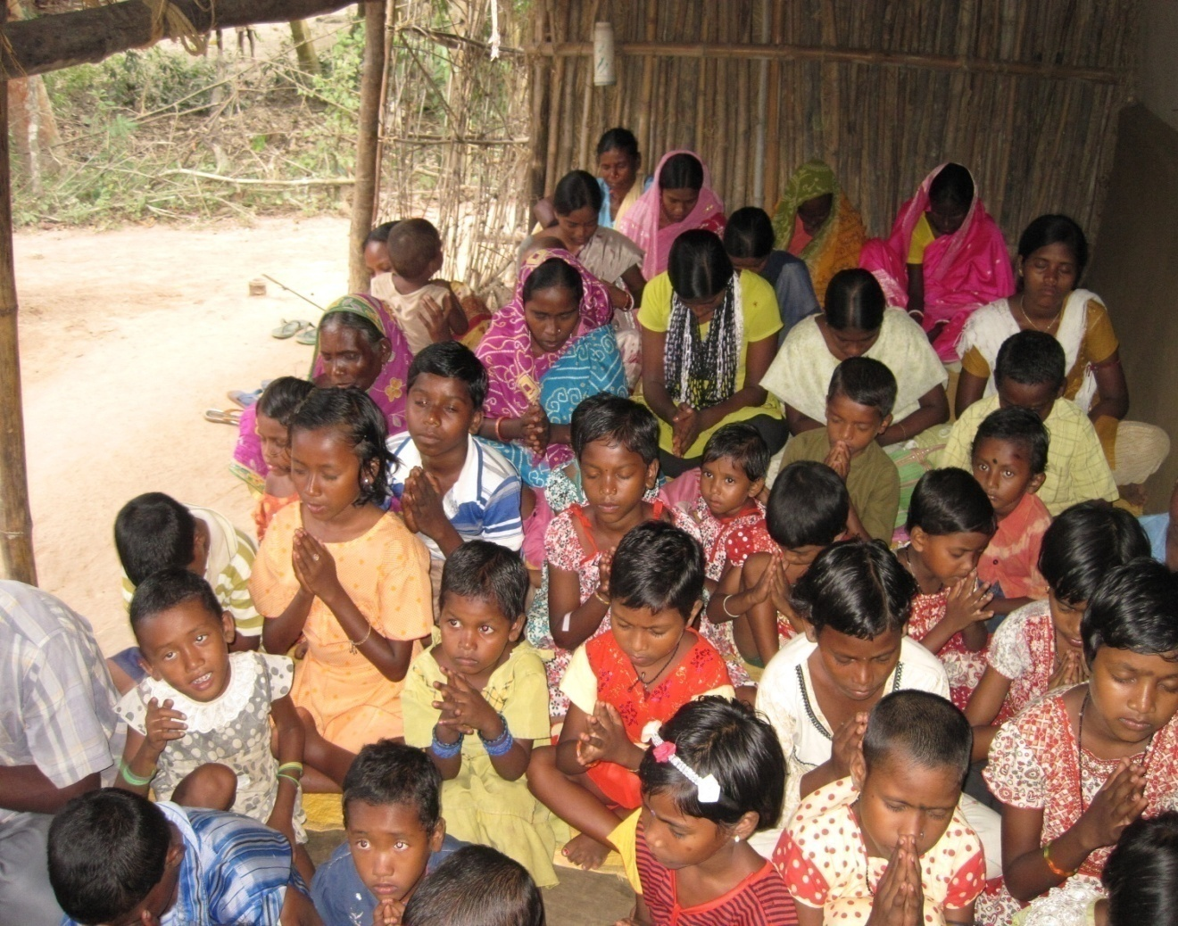

***Address:-*** *AT+PO+PS-Bishnupur*

***Dist****: – 24-Parganas South*

***State****: – West bengal*

*India.*

***Pin****:-743503*

[*Email-bbfindia@hotmail.com*](mailto:Email-bbfindia@hotmail.com)*, info@bbf-india.org*

***Phone:*** *+033-24809861*

***Mobile****: +919903174942*

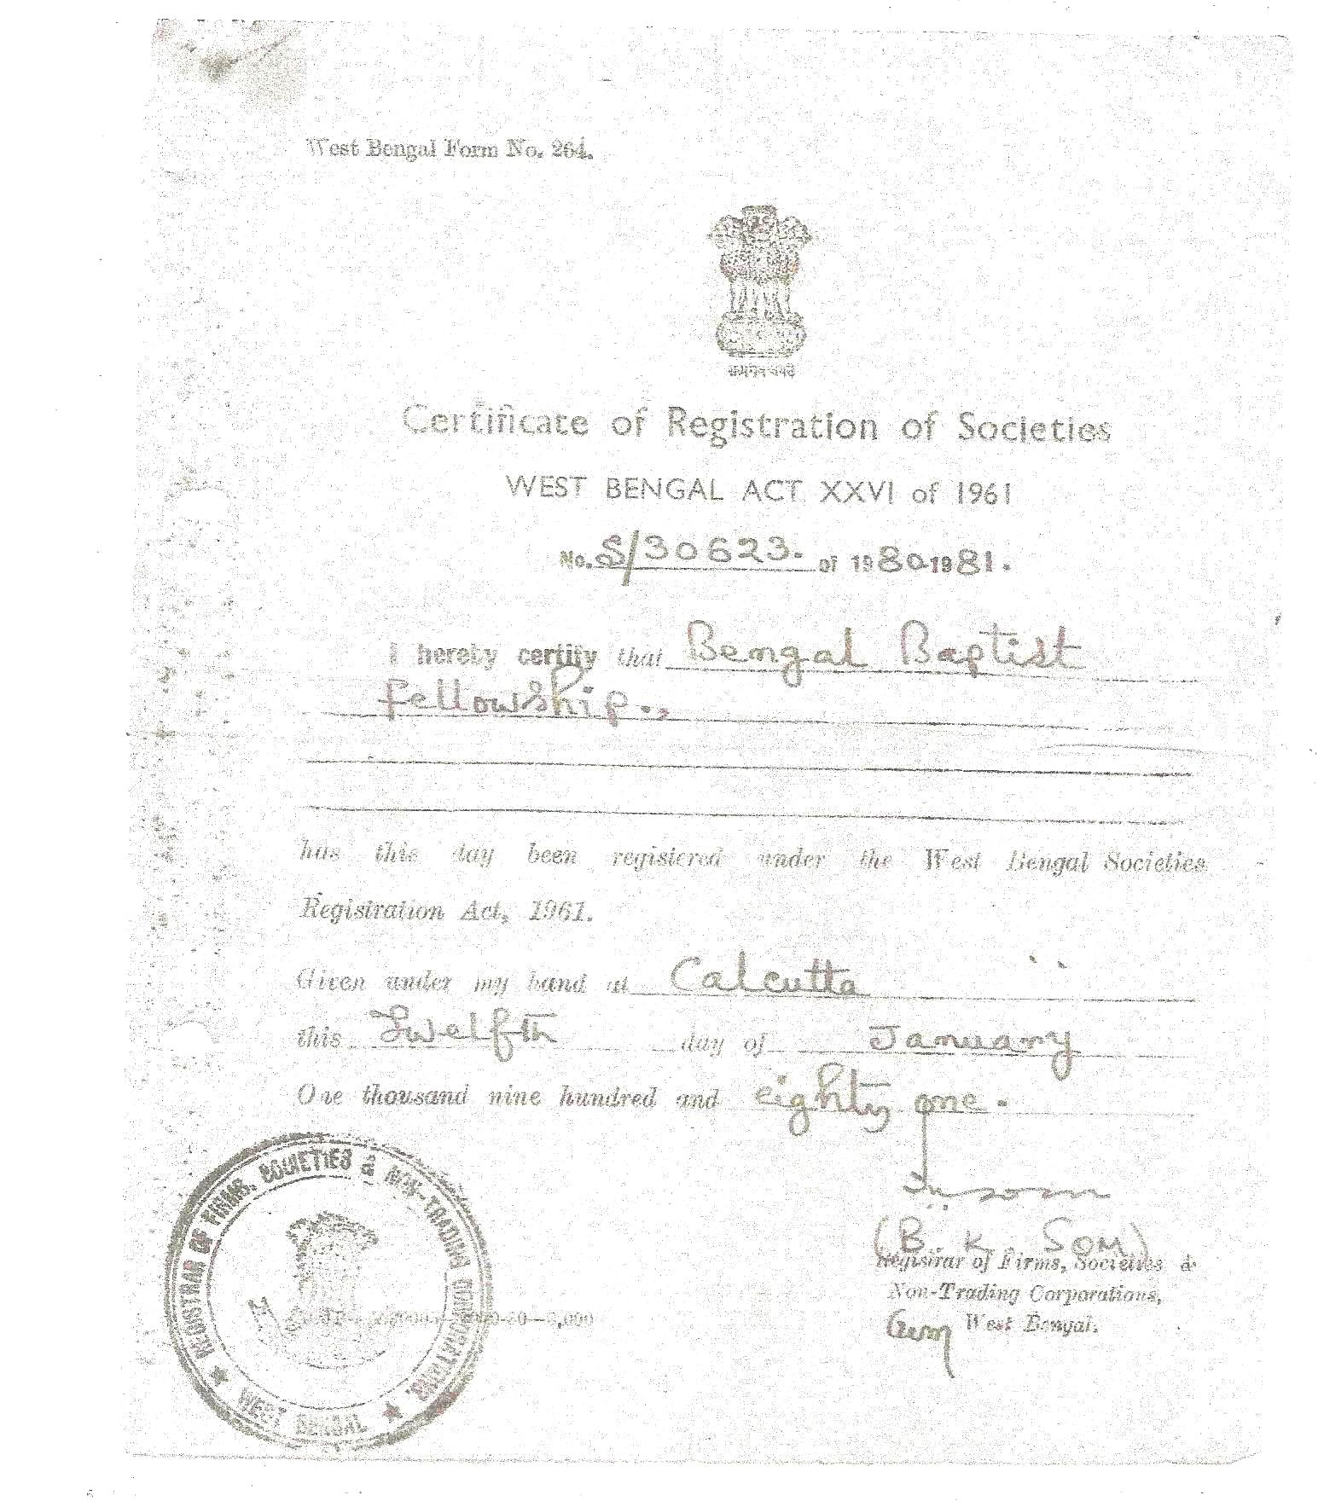

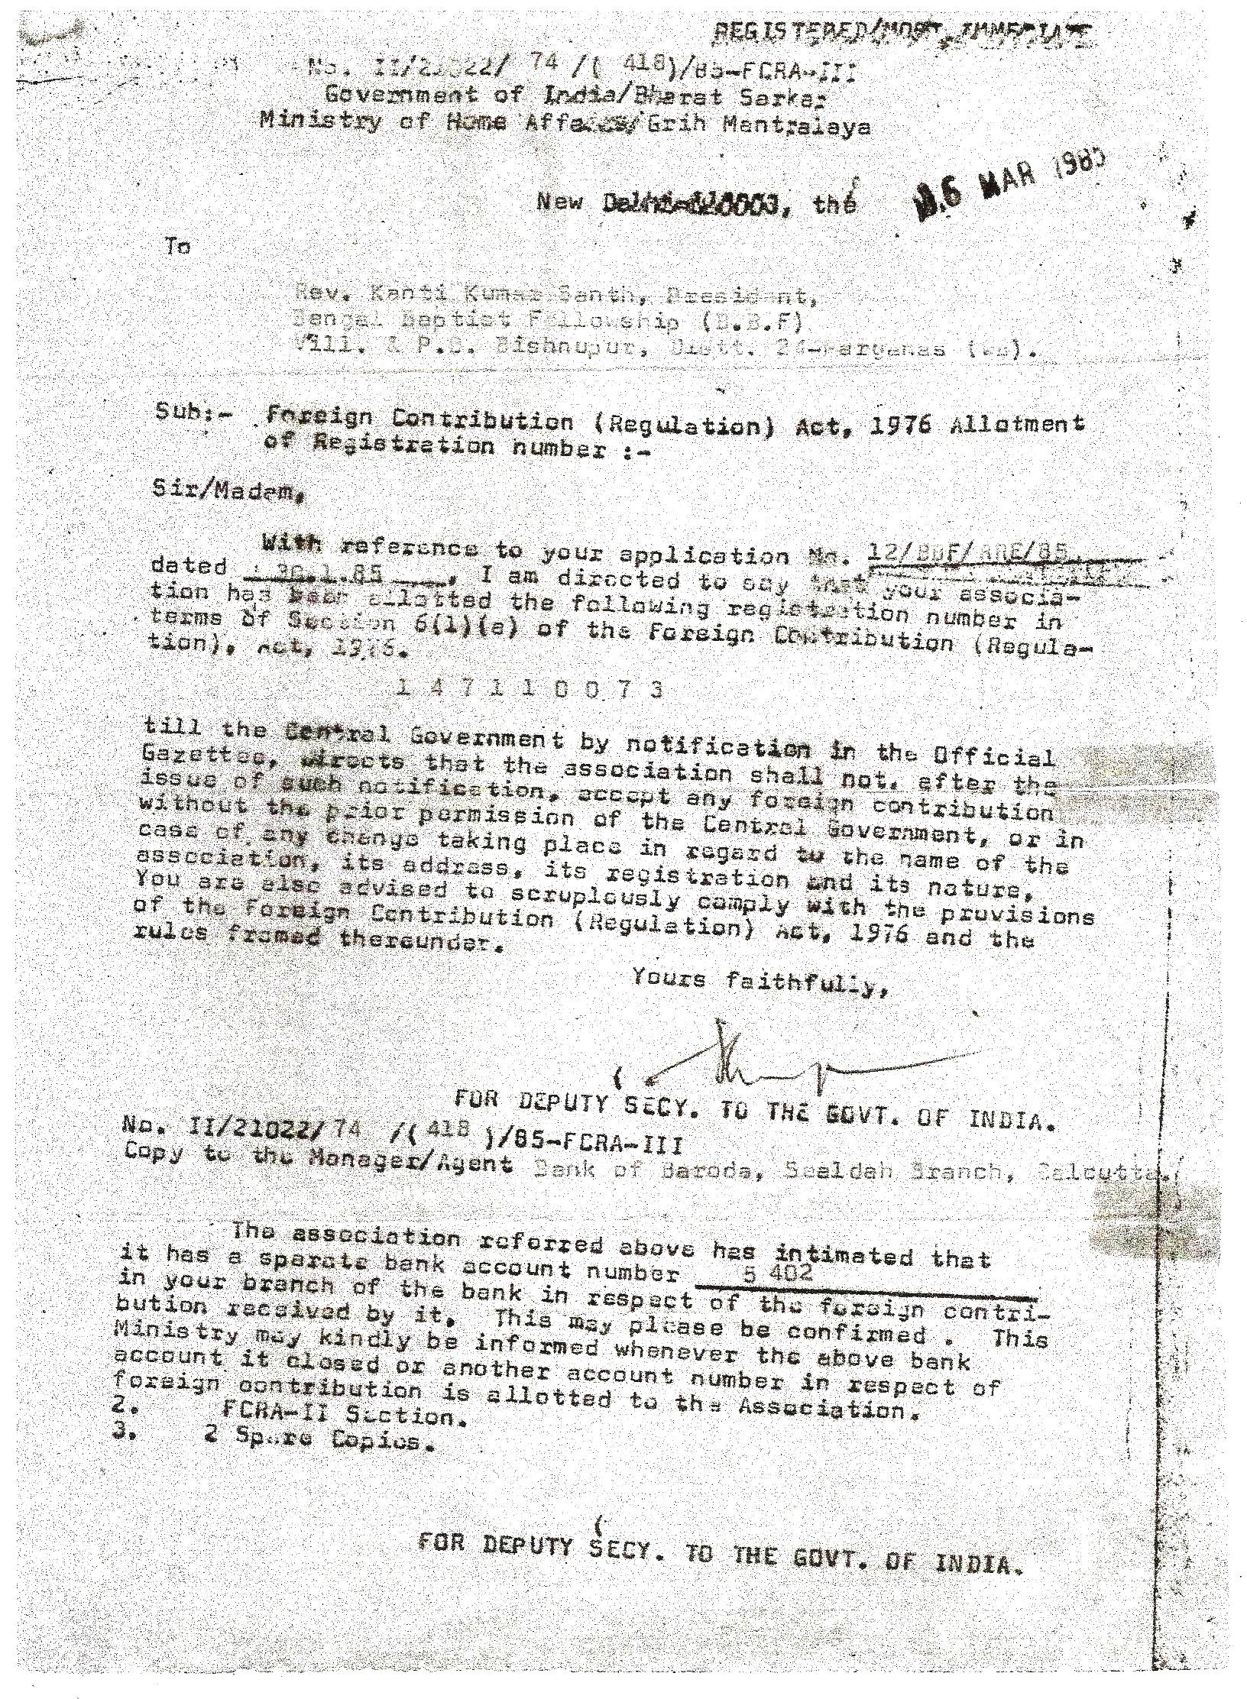

Vision:

Transform nation in all its fullness to witness the Good News as the disciple of Jesus Christ.

Short term Goal – 50,000 LIGHT Houses within 2022 in West Bengal.

Long Term Goal – 1,000,000 LIGHT Houses within 25years (2037) in India.

Goal For Children – 200,000,000 children to be reached for their physical and spiritual development program by 25 years.

WHAT IS **“LIGHT”** HOUSE?

L – Life

I – In

G – God’s

H – Hand

T – There

**Mission**

To train, equip and support the people to proclaim the Good News and share about the Love of God by serving the unreached and unengaged people for their holistic development

**Core Values**

1. We are Christian
2. We are Committed to the poor and unreached
3. We believe in transparency
4. We value people
5. We are servant
6. We honor partnership to achieve the Great commission with other Christian org/foundation
7. We are Accountable
8. We believe in personal integrity.
9. We are responsive.

**T**he Holy Bible of 66 books of the Old Testament and New Testament as fully and uniquely revealed the Word of God, infallible and entirely trustworthy and sole authority in all matters of faith and conduct.

**O**ne God infinite and eternally existent in three persons - Father, Son and Holly Spirit, the creator and the sustainer of the universe, who reveals himself in perfect Holiness and Love.

**T**wo institutions of the Church, via a) BAPTISM and b) HOLY COMMUNION to be only ordinances for the Church which Jesus enjoined his followers to observe which observances expresses the Lord’s death, burial, resurrection and hope of His second coming.

**T**he New Testament shows clearly Baptism by immersion after personal confession of acceptance of Christ as his Savior, to be the only true way of the initiation into the fellowship of the Church and believer publicly declares his desire (or avows his promise) to live a new life in Christ from then on, being perfectly satisfied that through this Baptismal right his belief in Christ’s death, burial and resurrection has been adequately demonstrated.

**T**he dignity of man created in the image of God, his universal sinfulness and consequent subject to God’s worth and condemnations his redemption from the guilt penalty and power of sin, his justification by the grace of God through repentance and faith alone in the Lord Jesus Christ.

**T**he resurrections of all men, who are saved and got eternal life, were lost in eternal condemnation.

**T**he illuminating, regenerating, indwelling and sanctifying work of the Holy Spirit, enabling the believer to live a Holy Life, to witness effectively to the Gospel and to serve the responsibility of the world.

a) To promote fellowship and unity among the believers which accept the Bible as their sole authority in all matters of faith and conduct.

b) To proclaim and safeguard the Biblical faith in the life to transform and Witnesses of the Church.

c) To proclaim the Gospel to all mankind in accordance with the Great commission of Jesus Christ (Matt. 28: 18-20).

d) To respect and safeguard the autonomy of member of the Church, church “body, council etc. in matter of administration policy, workshop sacrament, finance, and property.

e) To found churches (including church buildings) for spiritual care, care of Christians professing Baptist faith and who are willing to become members of the fellowship or its member bodies.

f) To accept the responsibility for administration and spiritual care of these Churches and their member bodies upon their request.

g) To promote the sense of stewardship for administration among the churches through its member bodies so that they may be self supporting churches.

h) To promote and maintain fraternal relations with other Evangeli­cal bodies on national and international level.

i) To have united voice in all matters pertaining to the fundamental human rights and freedom of religion.

j) To raise/receive funds, donation, loans gifts contribution endowments etc. from the national and international churches and church organization for furtherance of aims and objects of the fellowship.

k) To help Churches for Rehabilitation and Development works, this is to be done through Bengal Rehabilitation & Development Project.

l) To establish school /colleges both Theological and non-Theological, Library, Reading Room, Study Centers, Music Centers, Prayer Halls for evangelical purpose.

m) To publish books, leaflets, booklets, journals etc. relating to Christian religion from time to time.

n) To hold conferences, prayer meetings, in matter or matters of Christian religion.

o) To have authority to receive gifts from the member of Churches/ Church Organizations of national and international level and to administer from for the purpose afore said mentioned .

p) To sponsor Scholarship Schemes for students of theological-studies in India and/or High Theological studies outside India.

q) To acquire, hold, alienate movable and immovable property for in furtherance of the aims and objects.

s) To do all such things as are incidental or conductive to the attainment of the above aims and objects.

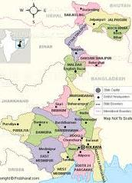 Geographical Location of Bengal Baptist fellowship office:

22.23N’88.16E’- Bishnupur, Nearest Location Siksha Sangha School and Bishnupur Police Station.

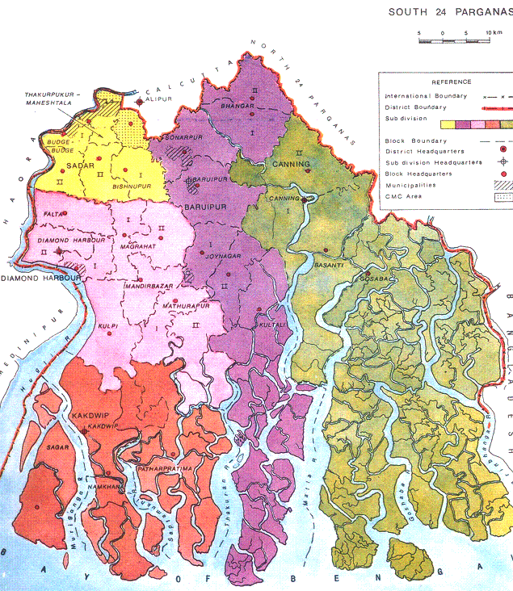 South 24 Parganas district is an important district of West Bengal State with its district headquarters in Alipore. It has the urban fringe of Kolkata on one side and the remote riverine villages in the Sundarbans.Agriculture, Industry and Pisciculture are all at their peak in the district. Sundarbans, formerly Sunderbunds, is a vast tract of forest and saltwater swamp forming the lower part of the Ganges Delta, extending about 160 miles (260 km) along the Bay of Bengal from the Hooghly River Estuary (India) to the Meghna River Estuary in Bangladesh. The whole tract reaches inland for 60-80 miles (100-130 km).A network of estuaries, tidal rivers, and creeks intersected by numerous channels, it encloses flat, marshy islands covered with dense forests. The name Sundarbans is perhaps derived from the term meaning "forest of sundari," a reference to the large mangrove tree that provides valuable fuel. Along the coast the forest passes into a mangrove swamp; the southern region, with numerous wild animals and crocodile-infested estuaries, is virtually uninhabited. It is one of the last preserves of the Bengal tiger and the site of a tiger preservation project. The cultivated northern area yields rice, sugarcane, timber, and betel nuts.The region is also famous for some commonly domesticated livestock breeds which includes the Garole breed of sheep and Chinae hens or Muscuovy ducks, the Garole sheep is considered as the progenitor of the Booroola merino sheep and is noted for its prolific character. However, the wool of the sheep which can be a valuable natural asset does not find any use among the natives. Bakkhali beach resort located on one of the islands jutting out into the Bay of Bengal is gaining in popularity, with improvements in transport links with Kolkata.Geographical Location Area Latitude North 20´20" South 22'06" Longitude. East 88'20"West 88'60" Area in Sq.Km. Total 8165.05

**It** all started more than 30 years back when a group of Baptist pastors of South 24 –Parganas especially from *Sundarban* island decided to walk in the path of door to door evangelism based on Romans 15:20, to establish the fellowships (house churches) but not the building, breaking the so called protocol of the churches of “four walls” with the leadership of founder president Rev. Kanti Kumar Santh at Bishnupur. As the time passed on there were many “ups and downs” in the organization. But till today by the grace of God organization is working for the Lord very faithfully with the **Goal of 50,000 house fellowships (LIGHT house) in West Bengal (each village one fellowship) by next 10 years.10,00,000(One million) LIGHT House in India by 25 Years. Reach out 200,000,000 children And their community for their transformation both physically and spiritually by Light houses.** The organization had a privilege to have mission partnership with the International and National organizations in later part of 80s and early 90s. The organization played a great role for holding the Carey Bi-centenary in Kolkata in 1993 as the foreign fund receiver under its FCRA account. At present it has 6 main fellowship or Churches and 22 house fellowships throughout west Bengal. 221 children are nourished spiritually and physically through the three different day care centers for children in three different Districts. The organization has main focus on Evangelism, Children development, Heath and social Awareness program, Relief and Rehabilitation in means of sharing the Good News for the Holistic Development.

The organization is now under leadership of Rev. Anirban Santh –Ministry Operation Director, has reached the new areas (Blocks and Districts) for the proclaiming the Good News. Through HIS will in last two months 6 new fellowships have been established in Jalpaiguri, Maldah and North 24-Parganas. For the year 2013 BBF has a goal to have at least 48 house churches in unreached, unengaged and non-gospel area by prayer, evangelism, church planting, education, health and especially children development program for 1500 in 2013 children concerning the global issues.

About our Present Leader

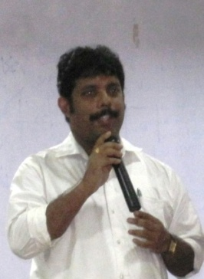**Anirban Santh** was born & raised in a Christian Missionary family in 24-Parganas District of West Bengal, India. He found the joy in Jesus Christ while he was studying in High School at age of 12at the Baptist Church at Bishnupur under the ministry of his Aunty Miss. Prativa Santh. Anirban finished High School with top honors academically. He then enrolled at Calcutta University as the Bengali literature Student with a honors degree specialize in Bengali literature, where he found the background of other people’s religious faith specially the Bengalis. After completing his Graduation study (BA. Hons) from Calcutta University, he received Jesus as his personal lord and savior with whom he started his relationship in his childhood. He decided to go deeper study of Divinity from any of the famous Bible colleges in Kolkata. It was a great challenge for him to go for the theological study. Because he had not enough financial support from his family as his father was a retired person, whose earning was only $35 per month and the members of the family were 4 adults to be survived.

Anirban’s father Rev. Kanti Kumar Santh who was a pastor also, somehow tried to get sponsorship for his son’s study, no one responded him and Anirban decided not to go for the theological study. But his father taught him to ask the things in prayer and he did so for continuously three months.

The great God gave a response for his faithful prayer through CIRCULAR ROAD BAPTIST CHAPEL’s pastor Rev. Mohit Kumar Pramanik and his committee. Through them God granted Anirban’s prayer and the answer he got from the Church was, “If you go to get admission in Senate of Serampore College we are going to sponsor you.” It was a great joy for him to study from the **Senate of Serampore College** which was founded by Dr. William Carey. In the time of his study he was assigned to serve the Bengali congregation of CIRCULAR ROAD BAPTIST CHAPEL.

Rev. Santh completed his BACHELOR OF DIVINITY from Serampore College founded by Dr.William Carey in 1999. He joined **World Vision** as the Community Development organizer in Decemeber 1999 and went to Maldah district which is 300 Kilometer northern side of Kolkata. Within 15 days he was assigned by his office to go for the **SUPER CYCLONE RELIEFE** in Orissa. He came back from there in January after completing his job successfully. He stayed at Gazole in Malda for 2years 3 month and had to come back in Kolkata because of his father’s death and to take care of his little sister who was only 15 years old. As his mother passed away before in 1999 there was none to take care of his sister. This time everyday he realized the presence of God in his life through different miracles. There was no financial support from anyone. Every relative even neighbor and the people once who were helped by his father rejected Anirban and his sister and they became literary orphan. In this time a offer came to Anirban to teach students in a coaching centre near to his house for Rs. 10,000/- per month.

He refused that offer as he decided to attempt great things for God. And he got a chance to serve God through **B**ehala **H**uman **C**are **M**ission as the research analyst for **DAWN**. Under his hard work two church growth research bulletins was published in 2003 from Behala Human care Mission. In this time two incident which made him so firm in his decision and he never forget in his life is- One day he found there is nothing in the kitchen to eat and the family members were in anxiety what they would eat in the evening. The day was 1st of October 2002 morning 9 am. The payment day from his office but there was no money to go to office also. He was searching to find some money from somewhere inside the house hoping if it is kept by his father or mother inside some books or some diaries. He was searching as a mad person because he had to reach office in time by 10.30am.Suddenly a old diary, which was maintained by Rev. Kanti kumar Santh his father, was found by his wife Nichora. While searching with a hope they found a Rs. 50/- note which was completely new and enough to go to his office and collect the monthly payment. With tears they give thanks to God for HIS faithfulness and promises.

The second one is like this- in 2003 month of June 2nd day when Rev.Anirban’s son Ankit was very little and taking the baby food. The situation was so bad for the day that there was no money to buy the food for his son from the morning itself, and his wife Nichora was not having sufficient breast milk to feed the little Ankit. Ankit was fed only water from the morning none has helped them to get some baby food. Only some sympathy was enough to this response. In the evening with a mourned mind and heart Anirban took a decision to go to any secular company job as a daily labor for their physical survival and came out with the application, bio data with his family in the path. He found a friend who stays 295 kilometer ahead of his place coming from the opposite side. He asked Anirban about his son when he was born and what was the age and all the things. Then he took out Rs. 500/- from his pocket saying, “ This is a gift from me to your son as I saw him first time.” This is wonderful God once again who confirmed Anirban that HE is with him and Rev. Anirban for his ministry not to be involved in world’s work. Hereafter Rev. Santh never turn back

as it was very clear for him that God has a different plan for him. But his prayer was as Jabesh’s prayer. And God answer his prayer in 2004. He got a chance to serve the whole West Bengal as a District Ministry Coordinator with Seva Bharat from May 2004. Seeing is performance management was pleased to assign him as the state ministry coordinator within short time.

Anirban tried his level best to serve God as State Ministry Coordinator and keep unity with all the organizations. When he joined in **Seva Bharat** (***Mission India*** ) there were 280 centers in West Bengal under SB ministry. But now it crossed 450 centers under his leadership. Though he was working with **Seva Bharat** there was a calling for more burden to him to establishing the 1,000,000 LIGHT houses in India within 25 years of time when there was All India Staff retreat in Hyderabad of Seva Bharat In Dec 2011. He could not keep quiet and shared it with his directors. They encouraged him and the vision what God shown to him.

Presently Rev. Anirban Santh serves the Lord though 22 LIGHT houses and 6 main Churches with eleven church planters under the banner of BBF. Also he operates three church base daycare centers where near about 221 children are nurtured spiritually and physically.

**Bengal Baptist Fellowship is now working for the wholistic development of the society through the local Church, LIGHT houses and by its committed believers to reach the unreached and unengaged areas to bring transformation in India in near future.**

Rev. Santh comes as a servant of God with a heart for Revival and transformation among the people of God. He brings together a rich blend of discipleship and practical ministry to speak a relevant word and serve to our generation. His heart continually beats in a great commitment to the Great Commandments and the Great Commission

**Present Activities of BBF in Brief**

**No Churches +Fellowships:- 28**

**With own Shelter –** 5

**Rented -**1

**Fellowship-**22

**Present Activities** – Outreach, Evangelism, training, Sunday school, Schools, Day care centers for Children, free tuition And awareness program, Relief and rehabilitation.

**Proposed Program:-** Bible College, Orphanage, Mobile Hospitals (medi-clinic),Mobile Library, Community Development.

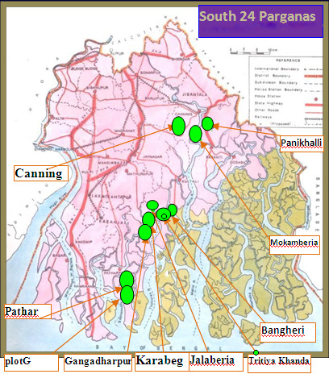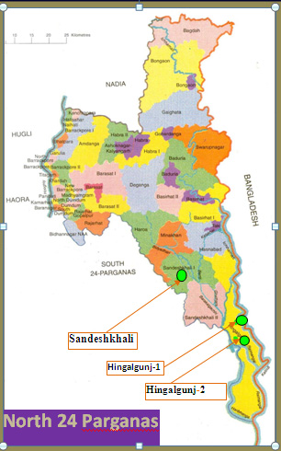

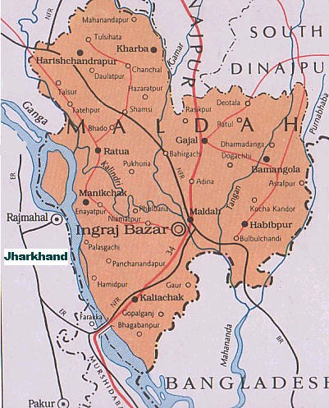

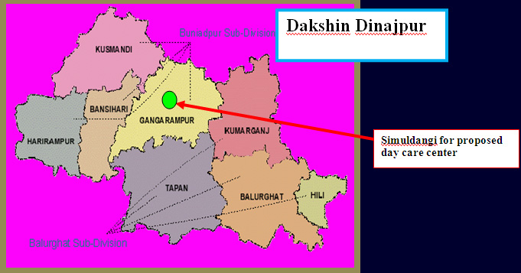

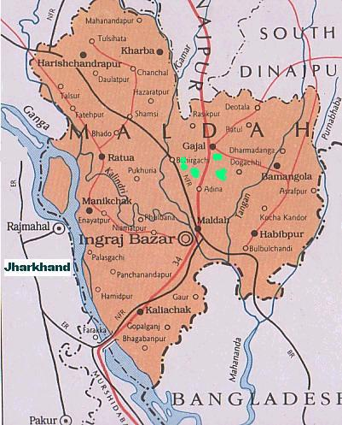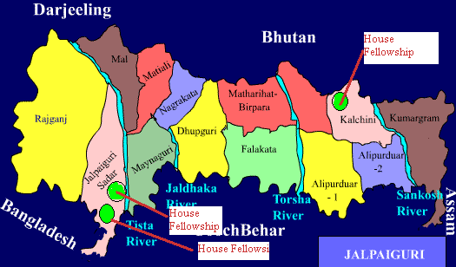

**Sample Strategy and Future Action Plan:-**

**2022**

**2021**

**2020**

**2019**

**2018**

**2017**

**2016**

**2015**

**19X2= 38+19=57 LIGHT House**

Build up Community Centres

**57X2=104**

**104x2-=208**

**208x2=416**

416x3=1,248

1248x3=3,744

3,744x3=11,232

11,232x5 = 56,160

**The Plan is for reaching the unreached and unengaged people through multiplication of the fellowships.**



**Presently Bengal Baptist Fellowship Is working Five Districts in West Bengal**

**South And North 24-Parganas, Malda, South Dinajpur And Jalpaiguri.**

**In 2013 we have plan to reach rest of the district.**

**We do the faith ministry and grateful to God as HE provides us HIS assistance with local resources we manage our programs. We start with Social program under the banner Bengal Rehabilitation And Development Project to reach unreached and unengaged area to share the love of God and take care of them.** Then we start the sharing the Gospel.

**Our focus In social Action Are** – **To establish God’s Justice and advocacy to irradicate poverty through –Education, Health, Environmental issues, Relief and Rehabilitation, Clean drinking water and hygiene Livelihoods &Food Security.**

On Going Program

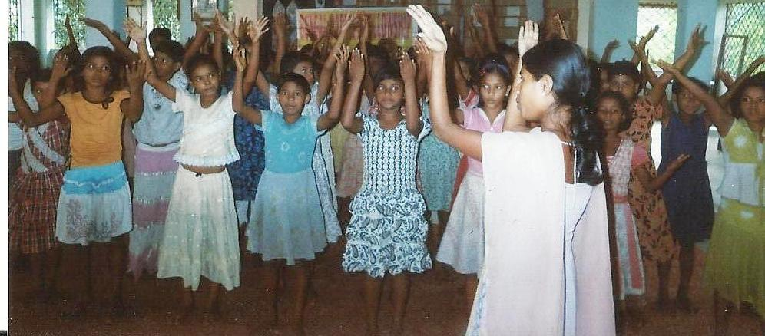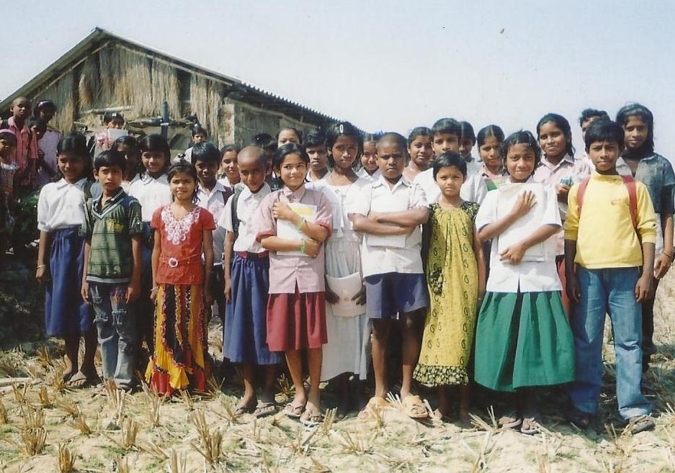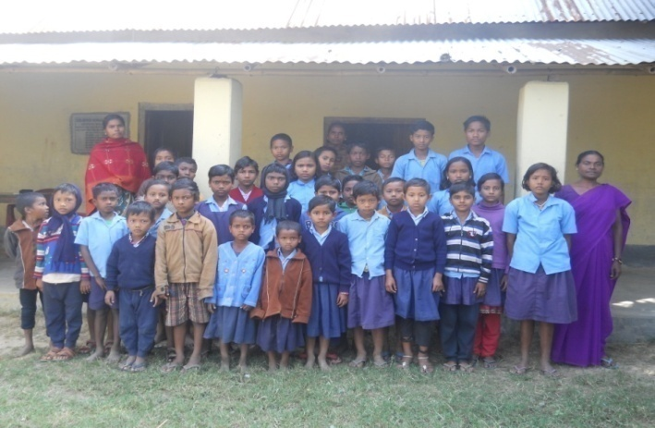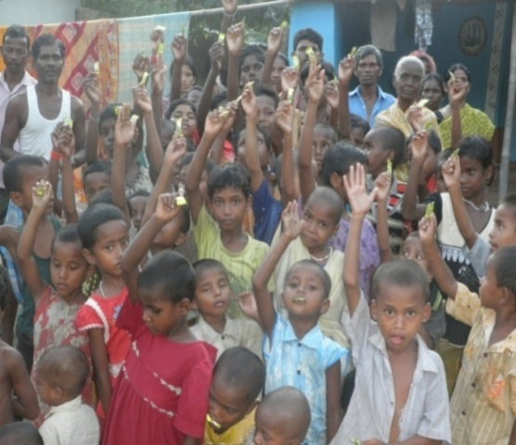Children Ministry:- The success in the life of a child is deeply rooted in the early education, both educational and spiritual. A successful early year program will focus on covering all the aspects of their life to bring the wholistic development like social, emotional, physical and of course spiritual in their life. The children ministry is one of the most important ministries for Bengal Baptist Fellowship. It helps the churches to reach the unreached and share the Good News time to time among the new generation. The Local fellowship (LIGHT House) is an agent to have all the programs in the village level. They organize day care centers, Sunday school at present. The teachers are paid very little honorarium by the organization as they work as the volunteer. The children of the centers learn many things - such as scripture, moral behavior, Social services, National Anthem, as much as they can learn or the volunteer can teach. This is the ministry which is making the future nation. The parents are happy to send their children to the day care centers & school. The interested parents are sending their dear ones to the Sunday School/Children Club where they are taught action song, dance, and story from the Bible. None of the children are unhappy with the activities they are doing with us. There are very few generous givers who provide the educational needs of the Children freely, which is not at all sufficient for all the students but for one or two organization can manage.

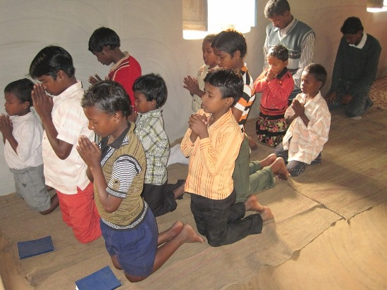There are 221 students in the four schools in Scheduled tribe (Santhal,Mahali and munda) are of Malda district and 179 are in 3 different places in west Bengal who reads up to class iv. There are 4 Sunday schools under the BBF among which one is completely led by the young girls and the participants are girls’ child in south 24 parganas.

In the time of worship in Sunday children are coming with their parents and attend main service and then Sunday school. In the next day they are going for their day care center and followed by going to the school. As the children are only below 12 years they are able to get involved in the primary level only. But there is a great need for High school going children. BBF is trying its level best to enroll those children in their target area with its network.

The organization has reached 10 villages with children ministry, day care and education program with the very limited support. But it is looking forward with prayer to see a great support in future for 200,000,000 children “The Future Nation”.

Evangelism:

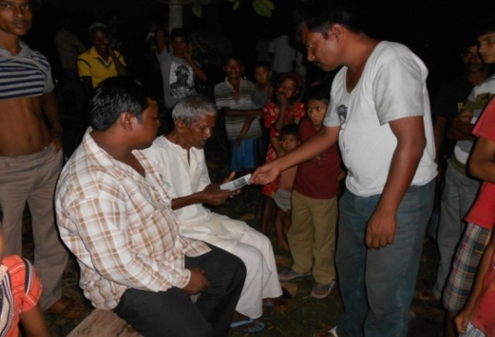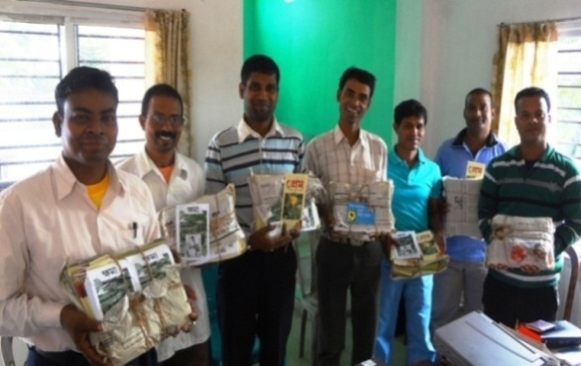The heart of the organization is Evangelism. BBF has the vision for transform the nation in all its fullness and it start with the inner transformation of the every person with the light of the Gospel. It is proven truth that Jesus Christ is the prince of the peace and when the world is searching for the peace we the Christian is having the experience and the love of him. So it is our duty to share it with the other people who don’t have it. So it is always tried by BBF to preach the Gospel where Christ is not known. And evangelism is the main part to accomplish the task. At present in five districts the organization has started to start the work with the help of 11 evangelists. They reach to door to door for evangelism and person to person with tracts and literature to share he Good News to the unreached and unengaged community through the fellowship with each other as the disciple of Jesus Christ. They receive the tracts from the head office first and then we use to have the training for the evangelist and then they are sent to their target fields.

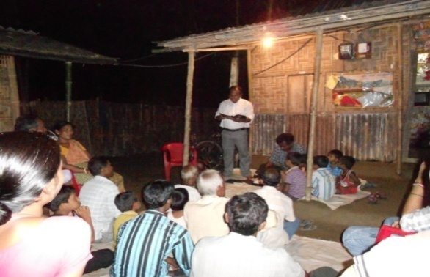They start to visit the field in the afternoon every day and they share the gospel and distribute the tracts to the people from small to old. Sometimes even in the dark comes they are not bother about their returning but they use to share the Gospel and then they come back. Till today 6 main Churches and 22 fellowships have been established throughout the target districts. Through these activities total 104 families are directly involved with the network of BBF. The Jesus film show is one of the outreach tools through which evangelism is taking place. The tribal people and the scheduled class people are getting the more emphasized.

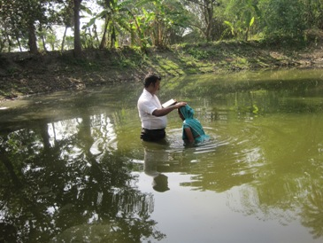Baptism is a regular program done by BBF at least 7-8 times in a year and the people who received Christ are given water baptism. Local Church use to arrange the program and the pastor/evangelist/leaders are permitted to give the baptism. They are allowed to do so that they can get the self confidence. There are many church planters are waiting to join in the ministry with BBF in near future we need only resources to fulfill it and to see every villages are reached. A New believer, who has taken baptism, is given a Bible. So that he/she can read it and obey it. The organization believe that all the evangelist, Missionaries whether male or female are the Children of God and have right to give the baptism without wasting the time.

BBF has a dream to have the mission which is local church based. The church or fellowship is the channel to their village as the representative of Christ. Out of 342 Blocks BBF have a plan to serve 60 villages through 60 unique administrative blocks by next year2014 to share the love of God by Evangelism and establishing fellowships.

Our vision is to transform the nation but there is nothing like prayer. Yet we are moving forward. Pray for BBF ministries that the people will know the true God and embrace Christ as their personal Lord and Savior in the days to come to establish peace, justice, unity and fellowship in Godly way.

Women Fellowship:-

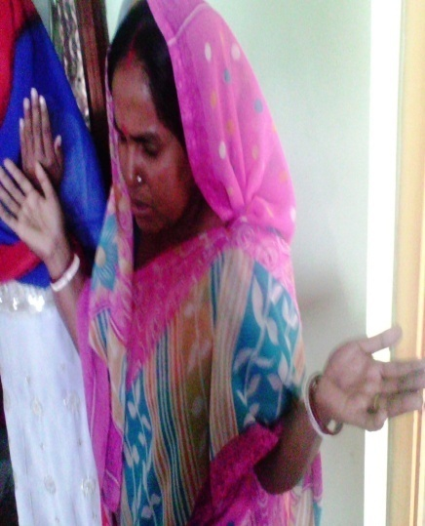The strength of the organization is prayer and specially the prayer by the women fellowship. There are 15 women church planters in BBF who are trained and equipped for evangelism. They are not from the same area but from the different areas. They use to share their life-story to other saying how Christ has changed their lives. They are the soldiers of God who can entre easily next to their houses.

**Cancer has Answer**

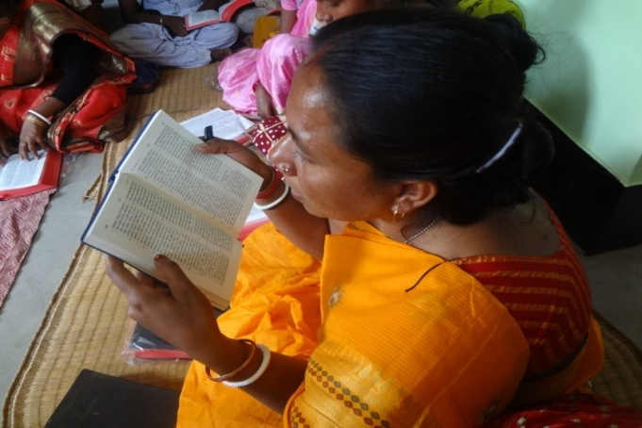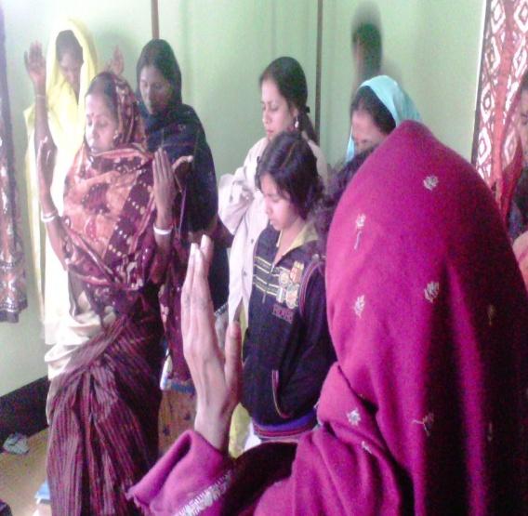Their prayer is so strong that it uses to have the answer. Here the woman who is praying in this picture is a completely cured lady from the life-harm disease “cancer”. Her name is Ekadashi Halder from Jalaberia village. Here 99.99% are Hindu believers. The only family who does believe in Jesus and left all their old practices and received Jesus is Ekadashi’s family. Last year she was found with the “cancer” in her body. Doctor told her family to go for the operation. But they did not have the sufficient money. The patient and the husband cried to God and they had strong trust in God and God answered their prayer. The same Doctor who checked up and created her report before now got shocked as there is no cancer in her body. The medical board was really in confusion and they did not believe their eyes what they are seeing. Again they gone through the check-up the whole body of Ekadashi and found there is no germs of cancer. They advised her only to take some medicines for her problems. She said, “It is because of prayer of all Jesus healed me.”There are many testimonies like Ekadshi are there in the ministry field of BBF if not cancer but they got answers of their prayers. The women fellowships are the strength for the churches and the LIGHT(**L**ife **I**n **G**od’s **H**and **T**here) houses. It is the first time BBF introducing the women as the evangelists not only that they have the authority to give the baptism to their own disciples. BBF has plan to teach the illiterate women in the village level to make them literate and to make some business for their livelihood so that they can support their own families and ministries.

There are some women leaders who can read the Bible and write the notes but maximum of them are illiterate. The Organization is in continuous prayer for them and the programs to make them sustainable both spiritually and physically. Some of the women are having knowledge of the basic nursing and social works they took the major roles to motivate and raise up their next line leaders. From organization we provide them training and some resources to preach the word of God which is very least and not at all sufficient. Even when they are going for the out reach they have to go by managing their own food and travels. As the organization we always pray for them so that God can help them in all their aspects and needs. They need your prayer and support as they are preparing to go next village to her/them each and every time.

**Community Development:-**

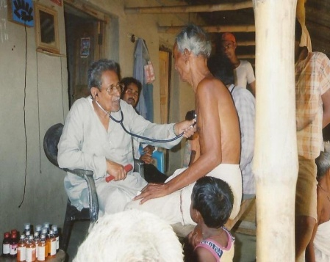Health :- BBF is not only concern for the spiritual and educational transformation but also concerned for the health of the target area people. So every year it arranges according to it’s financial strength to serve the poorest of the poor who cannot go to the Good doctor for treatment. BRDP, the social wings of BBF every year takes the initiatives to serve those needy people by giving free health check up and medicine. Every year near about 250-300 people get the benefits from it. Some of the friends and the generous giver extend their helpful hand for this great work. Organization provides the Tiffin for both the doctor and for the volunteers. The people what we can reach is only with doctors sample medicine. We use to have time to time awareness program in church base on health and on social awareness. BBF is looking to have a trained first aid team in each church can take care of the concerned village. RELIEF PROGRAM:-

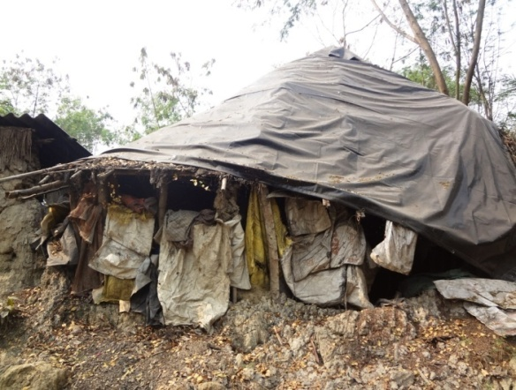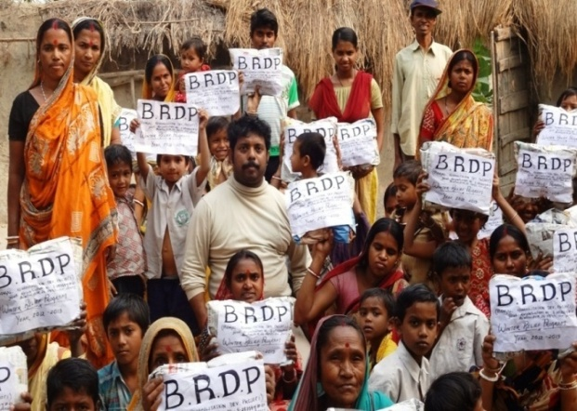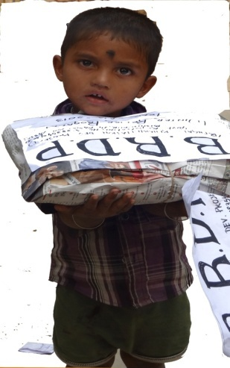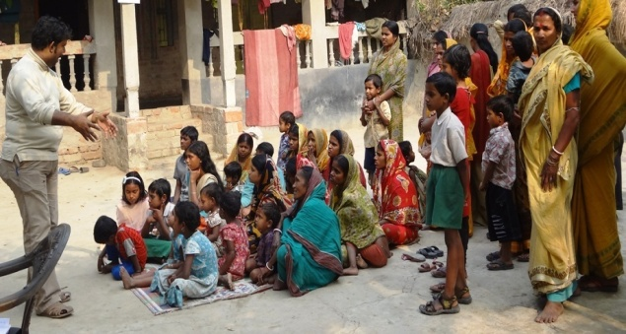70% - 80% of our ministry people are living below poverty line. They don’t even space for to have any program in their own houses. They have to come someone’s house who is little better than them. Every year BBF’s social wing use to arrange the winter relief distribution program. Before distribute the gift it is very much mandatory to share about the word of God to show how GOD love them and so we. Also it is more concerned about the flood relief and drought relief. So the organization board has made a decision to send it’s director to study for the MA degree in Rural Development and diploma in Disaster Management. BBF want to see the best professionals same time who are the believers of Jesus Christ to be involved in BBF ministry fully as full time worker.

This year BRDP has distributed cloths for the 135 needy families in Sunderban Area. There the people are farmer, daily labor, and fishermen. They don’t have proper cloth to wear in the time of winter season. Every year organization use to stand beside them with a help to make them survive in all situation.

The organization is looking forward for yours kind Prayer, friendship, mission partnership, valuable and continuous participatory support fulfillment of Great Commission. I believe it is possible only in that time when we join hand together with one another for the one and only common cause to proclaim the Good News and make disciples to see HIS kingdom in earth.

With love and Greetings

**Rev. Anirban Santh.**

Ministry Operation Director, BBF

The place where the78%of people live in Such Houses

30 families received