CARE FOR AFRICAN KIDS (CAFK)
P.O BOX 26489 KAMPALA UGANDA, EAST AFRICA
TEL: +256 752 509 125, +256 712 509 125, 0414 670 882
www.careforafricankids.org
E-mail: rpool@careforafricankids.org/davidk@careforafricankids.org
GIRL POWER PROJECT REPORT
PROJECT LOCATION: WAKISO DISTRICT UGANDA
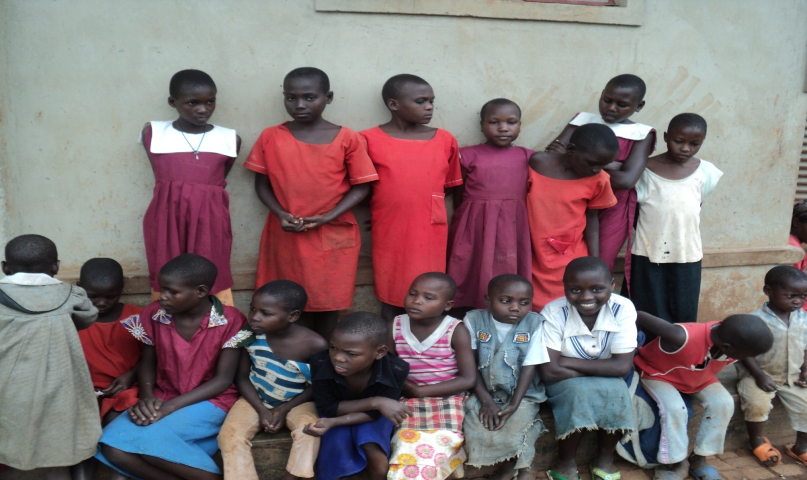
KEY CONTACT:
MR. ROBERT POOL
DIRECTOR CFAK AND PROJECT COORDINATOR
P.O BOX 26489 KAMPALA – UGANDA (EAST AFRICA)
TEL: +256 752 509 125, 0414 670 882
E-MAIL: rpool@careforafricankids.org
SKYPE: Robertpool2
MR. KAYEMBA DAVID
TREASURER CFAK AND ASSISTANT PROJECT COORDINATOR
EMAIL: davidk@careforafricankids.org
TEL: +256775282890/+256701289090
FACEBOOK: CFAKNGO

Background:
Care for African Kids is a charity organization registered as a community Based Organization registration number WCB/101/10 and also attached with a certificate of Incorporation registration number 107991 under the company’s Act Cap.110, Company Limited by guarantee without share capital.

It was founded by Robert Pool and Nalima Frank in the Estate of their beloved parents in April 24th 2009, with a commitment to achieve a society where all Widows, youth and children inclusive the most vulnerable ones live to their full potential, understand and respect the values of their culture. Under several projects that are curried by them directly at the orphanage centre in Wakiso under organization name or in the communities surrounding both as a single organization or in partnership with both local and international organizations.

GIRL POWER INFORMATION
With a lot of hope for the future mothers on 20th November 2011 at the CARE FOR AFRICAN KIDS home we introduced the GIRL POWER project under which the women number over 824 people are to directly benefit but girl child in focus mainly are to be protected from child abuse and violence, to make sure that their rights are fully protected and to make sure that they attain sustainable development in their future through the trainings that we are to give them at the center. And now we already have several homeless girls to we are giving food, shelter, medical, education, clothes and above a new family at the Orphanage centre in Wakiso, we are expecting to go beyond the communities surrounding us in time to come to see that the mothers of tomorrow life the life to its fullness.
CFAK has effective executive with several strategic plans that are to successfully lead to achievement of Girl power project objectives, these programs are based on research, monitoring, and documentation of human rights violation, human rights education legal aid service delivery and orphanage works.
The organization through girl power it is to facilitate also through the formation of community based human rights groups, monthly radio talks shows and human right centered drama and established human rights centre at the orphanage.

GIRL POWER MISSION
``To contribute to the promotion of social-economic development in girls and women through support of education, human rights protection, vocational trainings and health initiatives``.

GIRL POWER VISION
``To be a leading organization with the leading project in targeting girl and women empowerment in the region``.

GIRL POWER OBJECTIVES
- To protect the girls from child abuse and violence they are facing right now.
- To enhance access to education for disadvantaged girl child in the communities
- To contribute to improved health standards for the girls and women
- To contribute directly to improvement of living standards through increasing household incomes by getting necessary knowledge at the center training
- To train and equip girls with necessary practical activilities through training with ongoing projects at the orphanage
- To increase the effectiveness of GIRL POWER in the neighboring countries and the whole world as well.

Acknowledgements
Above everything we give special thanks to LADY CATHERINE HISLOPE UK, ALISON ROSS USA, JEAN-NOEL CHAZELLE FRANCE, STEVEN WOODS FRANCE that been spending sleepless nights and giving the whatever they can for the success of the project, also to people who attended GIRL POWER EVEN in November 20th 2011 at the orphanage center in Wakiso Uganda and those that advices us in whatever we to do in the project. We are to work with, all willing companies, organizations and individuals of which are to give all possible resources towards the success of the project.
Last but not least, to the girls at the orphanage and those that we have reached to for their effective immeasurable collaboration in girl power, human rights abuse victims, communities and groups who are ready to work with us in both thin and abundance, thank you for the confidence and trust in our services.

MESSAGE FROM THE DIRECTOR AND GIRL POWER PROJECT COORDINATOR
Mr. Robert Pool
Director CFAK

It is indeed with great honour to present to you GIRL POWER PROJECT report of Care for African Kids (CFAK) NGO which was launched on 20th November 2011, CFAK views girl power project as the best mechanism to the help of suffering girls and women. Partners, members and the communities under which CFAK work, we see this as the best way to help the disadvantaged girls in the project we are to undertake, the resources we will need and the challenges we are to face during the period of project.

During the project of girl power we are to make significant change towards the improvement of the girl welfare through our activilities that include health, education and community empowerment programs.

This contribution by GIRL POWER PROJECT complements the human rights protection, poverty eradication efforts of the central government, human rights organization and communities themselves.

As we shall see as time goes on from different reports that are to be published every three months, specific achievements shall be shown in fulfillment of organization`s objects highlighted together with the challenges that are to be realized.
These achievements are to be made possible by the generous support from our partners, friends, donors, who are to provide us with necessary technical and financial support.

I a special way I would like to recognize the support that is offered to girls under girl power of which include LADY, CATHERINE HISLOPE UK,MISS, ALISON ROSS USA, MR. JEAN-NOEL CHAZELLE FRANCE, MR. STEVEN WOODS FRANCE and others as well.

Special appreciation also go to CARE FOR AFRICAN KIDS Executive board members frothier strategic guidance and to staff members for their professional commitment that enabled them to come up with the girl power project idea under which girls are to be helped.
TOGETHER WE CAN
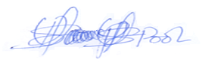
ROBERT POOL
DIRECTOR,
CARE FOR AFRICAN KIDS AND PROJECT COORDINATOR

INTRODUCTION
Mr. KAYEMBA DAVID
As we look back at the growth of Care for African kids through its activilities since its inception, we are extremely proud of the girl power project that is to improve the life of girls in the community and even more excited about promising but challenging future for the girls. We are to successfully change the life of women through empowering them and stopping of child abuse and violation but to do this we request all possible resources from our dear members, partners, donors, sponsors and well-wishers` cherished trust also along the way we are to go. It also gratifies to know that we can help disadvantaged girls that would otherwise never been able to live a good future life. By playing our part and working with similar institutions in shaping the destiny of our girl future in the world, in us it is the reason we exist.
With the wide spread economic problems we still need to sacrifice on the little we have for the better future of the girls.

I also thank all the people that came and attended the girl power project in November 2011, those who have given us countless support in our works, and also to individuals like LADY, CATHERINE HISLOPE UK,MISS, ALISON ROSS USA, MR. JEAN-NOEL CHAZELLE FRANCE, MR. STEVEN WOODS FRANCE and to assure you that together we shall meet our objectives members.

We still need as much help in terms of resources as much as possible since the more we raise the bigger the number of mothers that is to be saved.
It is a long way to go and we all need to join hands for the best from us towards them since they did nothing to live the kind of life that they are live and even to us that are somehow fine, we contributed nothing but it is just luck.
We are to produce a weekly report then after a monthly report to show what we have raised that it is doing and also to advice.
TOGETHER WE CAN
KAYEMBA DAVID

TREASURER
CARE FOR AFRICAN KIDS AND ASSISTANT PROJECT COORDINATOR

WE ARE TO DO ALL THE ABOVE THROUGH THE FOLOWING PROJECTS
EDUCATION OF GIRLCHILD
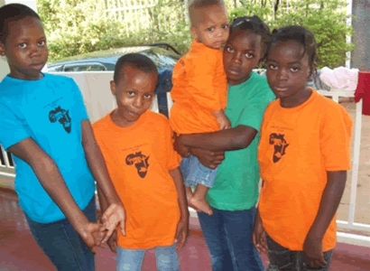
Care for African Kids (CFAK) under girl power project is to implement a primary, secondary and university school bursary scheme for disadvantaged girls who include youth and orphans, offering support to more than 1000 girls from Wakiso District and others as well, this is to be done through offering full bursaries and half bursaries, uniforms, sports kits books as well as all possible scholastic materials. The people are to be either from very poor families, orphans, handicapped, or this might be because of HIV/AIDS or other causes.
Under this scheme, orphans are to be provided with scholastic materials such as textbooks, exercise books, pens, pencils, geometry sets, Manila paper, sanitary towels, and special learning materials for children with disabilities at our orphanage home in Wakiso.
Resource Center,
A resource center is to be established at the secretariat in Wakiso. It has to have a collection of books, reports, newsletters and documentaries. The resource center will be open to researchers, students and those who need such information. CFAK still welcomes information materials for the center.
Vocational and technical scheme
In a near future we are planning to set up a vocational training center where the young girls, youth and widows will be equipped with knowledge of weaving, tailoring, catering, carpentry, electronics, Business skills training market oriented agriculture production child care and nutrition, building. Plumbing, mechanical and repair of motor vehicles, cars, phones, computers and so on.
Part of the land where this project is to be built has already been provided. Fundraising for the project are going on and several people and institution have been reached but the construction for the fast phase if necessary funds are got will be in 2012. However, the issue of fundraising is still a big challenge.
HEALTH
Under this program area, CFAK under GIRL POWER project is to offer counseling to HIV/AIDS affected and infected girls regularly for the purpose of renewing their hope, we shall also mobilize the participation of people in Government programs like immunization of killer disease like Polio, TB and Malaria. Also Mild May center to providing us with all necessary drugs offered to them freely by the Government.
Girl Child abuse and violation are to be stopped and this include acts of forced marriage, prostitution, early employment, corporal punishments to them.
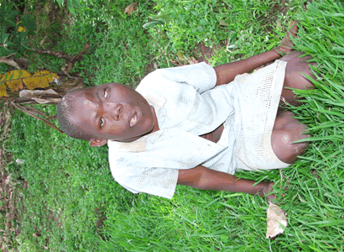
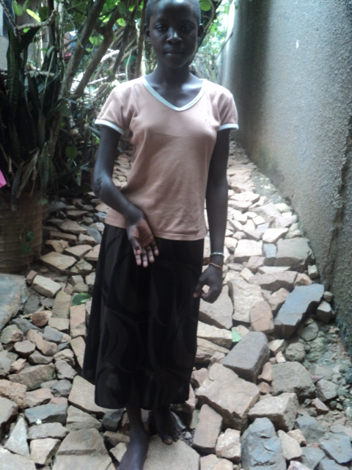 GIRL AND WOMEN EMPOWERMENT,
It is to be handled in a number of ways which will be through orphanage center trainings at the vocation, work shop (carpentry), Art and crafts work, fruit tree project, farming education, Diary and poultry project where to train girls from, village meetings, churches and way seen possible.
Of which all the projects above to move on need funds and technical knowledge of which we request from you friends.
LIKELY FUND SOURCE
The poultry project
The project started few months ago but it has been very promising and in this the Eggs laid by the chicken bought when they are chicks and others donated by the children from better families. The waste collected from the chicken is used as fertilizers for the school garden and some girls have already acquired some skills in poultry keeping which is very useful for developing their practical skills.
The Diary project
So far the few cows we started with have multiplied to a given number through giving birth to calf. The number would be more but the school lost two (2) cows and a calf. According to the Director, the cows produce a reasonable amount of milk, which is consumed by the girls for better nutrition and health.
School girl children, hence improving their diet and the surplus are taken for sale to help in supplementation to the income that is to be got. Women and girl Children have also acquired some skills in taking Care of cows. The project however faces challenges of costs of feeding the cows and the treatment.
And also need to increase on the number of cows kept at the orphanage since it is also used as a training center.
Workshop business also is to brings in a lot of profits for us since it cater for almost 25% of our budget all the year and also to train children.
The Fruit Tree Project is also in consideration to be set up in a near future.
Well-wishers and friends generous are to contribute up to 45% of girl power projects budget in the year.
Then agriculture also will add up to funds required, in this we are to do have Tomatoes, cabbages, sweet potatoes and others grown in a modern way for better training of future mothers.
Membership to other organization through GIRLPOWER PROJECT
In order to enhance closer partnership with NGOs with similar goals, CFAK is registered as a member with national NGO coalitions involved in socio justice, and, women and child right advocacy. There are Uganda National NGO Forum and National Association of Women Organization in Uganda (NAWOU) which are to help us more in our project.
GOVERNANCE
The project through the organization has a Board of Directors comprised of several members, who are professional in various fields and provide financial and technical guidance on policy issues and strategic direction. The patron is Robert Pool who is the project coordinator of Girl power project.
Work plan of the girl project every year project during the period.
The project is to be carried out in four quarters of the project year of which the fast three months are to mainly concentrate distributing and collection of resources and information for the activilities to be done by the project, in this also girls will be brought at the orphanage, announcements are done using the major media in the region and this include newspapers and Television channels and Radio stations where we are trying to call in people to come and give in a hand.
In the second quarter the project must lunch all its projects in the community of which at the occasion all the Directors, well-wishers, volunteers, partners, donors, sponsors and friends are invited to come and witness the moment.
In the 3rd quarter we expect all the programmes to be at their pick, with everything on ground already, and to think about ways how to achieve the stuck programmes at that time. At this stage we will be receiving visitors who will evaluate the degree of achievement in the communities where project is to be stationed, also sponsors are to come in and advice in weak areas and where we need more emphasis.
Lastly, the last quarter is to involve drafting of reports of the project, recognizing the areas which have been a success and awarding of the hard worked volunteers at an occasion which is to be at the orphanage and also the financial statements are to be red.
At the same time new projects will be announced and set on for boosting of girl power project works.

FOR HELP PLEASE CONTACT THE ADDRESS BELLOW
Care for African Kids (CFAK) where all well wishers, sponsors and friends can find and contact us easily, so please in case of any assistance in any kind towards the girl power project please we request you kindly to you just send it to us on address below because it is to make a difference in harts of disadvantaged girls.
P O BOX 26489 KAMPALA UGANDA E.AFRICA
TEL: +256775282890, 256414670882
EMAIL: davidk@careforafricankids.org
Treasurer
KAYEMBA DAVID
OUR BANK DETAILS
TITLE OF ACCOUNT : Centenary Rural Development Bank Ltd
ACCOUNT NAME : Care for African Kids Ltd
ACCOUNT NUMBER : 2215100618
BRANCH : Corporate
SWIFT CODE : CERBBUGKA

More pictures of the current girls we are helping
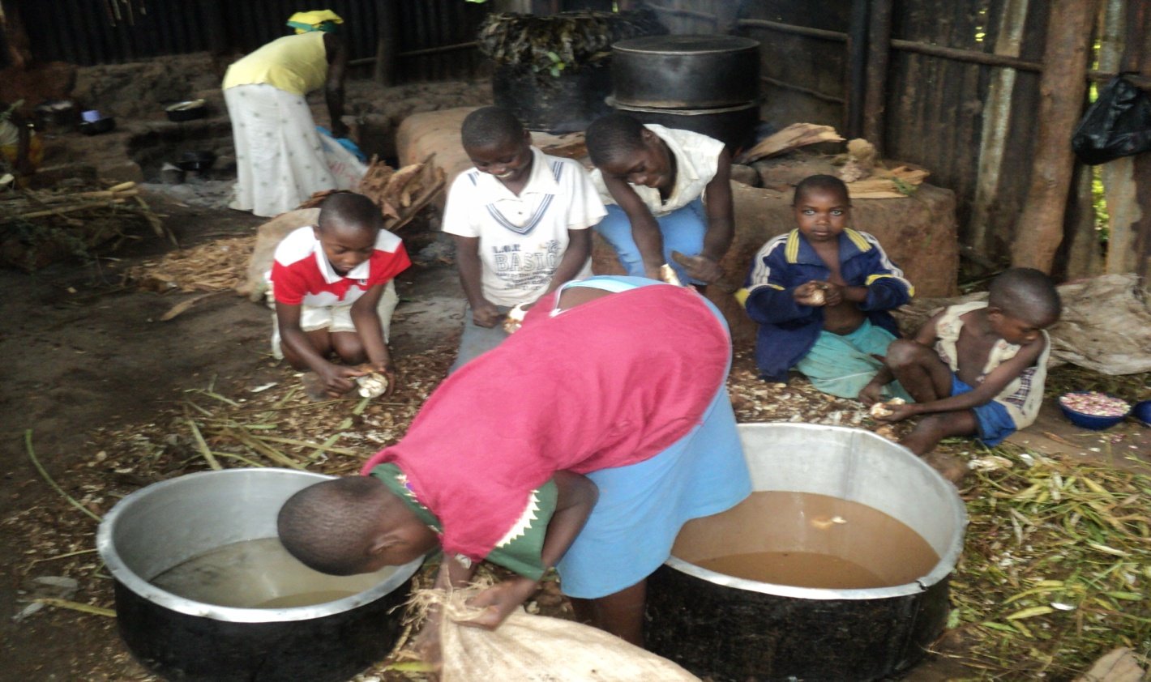
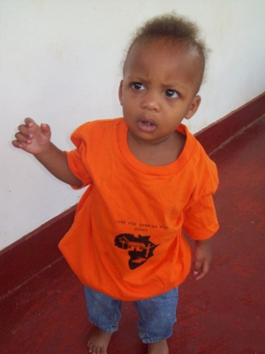
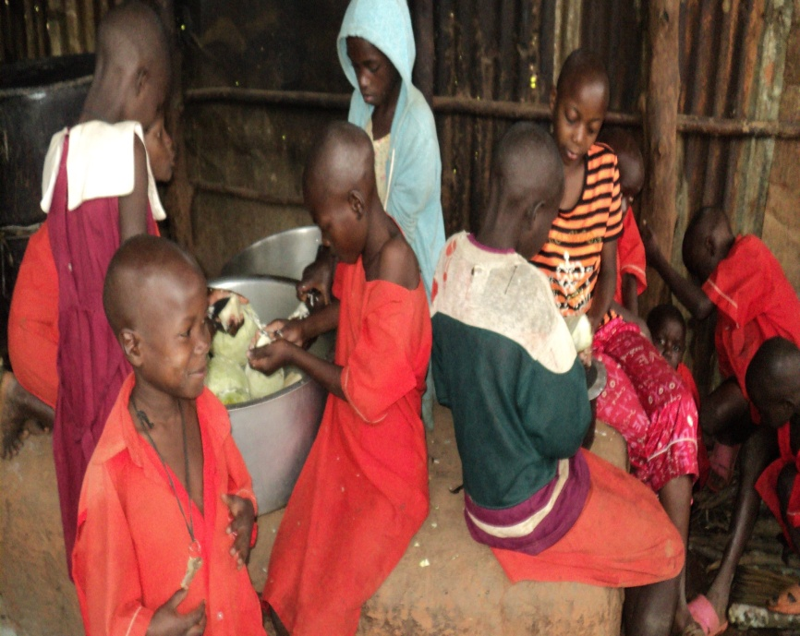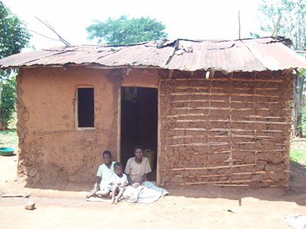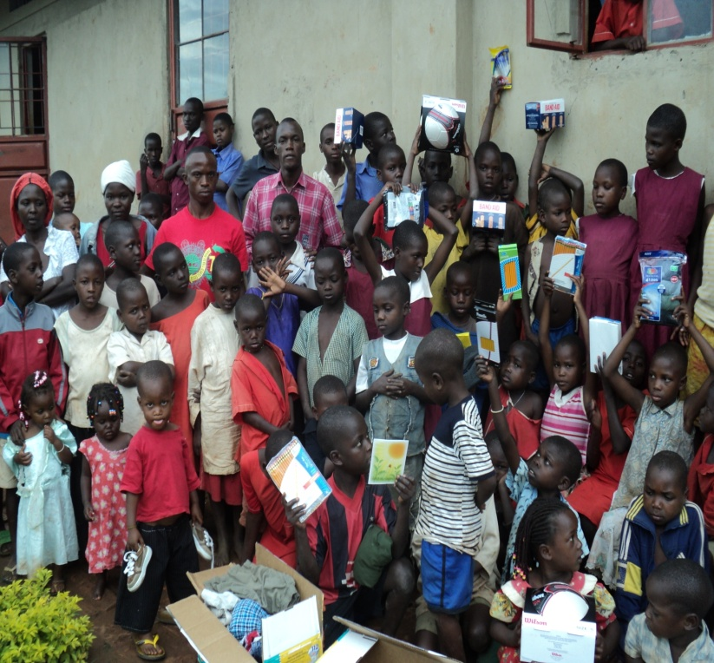

………..TOGETHER WE CAN……………….

THROUGH GIRL POWER PROJECT OF CARE FOR AFRICAN KIDS NGO
www.careforafricankids.org
Facebook: cfakngo

